Part 1. Temperature corrections of standard molar thermodynamic properties of condensed substances and gases using data in DComp records of GEM-Selektor

This calculation is derived from integration of the heat capacity equation Cp = f(T) which has the following form:

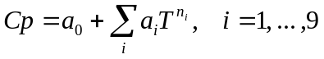 (1-1)
where a_{i} are the empirical coefficients, and power coefficients n_{i} are: n₀ = 0; n₁ = 1; n₂ = -2; n₃ = -0.5; n₄ = 2; n₅ = 3; n₆ = 4; n₇ = -3; n₈ = -1; n₉ = 0.5. Some of these terms are used in most published databases. The corresponding isobaric heat capacity equation is:

Cp = a₀ + a₁T + a₂ T ⁻² + a₃ T ^{-0.5} + a₄ T ² + a₅ T ³ + (1-2).
+ a₆ T ⁴ + a₇ T ⁻³ + a₈ T ⁻¹ + a₉ T ^{0.5} .

As known from chemical thermodynamics (e.g., Anderson and Crerar, 1993), the increment of standard molar Gibbs energy Gº at the reference pressure P_{r} = 1 bar from reference temperature T_{r} to temperature of interest T (in K) can be found by integrating the absolute molar entropy Sº :

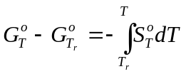 (1-3),

where 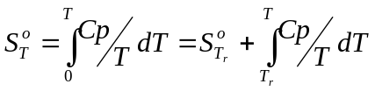. Equation (1-3) can be transformed as follows:

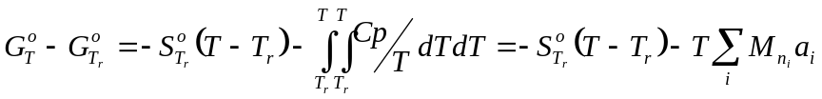 (1-4),

where the 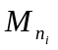terms stand for the Temkin-Shwarzman functions of temperature (Dorogokupets et al., 1988):

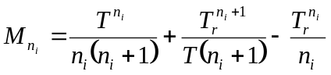.

Using these functions and coefficients n_{i} from eqn. (1-1), separate terms can be defined:

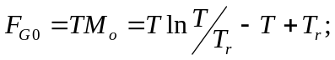
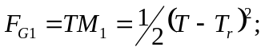
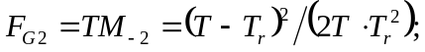
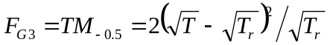;
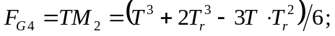
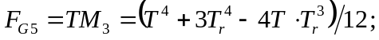
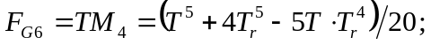
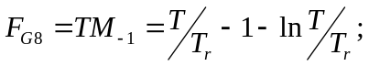
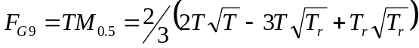.

Now, the standard molar apparent Gibbs energy function gº_{T} of a substance can be calculated easily at reference pressure P_{r} = 1 bar and temperature of interest T ≠ T_{r} (usually, reference temperature T_{r} = 298.15 K):

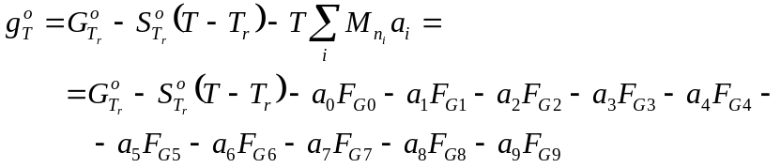 (1-5)

In a similar way, the standard molar entropy 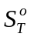 at P_{r} and T can be calculated

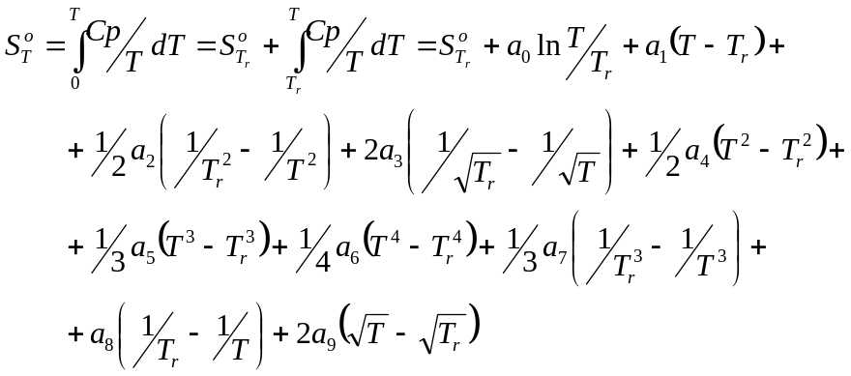 (1-6),

as well as the standard molar apparent enthalpy function :

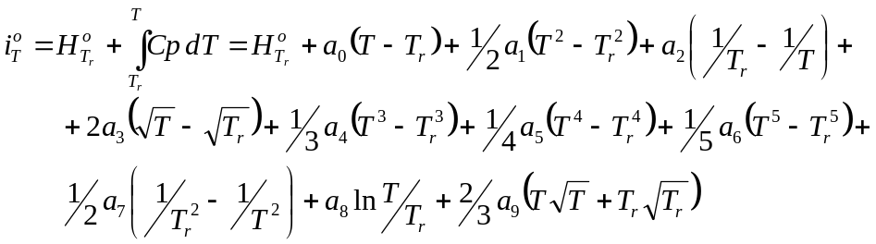 (1-7)

For any compound substance, the apparent molar 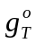 and can be converted into standard molar Gibbs energy 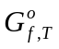 and enthalpy 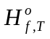 of formation from elements, respectively:

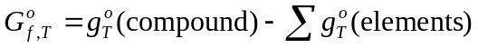; (1-8)
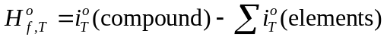. (1-9)

It follows that at T_{r} =298.15 K, 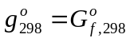 and 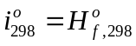 because, for any element at its standard state, 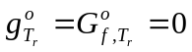 and 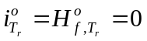 by convention. Note that in Selektor codes (as well as in SUPCRT92; Johnson et al., 1992), apparent molar functions and , but not the formation functions and are calculated throughout at elevated temperatures.

It is possible that, within a wide temperature range, the heat capacity function Cp = f(T) is approximated by more than one set of coefficients of the form eqns (1-1) and (1-2). In the DComp data format, up to 10 such sets are allowed, and each set of coefficients must be supplied with a temperature applicability interval [T_{min}; T_{max}]. No break is allowed within the whole temperature range covered by n(Q) sets; i.e. 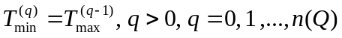.

For simplicity, let T₀ be the lowest temperature for the first Cp approximation interval; T₁ be the upper temperature for the latter (T₀ to T₁) and at the same time – the lower boundary for the next interval (T₁ to T₂), and so on. Usually, T₀ equals 273.15 or 298.15 K, and some of the intermediate temperature boundaries refer also to temperatures of phase transitions at P = P_{r}.

Let k be the index of the temperature interval containing the temperature of interest T_{int}. Obviously, if k = 0 and T₀ ≤ T_{r} < T₁ then T₀ ≤ T_{int} ≤ T₁ and eqns (1-2) and (1-5) to (1-7) apply directly using the first set of Cp=f(T) coefficients. If k > 0 then the value of molar Cp at T = T_{int} where T_{k} ≤ T_{int} ≤ T_{k+1} is still found from eqn (1-2) applied directly to the k-th set of Cp coefficients. However, the values of , and must be calculated incrementally in k loops, as shown in the flow chart below, which also includes accounting for optional molar increments S_{FT}, H_{FT}, G_{FT} at phase transitions. It is required that the temperature of any phase transition T_{FT} (at P_{r}) always co-insides with one of the boundary temperatures T_{j+1}.

Initial: Set j = 0; T_{r} = 298.15 K and T = T_{j+1} ;
Set T_{r} = T_{j+1}; j = j +1; and T = min(T_{j+1},T_{int})

Compute
(eqn 1-5),
(eqn 1-6),
(eqn 1-7)
Check if j < k
yes
no
Calculate Cp_{T} (eqn 1-2); Final
,
,
, Cp_{T}
Is there a phase transition
at T_{FT} = T_{j+1}?
Set
;
Retrieve non-zero S_{FT}, H_{FT}, and G_{FT}

yes
no
Set zero S_{FT}, H_{FT}, and G_{FT}

Note that usage of GEM solvers of equilibria does not really require representing phase transitions in a single DComp record as for a single dependent component. Polymorph modifications, as well as solid, liquid and gaseous states of a substance can be represented as different phases or phase components (i.e. separate DComp records), because GEM will always select the most stable one at T,P of interest. Besides, this also allows circumventing the problem of pressure dependence of the phase transition temperature.

References
Anderson G.M., Crerar D.A. (1993) Thermodynamics in geochemistry: The equilibrium model. Oxford Univ. Press, N.Y.,Oxford.
Dorogokupets P.I., Karpov I.K., Lashkevich V.V., Naigebauer V.A., Kazmin L.A. (1988) Isobaric-isothermal potentials of minerals, gases and aqueous species in the “Selektor” program package. In: Physicochemical models in geochemistry (Kiselev A.I., Karpov I.K., eds.), Nauka Publ., Novosibirsk, p. 124-147 (in Russian).
Johnson J.W., Oelkers E., Helgeson H.C. (1992) SUPCRT92: A software package for calculating the standard molal thermodynamic properties of minerals, gases, aqueous species, and reactions from 1 to 5000 bar and 0 to 1000 ºC. Comp. Geosci., 18, 899-947.

Appendix 1.1. Built-in options for calculation of temperature and pressure correction to standard molar (partial molal) properties of condensed substances and fluids (gases) using data in DComp records (GEM-Selektor v.2.3 PSI).

Code | Model | Input parameters
CSC | integration of heat capacity, constant molar volume | empirical Cp coefficients (a₀ to a₉) entered into aiCpT array; optional phase transition parameters entered into FT_p array
CSK | integration of heat capacity, molar volume from empirical V = f(T,P) function | empirical Cp coefficients (a₀ to a₉) entered into aiCpT array; 5 empirical coefficients for molar volume (a₀, a₁, a₃, b₀, b₁) entered into aiVTP array; optional phase transition parameters entered into FT_p array
CSE | integration of heat capacity, molar volume from HP Birch-Murnaghan equation | empirical Cp coefficients (a₀ to a₉) entered into aiCpT array; isothermal compressibility and isobaric expansibility into BetAlp fields
CHE | integration of heat capacity with Landau contribution, molar volume from HP Birch-Murnaghan equation | empirical Cp coefficients (a₀ to a₉) entered into aiCpT array; isothermal compressibility and isobaric expansibility into BetAlp fields; Smax and Tcrit of Lambda transition into LamST fields; Vmax into ab[0] field
CSB | integration of heat capacity, molar volume from Birch-Murnaghan equation | empirical Cp coefficients (a₀ to a₉) entered into aiCpT array; coefficients of BM equation into ai0Dc array
CSS | integration of ideal gas heat capacity, VdP contribution from Churakov-Gottschalk (CG) fluid EoS | empirical Cp coefficients (a₀ to a₉)entered into aiCpT array; coefficients of CG fluid EoS (sig, eps, mu, alp) into Cemp_s array
CSR | integration of ideal gas heat capacity, VdP contribution from Peng-Robinson-Stryjek-Vera (PRSV) fluid EoS | empirical Cp coefficients (a₀ to a₉) entered into aiCpT array; coefficients of PRSV fluid EoS (Tc, Pc, ω, k1, k2, k3) into CritPg array
CS7 | integration of ideal gas heat capacity, VdP contribution from Peng-Robinson (PR78) fluid EoS | empirical Cp coefficients (a₀ to a₉) entered into aiCpT array; coefficients of PR78 fluid EoS (Tc, Pc, ω) into CritPg array
CST | integration of ideal gas heat capacity, VdP contribution from Soave-Redlich-Kwong (SRK) fluid EoS | empirical Cp coefficients (a₀ to a₉) entered into aiCpT array; coefficients of SRK fluid EoS (Tc, Pc, ω) into CritPg array

Appendix 1.2. Built-in options for calculation of temperature and pressure correction to standard molar (partial molal) properties of aqueous species (and water) using data in DComp records (GEM-Selektor v.2.3 PSI).

Code | Model | Input parameters
CSA | integration of heat capacity, hydration properties of aqueous species from the Akinfiev-Diamond nonelectrolyte model | empirical Cp coefficients (a₀ to a₉) entered into aiCpT array; 3 coefficients of the Akinfiev-Diamond nonelectrolyte model (xi, a, b) into aiNEs array
HWF | water properties (stable state in single-phase fields, liquid properties on two-phase curve) from Haar-Gallagher-Kell (HGK) model | only standard state data need to be provided; paramters of HKF model in aiHKF array are all set to zero
HWG | properties of water vapor (on two-phase curve) from Haar-Gallagher-Kell (HGK) model | only standard state data need to be provided; paramters of HKF model in aiHKF array are all set to zero
HKF | aqueous species properties from revised Helgeson-Kirkham-Flowers (HKF) model | coefficients of revised HKF model (a₁, a₂, a₃, a₄, c₁, c₂, ω₀) into aiHKF array (in their original calorie-based units)
HKP | prediction of HKF parameters of aqueous complexes using Parcor correlation algorithm | DComp record is automatically created from ReacDC calculation in PRONSPREP/Parcor mode. Only recalculation of DComp is required to obtain correct standard state properties. Upon this, the code will be automatically changed to HKF.

