How To Create a project in GEMS using the THEREDA database
THEREDA - Thermodynamic Reference Database: Homepage
THEREDA is distributed with GEMS-Selektor package.
The database files are found in Gems3-app\Resources\DB.default

Create a new project
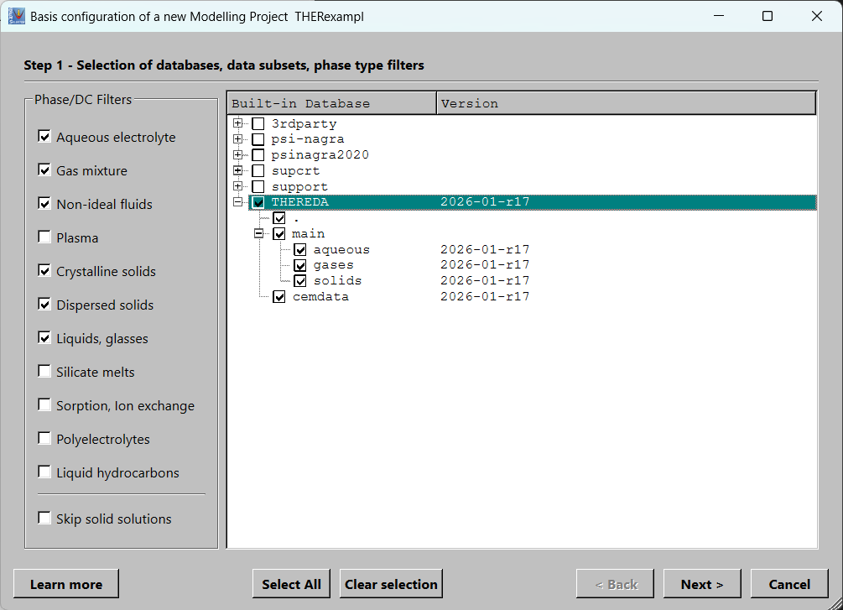
* if cement phases are not of interest untick cemdata

Select the elements you wish to use in the chemical system.
Attention!! To add a new element afterwords can be done only by cloning the project (create a new project using the selected one as template).
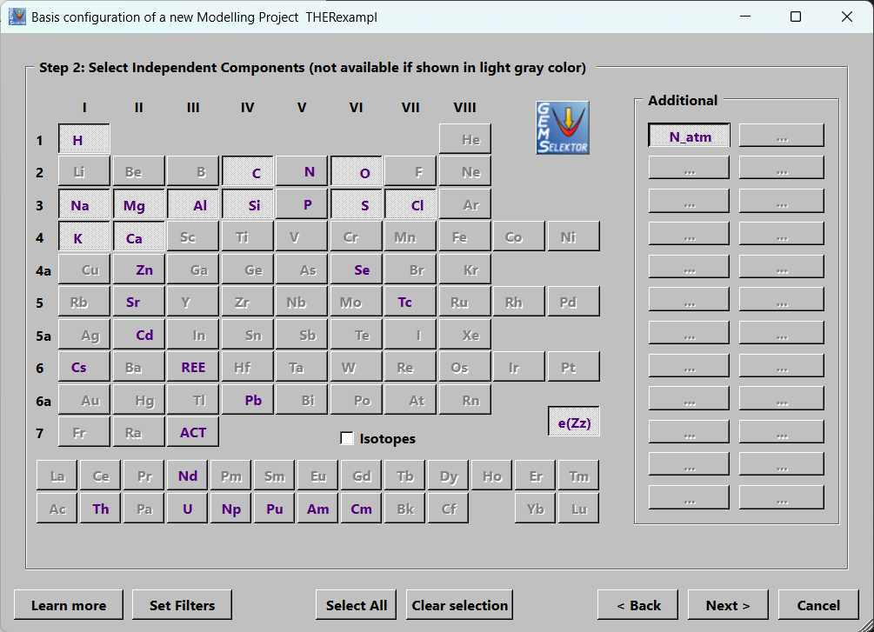
The Pitzer based aqueous phase is a defined phase record in the database (Check and OK) - tick that option.
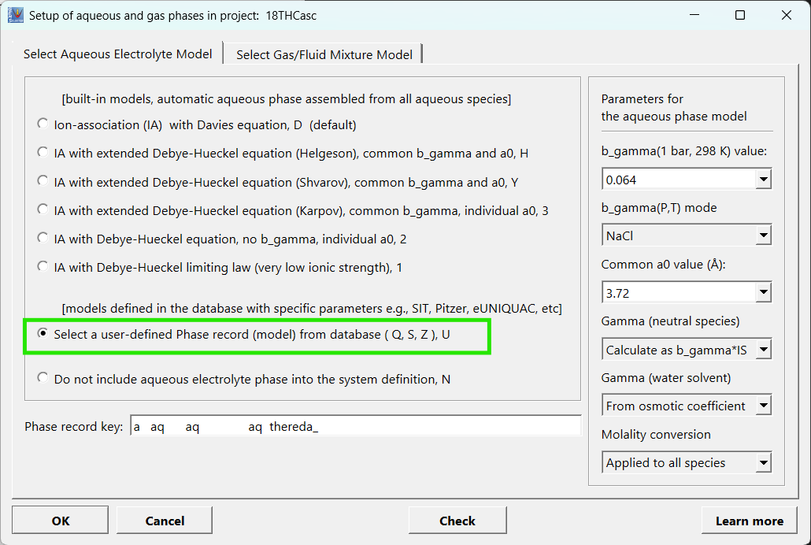

Notes (from building the test project TestTHERE with THEREDA r17)
Files: Resources/databases/THEREDA (Linux and macOS: the same folders under the Gems3 application; user projects are in ~/Library/Gems3/projects). Database files are named <type>.THEREDA.<main.aqueous|main.gases|main.solids|cemdata>.ver2026-01-r17.
Species and phase names differ from the 2022 PitzerTHE data (Ca+2 / Ca<2+>, CaSO4@ / Ca(SO4)<0>, phase group CaNaSO / NaCaSO). A recipe made with old names must be mapped before it is used.
Elements: add N_atm (inert nitrogen) if an inert component is needed. An element that appears only in a later Process (for example Ca in a Cl-brine calculation) must be in the system with a trace amount (1e-9 mol), otherwise the run stops with "No Ca IComp in the system".
Compos: the database has compos.THEREDA.ver2026-01-r17 (85 compositions). A stored calculation keeps the Compos it uses by their position in the project Compos list. After adding or deleting Compos records in a project that already has calculations, the calculations use the wrong Compos: export the equilibria before the change and recreate them afterwards.
Pitzer: the interaction parameter type codes are generated in the thermomatch repository; a wrong code stops the calculation with an error in PTcalc().
Example: the project TestTHERE (library project) has the PitzerTHE Processes, a cement-brine cascade (Compos for brine and concrete) and a seawater evaporation with mineral plots.

