Examples of Layout Tips for Technical Papers in Microsoft Word 2000
John Krumm
Microsoft Research
Microsoft Corporation
One Microsoft Way
Redmond, WA, USA 98052

Abstract
This document, written with Microsoft Word 2000, gives some examples of how to lay out technical documents. It is meant to accompany the web page that describes the techniques.

One-Column Title Followed by Two-Column Text
An example of this is shown above. Note that I’ve increased the width of the side margins to keep the long title more horizontally compact.

Numbering Equations
Tables work well for positioning equations and equation numbers on a line. The table borders should be invisible in the printed document, although they show up as dotted lines on the screen.
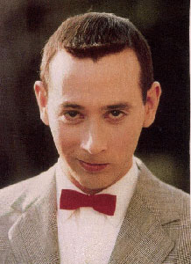
Figure 1: Here is a picture of Pee Wee Herman.
Here is an equation:

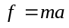 | ()

Here is another equation:

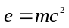 | ()

Here is a third equation:

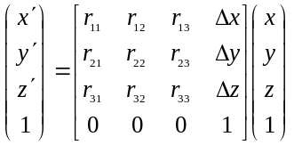 | ()

Now I can have a cross reference to the second equation, which is Equation ().

Figure Captions
I can reference figure captions as long as they are in frames rather than text boxes. For instance, the picture of Pee Wee Herman is in Figure 1. There are photos of three Hudson automobiles in Figure 2.

Multi-Column Figures
Figure 2 spans two columns. It is a table inside a frame. Putting a visible border around the frame didn’t work well, so the visible border is actually a border around the table.

Here Is a Level 2 Heading That Runs into a Second Line
This section is just meant to test the formatting of the “Heading 2” style.

Here is a Level 3 Heading that Runs into a Second Line
Just testing the “Heading 3” style.

Long Equations
Sometimes an equation is too wide to fit in one column. If there is room on the right, you can have it extend beyond the current column. As an example, here is a long equation giving the Taylor Series:
Note that this is just an equation in a table like the ones above. I have specified in “Table Properties” that “Text wrapping” should be “Around”. This lets the table extend into the adjacent column, whose text flows around the equation.
()

The Gettysburg Address by Abraham Lincoln
Four score and seven years ago our fathers brought forth on this continent a new nation, conceived in liberty and dedicated to the proposition that all men are created equal. Now we are engaged in a great civil war, testing whether that nation or any nation so conceived and so dedicated can long endure. We are met on a great battlefield of that war. We have come to dedicate a portion of that field as a final resting-place for those who here gave their lives that that nation might live. It is altogether fitting and proper that we should do this. But in a larger sense, we cannot dedicate, we cannot consecrate, we cannot hallow this ground. The brave men, living and dead who struggled here have consecrated it far above our poor power to add or detract. The world will little note nor long remember what we say here, but it can never forget what they did here. It is for us the living rather to be dedicated here to the unfinished work which they who fought here have thus far so nobly advanced. It is rather for us to be here dedicated to the great task remaining before us--that from these honored dead we take increased devotion to that cause for which they gave the last full measure of devotion--that we here highly resolve that these dead shall not have died in vain, that this nation under God shall have a new birth of freedom, and that government of the people, by the people, for the people shall not perish from the earth.

The Declaration of Independence by Thomas Jefferson
When in the Course of human events, it becomes necessary for one people to dissolve the political bands which have connected them with another, and to assume among the powers of the earth, the separate and equal station to which the Laws of Nature and of Nature's God entitle them, a decent respect to the opinions of mankind requires that they should declare the causes which impel them to the separation.
We hold these truths to be self-evident, that all men are created equal, that they are endowed by their Creator with certain unalienable Rights, that among these are Life, Liberty and the pursuit of Happiness. That to secure these rights, Governments are instituted among Men, deriving their just powers from the consent of the governed, --That whenever any Form of Government becomes destructive of these ends, it is the Right of the People to alter or to abolish it, and to institute new Government, laying its foundation on such principles and organizing its powers in such form, as to them shall seem most likely to effect their Safety and Happiness. Prudence, indeed, will dictate that Governments long established should not be changed for light and transient causes; and accordingly all experience hath shewn, that mankind are more disposed to suffer, while evils are sufferable, than to right themselves by abolishing the forms to which they are accustomed. But when a long train of abuses and usurpations, pursuing invariably the same Object evinces a design to reduce them under absolute Despotism, it is their right, it is their duty, to throw off such Government, and to provide new Guards for their future security.--Such has been the patient sufferance of these Colonies; and such is now the necessity which constrains them to alter their former Systems of Government. The history of the present King of Great Britain is a history of repeated injuries and usurpations, all having in direct object the establishment of an absolute Tyranny over these States.
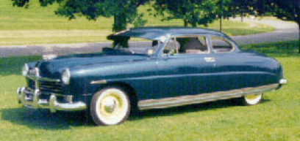 | 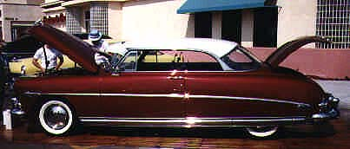 | 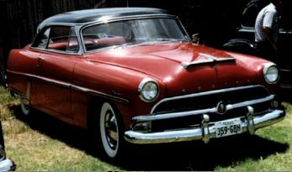
(a) | (b) | (c)
Figure 2: Here are three Hudson automobiles from 1949 (a), 1952 (b), and 1954 (c).

