Structure Editor: a Powerful Environment for Tagged Corpora

Leonid Iomdin, Victor Sizov
A.A.Kharkevich Institute for Information Transmission Problems,
Russian Academy of Sciences
iomdin@iitp.ru, sizov@iitp.ru

Abstract

The paper describes a software environment, Structure Editor, or StrEd, which is used to create and maintain a deeply tagged corpus of Russian texts. StrEd is language-independent and may be used in sophisticated corpora compilation for any language. Special attention is given to Intellectual Debugger, a module of StrEd that provides a technology for versatile checking and improvement of syntactic annotation of the corpus.

1. Introductory Remarks

SynTagRus, a deeply tagged corpus of Russian texts, is the first Russian Treebank that offers, in addition to morphological and lexical annotation, full syntactic annotation for each sentence in the form of dependency tree structures, as well as partial lexical functional annotation (Apresjan et al. 2006, Nivre-Boguslavsky-Iomdin 2008). The corpus is part of the ETAP-3 multipurpose linguistic processor developed by the Laboratory of Computational Linguistics of the Kharkevich Institute (see e.g. Apresjan et al. 2003a). Deeply annotated corpora, including SynTagRus, are used in diverse research paradigms and a large number of applications, such as information extraction and retrieval, parsing evaluation, learning phases of statistically-driven parsers etc.

The paper describes the language of corpus annotation and outlines tools and techniques used to develop and maintain SynTagRus, which constitute the multipurpose environment called Structure Editor.

2. Syntactic Markup Language

In order for a text corpus to be functional in a broad range of applications, it must meet a number of important criteria. In particular, 1) it must feature several layers of linguistic data that can be extracted from the annotation independently of each other; and 2) it should be scalable and incrementable both quantitatively and qualitatively so that new types of information could be added easily.

Naturally, such a corpus requires a data representation language that allows the implementation of such features. In addition, it must be supplied by standard programming means for text parsing, sophisticated search, and conversion. XML meets all of these conditions and has therefore been chosen as the corpus markup language.

At present, the following XML elements are used for markup.

The whole document (corresponding to one text in the corpus) is referred to with the TEXT tagging element, which has a ver attribute (tagging format version). TEXT contains two further elements: 1) info, which contains identification data about the text concerned, and 2) body, which lists all sentences of the text.

The info element has a number of attributes, including the title (full name of the text), source (book, newspaper, journal, website etc), author (one or more authors of the text), date (the file’s last-modified time), annot (the name(s) of the linguist expert(s) who correct the tagging).

In any text file, sentences are specified by S tags: the initial and final tags <S> and </S> define the sentence borders. Sentence properties are presented with three attributes: ID (sentence number), Comment (experts’ informal comments), and Status (the state of the sentence during the tagging, which may be assigned by the parser or the expert who corrects parsing results and, roughly, shows the correctness degree of the syntactic structure).

Each word of the sentence, including punctuation marks that may be assigned to it, are marked by the W tag. The initial and the final tags define the borders of the string of characters corresponding to the word form. Morpho-syntactic information on the word is presented with the following four attributes: ID (word number in the sentence); Lemma (dictionary entry form), Feat (the set of morphological features), Link (incoming syntactic relation, i.e. the syntactic relation going from the syntactic parent into the word); Dom (number of the word which is the syntactic parent of the word under consideration; if this word is the syntactic head of the sentence, the value of Dom attribute is _root).

The newest version of SynTagRus contains partial lexical functional annotation: for collocations that could be presented with the apparatus of lexical functions (LF, see e.g. Apresjan et al. 2003b, 2007) the tagging includes information on values and attributes of such lexical functions. Lexical functional annotation is presented with LF tagging elements, one element for each occurrence of the lexical function attribute/value pair. The element has three attributes: LFFUNC (name of the lexical function); LFARG (number of the word in the sentence that serves as the attribute of this lexical function) and LFVAL (number of the word in the sentence that serves as the value of this lexical function).

Since the corpus was annotated using the main parser and a few other modules of the ETAP-3 linguistic processor, the annotation includes certain data specific for ETAP: such data are necessary when the corpus is used as the benchmark resource for ETAP performance evaluation or a regression test resource. On the sentence level, two parameters are used: the PARAMS attribute is used (the list of text processing parameters set up by the ETAP parser when processing this particular sentence) and the TRANS attribute (which offers the English equivalent of the sentence concerned as produced by ETAP-3 MT module). On the word level, three more attributes are used: KSNAME (the name of the entry of the combinatorial dictionary corresponding to the word of the sentence) and EXTRAFEATS (a list of auxiliary ETAP features assigned to the word, such as the zero feature assigned to a noun or an adjective if these serve as predicate in the absence of a copula verb), and HYPOT (which stores the information on the particular parsing rule that established the syntactic link going into the word from its parent.

In addition to the above attributes, there are additional attributes for storing auxiliary information that facilitates the process of corpus annotation. In particular, the EXTRACOMM attribute presents information on annotation errors for individual words and for the whole sentence. Another attribute, SRCFILE, which stores the information on text title and sentence identification, was introduced for the sake of the technology of error correction offered by the Structure Editor environment: this technology enables one to create a separate file containing erroneously parsed sentences from different texts, correct the parses, and substitute the improved sentences for the old ones directly in the original files. One more attribute, CLASS, is used by annotators to manually classify sentences of the corpus according to any features that the annotators may consider relevant.

Fig. 1 below offers an example of morpho-syntactical annotation with the markup language for the Russian sentence Петр крепко спит ‘Peter is fast asleep’.

<S ID="1" >
<W DOM="3" EXTRAFEAT="CAP" FEAT="S ЕД МУЖ ИМ ОД" ID="1" KSNAME="ПЕТР" LEMMA="ПЕТР“ LINK="предик"> Петр</W>
<W DOM="3" FEAT="ADV" ID="2" KSNAME="КРЕПКО" LEMMA="КРЕПКО" LINK="обст">крепко</W>
<W DOM="_root" EXTRAFEAT="ЛИЧ"
FEAT="V НЕСОВ НЕПРОШ ИЗЪЯВ 3-Л ЕД" ID="3" KSNAME="СПАТЬ" LEMMA="СПАТЬ">спит</W> </S>.

Fig. 1. XML annotation of a Russian sentence

The EXTRAFEAT attribute “CAP” in the first line shows that the first word Петр is capitalized; the same kind of attribute “ЛИЧ” in the sixth line marks the finite form of the verb спит (this feature does not come from the morphology but assigned at a latter stage).

3. Annotation Tools

Considering the significant size of SynTagRus (which currently has over 500,000 words and constantly growing) the annotation process has to be automated to the fullest extent possible. On the other hand, automatic annotation has to allow for verification and, if need be, correction by a human expert. In particular, the need for eventual correction ensues from high morphological, lexical and syntactic ambiguity of sentences, some of which can only be resolved using extralinguistic information, which cannot always be expected from automatic parsers. This means that the environment has to provide for comfortable viewing and editing of annotated texts. Besides, it turns out that linguist annotators often overlook the errors made by the automatic parser and themselves make a considerable amount of mistakes while editing (the human factor). This is why the environment has to provide tools for easy detection and correction of mistakes. The

In order to illustrate the operation of the system of annotation tools, let us consider the annotation of the following text fragment:

Возлюбленную его звали Маргаритою Николаевной. Все, что Мастер говорил о ней, было сущей правдой. Он описал свою возлюбленную верно. Она была красива и умна.
(М. Булгаков, Мастер и Маргарита)

‘His beloved’s name was Margarita Nikolaevna. Everything the master told [the poor poet] about her was the exact truth. He described his beloved correctly. She was beautiful and intelligent.
(M. Bulgakov. Master and Margarita. Translated by Larissa Volokhonsky)

3.1. Preprocessing
The first step in the annotation of any text is to segment it into sentences. The tool used to solve this task is called Sentence Chopper. The segmenting algorithm is rather simple: it is based on the presence of end-sentence punctuation marks (dots, exclamation and question marks) paragraph characters, and the like, with a few rules that clear punctuation marks of sentence end marker status in contexts that are likely to be abbreviations (similar to English i.e., etc., cf. and the like), initials before or after surnames etc. No powerful statistics is used here, since, after automatic segmentation is finished, the result is submitted to a human editor, who corrects segmentation errors, typos, and other small defects of the text. After all segmentation corrections are made, the text is stored as an XML document to be further processed by the main annotation program, Structure Editor.

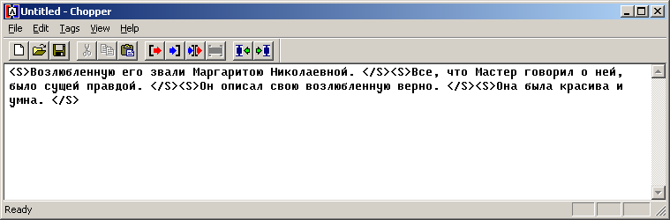

Fig.2. Screenshot of the Sentence Chopper showing the sample text segmented into sentences.

The XML document produced as the result of this segmentation is as follows:

<?xml version="1.0" encoding="windows-1251"?>
<text ver="1.1"><body>
<S>Возлюбленную его звали Маргаритою Николаевной. </S>
<S>Все, что Мастер говорил о ней, было сущей правдой. </S>
<S>Он описал свою возлюбленную верно. </S>
<S>Она была красива и умна. </S>
</body></text>

3.2. Structure Editor

Structure Editor (StrEd) is a complex software environment aimed at 1) automatic generation of morpho-syntactic and lexical functional annotation of texts, 2) manual editing of annotation results, and 3) fully manual annotation. Automatic generation is only possible for texts in natural languages that are supported by the ETAP-3 linguistic processor (at the moment, these include Russian and English). Automatic annotation is only possible if ETAP-3 linguistic processor is installed on the computer, otherwise, only manual editing and annotation can be performed. In principle, Structure Editor is not language-specific and can be used for annotation of texts in any natural language, primarily one with rich morphology, so that the Structure Editor perfectly suits all Slavic languages.

Let us consider typical actions performed by the corpus annotator using the StrEd. If the environment is launched on a computer with ETAP-3 pre-installed, the annotator chooses the configuration of the ETAP-3 processor: the language and the database in which grammar rules and dictionaries are stored. Besides, the annotator may choose one of the viewing options for the data with which he or she is planning to work.

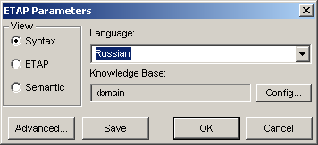

Fig. 3. ETAP-3 Initialization

StrEd allows the annotator to use diverse dialog interfaces enabling him or her 1) to view the whole text; 2) to view a sentence as a table in which every line corresponds to a particular word of the sentence; 3) to view the syntactic dependency tree for a sentence; 4) to view information on a particular word of the sentence; 5) to view the discrepancies within the results of automatic tagging and manual tagging of a sentence.

After the text to be processed has been loaded, the annotator receives the list of text sentences in the form of a table. Each row corresponds to a sentence. The first column of each row contains the initial text of the sentence in normal orthographic form plus a pictogram that presents the annotation status of the sentence. The latter reflects the degree to which the annotation is ready: 1) it may be fully tagged; 2) the tagging may contain lemmas and grammatical features but no syntactic tree and no lexical functional annotation, or, at an early stage, 3) it can just show word forms and punctuation marks. The screenshot in Fig. 4 corresponds to the latter case.

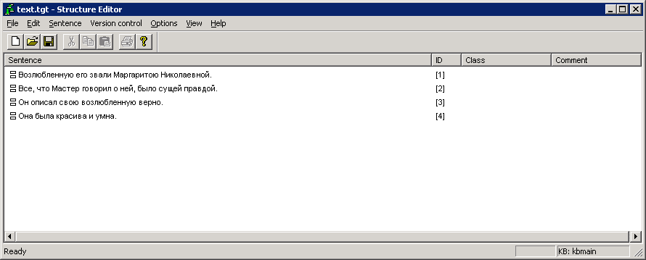

Fig. 4. StrEd view presenting the sample text at an initial stage
with no morphosyntactic tagging performed.

The next three columns present the sentence number, the class, which could be defined by the annotators according to their needs, and the informal comment regarding the sentence. The sentences may be sorted according to the values of any of the four columns in ascending or descending order.

Menu options permit the annotator to generate automatic tagging for all sentences or some of the sentences by selecting them in the table; load individual sentences for manual editing; divide the text into parts or merge several texts into one; split or merge sentences, or perform a number of other tasks.

As a rule, the first step of text annotation is automatic tagging. After it is obtained, the sentences are revised by the annotator, who detect and corrects the errors. To conveniently view the dependency tree structure and manipulate with it, Edit Structure dialog (Fig. 5) can be used.

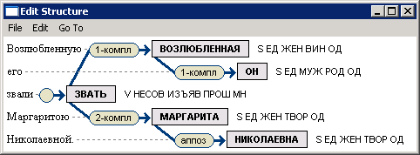

Fig. 5. Edit Structure Dialog of StrEd.

In this view, the annotator can easily perform all typical actions that modify the original tagging; in particular, the editor can rearrange the structure or delete the syntactic relations by simple mouse gestures, alter the lemmas, syntactic links, or grammatical features.

If these operations do not suffice to obtain the desirable results, the annotator may continue the editing by switching to another dialog, intended for sentence properties viewing and manipulation, which allows performing less typical operations with the sentence (Fig. 6).

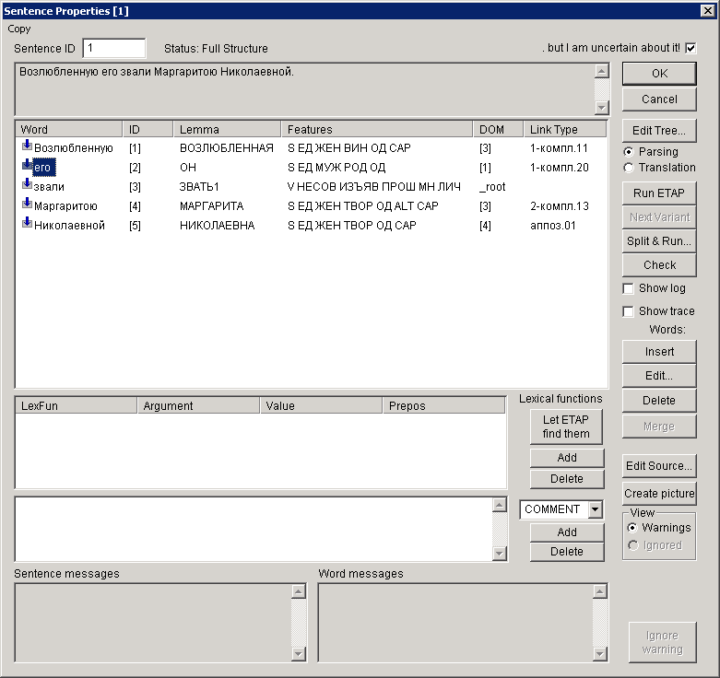

Fig. 6. Sentence Properties Dialog of StrEd.

In Fig. 6, the Edit tree command launches the structure editing interface described above and illustrated by Fig. 5. The Edit Source option opens the XML text file corresponding to the sentence processed: it may be edited manually if the annotator finds it convenient. The Create picture option produces a graphic file offering an image of the sentence structure as it is shown to the user in the structure editing interface.

Most of the operations that can be performed using the sentence properties dialog may be classed under five groups: 1) advanced editing of the sentence; 2) running the ETAP-3 syntactic parser on the sentence; 3) editing of lexical functional annotation; 4) processing of arbitrary tagging attributes, and 5) tackling system warnings. We will consider some of these operations in more detail.

Advanced editing allows modifying the annotation of individual words in a special dialog window, merge several neighbouring words into one, add new words into the sentence, or remove the existing ones.

Two or more adjacent words should be merged into one if these words are the result of specific processing by ETAP-3 parser of composite words like семиголовый ‘seven-headed’ or Минобразования ‘Ministry of Education’. Since such words are naturally absent from the ETAP-3 dictionary, ETAP’s morphological analyzer splits them into two (or more) words (семи ‘seven’ + головый ‘headed’ or мин (abbreviation of министерство ‘ministry’, explicitly mentioned in the respective entry of the morphological dictionary of ETAP-3) + образования (‘education’ in the genitive case). A similar approach is taken for the analysis of certain syntactic amalgams like негде ≈‘there is no place where one could’ or некого ≈ ‘there is no one who could be’, which are split into a fictitious verb with the meaning of non-existence не ≈ ‘there is none’ and the following relative pronouns. This approach is very useful for sentence processing in ETAP-3, e.g. for machine translation purposes. However, for a number of reasons (including the fact that corpus users are not necessarily people well-versed in linguistic subtleties), such units cannot be left split in the tagged corpus so they had to be merged again by hand.

The ETAP-3 parser can be run on the annotated sentence in one of two options – Parsing and Translation, which are launched by the respective radio buttons (see the rightmost part of Fig. 6). Parsing is the default mode, resorted to in order to produce the first result of syntactic parsing or alternative parses, produced by pressing the Next Variant button one or more times. The Translation mode is not used for corpus annotation; rather, it is employed to debug the machine translation options on the annotated sentences.

Large sentences (50 words or more) are best annotated using the Split & Run option. In this case, ETAP-3 parser produces syntactic structures for sentence fragments, whereupon the structures are manually merged into one. Sentence splitting is also performed by the annotator, whose expertise enables him or her to split the sentence into linguistically natural fragments, as exemplified by Fig. 7. This technique increases the chance of producing adequate parses for each of them.
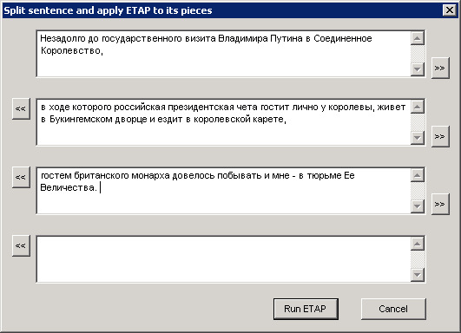
Fig. 7. Splitting long sentences for best annotation results

3.3. Lexical Functional Annotation
Lexical functional annotation of a corpus sentence can be produced in three ways: 1) automatically, together with syntactic parsing by running the ETAP-3 parser on the sentence; 2) automatically, by running a subset of ETAP-3 rules on the ready syntactic structure of the sentence approved by the expert; using the StrEd option “Let ETAP find them (LFs)”, 3) manually.

The list of LF argument and values, irrespective of the way it was produced, can be manually edited: information on functions can be modified, added, or removed.

3.4. Error Detection and Correction

To demonstrate how the Structure Editor can help detect errors and correct them, let us consider a typical situation where errors emerge as a result of a human annotator’s neglect.

Imagine that the annotator edits information of a particular word in the sentence using the word properties dialog box (Fig. 8). This dialog box can be opened from the sentence properties dialog (see Fig. 6 above) with a double click on the row of the table corresponding to the word in question:

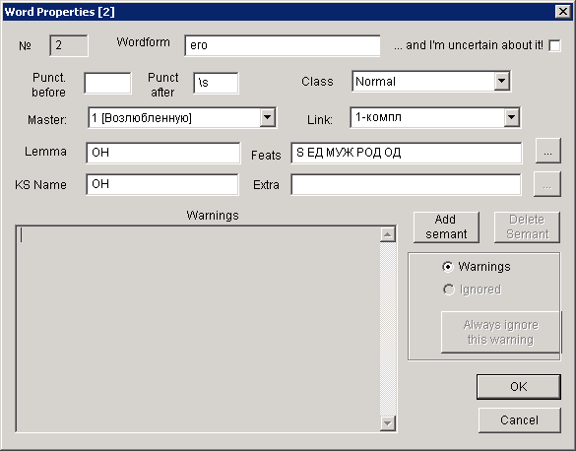
Fig. 8. Word Properties Dialog of StrEd.

The dialog box allows editing the morphosyntactic features of the word in a way similar to Edit Structure Dialog (see Fig. 5 above) but, in addition, it allows altering the word form, punctuation before or after it and viewing any diagnostic messages or warnings related to the word. The screenshot in Fig. 8 presents the second word of Sentence 1 of our illustrative text.

Imagine now that the annotator working with the word substituted by mistake the name of syntactic relation for “3-комп”, a non-existent one, or the morphological feature “од” (animate) for “одуш” (also non-existent). To detect such errors, StrEd makes use of the lists of admissible names of syntactic relations and morphological features. Such lists have to be created for each language of the corpus to be annotated. If a word is ascribed morphological features or syntactic relations outside the list, the annotator gets a warning message when trying to close the dialog window:

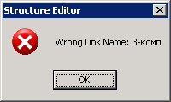
Fig. 9. StrEd’s warning message box

The dialog window cannot be closed unless the annotator enters a relation from the list, such as «3-компл».

Let us now consider a slightly more complicated case, when the annotator mistakenly adds wrong features or deletes the necessary ones. Imagine that the word in Fig. 8 lost the animateness feature. To prevent such a development, StrEd uses a list of admissible strings of morphological features for different parts of speech. The features are presented with a notation similar to Backus normal form. To give an example, the morphological features of Russian nouns are presented in the following way:

NOUN=S + (КОТОРЫЙ | LATIN_S | SIGNS | ((ЕД + GENDER | МН + (GENDER | $EMPTY)) + (CASE | $EMPTY) + ANIMATENESS) | GENDER + ANIMATENESS + СЛ);

This means that the animateness feature should be ascribed to all nouns except for the signs $, %, °, the word который ‘which’ and the words written in Roman characters. If a noun does not have an animateness feature, the module responsible for verifying the consistency of the morphological feature set will detect a discrepancy and display a warning message:

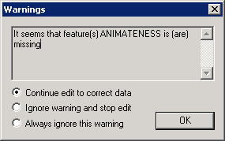
Fig. 10. Inconsistency warning message box

Unlike the previous case, such a discrepancy is not necessarily an error, since theoretically there might be exceptions not yet described in the morphology configuration file. For this reason, the annotator may ignore the warning message if he or she see it fit. The message can be ignored once, so that when the diagnostic procedure for this word is launched again, the warning reappears), or permanently. In the latter case, the warning is stored in word annotation and, should the word be subject to a new check, the diagnostic messages are compared with the stored ones and eventually ignored.

The annotator can review the list of the ignored messages for a word pressing the Ignored button, which appears in the Word Properties Dialog Box if there are ignored messages in its annotation. If one decides that the message should not be ignored, the list of ignored messages could be deleted.

Imagine that in the course of further tagging the expert restored the animateness of the word его, but left untouched the erroneous link 3-компл. The structure containing this link cannot be reproduced by the parser. It may seem at first glance that in such a case the annotation error could be diagnosed by producing the set of all sentence parses: if the syntactic structure offered by the annotator is absent from this set, then it is obvious that a mistake has been made. However, such an approach proved to be of little use. First, ETAP parser is not always able to produce an ideal structure, especially if the sentence is long and/or complicated, so that a false diagnosis is quite likely. Second, even if the diagnostics is correct, it may fail to determine exactly what annotation errors have been made, in which case the information that ETAP parser is unable to confirm that the verified structure is admissible becomes totally useless.

3.5. Intellectual Debugger

In order to diagnose nontrivial annotation errors, a powerful instrument, Intellectual Debugger (IntelDeb), was specially created by one of the author’s (Victor Sizov) in order for the human editor to verify, in one quick step, whether the current syntactic annotation of a sentence (probably the result of several human interventions) is compatible with at least one of the parsing in principle achievable through the automatic ETAP-3 parser. As a matter of fact, IntelDeb can be considered as a specific parser which, unlike the regular ETAP parser, does not produce multiple parses of a sentence. Instead, if the IntelDeb finds that the structure being subject to verification is inadmissible, its goal is to diagnose the cause, or causes, of the situation as precisely as possible.

The Check option of the Structure Editor triggers a powerful instrument, Intellectual Debugger, specially created by one of the author’s (Victor Sizov) in order for the human editor to verify, in one quick step, whether the current syntactic annotation of a sentence (probably the result of several human interventions) is compatible with at least one of the parsing in principle achievable through the automatic ETAP-3 parser. The underlying idea is to run the parser consecutively on all binary subtrees as presented by the annotation and see whether the existing syntactic rules and dictionaries permit the construction of such subtrees. The Intellectual Debugger algorithm checks all rules with regard to a specific syntactic link (there may be dozens of such rules and all possible lemmas for the given pair of words, starting with the rules and lemmas cited in the annotation but gradually loosening the grip and resorting to other rules and lemmas if the current choice cannot be confirmed. The debugger helps the annotator to detect errors in the annotation as well as errors in the ETAP-3 parser and/or dictionary: this could happen if an obviously correct syntactic structure produced by a human or with human intervention could not be confirmed by ETAP.

In order to better understand the principles of IntelDeb operation, let us summarize the parsing process performed by ETAP-3 parser. It consists of the following stages:

- Morphological and pre-syntactic analysis;
- Generation of the set of hypothetical syntactic links;
- Verification of context conditions for the syntactic link;
- Generation of the dependency tree.

The morphological analyzer receives a text as a sequence of character, segments it into words and produces, for each word, a set of possible morphological parses, each of which consists of a lemma name and a set of morphological features. Pre-syntactic analyzer assigns certain features to words, increases or decreases priorities of homonyms, and deletes some of the obviously irrelevant homonyms. The parser proper starts by producing all possible syntactic hypotheses, using dictionary information, morphological features, and the linear arrangement of words. As a result, an oriented graph (matrix) of syntactic links is built, whereupon every link is checked for compatibility with other links of the graph.

A link proves inappropriate and is deleted from the graph if 1) the graph does not have links or words whose presence is necessary for such a link to exist; 2) the graph has links or words whose presence contradicts the conditions of the legitimacy of the link considered and these links or words are final so that should such links or words be eliminated from the graph, the generation of a tree becomes impossible.

The last stage of parser operation – generation of the dependency tree – is performed according to the following algorithm:

- The top node of the tree is chosen, or a node is linked to a fragment built around the top node; deletion of nodes and links that contradict the choice made.
- Application of rules checking the contents and filters. Deletion of links for which conditions do not hold.
- If the tree is built, the procedure is considered successful; if not, the operation continues; if the tree is impossible to build, the algorithm retreats one step and chooses another variant, if there are no more variants, the algorithm builds an emergency tree.

Proceeding from the above, let us consider the reasons why the parser may not confirm a given sentence parse. It may happen in the following cases:
- The morphological analyzer was unable to obtain given parses for one or more words. In especially hard cases, even text segmentation into words may be different.
- The syntactic parser could not build one or more syntactic links of the given parse.
- The given words, their features, and syntactic links were individually confirmed but further on some of them were deleted since they contradicted each other.
For this reason, to reveal the reason why a given parse cannot be confirmed becomes a hard and far from trivial task. So, on the one hand, the given link may fail to be built because the morphological analyzer did not provide the expected lemma and/or its features. On the other hand, the parse could be obtained but later deleted because a given link was absent. It must be said that the deletion process for words and links may become avalanche-like. Accordingly, in order to correctly diagnose the ultimate cause of failure, the IntelDeb must prevent the recurring deletion of words and links.

The problem of recurring deletion is solved as follows: the absence of a required word or link is observed before the moment when it can trigger the deletion landslide: a diagnostic message is produced, whereupon the sentence is supplied with a word or link that serves as a substitute for the absent element. In case of an absent link the IntelDeb creates a special link whose name is identical with the absent one: this link cannot be deleted by further processing.

Substitution of a missing word is less trivial. If the lemma name is known, the IntelDeb loads the respective entry from the dictionary, assigning the required features. If the lemma name is unknown, a template entry is chosen, on the basis of morphological features, from the list of entries describing broad classes of unidentified words (animate feminine nouns, transitive or intransitive verbs, and the like).

We can now present the algorithm of IntelDeb operation, which consists of the following stages:
- Loading the structure to be verified and extracting the text of the sentence.
- Morphological analysis of this text.
- Checking whether a morphological parse exists for all words of the sentence. For missing parses, a diagnostic message is generated and a substitute word is chosen.
- Generating hypothetical syntactic links.
- Checking whether the required links exist for every word of the sentence. In case of a missing link, a diagnostic message is generated and a substitute link is formed. Links whose names do not coincide with the required ones are deleted..
- Launching the procedure of tree generation, checking for the required links and words at every step. If these are missing, diagnostic messages are generated and substitutes are formed.
- Launching the tracer for syntactic rules responsible for the production of the required links. If IntelDeb cannot confirm the correct structure, viewing the tracer operation step by step helps the annotator understand the causes of errors: in most cases, they are connected with errors in syntactic rules or dictionary entries..
As the result of IntelDeb processing of a tagged sentence, either the parse in confirmed, or diagnostic messages are produced which show unconfirmed morphological parsed or syntactic links. Another outcome of this processing is tracing of syntactic rules.

In our example, the diagnostic message will look as follows:
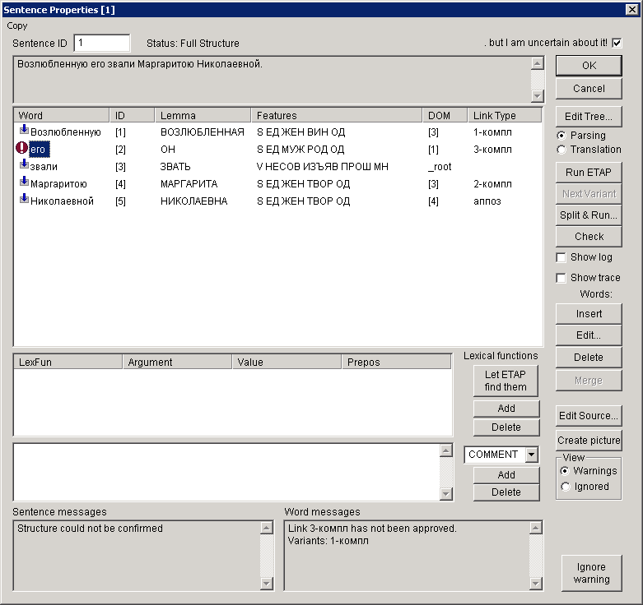

It is obvious that this algorithm allows the Intelectual Debugger to find errors in structures produced by humans or with human interference, as well as in structures produced automatically. This means that it can be used in a broad range of natural language processing tasks..

References
Apresjan Juri, Igor Boguslavsky, Leonid Iomdin, Alexander Lazursky, Vladimir Sannikov and Victor Sizov, Leonid Tsinman (2003a). ETAP-3 Linguistic Processor: a Full-Fledged NLP Implementation of the MTT // MTT 2003, First International Conference on Meaning – Text Theory (June 16-18 2003). Paris: Ecole Normale Superieure, 2003. P. 279-288.
Apresjan Ju., I. Boguslavsky, L. Iomdin et al. Lexical Functions as a Tool of ETAP-3 (2003b). // MTT 2003. First International Conference on Meaning-Text Theory. Paris: École Normale Supérieure, June 16–18, 2003.
Apresjan Juri, Igor Boguslavsky, Leonid Iomdin, Boris Iomdin, Andrei Sannikov and Victor Sizov (2006). A Syntactically and Semantically Tagged Corpus of Russian: State of the Art and Prospects // Proceedings of the 5th International Conference on Language Resources and Evaluation (LREC’2006). Genoa. Р. 1378-1381.
Apresjan Ju., Igor M. Boguslavsky, Leonid L. Iomdin and Leonid L. Tsinman (2007). Lexical Functions in Actual NLP-Applications // Leo Wanner (ed.) Selected Lexical and Grammatical Issues in the Meaning-Text Theory. In honour of Igor Mel'čuk, Amsterdam: Benjamins Academic Publishers. ISBN 978 90 272 3094 2. Р. 199-230.
Nivre, Joakim, Igor Boguslavsky, Leonid Iomdin (2008). Parsing the SYNTAGRUS Treebank of Russian // Coling 2008. 22nd International Conference on Computational Linguistics. Proceedings of the Conference. Vol. 2. P. 641-648. ISBN: 978-1-905593-47-7.

From: Structure Editor: a Powerful Environment for Tagged Corpora // MONDILEX Fifth Open Workshop, Ljubljana, Slovenia, 14–15 October, 2009. Ljubljana, 2009. ISBN 978-961-264-012-5. P. 1-12

This research has been funded in part by a grant from the Russian Foundation of Basic Research (No. 07-06-00339) and the Program of the Section of historical and philological sciences of the Russian Academy of Sciences “The text in interaction with the sociocultural environment: levels of historical literature and linguistic interpretation”, for which the authors are grateful.
Most of the punctuation marks are considered to be assigned to the word that precedes them (no matter how many punctuation marks occur one after another). Exceptions are left brackets and left quotation marks, as well as dashes opening the sentence, which are assigned to the word following them.
It is worth mentioning that since the creation of the tagged corpus requires significant manual labour at more complex stages, it is hardly reasonable to concentrate efforts to fully automate the preliminary stages of corpus processing.
Within ETAP-3, small MT prototypes are available for five more languages: French German, Spanish, Arabic and Korean; however the coverage is not sufficient to produce tagged corpora for these languages.
As a matter of fact, this relation is present in the list but is still erroneous in our case, since the correct name of the relation is 1-компл. We will show later how such errors can be detected.

