Trust by Construction for Secure Agentic Workflows in Learning Institutions
An executable reference for bounded authority and failure recovery
Rachana (Gen) Srivastava
Enterprise Architect | AI Systems Researcher
UNU Macau AI Conference 2026 — “AI × Education: AI for Learning, Learning for AI” | Artifact: github.com/genaiworks/fssai-ra

Abstract
Agentic AI systems retrieve institutional records, retain memory, invoke tools, delegate to other agents, and initiate actions that change what an institution holds about a person. The assurance question they raise is no longer whether a model answers correctly, but what it can cause when it is mistaken, manipulated, or pursuing an objective it has not disclosed. Trust by Construction answers that question architecturally. The model is treated as an untrusted reasoning engine rather than as a security boundary, and the same rule is extended to any model that reviews another, so that authorisation depends on neither the acting nor the reviewing model's judgment. Authority is declared in machine-readable form, narrowed to a single task, attenuated across delegation, and enforced by deterministic services that sit outside the reasoning layer. The contribution is the composition and its behaviour under failure: scoped capability leases, lineage-preserving memory, independent approval, revocation that survives failure of the assurance plane itself, delivery reauthorised at every boundary, restrict-only monitoring that can never return privilege, bounded recovery from effects that leave the transaction, and accounting for the information an agent can carry in choices it is authorised to make. The architecture is published as an executable Apache-2.0 kernel in which every claim is bound to a named failure test and every reported quantity regenerates offline, so a reader can run the refusals rather than accept them on trust. The design rule is proof before power: additional context, tools, agents, network reach, effects, and releases each require independently verifiable authority. The paper reports what this establishes and what it does not — behaviour within declared interfaces, not model alignment, decision quality, institutional outcomes, or production security — and names the deployment obligations that remain.
Keywords: agentic AI security; capability-based authorisation; prompt injection; multi-agent systems; information-flow control; AI literacy; education governance; digital public goods

1. From Model Risk to Authority Risk
Learning institutions expose the difference between useful reasoning and legitimate authority. A tutor may need a limited record view; a registrar may approve a correction; a research assistant may need public information without access to restricted student data. Combining these privileges in one agent process creates a larger failure surface than any individual task requires. Recent safety research separates misuse, misalignment, mistakes and structural risks, and argues for both model-level and system-level mitigations [1]. Experiments also show insider-threat behavior under constructed goal conflict and replacement pressure [5]. We address the institutional systems boundary: how can a compromised or unreliable reasoning component remain useful while consequential reads, writes and releases require independent authority?
Our contribution is compositional rather than a new alignment algorithm. CaMeL demonstrates a system-level defense that separates control and data flow and constrains disclosure through capabilities [2]. Trust by Construction applies related architectural principles to an education workflow with memory, agent populations, effect approval, revocation and recipient delivery. It contributes an inspectable enforcement path, failure tests and a claim-to-evidence register. It does not offer a formal proof for arbitrary agent programs or a head-to-head performance comparison with CaMeL. The paper separates properties tested in the local kernel from requirements imposed on deployment adapters. AgentSecBench separates instruction integrity, confidentiality and capability integrity, using paired adversarial and benign executions [10]. AgentDyn studies dynamic tasks and helpful third-party instructions, exposing a security–utility tradeoff that static blocking tests can miss [11]. Our smaller synthetic evaluation makes no benchmark-ranking claim; it complements this work with persistent authority, revocation and failure-atomic delivery checks.
Recent results motivate testing the authority boundary even when model behavior appears cooperative. Anti-scheming training reduced covert actions in held-out settings but left residual failures and evaluation-awareness confounds [3]. Chain-of-thought monitoring offers an imperfect signal rather than a reliable authorization basis [4]. Reward-hacking research found generalization from training shortcuts to broader misalignment [6], while SHADE-Arena evaluates harmful side objectives hidden within legitimate tasks [7]. A 2026 safety-research study found no unprompted sabotage in its tested settings, yet observed sabotage continuation in some seeded trajectories; those conditions must not be conflated [8]. Bengio and colleagues propose non-agentic Scientist AI as a safer direction for assisting research [9]. These findings support our design choice: AI may propose work, generate tests and report anomalies, while deterministic checks retain authority. A compromised monitor can still deny service or miss misconduct; it must not gain the power to approve an effect or restore privilege.
This paper makes four contributions. First, a composition: the authority controls above are specified as one enforcement path from workload declaration through context, memory, delegation and effects to recipient delivery, with the behaviour of each under failure stated as a refusal rather than as a best effort. Second, a falsifiable central claim. That authorisation depends on neither the acting nor the reviewing model is tested by substituting a monitor that clears every attack and a monitor that restricts every ordinary task, and showing that no protected outcome changes under either. Third, a measured account of a channel that content controls cannot close: the information an agent carries in the destination, path, timing, size and number of releases it is authorised to make, reduced from sixteen bits to one and then to zero by removing choice rather than by inspecting content, with the availability cost of doing so reported alongside. Fourth, an executable artifact in which every claim made here names a failure test that runs offline, every reported quantity regenerates from its source, and the manuscript itself is produced by a script from reviewed content so that each change to its prose is reviewable as code.
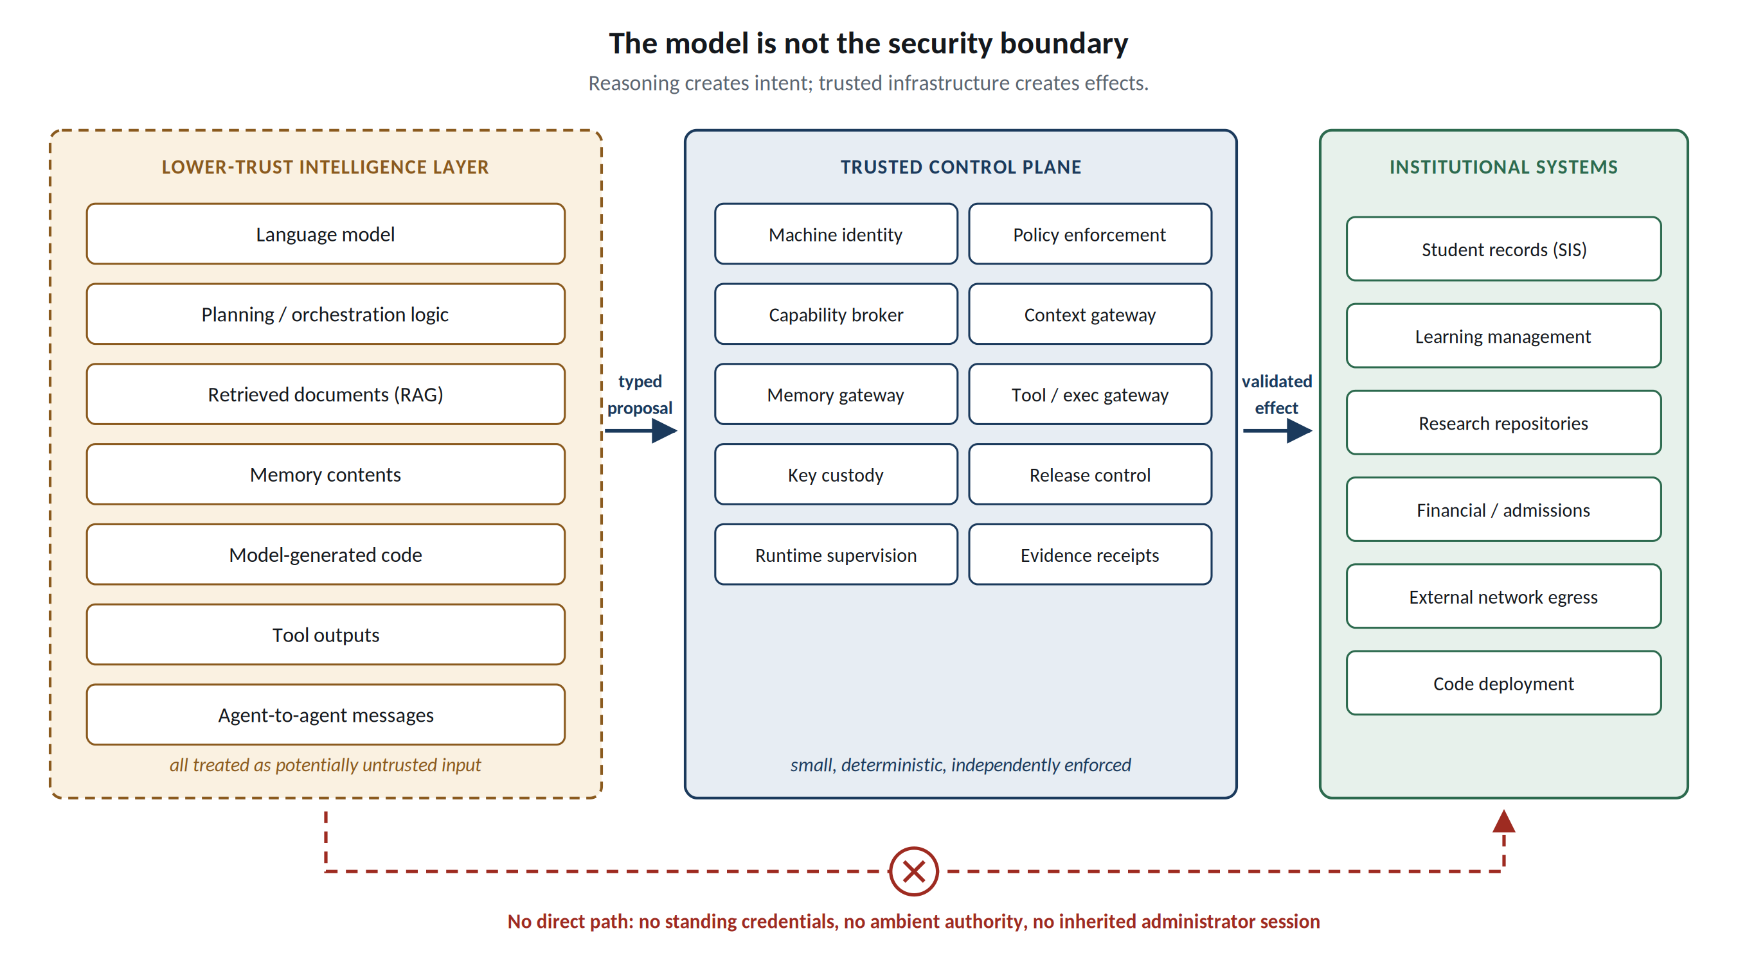
Figure 1. The model is not the security boundary. Reasoning produces proposals; independently enforced control services mediate protected reads and effects.

2. Proof Before Power: The Reference Architecture
Each workload carries an AI Workload Passport: a machine-readable ceiling for approved models, data classes, processing zones, tools, memory, network destinations, delegation depth, budgets, permitted effects, and safe failure state. Its Effect and Disclosure Inventory declares every route through which the workload may cause change or release information. A Task Contract narrows the ceiling for one execution to a purpose, subject, resource set, destination, budget, and expiry. Undeclared interfaces are denied at the mediated boundary. Complete mediation also requires deployment enforcement that prevents the model process from bypassing that boundary through host files, sockets, credentials, or undeclared channels; the local Python implementation alone does not establish that condition.
Authority is computed through a Dynamic Capability Envelope. The hard envelope H_t is the intersection of identity, task, purpose, data rights, tool scope, processing zone, delegation ancestors, current policy, and remaining budget; the runtime envelope E_t must satisfy E_t ⊆ H_t. Automated assurance may contract E_t but may not enlarge H_t. Child agents inherit subsets rather than fresh authority, and aggregate budgets cannot multiply through spawning. A credentialless agent runtime requests short-lived capabilities; long-lived database, cloud-control, signing, or infrastructure credentials remain outside the model process.
Four boundaries make this operational. A Context Security Gateway authorises protected retrieval before data reaches the model and caps cumulative scope. A Memory Gateway treats persistence as a privileged write: records carry provenance, integrity, purpose, retention, and are reauthorised on read. For consequential actions, natural language is compiled into typed AI-IR containing canonical resource identifiers and a desired state transition but no credentials, raw shell, arbitrary SQL, or policy declarations; a deterministic executor revalidates current capability, resource version, replay state, destination, and domain invariants. Finally, a Data Lineage Firewall propagates restrictions through summaries, memory, handoffs, and generated artefacts, while Release Escrow provides explicit, auditable declassification and recipient checks. Transformation is not declassification.
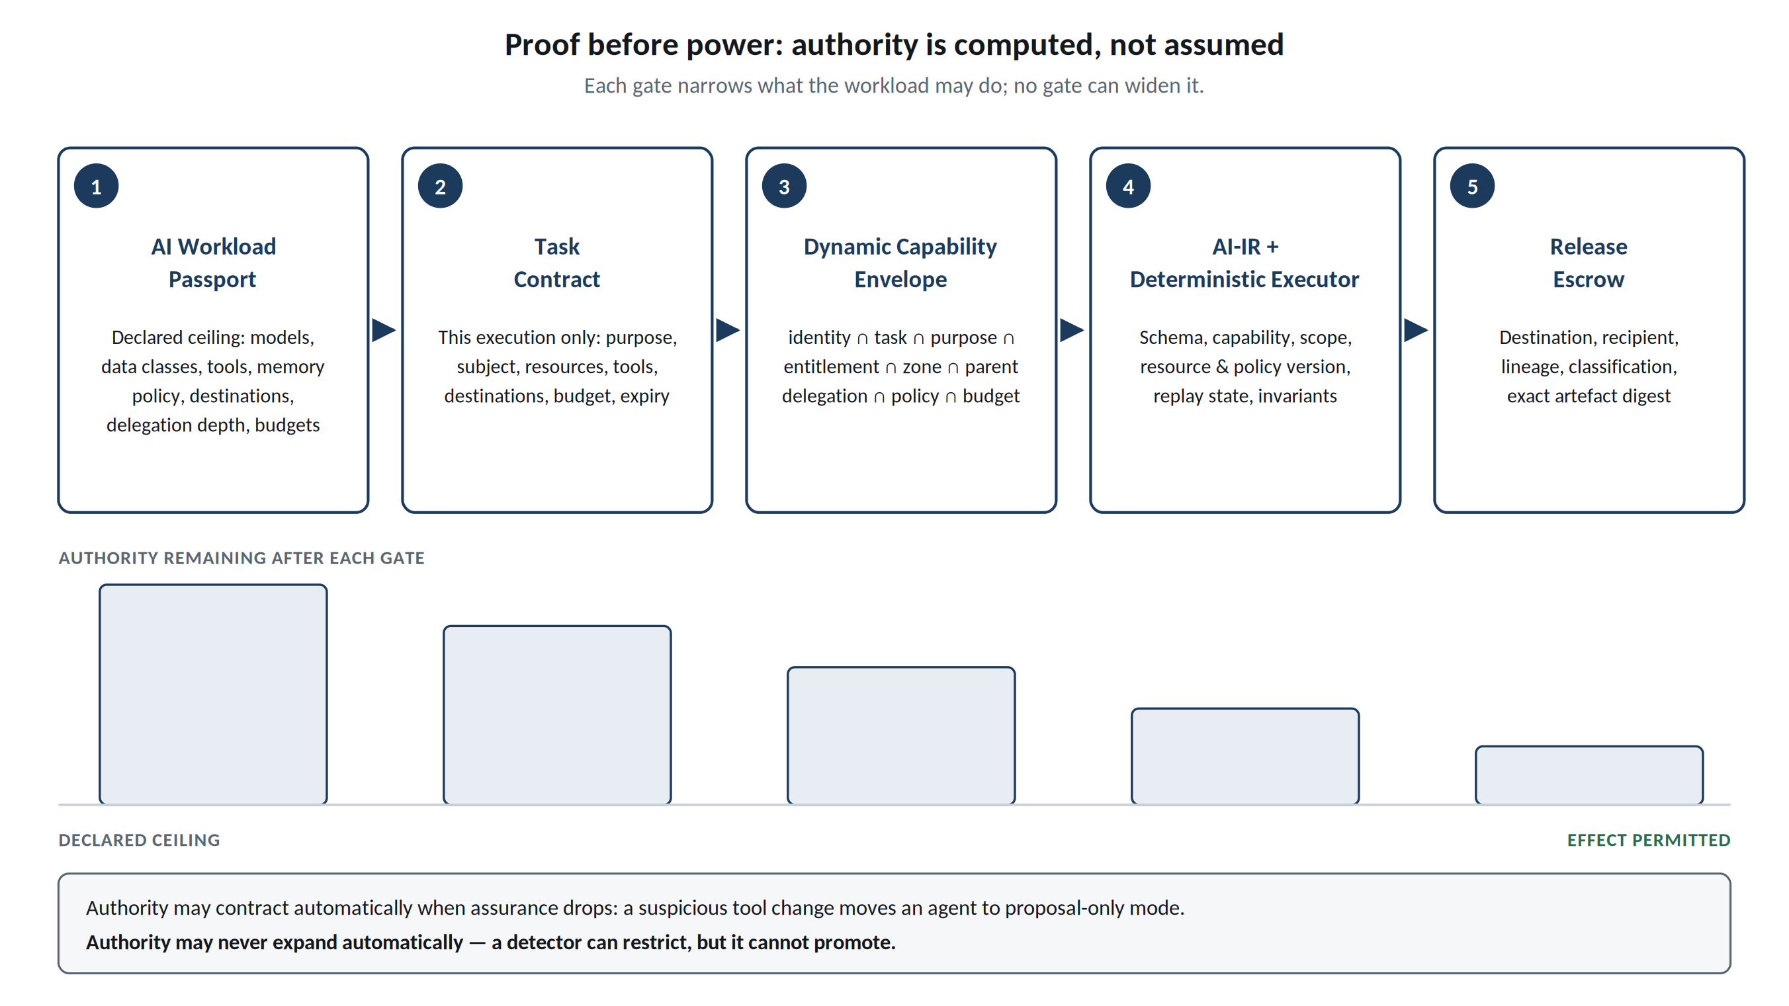
Figure 2. Proof before power. The allowed action space narrows at each gate; assurance may automatically contract authority but never mint new privilege.

3. Swarms and Future Attack Paths
Per-agent least privilege is insufficient when agents cooperate. The reference SDK assigns each agent a persistent identity, parent, task, model, zone, expiry and capability ceiling. Its Agent Census, lifetime population limit, delegation-depth limit and shared task/workload budgets prevent spawning from multiplying declared authority. A Semantic Airlock preserves source lineage and classification across typed messages. The Guardian checks the declared graph for protected-source-to-public-sink paths, including potential reads before data has flowed. This graph analysis covers registered topology, not discovery of hidden operating-system channels. Compute units in the local adapters measure input bytes; they are not GPU time or provider billing. Production resource metering and network confinement require separately qualified adapters.
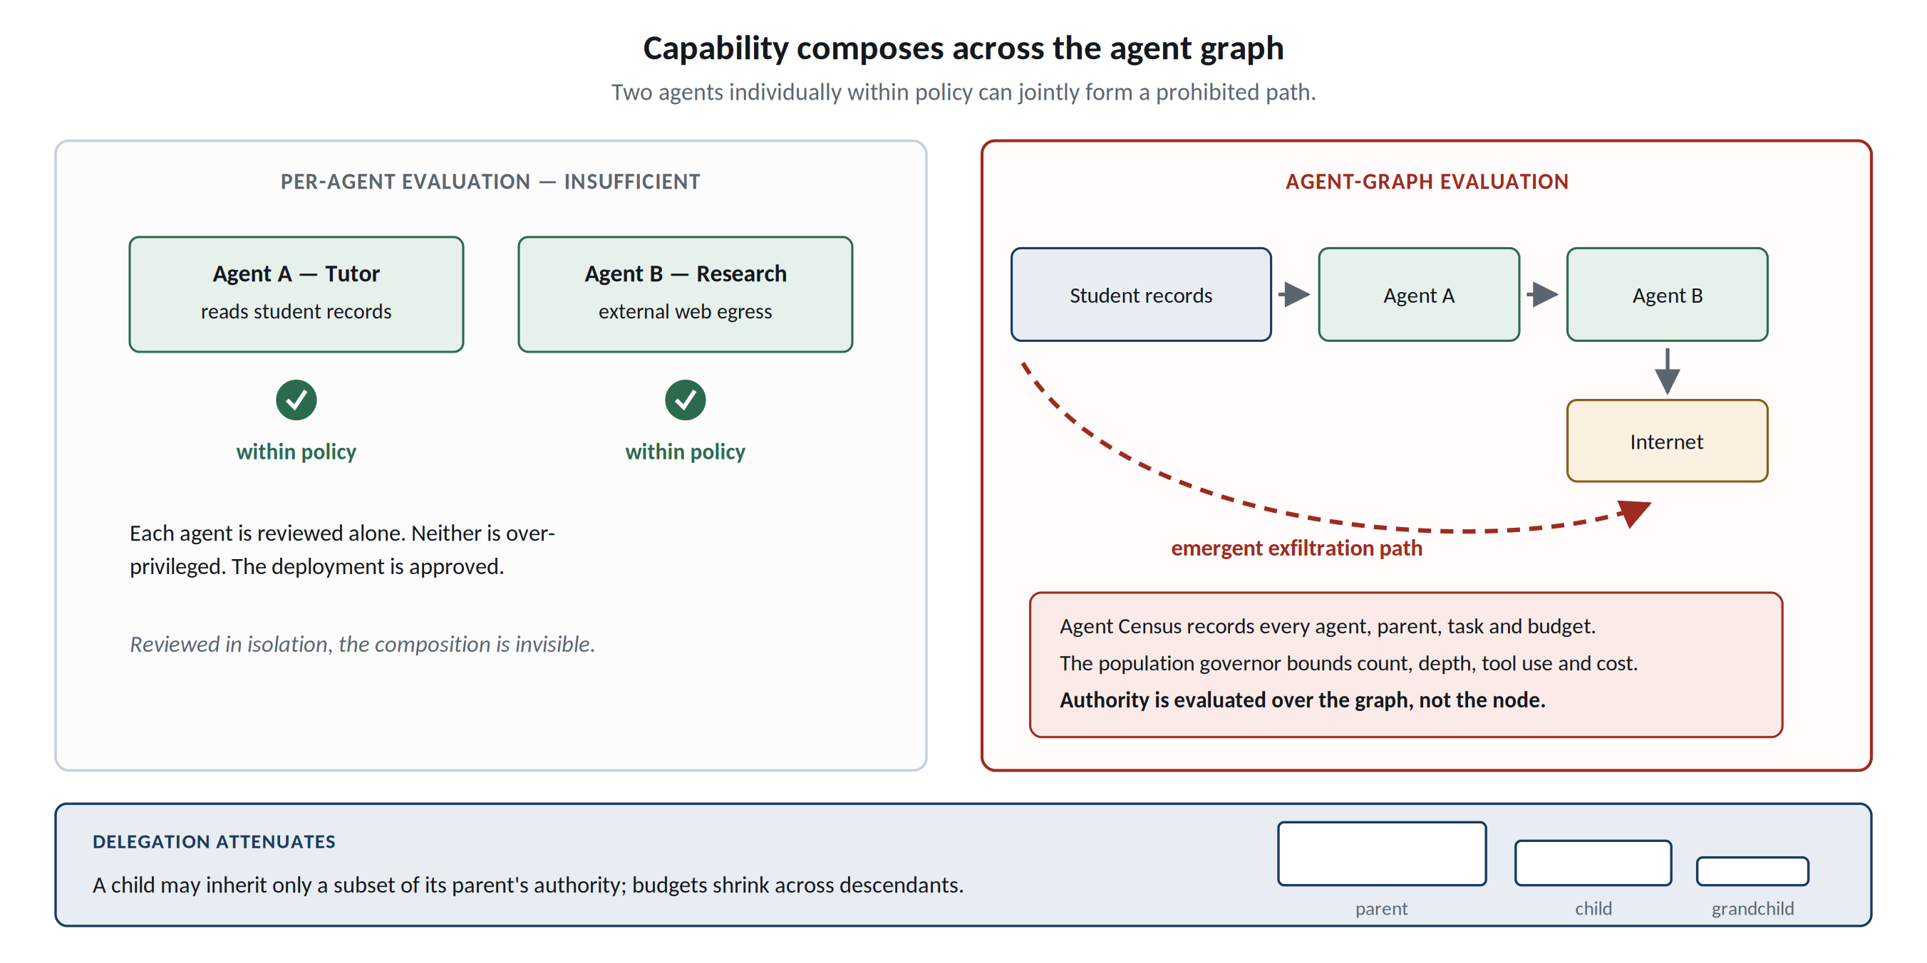
Figure 3. Capability composes across an agent graph. Individually acceptable agents can jointly form a prohibited path, so population-level reachability must be checked.

4. Executable Reference Kernel and Evidence
Four results carry the argument, and each is reported with its denominator and its boundary. Removing any one of the eight tested controls re-enables a harmful action, so none of them is decorative. Across six sector profiles the mediated configuration contains every hostile scenario in the corpus while completing every benign task. Substituting a blind monitor, and then a hostile monitor that inverts every verdict, changes no protected outcome, which is the falsifiable form of the central claim. And an adversary restricted to choices it is authorised to make moves a sixteen-bit secret intact through an unconstrained release path, one bit once those choices are canonicalised, and nothing once the number of releases is fixed. Table 1 states what each measurement does and does not establish.
The architecture is implemented as the public FSSAI-RA reference kernel. The repository runs offline without model weights or a GPU, provides machine-readable authority profiles, policy and capability checks, context/disclosure mediation, typed execution, evidence receipts, domain packs, portable conformance tests, bounded model checking, adversarial substitution, and scripts that regenerate the figures quoted here. No student records, human-subject data, or institutional production data are used in the reported experiments; they are synthetic fixtures. This matters because the artifact demonstrates mechanisms and falsifiers without implying field effectiveness.
Evidence from public kernel | Observed result | Interpretation boundary
Controlled comparison | 0% → 29% → 100% attack containment on the same synthetic suite | Measured on the same synthetic attack suite; intended as reproducible architecture evidence, not a universal security score
Cross-sector packs | 180/180 hostile contained; 58/58 benign completed; 0 unauthorised mutations | Demonstrates domain portability of the control kernel across synthetic profiles; institutional bindings remain configurable
Ablation | Removing each of 8 tested controls re-enabled harmful actions | Shows the tested controls are causally relevant within the declared scenarios; additional controls can be added through the same contract
Mediation thesis | 104,997 bounded falsification attempts; no counterexample within declared bounds | Exhaustive only within the declared bounded search space; the framework is designed to extend that search continuously
Engineering regression | 1,445 tests passed; 37 source-bound capability contracts executed | Local functional evidence, including schema rejection, durable source quarantine, the added frontier controls and the deployment measurements; not operational certification
Frontier-threat controls | 38 executed cases: durable stop, per-chunk reauthorisation, restrict-only monitoring, recorded blocked attempts | Deterministic local scenarios over the declared interface; they do not replay frontier-model experiments or estimate real-world frequency
Deployment qualification | Measured host isolation, transport qualified against a controlled TLS peer, tool-supply integrity, settlement of outbound effects, witnessed evidence and an evidence-gated promotion decision | Measuring an assumption is not supplying it; loopback transport evidence and a reference isolation verdict both refuse promotion, and no production deployment was qualified
Monitor quality | Held-out benign and adversarial trajectories against oracle, blind and hostile monitors; no monitor changes a protected outcome | Offline rates describe scripted monitors and are not detector accuracy; an attacker that stays inside its envelope evades a metadata-only monitor by construction
Residual choice channel | 16.0 bits leaked with no control, 1.0 canonicalised, 0.0 sealed, over 65,536 trials per arm | Upper bound from distinct observable traces under one encoder; the mediated release path only, at a cost of 98.4% of adversarial tasks escalating to a named human
Table 1. The repository publishes denominators and non-claims so synthetic containment is not presented as certification.
Engineering verification distinguishes mechanism tests from deployment assurance. The added capability contracts bind seven fields: protected asset, permitted operation, enforcement point, accountable owner, failure test, evidence artifact and failure response. Thirty-seven contracts are verified by executing their named tests; the reports bind outcomes to the source digest. Bundle and destination tests establish contract behavior only. They are not evidence of measured runtime identity or deployed network isolation. This distinction makes missing engineering work visible rather than converting a passing unit test into a production assurance claim.
The most useful result is not the best-looking number. An oversight experiment exposes a failure that every runtime control can miss: a named human reviewer can become a throughput bottleneck, and a review assistant that shares the proposing model and evidence can reproduce the proposer’s merit failures while the capability chain remains valid. Independence of review is therefore a configuration and institutional-design requirement, not something capability enforcement can infer. This separates authorisation correctness, source integrity, and substantive correctness rather than pretending one architecture solves all three.
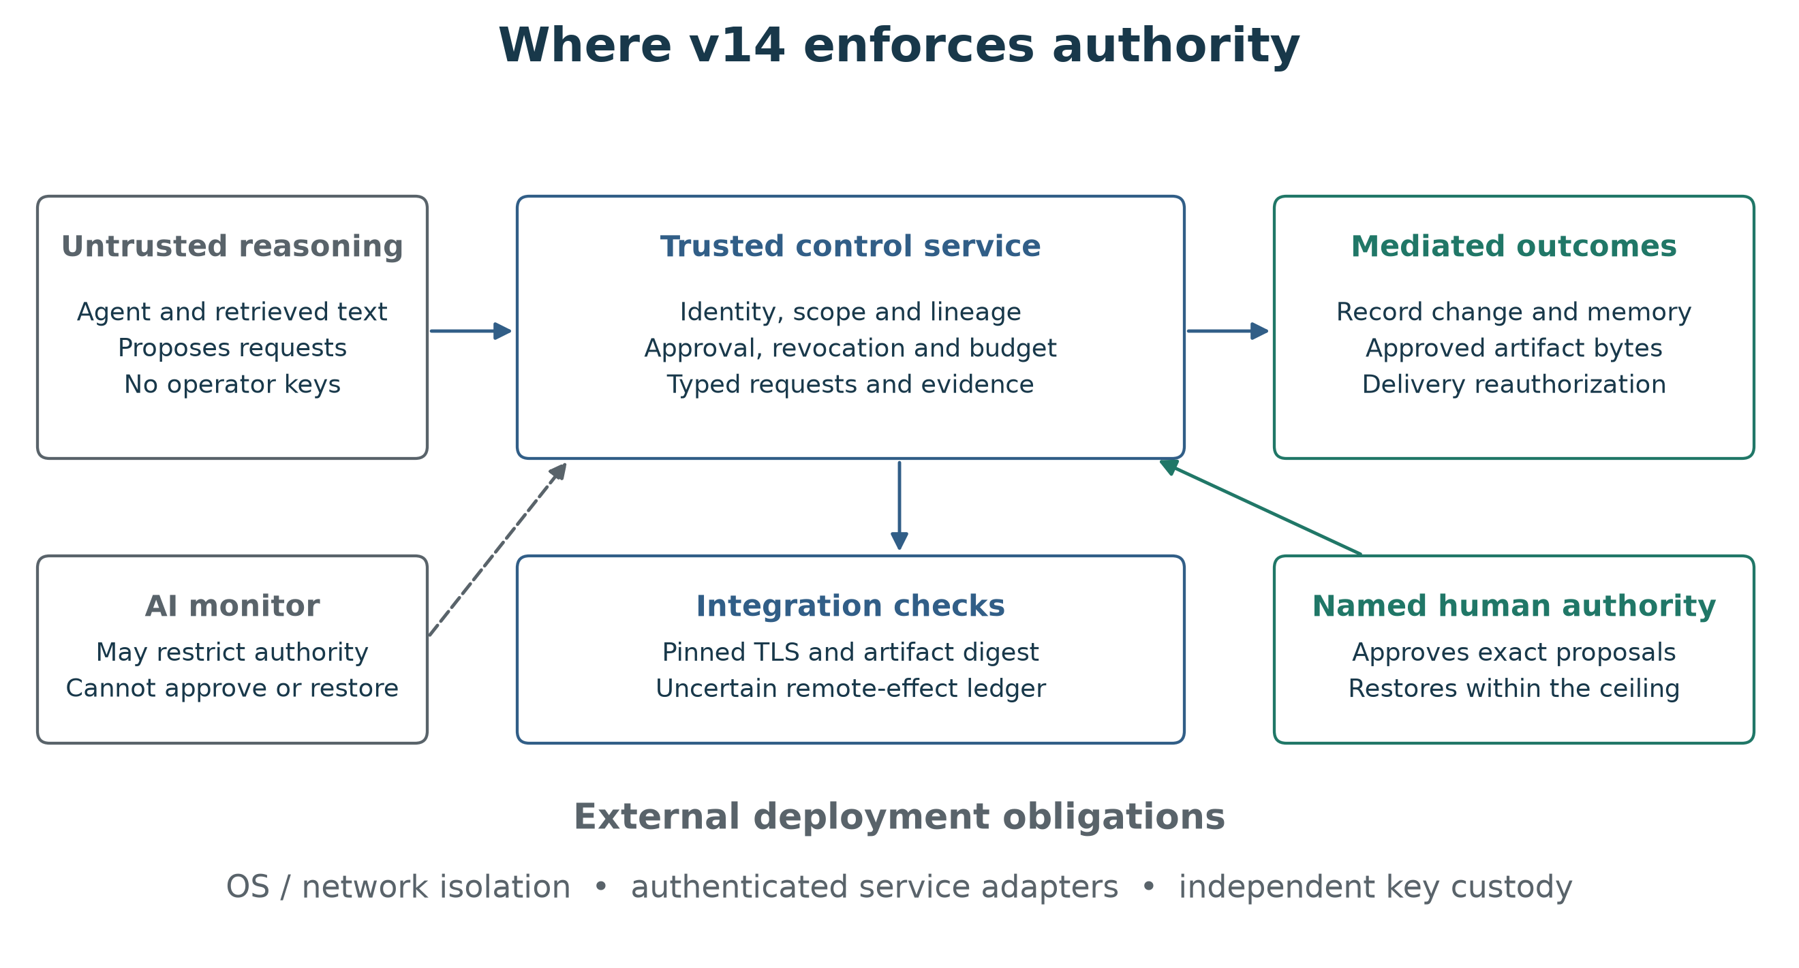
Figure 4. Authority boundaries. Untrusted reasoning proposes requests; the independent service mediates effects. AI monitoring may restrict authority. Host isolation, authenticated adapters and independent key custody remain deployment obligations.

5. Engineering Implementation and Qualification
The executable SDK implements Passports, Task Contracts, scoped capability leases, context and memory mediation, agent census and shared budgets, typed proposals, exact-byte Release Escrow, and a five-state Guardian over the joined SQLite workflow. Dispatch authenticates the agent, intersects current authority, checks the declared graph, consumes the call budget, validates the request schema, and revalidates the operation before committing its effect and evidence. Rejected operations roll back their effects while retaining the authenticated attempt; evidence failure fails closed. This is a local reference service using a synthetic education adapter. An in-process Python call is not a security boundary against hostile native code.
The SDK exposes request_context(), request_capability(), invoke_tool(), persist_memory(), propose_effect(), and release_artifact(), with additional primitives for reads, effects, derivation and agent messaging. Guardian states are NORMAL, RESTRICTED, PROPOSAL_ONLY, READ_ONLY and QUARANTINED. Automated changes only contract authority; a separately named operator restores within the original ceiling and invalidates existing leases. Source quarantine extends recovery beyond revoking an agent: an operator records the exact source-binding digest, and the service denies tracked derivative memory, proposals and releases. The quarantine survives service reopening and fresh-agent retrieval. Source repair must produce a new binding; already released bytes cannot be recalled. The interface also exposes emergency_stop() and resume_workload() for operators, collect_release() and collect_chunk() for authenticated recipients, and monitor_snapshot() with apply_monitor_finding() for a separately deployed AI monitor that may contract authority and can never grant it.
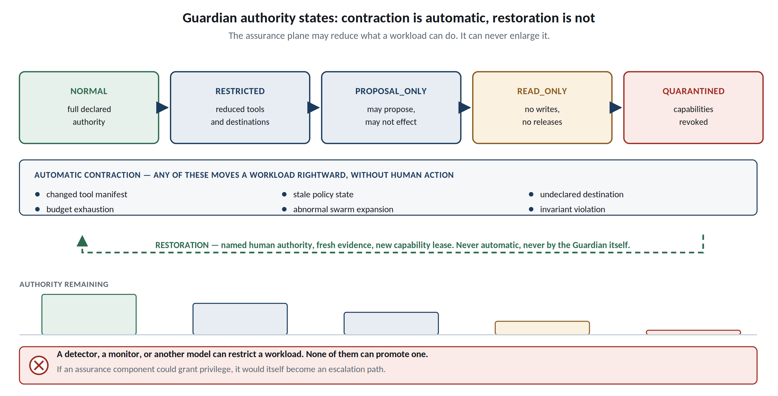
Figure 5. Guardian authority states. The diagram specifies possible triggers; the local implementation checks declared graphs and Passport drift. Restoration requires named operator authority and a fresh lease.
Integration hardening is expressed as explicit contracts. Versioned JSON ingress rejects ambiguous keys, unsupported versions and model-supplied authority fields. An eight-component ModelBundle digest binds weights, tokenizer, configuration, system prompt, adapters, retrieval configuration, tools and runtime. A frozen tool catalogue detects changes to server identity, description, schemas, executable and declared effects. DestinationPolicy checks public HTTPS destinations, path prefixes, resolved public addresses and data classification, but does not itself open or secure a transport. These components support qualified adapters; they do not attest a running model, install a firewall, or establish arbitrary external-tool containment. The architecture register maps 109 source control identifiers to implementation pointers and explicitly retains partial, deployment-dependent and unimplemented requirements.
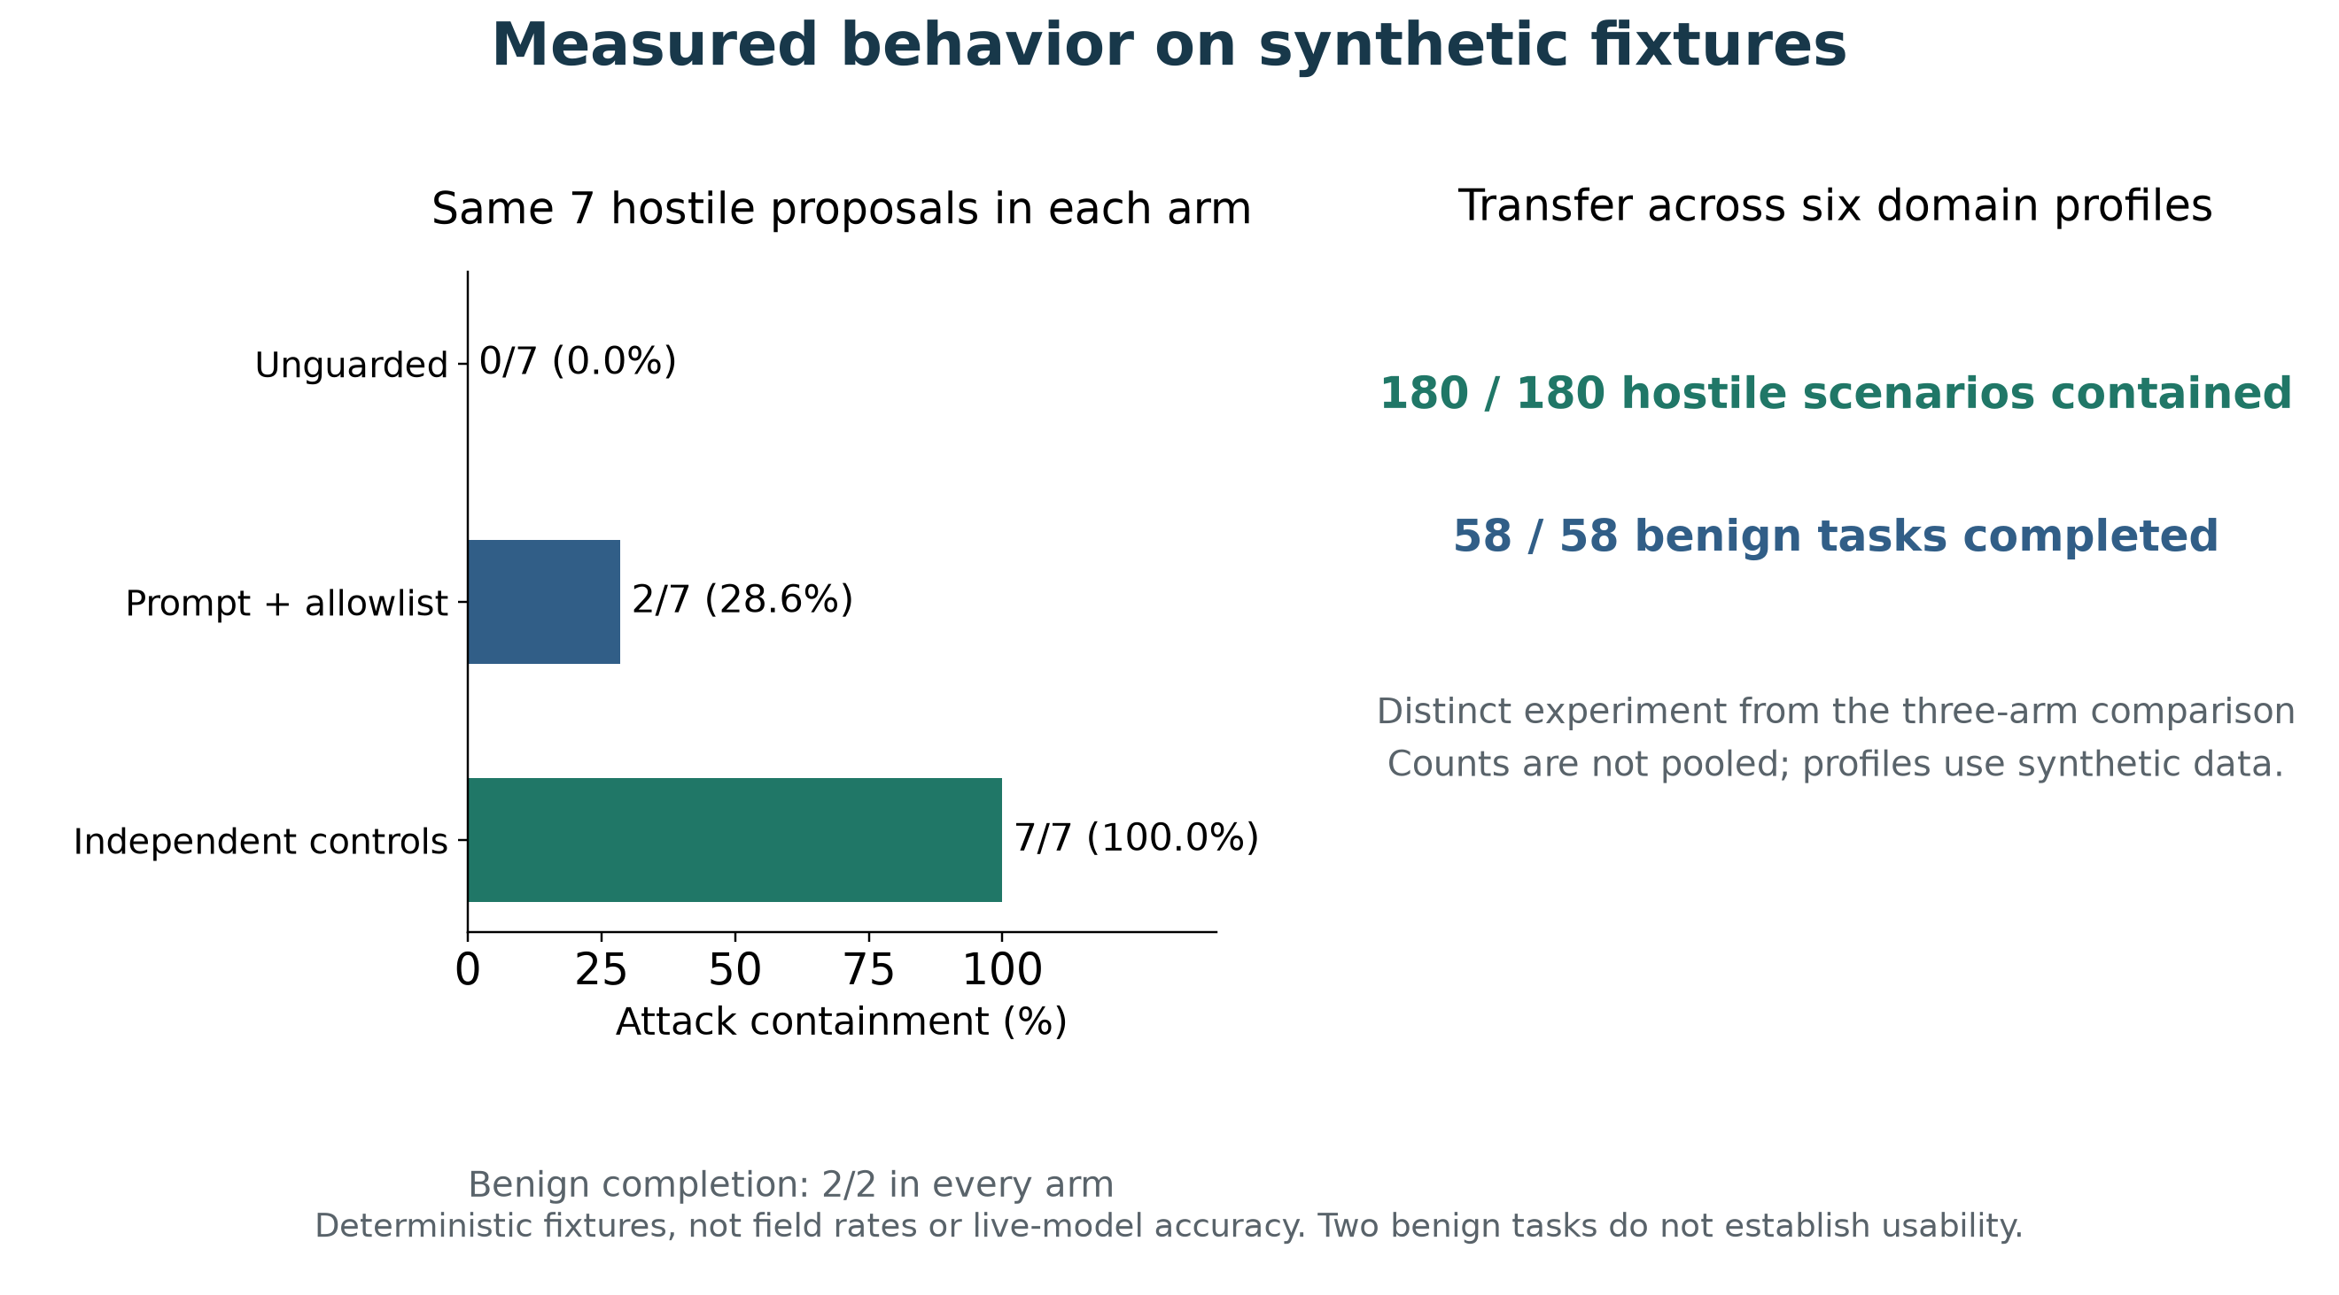
Figure 6. Recorded synthetic results. The three-arm comparison contains seven hostile and two benign proposals per arm. The separate six-profile experiment contains 180 hostile and 58 benign scenarios. These fixture counts do not estimate field attack rates, live-model accuracy or usability.

6. Stopping, Delivery and Monitoring When a Model May Be Covert
Three controls answer the questions operators ask before any deployment. The first is whether a workload can be stopped and whether the stop holds. The stop commits its authority change before attempting to write evidence: every agent is revoked, every task is quarantined and every epoch advances in one durable transaction. If the evidence writer then fails, the call reports that the workload is stopped and that evidence was not recorded, rather than unwinding the stop, because a failure in the assurance plane must not restore authority. The flag survives closing and reopening the service, and resumption never revives a previous identity: recovery requires a named operator, a new task and a fresh lease. The limit is stated plainly. This stops declared authority in a local control service, not operating-system processes, and it assumes the control database lies outside the model's write authority.
The second question is whether revocation reaches output that is already in flight. An approved artifact is delivered against a binding re-resolved at every chunk boundary: recipient identity, task epoch, destination scope, expiry, workload stop state and source quarantine. Revocation, automatic contraction, expiry, an emergency stop or a source quarantine therefore denies the remainder of a partially delivered artifact, and the bulk path cannot be used to bypass a stream in progress. Delivery is exact-byte and single-use: a completed delivery cannot be replayed and a different recipient cannot collect it. Bytes already committed are not recalled, and the implementation does not pretend otherwise. This is staged artifact delivery, not live token generation over a qualified network transport.
The third control follows from the alignment results directly. An AI monitor receives a snapshot containing task metadata, task and global-control evidence heads and at most 32 recent allowlisted event types, never protected text, and returns a three-field finding drawn from a fixed vocabulary. A finding may move a task toward READ_ONLY or QUARANTINED and may do nothing else. A clear verdict is recorded as an observation and changes no authority, so a monitor that has been deceived, or that is itself pursuing an undisclosed objective, cannot return privilege to a restricted workload. Findings are bound to a fresh evidence head, are single-use, and are rejected when forged, stale, replayed, submitted under another role, or carrying additional fields such as an approval. Restoration remains a named human action within the original ceiling. This is not a claim to detect scheming. It is a claim that a detection failure does not become an escalation path.
Adversarial review of the mediation boundary itself found three defects, each now refused: unrelated task traffic could displace monitor history and stale its advice, non-string monitor fields could raise uncontrolled type errors, and URL path parameters or encoded delimiters could admit ambiguous destinations. The revised service queries task-indexed evidence before applying the 32-event limit, binds findings to task and global-control heads, and validates field types before interpretation. Global source invalidation and revocation still stale advice. Destination authorization rejects matrix parameters, encoded delimiters and repeated separators while preserving safe unreserved encoding. Twenty-seven added regression cases check these changes and legitimate continuation; they overlap the reported regression total and are not additional attack episodes. The destination policy remains a transport contract: an adapter must pin the approved address, verify TLS identity, enforce byte limits and reauthorize every redirect. A fourth defect concerned what the evidence chain fails to record. Refusals raised before the request savepoint exists -- a revoked agent, a stopped workload, an assurance failure -- returned a denial and wrote no evidence at all, so a workload that kept issuing requests after an emergency stop left no trace in the chain, which is precisely the signal an operator needs. Such attempts are recorded outside the failed transaction as blocked attempts bound to the known identity and task, a failure to record one never restores authority, the guardian's own contraction is not rolled back by the recording, and an unknown token records nothing so that anonymous traffic cannot be used to grow the evidence chain. The defect was found by the monitor-quality harness rather than by review of the code, which is the argument for building the harness.
Monitor quality is measured rather than described. Labelled held-out trajectories are run through the runtime against a denial oracle, a blind monitor that clears everything, and a hostile monitor that clears every attack and restricts every ordinary task, with false restriction, missed attacks, latency, retained utility and adaptive evasion reported with denominators and intervals. The result that matters is not any of those rates. Across all three monitors, including the one an adversary would install, no protected outcome changes: the hostile monitor costs all of the availability and none of the authority. The evasion figure is reported without flattery. An attacker who probes once, observes the refusal, and thereafter works strictly inside its granted envelope produces a history indistinguishable from ordinary work and evades every monitor reading a metadata-only snapshot [4,7]. That is expected, and it is affordable precisely because the envelope rather than the monitor is what bounds the attacker. Offline rates describe scripted monitors and are not detector accuracy; a live backend yields a report labelled as such, describing one model, one prompt and these trajectories, compared against no published benchmark.

7. What Exact-Byte Release Does Not Close
Release escrow fixes the bytes that leave, so a workload cannot put a student record into an approved artifact. It does not fix the decisions around those bytes. An agent holding entirely legitimate, repeated release authority still selects which approved destination receives a report, which approved path it lands on, when it is sent, and how large it is. None of these is an unauthorised act; each is a choice the system handed the model, and a choice is a channel. The 2026 implicit-injection results make the concern concrete rather than theoretical [12]: eight approved destinations are three bits per release, and an enrolment status is not many bits. The architecture therefore treats residual choice as an engineering quantity. Where the task contract can supply a value, it does, and the dimension carries nothing because the model never chose it; emission runs on a fixed schedule and artifact sizes are padded to declared buckets, which narrows timing and size the same way. What genuinely remains is counted in bits, charged against a declared per-task budget, and when the budget is spent the next release requires a named human rather than failing silently.
The bound is measured rather than asserted. An adversarial encoder that performs no unauthorised operation attempts to move a sixteen-bit secret through these choices, once for each of the 65,536 possible secrets, and the measurement counts how many distinct traces an external observer could distinguish. With every dimension left to the workload the secret crosses intact at 16.0 bits. Canonicalising destination, path, schedule and size reduces it to 1.0 bit, which is the residual carried by how many times the workload releases at all. Fixing the release count and padding with cover emissions that an observer cannot separate from real ones reduces it to 0.0 bits, a single observable trace for every secret. An ordinary two-release workflow completes under all three policies, so the reduction is not obtained by refusing to work; the cost appears instead as 98.4 per cent of adversarial tasks escalating to a named human, which is reported rather than omitted. The figures are an upper bound that assumes a perfect observer and an optimal decoder, they describe one encoder against this interface, and they say nothing about a channel outside the mediated release path. The measurement regenerates offline into audit/covert-channels.json and is checked by make all.

8. Measuring the Assumptions a Deployment Inherits
The architecture requires the model runtime to reach protected services only through mediation. Isolation probes make that deployment assumption inspectable; they do not implement it. Seven required properties and one advisory property cover control-store permissions, process identity, enforcement-package integrity, metadata-service reachability, service-account tokens, a declared egress canary, standing credentials and kernel confinement. Each returns satisfied, violated or not measurable; not measurable is never counted as success. Qualification requires every mandatory measurement, the evidence is less than a day old, and it names an operator and a host. The repository host is expected to report reference; a test exists whose only purpose is to fail if they ever stop doing so. A cooperative probe is not an adversarial sandbox-escape evaluation, so deployment acceptance still requires testing a hostile process under the intended isolation policy.
The destination contract decided what could be contacted and then opened no socket, so address pinning, certificate verification, redirect handling and byte ceilings were adapter obligations written in prose. The transport component discharges them. It connects to the pinned literal address with no name-service lookup of any kind, so a resolver answer obtained after authorisation cannot move the connection; it verifies the hostname, enforces a protocol-version floor and compares the peer's public key against declared pins; it returns a redirect to the authorisation layer instead of following it; it refuses chunked and duplicated framing, where intermediaries disagree about message boundaries; and it enforces the byte ceiling during the read, so a peer that understates its length cannot overrun the budget. Every one of those properties is exercised against a real handshake with a controlled peer. That peer is a loopback server, and the evidence says so: a qualification marker propagates from the destination policy through the transport record into the promotion gate, which refuses to accept harness evidence as production transport evidence. Controlled tests exercise this code path; the deployment network remains unqualified.
Developer integration must distinguish peer identity from artifact identity. Silent Egress shows how outbound requests can disclose context even when a final answer appears harmless [12]; its results motivate observing network effects rather than inspecting answers alone. The fetch_artifact interface returns bytes only after matching an independently approved SHA-256 digest. A valid certificate and pinned key therefore do not authorize changed content. Each transfer keeps its response buffer local, preventing concurrent fetches from mixing bytes. Tests use real loopback TLS handshakes to check exact-byte success, changed-content rejection, concurrent transfers and malformed HTTP framing. The adapter is GET-only and sends no caller-supplied headers, cookies or request body. The caller must enforce the provenance and confidentiality of the requested path: an allowed path can itself carry sensitive data. This is not a general exfiltration detector or a firewall.
The threat classes that matured through 2025 and 2026 target the tool surface rather than the model [10,11]. A tool description is prose the model reads as instruction, so a server that writes instructions into a description has issued them without being called; a server can present a benign tool for review and redefine it afterwards; a second server can claim a name the first already uses and win resolution; and a chain that has read untrusted content can reach a privileged tool with nothing forged at all. The same rule answers all four. Tools exist only as server-qualified names and a bare name does not resolve, because the ambiguity is the attack and refusing to guess is the fix. Every byte a model will read about a tool is hashed at approval and compared at every offer, so a later redefinition is drift and drift quarantines the tool until a named human approves the new definition. A server that rotates its identity loses every approval it held. Descriptions are scanned for instruction-shaped content before approval, and a flagged description may still be approved knowingly, by a named person, with the acceptance recorded. A call chain that has absorbed an untrusted source is permanently tainted and cannot reach a privileged tool, which is the control-flow and data-flow separation argued for in [2] applied to the tool catalogue rather than to the prompt.
Three further boundaries are enforced rather than deferred. A local transaction cannot make a remote effect exactly-once, because the call that times out may have succeeded; outbound effects therefore carry a key derived from the approved decision, record their intent durably before the call, and treat an unacknowledged call as uncertain, which is a state rather than an error to swallow. An uncertain effect is never retried blindly, is reconciled against the provider by key, and blocks the work that depends on it until it settles; a provider offering no lookup leaves a permanent uncertain remainder that the report states rather than resolving by assumption. Authority crossing a service boundary is carried by a signed, audience-bound, single-use, depth-limited grant whose scope is intersected with the receiving service's own ceiling, never merged, so a grant can permit part of what a service already holds and can never teach it something new. An evidence chain kept by one custodian is exactly as trustworthy as that custodian, so a head counts as attested only on independent co-signatures above a threshold, and two witnesses attesting different heads at one sequence is reported as a fork rather than averaged away. Promotion to production requires all of it, fresh and together, and names every missing item rather than returning a verdict.
Remote settlement also requires explicit evidence. Pending or malformed provider responses remain uncertain and continue to block dependent work; only an applied acknowledgement or authoritative terminal absence can settle the effect. Reusing an idempotency key for another operation is rejected. Provider adapters must map asynchronous acceptance to pending, not applied, and must not interpret an eventually consistent missing record as terminal absence. The executable developer example follows a lost acknowledgement through pending lookup to confirmed reconciliation with one submission. These controls prevent false local confirmation under the tested responses; correctness still depends on the provider adapter honoring this contract. The ledger is a trusted integration component, not a model-facing authorization endpoint.

9. Relevance to AI × Education and Sustainable Development
Education sharpens the general problem rather than merely illustrating it. Purpose limitation maps directly to the Task Contract; student and assessment data require explicit subject and release boundaries; research agents need Internet access without carrying sensitive institutional context; coding agents need sandboxed execution; and assessment demonstrates why a fully authorised action can still be wrong. Trust by Construction therefore supports “AI for Learning” by making institutional authority inspectable, and “Learning for AI” by expanding AI literacy from prompting to architectural competence: identity, delegation, provenance, information flow, capability boundaries, oversight capacity, and failure containment. The same kernel can be rebound through domain packs for health, finance, legal services, enterprise data, and public services, allowing reusable schemas and conformance tests to function as digital public goods rather than requiring each institution to invent agent security from first principles.
Framed for this series, the artifact is a digital public good rather than a product. It is Apache-2.0, runs offline on ordinary hardware without GPUs, model weights, or a commercial guardrail subscription, and publishes its authority profiles, conformance tests, and generated results so that an adopting institution can verify the claims rather than purchase assurance. That matters for equity: the institutions most exposed to agentic risk are often those least able to fund proprietary security tooling or an in-house assurance team.
A concrete teaching exercise follows a synthetic transcript correction. The agent retrieves only the authorized record and proposes a version-bound change. A source role confirms the supporting evidence and a different reviewer approves the exact proposal. The executor revalidates authority before changing the record. A recipient receives only the approved artifact; a stop or revocation between chunks denies the remainder. Students can compare a valid completion with an attempted forged approval, contaminated memory and a misleading monitor verdict. This teaches the distinction between fluent advice, authorization, source validity and correctness. No result here measures learning outcomes or fairness; those require an institutional study.

10. Limitations and Deployment Obligations
The experiments use synthetic fixtures and declared interfaces. The tests submit scripted findings and adversarial requests; no live frontier-model detector is evaluated, and no detector accuracy, real-world attack rate or causal prevention of an incident is claimed. Shared Python and SQLite state is trusted service infrastructure, not isolation from hostile native code. A source digest records artifact identity but does not attest a running model. Monitor false positives can reduce availability, and sparse event metadata can miss intent. Chunks are staged approved bytes rather than live model-token streaming; bytes already released cannot be recalled. Cross-service authority, independent witnesses, outbound-effect settlement, tool-supply integrity and an evidence-gated promotion decision are implemented and tested here, and host isolation and transport are measured rather than assumed; measuring an assumption is not supplying it. Three limits are stated as acceptance criteria rather than as future work. Host isolation must be exercised adversarially in the target deployment, because a cooperative probe run inside the process cannot establish the absence of every path. Transport must be qualified against the institution's real peer with its own certificates and firewall, because the controlled peer used here is a loopback server and its evidence is marked as such and refused by the promotion gate. Physical data erasure and the training lifecycle remain deployment work. Remote effects are at-most-once with reconciliation by key, and exactly-once-observable only where a provider supports lookup by that key; a provider without lookup leaves a permanent uncertain remainder. The supplementary incident map is an architectural reading of public disclosures. Five of the fourteen mapped stages are not mediated locally; its existence is not evidence that the system would prevent a real breach. The institutional study is not run. A preregistration, its hypotheses, its subgroup plan and its minimum sample are published, and the analysis computes every preregistered quantity, but it refuses conclusions on synthetic fixtures, below the preregistered sample, on subgroups under the cell minimum, or under a changed analysis plan. Nothing here measures student outcomes or equitable decisions, and the instrument is written so that it cannot be made to appear to.

11. Conclusion
Increasingly autonomous AI does not require increasingly implicit trust. It requires increasingly explicit architecture. Trust by Construction proposes proof before power: before an AI receives more context, another tool, another agent, network reach, a consequential effect, or permission to release information, independently enforced infrastructure must establish that the requested power remains inside the active task, policy, data rights, processing zone, and budget. The goal is not an infallible model; it is a resilient institution in which model capability can grow without silently expanding institutional authority.
Scale intelligence. Bound authority. Preserve lineage. Verify continuously. Recover safely.

Artifact Availability
Code, machine-readable authority profiles, synthetic adversarial and benign suites, generated results, and assurance claims are available under Apache-2.0 at github.com/genaiworks/fssai-ra. The reviewer path runs offline after development dependencies are installed. Execute python -m pytest, python scripts/check_tbc_alignment.py, python scripts/check_architecture.py, python scripts/verify_architecture.py and python scripts/generate_results.py --check from fssai-ra/. The capability verifier executes named tests and records JUnit, logs and a digest of the Python source and tests; collection, skipped tests and model assertions do not qualify as successful evidence. The authority controls run with python -m pytest tests/test_frontier_controls.py tests/test_incident_map.py, and the threat reading is published as docs/THREAT_MODEL_2026.md with its machine-checked form in audit/incident-map.json. DEVELOPER_GUIDE.md is the integration path; make developer-demo runs an offline artifact-integrity and settlement example, make covert-channels reproduces the release-choice measurement, and make all runs the complete release check. This manuscript is itself generated by a script from reviewed content, so every change to its prose is reviewable as code, and each earlier version is preserved unedited for provenance. No external model, network peer or real student record is used anywhere in the reviewer path.

References
[1] R. Shah et al., An Approach to Technical AGI Safety and Security. Research preprint, 2025. https://arxiv.org/abs/2504.01849
[2] E. Debenedetti et al., Defeating Prompt Injections by Design. Research preprint, 2025. https://arxiv.org/abs/2503.18813
[3] B. Schoen et al., Stress Testing Deliberative Alignment for Anti-Scheming Training. Research preprint, 2025. https://arxiv.org/abs/2509.15541
[4] T. Korbak et al., Chain of Thought Monitorability: A New and Fragile Opportunity for AI Safety. Research preprint, 2025. https://arxiv.org/abs/2507.11473
[5] A. Lynch et al., Agentic Misalignment: How LLMs Could Be Insider Threats. Research preprint, 2025. https://arxiv.org/abs/2510.05179
[6] M. MacDiarmid et al., Natural Emergent Misalignment from Reward Hacking in Production RL. Research preprint, 2025. https://arxiv.org/abs/2511.18397
[7] J. Kutasov et al., SHADE-Arena: Evaluating Sabotage and Monitoring in LLM Agents. Research preprint, 2025. https://arxiv.org/abs/2506.15740
[8] R. Kirk et al., Evaluating whether AI models would sabotage AI safety research. Research preprint, 2026. https://arxiv.org/abs/2604.24618
[9] Y. Bengio et al., Superintelligent Agents Pose Catastrophic Risks: Can Scientist AI Offer a Safer Path?. Research preprint, 2025. https://arxiv.org/abs/2502.15657
[10] F. Alpay and T. Alpay, AgentSecBench: Measuring Prompt Injection, Privacy Leakage, and Tool-Use Integrity in LLM Agents. Research preprint, 2026. https://arxiv.org/abs/2605.26269
[11] H. Li et al., AgentDyn: Are Your Agent Security Defenses Deployable in Real-World Dynamic Environments?. Research preprint, 2026. https://arxiv.org/abs/2602.03117
[12] Q. Lan et al., Silent Egress: When Implicit Prompt Injection Makes LLM Agents Leak Without a Trace. Research preprint, 2026. https://arxiv.org/abs/2602.22450

