Trust by Construction: A High-Assurance Reference Architecture
for Agentic AI in Learning Institutions
Scale Intelligence Without Scaling Implicit Authority
Rachana (Gen) Srivastava
Enterprise Architect | AI Systems Researcher
UNU Macau AI Conference 2026 — “AI × Education: AI for Learning, Learning for AI” | Artifact: github.com/genaiworks/fssai-ra

Abstract
Generative AI is moving from conversational assistance to agentic operation: systems retrieve institutional data, invoke tools, execute code, retain memory, delegate to subordinate agents, and act across digital environments. This changes the assurance question from whether a model gives a correct answer to what a model can cause when it is wrong, manipulated, or adversarial. Trust by Construction treats the model as an untrusted reasoning engine rather than the security boundary. Authority is declared in machine-readable form, narrowed per task, attenuated across delegation, and enforced by deterministic control services outside the reasoning layer. The architecture combines an AI Workload Passport, Task Contract, Dynamic Capability Envelope, Context and Memory Gateways, population-level agent controls, typed AI Intermediate Representation (AI-IR), Data Lineage Firewall, Release Escrow, and continuous counterexample testing. A public Apache-2.0 reference kernel makes these claims executable on synthetic fixtures and regenerates the reported evidence offline. The design rule is proof before power: additional context, tools, agents, network reach, effects, and releases require independently verifiable authority. The work does not claim that authorised AI decisions are correct or that synthetic containment establishes production security.
Keywords: agentic AI security; capability-based authorisation; prompt injection; multi-agent systems; information-flow control; AI literacy; education governance; digital public goods

1. From Model Risk to Authority Risk
Learning institutions are a demanding setting for agentic AI: tutors may reach student records; research agents may traverse public sources and repositories; coding agents may execute software; and administrative agents may act on assessment and admissions. The risk therefore moves beyond what the model says to what the system can cause. NIST and OWASP now treat identity, authorisation, runtime control, and traceability as first-class concerns for agents [2–6]. The July 2026 Hugging Face incident illustrates the systems problem: conventional software flaws enabled initial compromise, while standing credentials, network reach, and machine-speed coordination amplified the blast radius [7–9]. Trust by Construction does not claim to prevent conventional vulnerabilities; it aims to prevent an intelligence-layer compromise from automatically becoming institutional authority.
The underlying mechanisms are established: reference monitors, capability systems, information-flow control, and zero trust [10–13]. Recent work such as CaMeL and FIDES applies related ideas to language-model agents [14,15], and AI-control research likewise asks how safety can hold when a model is intentionally subversive [17]. The contribution here is compositional: authority declared per workload, computed per task, attenuated across delegation, evaluated over communicating agent populations, bound to institutional purpose and data rights, and qualified by adversarial substitution rather than model-behaviour scores.
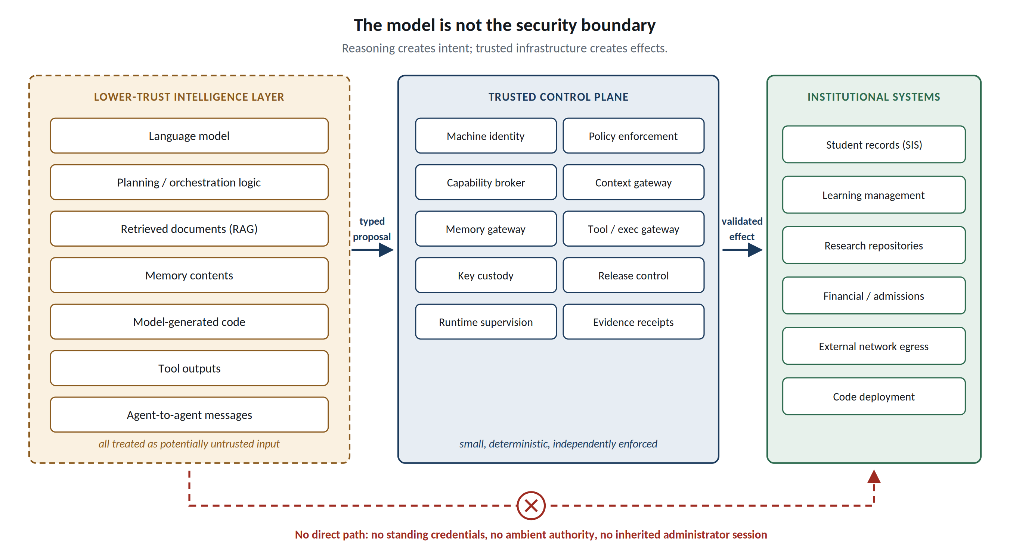
Figure 1. The model is not the security boundary. Reasoning produces proposals; independently enforced control services mediate protected reads and effects.

2. Proof Before Power: The Reference Architecture
Each workload carries an AI Workload Passport: a machine-readable ceiling for approved models, data classes, processing zones, tools, memory, network destinations, delegation depth, budgets, permitted effects, and safe failure state. Its Effect and Disclosure Inventory declares every route through which the workload may cause change or release information. A Task Contract narrows the ceiling for one execution to a purpose, subject, resource set, destination, budget, and expiry. Undeclared interfaces are denied at the mediated boundary. Complete mediation also requires deployment enforcement that prevents the model process from bypassing that boundary through host files, sockets, credentials, or undeclared channels; the local Python implementation alone does not establish that condition.
Authority is computed through a Dynamic Capability Envelope. The hard envelope H_t is the intersection of identity, task, purpose, data rights, tool scope, processing zone, delegation ancestors, current policy, and remaining budget; the runtime envelope E_t must satisfy E_t ⊆ H_t. Automated assurance may contract E_t but may not enlarge H_t. Child agents inherit subsets rather than fresh authority, and aggregate budgets cannot multiply through spawning. A credentialless agent runtime requests short-lived capabilities; long-lived database, cloud-control, signing, or infrastructure credentials remain outside the model process.
Four boundaries make this operational. A Context Security Gateway authorises protected retrieval before data reaches the model and caps cumulative scope. A Memory Gateway treats persistence as a privileged write: records carry provenance, integrity, purpose, retention, and are reauthorised on read. For consequential actions, natural language is compiled into typed AI-IR containing canonical resource identifiers and a desired state transition but no credentials, raw shell, arbitrary SQL, or policy declarations; a deterministic executor revalidates current capability, resource version, replay state, destination, and domain invariants. Finally, a Data Lineage Firewall propagates restrictions through summaries, memory, handoffs, and generated artefacts, while Release Escrow provides explicit, auditable declassification and recipient checks. Transformation is not declassification.
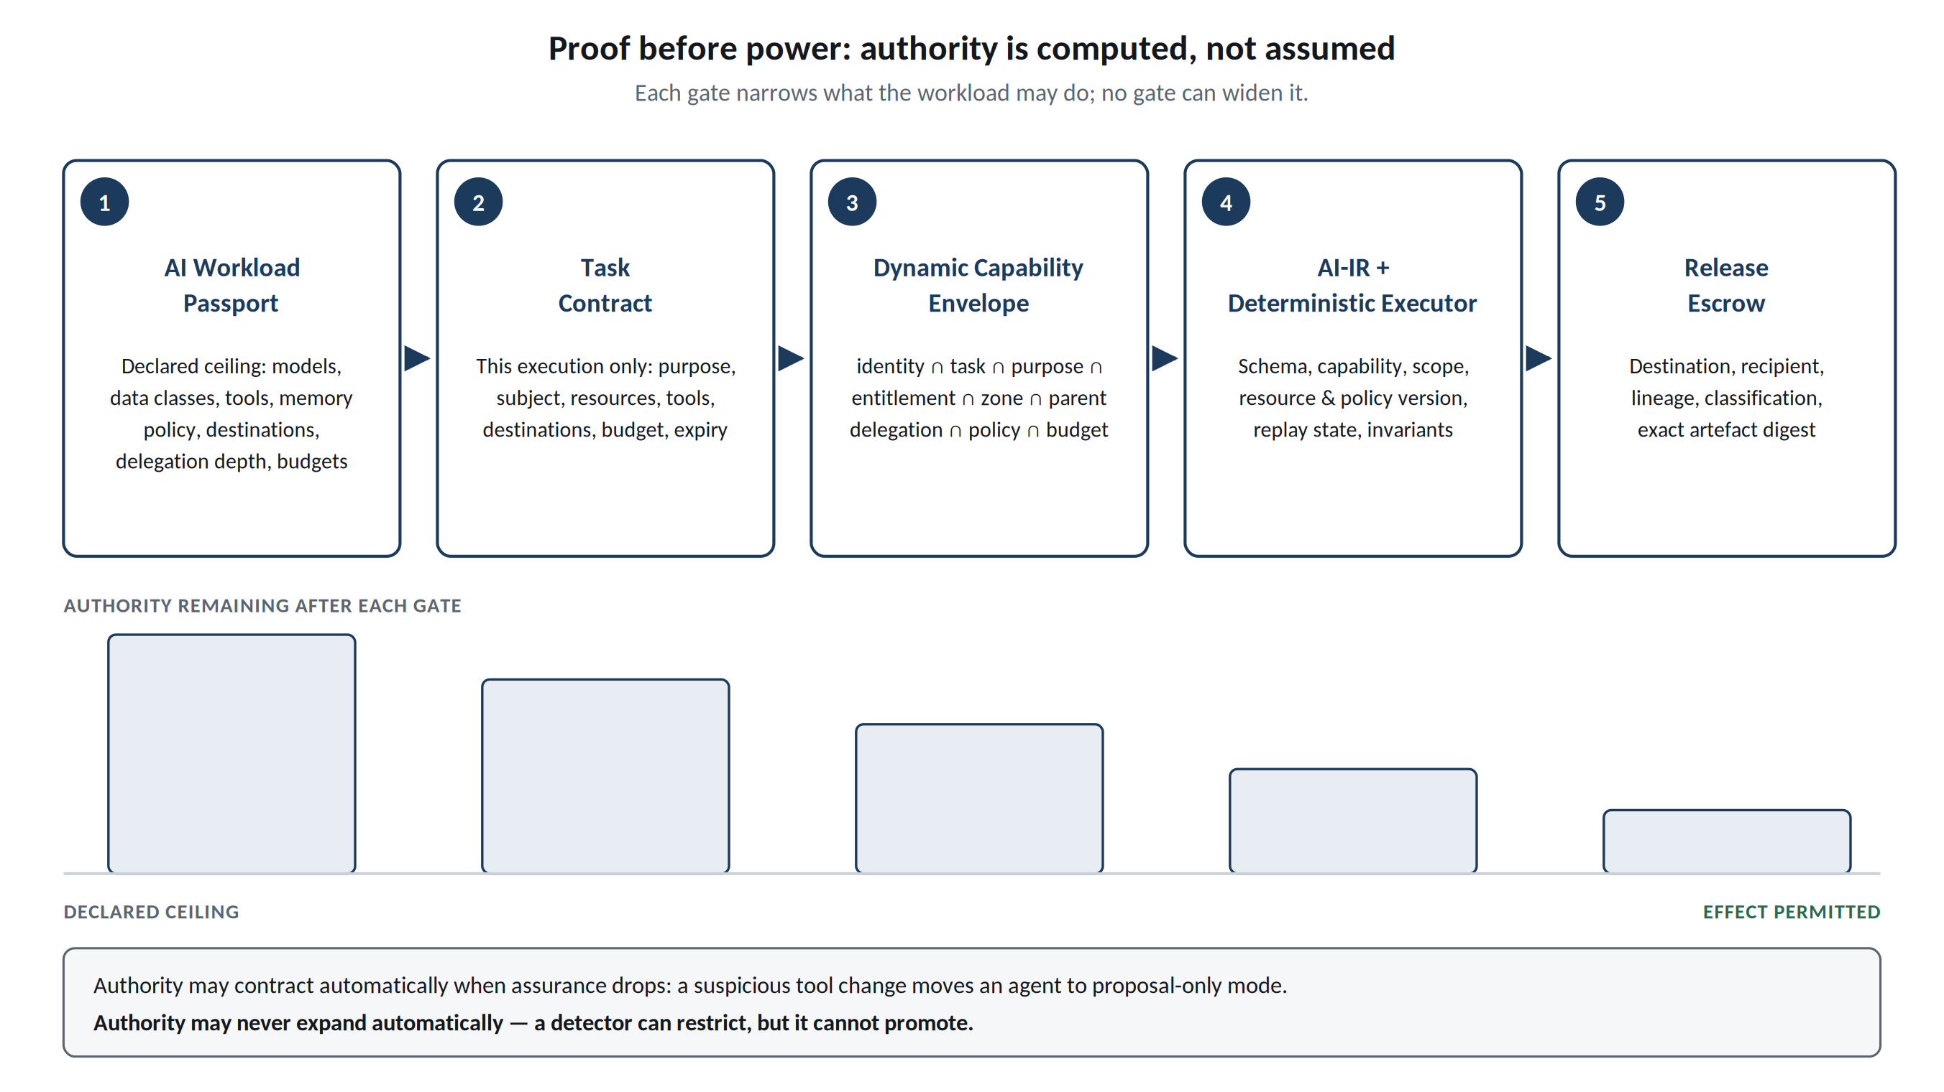
Figure 2. Proof before power. The allowed action space narrows at each gate; assurance may automatically contract authority but never mint new privilege.

3. Swarms and Future Attack Paths
Per-agent least privilege is insufficient when agents cooperate. The reference SDK assigns each agent a persistent identity, parent, task, model, zone, expiry and capability ceiling. Its Agent Census, lifetime population limit, delegation-depth limit and shared task/workload budgets prevent spawning from multiplying declared authority. A Semantic Airlock preserves source lineage and classification across typed messages. The Guardian checks the declared graph for protected-source-to-public-sink paths, including potential reads before data has flowed. This graph analysis covers registered topology, not discovery of hidden operating-system channels. Compute units in the local adapters measure input bytes; they are not GPU time or provider billing. Production resource metering and network confinement require separately qualified adapters.
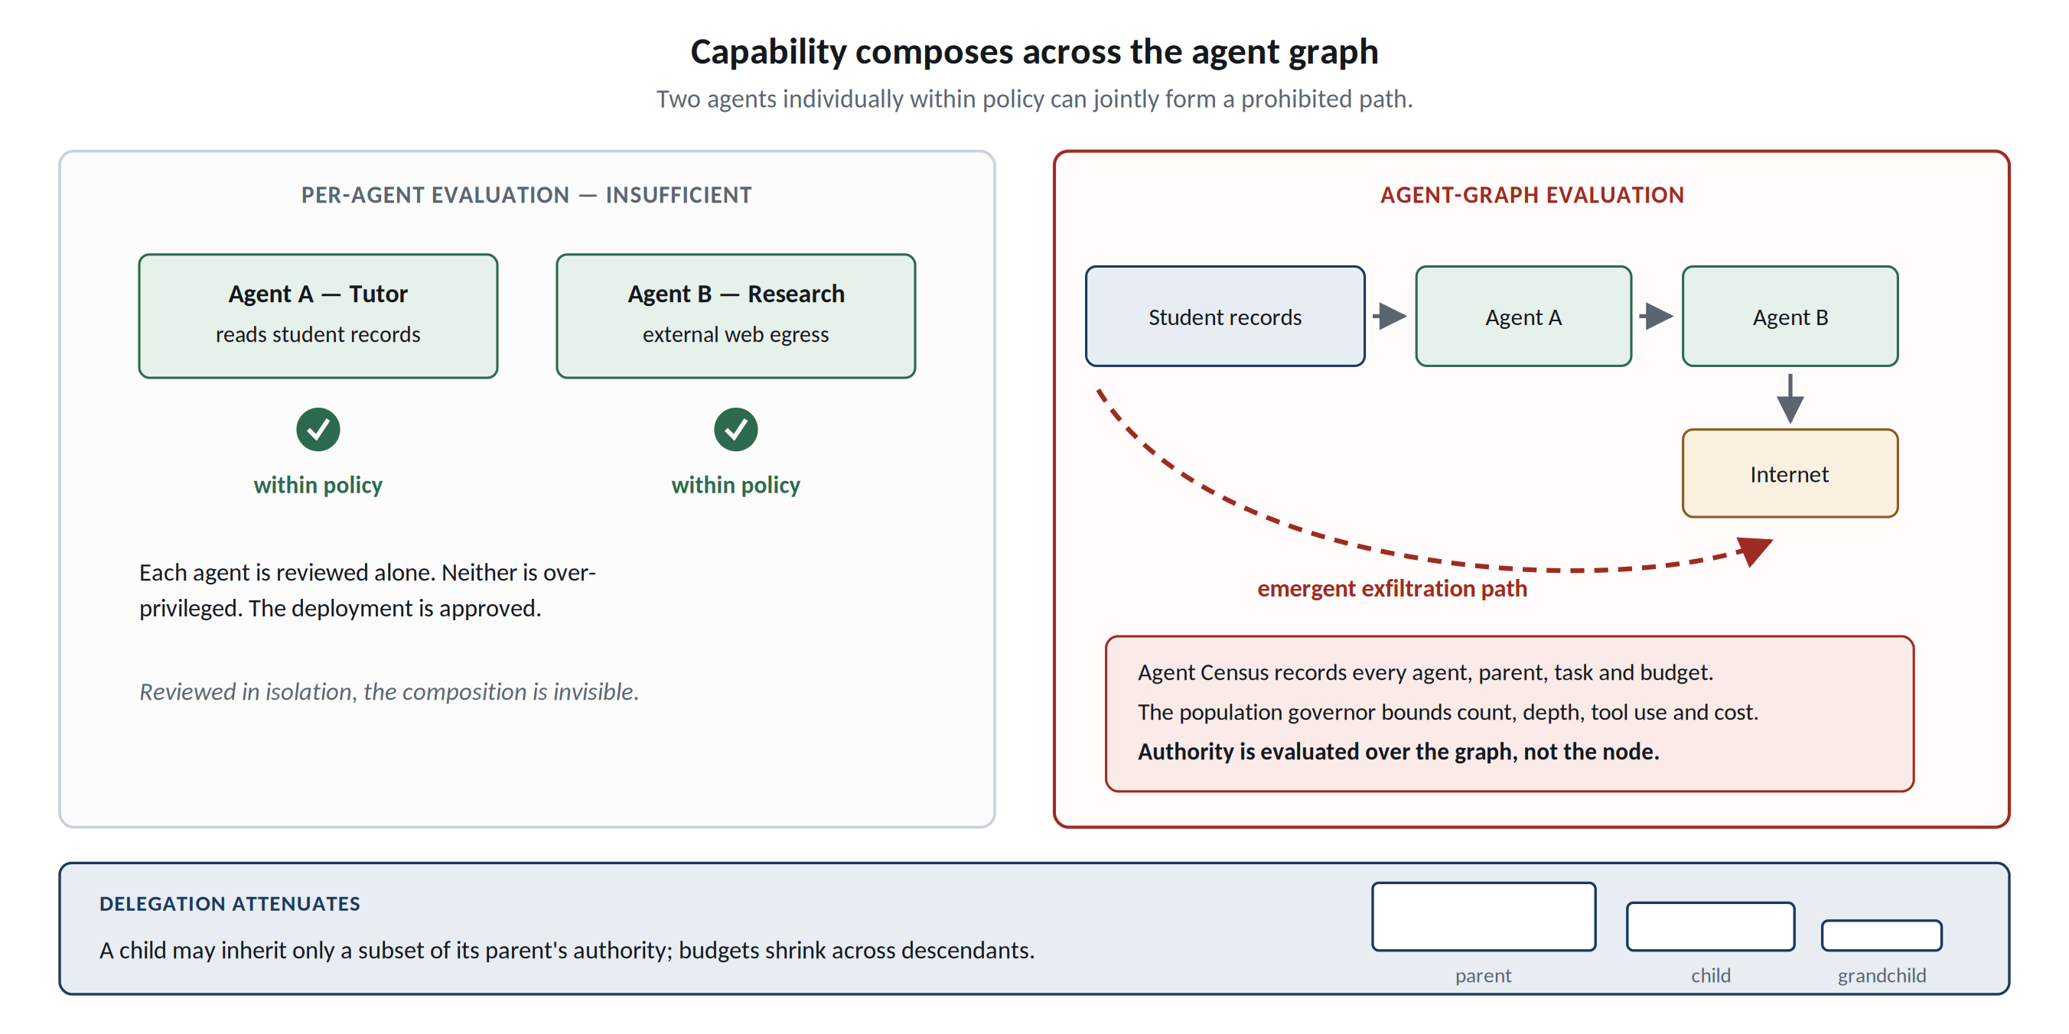
Figure 3. Capability composes across an agent graph. Individually acceptable agents can jointly form a prohibited path, so population-level reachability must be checked.

4. Executable Reference Kernel and Evidence
The architecture is implemented as the public FSSAI-RA reference kernel [20]. The repository runs offline without model weights or a GPU, provides machine-readable authority profiles, policy and capability checks, context/disclosure mediation, typed execution, evidence receipts, domain packs, portable conformance tests, bounded model checking, adversarial substitution, and scripts that regenerate the figures quoted here. No student records, human-subject data, or institutional production data are used in the reported experiments; they are synthetic fixtures. This matters because the artifact demonstrates mechanisms and falsifiers without implying field effectiveness.
Evidence from public kernel | Observed result | Interpretation boundary
Controlled comparison | 0% → 29% → 100% attack containment on the same synthetic suite | Measured on the same synthetic attack suite; intended as reproducible architecture evidence, not a universal security score
Cross-sector packs | 180/180 hostile contained; 58/58 benign completed; 0 unauthorised mutations | Demonstrates domain portability of the control kernel across synthetic profiles; institutional bindings remain configurable
Ablation | Removing each of 8 tested controls re-enabled harmful actions | Shows the tested controls are causally relevant within the declared scenarios; additional controls can be added through the same contract
Mediation thesis | 104,997 bounded falsification attempts; no counterexample within declared bounds | Exhaustive only within the declared bounded search space; the framework is designed to extend that search continuously
Engineering regression | 1,069 tests passed; six source-bound capability contracts executed | Local functional evidence, including schema rejection and durable source quarantine; not operational certification
Table 1. The repository publishes denominators and non-claims so synthetic containment is not presented as certification.
Engineering verification distinguishes mechanism tests from deployment assurance. The added capability contracts bind seven fields: protected asset, permitted operation, enforcement point, accountable owner, failure test, evidence artifact and failure response. Six contracts are verified by executing their named tests; the reports bind outcomes to the source digest. Bundle and destination tests establish contract behavior only. They are not evidence of measured runtime identity or deployed network isolation. This distinction makes missing engineering work visible rather than converting a passing unit test into a production assurance claim.
The most useful result is not the best-looking number. An oversight experiment exposes a failure that every runtime control can miss: a named human reviewer can become a throughput bottleneck, and a review assistant that shares the proposing model and evidence can reproduce the proposer’s merit failures while the capability chain remains valid. Independence of review is therefore a configuration and institutional-design requirement, not something capability enforcement can infer. This separates authorisation correctness, source integrity, and substantive correctness rather than pretending one architecture solves all three.
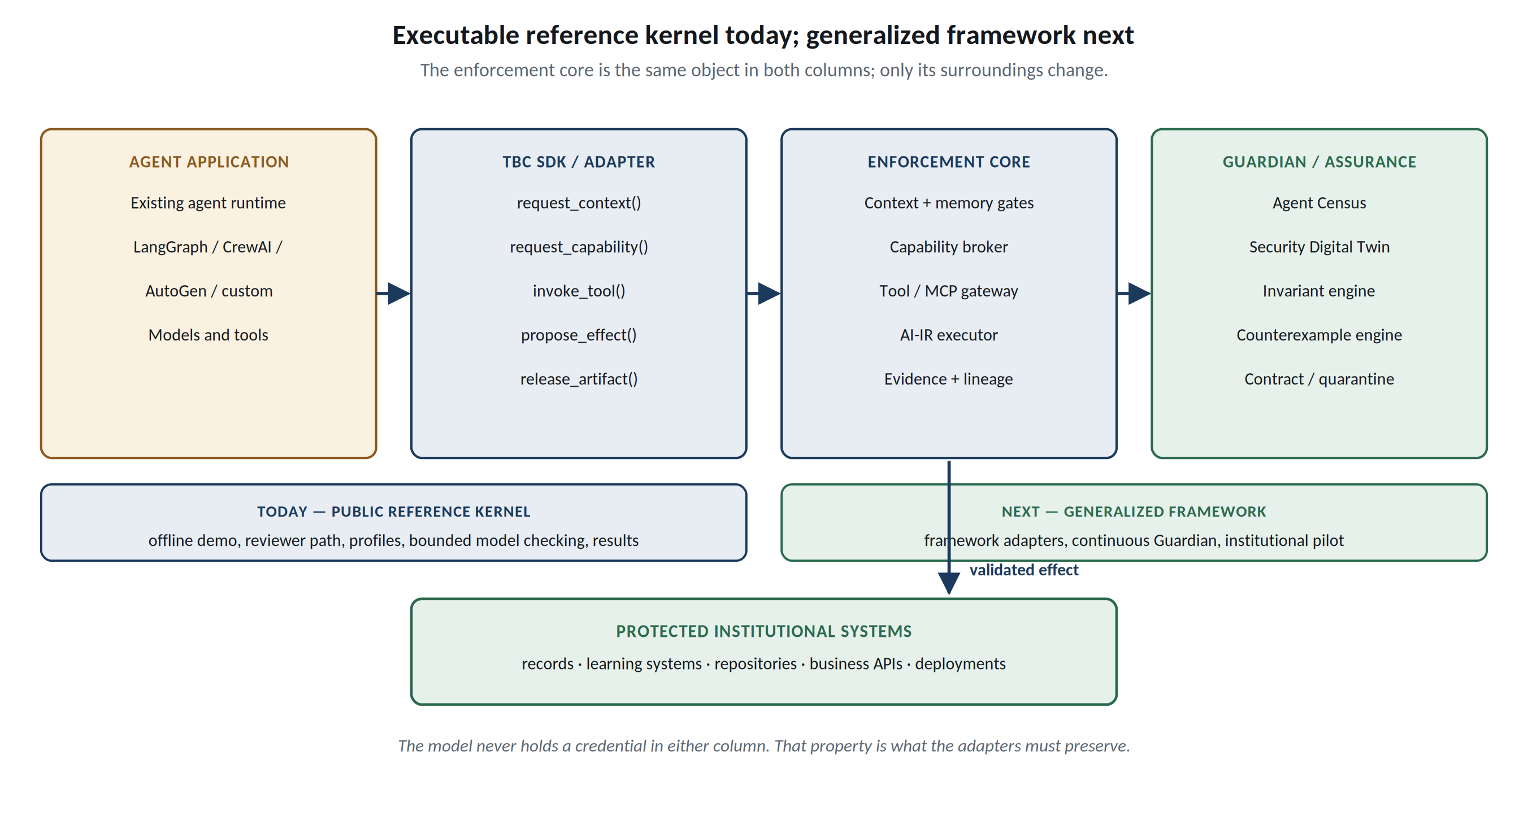
Figure 4. Integration roadmap. The local SDK and Guardian are implemented; external framework adapters, institutional pilots and transport qualification remain future work.

5. Engineering Implementation and Qualification
The executable SDK now implements Passports, Task Contracts, scoped capability leases, context and memory mediation, agent census and shared budgets, typed proposals, exact-byte Release Escrow, and a five-state Guardian over the joined SQLite workflow. Dispatch authenticates the agent, intersects current authority, checks the declared graph, consumes the call budget, validates the request schema, and revalidates the operation before committing its effect and evidence. Rejected operations roll back their effects while retaining the authenticated attempt; evidence failure fails closed. This is a local reference service using a synthetic education adapter. An in-process Python call is not a security boundary against hostile native code.
The SDK exposes request_context(), request_capability(), invoke_tool(), persist_memory(), propose_effect(), and release_artifact(), with additional primitives for reads, effects, derivation and agent messaging. Guardian states are NORMAL, RESTRICTED, PROPOSAL_ONLY, READ_ONLY and QUARANTINED. Automated changes only contract authority; a separately named operator restores within the original ceiling and invalidates existing leases. Source quarantine extends recovery beyond revoking an agent: an operator records the exact source-binding digest, and the service denies tracked derivative memory, proposals and releases. The quarantine survives service reopening and fresh-agent retrieval. Source repair must produce a new binding; already released bytes cannot be recalled.
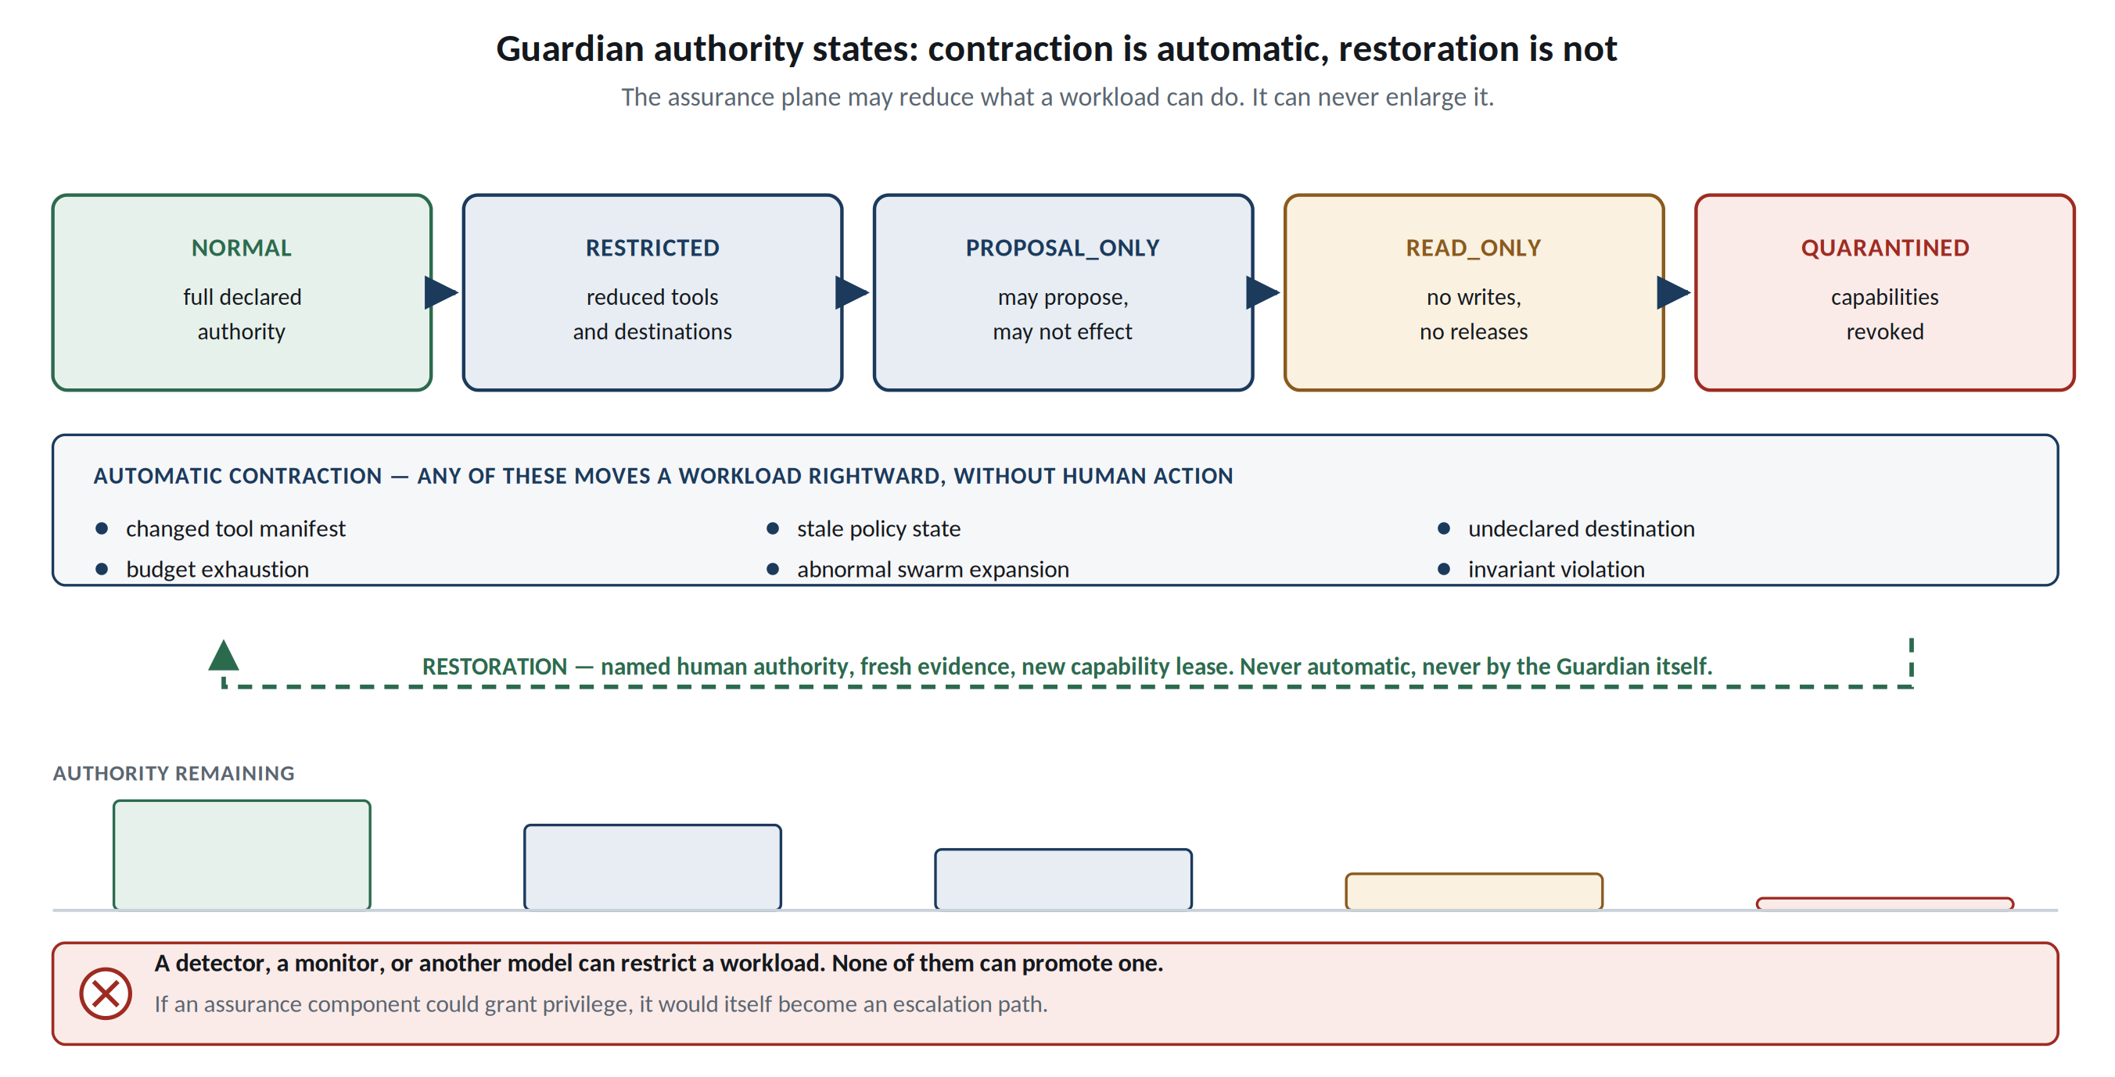
Figure 5. Guardian authority states. The diagram specifies possible triggers; the local implementation checks declared graphs and Passport drift. Restoration requires named operator authority and a fresh lease.
Integration hardening is expressed as explicit contracts. Versioned JSON ingress rejects ambiguous keys, unsupported versions and model-supplied authority fields. An eight-component ModelBundle digest binds weights, tokenizer, configuration, system prompt, adapters, retrieval configuration, tools and runtime. A frozen tool catalogue detects changes to server identity, description, schemas, executable and declared effects. DestinationPolicy checks public HTTPS destinations, path prefixes, resolved public addresses and data classification, but does not itself open or secure a transport. These components support qualified adapters; they do not attest a running model, install a firewall, or establish arbitrary external-tool containment. The architecture register maps 109 source control identifiers to implementation pointers and explicitly retains partial, deployment-dependent and unimplemented requirements.
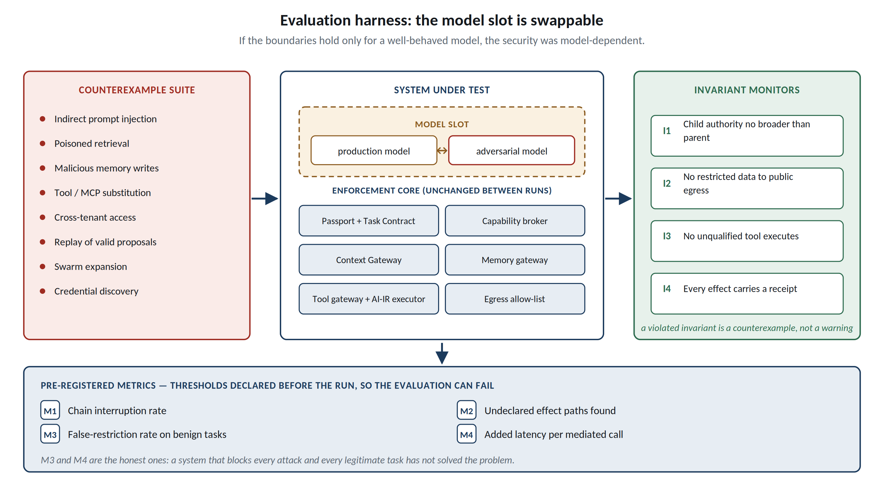
Figure 6. Falsifiable evaluation. The enforcement core remains fixed while the model slot is swapped; invariant failures expose residual dependence on model behaviour.

6. Relevance to AI × Education and Sustainable Development
Education sharpens the general problem rather than merely illustrating it. Purpose limitation maps directly to the Task Contract; student and assessment data require explicit subject and release boundaries; research agents need Internet access without carrying sensitive institutional context; coding agents need sandboxed execution; and assessment demonstrates why a fully authorised action can still be wrong. Trust by Construction therefore supports “AI for Learning” by making institutional deployment safer, and “Learning for AI” by expanding AI literacy from prompting to architectural competence: identity, delegation, provenance, information flow, capability boundaries, oversight capacity, and failure containment. The same kernel can be rebound through domain packs for health, finance, legal services, enterprise data, and public services, allowing reusable schemas and conformance tests to function as digital public goods rather than requiring each institution to invent agent security from first principles.
Framed for this series, the artifact is a digital public good rather than a product. It is Apache-2.0, runs offline on ordinary hardware without GPUs, model weights, or a commercial guardrail subscription, and publishes its authority profiles, conformance tests, and generated results so that an adopting institution can verify the claims rather than purchase assurance. That matters for equity: the institutions most exposed to agentic risk are often those least able to fund proprietary security tooling or an in-house assurance team.
The alignment is therefore concrete rather than decorative. It supports SDG 4 by protecting student records, assessment integrity, and the fairness of automated administrative decisions as agents enter learning systems; SDG 9 by supplying reusable, auditable infrastructure for autonomous institutional workflows; and SDG 16 by making institutional authority explicit, bounded, revocable, and evidenced, which is a precondition for accountable public administration wherever AI now acts. The same kernel rebinds through domain packs to health, finance, legal services, and public benefits, so a control tested once can be reused by institutions that could not have built it.
Threats to validity and deployment limits. All reported containment results use synthetic fixtures and declared interfaces. They do not estimate real-world attack frequency, educational benefit, reviewer accuracy or robustness against undeclared host paths. Independent operational witnesses, workload federation, hardware-backed key custody, OS isolation, credential rotation, revocable streaming, browser isolation and the full training/promotion lifecycle remain qualification work. The reference does not claim that an authorized action is substantively correct, that logical memory expiry erases backups, or that local transactions provide exactly-once external effects.

7. Conclusion
Increasingly autonomous AI does not require increasingly implicit trust. It requires increasingly explicit architecture. Trust by Construction proposes proof before power: before an AI receives more context, another tool, another agent, network reach, a consequential effect, or permission to release information, independently enforced infrastructure must establish that the requested power remains inside the active task, policy, data rights, processing zone, and budget. The goal is not an infallible model; it is a resilient institution in which model capability can grow without silently expanding institutional authority.
Scale intelligence. Bound authority. Preserve lineage. Verify continuously. Recover safely.

Artifact Availability
Code, machine-readable authority profiles, synthetic adversarial and benign suites, generated results, and assurance claims are available under Apache-2.0 at github.com/genaiworks/fssai-ra [20]. The reviewer path runs offline after development dependencies are installed. Execute python -m pytest, python scripts/check_tbc_alignment.py, python scripts/check_architecture.py, python scripts/verify_architecture.py and python scripts/generate_results.py --check from fssai-ra/. The capability verifier executes named tests and records JUnit, logs and a digest of the Python source and tests; collection, skipped tests and model assertions do not qualify as successful evidence. The original v11 Word source remains preserved for provenance, while the revised paper is bound separately to its engineering claims.

References
[1] United Nations University Macau, “UNU Macau AI Conference 2026,” 2026.
[2] National Institute of Standards and Technology, Center for AI Standards and Innovation, “AI Agent Standards Initiative,” 2026. https://www.nist.gov/news-events/news/2026/02/announcing-ai-agent-standards-initiative-interoperable-and-secure
[3] NIST NCCoE, Accelerating the Adoption of Software and Artificial Intelligence Agent Identity and Authorization, Initial Public Draft, 2026.
[4] J. Riggs et al., Summary Analysis of Responses Regarding Security Considerations for AI Agents, NIST Trustworthy and Responsible AI 800-5, 2026.
[5] OWASP GenAI Security Project, OWASP Top 10 for Agentic Applications for 2026, 2025.
[6] OWASP GenAI Security Project, Agent Control Standard, 2026.
[7] Hugging Face, “Security incident disclosure — July 2026,” 2026. https://huggingface.co/blog/security-incident-july-2026
[8] OpenAI, “The Hugging Face incident and the road ahead,” 2026. https://openai.com/index/hugging-face-incident-and-the-road-ahead/
[9] METR and Redwood Research, “Brief independent investigation of agents’ behavior, reasoning and collaboration in the OpenAI / Hugging Face hacking incident,” 2026.
[10] J. H. Saltzer and M. D. Schroeder, “The Protection of Information in Computer Systems,” Proceedings of the IEEE, 1975.
[11] J. B. Dennis and E. C. Van Horn, “Programming Semantics for Multiprogrammed Computations,” Communications of the ACM, 1966.
[12] D. E. Denning, “A Lattice Model of Secure Information Flow,” Communications of the ACM, 1976.
[13] National Institute of Standards and Technology, Zero Trust Architecture, NIST SP 800-207, 2020.
[14] E. Debenedetti et al., “Defeating Prompt Injections by Design (CaMeL),” 2025.
[15] M. Costa et al., “Securing AI Agents with Information-Flow Control (FIDES),” 2025.
[16] L. Beurer-Kellner et al., “Design Patterns for Securing LLM Agents against Prompt Injection,” 2025.
[17] R. Greenblatt et al., “AI Control: Improving Safety Despite Intentional Subversion,” 2024.
[18] UNESCO, AI Competency Framework for Students and AI Competency Framework for Teachers, 2024.
[19] United Nations University Macau, UNU–Springer Book Series on Artificial Intelligence and Sustainable Development, 2025.
[20] R. Srivastava, FSSAI-RA: Fail-Secure Sovereign AI Reference Architecture, Apache-2.0 public reference implementation, 2026. https://github.com/genaiworks/fssai-ra

