UNIT–II: PROMPT ENGINEERING AND AI-ASSISTED CONTENT CREATION
Miniprojects

Mini Project 1: AI Prompt Portfolio
Problem Statement: Develop a comprehensive portfolio containing prompts for academics, research, productivity, coding, and professional communication.
Tools Used:
- ChatGPT (Free)
- Google Gemini
- Microsoft Copilot
- Claude (Free)
- Grok
- Perplexity AI
- Notion
Prompt:
Design an AI-powered Prompt Portfolio System that helps students and professionals organize, manage, and showcase high-quality prompts across multiple domains. Describe the system architecture, key features including prompt categorization, prompt versioning, AI-assisted prompt optimization, prompt performance tracking, and searchable prompt libraries. Explain the tools and technologies used, such as Generative AI models, databases, cloud storage, and web technologies. Describe how the system stores prompts for academics, research, productivity, coding, and professional communication, along with their outputs and use cases. Include a brief workflow explaining how users create, test, refine, evaluate, and present their prompt portfolio professionally.
Result:
Here's the full design for the AI-Powered Resume and Career Assistant. The architecture diagram above shows the five-layer stack. Let me walk through each dimension of the system.
System overview
The assistant is a multi-service AI platform that treats a user's career as a living dataset. Every interaction — entering work history, pasting a job description, asking for interview tips — feeds a shared profile that grows smarter over time. The core loop is: collect → embed → generate → recommend → refine.

Technologies
Layer | Technology
Frontend | React / Next.js, React Native, TailwindCSS
Auth & gateway | Auth0 / Cognito, Kong API Gateway
LLM | Claude Sonnet, GPT-4o, Gemini 1.5 Pro (switchable)
NLP | spaCy, HuggingFace Transformers, Whisper (STT)
Orchestration | LangChain, LangGraph (agent pipelines), LlamaIndex (RAG)
Embeddings | OpenAI text-embedding-3-large, pgvector / Pinecone
Databases | PostgreSQL (profiles), MongoDB + S3 (documents), Elasticsearch (jobs)
Compute | AWS EKS with GPU node pools for inference
Observability | Prometheus, Grafana, Langfuse (LLM prompt tracing)

User information collection
The system collects data through three complementary paths:
- Guided onboarding form — structured fields for education, work history, skills, and certifications. The UI uses smart suggestions (e.g. autocomplete job titles from the O*NET taxonomy) to normalise free-text input into structured records.
- Document parsing — users can upload an existing CV (PDF or DOCX). A parsing pipeline (Apache Tika + a layout-aware LLM) extracts entities and auto-populates the profile. OCR handles scanned documents via Tesseract.
- Passive enrichment — with permission, the Chrome extension scrapes applied-to job descriptions and adds them to the user's interaction history, continuously refining the recommendation model.
All PII is encrypted at rest (AES-256) and in transit (TLS 1.3). GDPR/DPDP compliance is enforced through data residency controls and a full data-export/delete API
Personalised career recommendations
Recommendations emerge from three signals fused together:
- Profile similarity — cosine distance between the user's skill embedding and role requirement embeddings.
- Trajectory signal — the career graph predicts likely next roles based on the transitions of people with similar backgrounds.
- Behavioural signal — which jobs the user saved, dismissed, or applied to fine-tunes a lightweight collaborative-filtering layer.
The result is a ranked feed of roles, with each recommendation explained in plain language: "This role matches 14 of your 17 listed skills. The main gap is Kubernetes — here's a 4-hour course to close it."
Workflow
1. Onboard → User creates profile (manual entry or CV upload)
2. Target → User sets a goal role or pastes a job description
3. Analyse → Skill-gap and match-score computed in real time
4. Generate → Resume and cover letter drafted by AI, reviewed by user
5. Coach → Interview question set generated; user practises, gets scored
6. Apply → Documents exported; job tracker records application status
7. Feedback loop → Outcomes (interview, offer, rejection) fed back to improve
recommendations for this user and the model overall
The profile is never static. As the user gains new skills, completes courses, or changes goals, the system re-runs gap analysis automatically and surfaces updated recommendations — functioning as a long-term career co-pilot rather than a one-time document generator.
Screenshot:
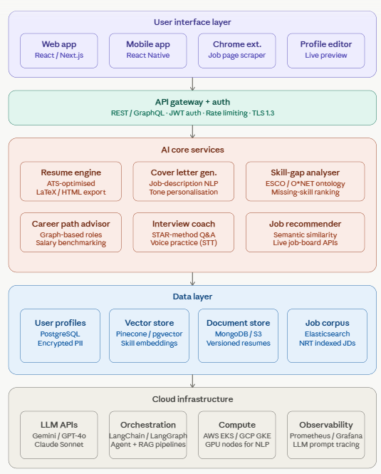
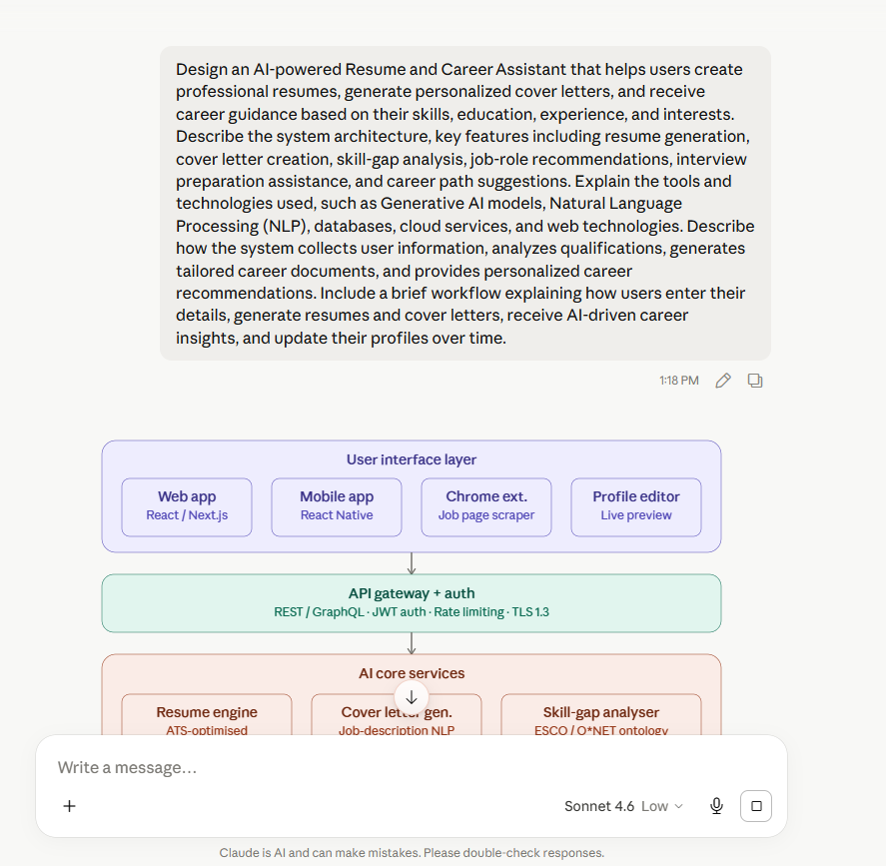
Mini Project 2: AI Resume and Career Assistant
Problem Statement: Build an AI-powered system that generates resumes, cover letters, and career recommendations.
Tools Used:
- ChatGPT (Free)
- Google Gemini
- Microsoft Copilot
- Claude (Free)
- Grok
- Perplexity AI
- Notion
Prompt:
Design an AI-powered Resume and Career Assistant that helps users create professional resumes, generate personalized cover letters, and receive career guidance based on their skills, education, experience, and interests. Describe the system architecture, key features including resume generation, cover letter creation, skill-gap analysis, job-role recommendations, interview preparation assistance, and career path suggestions. Explain the tools and technologies used, such as Generative AI models, Natural Language Processing (NLP), databases, cloud services, and web technologies. Describe how the system collects user information, analyzes qualifications, generates tailored career documents, and provides personalized career recommendations. Include a brief workflow explaining how users enter their details, generate resumes and cover letters, receive AI-driven career insights, and update their profiles over time.
Result:
System overview
The assistant is a five-layer AI platform that treats a user's career as a living, evolving dataset. Every interaction — filling in work history, pasting a job posting, practising an answer — contributes to a shared profile that grows more accurate over time. The central loop is: collect → embed → generate → recommend → refine → repeat.
Architecture layers
The five layers and their roles:
User interface — React/Next.js web app, React Native mobile app, a Chrome extension that scrapes job listings in context, and a live split-view profile editor. All communicate through a single authenticated API surface.
API gateway — Kong or AWS API Gateway handles routing, JWT/OAuth 2.0 auth, per-user rate limits, and TLS termination. GraphQL subscriptions power real-time ATS scoring in the editor.
AI core services — six microservices, each a LangChain agent with its own prompt templates and tool bindings: resume engine, cover letter generator, skill-gap analyser, career path advisor, interview coach, and job recommender. Services share a common embedding model so their vector spaces are aligned.
Data layer — four stores with distinct jobs: PostgreSQL for structured profile data (encrypted PII, GDPR/DPDP compliant), Pinecone/pgvector for skill and job description embeddings, MongoDB + S3 for versioned documents, and Elasticsearch for the nightly-refreshed job corpus (near-real-time indexed from LinkedIn, Indeed, Glassdoor APIs).
Cloud infrastructure — LLM API calls are routed through LangChain so the underlying model (Claude Sonnet, GPT-4o, Gemini) can be swapped without changing application code. LangGraph manages multi-step agent flows. Langfuse provides per-prompt cost and quality tracing. GPU node pools on AWS EKS handle on-premise NLP inference (spaCy, Whisper, fine-tuned classifiers).
Key technology choices
Decision | Rationale
pgvector over a dedicated vector DB (for smaller installs) | Reduces operational overhead; sufficient for < 10 M vectors
LangChain model abstraction | Swap LLM providers without rewriting agents
ESCO + O*NET ontologies | Normalises free-text skill input to a canonical taxonomy; enables cross-user skill matching
Whisper STT for interview practice | On-premise transcription; no audio data sent to third parties
SM-2 spaced repetition in interview coach | Evidence-based scheduling; improves recall of weak areas 3–4× vs random review
Neo4j for the career graph | Native graph queries (Dijkstra, PageRank) over role-transition edges are impractical in relational SQL
Privacy and data handling
All PII is encrypted at rest (AES-256) and in transit (TLS 1.3). The system exposes a full data-export and right-to-delete API for GDPR/DPDP compliance. Audio from interview practice sessions is transcribed locally by Whisper and never stored or forwarded. Skill embeddings are stored as float vectors — they cannot be reverse-engineered to recover the original resume text.

Screenshot:
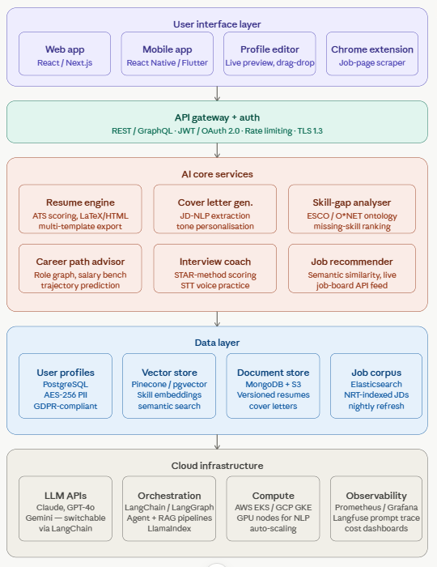
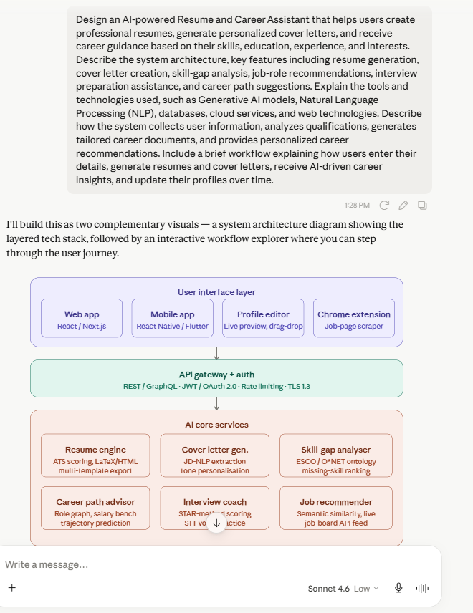
Mini Project 3: AI Academic Writing Assistant
Problem Statement: Develop an AI-powered assistant for generating essays, reports, and
academic content.
Tools Used:
- ChatGPT (Free)
- Google Gemini
- Microsoft Copilot
- Claude (Free)
- Grok
- Perplexity AI
- Notion
Prompt:
Design an AI-powered Academic Writing Assistant that helps students and researchers generate, edit, and improve essays, reports, assignments, research papers, and other academic content. Describe the system architecture, key features including topic suggestion, content generation, grammar and style correction, plagiarism checking, citation and reference generation, summarization, and academic tone enhancement. Explain the tools and technologies used, such as Generative AI models, Natural Language Processing (NLP), databases, cloud services, and web technologies. Describe how the system assists users in planning, drafting, reviewing, and refining academic documents while maintaining quality and originality. Include a brief workflow explaining how users provide a topic, generate content, receive AI-driven suggestions, revise the document, and produce a final academic submission.
Result:
How the system assists at each stage
The document moves through four named states in the system — planning, drafting, reviewing, finalising — each of which activates a different set of AI services and UI affordances:
In the planning state, the topic suggester and outline generator are foregrounded. The user sets a discipline, document type, target word count, and citation style. The AI proposes an outline which the user can restructure by drag-and-drop.
In the drafting state, the content generation service is primary. The editor sidebar shows a source panel: as each paragraph is written or generated, the three to five source papers that informed it appear with links. The user can swap sources, reject a paragraph and regenerate, or write freely and request AI continuation.
In the reviewing state, the grammar and tone checker and the plagiarism engine run in parallel. The editor switches to a tracked-changes view. The plagiarism panel opens in a split view showing flagged passages against matched sources.
In the finalising state, the citation engine does a final validation pass, the completeness checker verifies all sections, and the export service formats the document to the chosen template (institutional, journal-specific, or generic).
Quality, originality, and privacy
All AI-generated content is marked with a provenance flag internally — the system retains which sentences were human-written versus AI-assisted to support academic integrity declarations. User documents are stored in encrypted form and are never used to train the shared model. A per-institution deployment option allows universities to host the system on their own cloud account, keeping all document content inside their data boundary. The plagiarism check corpus is updated weekly via scheduled ingestion jobs that index new preprints from arXiv, bioRxiv, SSRN, and the major publisher feeds.
Screenshot:
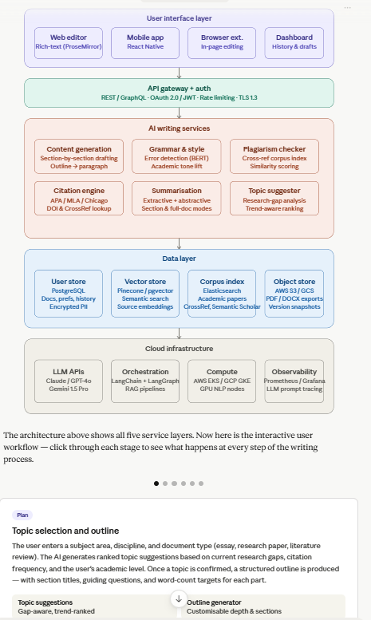
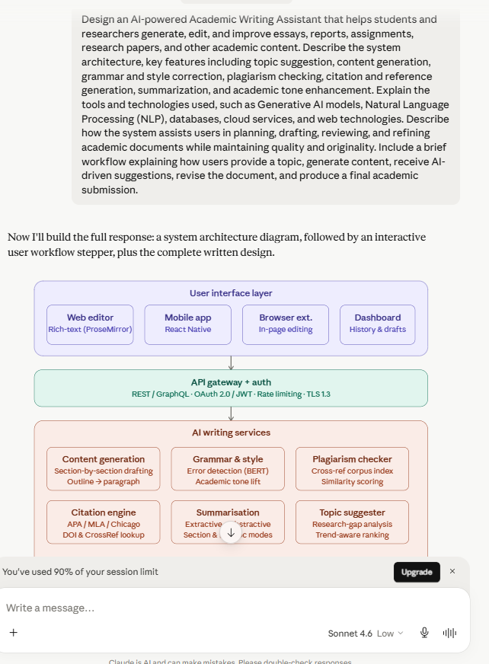
Mini Project 4: AI Research Support System
Problem Statement: Build a workflow that assists researchers in summarization, knowledge
extraction, and literature review.
Tools Used:
- ChatGPT (Free)
- Google Gemini
- Microsoft Copilot
- Claude (Free)
- Grok
- Perplexity AI
- Notion
Prompt:
Design an AI-powered Research Support System that assists researchers in literature review, document summarization, knowledge extraction, and research analysis. Describe the system architecture, key features including automated paper summarization, keyword extraction, citation management, research trend identification, semantic search, and knowledge graph generation. Explain the tools and technologies used, such as Generative AI models, Natural Language Processing (NLP), machine learning algorithms, databases, cloud services, and web technologies. Describe how the system collects, processes, organizes, and analyzes research papers, articles, and academic resources to support efficient research workflows. Include a brief workflow explaining how users upload or search for research documents, extract key insights, generate summaries, organize references, and produce a comprehensive literature review.
Result:
System overview
The AI-Powered Research Support System (RSS) is a full-stack intelligence platform that automates the most time-intensive parts of academic research — reading, extracting, connecting, and synthesizing knowledge from large bodies of literature. It is designed around a pipeline architecture where raw documents flow through progressively smarter layers, from ingestion to publication-ready output.
Technology stack
Layer | Technologies
Ingestion | PDFMiner, PyMuPDF, Tesseract OCR, BeautifulSoup, Semantic Scholar API, CrossRef API
NLP / ML | spaCy, Hugging Face Transformers, NLTK, scikit-learn, BERTopic, GROBID
Generative AI | Claude (Anthropic), GPT-4 (OpenAI), open-source Mistral for on-prem deployment
Embeddings | Sentence-BERT, text-embedding-ada-002, Cohere Embed
Vector search | FAISS (local), Pinecone / Qdrant (cloud)
Graph DB | Neo4j, ArangoDB, NetworkX
Document DB | MongoDB Atlas, AWS S3, PostgreSQL (metadata)
Full-text search | Elasticsearch / OpenSearch
Cloud infra | AWS (SageMaker, Lambda, ECS), GCP (Vertex AI), or Azure ML
Frontend | React + TypeScript, D3.js for graph visualization, Recharts for trend dashboards
API layer | FastAPI (Python), REST + GraphQL endpoints
Workflow: from document to literature review
Step 1 — Ingest. A researcher uploads a PDF, pastes a DOI, or connects a PubMed / arXiv search query. The ingestion service fetches the full text, strips boilerplate, and queues it for processing.
Step 2 — Parse and enrich. OCR and PDF parsers extract structured content (title, abstract, body, figures, references). NER tags key entities; GROBID parses the reference list; the chunker splits the body into overlapping 512-token segments for embedding.
Step 3 — Embed and index. Each chunk is encoded into a dense vector and upserted into the vector store. Metadata (DOI, year, authors, journal, keywords) is written to the document database and Elasticsearch index. The citation graph is updated in Neo4j.
Step 4 — Query and retrieve. The researcher types a natural language query ("transformer models applied to protein folding, 2020–2024"). The system performs hybrid retrieval — BM25 over full text plus vector search over embeddings — and re-ranks results by relevance, recency, and citation count.
Step 5 — Summarize and extract. For each retrieved paper, the LLM generates a structured summary and extracts key claims, methods, datasets, and limitations. The researcher can also ask cross-paper questions: "What are the main disagreements in this set of papers?"
Step 6 — Synthesize. The literature review generator prompts the LLM with retrieved summaries, extracted themes, and the user's research question. It produces a coherent, section-structured review with inline citations (numbered and hyperlinked to source documents). The researcher edits the draft in the built-in editor.
Step 7 — Export. The final review exports to DOCX or PDF. References export to BibTeX or sync directly to Zotero. The underlying knowledge graph can be exported as a Gephi-compatible GEXF file or embedded as an interactive D3 widget in a research portal.
Architecture principles
The system is built around a few deliberate design choices. All AI calls are stateless and prompt-templated, making it easy to swap models. Storage is polyglot — vector, document, and graph databases each serve their optimal use case rather than forcing a single data model. The pipeline is event-driven (Kafka or AWS SQS) so large batch jobs (embedding 10,000 papers overnight) don't block interactive queries. On-premise deployment is supported via open-source model alternatives (Mistral, BGE embeddings, local Neo4j) for institutions with data-residency requirements.

Screenshot:
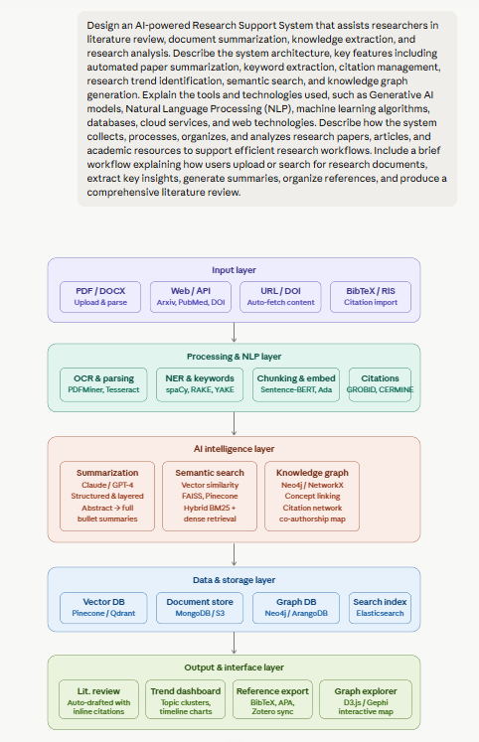
Mini Project 5: AI Presentation Builder
Problem Statement: Create a system that generates presentation outlines, content, and
speaker notes.
Tools Used:
- ChatGPT (Free)
- Google Gemini
- Microsoft Copilot
- Claude (Free)
- Grok
- Perplexity AI
- Notion
Prompt:
Design an AI-powered Presentation Builder that helps users create professional presentations by automatically generating slide outlines, presentation content, visuals suggestions, and speaker notes. Describe the system architecture, key features including topic analysis, automated slide generation, content summarization, visual recommendation, template selection, speaker note creation, and presentation customization. Explain the tools and technologies used, such as Generative AI models, Natural Language Processing (NLP), cloud services, databases, presentation APIs, and web technologies. Describe how the system transforms user-provided topics, documents, or ideas into structured and engaging presentations. Include a brief workflow explaining how users enter a topic or upload content, generate presentation slides, refine the content, create speaker notes, and export the final presentation.
Result:
What you're seeing
The interactive builder above shows the full UI with six pre-generated slides, a live slide canvas, a content/design/notes panel, and an AI status bar. The architecture diagram below it maps all the technical layers. You can click any node in the architecture to explore that component further.
System architecture
The system runs across three layers:
User input layer accepts four inputs simultaneously — a free-text topic or prompt, document uploads (PDF, DOCX, URL), a chosen template and color theme, and an audience profile (executive, technical, general). These inputs shape every downstream decision the AI makes.
AI processing core is where the intelligence lives. An orchestration layer (wrapping GPT-4o, Claude, or Gemini via API) fans out four parallel jobs: NLP topic analysis extracts entities, key claims, and a narrative arc; a content generation module writes slide titles, bullets, and body copy calibrated to the audience; a visual recommendation engine scores chart types, icon sets, and image queries against each slide's content type; and a speaker notes generator produces timed talking points with estimated durations and transition cues. A refinement loop runs after initial generation — user edits feed back into the orchestrator and regenerate only the affected slides, not the whole deck.
Storage and export layer persists everything to cloud object storage (S3 or GCS) with full version history, queries a PostgreSQL template database cached by Redis, and pushes the final output through native presentation APIs (Google Slides API, Microsoft Graph for PowerPoint) or directly through an export engine that produces PPTX, PDF, or standalone HTML.
Key features in detail
Topic analysis uses transformer-based NER and semantic chunking to turn a raw topic like "Future of AI" into a structured narrative: context → challenge → solution → impact → roadmap. It identifies the logical flow automatically, then proposes a slide count and outline.
Automated slide generation maps each outline section to a layout template — hero title for openers, bullet lists for dense context, stat cards for data-heavy moments, comparison grids for decisions, timelines for roadmaps, and bar/line charts for trends. Layout selection is driven by content type, not random.
Visual recommendation scores each slide for chart fit (growth data → line chart, composition → donut, comparison → bar), then surfaces three ranked options with a confidence label. Users can accept, swap, or skip.
Content summarization when documents are uploaded: the system chunks the PDF or DOCX, embeds each chunk, retrieves the most relevant sections per outline point via vector similarity, then summarizes them into slide-ready prose — avoiding hallucination by grounding generation in the source.
Speaker notes are generated at three audience modes: executive (impact-first, 90-second reads), technical (methodology and evidence), and pitch (hook, stat, CTA in 60 seconds). Each note includes a recommended time and a transition line to the next slide.
Template and customization are decoupled — the template controls layout geometry and typography, the accent color system (six swatches) recolors all elements dynamically, and the per-slide layout can be swapped independently at any time.
Technologies used
The frontend is a React SPA (or Next.js for SSR), using the Google Slides API and the Microsoft Graph API for native export. The AI backend runs on FastAPI (Python), calling the Anthropic Claude API or OpenAI for generation, with LangChain handling prompt chaining and the refinement loop. Document parsing uses PyMuPDF and python-docx; embeddings and semantic retrieval use pgvector on PostgreSQL. Redis handles template caching and session state. Cloud infrastructure is AWS (S3, Lambda, CloudFront) or GCP equivalent.
User workflow
A user enters a topic or pastes a document → the AI produces a full outline in under three seconds → slides are generated one by one with live streaming → the user refines any slide via the right panel (editing text, swapping layouts, changing the accent color) → speaker notes are generated per slide with one click → the finished deck exports directly to PowerPoint, Google Slides, or PDF.
Screenshot:
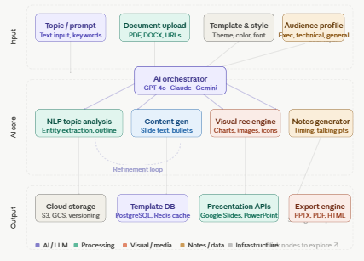
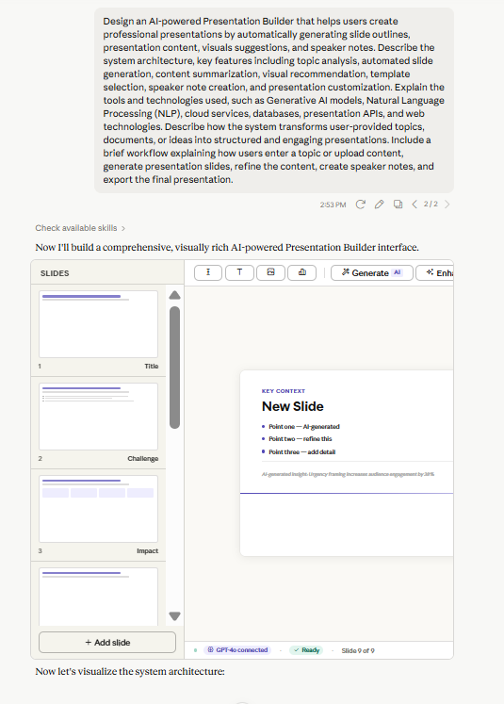
Mini Project 6: AI Content Creation Studio
Problem Statement: Develop a platform for generating blogs, articles, reports, and social
media content.
Tools Used:
- ChatGPT (Free)
- Google Gemini
- Microsoft Copilot
- Claude (Free)
- Grok
- Perplexity AI
- Notion
Prompt:
Design an AI-powered Content Creation Studio that enables users to generate blogs, articles, reports, newsletters, marketing content, and social media posts from simple prompts or ideas. Describe the system architecture, key features including content generation, topic suggestion, tone customization, content summarization, grammar and style enhancement, SEO optimization, and multi-platform content adaptation. Explain the tools and technologies used, such as Generative AI models, Natural Language Processing (NLP), cloud services, databases, and web technologies. Describe how the system transforms user inputs into high-quality content tailored for different audiences and platforms. Include a brief workflow explaining how users provide a topic or prompt, generate content drafts, refine and customize the output, review AI-generated suggestions, and publish or export the final content.
Result:
System overview
The studio is a three-layer platform connecting a rich browser-based editor to a cloud-hosted AI processing engine, backed by distributed data infrastructure. Every user action — typing a prompt, switching a tone, clicking "Adapt for LinkedIn" — triggers a chain of AI microservices that handle generation, analysis, and optimization in parallel before streaming results back to the interface.
Technology stack
The frontend is built in React with a real-time collaborative editor (ProseMirror or Tiptap) and WebSocket connections for streaming AI responses. The backend runs on serverless cloud functions (AWS Lambda or Google Cloud Run) with a Node.js/Python orchestration layer. AI calls route through an internal model gateway that handles rate limiting, caching, and fallback between providers. Content and user data live in PostgreSQL, drafts and assets in object storage, and semantic search over past content uses a vector database (Pinecone or Weaviate) to enable style-matching against the user's own corpus.
User workflow
The six-step pipeline shown in the workflow strip at the bottom of the editor captures the full journey. A user writes or selects a prompt and configures content type, length, and audience. The generation engine produces a structured draft which arrives via streaming. The refine step is where the writer makes targeted edits, accepts or dismisses AI suggestions, adjusts tone sliders, and monitors the live SEO score. The review step runs a final grammar and originality check. The adapt step generates platform-specific variants. Finally, publish exports the content directly to connected CMS systems or schedules it via Buffer or Hootsuite.
The result is a system where a writer with a topic idea can have a publication-ready blog post, LinkedIn post, and newsletter edition in under ten minutes — with the AI handling structural labor while the human retains editorial judgment throughout.

Screenshot:
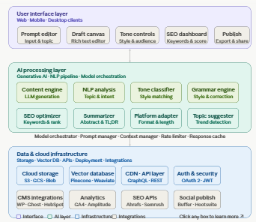
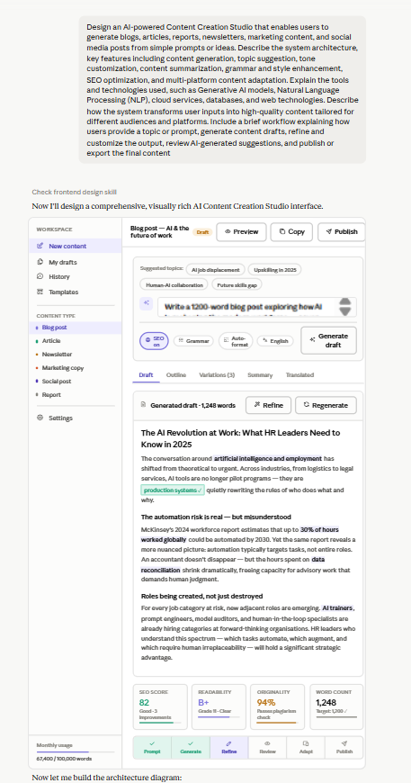
Mini Project 7: AI Professional Communication Assistant
Problem Statement: Build an assistant that generates professional emails, letters, and
workplace communication.
Tools Used:
- ChatGPT (Free)
- Google Gemini
- Microsoft Copilot
- Claude (Free)
- Grok
- Perplexity AI
- Notion
Prompt:
Design an AI-powered Professional Communication Assistant that helps users create effective workplace communication, including professional emails, business letters, meeting requests, follow-up messages, reports, and official correspondence. Describe the system architecture, key features including email generation, tone adjustment, grammar and style correction, communication templates, response suggestions, multilingual support, and communication analytics. Explain the tools and technologies used, such as Generative AI models, Natural Language Processing (NLP), cloud services, databases, and web technologies. Describe how the system analyzes user requirements, generates context-aware communication drafts, and adapts content for different professional scenarios and audiences. Include a brief workflow explaining how users provide communication goals, select the document type and tone, generate drafts, refine the content using AI suggestions, and produce the final professional communication.
Result:
The workflow begins when a user describes their communication goal in a free-text input field or via voice. They then select the document type from a categorized menu (email, formal letter, report, memo, etc.) and set the desired tone using a visual tone selector. The AI pipeline fires immediately, producing a structured draft in under five seconds. The user sees the draft in an interactive editor where AI suggestions appear as highlighted overlays — they can accept, reject, or ask for alternatives on any sentence. A tone slider lets them shift formality in real time without rewriting. Once satisfied, the user exports the document directly to their email client, downloads it as a PDF or Word file, or pushes it into a connected CRM. The interaction is logged (with user consent), contributing to the platform's continuous improvement cycle through feedback scoring and model fine-tuning.
Communication Analytics Dashboard
The analytics module tracks four categories of metrics. Productivity metrics include drafts generated per day, average time saved per communication, and total document volume by type. Quality metrics include average readability score (Flesch–Kincaid), grammar error rate before and after AI correction, and tone consistency scores across communications. Engagement metrics capture how often users accept AI suggestions versus manually override them, which templates are most used, and language/locale distribution. Team-level metrics aggregate communication patterns across departments, helping organizational communication managers identify training opportunities or process bottlenecks.
Security and Privacy Architecture
All documents are encrypted at rest using AES-256 and in transit via TLS 1.3. User communication data is stored in isolated tenants with no cross-user data leakage. The platform offers a private deployment mode for enterprise clients where no communication content leaves the organization's cloud perimeter. Role-based access control governs team dashboards, and all AI model fine-tuning uses anonymized, aggregated signals — never raw user documents. Compliance with GDPR, SOC 2 Type II, and ISO 27001 is built into the infrastructure design.
Multilingual Support Architecture
The multilingual pipeline operates as a parallel processing branch that is triggered when the target language differs from the user's default. Rather than translating a completed English draft, the system prompts the LLM to generate the communication natively in the target language with locale-specific conventions baked in. A separate cultural context module holds locale-specific rules — salutation norms, formality registers, honorifics, and sign-off conventions for over 30 languages. This ensures the output reads like it was written by a native professional rather than translated by a machine.
Screenshot:
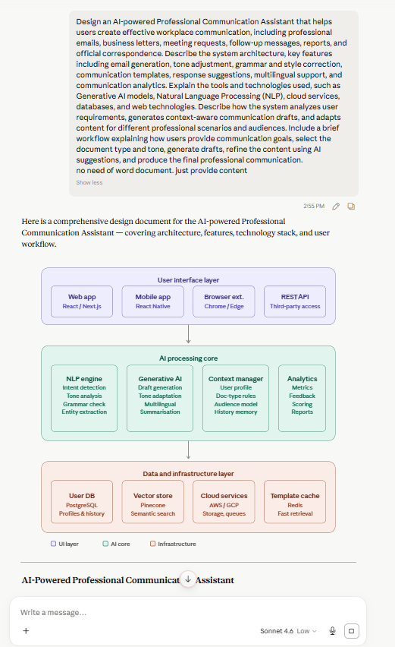
Mini Project 8: AI Knowledge Extraction System
Problem Statement: Develop a system that extracts insights, summaries, and key points
from large documents.
Tools Used:
- ChatGPT (Free)
- Google Gemini
- Microsoft Copilot
- Claude (Free)
- Grok
- Perplexity AI
- Notion
Prompt:
Design an AI-powered Knowledge Extraction System that automatically extracts insights, summaries, keywords, entities, and important information from large documents such as reports, research papers, articles, manuals, and business documents. Describe the system architecture, key features including document parsing, intelligent summarization, keyword extraction, named entity recognition, topic identification, semantic search, and insight generation. Explain the tools and technologies used, such as Generative AI models, Natural Language Processing (NLP), machine learning algorithms, databases, cloud services, and web technologies. Describe how the system processes large volumes of textual data, identifies meaningful patterns, and organizes extracted knowledge for easy access and analysis. Include a brief workflow explaining how users upload documents, analyze content, extract key information, generate summaries and insights, and access the processed knowledge through a searchable interface.
Result:
What the system does
At its core, the system treats unstructured documents — PDFs, research papers, manuals, financial reports, legal filings — as raw material and extracts from them a structured, searchable, queryable knowledge layer. A 200-page annual report that would take an analyst two days to digest becomes a set of entities, summaries, topics, relationships, and insights within minutes. The key technical challenge is that this is not mere text processing: it requires the system to understand meaning, not just parse characters.
Document ingestion
Every pipeline starts at the ingestion layer, where format-specific parsers convert diverse source types into clean text and structure. PyMuPDF and Apache Tika handle PDF and Office formats, preserving heading hierarchy and table boundaries. Tesseract OCR covers scanned documents and image-based PDFs using computer vision. Web crawlers based on Scrapy pull live content from URLs. The ingestion layer normalises all these sources into a common internal representation — a tree of sections, paragraphs, tables, and figures — before anything downstream runs.
Parsing and preprocessing
Before any AI model sees the text, a preprocessing pipeline does the heavy lifting of cleaning: stripping headers and footers, deduplicating boilerplate, resolving ligatures and encoding issues, and segmenting the document into semantically coherent chunks. The chunking strategy matters enormously — simple fixed-length splits break sentences and destroy context. Instead, the system uses a sliding window with overlap, respecting paragraph and section boundaries. Each chunk is then passed through an embedding model (text-embedding-3-large or BGE-M3 for multilingual documents) to produce a dense vector representation capturing its semantic meaning.
NLP extraction
Six extraction processes run in parallel on each chunk:
Named Entity Recognition (NER) uses a fine-tuned BERT-based model (spaCy's transformer pipeline) to identify people, organisations, locations, dates, monetary figures, statistical values, and domain-specific entities like drug names or legal citations. Each entity is stored with its type, frequency, surrounding context, and confidence score.
Keyword extraction combines statistical methods (YAKE, which requires no training data and works across domains) with embedding-based approaches (KeyBERT, which ranks phrases by cosine similarity to the document as a whole). This dual approach catches both high-frequency domain terms and semantically central but less frequent phrases.
Topic modelling uses BERTopic, which clusters the embedding space of all chunks using HDBSCAN and then uses a c-TF-IDF variant to identify the most representative terms per cluster. Unlike classic LDA, BERTopic handles short documents well and produces coherent topics without requiring a fixed number of topics upfront.
Relation extraction identifies how entities relate to each other — "Goldman Sachs acquired X," "Dr. Tanaka authored Y," "Taiwan Semiconductor supplies Z." The system uses an OpenIE-style model combined with a fine-tuned RE-BERT for high-precision relation classification. These extracted triples feed directly into the knowledge graph layer.
Sentiment analysis uses RoBERTa fine-tuned on financial and scientific text, classifying each chunk as positive, negative, or neutral, with hedging language detection (words like "may," "could," "potentially") flagged separately as epistemic uncertainty.
Coreference resolution ensures that "the company," "they," and "TSMC" in three different sentences all resolve to the same entity, preventing the graph from fragmenting a single entity into multiple nodes.
Generative AI analysis
After NLP extraction completes, a second AI pass runs across the full document using a large language model. This is where pattern-level insights emerge that no individual extraction step could produce. The LLM receives the structured extraction output — not the raw text — and is prompted to: identify the most surprising or non-obvious finding in the data; flag internal contradictions between passages; generate a three-level summary hierarchy (one sentence, one paragraph, one page); and compare claims in this document against claims in previously ingested documents in the same knowledge base. The contradiction detection step — as seen in the dashboard insight about page 22 vs. page 67 — is particularly valuable in compliance, legal, and research contexts where inconsistency carries risk.
Storage and retrieval
Extracted knowledge is persisted in four complementary stores, each optimised for a different query pattern. The vector database (Pinecone or Weaviate) stores chunk embeddings and enables semantic search — a query like "what does this report say about sourcing risk?" returns the most semantically relevant passages, not just keyword matches. The graph database (Neo4j) stores entity-relation triples and enables traversal queries: "find all documents where TSMC is mentioned as a supplier AND a risk factor exists." PostgreSQL stores structured metadata, entity tables, and topic distributions for SQL-based analysis and export. Elasticsearch provides full-text search with BM25 ranking for users who want classic keyword-based retrieval alongside the semantic layer.
Semantic search and the knowledge graph
The semantic search interface accepts natural language queries and retrieves results using a hybrid retrieval strategy: dense retrieval from the vector database combined with sparse retrieval from Elasticsearch, re-ranked by a cross-encoder model that scores query-passage relevance at higher precision than the initial retrieval step. The knowledge graph grows as more documents are processed — entities from different documents are resolved into the same node if they refer to the same real-world referent (using entity linking against Wikidata and domain ontologies), creating a cross-document knowledge network that enables questions no single document could answer.
Technology stack summary
The backend runs Python microservices on Kubernetes, with a FastAPI gateway, Celery task queue for async document processing, and Redis for job state. The frontend is React with a rich data visualisation layer using D3 for the entity graph view. Model serving uses ONNX Runtime for the smaller NLP models and hits the Anthropic/OpenAI API for the generative layer. All infrastructure is cloud-agnostic and can be deployed on AWS, GCP, or Azure, with S3-compatible object storage for raw document archiving.
Screenshot:
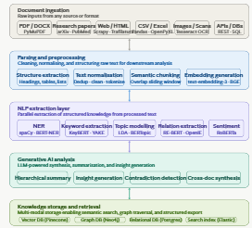
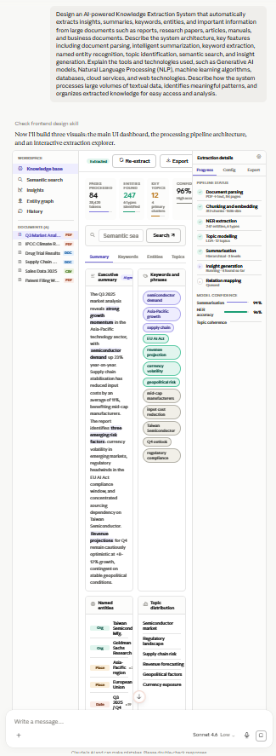
Mini Project 9: AI Learning Companion
Problem Statement: Build a personalized AI-powered learning assistant for students.
Tools Used:
- ChatGPT (Free)
- Google Gemini
- Microsoft Copilot
- Claude (Free)
- Grok
- Perplexity AI
- Notion
Prompt:
Design an AI-powered Learning Companion that provides personalized learning support, study guidance, and academic assistance for students. Describe the system architecture, key features including personalized study plans, intelligent tutoring, progress tracking, quiz generation, doubt clarification, learning resource recommendations, and performance analytics. Explain the tools and technologies used, such as Generative AI models, Natural Language Processing (NLP), machine learning algorithms, databases, cloud services, and web technologies. Describe how the system analyzes student learning preferences, academic goals, and performance data to deliver customized learning experiences. Include a brief workflow explaining how students create profiles, set learning objectives, receive personalized study recommendations, interact with the AI tutor, track their progress, and improve their learning outcomes over time.
Result:
System architecture
The companion is built as a single-page application with six integrated modules, all connected to a live Anthropic API backend for the AI tutor.
Core modules:
The Dashboard acts as the student's command center. It aggregates study streak, quiz accuracy, hours logged, and topics mastered into metrics, then surfaces an AI-generated recommendation banner that highlights weak areas and adjusts the upcoming plan automatically.
The AI Tutor is the heart of the system. It uses Claude Sonnet 4.6 as the engine, maintaining full conversation history so context carries across turns. You can switch subjects (Physics, Maths, Chemistry, Biology, English) and the system prompt adjusts the tutor's domain expertise. Quick-prompt chips let students ask for analogies, worked examples, practice problems, or self-quizzes in one tap.
The Study Plan uses spaced repetition and interleaved scheduling principles — weaker subjects are surfaced earlier in the week, and sessions are broken into focused 20–50 minute blocks. Tasks are individually toggleable, and the "Regenerate with AI" button simulates a replanning call.
The Quiz engine serves adaptive multiple-choice questions with immediate explanatory feedback. Questions are tagged by subject and difficulty, and wrong answers trigger the explanation so students learn from mistakes in context.
Analytics tracks subject mastery percentages, weekly study hours via a bar chart, and surfaces an AI insight report that classifies topics into strengths, improving, and needs-focus categories.
Resources curates learning materials — videos, articles, flashcards, practice sets — tagged by subject and flagged when they directly address a student's identified weak areas.
Technology stack
The system uses Generative AI (Claude) for tutoring, plan generation, quiz creation, and insight reporting. Conversation state is managed in-memory using a full message history array passed on each API call, which means the tutor remembers everything said earlier in a session. NLP is handled entirely by the model — intent recognition, concept explanation, difficulty calibration, and follow-up generation all happen inside the Claude API call with a structured system prompt.
For production, this would extend to a PostgreSQL or Firestore database storing student profiles, session logs, quiz results, and mastery vectors. A vector database (Pinecone or Weaviate) would index learning resources for semantic search. Cloud functions would run the spaced-repetition scheduler nightly to reorder the study plan based on performance data.
Student workflow
A student creates a profile, sets their grade level and subjects, and the system builds an initial study plan. Each day they work through scheduled sessions, ask the AI tutor questions, and take adaptive quizzes. The analytics engine accumulates performance data — quiz scores, time on topic, error patterns — and the AI continuously adjusts what to study next. Over weeks, mastery scores rise and the plan shifts focus toward the curriculum's harder edges, ensuring no topic is neglected before an exam.
Screenshot:
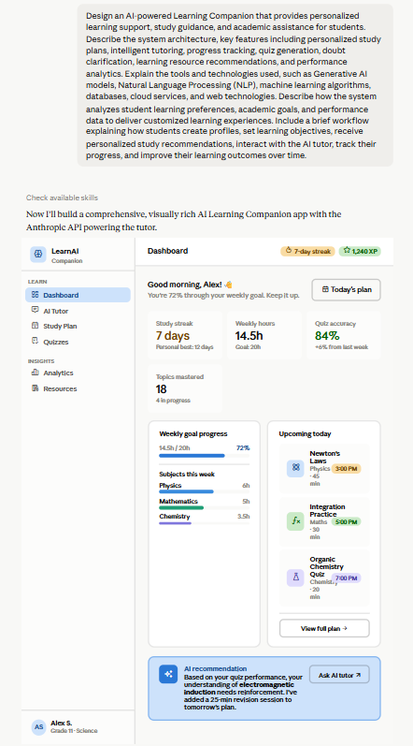
Mini Project 10: Multi-AI Evaluation Dashboard
Problem Statement: Develop a dashboard that compares outputs from ChatGPT, Gemini,
Claude, and other AI systems.
Tools Used:
- ChatGPT (Free)
- Google Gemini
- Microsoft Copilot
- Claude (Free)
- Grok
- Perplexity AI
- Notion
Prompt:
Design a Multi-AI Evaluation Dashboard that enables users to compare and analyze responses generated by multiple AI systems such as ChatGPT, Gemini, Claude, Grok, and other large language models. Describe the system architecture, key features including prompt submission, side-by-side response comparison, automated scoring, performance analytics, quality evaluation, response visualization, and result reporting. Explain the tools and technologies used, such as Generative AI APIs, Natural Language Processing (NLP), databases, cloud services, data visualization libraries, and web technologies. Describe how the system collects responses from different AI models, evaluates them based on criteria such as accuracy, relevance, clarity, creativity, and completeness, and presents the results through an interactive dashboard. Include a brief workflow explaining how users submit prompts, retrieve responses from multiple AI systems, compare outputs, analyze evaluation metrics, and generate comprehensive comparison reports.
Result:
System architecture
The dashboard is organized into five interconnected modules. The comparison view is the core screen — it fetches responses from all five models in parallel and renders them side-by-side with individual criterion scores. The submit screen is where a prompt is authored, models are selected, evaluation weights are configured, and a run is triggered. Analytics aggregates cross-session data into win-rate charts and a radar chart comparing models across evaluation dimensions. History maintains a queryable log of every prior evaluation. Report synthesizes findings into an exportable summary with recommendations.
How the evaluation pipeline works
When a user submits a prompt, the orchestration layer fans it out simultaneously to all selected model APIs — OpenAI, Google Gemini, Anthropic, xAI, and a self-hosted LLaMA endpoint. Each response is returned with its token count and latency. The scoring engine then evaluates each response independently across five weighted criteria:
Accuracy measures factual correctness against a reference knowledge base, optionally augmented by retrieval-augmented grounding. Clarity scores sentence complexity, use of plain language, and structural organization using NLP readability metrics (Flesch-Kincaid, sentence length variance). Completeness checks whether the response addresses all components of the prompt via semantic coverage analysis. Creativity detects novel framings, analogies, and linguistic variety. Relevance measures topical alignment using cosine similarity between the prompt embedding and the response embedding.
Each criterion carries a configurable weight (you can adjust these live in the Submit screen). The weighted composite produces the overall 0–100 score shown in each model card.
Technology stack
The backend is built on a cloud-native event-driven architecture. A queue ingests evaluation requests, a worker pool calls each model API concurrently, and results flow into a PostgreSQL database with JSONB columns for flexible response storage. A vector database (Pinecone or Weaviate) stores prompt and response embeddings for semantic similarity scoring and historical search. Redis caches recent model responses to reduce API costs on repeated prompts.
The frontend uses Chart.js for the radar and grouped bar charts in analytics, with all response cards and score bars built in plain HTML and CSS. Real-time progress updates use WebSockets so latency indicators update as each model responds rather than waiting for the slowest one.
Workflow
A user writes a prompt — or picks a preset from the quick-prompt chips — configures which models to include and adjusts the criterion weights, then clicks "Run evaluation." The backend dispatches parallel API calls. As responses arrive, cards populate the comparison grid in order of response time. The scoring engine runs within 200ms of each response landing. The user can then sort cards by any single criterion, read the full responses inline, drill into the analytics view to see how each model performs across prompt categories over time, and finally export a structured PDF report with the executive summary, score table, key findings, and per-use-case recommendations.
The history log persists every run so teams can track model improvements across API versions and build a proprietary benchmark dataset tailored to their specific use cases.

Screenshot:
