UNIT–II
PROMPT ENGINEERING &AI-ASSISTED CONTENT CREATION

TUTORIAL TASK 1: BASIC PROMPT CREATION

Problem Statement
Create simple prompts to obtain factual information from AI assistants and compare the generated responses.
Tools:
- ChatGPT
- Claude
- Microsoft Copilot

Prompt
"What is Artificial Intelligence?"

Response 1 (ChatGPT)
Artificial Intelligence (AI) is a branch of computer science that focuses on creating systems capable of performing tasks that typically require human intelligence. These tasks include learning, reasoning, problem-solving, decision-making, speech recognition, and language understanding. AI is widely used in applications such as virtual assistants, recommendation systems, healthcare, robotics, and autonomous vehicles.

Response 2 (Google Gemini)
Artificial Intelligence (AI) refers to the simulation of human intelligence in machines that are programmed to think, learn, and make decisions. AI technologies enable computers to perform tasks such as image recognition, natural language processing, and predictive analysis. AI is increasingly used across industries to improve efficiency and automate processes.

Comparison of Responses
Feature | ChatGPT Response | Gemini Response
Definition | Detailed explanation of AI | Concise definition of AI
Examples | Virtual assistants, healthcare, robotics | Image recognition, NLP, predictive analysis
Length | Longer and descriptive | Shorter and direct
Focus | Human-like intelligence and applications | Automation and industry usage

Analysis
Both AI assistants provide correct information about Artificial Intelligence. However, the responses differ in style:
- ChatGPT provides a more detailed explanation with multiple examples and applications.
- Gemini gives a concise definition and focuses on practical industry applications.
- Both responses explain that AI enables machines to perform tasks that normally require human intelligence.

SCREEN SHOT:

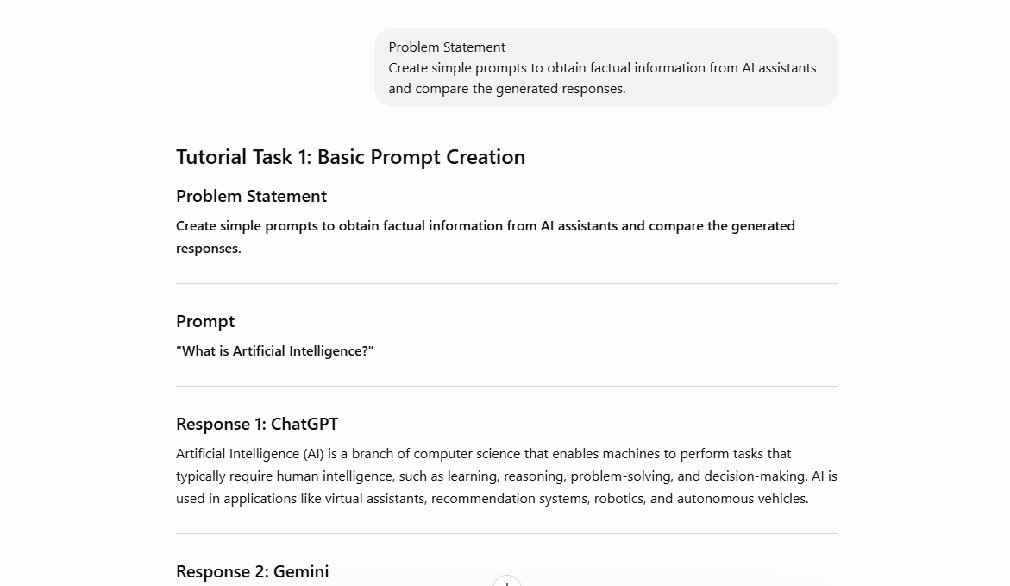

Conclusion
Artificial Intelligence is the ability of machines to mimic human intelligence and perform tasks such as learning, reasoning, and decision-making. Comparing responses from different AI assistants helps users understand various explanation styles and identify the most suitable response for their needs.

Outcome
- Learned how to create a simple factual prompt.
- Compared responses generated by different AI assistants.
- Understood the basic concept and applications of Artificial Intelligence.
- Observed differences in response style, detail, and focus among AI systems.

TUTORIAL TASK 2: PROMPT REFINEMENT EXERCISE

Tutorial Task 2: Prompt Refinement Exercise
Tools:
- ChatGPT
- Claude
- Microsoft Copilot

Basic Prompt
"Explain Artificial Intelligence."

Basic Response
Artificial Intelligence (AI) is a branch of computer science that enables machines to perform tasks that normally require human intelligence. These tasks include learning, reasoning, problem-solving, decision-making, and understanding language. AI is widely used in applications such as virtual assistants, chatbots, recommendation systems, and autonomous vehicles.

Refined Prompt
"Explain Artificial Intelligence for undergraduate engineering students. Include its definition, historical development, key concepts, types of AI, advantages, limitations, and current applications in healthcare, education, finance, and industry. Present the response in approximately 500 words with clear headings and bullet points."

Refined Response

Artificial Intelligence (AI)

Definition
Artificial Intelligence (AI) is a branch of computer science that focuses on creating systems capable of performing tasks that typically require human intelligence. These tasks include learning from data, reasoning, problem-solving, decision-making, language understanding, and pattern recognition.

Historical Development of AI

1950s – Foundation
- Alan Turing introduced the concept of machine intelligence.
- The Turing Test was proposed to evaluate intelligent machine behavior.

1956 – Birth of AI
- The term "Artificial Intelligence" was coined at the Dartmouth Conference.
- This event marked the beginning of AI as an academic field.

1980s – Expert Systems
- AI systems were developed to mimic human experts.
- Used in healthcare, business, and engineering applications.

1990s–2000s – Machine Learning Era
- AI shifted from rule-based systems to data-driven learning.
- Growth in computing power and data availability improved AI performance.

2010s–Present – Deep Learning and Generative AI
- Neural networks achieved significant breakthroughs.
- AI applications expanded to image recognition, natural language processing, and content generation.

Key Concepts of AI

Machine Learning (ML)
Allows computers to learn patterns from data and improve performance without explicit programming.

Deep Learning
A subset of machine learning that uses neural networks with multiple layers to process complex data.

Natural Language Processing (NLP)
Enables machines to understand and generate human language.

Computer Vision
Allows computers to interpret and analyze images and videos.

Robotics
Combines AI with mechanical systems to perform automated tasks.

Types of AI

1. Narrow AI (Weak AI)
- Designed for specific tasks.
- Examples: Chatbots, voice assistants, recommendation systems.

2. General AI (Strong AI)
- Can perform any intellectual task a human can perform.
- Still under research and development.

3. Super AI
- A theoretical AI that exceeds human intelligence.
- Does not currently exist.

Advantages of AI
- Improves efficiency and productivity.
- Reduces human errors.
- Automates repetitive tasks.
- Supports data-driven decision-making.
- Operates continuously without fatigue.
- Enhances innovation across industries.

Limitations of AI
- High development and maintenance costs.
- Requires large volumes of quality data.
- Privacy and security concerns.
- Potential job displacement in certain sectors.
- Limited creativity and emotional intelligence.
- Risk of biased decisions if training data is biased.

Current Applications of AI

Healthcare
- Disease diagnosis
- Medical image analysis
- Drug discovery

Education
- Intelligent tutoring systems
- Personalized learning platforms
- Automated assessment

Finance
- Fraud detection
- Risk analysis
- Algorithmic trading

Industry
- Predictive maintenance
- Quality control
- Industrial automation
- Smart manufacturing

Conclusion
Artificial Intelligence is transforming the way technology interacts with society. From healthcare and education to finance and industrial automation, AI provides innovative solutions that improve efficiency and decision-making. Understanding AI, its capabilities, and its limitations is essential for engineering students as it continues to shape the future of technology and industry.

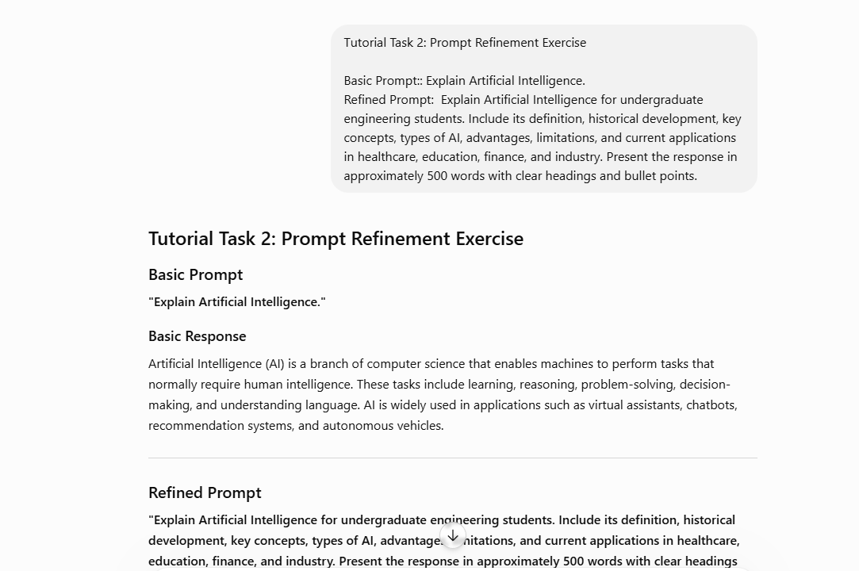

Outcome
The refined prompt produces a more detailed, structured, and audience-specific response, demonstrating how prompt refinement significantly improves the quality and usefulness of AI-generated content.

Tutorial Task 3: Zero-Shot Prompting

Prompt
Discuss the role of Artificial Intelligence in modern engineering and technology. Explain its impact on automation, decision-making, data analysis, and innovation. Present the response in a well-structured academic format without using examples or reference materials.
Tools:
- ChatGPT
- Claude
- Microsoft Copilot

Generated Response

The Role of Artificial Intelligence in Modern Engineering and Technology

Introduction
Artificial Intelligence (AI) has emerged as a transformative technology that significantly influences modern engineering and technological advancements. By enabling machines and systems to perform tasks that traditionally require human intelligence, AI enhances efficiency, accuracy, and productivity across various domains. Its integration into engineering and technology has reshaped the way complex problems are analyzed, managed, and solved.

Impact on Automation
One of the most significant contributions of AI is its ability to improve automation. AI-powered systems can perform repetitive and complex tasks with minimal human intervention. Through intelligent processing and adaptive learning, automated systems can operate continuously while maintaining consistency and precision. This capability reduces operational inefficiencies, enhances productivity, and allows human resources to focus on higher-level responsibilities.

Impact on Decision-Making
AI plays a crucial role in supporting decision-making processes. Advanced algorithms can analyze large volumes of information and identify meaningful patterns that assist in making informed decisions. AI-driven decision support systems enhance accuracy, reduce uncertainty, and provide valuable insights for strategic planning. As a result, organizations can make faster and more effective decisions based on data-driven analysis.

Impact on Data Analysis
The rapid growth of digital information has increased the importance of efficient data analysis. AI enables the processing and interpretation of vast datasets that would be difficult to analyze manually. By identifying trends, relationships, and anomalies within data, AI helps generate actionable insights. This capability supports improved forecasting, optimization, and performance evaluation across engineering and technological environments.

Impact on Innovation
AI serves as a catalyst for innovation by enabling the development of advanced solutions and intelligent systems. It supports the creation of new methodologies, enhances research capabilities, and accelerates technological progress. AI-driven innovation encourages continuous improvement in products, services, and processes, leading to higher levels of efficiency and competitiveness. Its ability to learn and adapt contributes to the discovery of new opportunities and advancements in engineering design and development.

Challenges and Considerations
Despite its advantages, AI implementation presents several challenges. These include concerns related to data quality, system reliability, privacy, security, and ethical considerations. Effective governance and responsible development practices are essential to ensure that AI technologies are deployed safely and efficiently.

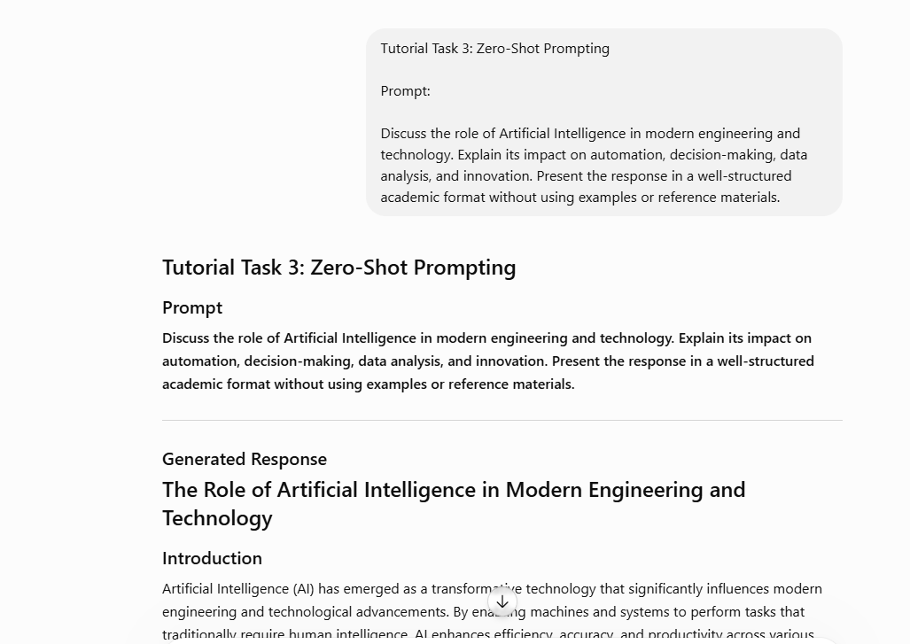

Conclusion
Artificial Intelligence has become a fundamental component of modern engineering and technology. Its contributions to automation, decision-making, data analysis, and innovation have transformed traditional approaches to problem-solving and system development. As AI continues to evolve, it is expected to play an increasingly important role in shaping the future of engineering and technological advancement.

Tutorial Task 4: Few-Shot Prompting

Problem Statement
Design prompts with examples to improve AI response quality for specific tasks.
Tools:
- ChatGPT
- Claude
- Microsoft Copilot

Prompt
Act as an AI academic assistant. Classify the following technologies into their correct categories: Artificial Intelligence (AI), Machine Learning (ML), or Data Science (DS). Use the examples provided to guide your classification.

Examples
Example 1:
- Technology: Chatbot
- Category: Artificial Intelligence (AI)
Example 2:
- Technology: Neural Network
- Category: Machine Learning (ML)
Example 3:
- Technology: Data Visualization
- Category: Data Science (DS)

Technologies to Classify
- Expert System
- Decision Tree
- Data Mining
- Natural Language Processing
- Regression Analysis
- Computer Vision
- Predictive Analytics
- Reinforcement Learning

Generated Response
Technology | Category
Expert System | Artificial Intelligence (AI)
Decision Tree | Machine Learning (ML)
Data Mining | Data Science (DS)
Natural Language Processing | Artificial Intelligence (AI)
Regression Analysis | Machine Learning (ML)
Computer Vision | Artificial Intelligence (AI)
Predictive Analytics | Data Science (DS)
Reinforcement Learning | Machine Learning (ML)

Explanation

Artificial Intelligence (AI)
Technologies that enable machines to simulate human intelligence and perform tasks such as reasoning, perception, and language understanding.
- Expert System
- Natural Language Processing
- Computer Vision

Machine Learning (ML)
A subset of AI that focuses on learning patterns from data and making predictions or decisions.
- Decision Tree
- Regression Analysis
- Reinforcement Learning

Data Science (DS)
A field focused on extracting knowledge and insights from data using analytical and statistical techniques.
- Data Mining
- Predictive Analytics
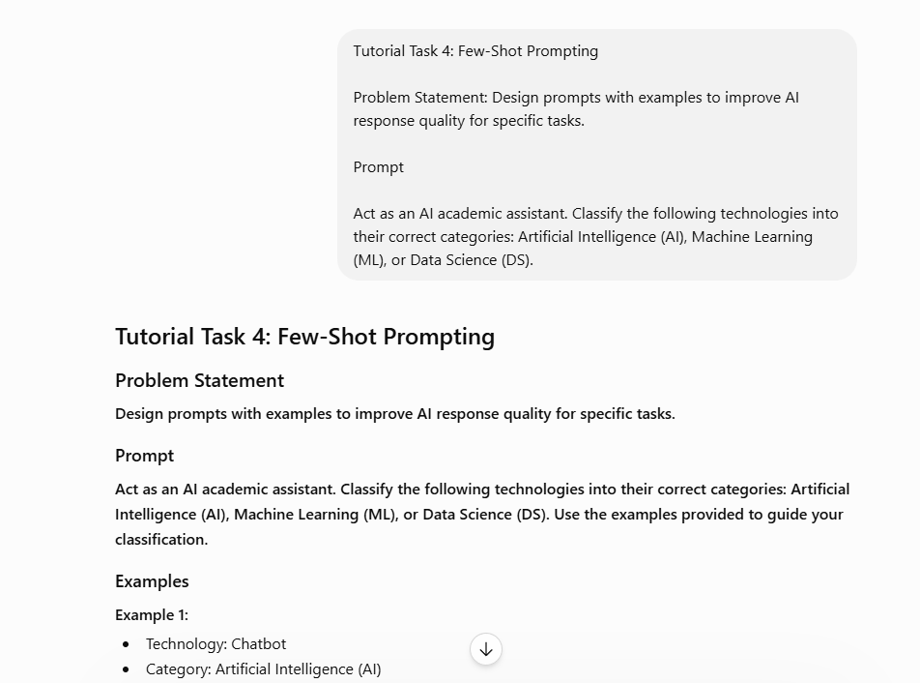

Conclusion
Few-shot prompting improves response quality by providing examples before the actual task. The examples help the AI understand the expected format and classification criteria, resulting in more accurate and consistent outputs.

TUTORIAL TASK 5: CHAIN-OF-THOUGHT PROMPTING

Problem Statement
Create prompts that encourage AI systems to explain reasoning steps while solving problems.

Prompt
"A B.Tech student studies 4 hours per day for 6 days and 2 hours on Sunday. Calculate the total study hours for the week. Show all reasoning steps."
Tools:
- ChatGPT
- Claude
- Microsoft Copilot

AI Generated Response

Step 1: Calculate study hours for 6 days
Study hours per day = 4
Number of days = 6
Total hours = 4 × 6
Total hours = 24

Step 2: Calculate study hours for Sunday
Study hours on Sunday = 2

Step 3: Add both values
Total weekly study hours = 24 + 2
Total weekly study hours = 26

Final Answer
The student studied 26 hours during the week.

Explanation
The prompt explicitly asks the AI to show reasoning steps. This encourages logical and transparent problem-solving.

Outcome
- Improved understanding of step-by-step reasoning.
- Enhanced problem-solving and mathematical analysis skills.

SCREEN SHOT:

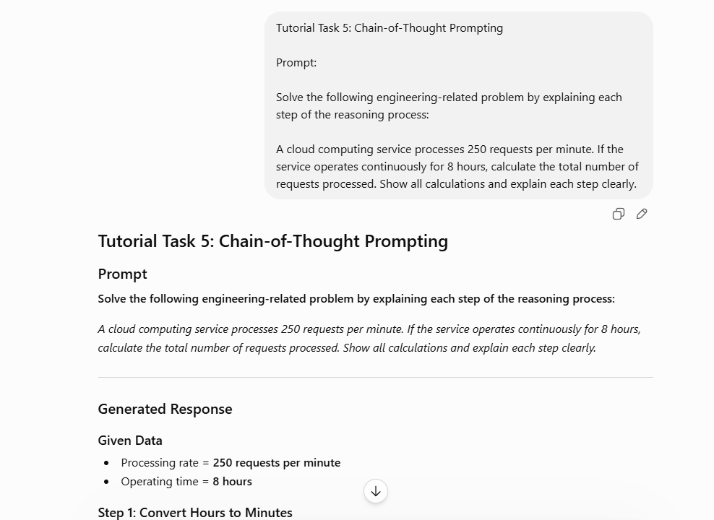

TUTORIAL TASK 6: STRUCTURED PROMPT CREATION

Problem Statement
Design structured prompts using roles, context, objectives, and output formats.

Structured Prompt
Role: You are a Computer Science Professor.
Context: The audience consists of third-year B.Tech students studying Artificial Intelligence.
Objective: Explain Deep Learning, its working process, advantages, and applications.
Output Format: Provide the answer in four headings: Introduction, Working, Advantages, and Applications.
Tools:
- ChatGPT
- Claude
- Microsoft Copilot

AI Generated Response

Introduction
Deep Learning is a subset of Artificial Intelligence and Machine Learning that uses artificial neural networks to learn patterns from large amounts of data. It is inspired by the structure of the human brain.

Working
Deep Learning models consist of multiple layers of neurons. Data is provided as input, processed through hidden layers, and finally produces an output. The model continuously adjusts its parameters to improve accuracy during training.

Advantages
- High accuracy for complex tasks
- Automatic feature extraction
- Handles large datasets efficiently
- Improves performance with more data

Applications
- Image Recognition
- Speech Recognition
- Self-Driving Cars
- Medical Diagnosis
- Natural Language Processing
Screen Shot:
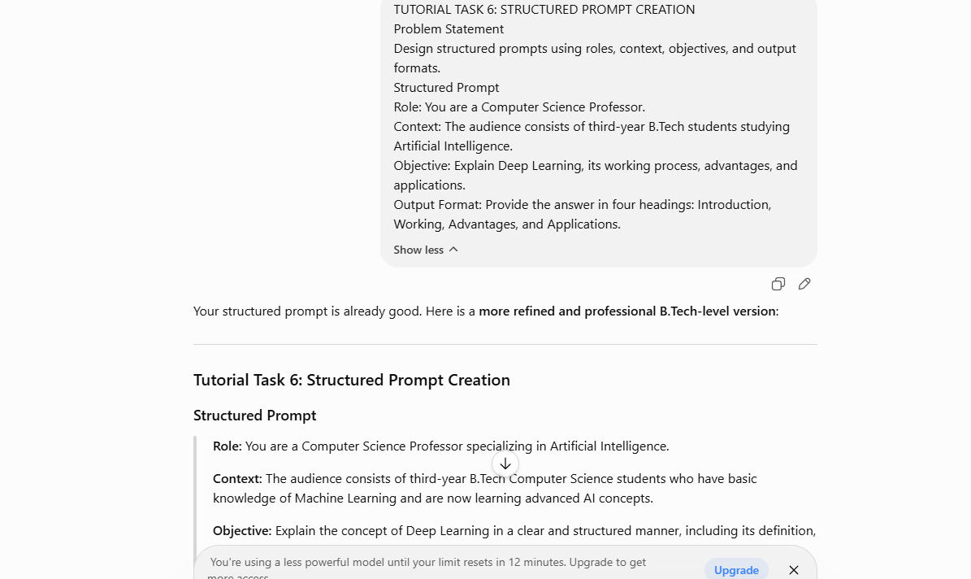

Outcome
- Learned how to create structured prompts.
- Improved control over AI-generated outputs.

TUTORIAL TASK 7: ACADEMIC SUMMARY GENERATION

Problem Statement: Generate concise summaries of academic topics using AI-assisted prompting techniques.

Prompt : "Act As an AI Assistant & Summarize the topic Block chain Technology in approximately 150 words for B.Tech students."
Tools:
- ChatGPT
- Claude
- Microsoft Copilot

AI Generated Response
Blockchain Technology is a decentralized digital ledger used to record transactions securely across multiple computers. Each transaction is stored in a block, and blocks are linked together to form a chain. Because records are distributed and encrypted, blockchain provides transparency, security, and immutability.
The technology eliminates the need for a central authority and reduces the risk of fraud or data manipulation. Blockchain is widely used in cryptocurrencies such as Bitcoin, but its applications extend to supply chain management, healthcare, banking, voting systems, and digital identity management.
Key advantages include enhanced security, transparency, traceability, and reduced operational costs. As organizations increasingly adopt decentralized systems, blockchain is becoming a significant technology in modern computing and business environments.
Screen Shot:
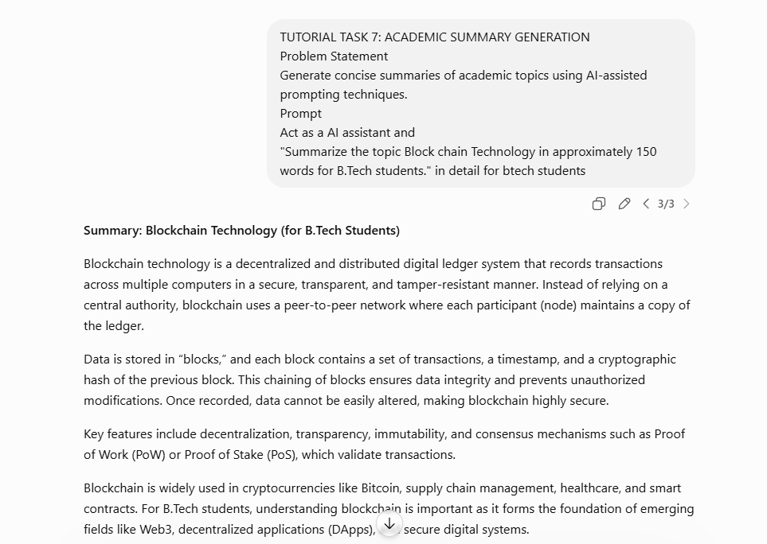
.

TUTORIAL TASK 8: PROFESSIONAL EMAIL GENERATION

Problem Statement
Create professional emails using AI for academic and workplace communication.

Prompt
"Write a professional email to a faculty member requesting an extension for a project submission due to medical reasons."
Tools:
- ChatGPT
- Claude
- Microsoft Copilot

AI Generated Response
Subject: Request for Extension of Project Submission
Dear Sir/Madam,
I hope you are doing well. I am writing to request an extension for the submission of my project report, which is currently due on June 25, 2026.
Unfortunately, I have been experiencing health issues and have been advised to take rest by my doctor. Due to this situation, I am unable to complete the project within the given deadline.
I kindly request an extension of one week to complete and submit the project. I assure you that I will utilize this additional time effectively and submit quality work.
Thank you for your understanding and consideration. I look forward to your positive response.
Sincerely,
AkhilaVempati
B.TechStudent
Department of Computer Science

Screen Shots:
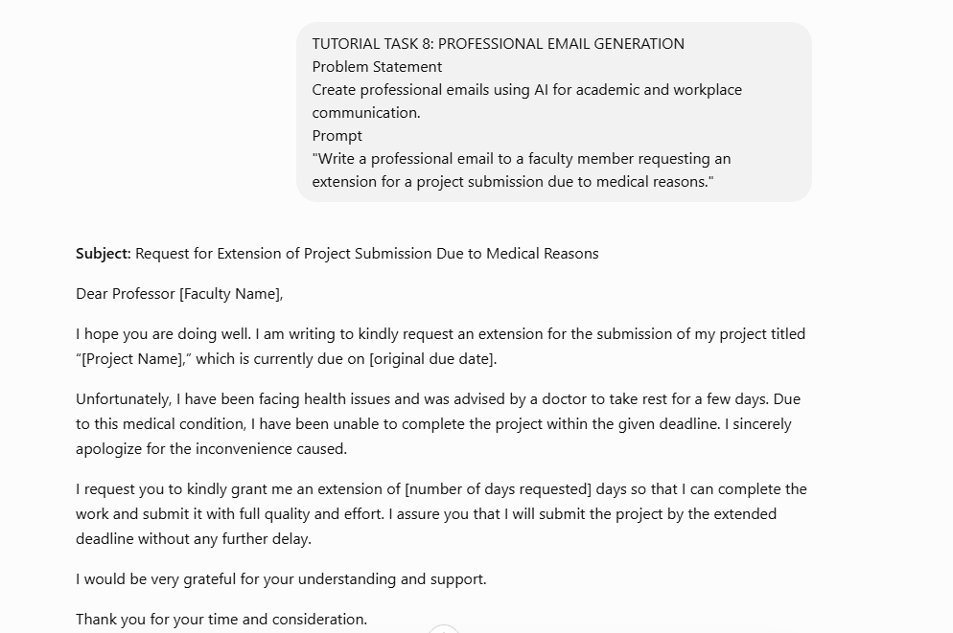

TUTORIAL TASK 9: AI-BASED RESUME DRAFTING

Problem Statement
Generate a professional resume using AI-assisted content creation tools.

Prompt
"Create a professional resume for a final-year B.Tech Computer Science student seeking a Software Developer position."
Tools:
- ChatGPT
- Claude
- Microsoft Copilot

AI Generated Response

RESUME

Akhila Vempati
akhila@email.com
+91-9876543210
Vijayawada, Andhra Pradesh

Career Objective
Motivated and enthusiastic final-year B.Tech Computer Science student seeking a Software Developer position where I can apply my programming, problem-solving, and software development skills to contribute to organizational growth while enhancing my technical expertise.

Education
Bachelor of Technology (Computer Science Engineering)
XYZ Engineering College
2022 – 2026
CGPA: 9.5/10

Technical Skills
- Programming Languages: Python, Java, C
- Web Technologies: HTML, CSS, JavaScript
- Database: MySQL
- Tools: Git, GitHub, VS Code
- Concepts: Data Structures, OOP, DBMS

Academic Projects
I Personal Knowledge Management System
- Developed an AI-powered system for organizing notes and learning resources.
- Implemented document categorization and search functionalities.

Student Management System
- Designed a database-driven application for managing student records.

Certifications
- Introduction to Artificial Intelligence
- Python Programming
- Cloud Computing Fundamentals

Strengths
- Problem Solving
- Teamwork
- Communication Skills
- Quick Learner

Declaration
I hereby declare that the above information is true to the best of my knowledge.
Signature
Akhila Vempati

Screen Shot:

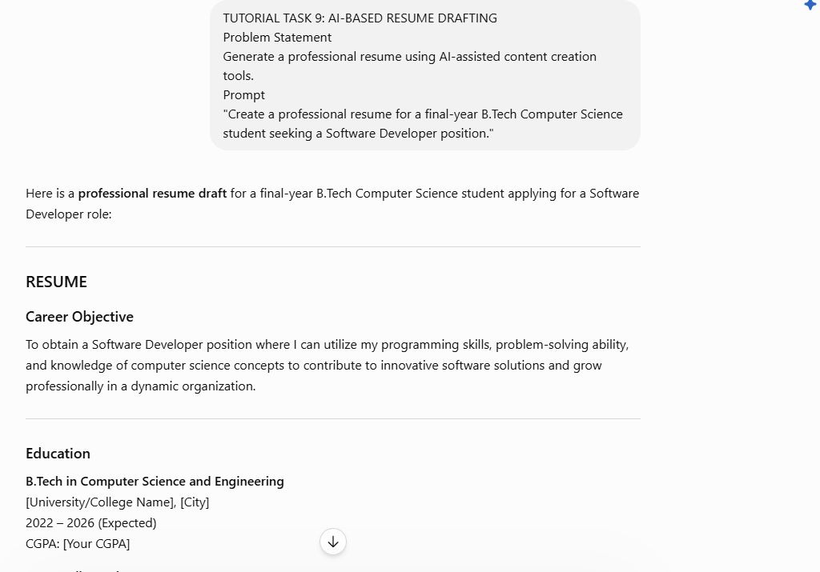

Tutorial Task 10: Cover Letter Creation

Problem Statement
Develop personalized cover letters using AI-generated content.

Prompt
"Write a cover letter for a B.Tech Computer Science student applying for a Software Developer Internship."
Tools:
- ChatGPT
- Claude
- Microsoft Copilot

AI Generated Response
Subject: Application for Software Developer Internship
Dear Hiring Manager,
I am writing to express my interest in the Software Developer Internship position at your organization. I am currently pursuing a Bachelor of Technology in Computer Science and have developed strong skills in programming, web development, and problem-solving.
Through my academic projects, including an AI Personal Knowledge Management System and a Student Management System, I have gained practical experience in software development, database management, and application design. I am proficient in Python, Java, HTML, CSS, JavaScript, and MySQL.
I am eager to contribute my technical knowledge, creativity, and enthusiasm to your team while learning from experienced professionals. I believe this internship would provide an excellent opportunity to enhance my skills and contribute to innovative projects.
Thank you for considering my application. I look forward to discussing how my skills and interests align with your organization's goals.
Sincerely,
AkhilaVempati
B.Tech Computer Science Student

Screen Shot:
- 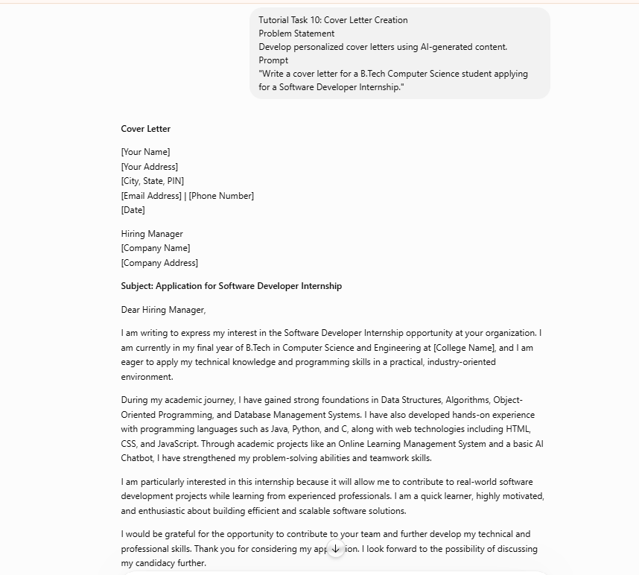.

Conclusion
These tasks demonstrate advanced prompt engineering techniques for practical academic and professional applications. B.Tech students can use AI to create structured content, summarize technical topics, draft professional emails, generate resumes, and write effective cover letters, thereby improving productivity, communication, and career readiness.

