Tutorial Task 11: Report Drafting
Problem Statement: Generate structured reports on academic topics using AI-assisted writing tools.
Prompt:
Generate a professional academic report on the topic Cyber security. Include:
- Title
- Introduction
- Main Discussion
- Applications/Examples
- Advantages and Challenges
- Conclusion
- References
Use clear academic language, proper headings, and relevant examples. The report should be well-structured, informative, and suitable for a college assignment.
AI Generated Response:
Cyber Security
Introduction
Cyber Security refers to the practice of protecting computer systems, networks, devices, and data from unauthorized access, cyberattacks, and digital threats. As technology becomes increasingly integrated into daily life, businesses, governments, and individuals rely heavily on digital systems for communication, financial transactions, and information storage. This dependence has made cyber security a critical field in ensuring the confidentiality, integrity, and availability of information.
With the rapid growth of the internet, cloud computing, and smart devices, cyber threats such as malware, phishing, ransomware, and data breaches have become more sophisticated. Effective cyber security measures help organizations and individuals safeguard sensitive information and maintain trust in digital environments.
Main Discussion
Cyber security encompasses various technologies, processes, and practices designed to protect digital assets. It is broadly divided into several areas:
Network Security
Network security focuses on protecting computer networks from unauthorized access and attacks. It involves the use of firewalls, intrusion detection systems, and secure communication protocols to prevent malicious activities.
Information Security
Information security ensures that sensitive data remains confidential and protected from unauthorized access, modification, or destruction. Encryption and access control mechanisms are commonly used to secure information.
Application Security
Application security involves securing software and applications throughout their development lifecycle. Developers implement security measures such as code reviews, vulnerability testing, and secure authentication methods to prevent exploitation.
Cloud Security
As organizations increasingly store data in cloud environments, cloud security has become essential. It includes protecting cloud infrastructure, applications, and data through encryption, monitoring, and identity management.
Endpoint Security
Endpoint security protects devices such as computers, smartphones, and tablets from cyber threats. Antivirus software, endpoint detection systems, and regular updates help secure these devices.
Common Cyber Threats
- Malware: Malicious software designed to damage or disrupt systems.
- Phishing: Fraudulent attempts to obtain sensitive information through deceptive emails or websites.
- Ransomware: Malware that encrypts data and demands payment for its release.
- Denial-of-Service (DoS) Attacks: Attacks that overwhelm systems and make services unavailable.
- Data Breaches: Unauthorized access to confidential information.
Organizations adopt cyber security frameworks and policies to identify risks, implement controls, and respond effectively to incidents.
Applications and Examples
Cyber security is applied across various sectors:
Banking and Finance
Banks use cyber security technologies to protect customer accounts, online transactions, and financial records. Multi-factor authentication and encryption help prevent fraud and unauthorized access.
Healthcare
Hospitals and healthcare organizations secure patient records and medical devices to maintain privacy and comply with regulations.
Education
Educational institutions protect student information, online learning platforms, and research data from cyber threats.
Government
Government agencies use cyber security to safeguard national infrastructure, sensitive information, and public services from cyber espionage and attacks.
E-Commerce
Online businesses implement secure payment systems and data protection measures to ensure safe transactions and maintain customer trust.
For example, organizations often use firewalls, antivirus software, and employee awareness training programs to reduce the risk of cyberattacks.
Advantages and Challenges
Advantages
- Protection of Sensitive Data: Prevents unauthorized access to confidential information.
- Business Continuity: Reduces disruptions caused by cyber incidents.
- Enhanced Trust: Builds confidence among customers and stakeholders.
- Compliance: Helps organizations meet legal and regulatory requirements.
- Financial Protection: Minimizes losses associated with cybercrime and data breaches.
Challenges
- Evolving Threat Landscape: Cybercriminals continuously develop new attack methods.
- High Implementation Costs: Advanced security solutions can be expensive.
- Human Error: Employees may unintentionally expose systems to risks.
- Skill Shortage: There is a growing demand for qualified cyber security professionals.
- Complexity: Managing security across multiple devices and platforms can be challenging.
Organizations must continuously update security measures and provide training to address these challenges effectively.
References
- Stallings, W. (2021). Network Security Essentials: Applications and Standards. Pearson.
- Whitman, M. E., & Mattord, H. J. (2021). Principles of Information Security. Cengage Learning.
- National Institute of Standards and Technology (NIST). Cybersecurity Framework.
Conclusion
Cyber Security plays a vital role in protecting digital systems, networks, and information from a wide range of cyber threats. As technology continues to evolve, the importance of implementing strong security measures becomes increasingly significant. Effective cyber security practices help organizations safeguard sensitive data, ensure business continuity, and maintain customer trust. Although challenges such as evolving threats and skill shortages exist, continuous investment in security technologies, awareness programs, and skilled professionals can significantly strengthen cyber resilience. Therefore, cyber security remains an essential component of modern digital infrastructure and a key factor in ensuring a safe and secure online environment.

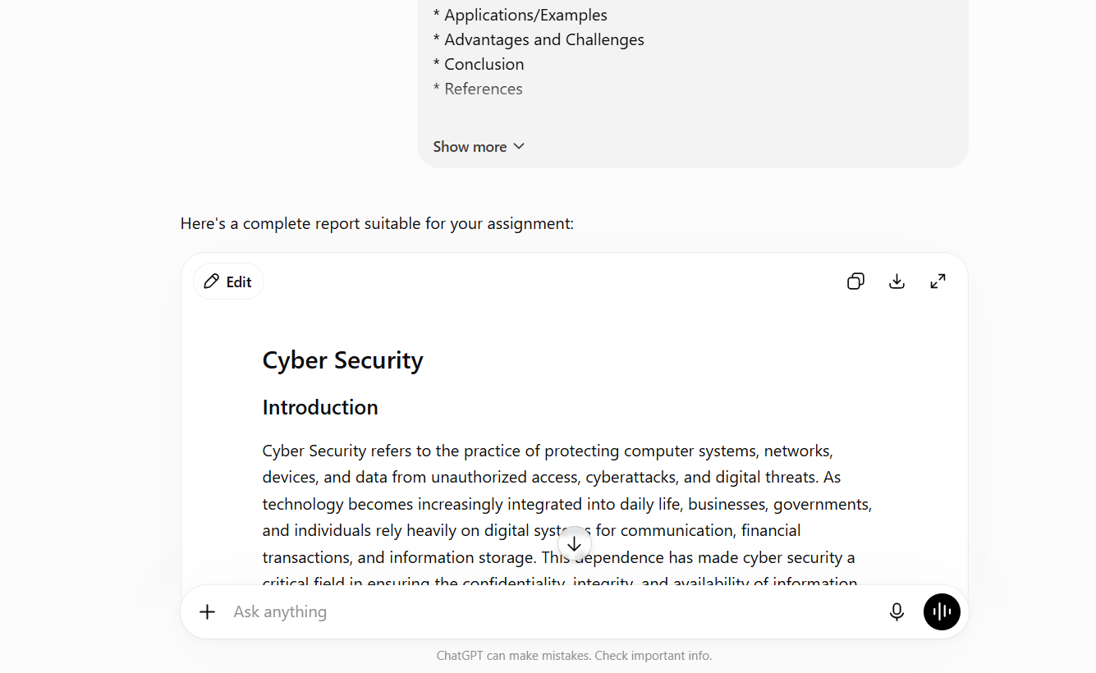
Result:
Generated a comprehensive academic report on the selected topic with a proper structure including title, introduction, main discussion, applications, advantages, challenges, conclusion, and references. The report was well-organized, informative, and suitable for academic submission.

Tutorial Task 12: Presentation Outline Generation
Problem Statement: Create presentation outlines using AI-generated content.
Prompt: Create a professional presentation outline on the topic Artificial Intelligence. Include:
- Title Slide
- Introduction
- Overview of the Topic
- Key Concepts
- Applications/Examples
- Advantages and Challenges
- Future Scope
- Conclusion
- References
For each slide, provide a slide title and 3–5 concise bullet points. The presentation should contain 8–10 slides and be suitable for a college-level audience.
AI Generated Response:
Presentation Outline: Artificial Intelligence
Slide 1: Title Slide
- Artificial Intelligence (AI)
- Understanding Intelligent Machines
- Presenter Name
- College/Institution Name
Slide 2: Introduction
- Definition of Artificial Intelligence
- AI as a branch of Computer Science
- Importance of AI in modern technology
- Objectives of the presentation
Slide 3: Overview of Artificial Intelligence
- History and evolution of AI
- Types of AI: Narrow AI, General AI, Super AI
- Growth of AI across industries
- Role of data and computing power
Slide 4: Key Concepts of AI
- Machine Learning (ML)
- Deep Learning and Neural Networks
- Natural Language Processing (NLP)
- Computer Vision and Robotics
Slide 5: Applications and Examples
- Virtual Assistants (ChatGPT, Siri, Alexa)
- Healthcare diagnosis and treatment
- Self-driving vehicles
- Recommendation systems (Netflix, Amazon)
Slide 6: Advantages of AI
- Automation of repetitive tasks
- Increased efficiency and productivity
- Improved decision-making
- 24/7 availability and support
Slide 7: Challenges of AI
- Privacy and security concerns
- High development and maintenance costs
- Bias in AI algorithms
- Potential job displacement
Slide 8: Future Scope of AI
- AI in smart cities and IoT
- Advanced healthcare solutions
- AI-powered education systems
- Human-AI collaboration in workplaces
Slide 9: Conclusion
- AI is transforming industries worldwide
- Offers significant benefits and opportunities
- Challenges require responsible implementation
- Future growth of AI is promising
Slide 10: References
- Russell, S., & Norvig, P. Artificial Intelligence: A Modern Approach
- IBM AI Resources
- Google AI Research
- Microsoft AI Documentation
- Research articles and academic journals

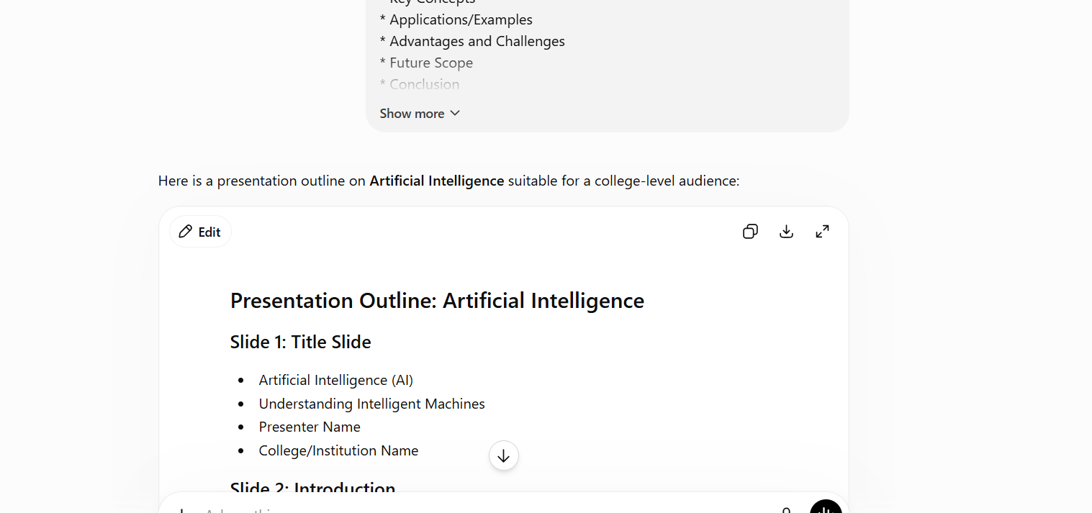

Result:
Created a professional presentation outline consisting of 8–10 slides. Each slide contained a title and concise bullet points, covering introduction, key concepts, applications, advantages, challenges, future scope, conclusion, and references. The outline was ready to be converted into a PowerPoint presentation.

Tutorial Task 13: Research Question Generation
Problem Statement: Use AI tools to generate research questions on a selected topic.
Prompt: Generate 10–15 research questions on the topic Web Development.
Requirements:
- Questions should be clear, specific, and suitable for academic research.
- Include a mix of descriptive, analytical, and exploratory questions.
- Focus on current trends, challenges, applications, and future developments.
- Ensure the questions are relevant for college-level projects, assignments, or research studies.
- Present the questions as a numbered list.
AI Generated Response:
Research Questions on Web Development
- How has web development evolved from static websites to modern interactive web applications?
- What are the key differences between front-end, back-end, and full-stack web development?
- How do modern JavaScript frameworks such as React, Angular, and Vue.js impact web application performance and user experience?
- What role does responsive web design play in improving accessibility across different devices?
- How can web developers enhance website security against common cyber threats such as SQL injection, cross-site scripting (XSS), and phishing attacks?
- What are the advantages and limitations of Progressive Web Applications (PWAs) compared to native mobile applications?
- How does Artificial Intelligence influence modern web development practices and user experiences?
- What factors affect website loading speed, and how can performance optimization techniques improve user engagement?
- How does cloud computing support the development and deployment of scalable web applications?
- What are the challenges of maintaining data privacy and security in web-based systems?
- How do web accessibility standards improve the usability of websites for people with disabilities?
- What is the impact of Search Engine Optimization (SEO) techniques on website visibility and traffic?
- How can modern web development frameworks contribute to faster and more efficient software development?
- What are the emerging trends in web development, including serverless architecture, Web3, and AI-powered applications?
- How might future technologies reshape the design, functionality, and security of web applications over the next decade?
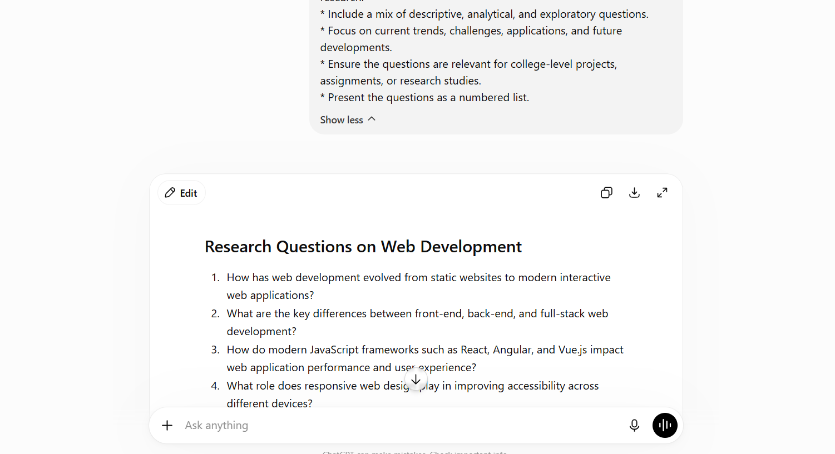
Result:
Generated a list of relevant and research-oriented questions related to the selected topic. The questions covered fundamental concepts, current trends, practical applications, challenges, and future developments, making them useful for academic research and project work.

Tutorial Task 14: Content Expansion
Problem Statement: Expand short content into detailed explanations using AI assistance.
Prompt:
Expand the following short content into a detailed and well-structured explanation:
“Artificial Intelligence is the simulation of human intelligence by machines."
Requirements:
* Explain the topic in detail using clear and simple language.
* Include an introduction, main explanation, examples, and conclusion.
* Add relevant facts, features, advantages, challenges, and applications where appropriate.
* Maintain logical flow and proper paragraph structure.
* Ensure the expanded content is informative, engaging, and suitable for a college-level assignment.
AI Generated Response:
Artificial Intelligence: The Simulation of Human Intelligence by Machines
Introduction
Artificial Intelligence (AI) is the simulation of human intelligence by machines, particularly computer systems. It is one of the most significant technological advancements of the modern era. AI enables machines to perform tasks that typically require human intelligence, such as learning, reasoning, problem-solving, decision-making, and understanding language. The goal of AI is to create systems that can think, learn from experience, and adapt to new situations with minimal human intervention.
Today, AI has become an essential part of everyday life. From virtual assistants like Siri and ChatGPT to recommendation systems on Netflix and Amazon, AI technologies are transforming the way people interact with digital systems and services.
Main Explanation
Artificial Intelligence works by combining large amounts of data with advanced algorithms and computing power. AI systems analyze patterns in data, learn from those patterns, and use the acquired knowledge to make predictions or decisions. Unlike traditional computer programs that follow fixed instructions, AI systems can improve their performance over time through learning.
AI can be classified into different categories. Narrow AI, also known as Weak AI, is designed to perform specific tasks such as voice recognition or image classification. General AI refers to a theoretical system capable of performing any intellectual task that a human can do. Super AI is a hypothetical form of intelligence that would surpass human intelligence in all aspects.
Several important technologies contribute to AI development. Machine Learning enables computers to learn from data without explicit programming. Deep Learning uses artificial neural networks to process complex information and recognize patterns. Natural Language Processing (NLP) helps machines understand and generate human language, while Computer Vision allows systems to interpret and analyze visual information such as images and videos.
Applications and Examples
Artificial Intelligence has applications in many industries and sectors.
Healthcare
AI assists doctors in diagnosing diseases, analyzing medical images, and recommending treatments. AI-powered systems can detect certain illnesses more quickly and accurately than traditional methods.
Education
AI supports personalized learning by adapting educational content to individual student needs. Intelligent tutoring systems help students learn at their own pace.
Business and Finance
Banks and financial institutions use AI to detect fraudulent transactions, assess risks, and provide customer support through chatbots.
Transportation
Self-driving vehicles use AI technologies such as sensors, machine learning, and computer vision to navigate roads and make driving decisions.
Entertainment
Streaming platforms like Netflix and YouTube use AI algorithms to recommend content based on user preferences and viewing history.
E-Commerce
Online shopping platforms utilize AI to suggest products, improve customer experiences, and optimize inventory management.
Advantages of Artificial Intelligence
Artificial Intelligence offers numerous benefits across various domains:
- Increased Efficiency: AI can perform tasks faster and more accurately than humans.
- Automation: Repetitive and time-consuming tasks can be automated, reducing human effort.
- Improved Decision-Making: AI analyzes large datasets to provide valuable insights and predictions.
- 24/7 Availability: AI-powered systems can operate continuously without fatigue.
- Enhanced Accuracy: AI reduces human errors in many applications, especially in healthcare and manufacturing.
These advantages contribute to increased productivity, cost savings, and innovation in organizations worldwide.
Challenges and Limitations
Despite its benefits, AI also presents several challenges.
- Job Displacement: Automation may replace certain jobs, creating concerns about unemployment.
- Privacy Issues: AI systems often require large amounts of personal data, raising privacy concerns.
- Bias and Fairness: AI algorithms can produce biased results if trained on biased data.
- High Development Costs: Building and maintaining AI systems can be expensive.
- Security Risks: AI technologies may be vulnerable to cyberattacks and misuse.
Addressing these challenges requires responsible development, ethical guidelines, and proper regulations.
Conclusion
Artificial Intelligence is revolutionizing the world by enabling machines to simulate human intelligence and perform complex tasks efficiently. Through technologies such as Machine Learning, Deep Learning, Natural Language Processing, and Computer Vision, AI is transforming industries including healthcare, education, finance, transportation, and entertainment. While AI offers significant advantages such as automation, efficiency, and improved decision-making, it also presents challenges related to privacy, ethics, and employment. As AI continues to evolve, responsible implementation and continuous innovation will be essential to maximize its benefits while minimizing potential risks. Therefore, Artificial Intelligence remains a powerful technology that is shaping the future of society and driving progress across the globe.
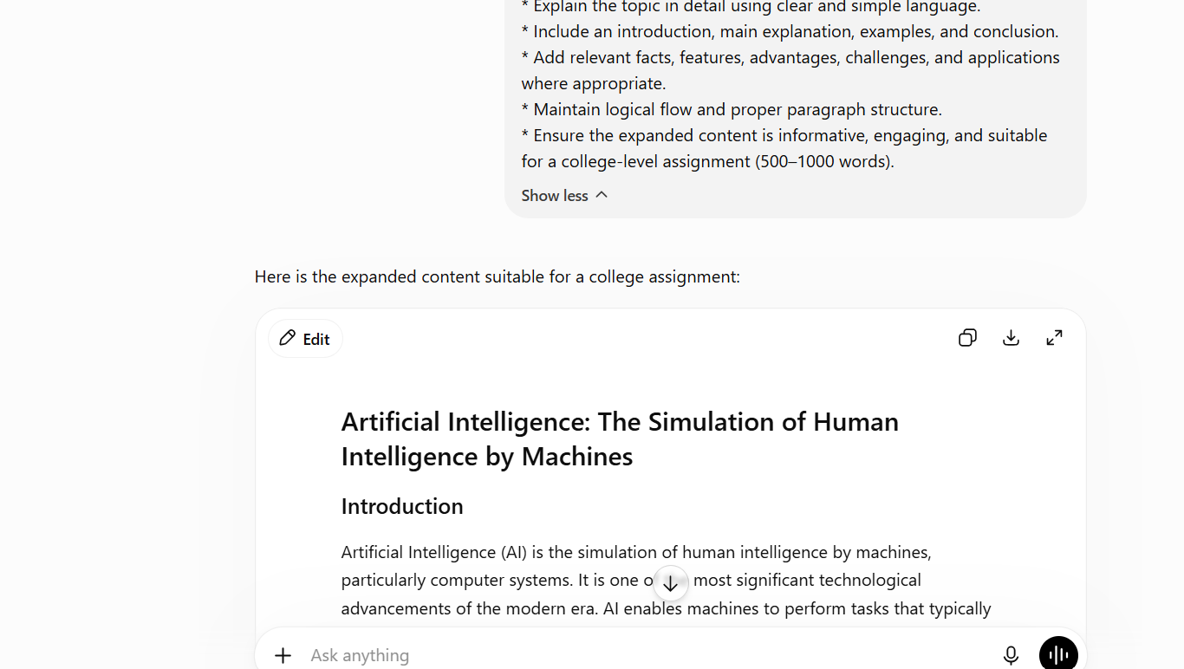
Result:
Expanded a short statement into a detailed explanation by adding background information, key concepts, examples, applications, advantages, challenges, and a conclusion. The resulting content was informative, well-structured, and appropriate for college-level assignments.

Tutorial Task 15: Content Simplification
Problem Statement: Simplify complex technical content into beginner-friendly explanations.
Prompt:
Simplify the following technical content into a beginner-friendly explanation:
“Machine Learning algorithms use statistical models to identify patterns in large datasets and make predictions without explicit programming."
Requirements:
* Use simple and easy-to-understand language.
* Avoid technical jargon or explain it in simple terms.
* Break complex concepts into smaller, understandable parts.
* Include real-life examples or analogies where appropriate.
* Maintain the original meaning and key points.
* Present the explanation in a clear and organized manner suitable for beginners or students.
AI Generated Response:
Beginner-Friendly Explanation of Machine Learning
Machine Learning is a branch of Artificial Intelligence (AI) that allows computers to learn from data and improve their performance without being directly programmed for every task.
In simple terms, instead of giving a computer detailed instructions for every situation, we provide it with a large amount of information (data). The computer studies this data, finds patterns, and uses those patterns to make decisions or predictions.
For example, imagine you want to teach a child to recognize cats. Instead of explaining every feature of a cat, you show the child many pictures of cats. Over time, the child learns to identify cats by recognizing common features. Machine Learning works in a similar way.
The phrase "statistical models" refers to mathematical methods that help computers analyze information and find relationships within the data. These models help the computer understand what is happening and make accurate predictions.
A common real-life example is email spam detection. A Machine Learning system looks at thousands of emails and learns which characteristics are common in spam messages. When a new email arrives, the system predicts whether it is spam or not based on what it has learned.
Another example is movie recommendations on platforms like Netflix or product suggestions on Amazon. The system analyzes your previous choices and compares them with the behavior of other users to predict what you might like next.
Key Points
- Machine Learning helps computers learn from data.
- It finds patterns and relationships in information.
- It can make predictions or decisions based on what it has learned.
- It does not require explicit instructions for every situation.
- It is used in many everyday applications such as recommendations, voice assistants, and spam filters.
In summary, Machine Learning is a technology that enables computers to learn from experience, much like humans learn from practice and observation. This ability makes computers smarter and more useful in solving real-world problems.
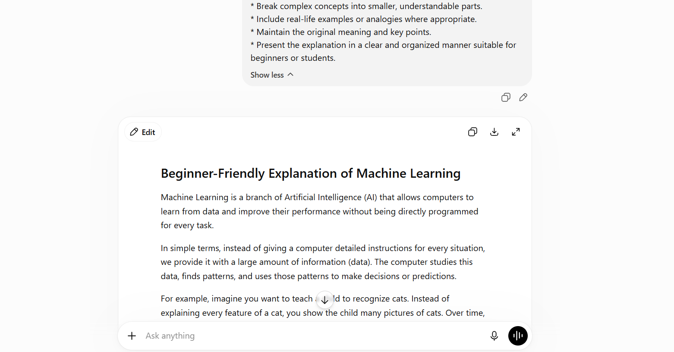

Result:
Simplified complex technical content into easy-to-understand language. Difficult terms were explained in simple words, and examples were provided to improve understanding. The output was suitable for beginners and students with limited technical knowledge.

Tutorial Task 16: AI-Assisted Note Making
Problem Statement: Generate organized notes from academic content using AI tools.
Prompt:
Generate organized study notes from the following academic content:
Artificial Intelligence is the simulation of human intelligence by machines...
Requirements:
* Create clear and concise notes.
* Organize information using headings and subheadings.
* Highlight key concepts, definitions, and important points.
* Use bullet points for easy readability.
* Include a brief summary at the end.
* Ensure the notes are suitable for college students and exam preparation.
AI Generated Response:
Study Notes: Artificial Intelligence (AI)
1. Definition of Artificial Intelligence
- Artificial Intelligence (AI) is the simulation of human intelligence by machines.
- AI enables computers to perform tasks that normally require human thinking.
- These tasks include learning, reasoning, problem-solving, decision-making, and language understanding.
2. Key Concepts of AI
Machine Learning (ML)
- A subset of AI that allows computers to learn from data.
- Improves performance without explicit programming.
- Used in recommendation systems and spam filters.
Deep Learning
- Advanced form of Machine Learning.
- Uses artificial neural networks to process large amounts of data.
- Commonly used in image and speech recognition.
Natural Language Processing (NLP)
- Helps computers understand and generate human language.
- Used in chatbots, virtual assistants, and translation tools.
Computer Vision
- Enables machines to interpret images and videos.
- Applied in facial recognition and self-driving cars.
3. Features of Artificial Intelligence
- Learning from data and experiences.
- Problem-solving capabilities.
- Decision-making based on analysis.
- Automation of repetitive tasks.
- Continuous improvement through training.
4. Applications of AI
Healthcare
- Disease diagnosis.
- Medical image analysis.
- Drug discovery and research.
Education
- Personalized learning systems.
- Intelligent tutoring platforms.
- Automated grading.
Business and Finance
- Fraud detection.
- Customer service chatbots.
- Market analysis and forecasting.
Transportation
- Self-driving vehicles.
- Traffic management systems.
- Route optimization.
Entertainment
- Movie and music recommendations.
- Content personalization.
- Gaming applications.
5. Advantages of AI
- Increases efficiency and productivity.
- Reduces human errors.
- Provides 24/7 service availability.
- Automates repetitive tasks.
- Supports better decision-making.
6. Challenges of AI
- Privacy and security concerns.
- High implementation costs.
- Risk of job displacement.
- Bias in algorithms and data.
- Ethical and legal issues.
7. Important Exam Points
- AI = Simulation of human intelligence by machines.
- Main branches: Machine Learning, Deep Learning, NLP, Computer Vision.
- Common applications: Healthcare, Education, Finance, Transportation.
- Major benefits: Automation, accuracy, efficiency.
- Main challenges: Privacy, ethics, cost, employment concerns.

Summary
Artificial Intelligence is a technology that enables machines to mimic human intelligence and perform complex tasks. It includes Machine Learning, Deep Learning, Natural Language Processing, and Computer Vision. AI is widely used in healthcare, education, business, transportation, and entertainment. While it offers benefits such as automation and improved efficiency, it also presents challenges related to privacy, ethics, and employment. AI continues to play a significant role in shaping the future of technology and society.

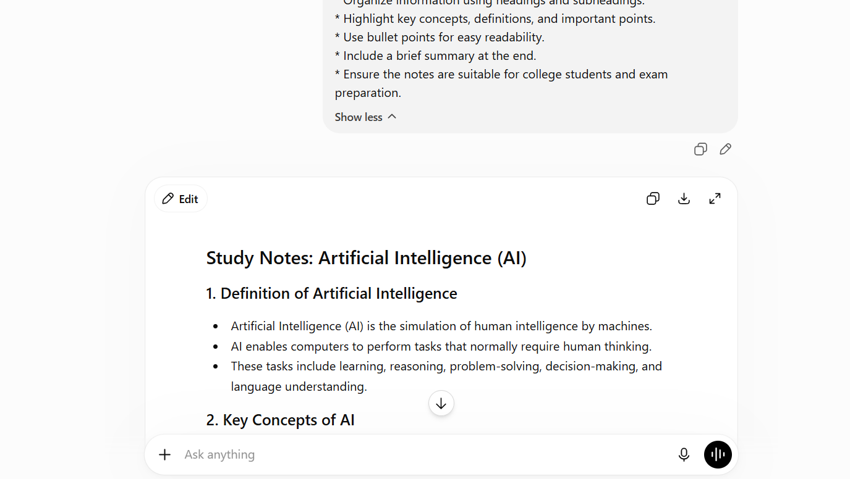

Result:
Converted lengthy academic content into organized study notes. Important concepts were categorized under headings and subheadings, key points were highlighted, and a summary was included. The notes were concise and useful for exam preparation and revision.

Tutorial Task 17: Knowledge Extraction Exercise
Problem Statement: Extract key points and insights from large textual content using AI.
Prompt:
Extract the key points and insights from the following textual content:
“Artificial Intelligence is transforming industries through automation, machine learning, and data-driven decision-making...”
Requirements:
* Identify the main ideas and important concepts.
* Summarize the content in concise bullet points.
* Highlight important facts, findings, and conclusions.
* Organize the extracted information under relevant headings.
* Include 5–10 key insights or takeaways.
* Ensure the output is clear, accurate, and suitable for study, revision, or research purposes.
AI Generated Response:
Knowledge Extraction: Artificial Intelligence
Main Ideas
- Artificial Intelligence (AI) is transforming industries by enabling machines to perform tasks that typically require human intelligence.
- AI uses technologies such as Machine Learning, Deep Learning, and Data Analytics to process information and make decisions.
- Automation powered by AI increases efficiency and reduces the need for manual intervention.
Important Concepts
Automation
- AI automates repetitive and time-consuming tasks.
- Helps organizations improve productivity and operational efficiency.
Machine Learning
- A branch of AI that allows systems to learn from data.
- Improves performance and accuracy without explicit programming.
Data-Driven Decision Making
- AI analyzes large volumes of data to identify patterns and trends.
- Supports faster and more informed decision-making.
Key Facts and Findings
- AI is widely used across industries such as healthcare, finance, education, transportation, and e-commerce.
- Businesses use AI to improve customer experiences, optimize operations, and increase profitability.
- AI technologies continue to evolve, leading to more advanced applications and innovations.
Key Insights / Takeaways
- AI is a major driver of digital transformation across industries.
- Automation helps reduce human effort and improve efficiency.
- Machine Learning enables systems to learn and improve from experience.
- Data analysis is a critical component of AI-powered decision-making.
- AI supports faster, more accurate, and evidence-based decisions.
- Organizations use AI to gain competitive advantages and improve productivity.
- AI applications are expanding rapidly in healthcare, education, finance, and transportation.
- Continuous advancements in AI are creating new opportunities for innovation.
- Ethical considerations, privacy, and security remain important challenges.
- AI is expected to play an increasingly significant role in the future of technology and business.
Conclusion
Artificial Intelligence is revolutionizing industries through automation, Machine Learning, and data-driven decision-making. By improving efficiency, accuracy, and innovation, AI is becoming an essential technology for organizations worldwide. Its growing adoption highlights its importance in shaping the future of business, society, and technological development.
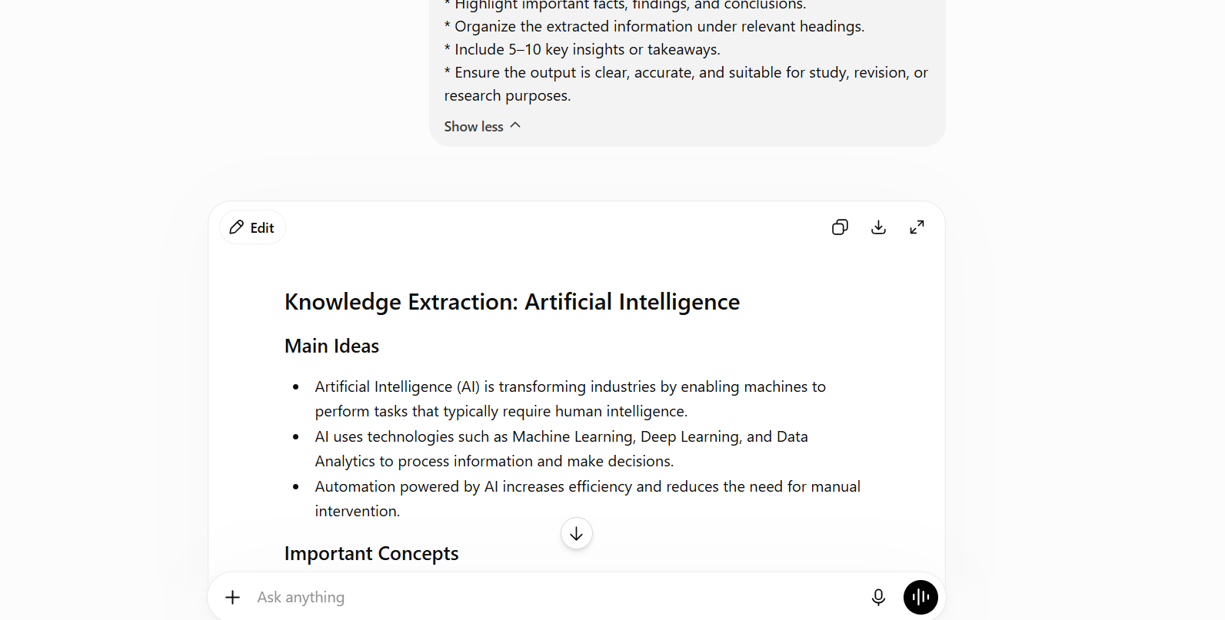

Result:
Extracted the most important information from the provided text. Main ideas, significant facts, key concepts, and conclusions were identified and organized under relevant headings. The output enabled quick understanding of large amounts of content.

Tutorial Task 18: AI-Based FAQ Creation
Problem Statement: Generate frequently asked questions and answers for a chosen topic.
Prompt:
Generate a list of Frequently Asked Questions (FAQs) and their answers on the topic python programming.
Requirements:
* Create 10–15 relevant FAQs.
* Include both basic and advanced questions.
* Provide clear, concise, and accurate answers.
* Cover definitions, features, applications, advantages, challenges, and future scope.
* Organize the FAQs in a question-and-answer format.
* Ensure the content is suitable for college students, beginners, and academic purposes.
AI Generated Response:
Frequently Asked Questions (FAQs) on Python Programming
1. What is Python?
Answer:
Python is a high-level, interpreted programming language known for its simple syntax, readability, and versatility. It is widely used in web development, data science, artificial intelligence, automation, and software development.
2. Why is Python popular among beginners?
Answer:
Python has an easy-to-understand syntax that resembles English, making it easier to learn and write programs compared to many other programming languages.
3. What are the main features of Python?
Answer:
- Simple and readable syntax
- Interpreted language
- Object-oriented programming support
- Large standard library
- Cross-platform compatibility
- Open-source and free to use
4. What is the difference between a compiler and an interpreter?
Answer:
A compiler translates the entire program into machine code before execution, while an interpreter executes code line by line. Python uses an interpreter.
5. What are variables in Python?
Answer:
Variables are used to store data values. Python automatically determines the data type based on the assigned value.
Example:
name = "Abhi"
age = 21
6. What are the commonly used data types in Python?
Answer:
- Integer (int)
- Float (float)
- String (str)
- Boolean (bool)
- List
- Tuple
- Dictionary
- Set
7. What is a function in Python?
Answer:
A function is a reusable block of code designed to perform a specific task.
Example:
def greet():
print("Hello World")
8. What is Object-Oriented Programming (OOP) in Python?
Answer:
OOP is a programming approach based on objects and classes. It helps organize code and improves reusability through concepts like inheritance, encapsulation, and polymorphism.
9. What are Python libraries and modules?
Answer:
Libraries and modules are collections of pre-written code that provide additional functionality. Examples include:
- NumPy for numerical computing
- Pandas for data analysis
- Matplotlib for visualization
- TensorFlow for AI and Machine Learning
10. What are the major applications of Python?
Answer:
- Web Development
- Data Science
- Artificial Intelligence
- Machine Learning
- Automation and Scripting
- Cybersecurity
- Game Development
- Scientific Computing
11. What are the advantages of Python?
Answer:
- Easy to learn and use
- Faster development process
- Extensive community support
- Large collection of libraries
- Platform independence
- Suitable for multiple domains
12. What challenges or limitations does Python have?
Answer:
- Slower execution compared to compiled languages
- Higher memory consumption
- Less suitable for mobile application development
- Not ideal for performance-critical applications
13. How is Python used in Artificial Intelligence and Machine Learning?
Answer:
Python provides powerful libraries such as TensorFlow, Keras, Scikit-learn, and PyTorch that simplify AI and Machine Learning development, making it the most popular language in these fields.
14. What is the future scope of Python?
Answer:
Python has strong future demand due to its extensive use in AI, Data Science, Cloud Computing, Automation, and Cybersecurity. It continues to be one of the most sought-after programming languages globally.
15. Why should students learn Python?
Answer:
Students should learn Python because it is beginner-friendly, widely used in industry, and provides career opportunities in software development, data science, AI, machine learning, and automation.
Conclusion
Python is a powerful, versatile, and beginner-friendly programming language. Its simplicity, extensive libraries, and wide range of applications make it one of the most popular programming languages for students, researchers, and professionals. As technology continues to evolve, Python's importance and demand are expected to grow even further.
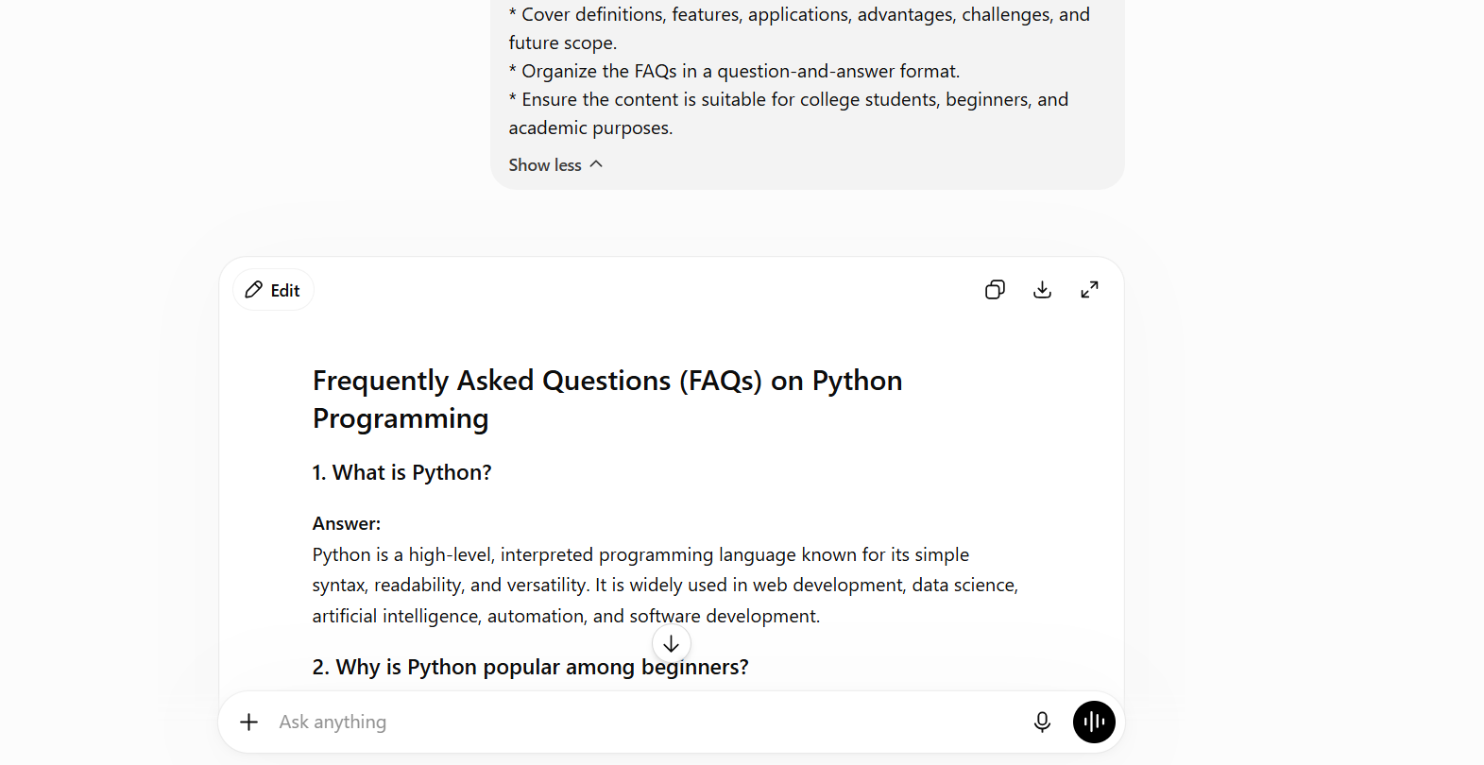
Result:
Generated a comprehensive list of frequently asked questions along with accurate and concise answers. The FAQs covered definitions, features, applications, benefits, challenges, and future scope of the topic, making them useful for learning and self-assessment.

Tutorial Task 19: Prompt Documentation
Problem Statement: Document prompts and their effectiveness for different tasks.
Prompt:
Document and analyze the effectiveness of the following AI prompt:
“ Generate 10–15 FAQs with answers on the topic Python Programming.
Requirements:
* Include basic and advanced questions.
* Provide clear and concise answers.
* Cover features, applications, advantages, challenges, and future scope.
* Organize the content in a question-and-answer format.”
Include:
* Task Name
* Prompt Used
* Purpose of the Prompt
* AI-Generated Output Summary
* Effectiveness Evaluation
* Strengths of the Prompt
* Limitations of the Prompt
* Suggested Improvements
* Conclusion
Present the documentation in a clear and structured format suitable for a college assignment.
AI Generated Response:
Prompt Documentation and Effectiveness Analysis
1. Task Name
AI-Based FAQ Creation on Python Programming
2. Prompt Used
Generate 10–15 FAQs with answers on the topic Python Programming.
Requirements:
- Include basic and advanced questions.
- Provide clear and concise answers.
- Cover features, applications, advantages, challenges, and future scope.
- Organize the content in a question-and-answer format.
3. Purpose of the Prompt
The purpose of this prompt is to generate a comprehensive set of frequently asked questions and answers about Python Programming. It aims to provide learners with an easy-to-understand overview of Python, covering both fundamental and advanced concepts.
4. AI-Generated Output Summary
The AI generated 15 FAQs related to Python Programming. The questions covered:
- Definition of Python
- Features of Python
- Variables and data types
- Functions and Object-Oriented Programming
- Python libraries and modules
- Applications of Python
- Advantages and limitations
- AI and Machine Learning applications
- Future scope of Python
The answers were concise, accurate, and suitable for students and beginners.
5. Effectiveness Evaluation
Rating: Excellent
The prompt successfully generated well-structured FAQs that met all the specified requirements. The content was relevant, informative, and covered a broad range of Python Programming topics.
6. Strengths of the Prompt
- Clear and specific instructions.
- Covers both basic and advanced concepts.
- Encourages comprehensive coverage of the topic.
- Produces organized question-and-answer content.
- Suitable for academic learning and exam preparation.
7. Limitations of the Prompt
- Does not specify the difficulty level in detail.
- May generate answers that are too brief for advanced learners.
- Does not request practical coding examples.
8. Suggested Improvements
- Request code examples for technical questions.
- Specify the target audience (beginners, intermediate, or advanced learners).
- Include a requirement for real-world applications and case studies.
- Ask for references or additional learning resources.
9. Conclusion
The prompt is highly effective for generating FAQs on Python Programming. It produces clear, relevant, and organized content that is useful for students, beginners, and academic purposes. With minor improvements such as adding coding examples and references, the prompt can become even more valuable for learning and research.
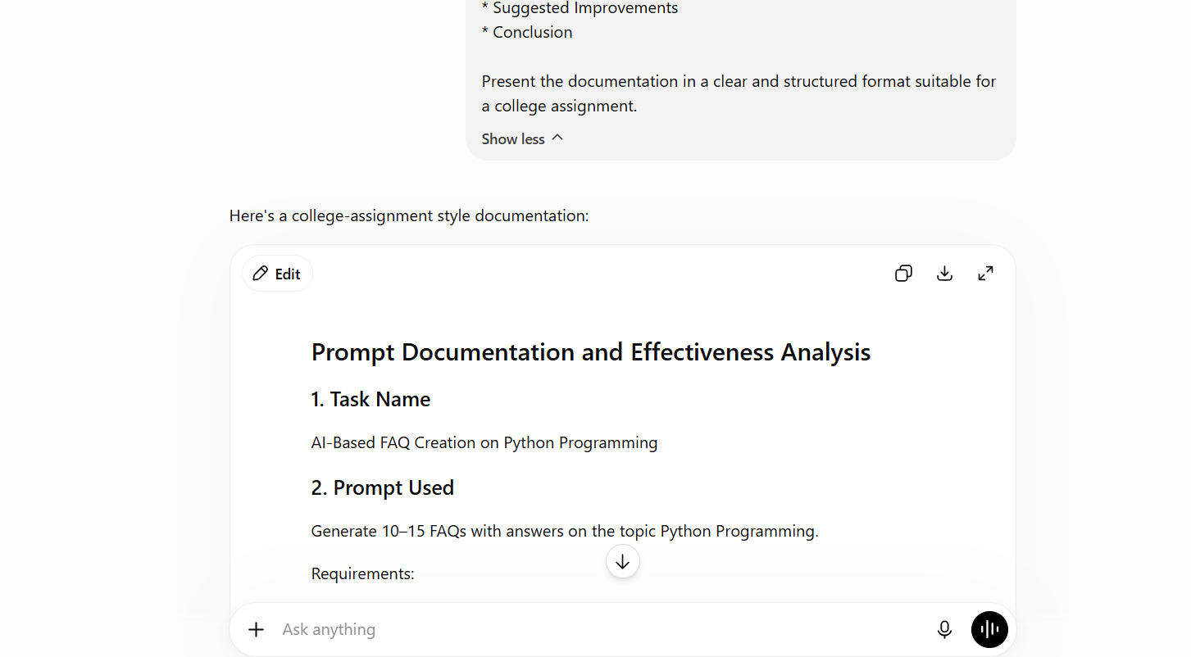

Result:
Documented the selected prompt by explaining its purpose, generated output, effectiveness, strengths, limitations, and possible improvements. This helped evaluate the quality of the prompt and understand how prompt design influences AI-generated responses.

Tutorial Task 20: Prompt Portfolio Development
Problem Statement: Create a portfolio containing effective prompts for academic and professional activities.
Prompt:
Create a Prompt Portfolio containing 10 effective AI prompts for academic and professional activities. For each prompt, include the Task Name, Prompt Used, Purpose, and Expected Output. Present the portfolio in a clear, organized, and professional format.
AI Generated Response:
Prompt Portfolio for Academic and Professional Activities
1. Task Name: Report Writing
Prompt Used: Generate a professional report on [Topic].
Purpose: To create detailed academic reports.
Expected Output: A structured report with introduction, discussion, and conclusion.
2. Task Name: Presentation Creation
Prompt Used: Create a presentation outline on [Topic] with slide titles and key points.
Purpose: To prepare presentation content quickly.
Expected Output: Slide-wise presentation outline.
3. Task Name: Research Question Generation
Prompt Used: Generate 10 research questions on [Topic].
Purpose: To identify research areas and project ideas.
Expected Output: List of research questions.
4. Task Name: Content Expansion
Prompt Used: Expand the following content into a detailed explanation: [Text].
Purpose: To elaborate on short content.
Expected Output: Detailed and structured explanation.
5. Task Name: Content Simplification
Prompt Used: Simplify the following technical content for beginners: [Text].
Purpose: To make complex concepts easier to understand.
Expected Output: Beginner-friendly explanation.
6. Task Name: Note Making
Prompt Used: Generate organized study notes from the following content: [Text].
Purpose: To create concise notes for learning and revision.
Expected Output: Well-structured study notes.
7. Task Name: Knowledge Extraction
Prompt Used: Extract key points and insights from the following content: [Text].
Purpose: To identify important information quickly.
Expected Output: Summary of key ideas and takeaways.
8. Task Name: FAQ Creation
Prompt Used: Generate 10 FAQs with answers on the topic [Topic].
Purpose: To create learning and revision material.
Expected Output: Question-and-answer format FAQs.
9. Task Name: Resume Writing
Prompt Used: Create a professional resume using the following details: [Details].
Purpose: To prepare resumes for job applications.
Expected Output: A professional resume.
10. Task Name: Email Writing
Prompt Used: Write a professional email regarding [Purpose].
Purpose: To draft formal communication.
Expected Output: A professional email message.
Conclusion
This prompt portfolio demonstrates how AI can assist in various academic and professional activities. These prompts help users efficiently generate reports, presentations, research questions, notes, FAQs, resumes, and emails, improving productivity and communication.

Result:
Developed a portfolio containing effective prompts for multiple academic and professional activities. Each prompt included the task name, prompt text, purpose, and expected output. The portfolio served as a reusable collection of prompts for future learning and productivity tasks.

