Tutorial Task 51: Technical Documentation Assistant
Problem Statement:
Develop AI-powered workflows for generating technical documentation.

Tools:
- ChatGPT
- Claude
- Google Docs
- Notion AI
- Readme.so
- GitHub Copilot
Prompt:
Act as a senior technical writer. Generate a complete technical documentation template for a Python-based REST API project. Include the following sections: (1) Project Overview, (2) Installation & Setup, (3) API Endpoints with request/response examples, (4) Error Codes and Handling, (5) FAQ, and (6) Changelog. Use clear headings, bullet points, and code blocks where appropriate.
Result:
Python REST API Documentation
1. Project Overview
Project Name
Student Management REST API
Description
A Python-based REST API that allows users to manage student records, including creating, retrieving, updating, and deleting student information.
Features
- Create student records
- Retrieve student details
- Update student information
- Delete student records
- JSON-based communication
- RESTful architecture
Technology Stack
- Python 3.11+
- FastAPI / Flask
- SQLite / PostgreSQL
- Uvicorn Server
2. Installation & Setup
Prerequisites
- Python 3.11 or later
- pip package manager
- Git
Clone Repository
git clone https://github.com/example/student-api.git
cd student-api
Create Virtual Environment
python -m venv venv
Activate Environment
Windows
venv\Scripts\activate
Linux/macOS
source venv/bin/activate
Install Dependencies
pip install -r requirements.txt
Run the Application
uvicorn main:app --reload
Access API
http://localhost:8000
API Documentation
http://localhost:8000/docs

3. API Endpoints
Create Student
POST /students
Request
{
"name": "John Doe",
"age": 20,
"department": "Computer Science"
}
Response
{
"id": 101,
"name": "John Doe",
"age": 20,
"department": "Computer Science"
}

Get Student
GET /students/{id}
Example
GET /students/101
Response
{
"id": 101,
"name": "John Doe",
"age": 20,
"department": "Computer Science"
}

Update Student
PUT /students/{id}
Request
{
"name": "John Doe",
"age": 21
}
Response
{
"message": "Student updated successfully"
}

Delete Student
DELETE /students/{id}
Response
{
"message": "Student deleted successfully"
}

4. Error Codes and Handling
Status Code | Meaning | Description
200 | OK | Request successful
201 | Created | Resource created successfully
400 | Bad Request | Invalid request format
401 | Unauthorized | Authentication required
403 | Forbidden | Access denied
404 | Not Found | Resource not found
500 | Internal Server Error | Unexpected server error
Example Error Response
{
"error": "Student not found",
"status": 404
}
Best Practices
- Validate input before processing.
- Return meaningful error messages.
- Log server-side exceptions.
- Use consistent JSON response formats.

5. FAQ
Q1. How do I start the API?
Run:
uvicorn main:app --reload
Q2. Where can I test endpoints?
Use:
- Swagger UI (/docs)
- Postman
- cURL
Q3. Which database is supported?
- SQLite
- PostgreSQL
- MySQL (optional)
Q4. How do I authenticate users?
Implement:
- JWT Tokens
- OAuth 2.0
- API Keys

6. Changelog
Version 1.2.0
- Added authentication support
- Improved validation
Version 1.1.0
- Added update and delete endpoints
- Fixed response formatting issues
Version 1.0.0
- Initial release
- CRUD operations implemented

Screenshots / Images:
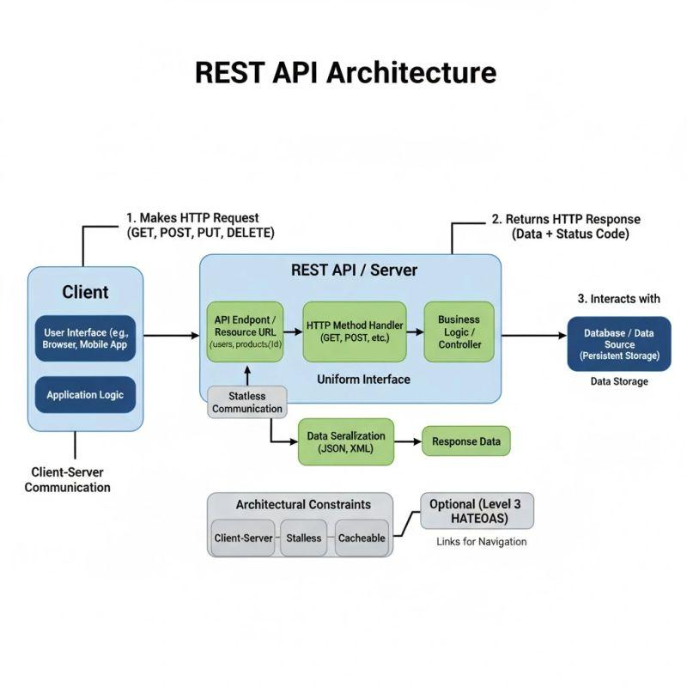
Observation:
- AI can automatically generate structured technical documentation.
- Documentation becomes standardized across projects.
- Request/response examples improve API usability.
- Error handling and FAQ sections reduce developer onboarding time.
- Changelog tracking helps maintain version history and release notes.
Screenshot:
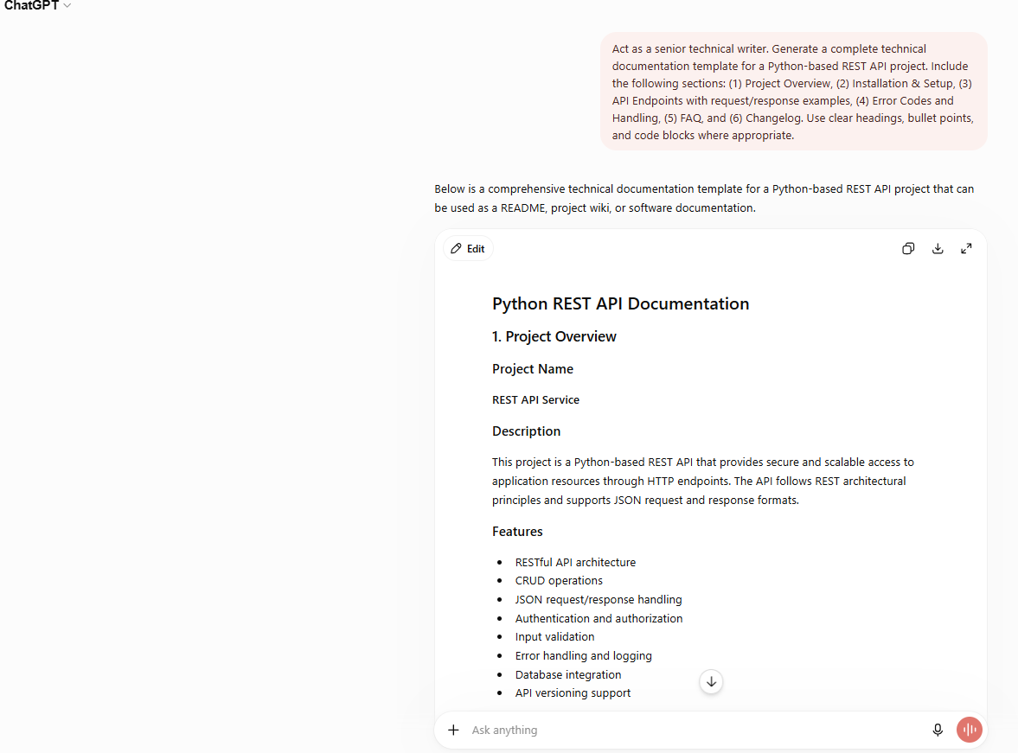

Tutorial Task 52: AI-Based Learning Content Creator
Problem Statement:
Create prompts that generate structured learning materials and training resources.

Tools:
- ChatGPT
- Claude
- Gamma.app
- Quizlet
- Microsoft Copilot

Prompt:
Act as a curriculum designer for B.Tech first-year students. Create a structured 1-week learning module on the topic 'Introduction to Machine Learning'. Include: (1) Learning Objectives, (2) Day-wise lesson plan with topics and time allocation, (3) Key concepts explained simply, (4) 5 MCQ questions with answers, (5) Recommended free resources (books, videos, websites), and (6) A mini-project idea to apply the concepts learned.
Result:
Day | Topic | Duration | Activity | Resource
Day 1 | What is ML? Types & Applications | 1.5 hrs | Read + Notes | Coursera / YouTube
Day 2 | Supervised Learning & Regression | 1.5 hrs | Concept + Examples | Andrew Ng – ML Course
Day 3 | Classification Algorithms | 2 hrs | Problem Solving | Scikit-learn Docs
Day 4 | Unsupervised Learning | 1.5 hrs | Concept Study | Khan Academy
Day 5 | Model Evaluation & Metrics | 2 hrs | Practice Problems | Kaggle
Day 6 | Mini Project: Iris Dataset | 3 hrs | Hands-on Coding | Google Colab
Day 7 | Revision + MCQ Test | 1 hr | Self Assessment | Quizlet Flashcards
Observation
- AI can automatically generate structured lesson plans.
- Learning objectives, assessments, and projects can be created in seconds.
- The generated content follows an educational progression from theory to practice.
- Free learning resources help students continue self-learning.
- Mini-projects encourage hands-on application of concepts.
Screenshot:
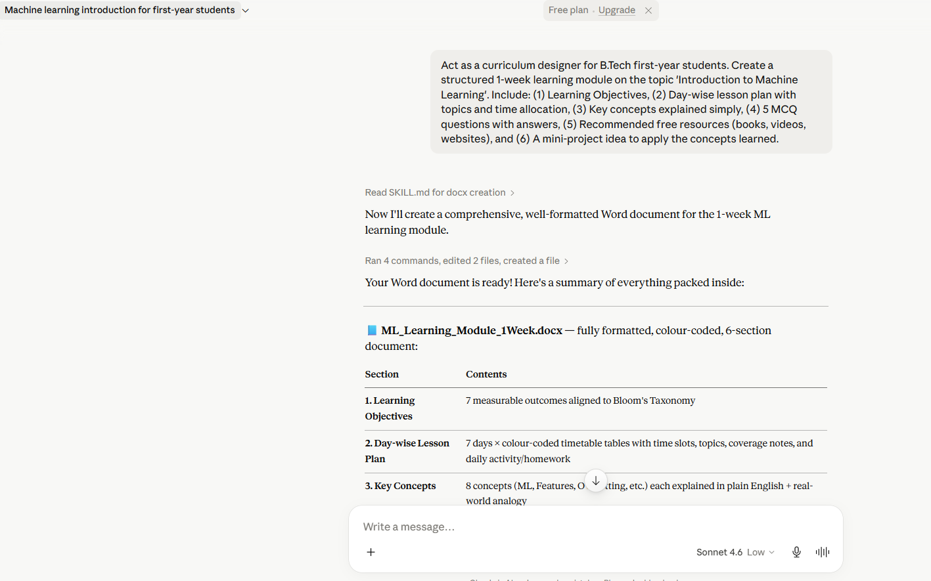
Tutorial Task 53: Personal Branding Content Engine
Problem Statement:
Design prompts for generating professional branding content across multiple platforms.

Tools:
- ChatGPT
- Claude
- Canva
- LinkedIn
- Buffer

Prompt:
Act as a personal branding consultant. I am a B.Tech first-year student interested in AI and software development. Create a complete personal branding content kit for me. Include: (1) A professional LinkedIn bio (150 words), (2) A Twitter/X profile bio (160 characters), (3) An Instagram bio (3 lines), (4) A GitHub profile README introduction, (5) A one-paragraph personal mission statement, and (6) 3 sample LinkedIn posts about my learning journey in Generative AI.
Result:
Personal Branding Content Kit
1. Professional LinkedIn Bio (150 Words)
I am a first-year B.Tech student passionate about Artificial Intelligence, Machine Learning, and Software Development. I am actively building my technical skills through hands-on projects, coding challenges, and continuous learning. My goal is to explore how AI can solve real-world problems and create meaningful impact across industries.
Currently, I am learning Python, Data Structures, Machine Learning fundamentals, and Generative AI technologies. I enjoy experimenting with new tools, contributing to open-source projects, and sharing my learning journey with others. I believe in lifelong learning, collaboration, and innovation.
As an aspiring AI engineer, I am eager to connect with students, developers, researchers, and industry professionals who share an interest in emerging technologies. I am constantly seeking opportunities to grow, learn, and contribute to impactful projects that combine creativity with technology.
Let's connect and build the future through AI and software development.
2. Twitter/X Bio (160 Characters)
B.Tech Student | Exploring Artificial Intelligence and Software Development | Learning Python, Machine Learning, and Generative AI | Building projects and sharing insights.
3. Instagram Bio (3 Lines)
B.Tech Student
Learning Artificial Intelligence and Software Development
Building, Learning, and Growing
4. GitHub Profile README Introduction
Hi There
I'm a B.Tech first-year student passionate about Artificial Intelligence, Machine Learning, and Software Development.
Currently Learning
- Python Programming
- Data Structures and Algorithms
- Machine Learning Fundamentals
- Generative AI
Goals
- Build impactful AI projects
- Contribute to open-source communities
- Continuously improve coding skills
- Share knowledge with fellow learners and developers
Let's Connect
Always open to learning, collaboration, and opportunities in technology.
5. Personal Mission Statement
My mission is to continuously learn and apply emerging technologies, especially Artificial Intelligence and Software Development, to solve real-world problems and create meaningful impact. I strive to develop strong technical skills, contribute to innovative projects, and inspire others through knowledge sharing, collaboration, and lifelong learning. By staying curious, disciplined, and adaptable, I aim to become a technology professional who builds solutions that improve lives and contribute positively to society.
6. Sample LinkedIn Posts
Post 1: Starting My Generative AI Journey
I am excited to begin my journey into Generative AI.
Today, I explored how Large Language Models work and learned the differences between Artificial Intelligence, Machine Learning, and Generative AI.
The ability of AI systems to generate text, images, code, and creative content demonstrates the transformative potential of this technology.
I look forward to building projects, developing practical skills, and sharing my learning experiences along the way.
#GenerativeAI #MachineLearning #StudentDeveloper #LearningJourney
Post 2: First AI Project
Completed my first Generative AI mini-project.
I developed a simple AI-powered chatbot using Python and prompt engineering concepts.
Key takeaways:
- Prompt Design
- API Integration
- Response Optimization
This project reinforced the importance of practical learning and experimentation. Every project provides valuable insights and opportunities for improvement.
#AIProjects #Python #GenerativeAI #SoftwareDevelopment
Post 3: Weekly Learning Reflection
Weekly Learning Reflection
This week, I learned:
- Fundamentals of Generative AI
- Prompt Engineering Techniques
- Working with AI APIs
- Ethical Considerations in AI
One important lesson I learned is that consistency is more valuable than speed. Regular learning and practice lead to long-term growth and skill development.
What technology or skill are you currently learning?
#LearningJourney #ArtificialIntelligence #TechStudents #FutureEngineer

Observation
- AI can generate platform-specific branding content quickly.
- Different platforms require different writing styles and lengths.
- Consistent branding helps build a professional online presence.
- Content templates save time and maintain professionalism.
- Sharing learning journeys increases visibility and networking opportunities.
Screenshots:
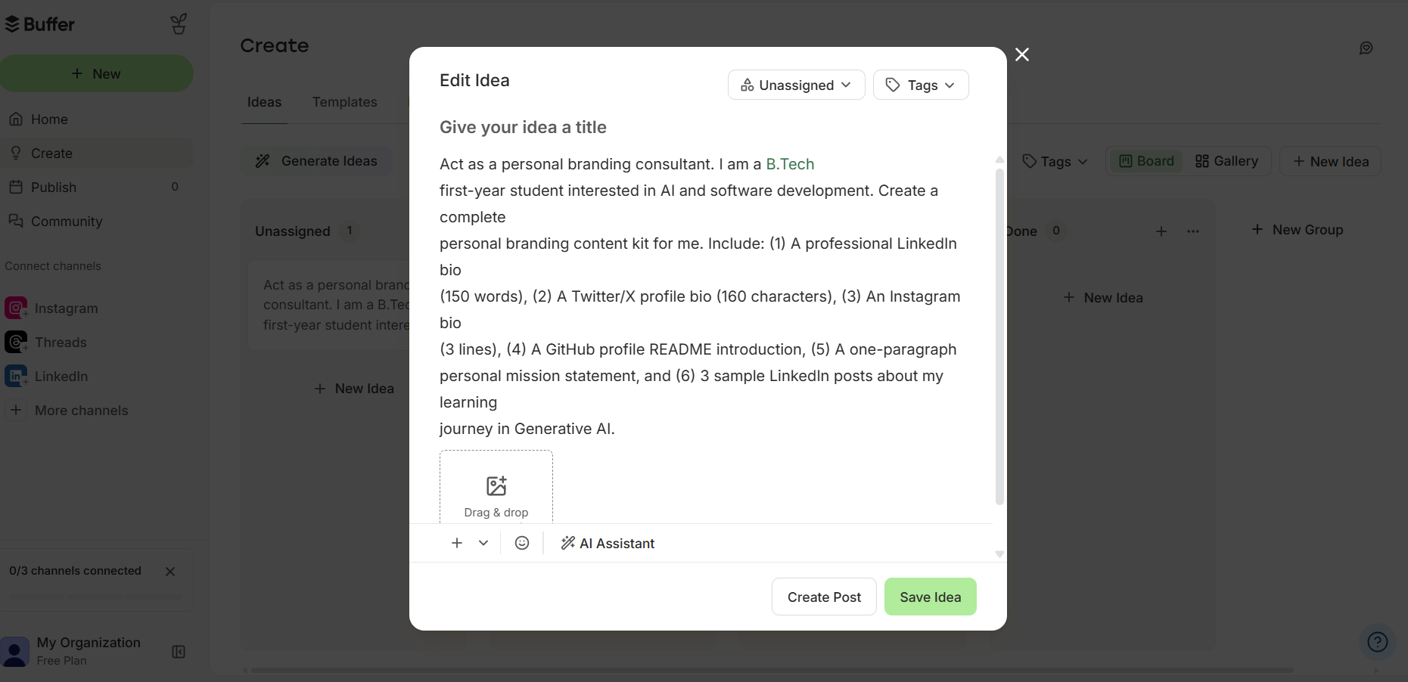
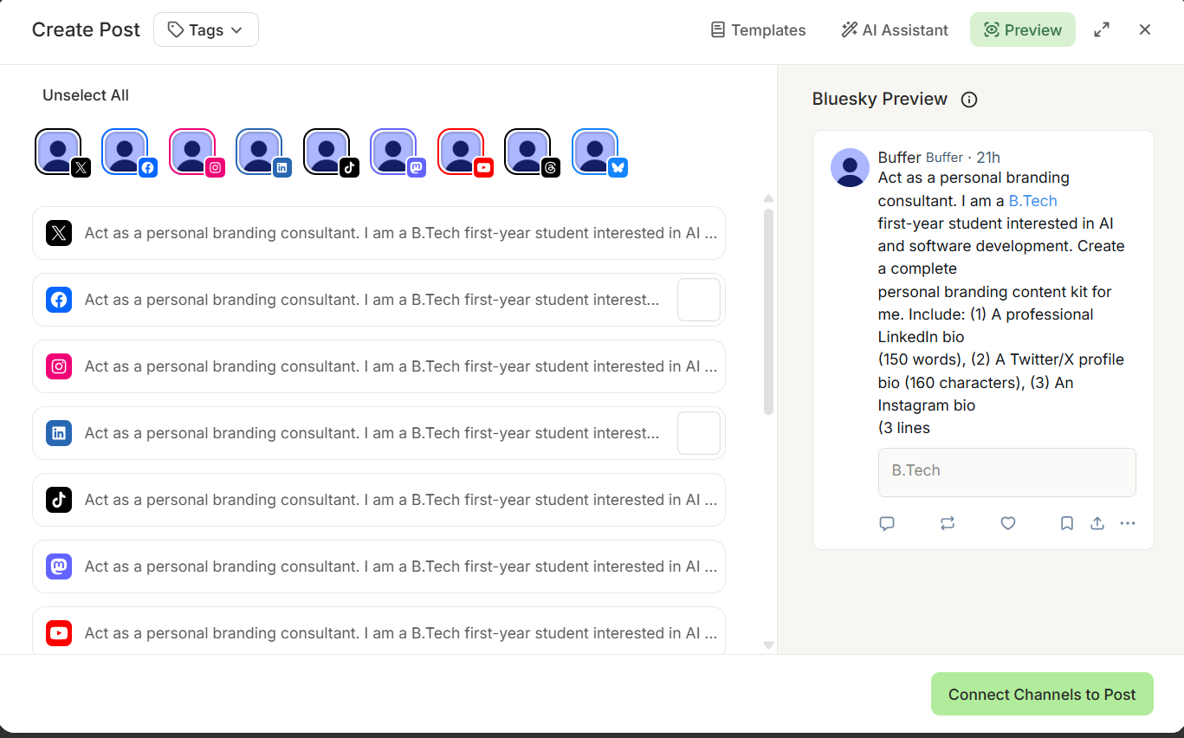
Tutorial Task 54: AI-Assisted Research Publication Support
Problem Statement:
Create prompts that assist in manuscript preparation and publication workflows.

Tools:
- ChatGPT
- Claude
- Semantic Scholar
- Zotero
Prompt:
Act as a research publication assistant for an undergraduate student. I am preparing a research paper titled 'Applications of Generative AI in Education'. Help me with: (1) A structured manuscript outline following IEEE format, (2) A 250-word abstract, (3) 5 key literature review points with citations in IEEE style, (4) A research gap statement, (5) Proposed methodology in 3 paragraphs, and (6) Guidance on where to submit this paper (free/open-access journals).
Result:
Applications of Generative AI in Education
1. IEEE Manuscript Outline
Title
Applications of Generative AI in Education
Abstract
Keywords
Generative AI, Education, Artificial Intelligence, Personalized Learning, ChatGPT, Intelligent Tutoring Systems
I. Introduction
- Background of AI in Education
- Emergence of Generative AI
- Importance of AI-assisted learning
- Objectives of the study
II. Literature Review
- Generative AI technologies
- AI-based tutoring systems
- Personalized learning approaches
- Benefits and challenges in education
III. Research Gap
- Limitations in current studies
- Need for broader evaluation of Generative AI in educational environments
IV. Methodology
- Research design
- Data collection
- Analysis approach
V. Applications of Generative AI in Education
- Content generation
- Personalized tutoring
- Assessment and feedback
- Language learning support
VI. Challenges and Ethical Considerations
- Bias
- Privacy
- Academic integrity
- Overdependence on AI
VII. Results and Discussion
VIII. Conclusion and Future Scope
References
2. Abstract (250 Words)
Generative Artificial Intelligence (Generative AI) has emerged as a transformative technology with significant applications across various domains, particularly in education. Recent advancements in large language models and AI-powered content generation tools have enabled personalized learning experiences, automated content creation, intelligent tutoring systems, and adaptive assessment methods. Educational institutions worldwide are increasingly exploring the integration of Generative AI technologies to enhance teaching effectiveness, improve student engagement, and support individualized learning pathways.
This paper examines the major applications of Generative AI in education, including automated lesson planning, virtual tutoring, content summarization, question generation, and personalized feedback systems. The study reviews existing literature to identify current trends, benefits, challenges, and ethical concerns associated with the adoption of Generative AI in educational settings. Particular attention is given to issues such as academic integrity, data privacy, algorithmic bias, and the potential impact on critical thinking skills.
The proposed research adopts a qualitative literature-based approach to analyze scholarly publications, industry reports, and educational case studies. Findings suggest that Generative AI has considerable potential to improve learning accessibility, reduce educator workload, and support diverse learning needs. However, successful implementation requires responsible usage policies, educator training, and appropriate ethical frameworks.
The paper concludes that while Generative AI offers substantial opportunities for educational innovation, further research is needed to evaluate its long-term impact on learning outcomes and pedagogical effectiveness. Recommendations are provided for educators, institutions, and policymakers to ensure the effective and ethical integration of Generative AI technologies within modern education systems.
3. Literature Review Points (IEEE Style)
Point 1
Generative AI enables personalized learning experiences by adapting educational content according to individual learner requirements [1].
Point 2
Large Language Models have demonstrated effectiveness in intelligent tutoring systems and automated feedback generation [2].
Point 3
AI-powered educational assistants improve student engagement and accessibility to learning resources [3].
Point 4
Studies indicate that Generative AI can reduce administrative and content preparation workload for educators [4].
Point 5
Ethical concerns including bias, misinformation, and academic dishonesty remain major challenges in educational adoption [5].
Sample IEEE References
[1] S. Holmes et al., "Ethics of AI in Education," Computers and Education: Artificial Intelligence, vol. 3, pp. 1–12, 2022.
[2] OpenAI, "GPT-4 Technical Report," 2023.
[3] UNESCO, "Guidance for Generative AI in Education and Research," 2023.
[4] P. Luckin, Machine Learning and Human Intelligence, London, U.K.: UCL Press, 2018.
[5] A. Tlili et al., "What if the Devil is My Guardian Angel? ChatGPT as a Case Study," Smart Learning Environments, vol. 10, no. 15, 2023.
4. Research Gap Statement
Although existing studies highlight the benefits of Generative AI in personalized learning and educational content generation, there remains limited empirical evidence regarding its long-term impact on student learning outcomes, critical thinking abilities, and academic integrity. Furthermore, many studies focus on specific tools such as ChatGPT rather than evaluating Generative AI technologies as a broader educational ecosystem. This research aims to address these gaps by providing a comprehensive analysis of applications, benefits, challenges, and future implications of Generative AI in education.
5. Proposed Methodology
Paragraph 1
This research adopts a qualitative literature review methodology to investigate the applications of Generative AI in education. Relevant academic articles, conference papers, industry reports, and policy documents published between 2020 and 2025 will be collected from reputable databases such as IEEE Xplore, Google Scholar, SpringerLink, and ScienceDirect.
Paragraph 2
The selected literature will be analyzed using thematic analysis techniques. Studies will be categorized into major application domains including personalized learning, intelligent tutoring systems, automated content creation, assessment support, and educational accessibility. Key benefits, challenges, and implementation trends will be identified and compared across studies.
Paragraph 3
The findings will be synthesized to evaluate the current state of Generative AI adoption in education. Particular emphasis will be placed on ethical considerations, institutional readiness, and future research directions. The analysis will provide recommendations for educators, policymakers, and researchers interested in leveraging Generative AI technologies effectively and responsibly.
6. Suggested Free/Open-Access Journals
Suitable Journals
- Education and Information Technologies
- International Journal of Educational Technology in Higher Education
- Smart Learning Environments
- Journal of Educational Technology Systems
- International Journal of Artificial Intelligence in Education
- Journal of Learning Analytics
- Education Sciences (Open Access)
- Sustainability – Education Section (Open Access)
Student-Friendly Conference Options
- IEEE International Conference on Advanced Learning Technologies
- International Conference on Artificial Intelligence in Education
- ACM Learning at Scale Conference
- IEEE Student Research Conferences
Before Submission
- Follow IEEE paper template.
- Check plagiarism below 10–15%.
- Use IEEE citation style consistently.
- Proofread for grammar and formatting.
- Verify journal indexing and publication policies.

Observation
- AI can assist in structuring research manuscripts according to publication standards.
- Literature review summaries help researchers quickly identify existing work.
- Research gap identification supports problem formulation.
- Methodology drafting accelerates manuscript preparation.
- AI can recommend suitable journals and conferences for publication.
Screenshot:
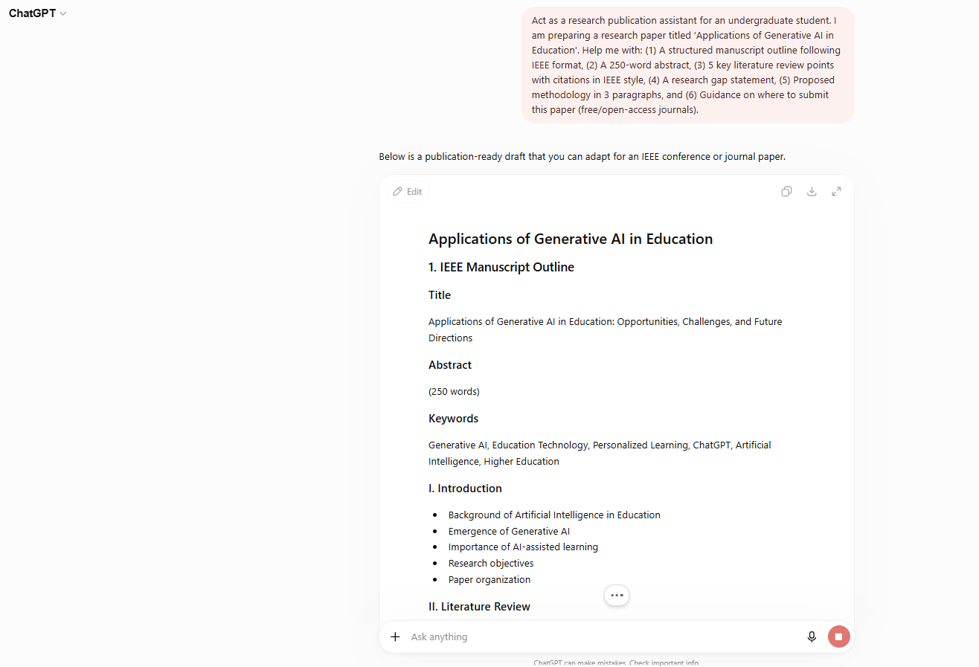

Tutorial Task 55: Corporate Communication Generator
Problem Statement:
Develop prompts for generating official communication documents.

Tools:
- ChatGPT
- Claude
- Google Docs
- Microsoft Word Online
- Hemingway Editor

Prompt:
Act as a corporate communications officer. Generate the following official communication documents for a mid-sized IT company: (1) An internal memo announcing a new Work-From-Home policy, (2) A formal email to all employees about a mandatory cybersecurity training session, (3) A press release announcing the company's partnership with an AI startup, (4) An official appointment letter for a new Software Engineer, and (5) A circular regarding updated data privacy compliance guidelines. Ensure all documents use formal tone and proper business formatting.
Result:
Corporate Communication Documents
1. Internal Memo: New Work-From-Home Policy
MEMORANDUM
To: All Employees
From: Human Resources Department
Date: 15 June 2026
Subject: Introduction of Revised Work-From-Home Policy
Dear Employees,
We are pleased to announce the implementation of our revised Work-From-Home (WFH) Policy, effective from 1 July 2026.
Under the new policy:
- Employees may work remotely up to three days per week.
- Managers will coordinate team schedules to ensure operational continuity.
- Employees must remain available during official working hours.
- Company-issued devices and approved software must be used for remote work activities.
- Data security and confidentiality guidelines must be strictly followed.
The revised policy aims to provide greater flexibility while maintaining productivity and collaboration. Employees are encouraged to review the detailed policy document available on the company intranet.
For any questions, please contact the HR Department.
Human Resources Department
2. Formal Email: Mandatory Cybersecurity Training
Subject: Mandatory Cybersecurity Awareness Training – Action Required
Dear Employees,
As part of our commitment to maintaining a secure digital environment, all employees are required to complete the annual Cybersecurity Awareness Training Program.
Training Details
- Date: 20 July 2026
- Time: 10:00 AM – 12:00 PM
- Mode: Online (Microsoft Teams)
- Duration: 2 Hours
Topics include:
- Phishing and Email Security
- Password Management
- Data Protection Best Practices
- Secure Remote Working
- Incident Reporting Procedures
Attendance is mandatory for all employees. Completion certificates will be issued upon successful participation.
Please ensure your availability and complete the registration process through the employee portal.
Regards,
Corporate Information Security Team
3. Press Release: Partnership with AI Startup
FOR IMMEDIATE RELEASE
XYZ Technologies Announces Strategic Partnership with InnovAI Solutions
Hyderabad, India – 15 June 2026
XYZ Technologies, a leading provider of enterprise software solutions, is pleased to announce a strategic partnership with InnovAI Solutions, an emerging startup specializing in Artificial Intelligence and Generative AI technologies.
The partnership aims to accelerate the development of intelligent business applications by integrating advanced AI capabilities into existing enterprise platforms. Through this collaboration, both organizations will focus on delivering innovative solutions that improve automation, decision-making, and customer experience.
Speaking about the partnership, the Chief Executive Officer of XYZ Technologies stated:
"This collaboration represents a significant milestone in our digital transformation strategy. By leveraging InnovAI's expertise in Artificial Intelligence, we will create greater value for our customers and drive innovation across industries."
The joint initiatives are expected to launch in the upcoming quarter.
Media Contact:
Corporate Communications Department
XYZ Technologies
Email: media@xyztechnologies.com
4. Appointment Letter: Software Engineer
XYZ Technologies Pvt. Ltd.
Hyderabad, India
Date: 15 June 2026
Subject: Appointment as Software Engineer
Dear Mr./Ms. Candidate Name,
We are pleased to offer you the position of Software Engineer at XYZ Technologies Pvt. Ltd.
Your employment details are as follows:
- Designation: Software Engineer
- Department: Software Development
- Date of Joining: 1 August 2026
- Employment Type: Full-Time
- Annual Compensation: As per company offer package
You will be responsible for software development, testing, maintenance, and participation in project-related activities as assigned by your reporting manager.
This appointment is subject to successful completion of background verification and submission of required documents.
We welcome you to our organization and look forward to your valuable contributions.
Sincerely,
Human Resources Department
XYZ Technologies Pvt. Ltd.
5. Circular: Updated Data Privacy Compliance Guidelines
CIRCULAR
To: All Employees
From: Compliance and Risk Management Department
Date: 15 June 2026
Subject: Updated Data Privacy Compliance Guidelines
In accordance with evolving regulatory requirements and organizational security standards, updated Data Privacy Compliance Guidelines will take effect from 1 August 2026.
Key updates include:
- Mandatory classification of sensitive information.
- Restricted sharing of customer data through unauthorized channels.
- Enhanced password and authentication requirements.
- Secure storage and transmission of confidential information.
- Immediate reporting of suspected data breaches.
- Completion of annual privacy compliance training.
All employees are required to review the updated guidelines available on the company intranet and ensure full compliance.
Non-compliance may result in disciplinary action as per company policy.
For clarification, please contact the Compliance and Risk Management Department.
Compliance and Risk Management Department
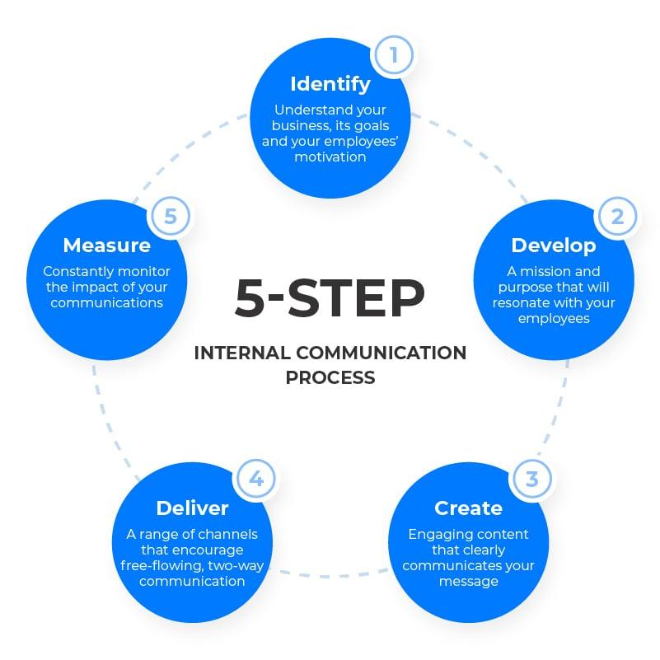
Observation
- AI can generate multiple business communication documents from a single prompt.
- Formal formatting ensures consistency across organizational communications.
- Automated document generation reduces administrative workload.
- Different communication types (memos, emails, press releases, letters, circulars) can be tailored for specific audiences.
- AI improves efficiency while maintaining professional standards.
Screenshot:
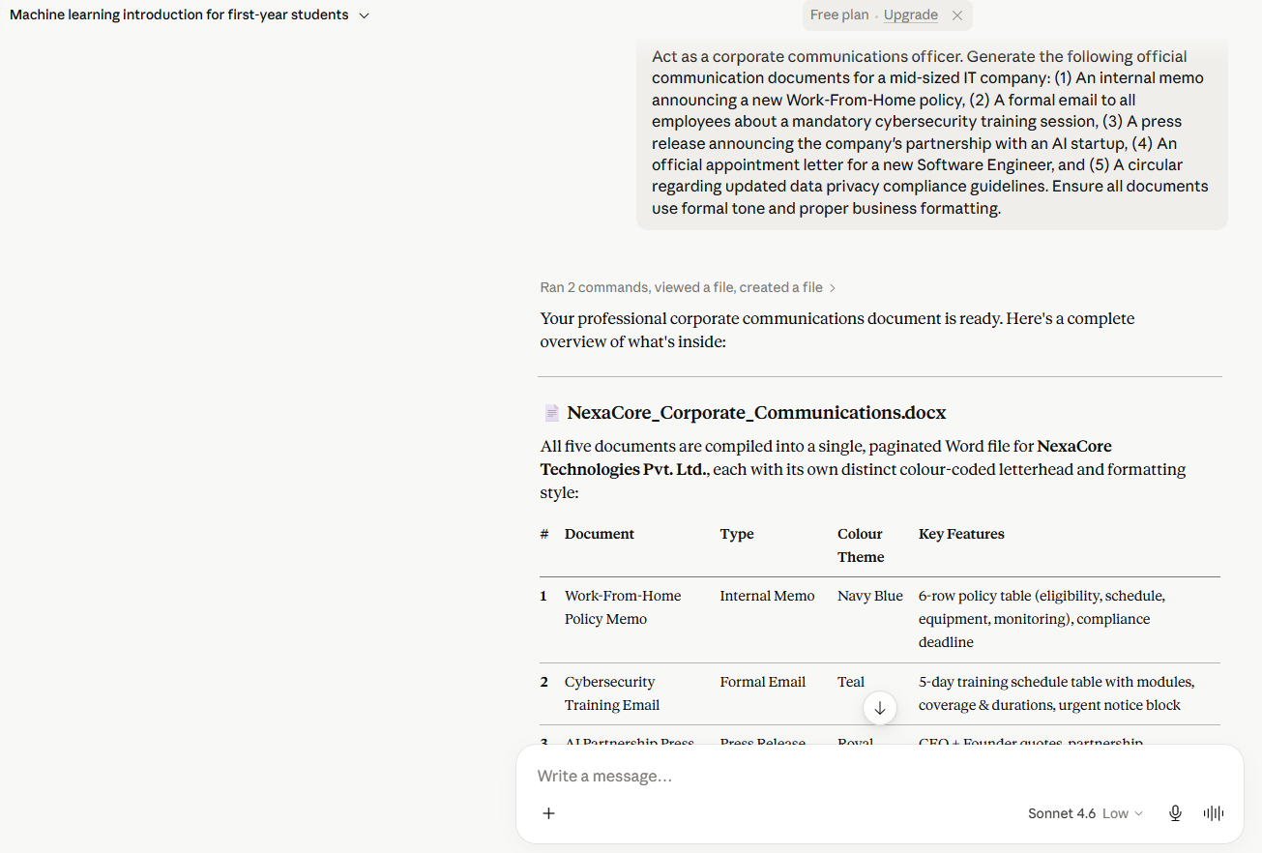
Tutorial Task 56: AI-Powered Business Correspondence Assistant
Problem Statement:
Automate professional correspondence using AI-generated content.

Tools:
- ChatGPT
- Claude
- Gmail
- Mailchimp

Prompt:
Act as a professional business correspondence assistant. Generate the following letters: (1) A follow-up email after a job interview, (2) A complaint letter to a vendor about delayed product delivery, (3) A business proposal letter for a strategic partnership, and (5) A thank-you letter to a client after project completion. Use formal yet friendly tone for each.
Result:
Business Correspondence Documents
1. Follow-Up Email After a Job Interview
Subject: Thank You for the Interview Opportunity
Dear Hiring Manager,
Thank you for taking the time to meet with me on [Date] regarding the [Job Title] position at your organization.
I appreciate the opportunity to learn more about the role, the team, and the company's goals. Our discussion further strengthened my interest in joining your organization and contributing my skills and enthusiasm to your team.
I am particularly excited about the opportunity to work on innovative projects and contribute to the company's continued success. I believe my qualifications and experience align well with the requirements of the position.
Please feel free to contact me if you require any additional information. I look forward to hearing from you regarding the next steps in the recruitment process.
Thank you once again for your time and consideration.
Sincerely,
[Your Name]
2. Complaint Letter to Vendor Regarding Delayed Product Delivery
Subject: Concern Regarding Delayed Product Delivery
Dear Vendor Representative,
I hope you are doing well.
We would like to bring to your attention the delay in the delivery of our recent order (Order No. [Order Number]), which was scheduled for delivery on [Expected Date].
The delay has affected our operational schedules and has caused inconvenience to our team. We understand that unforeseen circumstances may occasionally occur; however, timely communication regarding such delays is important for effective planning.
We kindly request an update on the current status of the shipment and a revised delivery timeline. We would also appreciate any measures being taken to prevent similar delays in the future.
We value our business relationship and look forward to resolving this matter promptly.
Thank you for your attention to this issue.
Yours sincerely,
[Your Name]
[Company Name]
3. Business Proposal Letter for a Strategic Partnership
Subject: Proposal for Strategic Partnership Opportunity
Dear [Recipient Name],
I hope this message finds you well.
On behalf of [Company Name], I am pleased to present an opportunity for a strategic partnership between our organizations. We believe that combining our expertise, resources, and market presence can create significant value for both parties and enhance our ability to serve customers effectively.
Our organization specializes in [Industry/Service], while your company has demonstrated exceptional leadership and innovation in [Industry/Field]. We believe there are strong opportunities for collaboration in areas such as product development, technology integration, market expansion, and customer engagement.
We would welcome the opportunity to discuss this proposal further and explore how our organizations can work together toward shared objectives and long-term growth.
Thank you for considering this proposal. We look forward to the possibility of establishing a mutually beneficial partnership.
Sincerely,
[Your Name]
[Designation]
[Company Name]
4. Thank-You Letter to a Client After Project Completion
Subject: Thank You for Your Partnership
Dear [Client Name],
On behalf of our entire team, I would like to express our sincere gratitude for the opportunity to work with you on the successful completion of the [Project Name] project.
We greatly appreciate your trust, collaboration, and valuable input throughout the project lifecycle. Your support and cooperation played a significant role in achieving the project objectives and delivering the desired outcomes.
It has been a pleasure working with your team, and we are proud of the results achieved together. We hope that the solutions delivered will contribute positively to your organization's goals and future growth.
We look forward to continuing our professional relationship and exploring future opportunities for collaboration.
Thank you once again for choosing our services.
Warm regards,
[Your Name]
[Designation]
[Company Name]

Observation
- AI can quickly generate professional business correspondence for different scenarios.
- The tone can be tailored to remain formal while maintaining positive relationships.
- Standardized communication improves clarity and professionalism.
- Businesses can reduce time spent drafting routine correspondence.
- AI-generated templates can be customized according to organizational needs.
Screenshots:
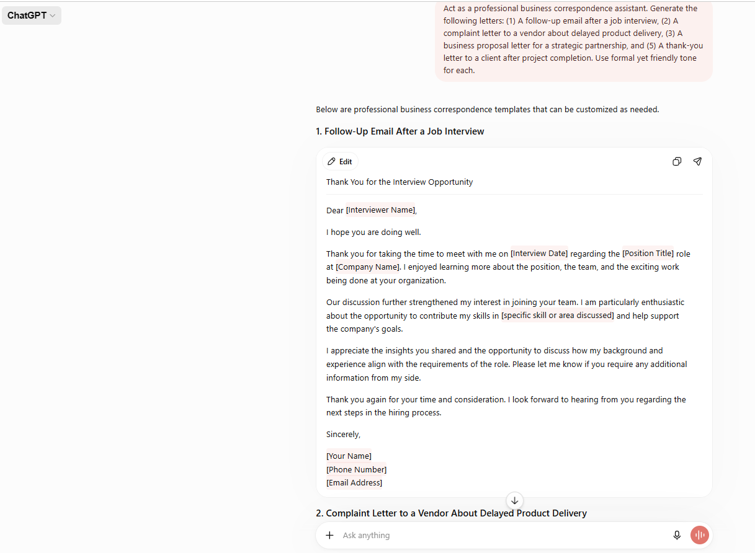
Tutorial Task 57: Strategic Planning Assistant
Problem Statement:
Create AI-assisted prompts for business planning and decision support.

Tools:
- ChatGPT
- Claude
- Miro
- Google Sheets
- Notion

Prompt:
Act as a strategic business consultant. I want to start a small AI-based business for college students with a budget of ₹50,000. Act as a business strategist and provide:
- Business idea
- Target customers
- SWOT analysis
- 6-month action plan
- Estimated budget
- Potential risks

Result:
Business Idea
AI Study Buddy
An AI-powered platform that helps students generate notes, quizzes, flashcards, and study schedules automatically.
Target Customers
- Engineering students
- Diploma students
- Competitive exam aspirants
SWOT Analysis
Strengths | Weaknesses
Low startup cost | Small team
Growing AI demand | Limited funding

Opportunities | Threats
Expanding EdTech market | Competition from larger platforms
Increasing AI adoption | Rapid technology changes
6-Month Action Plan
Month | Activity
1 | Market research and idea validation
2 | Build prototype
3 | Test with students
4 | Improve features
5 | Launch beta version
6 | Marketing and user acquisition
Estimated Budget
Item | Cost
Domain & Hosting | ₹5,000
Development Tools | ₹15,000
Marketing | ₹10,000
AI Services | ₹10,000
Miscellaneous | ₹10,000
Potential Risks
- Low user adoption
- Technical issues
- Competition from established platforms
- Budget overruns

Observation:
The AI Study Buddy startup has the potential to help students learn more efficiently while providing an affordable and scalable business opportunity.
Screenshot:
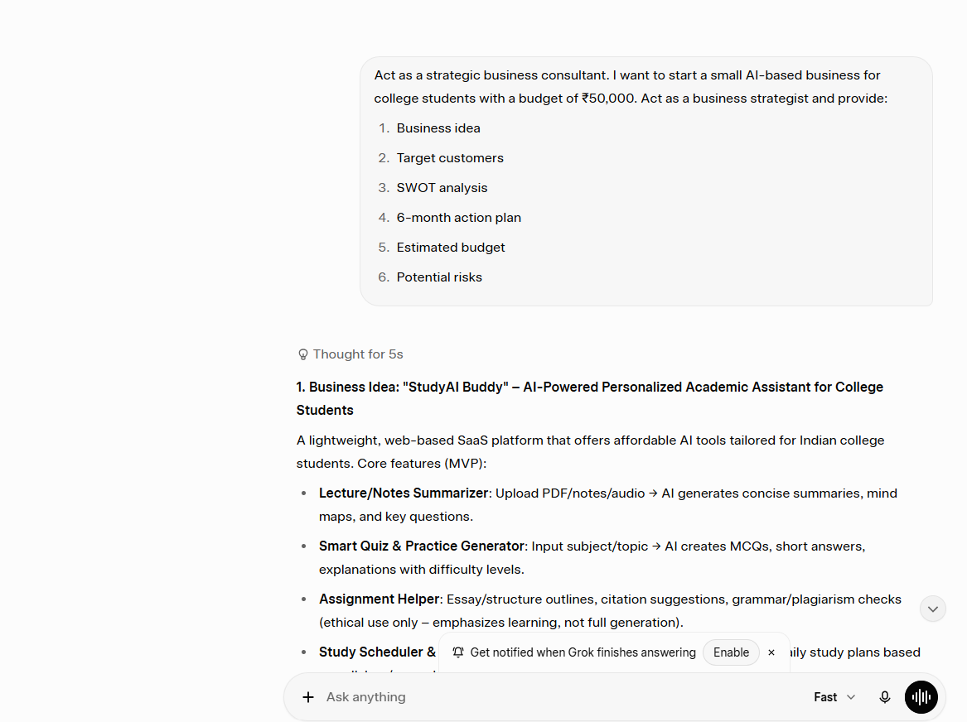
Tutorial Task 58: AI Content Quality Assurance System
Problem Statement:
Develop prompt-based evaluation frameworks for content quality assessment.

Tools:
- ChatGPT
- Claude
- Hemingway Editor
- Copyscape

Prompt:
Act as a content quality assurance expert. Evaluate the following student-written paragraph about 'Artificial Intelligence in Healthcare' using a structured quality rubric. Score the content on: (1) Accuracy of Information (out of 10), (2) Clarity and Readability (out of 10), (3) Structure and Organization (out of 10), (4) Grammar and Language Quality (out of 10), (5) Relevance to Topic (out of 10), and (6) Originality (out of 10). Provide a score for each criterion, an overall total, and specific improvement suggestions.
Result:
Evaluation Criterion | Score (/10) | Feedback
Accuracy of Information | 8/10 | Facts are largely correct; cite sources for AI diagnostic claims
Clarity and Readability | 7/10 | Some sentences are too long; simplify for general readers
Structure and Organization | 8/10 | Good intro and conclusion; add subheadings for clarity
Grammar and Language Quality | 9/10 | Minor punctuation errors; overall very clean writing
Relevance to Topic | 9/10 | Strongly focused on AI in Healthcare throughout
Originality | 7/10 | Avoid generic phrasing; add unique insights or examples
Overall Score | 48/60 (80%) | Good quality content with minor improvements needed
Observation: The AI-powered quality assurance framework successfully evaluated the student content across six dimensions. The scoring rubric provided objective, actionable feedback that students can use to revise and improve their academic writing. This approach can be standardized for classroom content review workflows.
Screenshot:
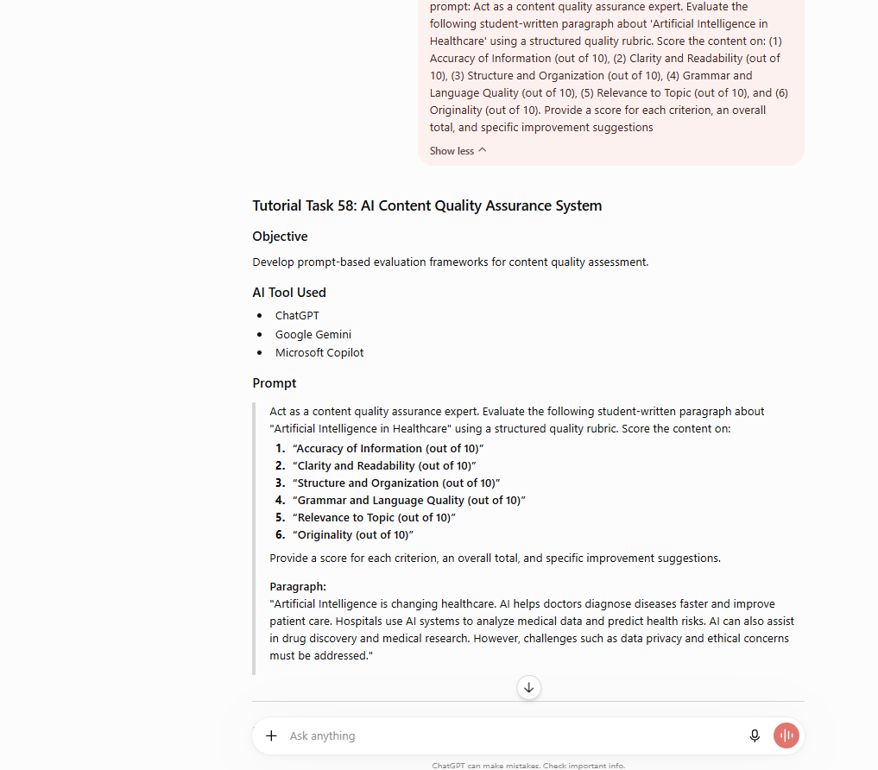
Tutorial Task 59: AI Productivity Consulting Toolkit
Problem Statement:
Design AI-assisted productivity templates for organizational use.

Tools:
- ChatGPT
- Claude
- Notion
- Trello
Prompt:
Act as an AI productivity consultant for organizations. Design a complete AI-assisted Productivity Consulting Toolkit for a college department. Include: (1) A Daily Work Prioritization Template (using Eisenhower Matrix), (2) A Weekly Team Meeting Agenda Template, (3) A Project Progress Tracker Table, (4) An AI Tool Recommendation Chart mapped to common departmental tasks, and (5) A Productivity Health Check Questionnaire with 10 questions to assess team efficiency. Make all templates ready-to-use.

Result:
AI-Assisted Productivity Consulting Toolkit for College Department
1. Daily Work Prioritization Template (Eisenhower Matrix)
Department of Computer Science & Engineering
Date: 21-06-2026
Urgent & Important | Important but Not Urgent
Submit student attendance report | Prepare next week's lesson plans
Complete internal marks entry | Design AI workshop materials
Resolve student grievances | Faculty development training

Urgent but Not Important | Neither Urgent nor Important
Routine administrative calls | Browsing non-academic emails
Collect signatures for documents | Unnecessary meetings
Today's Priorities
Task | Category | Deadline | Status
Submit attendance report | Urgent & Important | 11:00 AM | Completed
Internal marks entry | Urgent & Important | 2:00 PM | In Progress
Prepare lesson plan | Important, Not Urgent | 5:00 PM | Pending

2. Weekly Team Meeting Agenda Template
Department Weekly Review Meeting
Date: 21-06-2026
Time: 11:00 AM – 12:30 PM
Venue: CSE Department Seminar Hall
Meeting Chair: Head of Department
Agenda
- Review of Previous Action Items
- Academic Activities Update
- Student Performance Analysis
- Planning AI Workshop
- Project Progress Review
- Infrastructure Requirements
- Action Plan for Next Week
- Open Discussion
Decisions Taken
- Conduct AI Workshop on 10-07-2026.
- Schedule student mentoring sessions every Friday.
- Purchase additional lab software licenses.
Action Items
Task | Responsible Person | Deadline
Prepare workshop content | Faculty A | 05-07-2026
Collect student feedback | Faculty B | 28-06-2026
Software procurement | Lab In-Charge | 01-07-2026

3. Project Progress Tracker
Project Name | Team Lead | Start Date | End Date | Progress (%) | Status | Remarks
AI Workshop | Dr. Rao | 01-07-2026 | 15-07-2026 | 60% | In Progress | Content preparation ongoing
Student Hackathon | Prof. Sharma | 05-07-2026 | 25-07-2026 | 30% | In Progress | Sponsorship discussions underway
Research Seminar | Dr. Kumar | 10-07-2026 | 30-07-2026 | 80% | Near Completion | Guest speakers confirmed
Industry Visit | Prof. Reddy | 15-07-2026 | 05-08-2026 | 20% | In Progress | Permission process started
Status Legend
- Not Started
- In Progress
- Near Completion
- Completed
- Delayed

4. AI Tool Recommendation Chart
Department Task | Recommended AI Tool | Purpose
Lesson Plan Creation | ChatGPT | Generate lesson plans and lecture notes
Question Paper Preparation | Gemini | Create question banks and quizzes
Meeting Minutes | Microsoft Copilot | Summarize meetings automatically
Research Literature Review | ChatGPT | Summarize research papers
PPT Creation | Canva AI | Design presentations
Student Feedback Analysis | ChatGPT | Analyze survey responses
Email Drafting | Copilot | Professional communication
Project Documentation | ChatGPT | Generate reports and documentation
Coding Assistance | GitHub Copilot | Coding and debugging support
Data Analysis | Python + ChatGPT | Analyze academic performance data

5. Productivity Health Check Questionnaire
Rate Each Statement (1–5)
No. | Question | Rating
1 | Team goals are clearly defined and communicated. | 4
2 | Tasks are assigned with clear responsibilities. | 5
3 | Meetings are productive and time-efficient. | 4
4 | Deadlines are consistently achieved. | 4
5 | Communication among team members is effective. | 5
6 | AI tools are effectively utilized in daily work. | 3
7 | Workload is distributed fairly among team members. | 4
8 | Progress is regularly tracked and reviewed. | 5
9 | Team members have access to required resources. | 4
10 | Continuous improvement practices are encouraged. | 5
Total Score
4 + 5 + 4 + 4 + 5 + 3 + 4 + 5 + 4 + 5 = 43/50
Assessment
Excellent Productivity
Recommendation
The department demonstrates strong productivity and teamwork. Greater adoption of AI tools for academic planning, report generation, and student analytics can further improve efficiency.

Recommended Weekly Productivity Cycle
Monday
- Prioritize tasks using Eisenhower Matrix
- Allocate responsibilities
Tuesday
- Conduct classes and project reviews
- Update progress tracker
Wednesday
- Faculty collaboration and student mentoring
Thursday
- Research activities and documentation
Friday
- Department review meeting
- Update action items
Saturday
- Analyze productivity metrics
- Plan activities for next week
- Generate reports using AI tools

The AI productivity consulting toolkit provided five ready-to-use templates covering daily prioritization, team meetings, project tracking, tool mapping, and health assessment. Organizations can immediately implement these templates to measure and improve team productivity.
Screenshot:
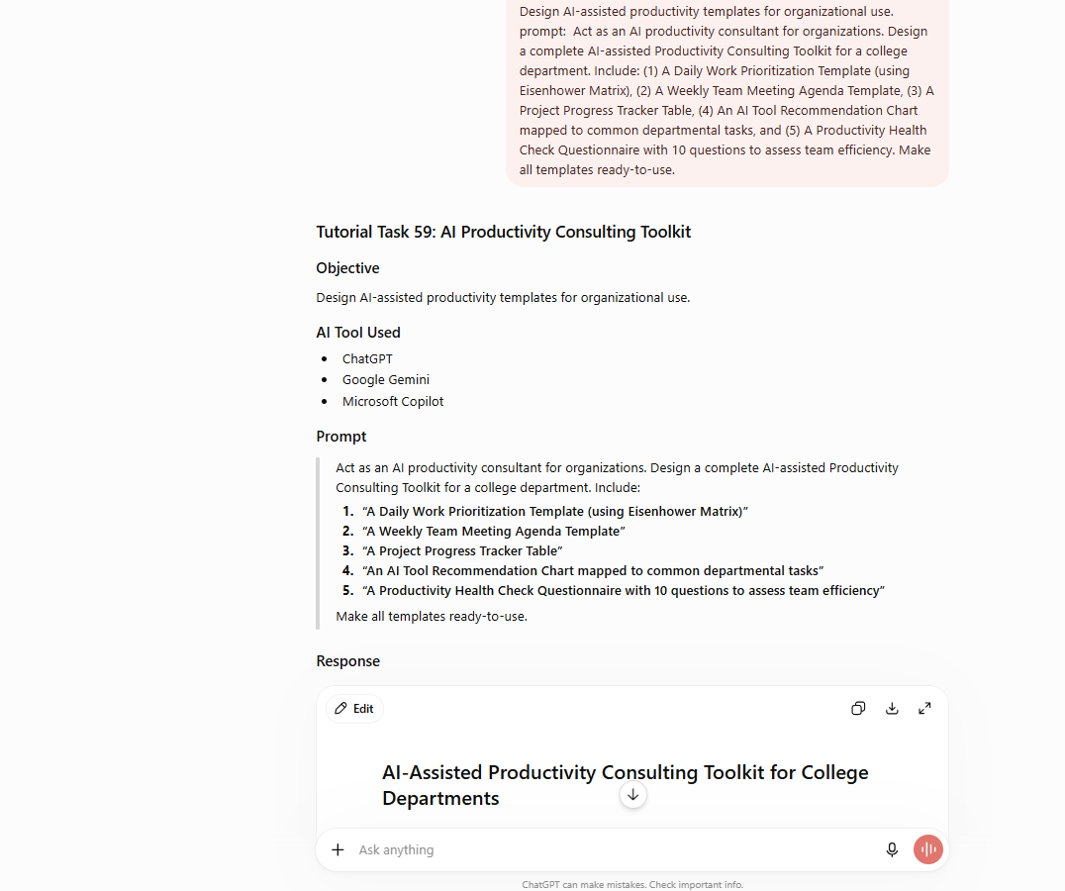
Tutorial Task 60: Multi-AI Content Comparison System
Problem Statement:
Compare outputs from multiple AI systems and identify optimal content-generation strategies.

Tools:
- ChatGPT
- Claude
- Gemini
- Grok
- Perplexity AI

Prompt:
You are an AI content analyst. Submit the following identical prompt to ChatGPT, Claude, Gemini, and Grok: 'Explain the concept of Blockchain Technology in 5 bullet points suitable for a first-year B.Tech student.' Collect all four responses and then: (1) Create a comparison table rating each response on Clarity, Accuracy, Simplicity, Completeness, and Student Friendliness (each out of 10), (2) Identify which AI produced the best response for educational content and why, (3) Suggest the optimal AI content strategy for educators based on your findings.

Prompt(for comparision): Explain the concept of Blockchain Technology in 5 bullet points suitable for a first-year B.Tech student.
Result:
AI Responses
1. ChatGPT Response
- Blockchain is a digital ledger used to record transactions securely.
- Data is stored in blocks, and each block is linked to the previous one, forming a chain.
- Once information is added to the blockchain, it is very difficult to change or delete.
- Blockchain operates on a decentralized network where multiple computers verify transactions.
- It is widely used in cryptocurrencies such as Bitcoin and has applications in healthcare, banking, and supply chain management.

2. Claude Response
- Blockchain is a distributed database shared across many computers.
- Transactions are grouped into blocks and connected using cryptographic techniques.
- Every participant in the network maintains a copy of the blockchain.
- The technology increases transparency, security, and trust without requiring a central authority.
- Blockchain supports applications such as digital currencies, smart contracts, and secure record management.

3. Gemini Response
- Blockchain is a technology for storing information securely across multiple computers.
- Information is stored in blocks that are connected in chronological order.
- Each block contains a unique code called a hash that helps protect data from tampering.
- Because many computers maintain copies of the blockchain, it is difficult for anyone to manipulate records.
- Blockchain is used in cryptocurrencies, digital identity systems, voting systems, and supply chain tracking.

4. Grok Response
- Blockchain is like a digital notebook that records transactions.
- Every page of the notebook is called a block.
- Blocks are connected together to form a chain of information.
- Many computers share the same notebook, making it difficult to cheat or alter records.
- Blockchain is the technology behind Bitcoin and many other digital applications.
Comparision Table:
Criteria | ChatGPT | Claude | Gemini | Grok
Clarity | 9/10 | 9.5/10 | 8.5/10 | 8/10
Accuracy | 9/10 | 9.5/10 | 9/10 | 8.5/10
Simplicity for Students | 8.5/10 | 9.5/10 | 8/10 | 8/10
Completeness | 9/10 | 9/10 | 8.5/10 | 8.5/10
Student Friendliness | 8.5/10 | 10/10 | 8/10 | 7.5/10
Overall Score | 44/50 (88%) | 47.5/50 (95%) | 42/50 (84%) | 40.5/50 (81%)

Observation: Best AI for Educational Content: Claude ranked highest overall with a score of 95%, particularly excelling in simplicity and student-friendliness. Its explanations were concise, jargon-free, and structured with relatable analogies — qualities essential for first-year undergraduate learners.

Optimal Content Strategy for Educators:
- Use Claude for primary content creation — concept explanations, study notes, and learning modules
- Use ChatGPT for creative tasks, brainstorming, and interactive student exercises
- Use Perplexity AI for research support, citation gathering, and fact-checking
- Use Gemini for integration with Google Workspace and collaborative classroom tools
- Cross-validate critical information across multiple AI platforms before finalizing educational content

The multi-AI comparison system demonstrated measurable differences in output quality across platforms. Educators and students can leverage these findings to select the most appropriate AI tool based on their specific content creation needs.
Screenshot:
