USER: ADMIN

1.Manage area

- area should not allow to create same area -------- DONE

2.Fridge module

- when assigning-data will remain from the last chosen client and store name

3. Orders > for delivery

-if orders are not confirmed and the day has passed. that transaction should go directly to Undelivered

incase staff wont be able to cancel the order(na fix naman ni sir no?) -------- DONE

-add which store order belongs to above delivery date ----------- DONE

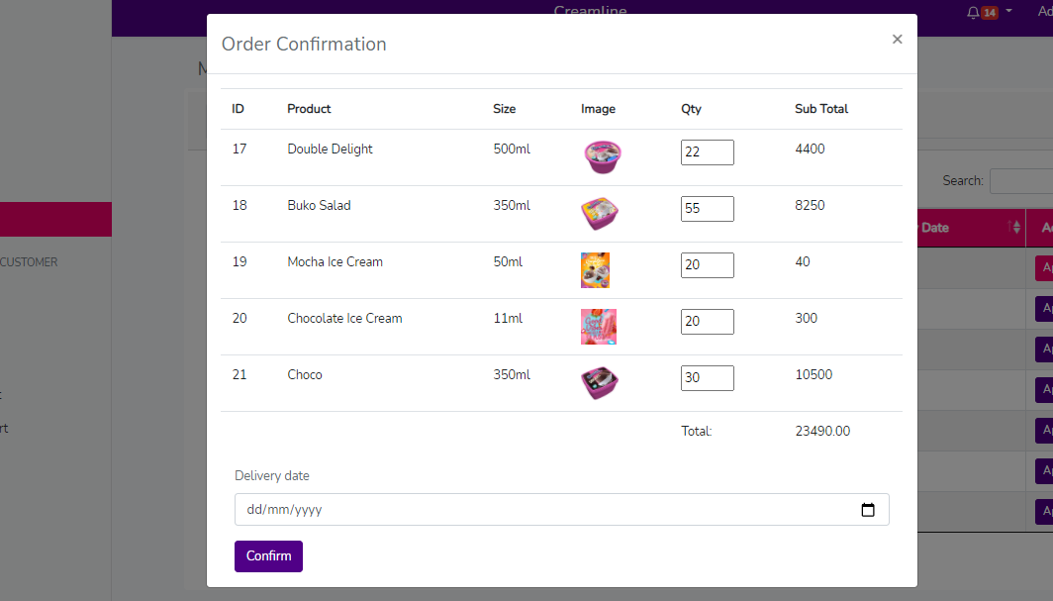

-admin can cancel the pending orders in action column ------- DONE

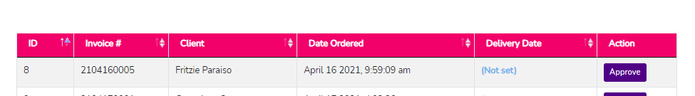

Staff

* edit staff, after saving staff should not be inactive ---------- DONE

Replacement

-please place invoice number ----- done

orders reports

-we need to filter dates

Products

-manage stocks can add the same Size ------ done

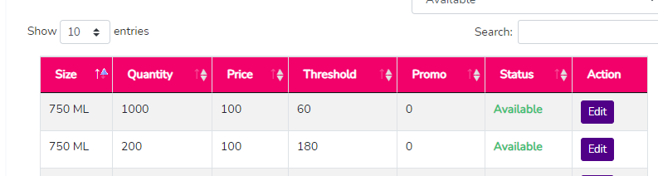

SMS for confirmation of orders ------- DONE

-----------------------------------------------------------------------------------------------------------------------------------------

USER: STAFF

1. Dashboard for staff should autoload --------- done

ALL

Notifications

-should not appear once viewed

