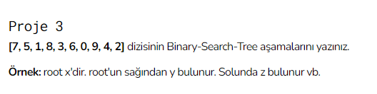

[7,5, 1, 8, 3, 6, 0,9, 4, 2]

Root

5

4 6

1 3 7 8

0 2 9

min max