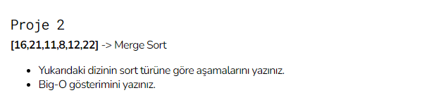

MERGE SORTING

16, 21, 11, 8, 12, 22

16, 21, 11 8, 12, 22

16 21, 11 8, 12 22

16 21 11 8 12 22

16, 21 11 8, 12 22

11, 16, 21 8,12,22

[8,11,12,16,21,22]

Big-O = O(nlogn)