|  |
| --- |
| C# Bootcamp |

|  |  |  |  |
| --- | --- | --- | --- |
| Name | KEVIN PACUNAYEN |  |  |
|  |  |  |  |
| Date | JUNE 13, 2022 |  |  |

**Part 1 (20 Points):** Let’s get a little more practice with conditional tests and loops. Take a look at the code below. Circle the conditional tests, and fill in the blanks so that the comments correctly describe the code that’s being run.

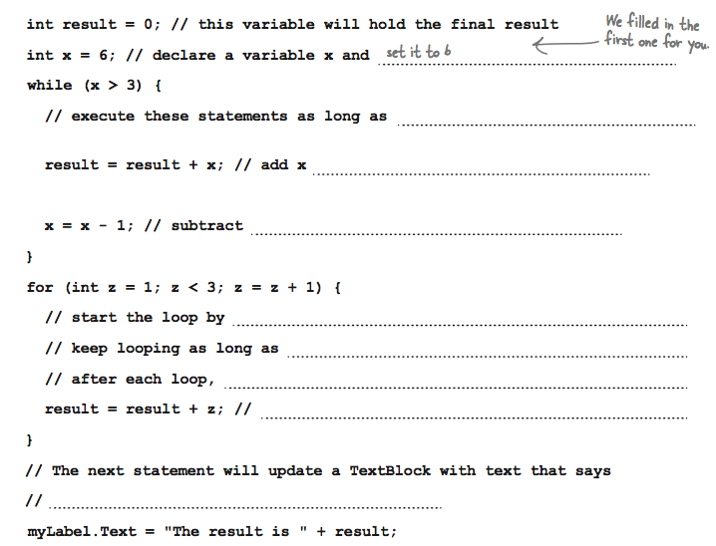

Add result to the updated value of z

the value of z must increment to 1

the value of z is less than 3

initializing of x is equal to 1

the updated value of x to 1

to the updated value of result

the value of x is less than 3

**Part 2 (10 Points):** Here are a few loops. Write down if each loop will repeat forever or eventually end. If it’s going to end, how many times will it loop?

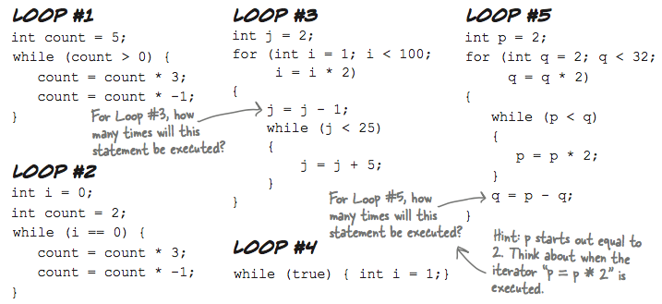

**Part 2**: Write your answer on the space provided.

1. Loop #1 - ___Controlled Loop: 1 Loop only____________________
2. Loop #2 - ___Infinite Loop__________________________________
3. Loop #3 - __For loop = 7 Loops && While Loop = 6 Loops (Controlled Loop)__
4. Loop #4 - _Infinite Loop________________________________________
5. Loop #5 - For Loop = 3 Loops && While Loop = 8 Loops (Controlled Loop)_

**Part 3 (20 Points):** Part of a C# program is all scrambled up on the fridge. Can you rearrange the code snippets to make a working C# program that produces the output and circle the conditional tests? Some of the curly braces fell on the floor and they were too small to pick up, so feel free to add as many of those as you need! (Hint: you’ll definitely need to add a couple. Just write them in!). Write your answer inside the box below.

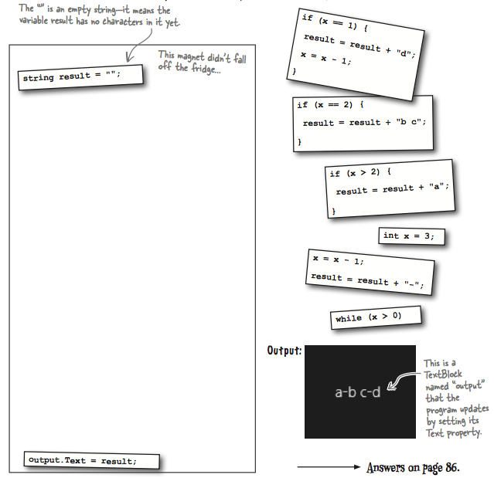**re**