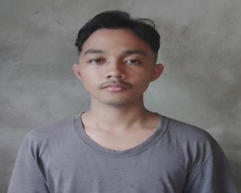
NUÑEZ,
Genesie B.
Balon-Anito Mariveles Bataan
Genesie.nunez01@gmail.com
+639126164989
Production Crew

Objective
To provide a best service for your team and to gain experience so we can both grow .

Experience
167 Archo Resources.
Collection Agent / July 01 2023 – August 31 2024
- The main focus of this job is to collect the payment of our clients and to provide a best way to settle their payment without any problem or issues that can be affected their financial status after the payment .
- We are also assigned to negotiate with the cold client who doesn’t want / insisting to pay what they owe at the company .

Education
Antonio G. Llmas Elementary school
Mariveles National High School Poblacion Campus
Mariveles National Senior High School Camaya Campus ( Accountancy and Businesses Management Strand )
Softnet Information Technology Center – Currently enrolled

Skills

- Knowledge at Microsoft Application/ Programs
- Communication Skills / Social Skills
- Eagerness To learn
- Negotiation Skill
- Acceptance about failure

