# Installing the Onyx Heated Bed

This short supplement will guide you through replacing the Phebe I heated bed on your Rostock MAX with the new Onyx heated bed.

Your Onyx upgrade kit should include the following components:

1. 6 #4-40 T-Nuts
2. 6 Nylon stand-offs
3. 6 #4-40 flat head mounting screws
4. 1 Melamine heated bed mounting plate
5. 1 Onyx Heated Bed
6. 1 Thermistor
7. 1 short length of PTFE tubing (used to insulate the Thermistor wires)
8. 1 Resistor (allows the LED to be powered by 12v)
9. 1 LED

Things required for installation:

1. P2 sized Philips screwdriver
2. Wire strippers/cutters
3. Soldering Iron and solder
4. RTV (the same stuff you used when assembling your hot end)
5. 280mm round build plate

I would recommend that you not use the original Phebe I power wiring. The Onyx requires more current to heat up and benefits greatly from larger gauge wire. I would recommend at least two 18ga wires for each of the two power pads on the heated bed. 18ga stranded wire can be purchased from your local Radio Shack or home center.

The Onyx doesn’t include a build plate, so you’ll need to source one from a local glass shop. Many people have had good luck using a 1/8” thick sheet of mirror glass. It does need to be 280mm in diameter.

Installing the Onyx heated bed is a very simple and straightforward task. If you’re being pokey about it, it’ll take about an hour to install (not including RTV cure time!).

Step 1 – Preparing the Rostock MAX:

Remove the original heated bed and mark the new mounting holes for the Onyx heated bed as indicated by the arrows in Fig. 1:

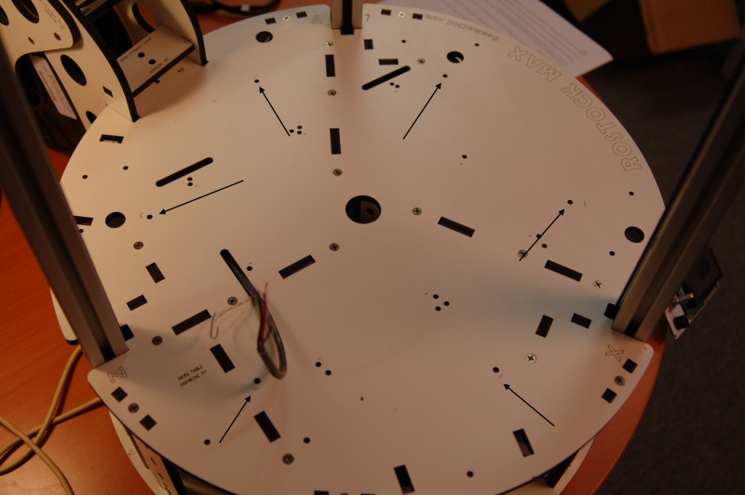

Figure 1 - Onyx mounting holes.

Install a 4-40 T-Nut in each of the marked holes. This works the same way as it did when you installed the Phebe I bed during the original build. The only gotcha with this is that one of the holes sits directly over the power supply. You’ll have to dismount the supply and move it out of the way in order to reach the mounting hole. The good news is that unless you trimmed your wiring really short, you won’t have to disconnect the wiring from the RAMBo. You WILL need to remove the power switch if you installed it in the default location however. (The power supply won’t clear it when trying to remove it) The simplest way to seat the T-Nuts is to use one of the #4-40 flat head screws and a Nylon spacer – hold the T-Nut in place with your finger and pass the screw through the spacer, into the mounting hole. Tighten it down until the T-Nut is fully seated. Rinse, repeat.

Older kits may require that you drill the mounting holes for the Onyx heated bed. You can use the Melamine base plate as a marking template for this. Try to keep the holes as close to the positions shown above as you can.

Step 2 – Installing the Thermistor:

Next up you’ll need to get the thermistor installed in the heated bed itself. Unlike the Phebe I bed, the thermistor in the Onyx is installed underneath the bed, in the center. Before you begin, place a bit of scotch or Kapton tape over the hole in the top side of the heated bed. This will allow you to fill the hole with RTV and prevent it from smearing all over the surface of your shiny new bed.

Cut two ¼” (or so) lengths of the tiny PTFE tubing and slip them over the thermistor leads, one for each lead. Bend the wires at the thermistor end at a 90 degree angle, making sure the exposed portion of the wires don’t touch. Set it aside. Flip the Onyx upside down and fill the center hole with RTV. Press the thermistor into the RTV hole and align it as shown in Fig. 2.

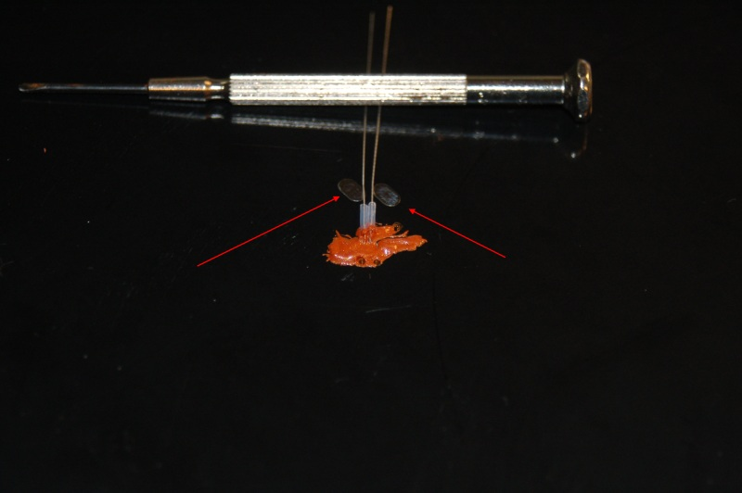

Figure 2 - Thermistor installed and ready to solder.

After the RTV has cured, spread the wires a bit so each crosses the solder pads as shown above and solder the leads to the pads and trim off the excess wire.

Step 3 – Installing the power leads:

With the bed still upside down, you’ll want to “tin” the connection points for the power wires as shown in Fig. 3. This makes connecting the power wires a lot easier.

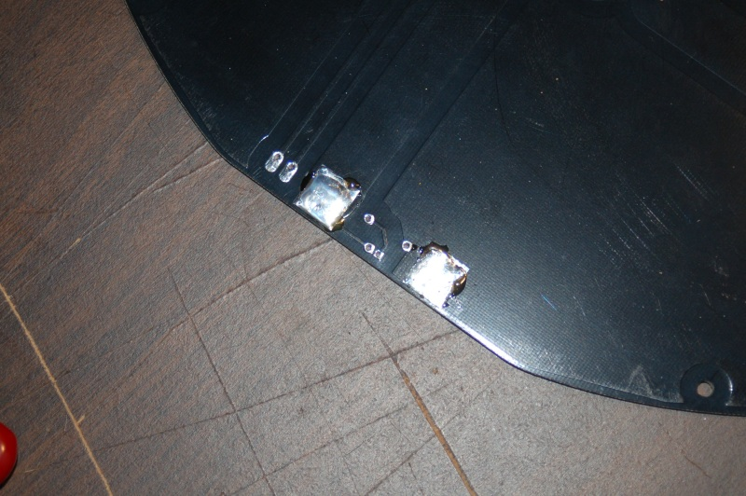

Figure 3 - Tinning the power pads.

The top of the bed has the polarity of the bed marked, so when you solder your power leads to the bed, please make sure you follow that guide! The power LED will not work properly if you reverse the polarity.

Solder the power leads to the pads you just tinned. Install at *least* two 18ga wires to each pad as shown in Fig. 4.

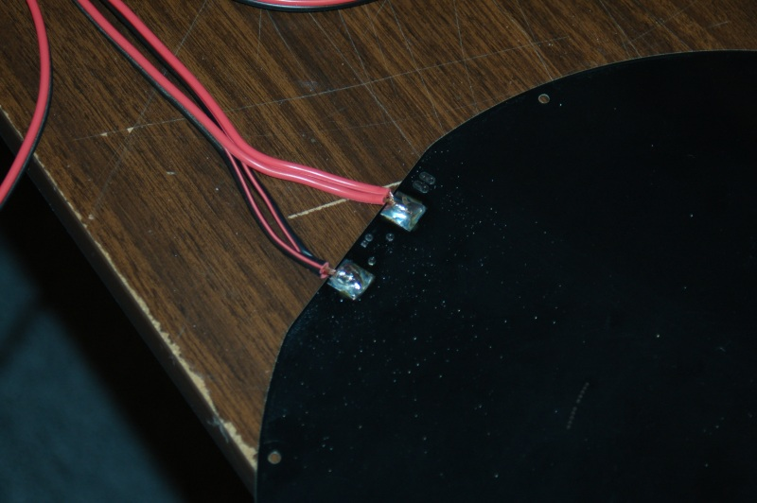

Figure 4 - Installing the power leads.

It should be noted that you need a good soldering iron to do this task. The surface area of the pads is quite large and will require a lot of heat to properly melt the solder. Tinning the power wires will help quite a bit.

Step 4 – Installing the resistor & power-on LED:

Instead of installing the resistor and power-on LED on the top of the bed, I recommend doing it from the bottom. I say this because build plate is so large that it won’t properly center on the bed if these components are mounted to the top of the bed as indicated by the top surface markings.

Install the resistor by laying the leads across the mounting holes and soldering it in place. Do the same for the power-on LED. The LED must be installed with the proper polarity in order for it to operate. The negative wire of the LED is closest to the “side” of the LED that has a flat spot ground in it (this is called the Cathode). Looking at the bottom of the heated bed, the negative lead is near the negative power input lead. (The black wire in Fig. 5)

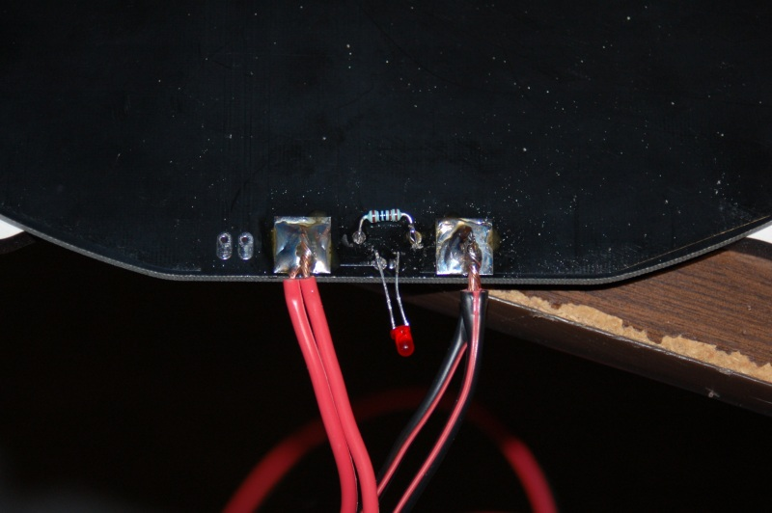

Figure 5 - Installing the Power-On LED & Resistor.

Step 6 – Installing the Thermistor Wiring:

This step is very simple and straightforward. The thermistor wires that you removed from the Phebe I heated bed get installed on the Onyx as shown in Fig. 6.

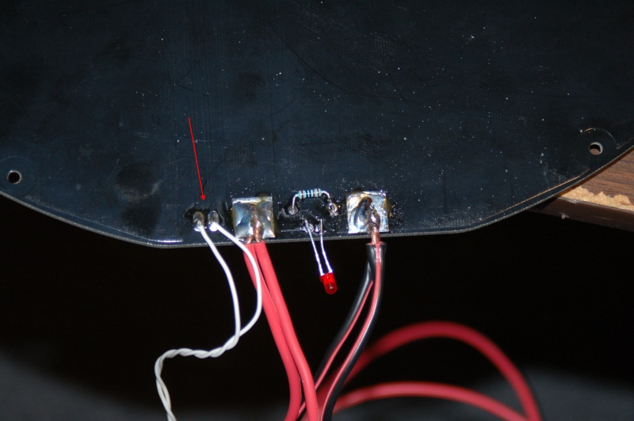

Figure 6 - Installing the thermistor wiring.

Step 7 – Installing the Onyx on your Rostock MAX:

This step takes a bit of prep. You’re going to want to route the power & thermistor wires through the same slot the Phebe I bed used. However, because the Onyx is so much larger, it actually partially covers that slot. Go ahead and route the wires through the slot and then lean the bed against one of the towers while you align the other components.

Place a Nylon spacer over each one of the six mounting holes you inserted a T-Nut into in Step 1 then carefully place the Melamine base plate atop those spacers. An easy way to help align them would be to use a small Jeweler’s screwdriver as a “pin” to hold the base in place and align the holes.

Set the Onyx on top of the Melamine base plate and start screwing it down using the #4-40 flat head screws. Please pay careful attention to the end of the bed where the wires are. The fit is VERY tight. Make sure that when you’ve got the bed firmly attached that the wiring is not applying any pressure to the Onyx itself. If it is, it’s going to cause a “high” spot in that area of the bed and cause problems with prints in the future.

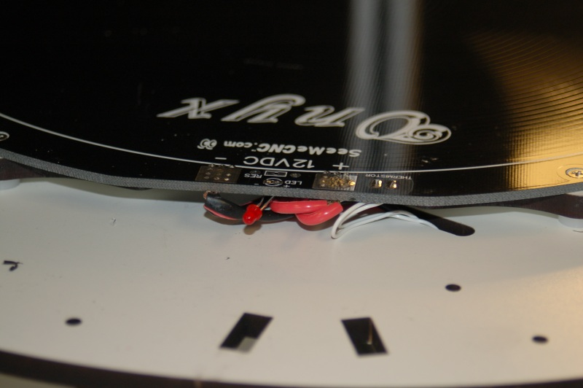

Figure 7 - Routing the wires.

Do NOT over-tighten the screws! Doing so will damage the Onyx!

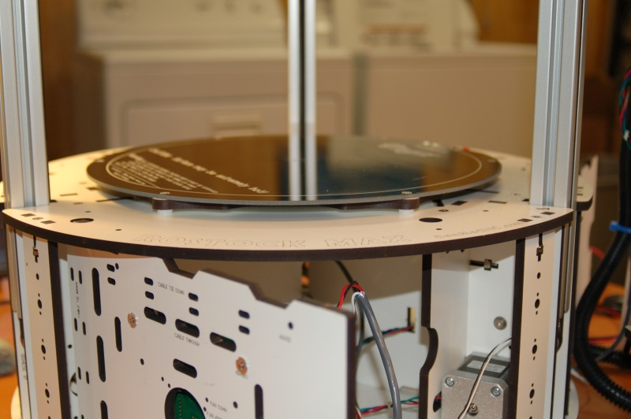

Figure 8 - Onyx bed installed.

Step 8 – Attach build plate and re-calibrate:

Simply set the glass on the bed, center it as best you can and clip in place using the binder clips that you used with your Phebe I bed. You may want to add more clips if you don’t feel that the four are sufficient. Don’t forget to carefully remove the tape you placed over the hole on the top of the bed!

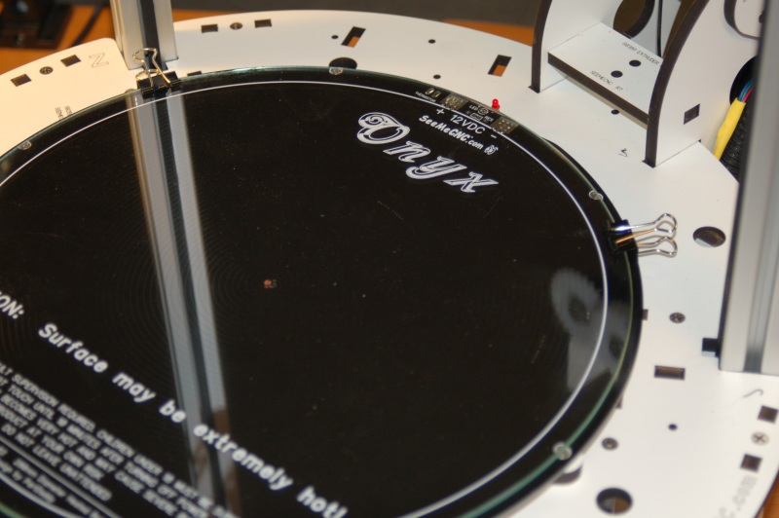

Figure 9 - Build plate installed.

The Onyx heated bed will change the Z height of your Rostock MAX by a small amount. Before printing any parts, you’ll need to repeat the calibration steps you performed when originally assembling your Rostock MAX.