

**AMA Computer College Naga City**

**Panganiban Dr, Camarines Sur, Naga**

**Documentary Requirement Presented**

**to the Senior High School Department for Work Immersion**

**________________________________**

In Partial Fulfillment of the Requirements

For

**Information Communication and Technology (ICT) Strand**

**PROGRAMMING**

**_________________________________**

**By:**

**JOHCEL GENE BITARA**

**Submitted To:**

**JEFFREY LEONEN**

**Work Immersion Adviser**

March 2021

**ACKNOWLEDGEMENT**

I would like to express my thanks of gratitude to our teacher online as well as our principal in our branch for their guidance and for allowing me to showcase the fruit of my skills throughout this whole school year which helped me learn new things and grow as a better student, for that, I am thankful for it.

I would also like to thank my parents for their time and effort in taking care of me while I work hours on this project and to my supported friends that helped me create ideas, advice, and give proper feedback on my project, their time and effort are greatly appreciated as it helped me balanced my project that made it better.

**TABLE OF CONTENTS**

TITLE PAGE ………………………………………………………………………………………………..I

ACKNOWLEDGMENT……………………………………………………………………………………..II

TABLE OF CONTENTS …………………………………………………………………………………..III

I. COMPANY NAME AND BRIEF DESCRIPTION……………………………………….

II. SYSTEM BRIEF DESCRIPTION………………………………………………………....

III. SCREENSHOTS OF THE SYSTEM……………………………………………………..

IV. PROGRAM CODE…………………………………………………………………………….

V. RESUME………………………………………………………………………………………….

VI. REFERENCE……………………………………………………………………………………

1. **COMPANY NAME AND BRIEF DESCRIPTION**

This project is more targeted to companies that are Game Studios. However, this project is not only specific to Games, It is also applicable to PC Applications or be used as an Online Application.

1. **SYSTEM BRIEF DESCRIPTION**

This project showcases and highlights the library; Photon Network in Unity Game Engine. The project uses Unity’s programming language: C-Sharp. An Object-Oriented Language similar to Java which uses classes and objects for handling data.

*“Photon Unity Networking (PUN) is a Unity package for multiplayer games. Flexible matchmaking gets your players into rooms where objects can be synced over the network. Fast and reliable communication is done through dedicated Photon server(s), so clients don't need to connect one to one.”*

As said, the Photon Network library takes the heavy work in handling servers and connections as it is easy to use.

This project’s main feature is the chat box system and the visual game scene of players when they are connected and are inside a room. How this entire project works is shown in this flow chart graph:

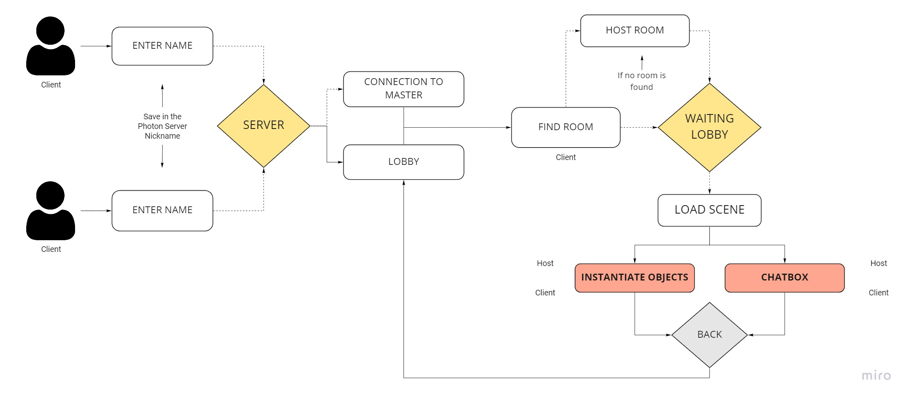

1. **SCREENSHOT OF SYSTEM**
2. **PROGRAM CODE**
3. **RESUME**

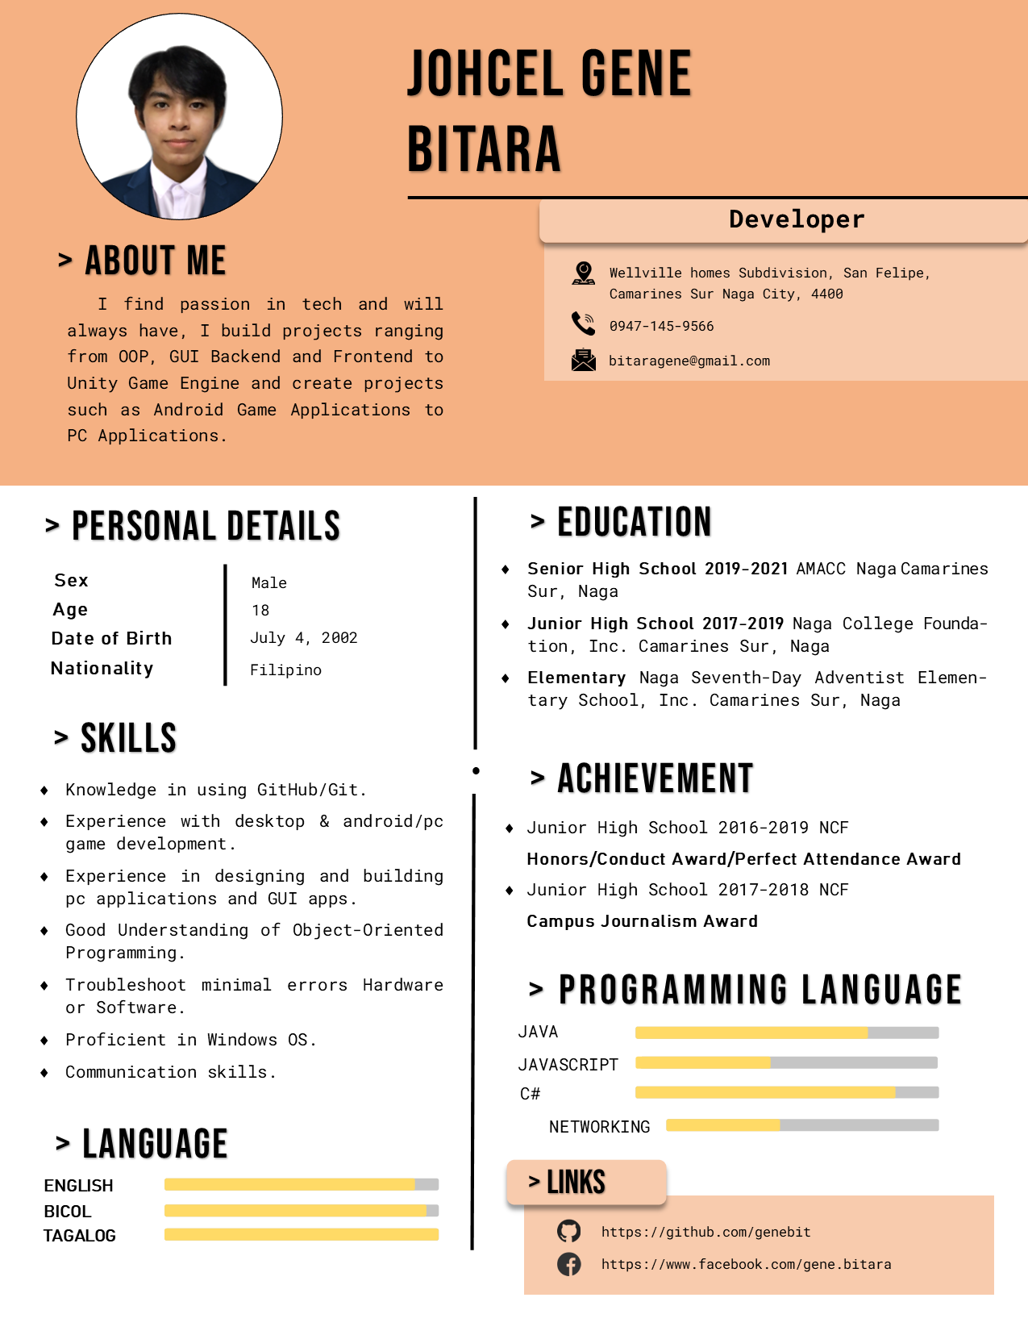

1. **REFERENCE**

[*https://www.photonengine.com/en-US/Photon*](https://www.photonengine.com/en-US/Photon)

[*https://dribbble.com/avatars*](https://dribbble.com/avatars)

*https://www.flaticon.com/*