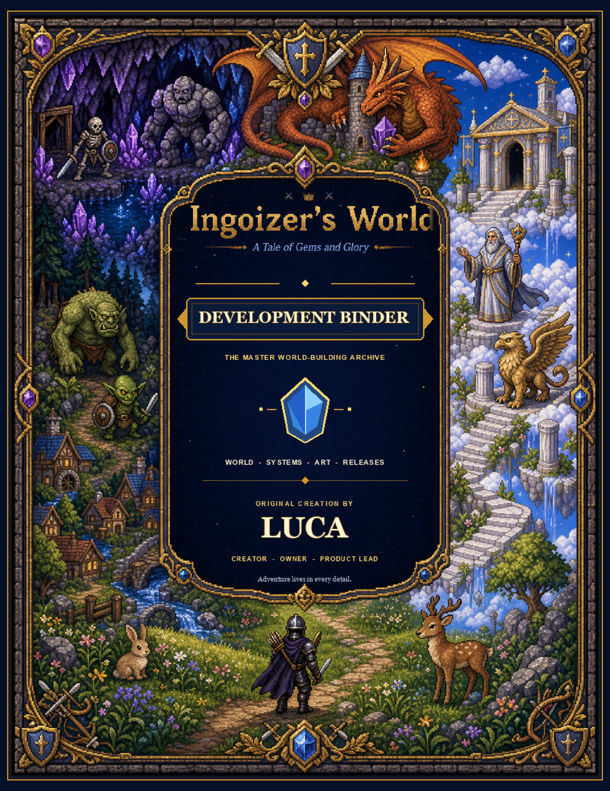
DEVELOPMENT REFERENCE
Ingoizer's World
A Clear Guide to the Game, Its Story, and Future Ideas
Working master | August 2026 | Current build: ab1b48f
Made for Luca, the creator, owner, and game leader. Pages about the current game and pages about new ideas are clearly labeled. Luca makes the final choices.

Binder Table of Contents
Use numbered divider tabs in the printed binder. New pages can be added behind a tab without changing the tab numbers.
Tab | Section | Primary contents | Status today
00 | How to Use This Binder | Who decides, page labels, update rules, and page list | In this guide
01 | Luca's Game Vision | What Luca wants players to feel and what must stay special | Good next page to make
02 | The Game Right Now | README, game link, controls, features, and known facts | README is ready
03 | The Story Right Now | Official story, where players learn it, exact lore, items, and open questions | In this guide
04 | Version 3.2 Proposal | Cover, goals, ideas, choices, and Luca's approvals | Cover and pictures exist
05 | Art Style Guide | Colors, pixel-art rules, character rules, world rules, and concept pictures | Strong draft exists
06 | Worlds and Maps | Main world, caves, Cloudlands, maps, exploration, and fog of war | Pictures exist; rules still needed
07 | Characters and Creatures | Ingoizer, hero choices, people, animals, monsters, and bosses | Current list and new pictures exist
08 | Game Rules | Fighting, elements, items, friends, shops, quests, rewards, and progress | The current code tells us the facts
09 | Screens and Controls | Start screen, inventory, shops, HUD, maps, easy-to-use options, and mobile | Version 3.2 pictures exist
10 | How the Code Works | Sixth-grade diagrams, game parts, memory, worlds, and future saves | In this guide
11 | Building and Testing a Release | What is included, work steps, tests, and bug list | Good next page to make
12 | Luca's Decisions | Approved ideas, rejected ideas, story changes, and release notes | Blank form below
13 | Creator's Workshop | Blank pages for ideas, story, lore, characters, worlds, quests, screens, tests, and releases | Printable master pages included
A | Extra Information | README, controls, source list, word list, and old reviews | README is included

How to put the binder together
- Place the illustrated Development Binder cover in the front sleeve.
- Add this master document behind Tab 00.
- Place the current README behind Tab 02.
- Place the Current Lore Compendium behind Tab 03.
- Place the Version 3.2 proposal cover and proposal pages behind Tab 04.
- Print the art review and concept pictures behind Tabs 05-09 using the page list below.
- Place the illustrated “How the Game Works” chapter behind Tab 10.
- Keep Luca's decision pages and release pages easy to replace. They will change often.
- Place the blank Creator's Workshop masters behind Tab 13. Keep one clean copy of every master and print a copy before writing on it.

Page labels
Put one of these labels on every page or design:
- CURRENT: This is in the playable game now and was checked in the code.
- PROPOSED: This is a new idea waiting for Luca's choice.
- APPROVED: Luca said yes, but it may not be built yet.
- IMPLEMENTED: The approved idea is now in the game.
- SUPERSEDED: A newer choice replaced this one. Keep it for history.
- REJECTED: Luca thought about this idea and chose not to use it.

Luca's decision form
Decision ID: IW-YYYY-NNN
Topic:
Choices considered:
Luca's decision:
How this changes the story or game:
Release it belongs in:
Date approved:
Building status:
Files or pictures affected:

How to Use This Binder

Luca is the game leader
Ingoizer's World is Luca's original creation. This binder keeps three things organized: the game as it is now, ideas for the future, and Luca's choices. Keep those three groups clearly labeled.
Luca must approve these choices:
- The identity, history and role of Ingoizer.
- Official story, places, names, and character relationships.
- What goes into each release and what gets built first.
- Final character, monster, boss and environment designs.
- Changes to difficulty, progression, rewards and endings.
- Public descriptions, logos, credits, and ownership words.

What to put at the top of a new page
Each new binder page should show:
- Section and document title.
- Its page label: Current, Proposed, Approved, Implemented, Superseded, or Rejected.
- The game version or build that was checked.
- Who made the page.
- The date it was updated.
- A decision number if Luca needs to approve it.

Where the current pages and pictures are
Page or picture | File location | Binder tab
Development binder cover | output/pdf/ingoizers-world-development-binder-cover.pdf | Front sleeve
Version 3.2 proposal cover | output/pdf/ingoizers-world-v3.2-design-proposal-cover.pdf | 04
Whole-game art review | docs/art-direction/ART_DIRECTION_REVIEW.md | 05
Start and character-selection concept | docs/art-direction/concepts/start-character-select-concept.png | 07 and 09
Main, cave and Cloudlands fog maps | docs/art-direction/concepts/*-fog-map-concept.png | 06 and 09
Inventory and shop concept | docs/art-direction/concepts/inventory-shop-concept.png | 09
Main-world, cave and Cloudlands environments | docs/art-direction/concepts/*-environment-concept.png and green-meadow-concept.png | 05 and 06
Monster size-and-shape picture | docs/art-direction/concepts/monster-roster-concept.png | 07
Sixth-grade guide to how the game works | This master, “How the Game Works” chapter | 10
Current README | README.md | 02 and Appendix A
Older game and code review | RECOMMENDATIONS.md | Appendix A; label it as old

Helpful pages to make next
- One-page game vision: Luca explains what the game is, who it is for, and what must always stay special.
- Version 3.2 summary: what the release should do, what it will not do, and which ideas need Luca's approval.
- Who is Ingoizer?: one page comparing the possible answers.
- Release test sheet: clear checks for fog of war, character selection, and the new inventory.
- Current build card: date, game link, code version, supported devices, and finished parts of the adventure.
- Story change list: every story change Luca approves, while keeping the older version for history.
- Playtest notes: who played, when they played, what happened, how serious each problem is, and Luca's choice.
- Art list: every character, monster, tile set, icon, and screen, labeled Final, Proposed, or Rejected.

The Story in the Current Game

What this section includes
This section explains the story that players can learn in the game right now. It keeps official story facts separate from game rules, clues in the world, and older ideas.
Main files checked:
- js/constants.js: Merlin's 11 lore pages, world names, items, enemies, bosses, Olympians, and riddles.
- js/game.js: the opening story, quests, discoveries, boss speeches, changes, and endings.
- js/world.js: places, maps, landmarks, and names shown in the world.
- js/ui.js: the Ancient Lore screen, item screens, riddles, and endings.
- index.html: the title, subtitle, controls, and named screens.
STORY RULE: Story text in the playable game is official right now. Instructions, random riddles, and simple item rules may not be story facts. RECOMMENDATIONS.md and the new concept art are ideas, not official story.

The current story in one page
The current game shows Ingoizer as one young male knight from Green Meadow. He wakes up with a rusty sword and bow. His quest is to find five Blue Gems. Ancient elemental spirits made the gems in Crystal Lake. A great disaster scattered them. The Black Knight wants the gems. He took over Ing Castle and made the land afraid.
The five gems awaken Fire, Water, Ice, Lightning, and Earth. Ingoizer needs all five to face the Black Knight. Beating him reveals the Green Knight's Domain, two Green Gems, and another champion. Four caves lie under the realm. They hold mazes, guards, Purple Gems, and powerful objects. At Crystal Lake, the Lady of the Lake tests Ingoizer. He must bring back Excalibur's jeweled sheath. Merlin was forced away from Ing Castle. He asks Ingoizer to find his wand, then gives him the Enchanter's Mallet.
The Worldtree stands in the far northeast. It is older than the mountains and touches two worlds. A fire arrow reveals a ladder hidden inside it. The ladder leads to the Cloudlands, a land of hard cloud and white marble. Strong keepers guard it. Beating five keepers wakes the Temple of Olympus. Zeus fights as the Twelve Olympians, one after another. When all 12 masks are gone, Ingoizer can fight Zeus himself. Winning turns all of Ingoizer's arrows into lightning bolts.

Where players learn the story
Story source | Where it is | What the player does | What the player learns
Opening words | Green Meadow starting point | Choose Begin Adventure | Ingoizer wakes up, must find five gems, learns about Ing Castle and animals
Ancient Lore library | Merlin's Hut near Ing Castle | Press E at the hut | 11 full lore pages about the main story and Cloudlands
Lady of the Lake | Island at Crystal Lake | Speak to the Lady | Excalibur, its sheath, the guardian troll and worthiness test
Merlin | Merlin's Swamp | Speak to Merlin | His exile, missing wand and Enchanter's Mallet quest
Blue Gems | Random places and monster drops | Pick up a gem | A new element awakens; five gems are needed at Ing Castle
Black Knight encounter | Outside Ing Castle | Approach with all five Blue Gems | His claim to the gems and the battle for the realm
Greenlands reveal | South after the Black Knight fight | Beat the Black Knight | The Green Knight, two Green Gems, and a new land
Cave discoveries | Four cave entrances and their rooms | Clear the obstacle, enter, and reach treasure or a boss | Underground guards, Purple Gems, and special items
Hidden base | Northwest wall inside Ing Castle | Use Ice Gem nearby, then climb | Ingozer's Armour, Bow of Arrow Strength and Rainbow Gem cache
Fountain of Youth | A set area near the meadow and village | Answer three random riddles | A magical healing fountain; its history is not explained
Worldtree | Far northeast | Unlock Fire, approach and shoot a fire arrow | Tree between worlds, non-mortal ladder and route to Cloudlands
Cloudlands | Above the Worldtree | Climb ladder | Sky country, keepers, Temple of Olympus and its challenge
Olympian encounter | Temple of Olympus | Defeat five keepers and approach temple | Twelve masks, Zeus's true form and divine reward
Maps and place names | Small map, world map, and area entrances | Explore or press M | Names and locations in the three world layers
Inventory and pickups | Throughout all realms | Obtain or inspect an item | Short histories and powers of relics, gems, weapons and armor
Victory screens | Green Knight and Zeus conclusions | Defeat the boss | Champion status, freedom of the land and mastery of the realms

Merlin's Ancient Lore Library
All 11 entries are available at Merlin's Hut near Ing Castle. The player walks to the hut, presses E, and uses Previous and Next. The exact words below come from js/constants.js. The screen that shows them is built in js/ui.js.
LUCA'S WORDS: The lore passages below are kept exactly as they appear in the current game. Some words may be above sixth-grade level because they are Luca's story words. They should not be simplified unless Luca chooses to edit them.

1. The Legend of Ingoizer
Learned at: Merlin's Hut.
Why it matters: Introduces Ingoizer, where he came from, his courage, and his main quest.
In an age of shadow and fading hope, a young knight named Ingoizer arose from the humble Green Meadow. Though armed with only a rusty sword and bow, his heart burned with courage that no darkness could extinguish. Destiny chose him to reclaim the stolen Blue Gems and restore peace to a land gripped by evil. His journey would take him through treacherous forests, scorching deserts, and haunted ruins — but Ingoizer would not falter, for the fate of the realm rested upon his shoulders.

2. The Five Blue Gems
Learned at: Merlin's Hut; repeated in the message shown when a gem is collected.
Why it matters: Explains who made the gems, what they do, and why they are spread across the land.
Long ago, five Blue Gems of immense power were forged in the heart of Crystal Lake by the ancient elemental spirits. Each gem holds the essence of a primal force — Fire, Water, Ice, Lightning, and Earth. Scattered across the land by a great cataclysm, the gems call out to those brave enough to seek them. When united, they grant the bearer mastery over all five elements and the strength to challenge even the darkest of foes. Monsters who have absorbed their energy may carry gem fragments within.

3. Merlin the Wizard
Learned at: Merlin's Hut; reinforced by Merlin's quest in the swamp.
Why it matters: Explains Merlin's past, why he lives in the swamp, why his magic is weaker, and what his mallet does.
I, Merlin, have walked these lands for centuries, watching kingdoms rise and fall. My swamp may seem humble, but it is steeped in ancient magic. I once served as advisor to the great kings of Ing Castle, until the Black Knight drove me into exile. My Enchanter's Mallet, a relic of the old world, can imbue weapons and armor with elemental fury. Though my powers have waned without my wand, my knowledge endures. Seek wisdom, young Ingoizer, for brute strength alone will not save the realm.

4. The Black Knight
Learned at: Merlin's Hut; reinforced outside Ing Castle.
Why it matters: Keeps his real name a mystery and explains why he took the castle and why all five gems are needed.
None know the Black Knight's true name — only that he appeared from the shadows when the gems were scattered. Clad in armor darker than midnight, with eyes that glow like embers of hate, he seized Ing Castle and claimed the gems as his own. His power grows with each passing day, feeding on the fear of the land. He commands legions of monsters and dark magic that grows stronger the longer the gems remain apart. Only one who carries all five gems can force him from the shadows to face battle.

5. Ing Castle
Learned at: Merlin's Hut; reinforced by the castle landmark and boss approach.
Why it matters: Explains what the castle used to be, how the Black Knight changed it, and why its gates are sealed.
Ing Castle once stood as a beacon of hope and justice, home to noble kings who ruled with wisdom and compassion. Its walls were built from enchanted stone, said to be unbreakable by mortal weapons. When the Black Knight conquered the castle, a dark shroud fell over its towers, and the once-golden banners turned to ash. The castle gates remain sealed to all but those who carry the five Blue Gems. Beyond those gates, the Black Knight waits, drawing power from the very stones that once protected the realm.

6. The Lady of the Lake
Learned at: Merlin's Hut; enacted through the Crystal Lake quest.
Why it matters: Explains who the Lady is, why Excalibur is special, and how Ingoizer must prove himself.
At the heart of Crystal Lake dwells the Lady of the Lake, an ethereal guardian who has watched over Excalibur since time immemorial. She is neither mortal nor spirit, but something in between — a keeper of ancient promises. The legendary sword Excalibur, forged by gods and tempered in starlight, rests in her care. She will bestow it only upon a warrior who proves their worth by recovering its jewel-encrusted sheath from the fearsome Sheath Guardian Troll that lurks in the Dark Forest.

7. The Elemental Powers
Learned at: Merlin's Hut; reinforced whenever a Blue Gem is collected.
Why it matters: Explains the five elements and what each one does in a fight.
The five elements — Fire, Water, Ice, Lightning, and Earth — are the fundamental forces that shaped this world. Fire burns with untamed fury, consuming all in its path. Water heals and cleanses, but strikes with the force of crashing waves. Ice freezes foes in their tracks, cold and merciless. Lightning strikes with devastating precision, the wrath of storms made manifest. Earth, the most ancient power, shakes the ground itself, stunning all who stand upon it. As Ingoizer collects the Blue Gems, these powers awaken within him. Master them all, and no enemy shall stand.

8. The Lands of the Realm
Learned at: Merlin's Hut; reinforced by map and zone-name displays.
Why it matters: Names the main lands and explains how each one feels.
The realm stretches from the peaceful Green Meadow in the west to the dread Darklands in the east. Camelot Village shelters honest folk and merchants. The Dark Forest hides dangers and treasures in equal measure. The Scorched Wastes bake under an unforgiving sun, while the Dragon Mountains pierce the clouds with jagged peaks. Merlin's Swamp bubbles with arcane energy, and the Ancient Ruins hold secrets of civilizations long forgotten. Each land harbors unique monsters and challenges for those who dare explore.

9. The Worldtree
Learned at: Merlin's Hut; hinted again when Fire unlocks; discovered in the far northeast.
Why it matters: Explains how old the tree is, how it joins two worlds, and why a fire arrow is the key.
In the farthest northeast corner of the realm, where no road runs and no monster dares nest, there stands a single ancient tree. It was old when the mountains were young. The elders called it the Worldtree, for its roots drink from this world while its crown drinks from another. No axe has ever marked it and no storm has ever bent it — but the old texts whisper of one key: fire loosed from a bowstring. Set a fire arrow into the Worldtree, and what the trunk conceals will finally be laid bare. A ladder. And it does not go down.

10. The Cloudlands
Learned at: Merlin's Hut; confirmed when climbing the Worldtree ladder.
Why it matters: Introduces the sky world, its guards, its temple, and the rule for waking the temple.
Above the sky there is another country. Islands of hardened cloud drift over a blue abyss, joined by bridges of vapour, and at their heart stands a temple of white marble that no mortal mason ever raised. This is the Cloudlands. Its guardians — storm harpies, golden griffins, giants of cloud and men of bronze — make the deepest cave troll look like a village nuisance. Slay five of the Cloudlands' keepers and the temple will wake. Something in it has been waiting a very long time for a mortal rude enough to climb.

11. The Twelve Olympians
Learned at: Merlin's Hut; demonstrated in the Temple of Olympus encounter.
Why it matters: Explains the 12-part boss fight, when Zeus can be hurt, and what the player wins.
Zeus does not fight as men fight. When he is roused he wears his family like armour: strike him and he is Hera; strike Hera and he is Poseidon, then Demeter, Athena, Apollo, Artemis, Ares, Aphrodite, Hephaestus, Hermes, Dionysus — twelve faces, twelve furies, and not one of them can be slain, for you cannot kill a god by killing the mask. Endure all twelve and the masks run out. What stands before you then is Zeus himself, and Zeus himself can bleed. Break him, and his bolts become your arrows.

Story Learned by Playing

Opening sequence
Where and when: Choose Begin Adventure; Ingoizer starts in Green Meadow.
What players learn: Ingoizer wakes with a rusty sword and bow. Five Blue Gems can be found in the world or carried by monsters. A dark enemy waits at Ing Castle. Fire can light arrows. Animals are safe and may join Ingoizer after he gives them apples.
The opening is the only story part every player must see. Merlin's library can be missed. Important game directions must still make sense if a player never finds the hut.

Lady of the Lake and Excalibur
Where and when: The Lady stands on the island at Crystal Lake, near tile 50,68. Press E to speak.
Quest steps: Meet the Lady -> beat the Sheath Guardian in Dark Forest -> take the jeweled sheath -> return to the Lady -> receive Excalibur, which is equipped automatically.
Story facts: The Lady has the mightiest blade ever forged. Excalibur is the famous sword of kings. Ingoizer proves he is worthy by showing courage. The magical sheath makes weapons stronger. The troll guards the test.

Merlin, his wand and the Enchanter's Mallet
Where and when: Merlin stands in Merlin's Swamp near tile 75,75. His old hut is near Ing Castle around tile 158,58.
Quest steps: Speak to Merlin -> get the wand from the hut -> return the wand -> receive the Enchanter's Mallet.
Story facts: Merlin calls himself the great wizard of the swamps. Losing his wand made him weaker. The hut near Ing Castle was his home. The Enchanter's Mallet can put elemental power into weapons and armor.

Blue Gems and elemental awakening
Where and when: Three gems appear in randomly chosen surface lands. Up to two more can be dropped by monsters carrying gems.
What players learn: Each gem unlocks the next element. After finding all five, Ingoizer is sent to Ing Castle. Unlocking Fire also brings back a verse about the Worldtree and the fire-arrow answer.

Black Knight and the fall of Ing Castle
Where and when: Walk to the outside gate of Ing Castle with all five Blue Gems.
What he says: The Black Knight says the gems belong to him and threatens Ingoizer.
What winning does: He drops the Dark Knight's Crest. Ingoizer's maximum health goes up. The Green Knight's Domain appears in the south.
The current game does not tell us the Black Knight's real name, where he came from, or why he acts this way beyond wanting power and using fear. An older idea calls him Sir Mordain. That idea is not official story.

Green Knight's Domain
Where and when: The southern land appears after the Black Knight is beaten. Find both Green Gems and walk to the Green Castle.
What players learn: Legends tell of the Green Knight and strong Green Gems. One gem raises attack. The other raises defense. The Green Knight says this is his land and calls Ingoizer an intruder. Winning gives Ingoizer the Magic Charm. The ending calls him the true champion and says the land is free.
In the current game, the Green Knight fights against Ingoizer. An older idea says he could be giving Ingoizer an honorable test. That idea has not been built.

The four caves
Locations and access:
- Southwest Cave: blocked by trees; Fire clears the entrance; maze and treasure.
- Southeast Cave: blocked by eternal flame; Water clears the entrance; maze and Purple Gem of Vitality.
- Northwest Cave: blocked by water; Ice clears the entrance; Stone Warden and Purple Gem of Fury.
- Northeast Cave: blocked by rocks; Earth clears the entrance; Crystal Titan, Purple Gem of Fortification and Titan's Gauntlet.
What the story says now: The caves are dark mazes or guarded places with valuable objects. The Stone Warden and Crystal Titan rise from the cave floor. They say no one may steal from their lands. The game does not explain where they came from, who made the Purple Gems, or how the four caves are connected.

Fountain of Youth
Where and when: The fountain appears in one of several planned spots near the meadow and village. Interact with it and answer three random riddles correctly.
What players learn: The fountain rewards wisdom. It becomes quiet after a wrong answer. It heals the player after all three right answers. The game does not say who made it or why its exact spot can change.
The riddle screen says “The Lady of the Lake” even when the player uses the Fountain of Youth. The same screen is probably being reused. The game does not confirm a story link between them.

Hidden base above Ing Castle
Where and when: Use the Ice Gem near the northwest wall inside Ing Castle. A frozen wall opens and shows a ladder to a secret base.
Artifacts: Ingozer's Armour, Bow of Arrow Strength and Rainbow Gem.
What the story says now: The hidden collection is legendary and was placed above the castle on purpose. The Rainbow Gem makes weapons, bows, and armor stronger. The game does not say who built the base, who owned it, or why it exists.

Worldtree discovery
Where and when: Far northeast near tile 193,6. Unlock Fire to remember a verse. Walk close for another hint. Shoot the tree with a fire arrow.
What players learn: The tree is older than the mountains and joins two worlds. Hands that were not human wore down the ladder steps. Fire burns away the tree and leaves the ladder standing in the air.

Cloudlands and Temple of Olympus
Where and when: Climb the ladder revealed inside the Worldtree.
What players learn: Islands made of hard cloud float over a blue emptiness. A white marble temple stands in the center. Storm Harpies, Thunder Wisps, Golden Griffins, Cloud Giants, and Bronze Talos guard the land. Beating five of them wakes the temple.

Twelve Olympians and Zeus
Where and when: Beat five Cloudlands keepers and walk to the Temple of Olympus.
The fight: Zeus says Ingoizer is far from his meadow. He warns that another god stands behind each form. Each hit shows the next form: Zeus, Hera, Poseidon, Demeter, Athena, Apollo, Artemis, Ares, Aphrodite, Hephaestus, Hermes, and Dionysus. After the 12th face is gone, Zeus returns as himself and can be hurt.
Ending: Zeus turns into weather. The ancient storm becomes quiet. Every arrow Ingoizer has now or finds later becomes a lightning bolt. The victory words say Ingoizer now commands the land, the caves below it, and the heavens above. The player may keep exploring.

Special Story Items
Item | Where the player gets or learns about it | What it means in the current story
Five Blue Gems | Exploring the surface, monster drops, Merlin's lore | Elemental spirits made them; together they unlock five powers and the Black Knight fight
Excalibur | Lady of the Lake quest at Crystal Lake | Legendary sword of kings, forged by gods and tempered in starlight
Jewel-encrusted Sheath | Sheath Guardian in Dark Forest | Proof of courage and a magical item that makes weapons stronger
Merlin's Wand | Merlin's Hut near Ing Castle | Gives back or increases Merlin's weakened power
Enchanter's Mallet | Reward from Merlin | Old-world relic that binds elemental energy into equipment
Dark Knight's Crest | Defeat Black Knight | Dark emblem of power that increases maximum health
Green Gem of Power | Green Knight's Domain | Raises attack forever during the current run
Green Gem of Fortitude | Green Knight's Domain | Raises defense forever during the current run
Magic Charm of Might | Defeat Green Knight | Shimmering charm that strengthens all weapons
Purple Gem of Vitality | Southeast Cave | Raises maximum health for the current run
Purple Gem of Fury | Stone Warden, Northwest Cave | Raises weapon damage for the current run
Purple Gem of Fortification | Crystal Titan, Northeast Cave | Raises armor defense for the current run
Titan's Gauntlet | Crystal Titan, Northeast Cave | A special item found in the titan's pieces that makes weapons and bows stronger
Ingozer's Armour | Hidden base above Ing Castle | “Most defensive armour in the land”; ownership history is unexplained
Bow of Arrow Strength | Hidden base above Ing Castle | Legendary bow equal to Excalibur in base damage and improved by gems/enchanting
Rainbow Gem | Hidden base above Ing Castle | Adds 4 points to weapons, bows, and armor
Ambrosia of Olympus | Hidden supplies in Cloudlands | A godly item that fully heals and gives gold and a Greater Potion
Zeus's Lightning Bolts | Defeat Zeus | Transforms all current and future arrows into divine bolts

Places and What They Tell the Player
Place | What it is like in the current game
Green Meadow | Ingoizer's simple home, waking place, and return point after defeat
Camelot Village | Safe home for friendly people and shopkeepers
Crystal Lake | Birthplace of the Blue Gems and home of the Lady of the Lake
Dark Forest | A dangerous place with hidden treasure and the Sheath Guardian
Scorched Wastes | Harsh desert under an unforgiving sun
Merlin's Swamp | A magical land where Merlin lives after being forced away from the castle
Dragon Mountains | Jagged peaks associated with dragon-kind
Ancient Ruins | Leftover buildings from people who lived long ago
Darklands | A frightening eastern land shaped by shadow
Ing Castle | A castle that once stood for fairness, now taken by the Black Knight
Green Knight's Domain | A southern land and champion's castle that appear after the Black Knight
Four Caves | Underground tests opened with elements; they hold special items
Worldtree | Ancient bridge between the surface realm and sky country
Cloudlands | A country above the sky, made from hard cloud and marble built by gods
Temple of Olympus | Center of Cloudlands and entrance to the Olympian fight

Story Choices for Version 3.2
These are not mistakes for someone else to quietly fix. They are story choices for Luca.

Choice 1: Who is Ingoizer?
In the current game: Ingoizer is one young male knight. The story uses “he,” “him,” and “his.” He comes from Green Meadow and has one special destiny.
The new question: The proposed start screen shows three men and three women. The story must explain whether they are different looks for one hero, six different people, or heroes who share the title Ingoizer.
Possible answers:
- Ingoizer is a hero title. The chosen hero becomes the current Ingoizer. All six choices can belong in the story. The game title and main quest stay the same.
- Ingoizer is one person with different looks. The six choices are different ways the same hero can look. The game changes words such as he, she, him, and her. Everyone shares the same past.
- Ingoizer stays one fixed hero. The six choices become companions or costumes, or character selection is removed. This requires the fewest story changes.
- There are six named heroes. Each hero has a name and a reason to be part of Ingoizer's World. This gives the most character detail but needs the most new writing, screens, and endings.
Luca needs to choose: the answer, the words used for the hero, the naming rules, and how pronouns work before the character-selection writing is finished.

Choice 2: Should the Black Knight's real name stay a mystery?
The current game says no one knows his true name. An older idea calls him “Sir Mordain, fallen First Knight of Ing Castle,” but the game does not say this. Luca should approve, change, or reject that idea before it becomes official story.

Choice 3: Why does the Green Knight fight Ingoizer?
In the current game, the Green Knight calls Ingoizer an intruder and fights him. A new idea says he could be an honorable champion testing Ingoizer. This choice would change what he says, how the ending feels, and why he has the Green Gems.

Choice 4: Who made the caves and Purple Gems?
The caves are important, but the game does not explain their past. Luca could connect the Stone Warden, Crystal Titan, elemental locks, and Purple Gems to the spirits who made the Blue Gems. He could also create a different group that lived underground.

Choice 5: Who owned the hidden base?
The base holds “Ingozer's Armour,” a bow as strong as Excalibur, and a Rainbow Gem. The game does not explain why. “Ingozer” is also spelled differently from “Ingoizer.” Luca can decide if this is a spelling mistake, an ancestor, a group, an older hero, or another person.

Choice 6: How do all the myths fit in one world?
The game brings together Camelot, Merlin, Excalibur, the gem story, and the Greek gods. This can be fun and magical. A short explanation would show why they belong together. They might all live in one realm. Different realms might meet at the Worldtree. The world might also bring in legends from many cultures.

Choice 7: What happens to the Worldtree after it burns?
In the current game, fire burns the ancient tree so Ingoizer can reach Cloudlands. Luca can decide if the tree grows back, changes instead of dying, was always a door meant to open, or causes a later problem. The answer will affect how this moment feels.

Choice 8: Is the Fountain connected to the Lady?
The riddle screen shows the Lady's name, but the code treats the fountain as a separate object. Luca can decide if the Lady watches over both waters, if the name is only a screen mistake, or if another guardian should speak.

Helpful story work for Version 3.2
- Decide who Ingoizer is before writing the character-selection screen.
- Let the lore list mark each page Hidden, Found, or Read.
- Let players find lore during the adventure instead of showing all 11 Merlin pages at once.
- Add one cave lore entry and one Green Knight entry.
- Add one sentence explaining the hidden base and the “Ingozer” spelling.
- Save a copy of all current story words before changing them.
- Keep a list of Luca-approved story changes behind Tab 12.

Putting the Version 3.2 Proposal Together

Ideas already included in the proposal
- Fog of war: maps for the main world, caves, and Cloudlands that uncover as the player explores.
- Character selection: six hero looks and a story choice about who can be Ingoizer.
- New inventory and character screen: equipment, number comparisons, pictures, and information that are easier to understand.

Concept pictures that support the proposal
- Sample picture of the start and character-selection screen.
- Main-world, cave-system and Cloudlands environment upgrades.
- Main, cave and Cloudlands fog-of-war maps.
- Inventory and shop redesign.
- Monster shape and size lineup.
- One polished sample of Green Meadow.
- Illustrated world map.

Suggested page order
- Version 3.2 proposal cover.
- One-page summary and a place for Luca's approval.
- What the current game does and what could be clearer.
- What this release should and should not change.
- Decision page: Who is Ingoizer?
- Character-selection idea and sample screen picture.
- Rules for how fog of war should work.
- Three fog-map concept plates.
- Inventory and character-screen proposal.
- New art ideas for worlds and creatures.
- How the team could build the ideas and which parts depend on other parts.
- Pass-or-fail checks and a playtest plan.
- How much work there is, what order to use, and what might go wrong.
- Final Luca decision page.

What Version 3.2 should try to do
- Make exploration feel mysterious without making navigation frustrating.
- Help players feel connected to the hero while keeping the story of Ingoizer's World clear.
- Make equipment, stats, items and comparisons understandable at a glance.
- Add more visual detail while keeping the warm style and easy-to-recognize pixel shapes.
- Make keyboard, touch, small landscape screens, and helpful access options work equally well.

What Version 3.2 should not change unless Luca says so
- Do not add fighter classes unless Luca chooses to make character selection a bigger feature.
- No stat advantages tied to gender or cosmetic hero choice.
- Do not rebuild the whole world.
- No replacement of the friendly animal or Olympian direction that already works.
- Do not change an old story fact without recording Luca's choice.

How to Know the New Features Work
These are starter checks for the proposed Version 3.2 features. They describe future ideas, not the current game.

Fog of war
- Places the player has never seen do not show land shapes, names, markers, or hidden goals.
- Places explored before stay on the map, but do not show moving characters that are out of sight.
- Places the player can see right now show the full current picture.
- The main world, each cave, and Cloudlands remember their own explored areas.
- The map remains usable on desktop and compact landscape screens.

Character selection
- Exactly three men and three women are available.
- Every choice has the same game numbers and access unless Luca approves classes.
- Every hero looks different in both the portrait and the small game sprite.
- Every pronoun, speech, and ending matches Luca's choice about who Ingoizer is.
- A future save system remembers the chosen hero look.

Inventory and character screen
- Equipment, owned items, usable items, and quest items are easy to tell apart.
- Weapon, bow, and armor comparisons show the old and new numbers next to each other.
- Close and Back buttons stay visible on every supported screen size.
- Color is never the only clue. Use words, shapes, or icons too.
- Original item names, powers and quest rules remain accurate.

How Ingoizer's World Works

A sixth-grade guide to the game and its systems
Status: CURRENT explanation, with future ideas clearly marked PROPOSED
Audience: Luca and anyone helping him. It is written at about a sixth-grade level and follows the game from a button press to a boss reward.
BIG IDEA: A game is a group of parts working together very quickly. The Game class is like a conductor leading a band. It listens to the player, updates the current world and characters, checks the rules, and tells the screen and speakers what happened.
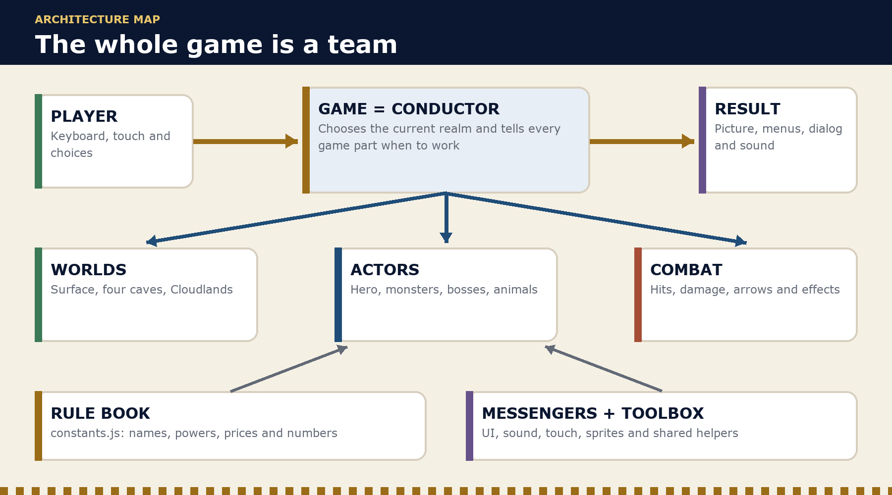
Figure 10.1 - The conductor connects the player, worlds, characters, rules, and results.

Words to know
Word | Plain meaning in this game
Architecture | The plan that shows how all the game parts fit and work together
System | A part of the game with one main job, such as combat, maps or sound
State | Facts that can change, such as health, gems, quests and the current realm
Game loop | The fast repeating cycle that listens, updates the game and draws the next picture
Trigger | An event the code can notice, such as entering a place or defeating a boss
Render | To draw the world, characters, effects or interface on the screen
Flag | A named yes/no or step-by-step fact that remembers whether something happened
Instance | One created copy of a game object. Each of the four caves has its own copy of CaveWorld.

The eight building blocks
Building block | Sixth-grade explanation | Where it lives
Stage | Holds the canvases, menus, buttons and overlays the player can see or touch | index.html
Style book | Decides how the stage, menus, HUD and screens look | css/style.css
Rule book | Names weapons, monsters, gems, zones, bosses, prices and important numbers | js/constants.js
Conductor | Starts the adventure, remembers the current play session, and tells the systems when to work | js/game.js
Worlds | Builds and draws the surface, four caves and Cloudlands; answers “can I walk here?” | js/world.js
Actors | Gives the hero, monsters and bosses their bodies, movement, health and behavior | js/entities.js, js/animals.js, js/sprites.js
Referee | Decides which attacks hit, how much damage happens, and which effects appear | js/combat.js
Messengers | Turn game events into HUD, dialogs, shops, inventory, sound and touch controls | js/ui.js, js/sound.js, js/touch.js

js/utils.js is a shared toolbox. It helps with distance, random choices, map positions, touching objects, and other small jobs used by several systems.

What happens during one game heartbeat
The browser repeats this loop many times each second. A smooth game often completes the whole circle about 60 times each second.
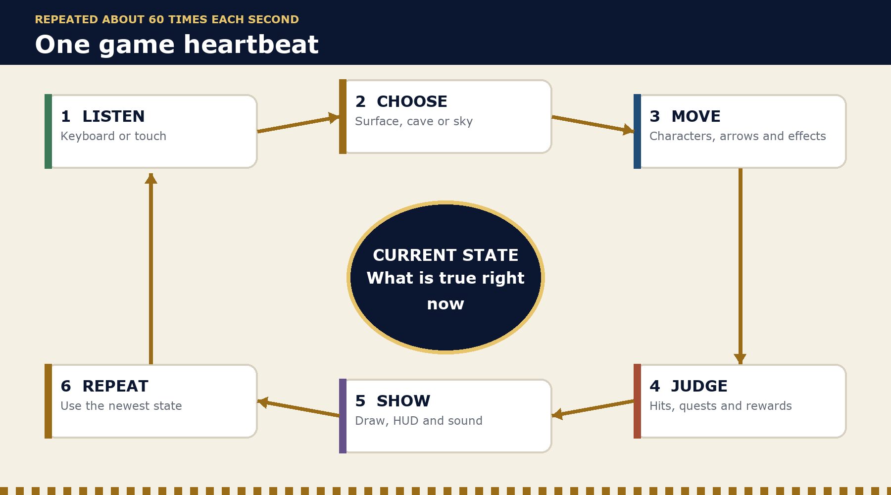
Figure 10.2 - One complete update-and-draw heartbeat; every step uses and changes current state.
- Listen: keyboard or touch controls report what the player is trying to do.
- Choose the stage: the conductor selects the surface, the active cave or Cloudlands.
- Move the actors: player, monsters, bosses, animals, arrows and effects update.
- Check results: touching objects, attacks, pickups, quests, gates, deaths, and rewards are checked.
- Tell and draw: the world, actors, particles, HUD, map, dialog and sound show the result.
- Repeat: the next heartbeat begins with the newest state.

The game remembers a run in layers
“State” means facts that can change. Examples are health, collected gems, the current realm, defeated bosses, open quests, and revealed ladders. Right now, the browser remembers these facts only while the game is open.
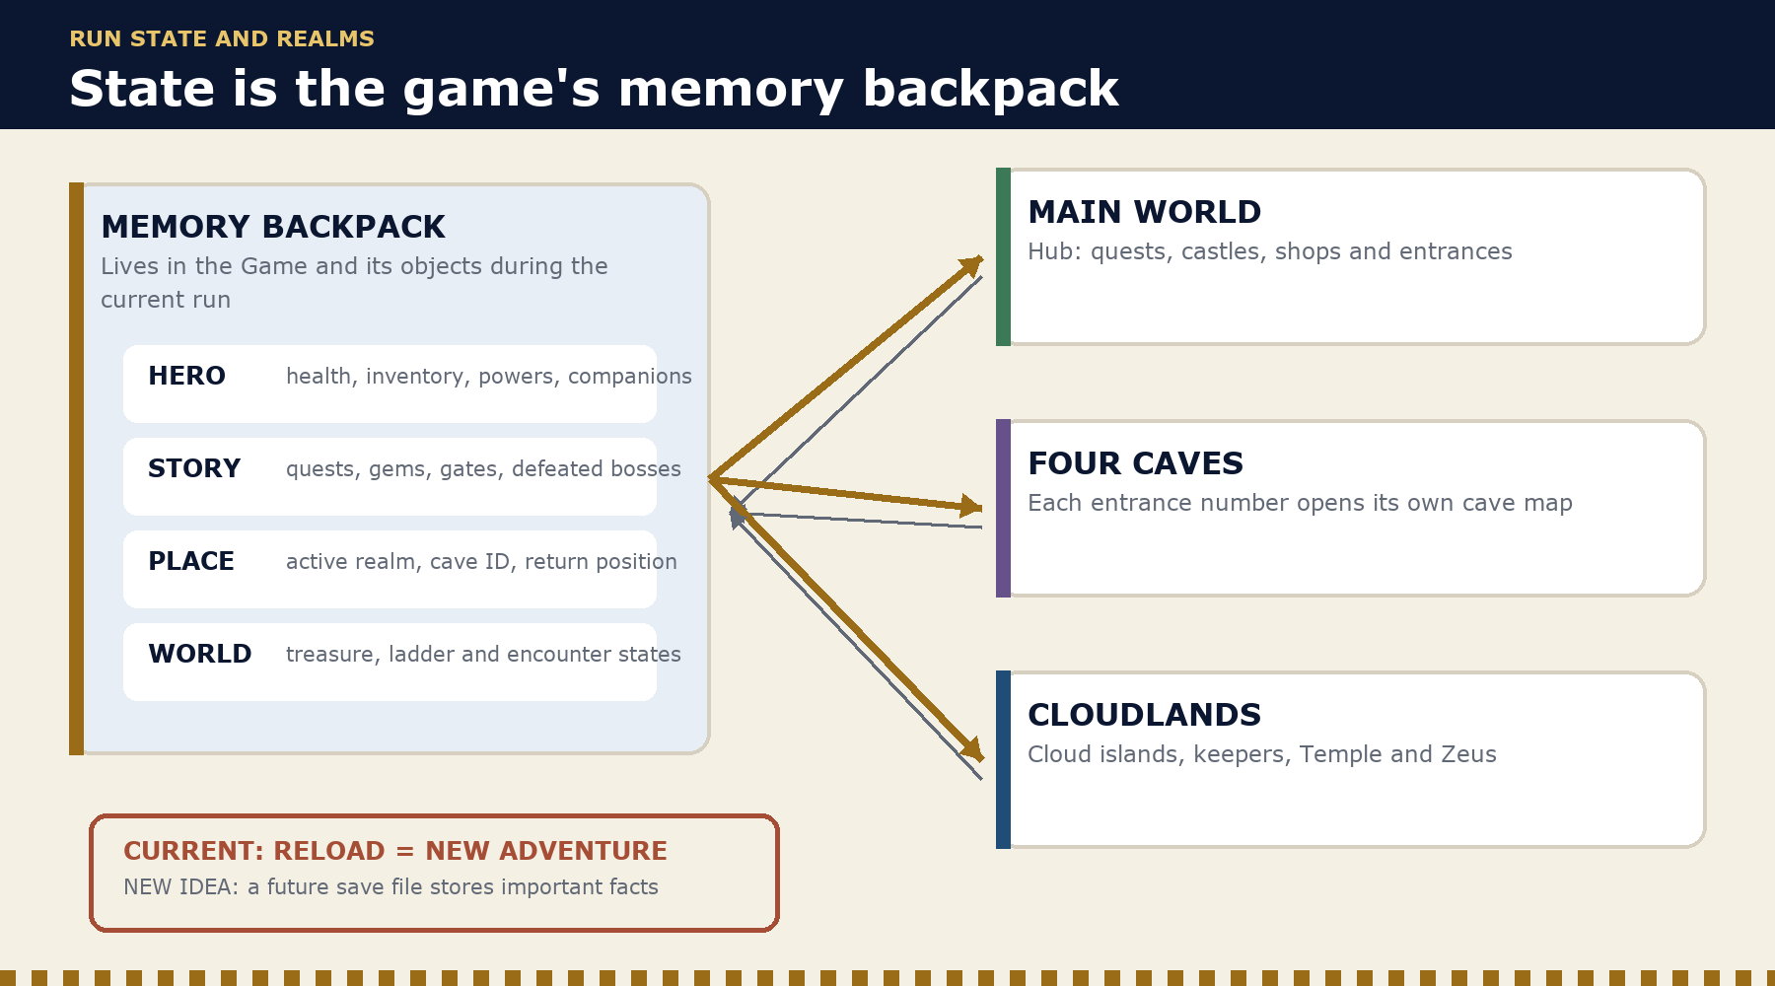
Figure 10.3 - One hero's game facts travel through all three realms during the current play session.
CURRENT LIMIT: The current game does not have a permanent save system. Restarting or reloading begins a new adventure. savedSurfacePos only remembers where Ingoizer should return during the same play session after visiting a cave or Cloudlands. A future save system would need to record important facts, check that they are safe to use, and rebuild the same adventure later.

How the three realms connect
- Main world: the central hub. It owns zones, shops, Blue Gems, the Lady, Merlin, the Black and Green Knight arcs, cave entrances, the Fountain and the Worldtree.
- Four caves: four separate copies of CaveWorld, each matched to an entrance number. Every cave has its own rooms, monsters, exits, obstacles, treasure, and possible boss.
- Cloudlands: one SkyWorld reached by the Worldtree ladder. It contains the cloud islands, keepers, Ambrosia, temple, and Olympian fight.
- The conductor carries the hero between them: the player, inventory, powers and companions remain part of the same run while the active world changes.

Use this game plan when designing Version 3.2
Feature | Rules and state | Game logic | World or actors | Player-facing result
Fog of war | A map list for explored spaces in each realm | Update spaces the player can see or has seen | Maps draw unseen, explored, and visible spaces differently | Clear map key, discovery feedback, and support for a future save system
Character selection | Six equal hero choices and the number of the chosen hero | Choose before startGame() makes the player | The small hero and portrait use the chosen look | The start screen, pronouns, and endings match Luca's story choice
Inventory redesign | The same facts about owned, equipped, quest, and upgraded items | Keep equip, use, buy, and sell rules correct | Item pictures and the hero preview match the facts | One clear character screen for keyboard and touch

A good feature plan follows one fact through the whole game: name it, change it, show it, test it, and save it if it should still exist after a reload.

Luca's five questions for tracing any feature
Use these questions when a new idea feels complicated. If each answer is clear, the system usually has a sensible home.
- What fact changes? Example: “this tile has been explored” or “this fox is the selected companion.”
- Who owns that fact? The player, one realm, one actor, the conductor or future save data?
- What event changes it? A button press, touching something, a pickup, quest, timer, boss win, or return from another realm?
- Who needs to know? World drawing, combat, UI, sound, dialog, map, touch controls or several of them?
- How will we prove it works? Decide what players should see, what happens in unusual cases, what a reload does, and how to playtest it.
CREATOR HABIT: Explain a feature once as a player story and once as a state change. “I explored a dark cave and my map remembered it” becomes “visible tiles update the cave's discovery grid; the map renders that grid; future save data stores it.”

Secret Builder

Use the game plan to create secrets with a reason
Status: PROPOSED idea-making tool. The examples are not in the current game and are not official story.
A GOOD SECRET is hidden but fair. The player notices clues, tries an idea, sees the world answer, and earns a reward that fits the secret.
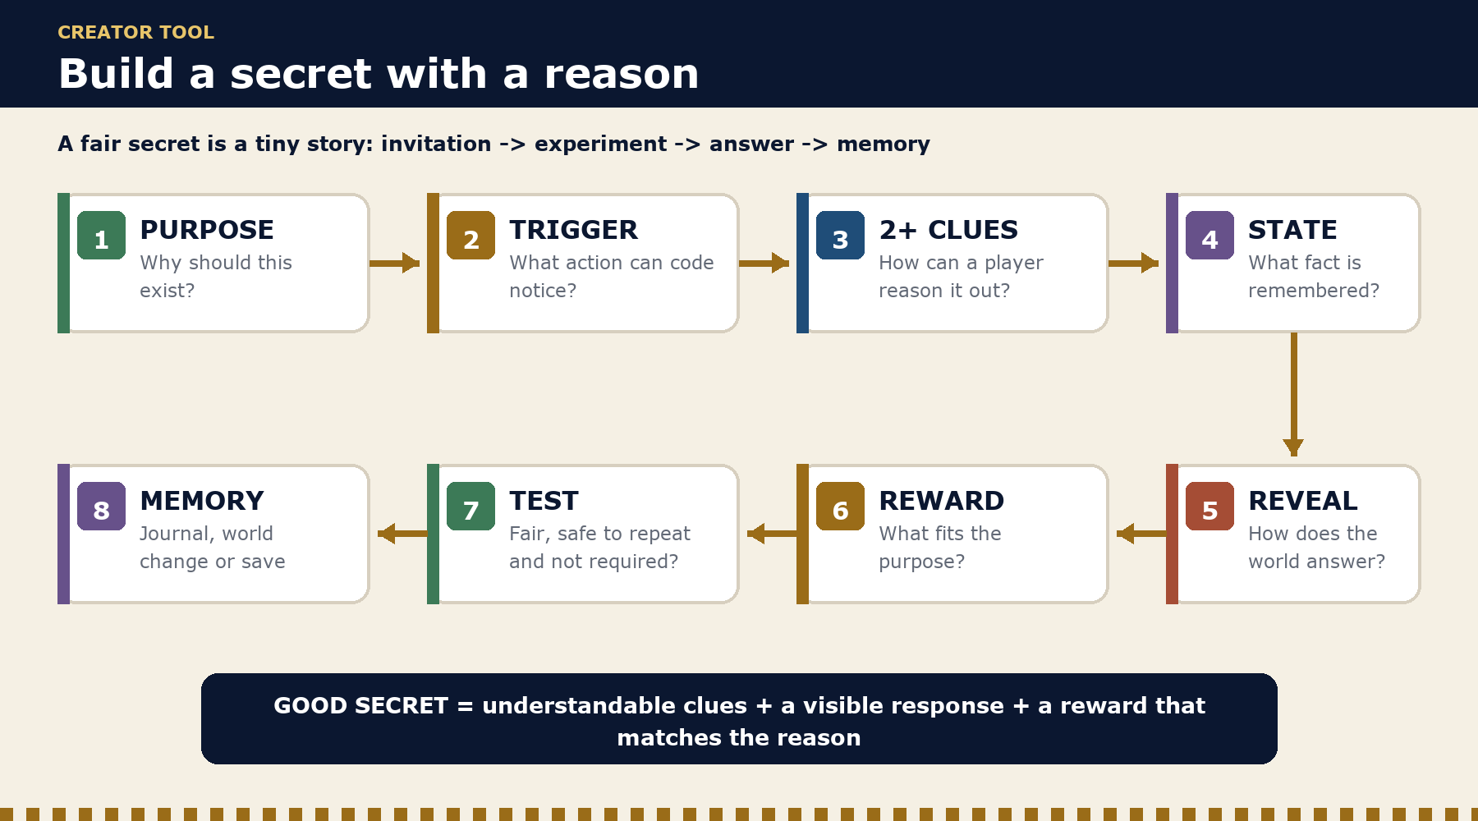
Figure 10.4 - A reusable path from design purpose to a fair, remembered discovery.

First, decide why the secret should exist
Reason for a secret | What the player should feel | Good reward types
Exploration | “I found a place most players might miss.” | Shortcut, hidden room, map detail, treasure
Lore | “I understand this world better now.” | Journal page, mural, NPC memory, new dialog
Mastery | “I used a game rule cleverly.” | Upgrade, rare material, efficient route
Kindness | “The world noticed how I treated its creatures.” | Animal friendship, safe haven, cosmetic token
World connection | “Things in different realms belong to one story.” | Clues in several realms, a star picture, or joined special items
Playfulness | “The creator left me a delightful surprise.” | Harmless animation, sound, costume or joke room

Luca's seven-step secret recipe
- Purpose: Write one sentence that says why this secret belongs in Ingoizer's World.
- Trigger: Choose something the code can notice. It might be a place, item, element, animal friend, action order, time, or finished quest.
- Clues: Give at least two hints through the world, lore, sound, map, or speech. The secret can be hard, but it should not need a wild guess.
- Memory flag: Name the fact the game remembers, such as foxGroveDiscovered. Decide when it is Hidden, Found, Finished, and Rewarded.
- Reveal: Change something players can see or hear so they know their idea worked.
- Reward: Choose a reward that fits the purpose. A secret does not always need to make fighting easier.
- Test: Make sure the secret can be found, cannot give its reward twice by mistake, works with touch and keyboard, and never blocks the main adventure.

Three example secrets Luca could think about

The Fox's Apple Trail — kindness
PROPOSED: A fox friend pauses at three stones marked with paws. Visiting all three in any order reveals a tiny apple grove. The code checks which animal is with the player and which places were visited. The world shows the grove. The screen and sound celebrate. A memory flag stops the reward from being given twice. The reward is about friendship, not fighting power.

The Echoing Cave Runes — mastery and lore
PROPOSED: A cave wall shows two element symbols and one broken symbol. Clues nearby help the player find the missing element. Using the three powers in the right order opens a small lore room. The fighting system reports which powers were used. The cave checks the order. One wall piece changes, and the lore screen remembers the discovery.

The Three-Realm Star — world connection
PROPOSED: One star mark appears on the surface, one in a cave, and one above the clouds. Finding all three finishes a star picture in the journal. It also explains why the realms reflect one another. Each realm remembers its own discovery. The conductor notices when the set is complete. The reward is a story page and a glow around the arrow holder. The glow does not change fighting power.

Secret design card
SECRET DESIGN CARD | WORKING NOTES
Secret name | Write here
Why it exists and how it should feel | Write here
Current game or new idea? | Write here
Clue 1 and location | Write here
Clue 2 and location | Write here
Trigger the code can recognize | Write here
Memory name and what a reload does | Write here
World change or reveal | Write here
Reward | Write here
Game parts needed | Write here
What might confuse the player | Write here
Luca's decision number | Write here

CREATOR CHECK: If a secret has no reason, no clues, or no satisfying answer, it is only hidden information. Give every secret a tiny story: invitation, experiment, answer, and memory.

Creator's Workshop

Blank master pages for Luca's ideas
Status: WORKING NOTES. Nothing written on these pages becomes official until Luca approves it.
PRINTING RULE: Keep one clean master of every worksheet behind Tab 13. Print or photocopy a fresh page before using it. Add more pages whenever Luca needs them.
These pages turn a big idea into smaller choices that are easier to explain, draw, build, and test. Luca can use only the page he needs. He does not have to fill every box.
Blank master | Best time to use it
Big Idea Spark Sheet | A new idea is exciting but still hard to explain
Story Arc and Plot Map | A whole adventure needs a beginning, middle, biggest test, and ending
Story Timeline | Events and clues need to happen in a clear order
Lore Entry Builder | A new fact, legend, memory, book, mural, or speech may join the official story
Character Creator | A hero, friend, shopkeeper, guide, rival, or villain needs a clear role and look
Relationship Web | Characters need friendships, rivalries, secrets, promises, or family ties
Creature and Monster Designer | An animal or enemy needs a readable shape, behavior, habitat, and fair rules
Location and Map Designer | A new room, path, town, cave, island, or realm needs a purpose and layout
Quest Builder | A task needs a reason, steps, clues, obstacles, and a reward
Boss Fight Planner | A boss needs a story reason, fair signals, phases, counters, and a result
Puzzle and Mystery Planner | A challenge needs an answer, clues, feedback, and a fair way to try again
Item, Reward, and Shop Designer | An item needs a use, value, place in the world, and clear shop rules
Screen and Menu Sketch | A screen needs a purpose, layout, controls, and a clear next action
Feature and System Builder | A feature needs facts, triggers, game parts, visuals, saving, and tests
Playtest and Bug Hunt | A tester's actions and problems need to be recorded without guessing
Release Planner | A game version needs a goal, included work, checks, and a stopping point
Luca's Decision Record | An important choice needs Luca's answer and a record of what it changes

CREATOR'S WORKSHOP | BLANK MASTER | PRINT A COPY BEFORE WRITING

Big Idea Spark Sheet
Catch the exciting part first. Then find the smallest version that could prove the idea is fun.
CREATOR: | DATE: | GAME VERSION: | PAGE LABEL:

LUCA'S IDEA IN HIS OWN WORDS
Write or draw the idea exactly as Luca first explains it.

PLAYER FEELING  What should the player feel? | WHY IT BELONGS  Why does this fit Ingoizer's World?

WHAT THE PLAYER DOES  Actions, choices, controls | HOW THE WORLD ANSWERS  What changes on screen or in sound? | WHAT THE PLAYER EARNS  Reward, knowledge, access, or delight

CURRENT PARTS IT USES  Characters, places, items, rules, or code already in the game | NEW PARTS IT NEEDS  Art, sound, story, rules, screens, or code

SMALLEST FUN TEST  What tiny version could we build or act out first? | QUESTIONS TO ANSWER  What is still unclear?

NEXT STEP  [ ] Keep thinking [ ] Draw it [ ] Build a tiny test [ ] Playtest [ ] Decide | LUCA'S DECISION ID  Only needed after Luca decides

CREATOR'S WORKSHOP | BLANK MASTER | PRINT A COPY BEFORE WRITING

Story Arc and Plot Map
Plan the change from the hero's starting problem to the choice or victory at the end.
CREATOR: | DATE: | GAME VERSION: | PAGE LABEL:

STORY NAME  Working title | MAIN HERO OR GROUP  Who changes during this story?

STARTING WORLD  What is normal at first? | WANT OR NEED  What does the hero want, and what do they truly need?

THE STORY BEGINS WHEN...  What event makes the hero act? | FIRST HARD CHOICE  What choice proves this adventure matters?

MIDDLE: TROUBLE GROWS  List new problems, discoveries, allies, clues, or losses. | MIDDLE TURN  What discovery changes the hero's plan?

BIGGEST TEST OR CLIMAX  What must the hero do, risk, or choose? | ENDING  What happens because of the hero's choice?

WHAT CHANGED?  Hero, world, relationships, or rules | WHAT IS STILL OPEN?  Questions that can lead to another adventure

NEXT STEP  [ ] Keep thinking [ ] Draw it [ ] Build a tiny test [ ] Playtest [ ] Decide | LUCA'S DECISION ID  Only needed after Luca decides

CREATOR'S WORKSHOP | BLANK MASTER | PRINT A COPY BEFORE WRITING

Story Timeline
Put events, clues, and choices in order. Use arrows when two events cause each other.
CREATOR: | DATE: | GAME VERSION: | PAGE LABEL:

1. LONG BEFORE THE GAME  Old event, legend, promise, disaster, or mystery | 2. JUST BEFORE THE GAME  What recently changed?

3. OPENING  What does the player see, learn, and do first? | 4. FIRST TURN  What sends the player in a new direction?

5. MIDDLE DISCOVERY  A clue or truth changes what the player believes | 6. TROUBLE GETS BIGGER  A cost, setback, or new danger

7. BIG CHOICE OR BATTLE  The event everything has been leading toward | 8. RESULT  What changes right away?

PLOT THREADS TO FOLLOW
Track promises, mysteries, missing people, special items, rivals, and world problems.

CLUES THAT MUST APPEAR EARLIER  Make the result feel earned, not random. | FUTURE STORY SEEDS  Small questions that may matter later

NEXT STEP  [ ] Keep thinking [ ] Draw it [ ] Build a tiny test [ ] Playtest [ ] Decide | LUCA'S DECISION ID  Only needed after Luca decides

CREATOR'S WORKSHOP | BLANK MASTER | PRINT A COPY BEFORE WRITING

Lore Entry Builder
A lore idea is not official until Luca approves its exact words and the game gives players a way to learn it.
CREATOR: | DATE: | GAME VERSION: | PAGE LABEL:

LORE TITLE  Name of the book, memory, mural, speech, place, or legend | FACT OR LEGEND?  Is it true, believed, uncertain, or a lie told by someone?

LUCA'S EXACT DRAFT
Keep Luca's words as Luca wrote or said them. Mark any later editing separately.

WHERE PLAYERS LEARN IT  Person, item, place, event, screen, or secret | HOW THEY FIND IT  Main path, optional exploration, reward, or puzzle

WHY IT MATTERS  What does this help the player understand or feel? | FACTS IT MUST NOT CHANGE  Names, events, rules, or relationships already official

VISUAL OR SOUND CLUE  Symbol, color, object, music, voice, or environment detail | NEW QUESTIONS IT CREATES  A good mystery can invite another discovery

NEXT STEP  [ ] Keep thinking [ ] Draw it [ ] Build a tiny test [ ] Playtest [ ] Decide | LUCA'S DECISION ID  Only needed after Luca decides

CREATOR'S WORKSHOP | BLANK MASTER | PRINT A COPY BEFORE WRITING

Character Creator
Make the character readable as a person and as a game piece: shape, purpose, choices, and voice.
CREATOR: | DATE: | GAME VERSION: | PAGE LABEL:

NAME AND ROLE  Hero, friend, guide, shopkeeper, rival, villain, or other | WHERE WE MEET  Realm and exact place

SKETCH  Front view, side view, size, important shapes | LOOK AND SILHOUETTE  Clothes, face, hair, colors, objects, and one detail seen at small pixel size

WANTS  What are they trying to get or protect? | FEARS OR AVOIDS  What makes choices hard? | STRENGTH AND FLAW  One of each

PERSONALITY AND VOICE  How do they act and speak? Keep sample words in Luca's voice. | RELATIONSHIPS  Who do they trust, love, owe, fear, or oppose?

GAMEPLAY ROLE  What can the player do with or because of them? | STORY CHANGE  What is different after meeting them?

NEXT STEP  [ ] Keep thinking [ ] Draw it [ ] Build a tiny test [ ] Playtest [ ] Decide | LUCA'S DECISION ID  Only needed after Luca decides

CREATOR'S WORKSHOP | BLANK MASTER | PRINT A COPY BEFORE WRITING

Character Relationship Web
Draw lines between people. Label each line with what both characters want, know, or hide.
CREATOR: | DATE: | GAME VERSION: | PAGE LABEL:

MAIN CHARACTER OR GROUP
Write the name in the center before drawing the web.

DRAW THE RELATIONSHIP WEB
Add friends, family, rivals, mentors, enemies, promises, debts, and secrets. Use arrows to show one-way feelings or knowledge.

STRONGEST BOND  Why does it hold? | BIGGEST TENSION  What could break or change?

WHO KNOWS A SECRET?  What do they know and why have they stayed quiet? | RELATIONSHIP THAT CHANGES  What event changes it during the game?

NEXT STEP  [ ] Keep thinking [ ] Draw it [ ] Build a tiny test [ ] Playtest [ ] Decide | LUCA'S DECISION ID  Only needed after Luca decides

CREATOR'S WORKSHOP | BLANK MASTER | PRINT A COPY BEFORE WRITING

Creature and Monster Designer
A troll should read as a troll at game size. Start with a clear body shape, then add behavior and fair rules.
CREATOR: | DATE: | GAME VERSION: | PAGE LABEL:

NAME AND TYPE  Animal, friendly creature, monster, guardian, or boss helper | HOME  Where and why does it live there?

SILHOUETTE AND SIZE SKETCH  Draw the body shape beside the hero for scale. | MUST-SEE DETAILS  The two or three traits that make it recognizable in a tiny sprite

NORMAL BEHAVIOR  What does it do before the player arrives? | PLAYER RELATIONSHIP  Friendly, shy, neutral, dangerous, or changeable?

ATTACK OR ACTION TELLS  What warning happens before it acts? | COUNTER OR WEAKNESS  How can a careful player answer fairly?

REWARD OR RESULT  Drop, friendship, clue, path change, or nothing | STORY PURPOSE  Why is this creature part of this world?

NEXT STEP  [ ] Keep thinking [ ] Draw it [ ] Build a tiny test [ ] Playtest [ ] Decide | LUCA'S DECISION ID  Only needed after Luca decides

CREATOR'S WORKSHOP | BLANK MASTER | PRINT A COPY BEFORE WRITING

Location and Map Designer
Give every place a reason to explore it, a readable shape, and connections to the rest of the world.
CREATOR: | DATE: | GAME VERSION: | PAGE LABEL:

PLACE NAME AND REALM  Room, path, town, cave, island, dungeon, or world | PURPOSE  Story, travel, safety, shop, battle, secret, or discovery

MAP SKETCH - NORTH UP
Draw paths, walls, entrances, exits, landmarks, gates, shortcuts, safe spaces, and fog-of-war boundaries.

MOOD, COLOR, AND SOUND  What makes this place feel different? | LANDMARKS  What helps the player know where they are?

PEOPLE AND CREATURES  Who belongs here? | ITEMS, QUESTS, AND LORE  What can be found or learned?

RULES OR HAZARDS  What can happen here? | CONNECTIONS  Where can the player go next or return from?

NEXT STEP  [ ] Keep thinking [ ] Draw it [ ] Build a tiny test [ ] Playtest [ ] Decide | LUCA'S DECISION ID  Only needed after Luca decides

CREATOR'S WORKSHOP | BLANK MASTER | PRINT A COPY BEFORE WRITING

Quest Builder
A clear quest tells the player why it matters, what to try next, and how the world changes afterward.
CREATOR: | DATE: | GAME VERSION: | PAGE LABEL:

QUEST NAME  Working title | GIVER OR START EVENT  Who or what begins it? | STARTING PLACE  Where does it begin?

WHY THE PLAYER CARES  Story, kindness, danger, curiosity, progress, or reward | CLEAR GOAL  What should the player be able to say they are trying to do?

QUEST STEPS
1.
2.
3.
4.
5.

OBSTACLES AND CLUES  What makes the steps interesting but understandable? | OPTIONAL CHOICES  Can the player solve it in more than one way?

SUCCESS, REWARD, AND WORLD CHANGE  What proves the quest is complete? | FAILURE OR RETRY  Can the player try again without losing the main adventure?

NEXT STEP  [ ] Keep thinking [ ] Draw it [ ] Build a tiny test [ ] Playtest [ ] Decide | LUCA'S DECISION ID  Only needed after Luca decides

CREATOR'S WORKSHOP | BLANK MASTER | PRINT A COPY BEFORE WRITING

Boss Fight Planner
A strong boss is a character, a test of learned skills, and a fair pattern the player can understand.
CREATOR: | DATE: | GAME VERSION: | PAGE LABEL:

BOSS NAME AND TITLE  Keep official names exact. | STORY REASON  Why must this fight happen now?

ARENA SKETCH  Starting spots, safe space, hazards, exits, landmarks | BOSS LOOK AND SCALE  Silhouette, weapon, movement, and one unforgettable detail

PHASE 1  Tell, attack, player answer | PHASE 2  What changes and why? | PHASE 3 OR FINISH  Final test or ending moment

FAIR WARNINGS  How can the player learn without guessing? | PLAYER COUNTERS  Movement, element, item, timing, or companion

WIN RESULT AND REWARD  Story, world, item, access, or ending | LOSS AND RETRY  Where does the player return and what stays clear?

NEXT STEP  [ ] Keep thinking [ ] Draw it [ ] Build a tiny test [ ] Playtest [ ] Decide | LUCA'S DECISION ID  Only needed after Luca decides

CREATOR'S WORKSHOP | BLANK MASTER | PRINT A COPY BEFORE WRITING

Puzzle and Mystery Planner
The answer may be hidden, but the clues and the world's response should make sense.
CREATOR: | DATE: | GAME VERSION: | PAGE LABEL:

PLAYER'S QUESTION  What are they trying to open, learn, arrange, reach, or prove? | ANSWER  Write the exact solution for the builder and tester.

CLUE 1 AND LOCATION | CLUE 2 AND LOCATION | CLUE 3 AND LOCATION

PLAYER ACTIONS  What can the player try? | WORLD FEEDBACK  What happens after a useful, wrong, or correct try?

RESET OR RETRY  How can the player safely try again? | REWARD OR REVEAL  Why was solving this worth it?

FAIRNESS CHECK
[ ] At least two clues [ ] No wild guess needed [ ] Feedback helps [ ] Touch and keyboard work [ ] Main story cannot be trapped

NEXT STEP  [ ] Keep thinking [ ] Draw it [ ] Build a tiny test [ ] Playtest [ ] Decide | LUCA'S DECISION ID  Only needed after Luca decides

CREATOR'S WORKSHOP | BLANK MASTER | PRINT A COPY BEFORE WRITING

Item, Reward, and Shop Designer
Design what the item does, why it exists, how players understand it, and how they get it.
CREATOR: | DATE: | GAME VERSION: | PAGE LABEL:

ITEM OR REWARD NAME  Keep official names exact. | TYPE  Weapon, armor, quest item, food, material, key, cosmetic, or other

PIXEL-ART SKETCH  Ground sprite, inventory icon, equipped look | ONE-LINE DESCRIPTION  What should a player understand right away?

GAME EFFECT  What fact or rule changes? | LIMITS  Uses, cooldown, equip slot, element, or who can use it

HOW IT IS EARNED  Found, quest, boss, secret, gift, craft, or shop | STORY REASON  Who made it, used it, lost it, or values it?

SHOP RULES  Buy price, sell price, stock, required progress, and whether selling could block a quest | PLAYER FEEDBACK  Icon, sound, message, animation, and inventory change

NEXT STEP  [ ] Keep thinking [ ] Draw it [ ] Build a tiny test [ ] Playtest [ ] Decide | LUCA'S DECISION ID  Only needed after Luca decides

CREATOR'S WORKSHOP | BLANK MASTER | PRINT A COPY BEFORE WRITING

Screen and Menu Sketch
Start with the player's goal. Make the next useful action easy to see on keyboard and touch.
CREATOR: | DATE: | GAME VERSION: | PAGE LABEL:

SCREEN NAME  Start, character choice, map, inventory, shop, dialog, pause, or other | PLAYER'S GOAL  What are they trying to understand or do?

WIREFRAME SKETCH
Draw buttons, pictures, text, selection, back/close action, and the most important information.

KEYBOARD CONTROLS  Keys and focus order | TOUCH CONTROLS  Tap targets, landscape layout, and thumb reach

WHAT MUST BE SEEN FIRST  Clear visual order | ERROR, EMPTY, OR LOCKED STATE  What happens when an action is unavailable?

NEXT STEP  [ ] Keep thinking [ ] Draw it [ ] Build a tiny test [ ] Playtest [ ] Decide | LUCA'S DECISION ID  Only needed after Luca decides

CREATOR'S WORKSHOP | BLANK MASTER | PRINT A COPY BEFORE WRITING

Feature and System Builder
Trace one idea from the player's story to the facts, game parts, screen result, memory, and tests.
CREATOR: | DATE: | GAME VERSION: | PAGE LABEL:

PLAYER STORY
Example shape: I did __, the world __, and I learned or earned __.

FACT THAT CHANGES  What state must the game know? | OWNER OF THE FACT  Player, realm, actor, conductor, or future save data

TRIGGER  What event changes the fact? | GAME PARTS THAT NEED IT  World, actor, combat, screen, sound, dialog, map, controls

PLAYER-FACING RESULT  What appears, moves, sounds, unlocks, or changes? | RELOAD RULE  Should the fact stay after a reload? Why?

SMALLEST BUILD  What is the first useful version? | TESTS AND STRANGE CASES  List normal, edge, touch, keyboard, and repeat-use tests.

NEXT STEP  [ ] Keep thinking [ ] Draw it [ ] Build a tiny test [ ] Playtest [ ] Decide | LUCA'S DECISION ID  Only needed after Luca decides

CREATOR'S WORKSHOP | BLANK MASTER | PRINT A COPY BEFORE WRITING

Playtest and Bug Hunt
Watch what the tester does. Record facts first. Explain or suggest a fix only after the test step ends.
CREATOR: | DATE: | GAME VERSION: | PAGE LABEL:

TESTER  Name | BUILD OR VERSION | DEVICE AND CONTROLS | DATE

TEST GOAL
What task should the tester try without being coached?

WHAT THE TESTER TRIED  Write actions and words in order. | WHAT THE GAME DID  Record the visible result, including errors. | FUN OR CONFUSING MOMENTS  Do not guess why yet.

BUGS OR PROBLEMS  Where, steps to repeat, expected result, actual result | IMPORTANCE  [ ] Blocks play [ ] Major [ ] Small [ ] Polish

NEXT CHANGE TO TEST  Change one thing when possible. | RETEST RESULT  Build, date, and what happened

NEXT STEP  [ ] Keep thinking [ ] Draw it [ ] Build a tiny test [ ] Playtest [ ] Decide | LUCA'S DECISION ID  Only needed after Luca decides

CREATOR'S WORKSHOP | BLANK MASTER | PRINT A COPY BEFORE WRITING

Release Planner
A release is finished when its promised goal works well, not when every possible idea has been added.
CREATOR: | DATE: | GAME VERSION: | PAGE LABEL:

VERSION AND RELEASE NAME | ONE-SENTENCE GOAL  What should be better for players?

MUST INCLUDE  The release cannot meet its goal without these. | NICE IF READY  Useful ideas that may move to a later release

STORY AND LORE CHANGES  Decision IDs and exact approved words | ART, SCREEN, AND SOUND CHANGES  Assets and mockups

CODE AND GAME RULE CHANGES  Systems, files, state, saving, and controls | NOT IN THIS RELEASE  Protect the stopping point

TESTS BEFORE RELEASE  Main path, bosses, worlds, touch, keyboard, reload, and unusual cases | KNOWN PROBLEMS  What is accepted, fixed later, or release-blocking?

NEXT STEP  [ ] Keep thinking [ ] Draw it [ ] Build a tiny test [ ] Playtest [ ] Decide | LUCA'S DECISION ID  Only needed after Luca decides

CREATOR'S WORKSHOP | BLANK MASTER | PRINT A COPY BEFORE WRITING

Luca's Decision Record
Use this page for a choice that changes the official story, game rules, art direction, release plan, or public description.
CREATOR: | DATE: | GAME VERSION: | PAGE LABEL:

DECISION ID  IW-YYYY-NNN | DATE | GAME VERSION

QUESTION LUCA IS DECIDING
Write the choice in one clear sentence.

CHOICE A  Benefits and costs | CHOICE B  Benefits and costs | CHOICE C OR LUCA'S NEW IDEA  Benefits and costs

LUCA'S DECISION IN HIS OWN WORDS
Keep his exact meaning and special names.

WHY HE CHOSE IT | WHAT THIS CHANGES  Story, art, rules, screens, code, tests, README, or release

DECISION STATUS  [ ] Approved [ ] Rejected [ ] Replaced by decision: ______ | BUILDING STATUS  [ ] Not started [ ] Building [ ] Implemented [ ] Tested

NEXT STEP  [ ] Keep thinking [ ] Draw it [ ] Build a tiny test [ ] Playtest [ ] Decide | LUCA'S DECISION ID  Only needed after Luca decides

Extra A: Current Project README
The project did not have a README before this binder work. A README now lives at README.md. Print it behind Tab 02. Replace it when the public game description changes in an important way.

README summary
Title: Ingoizer's World - A Tale of Gems and Glory
Creator, owner and product lead: Luca
Live build: https://genemagg10.github.io/adventure-game/
How it is built: Plain HTML, CSS, and JavaScript; no build step
How it is played: In a web browser; keyboard or a mobile device held sideways
Main path: Five Blue Gems -> Black Knight -> Greenlands and Green Knight. The caves, Excalibur, Merlin, Worldtree, Cloudlands, and Zeus are also major adventures.
The full README also lists the controls, how to run the game on a computer, current features, what each code file does, where the design pages live, where lore is found, and the current copyright status.

Extra B: Where the Story Facts Come From
Kind of story fact | File used by the current game
Title and subtitle | index.html
Realm names and map positions | js/constants.js, js/world.js
Eleven Ancient Lore entries | js/constants.js (MERLIN_LORE)
Lore overlay and navigation | js/ui.js
Opening, quests, discoveries and endings | js/game.js
Item and artifact descriptions | js/constants.js, js/ui.js
Boss names, titles, and fight rules | js/constants.js, js/entities.js, js/game.js
Map labels and environmental storytelling | js/world.js
Older story ideas | RECOMMENDATIONS.md - not official story
Version 3.2 visual proposals | docs/art-direction/ - proposed until approved

Extra C: Binder Update Checklist
- Check the live game link and the code version that was reviewed.
- Mark every new page Current, Proposed, Approved, Implemented, Superseded or Rejected.
- Write Luca's decision number on approved story and feature changes.
- Update the official story summary after Luca approves a story change.
- Update the README after public feature or control changes.
- Replace old concept pictures. Do not mix final art and new ideas without labels.
- Keep replaced decisions behind Tab 12 so the project history is not lost.
- Run a print check after changing tables, images or section breaks.

