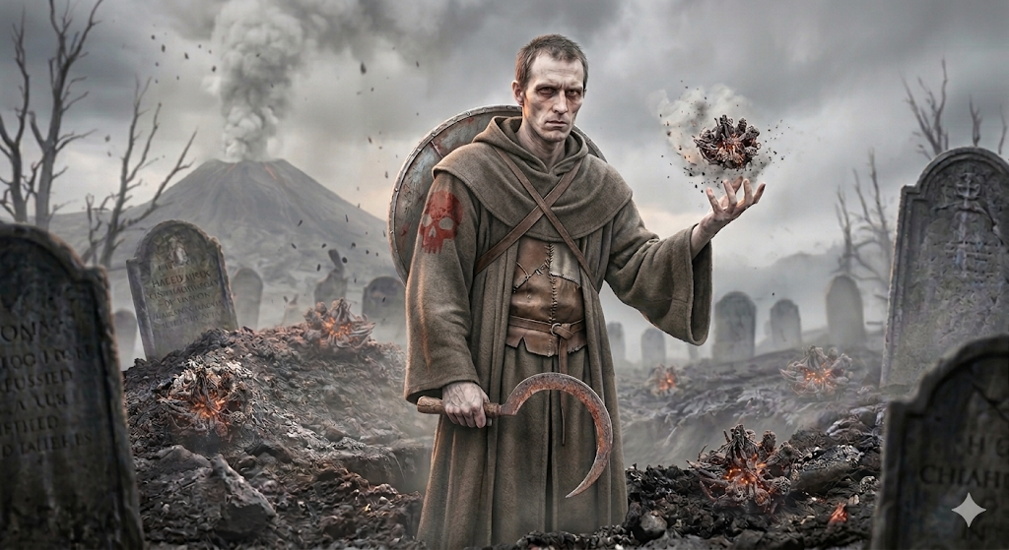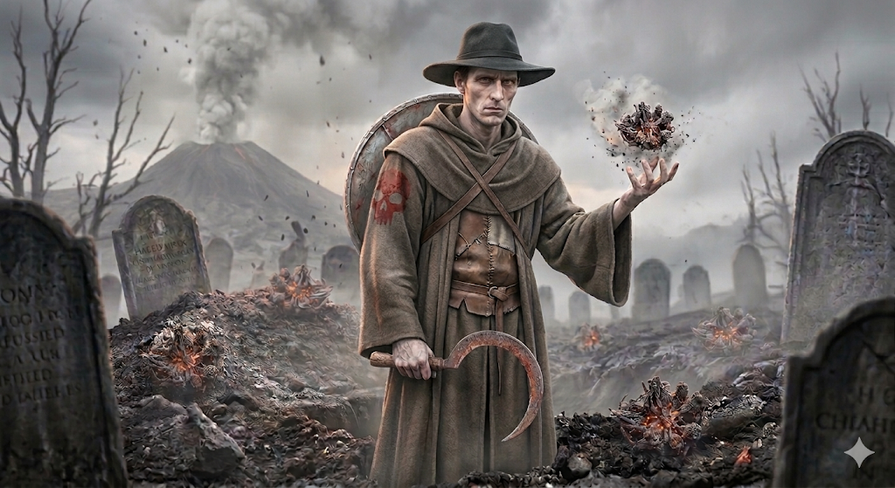

NPC: Kaelen the Harvester, Druid of Nerull (Level 1)
Race: Human (Variant)
Class: Druid
Alignment: Neutral Evil
Ability Scores & Stats
STR | DEX | CON | INT | WIS | CHA
10 (+0) | 14 (+2) | 14 (+2) | 12 (+1) | 16 (+3) | 8 (-1)
- Armor Class: 15 (Hide Armor + Shield)
- Hit Points: 10 ($1d8 + 2$)
- Proficiency Bonus: +2

Combat & Actions
- The Gleaner (Sickle): Melee Weapon Attack: +4 to hit, reach 5 ft., one target.
  - Hit: 1d4 + 2 slashing damage.
- Spellcasting: (Save DC 13, Attack +5)
  - Cantrips: Primal Savagery (his teeth/fingernails sharpen into acidic rot), Guidance (Nerull whispers a cold truth).
  - Level 1 Slots (2): Entangle (grasping skeletal roots), Thunderwave (a pulse of necrotic cold that pushes enemies back), Cure Wounds (stitching flesh together with grey thread).

Special Trait (Variant Human Feat)
Since he is a Variant Human, he starts with one feat. To keep the "Reaper" theme strong at Level 1, we’ll give him:
Feat: Magic Initiate (Wizard)
This allows him to tap into Nerull’s arcane deathly power without being a multiclassed Wizard.
- Chill Touch (Cantrip): A ghostly, skeletal hand touches the target. +5 to hit, 120 ft range. 1d8 necrotic damage, and the target can’t regain hit points until the start of your next turn.
- Ray of Frost (Cantrip): The cold of the grave slows enemies by 10 ft.
- False Life (1st Level Spell, 1/day): Kaelen can grant himself 1d4 + 4 temporary hit points as he draws vitality from the dying world around him.

Roleplaying Note
At Level 1, Kaelen is more of a "creepy hermit" than a powerhouse. He likely follows the party or hangs around the edges of a village, watching the elderly or the sick with an unsettling amount of patience. He isn't necessarily violent—he just knows that everyone eventually belongs to Nerull, and he’s happy to wait for his turn to "harvest."
This setting is a perfect pressure cooker for a Druid of Nerull. The volcano represents nature’s most violent form of "harvest," while the cemetery represents the quiet aftermath.
Here is a plot hook that ties Kaelen the Harvester to this volatile landscape:

Plot Hook: The Ash-Choked Harvest
The Setup: The village of Oakhaven sits in the shadow of Mount Vane, a grumbling volcano. For weeks, a fine, grey ash has been falling like snow. The villagers are terrified of an eruption, but the local cemetery has developed a more immediate, localized problem: the bodies aren't staying buried, but they aren't "undead" in the traditional sense.
The Conflict: The volcanic ash is magically infused with brimstone and necrotic energy from a deep vein of "Death-Glass" (obsidian) recently exposed by a tremor. This ash acts as a perverse fertilizer. Instead of ghosts or zombies, the corpses in the cemetery are being "overgrown" by charcoal-colored, heat-resistant fungi that use the bones as a trellis.
Kaelen’s Role:
The players find Kaelen in the cemetery during an ash-storm. He isn't fighting the fungal horrors; he is pruning them with his sickle.
- Kaelen’s Perspective: He believes the volcano is Nerull’s way of "clearing the fields." He is tending to the "Ash-Spore" corpses, claiming they are a rare crop that only blooms once a century.
- The Twist: Kaelen is actually preventing the village priest from "blessing" the graves. He claims the holy water will cause a chemical reaction with the volcanic ash that will trigger a localized explosion or a toxic gas cloud.

Why this works:
- Moral Ambiguity: Is Kaelen a creepy lunatic, or is his "death-wisdom" actually saving the town from a volcanic gas leak?
- Environmental Hazard: Combat in the cemetery can include Low Visibility (ash) and Difficult Terrain (shifting soot and grasping fungal limbs).
- The Reward: If the players help Kaelen "harvest" the cemetery, he might grant them a shard of Volcanic Obsidian that can be used as a spellcasting focus or forged into a +1 Sickle.
Since your players are Level 1, a Challenge Rating (CR) 1/2 creature is a "tough" minion—it can take a hit and deal enough damage to make a Level 1 Wizard sweat, but it won't wipe the party instantly.

