Introduction to Model-Based qNMR Software

This document outlines the main features of the model-based qNMR software (nmrQuant) and provides details of using it in an example of quantitative analysis of a chemical mixture.

- Installation
There are two ways to run the software. First, one can use the compiled package of the GUI version; however, it only provides limited processing capabilities. The latest version of the software can be downloaded from Google drive. The software is developed for the Windows 10 operating system.
Alternatively, to have access to the full functionality (including the ability to write and execute processing scripts, use GUI for simple analysis tasks, and modify the code), it is recommended to clone the containing GitHub repository to a local machine and work with the code directly. The ‘release’ branch contains the latest stable version of the software.
The software is written in Python 3.7; the easiest way to set up a Python environment on a local machine is to use a package manager, such as Anaconda (https://www.anaconda.com/). The GitHub repository contains the virtual environment description file (py37-nmr.yml) with the list of all additional packages to be installed, which can be imported to Anaconda. For this, in Anaconda Navigator, open the Environments tab on the left and click “Import” on the bottom of the screen; select the py37-nmr.yml file, which will download and install a Python instance with all required components. After the installation is complete, ensure that the correct environment is currently selected. In this guide we will use examples of data processing set up in a Jupyter Notebook tutorial.ipynb. A link to run Jupyter can be found in the Home tab in Anaconda, or it can also be launched by clicking on the triangle next to the environment name in the Environments tab and selecting “Open with Jupyter notebook” in the pop-up menu. If the folder structure is preserved as in the original repository, the code in the example notebook should run without any modification. Otherwise, it is necessary to ensure that the main nmrQuant directory is in the Python PATH; if needed, it can be added to the PATH with the following command directly within the notebook: “sys.path.insert(0, ‘absolute_path_to_nmrQuant’)”.
Alternatively, to start the GUI, navigate to the containing folder (using ‘cd dir_path\nmrQuant’) and run the command ‘python main.py’ in the terminal. To ensure that the code is run in the correct python environment, it is recommended to launch the terminal directly from Anaconda by clicking on the triangle next to the environment name and selecting “Open Terminal”.

- Data Architecture
All analysed spectra are contained in the top-level structure, called Workspace. Workspaces can be saved and loaded with all experimental spectra and the results of analysis. Each Workspace can contain results of several experiments and their spectra, called Data. Typically, data in a Workspace would be of similar samples/experiments, but possibly acquired at different times or even on different spectrometers. The model definition (i.e. the set of chemical species) is shared among all Data in the Workspace, but specific model parameters will normally differ between the datasets and will need to be found by model fitting. There are two distinct types of Workspaces, one for 1H data, and another for 13C; spectra of different nuclei can not be mixed in the same Workspace.
Furthermore, for convenience, several Data instances can be combined in Series. This is useful for processing reaction monitoring datasets, for example, or sets of samples from related experiments. Specifications of model parameters (e.g. minimum and maximum values of their possible ranges) can be set for an entire Series at once, and parameter values can be copied between different Data.
In the model-based quantification approach, we aim to find a model spectrum that is as close as possible to the experimental data and estimate the sought quantities of interest (e.g. concentrations) from corresponding fitted model parameters. Thus, the first step of the analysis is to define a generic model of the studied chemical mixture, i.e. the set of chemical species present in the sample. A model of each chemical species is characterized by its spin chemical shifts and connectivity between them, which eventually produces a signature NMR spectrum. Specific sets of model parameters (namely, chemical shifts, J-coupling values, peak widths, and component intensities, as well as phasing and baseline parameters) give rise to different model spectra; it is the main goal of the analysis to adjust these values accordingly to minimize the residual between the model and the experimental data being analysed. During the model fitting, we would normally adjust only the non-linear parameters (chemical shifts and peak widths); the intensities of the components can then be found in the least-squares sense.
Several chemical species in the model can be grouped together resulting in a hierarchical structure – a tree – where higher level chemical shifts and peak widths affect all corresponding underlying values. This allows us to control the chemical shifts and peak widths of related species as a group using far fewer parameters without changing the positions of their peaks relative to each other.
The package comes with a library of a few dozens of common chemical species, which can be immediately used in the analysis. Adding new species to the library is straightforward and is described in Supplementary material.
Each parameter in the model is specified in the Bayesian sense using its prior probability density function, i.e. it describes the most likely values of a parameter based only on the prior experience with similar samples (disregarding the currently analysed spectrum). In most cases, we would use uniform priors, which allow us to set minimum and maximum values for model parameters, and specify, for example allowed ranges of chemical shifts for each proton.
Parameter adjustment can be performed manually or (semi-)automatically. Usually, we would select a few parameters (1-3) and fit only them, while holding the rest of the model fixed. When suitable values for the selected parameters are found, we proceed by fitting other parameters. It is often necessary to return to previously fitted parameters and fine tune them when the rest of the model has changed. Thus, the optimization is performed in a sequence of steps, with certain parameters optimized on each step. It is a good practice to start model fitting with the most prominent peak (e.g. solvent) and proceed to smaller peaks. For each new application, it is necessary first to set up a list of optimization steps, after which other similar samples can be analysed automatically by applying this sequence.
Finally, we define frequency ranges to restrict the model fitting only to a relevant part of the spectrum; only data points falling within selected frequency ranges will be considered in model fitting.

- Software Interface (GUI)
The graphical user interface of the software is divided into three main regions. The spectrum of the currently open dataset is displayed in the middle part of the window; navigation between different spectra and controlling their parameters (such as zero-filling, selections of regions of interest), as well as a plot of resulting concentrations are shown on the left. Here, one can control the definitions of optimization ranges interactively using the corresponding (add/remove/modify optimization range) commands accessible from the top toolbox panel. Optimization frequency ranges are defined for entire Series.
Finally, the right-hand side of the window contains a table of user-defined optimization steps along with the complete list of all mixture components, their parameters and current parameter values. The interface allows one to add/remove steps, modify the list of parameters fitted on each of them, select and fit any step individually, all steps in a sequence, or a sequence of select steps.

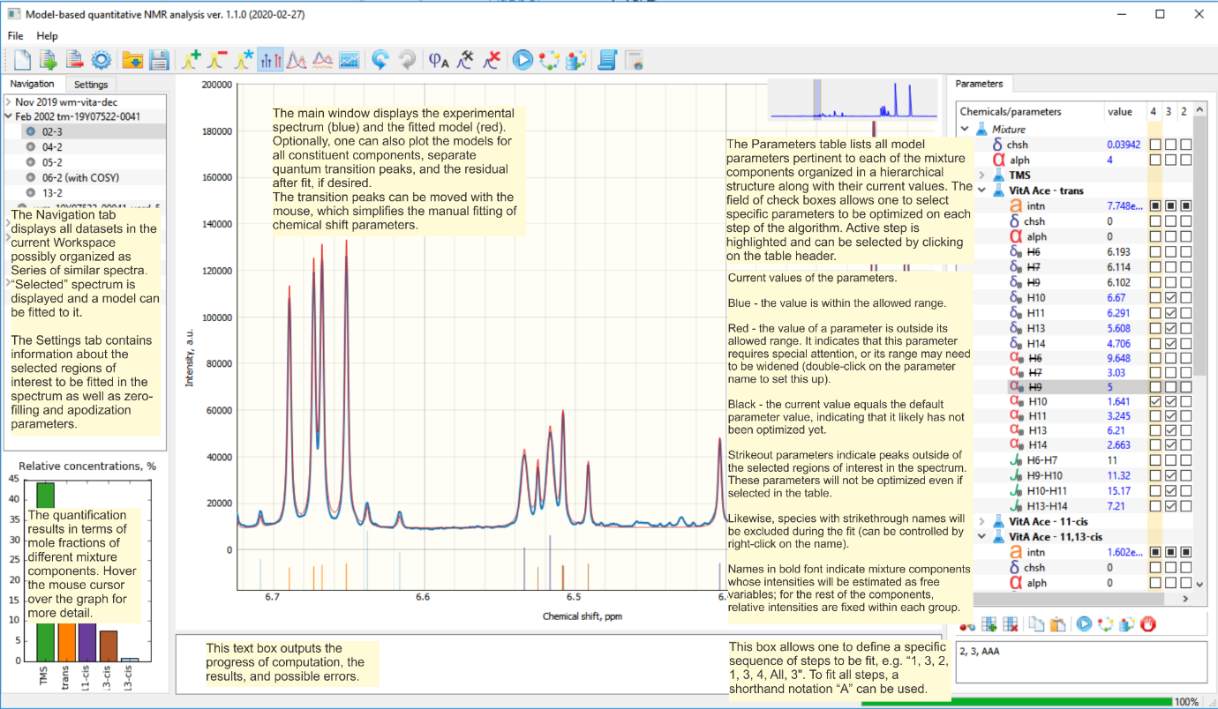

- Example of Data Analysis
Here we present a detailed step-by-step workflow of a data analysis procedure. As an example, we consider a mixture of thiamine, pyridoxine, glycerol, and maleic acid in D₂O measured with a benchtop NMR spectrometer. This system exhibits some features often observed in medium-field spectra, such as overlapping peaks and higher order coupling effects, and thus this example should provide a guide for setting up the analysis of other similar mixtures. We describe the actions taken in the GUI, but also provide equivalent commands that can be run in the script mode.

  - Creating a Workspace and Loading the Data.
On the start up of the GUI, a new Workspace for the analysis of 1H data is created automatically. If the intention is to analyse 13C data, the Workspace can be converted to the corresponding mode by clicking the “New 13C workspace” button located in the top panel. Note that the parameter tree initially contains only a single top-level node (“Mixture”) and no actual chemical species.
To load the experimental data, use the “Import files” () button in the top panel, navigate to a containing folder, and select the desired fid file. Alternatively, to load a number of Spinsolve files, one can drag and drop the containing folder into the GUI window. Currently, only Spinsolve, Bruker, and JEOL files are supported with possible limitations. The easiest way to load data saved in unsupported formats is to first open it in Mnova and then save the desired fid as a text file. For this, in the main menu of Mnova, navigate to Tools -> Export -> Group Delay Corrected FID; the resulting .txt file can be loaded into the software directly. (Please ensure that there is no frequency domain clipping applied in the Processing Template in Mnova; other processing, such as phase and baseline correction do not affect the saved file.)
Upon loading the first data file, a new Series with a single Datum in it will be created. Subsequent files will be added to the currently selected Series, unless they were acquired on an instrument with a different field strength, in which case a new Series will be created. To explicitly create a new Series, please use the corresponding context menu option in the Navigation tab (accessed by the right button click). To insert the spectrum into a specific Series, please right-click on the specific Series header in the navigation panel and use the “Import files” option displayed in the context menu.
To pan the spectrum, hold the left button and drag the mouse; for zooming, use the mouse wheel (possibly focusing on a specific axis). The “Autoscale” button () in the top panel sets the best view to the selected regions of interest. When the spectrum is rescaled, the small button found in the bottom left corner of the figure labelled “A” restores it to the original full view.
In this example, we will be working with two Series, the first one containing spectra S20.10 (a sample of thiamine and pyridoxine in almost equal molar ratios) and S20.11 (a sample of thiamine, pyridoxine and glycerol), and the second - containing a series of experiments S20.13.x (samples of thiamine, pyridoxine, and glycerol with increasing amounts of maleic acid). The following figure demonstrates the view of the main GUI window after the datasets have been loaded; the saved workspace can be found in supplementary material (tutorial_step_1.wsp).

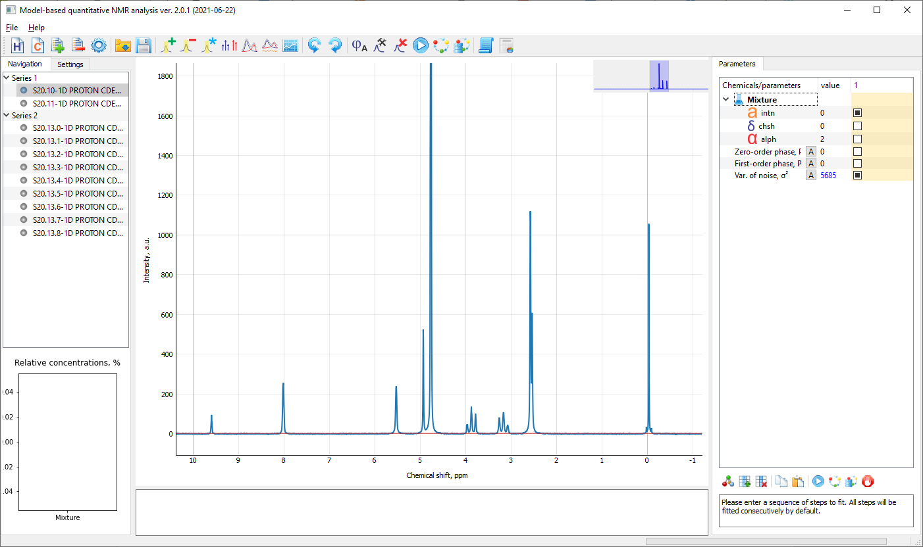

The same actions can be accomplished using the following commands:
# Create a new Workspace
wsp = Workspace(HCmode='1H')

# Create a new Series
ser = wsp.addSeries(name = 'Series 1')

# Read the FID (yT), array of time stamps (t), and dictionary of acquisition parameters (dic)
t, yT, dic = read_any_file('data_tutorial\S20.10\data.1d')

# Set the parameters in the Series
ser.c0, ser.f0, ser.t = dic['c0'], dic['f0'], t
ser.fullReset()

# Add the new spectrum
dat = ser.addDatum(yT, name=dic['name'])

  - Initial Preprocessing
After the files have been loaded, optionally, one may apply zero-filling and apodization, if desired. By default, the length of the computed spectrum is equal to the next power of two above the number of time samples. The new zero-filling and apodization parameters apply to all Datums in a Series.
# Apodization and zero-filling
ser.resetFreqs(zff=1, apod=0.5)

If necessary, phasing can be corrected by using the autophasing button in the main toolbar (). Alternatively, the phase can be adjusted by varying the values of corresponding parameters in the parameter tree (second and third rows from the bottom). The main goal here is to achieve acceptable (but possibly imperfect) phasing to simplify working with the data and model fitting. If desired, the phasing parameters can be adjusted later in the process of the model fitting, which in certain cases improves the quantification.
# Autophasing
dat.auto_phase(fit_Ph1=False)

  - Setting up the Models of Chemical Species
Initially, the model contains only one node named “Mixture” with three parameters: intensity, chemical shift, and peak width, as displayed in the parameters table in the right part of the GUI window. This is a parent node (the root of the parameter tree), which serves the purpose of grouping together all chemical species. It is always present and sets the global parameters of the model (e.g., one may use it to specify a reference chemical shift for the spectrum or set an approximate relaxation rate to control the widths of all peaks). For example, by setting the global chemical shift to -0.03 ppm in our example, it is possible to align the reference TMSP peak to 0 ppm. For this, double click on the value column in the ‘chsh’ row and enter a desired number; there is also an option to do this in more automated manner, as will be discussed later.
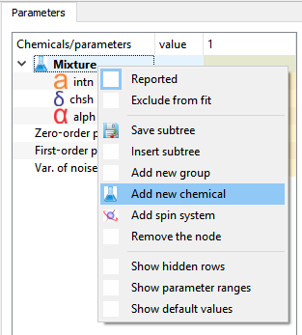
There are several options to build the model for a particular chemical system. First, one may add the chemical species of interest to the tree manually. To do this, please call the context menu by clicking the right button on a specific node in the tree; the new chemical species will be added to the selected node (in our example, to the root node “Mixture”). Click the option to “Add new chemical” and select a desired entry from the database. This will produce a signature model for a specific chemical initialised with default parameters. The inserted node becomes a child of the parent node and has its own set of parameters (usually, chemical shifts of specific nuclei, corresponding relaxation rates of their peaks, possibly J-coupling values, and also the “global” chemical shift and rate, which now affect all parameters of only this specific node). Any of these parameters can be adjusted during the model fitting. Repeat this step to add as many chemical species from the database to the tree as needed (e.g. in our example, we may want to add thiamine, pyridoxine, glycerol, maleic acid, TMSP, and water to the tree).
Instead of using the predefined signatures of chemical species from the database, one can build them directly in the software from separate spin systems (currently, only singlet peaks are available). This could be useful for modelling impurities or any unknown peaks.
Furthermore, to group similar species together, sometimes it is convenient to use group nodes and to add new chemicals directly to them. The group nodes do not produce any signals, but can control positions and peak widths of all descending nodes. For example, the above models thiamine and pyridoxine can be grouped together with an upper-level node ‘Vitamins’, modified and quantified as a group (please note that grouping chemicals should be done before inserting them into the model).
# Create an instant of a chemNode
newNode = chemNodeQM('Water')

# Add it to the root of chemTree in the Workspace
wsp.addTreeNode(newNode)

# Add a group node.
newGroupNode = chemNode('Vitamins')
wsp.addTreeNode(newGroupNode)

# Children nodes can be added to the group in two ways:
# 1. Directly to the group
newGroupNode.addChild(chemNodeQM('Thiamine'))
# 2. Via addTreeNode method
wsp.addTreeNode(chemNodeQM('Pyridoxine'), prntName='Vitamins')

# Add more species
wsp.addTreeNode(chemNodeQM('Glycerol'))
wsp.addTreeNode(chemNodeQM('Maleic acid'))
wsp.addTreeNode(chemNodeQM('TMSP'))
Some of the nodes in the tree should be designated as “Reported” – they will be treated as distinct components in the mixture and their intensities will be computed. The reported nodes can be either individual chemicals, groups of chemicals, or even individual peaks in NMR signatures. All components included in a reported group will be assumed to have fixed intensities relative to each other. The “Reported” flag can be set with the corresponding command in the context menu (by right clicking on the component to be reported) and is displayed with the node name in bold font.
# Set the node as reported
wsp.setRepRoot('Vitamins', flag=False)
wsp.setRepRoot('Thiamine', flag=True)
The parameter tree can be saved (including all fitted parameters) and loaded into another Workspace, if needed. The “Insert subtree” option will place the loaded tree in the specific location in the existing hierarchy, whereas to completely overwrite this structure, one can use the “Load new tree” button () from the menu below.
# Save a Vitamins subtree in a file
saveTree('data_tutorial\Vitamins.ctr', wsp.getTree('Vitamins'))

# Remove the subtree from the workspace
wsp.delTreeNode('Vitamins')

# Insert a subtree from file
subTree = loadTree('data_tutorial\Vitamins.ctr')
wsp.addTreeNode(subTree)
Finally, if some of the species defined in the sample, there is an option to turn them off and don’t estimate their intensities in a specific Datum or Series. This is useful if other samples with slightly different compositions need to be processed within the same workspace. To reduce the clutter (and potential errors with fitting), it is advised to exclude the absent species from the model for a specific spectrum. This can be done by choosing the “Exclude from fit” command in the context menu shown by the right click on the name of the species in the table.
# Exclude glycerol from fit in the second Datum
dat = wsp[0,1]
dat.setXclRootName('Glycerol', flag=True)

# Exclude maleic acid from fit in the first Series
wsp[0].setXclRootName('Maleic acid', flag=True)

# Display excluded nodes
print(dat.xclRootNames)
  - Setting Frequency Blocks for Optimization
In principle, the entire spectrum can be fitted with appropriate models. However, we found it useful to restrict the fitting to specific regions of interest in each example. This allows us to exclude parts of the spectrum with unknown species or impurities present, or parts of the molecule, whose modelling is especially difficult (and often unnecessary, since the intensity can be estimated from other peaks). It is often advised to exclude the region around 1 ppm, where overlapping peaks of methyl groups of many molecules are located; similarly, we would typically omit aromatic protons at 7 ppm, if present, since modelling them explicitly is often infeasible. Each frequency block will be fitted with its own polynomial baseline.
To select regions of interest to be fitted in the spectrum, use the “Add optimization range” button () from the top panel and drag the mouse across the spectrum while holding the left button pressed. This will create a new entry in the list of optimization ranges in the Settings tab, where one can adjust its boundaries and set the order of fitted baseline (by default, zero order corresponds to a uniform offset). Alternatively, the range can be modified interactively by using the corresponding button ().
The chosen regions of interest can be disjoint and overlap. However, it is important that at least one peak (i.e. the chemical shift parameter) of each reported component lies within a region of interest. Otherwise, this component will not be fitted and its intensity will remain unchanged.
For demonstration, in this example, we select the range from -1.0 to 9.0 ppm, which contains most of the peaks in the spectrum. In addition, to improve the fit of the TMSP peak, we also select the region around 0 ppm (e.g. -0.3…0.3 ppm); once a good fit is obtained for the reference chemical shift, such that the chemical shift of TMS/TMSP is zero, this region can be turned off in the “Settings” tab on the right. Similarly, we add a few additional blocks to cover other regions of interest. Finally, we note that in especially complicated examples, it might be useful to adjust the fitting regions as the model fit progresses.
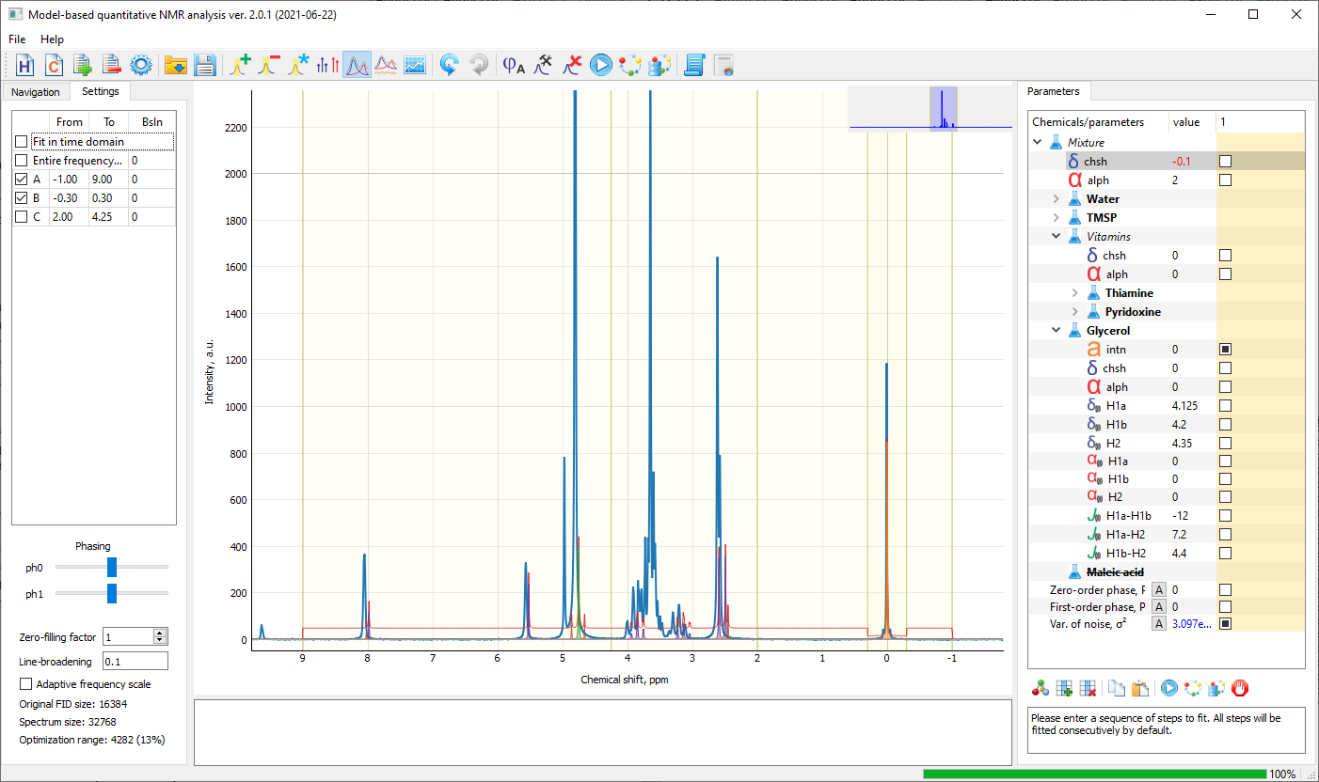
The frequency blocks can be defined in a script using the following commands:
# Add new frequency blocks
ser1.addFreqBlock(lims=(-1.0, 9.0), select=True) # Block 1. All peaks
ser1.addFreqBlock(lims=(-0.3, 0.3), select=True) # Block 2. TMSP
ser1.addFreqBlock(lims=(2.0, 4.25), bslnOrder=1, select=False) # Block 3.
ser1.addFreqBlock(lims=(6.0, 7.0)) # Block 4.

# Remove the last frequency block
ser1.remFreqBlock(indx=4)

# Display all frequency blocks in a Series
ser1.showFreqBlocks()

  - Specifying the Model Parameters
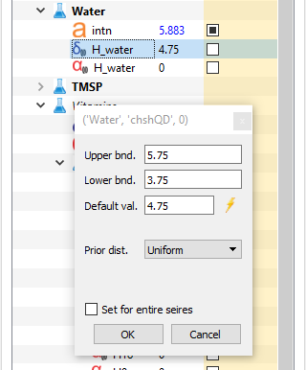Each model parameter (chemical shift, peak width, etc.) is characterized by its prior distribution, with its minimum and maximum values being the most important characteristics. The default prior probabilities for parameters are inserted from the database or are loaded with an imported parameter tree. Often, it is necessary to adjust them to account for specific experimental conditions (e.g. to vary chemical shift ranges). This can be done in the menu accessible by a double-click of the left button on a specific parameter in the tree. The same prior distribution can be applied either to only the currently open Datum (by default), entire Series (by checking the corresponding option), or the entire Workspace (for this, call the context menu by clicking the right button on the parameter name in the tree and select the “Set prior as global” option).
To alter the priors for model parameters in the code, use the following commands (see the tutorial.ipynb notebook in Supplementary material for more detail about the syntax):
# Set default value and alter the range
key = ('Mixture', 'chsh', 0)
dat.setPrior(key, dval=-0.01, min=-0.05, max=0.05, label='Global')

# Display the specification
print(dat.getPrior(key))

  - Fitting the Model
After the chemical tree has been set up, a vector of current values of all model parameters associated with each Datum in the Workspace is initialized to default values in each parameter specification. These values are used to produce a model spectrum, compare it to the experimental data, and estimate the sought intensities. The optimization algorithm run on any step starts with this vector of current values as the initialization. The current values are listed in the parameters table in the right part of the screen and can be changed by a double-click on a specific entry. This recomputes the model and is a convenient way to refresh the view.

4.6.1. Setting the Parameters Manually
We demonstrate the process of parameter fitting by adjusting the global chemical shift of the Mixture. The parameter tree loaded from the database are slightly misaligned with the data. This can be remedied by setting the top-most chemical shift, which will move the entire spectrum with respect to the model.
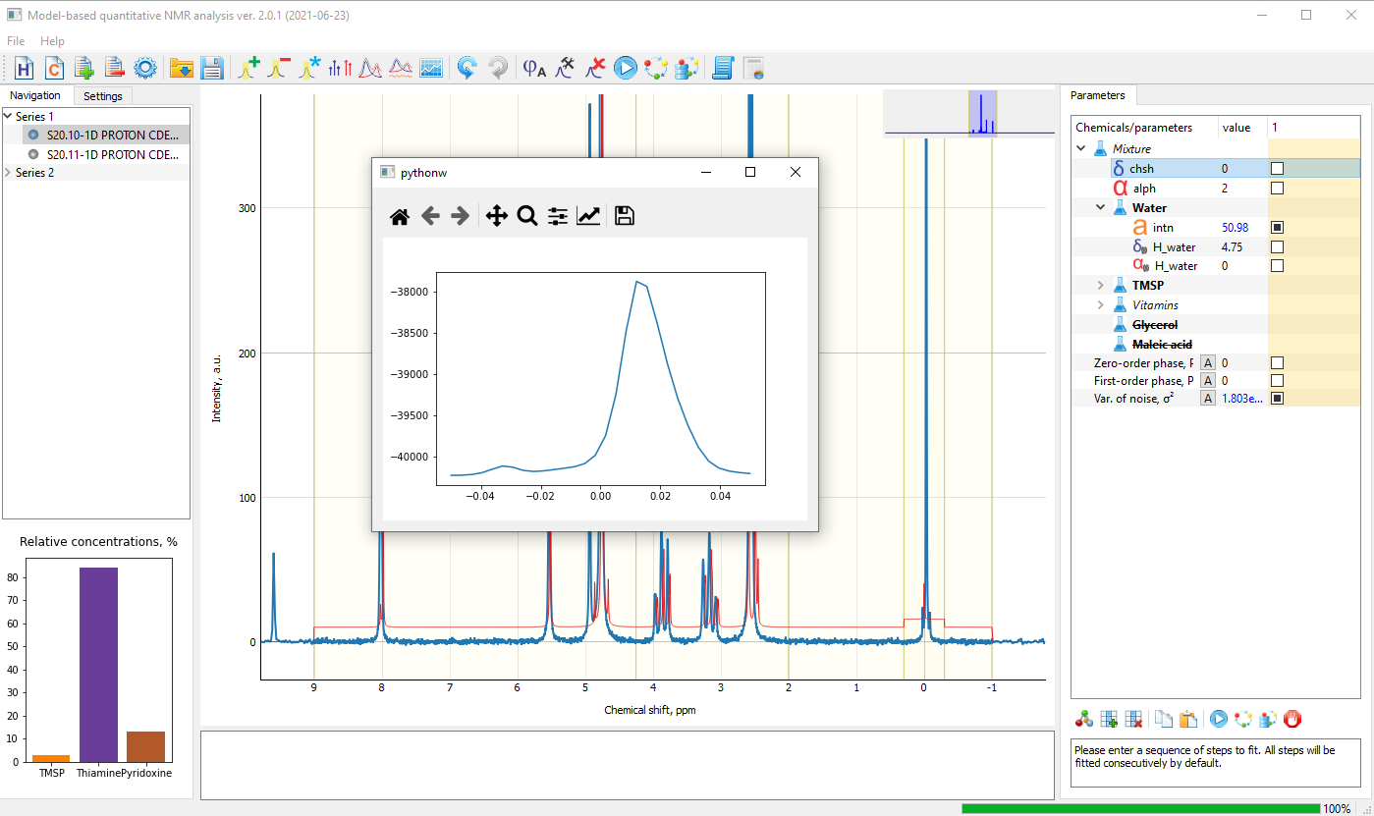
The model fitting is performed by maximizing the value of objective function – a measure of similarity between the model and the data. This function can be plotted with respect to any parameter (by using the “Display cost function” option in the context menu of the parameter), which helps to visually estimate its rate of change, set up the appropriate optimization ranges for the parameter, and manually define the best current value, if needed. In our case, the maximum of the objective function is attained at the global chemical shift of approximately 0.015 ppm. This value is entered in the corresponding field of the parameter table, which readjusts the model and achieves better fit. Programmatically, this corresponds to the following commands:
# Set a parameter value manually
dat.setCrntVal(key=('Mixture', 'chsh', 0), val=0.015)

# Display the current parameter value
print(dat.getCrntVal(key))

# Reevaluate the model and estimate the cost function
cfun_value, _ = dat.evaluate()

# Display the estimated values of component intensities
print(dat.report_results())

Furthermore, we note that the objective function has a (much smaller) local maximum, which is often the case in complex datasets. By restricting the range of the parameter (upper and lower bounds in the parameter settings dialog), it is possible to prevent the optimization algorithm from becoming trapped in one of these points. On the other hand, setting the range of a parameter too narrow poses a risk of omitting the optimum. In this case, one may set the bounds for the global chemical shift to [0.00, 0.04], but it is often unnecessary if a good initial value is entered in the table (double-click on the current value in the table and enter the desired value). Moreover, adding line-broadening (e.g. with the rate approximately equal the relaxation rate of peaks in the spectrum) can also help to fit global chemical shift parameters, but improved resolution is beneficial when adjusting individual peaks especially in crowded spectral regions.
If the model initialized with default chemical shifts and the experimental spectrum are misaligned, the intensities of components can be estimated to be negligibly small, making the model spectrum difficult to observe. To overcome this, before adjusting the global position of the model, one may display the transition peaks calculated in the model with stem lines. For this, use the “Show transition lines” button () in the top toolbox panel. Each group of lines can be moved with the mouse to conveniently adjust the corresponding chemical shift

4.6.2. Optimizing Parameters One at a Time
After a suitable initialization of the current value of the global chemical shift (e.g. 0.015 ppm), we run the optimization algorithm to refine this parameter. For this, in the first step in the parameter table, select the check box next to the chsh parameter in the “Mixture” node and call the optimization by clicking the “Fit active step” button () in the command panel. Furthermore, we note that the intensities of the model components (as well as the variance of the residual noise) are selected with black boxes instead of tick marks; this indicates that these parameters will be marginalized in the joint posterior distribution and effectively their values will be estimated “automatically” based on the rest of the current parameters. This is possible only for some of the parameters (namely, the intensities, zero-order phase shift, and the variance of noise, but only when specific types of prior distributions are used). Nevertheless, any of these parameters can be fitted in a usual way by solving the corresponding optimization problem (for this, click on the corresponding check box to change the square into a tick mark); usually, this is not advised though. The rest of the model parameters, whose check boxes are not selected, will not change at this optimization step. After the optimization is finished, the current value of the global chemical shift is updated, along with the intensities of the components. The current results are displayed on the left hand side of the screen in the “Navigation” tab.
The following code can be used to optimize a parameter in the script:
# Set up lists of parameters to optimize
parsKeys = [('Mixture', 'chsh', 0)]
autoKeys = [('.', 'sigma2', 0), ('TMSP', 'ampl', 0)]

# Run the optimization algorithm
dat.optimize(parsKeys, autoKeys=autoKeys, frqBlkIds=[1,2])

4.6.3 Optimizing Sequences of Model Parameters
Next, we optimize the global relaxation rate in a similar way. For this, we add a new step in the table by clicking the corresponding button (), and select the alph parameter in the node “Mixture”. The new step is added to the end of the list and automatically becomes active, meaning that its list of parameters will be optimized by the click on the () button. To fit both steps sequentially, one may use the “Fit all steps” () button instead. However, often we found it useful to postpone the optimization of the peak width until all chemical shifts are estimated precisely. Thus, we found it useful to first initialize the global relaxation rate to some relatively small value (e.g. 2 s⁻¹), which produces a model with sufficiently sharp peaks, adjust all chemical shifts, and only then proceed with fitting the relaxation rate parameters (globally and individually for each peak).
In most cases, the default chemical shifts loaded from the database serve as a good approximation, however it is often necessary to adjust them slightly to account for possible peak shifts. The discrepancies can be revealed by visual inspection of the fitted model or by observing the residual after fit, which is displayed using the () button in the top toolbox panel. For example, in our case, in the process of adjusting the global position of the spectrum, the chemical shift of the reference TMSP has moved from its standard value, 0.0 ppm. This can be easily corrected by dragging the corresponding transition stem lines with the mouse to the desired location. Alternatively, the value can be refined by checking the corresponding chemical shift parameter in the table and fitting it with the () button, as done previously for the global parameters. Furthermore, to align it with the origin while keeping the rest of the model fitted, one may select “Set reference” in the context menu.
When loading a new spectrum, it is always advised to check if the initial values of all chemical shifts are close to their expected values before proceeding with the automated fitting. For example, here the entire model signature of glycerol imported from the chemical database is shifted by approximately -0.5 ppm relative to the data. Instead of refining the three chemical shifts in the glycerol molecule, it can be corrected by adjusting their common chemical shift (‘Glycerol’, ‘chsh’, 0). It is also important to ensure that the parameter ranges set in its specification are valid.
Similarly, we proceed to adjusting the rest of the model parameters. For fitting each of them, one may define a specific step in the table. It is possible to select more than one parameter to optimize on each step (at the increased computation time for such step). Selecting more than four parameters in one step will break them into groups and optimize each parameter individually. Therefore, if the exact order of fitting is not important (e.g. on the final optimization stages), one may select all parameters of interest in a single step for convenience.
Use the following commands to define and run a sequence of model fitting steps:
# Clear the existing processing steps
ser1.steps.clear()

# Fit the global chemical shift and peak width
ser1.steps.append(Step(parsKeys=[('Mixture', 'chsh', 0), ('Mixture', 'alph', 0)],
autoKeys = [('.', 'sigma2', 0), ('Water', 'ampl', 0)],
frqBlkIds=[1, 2], nrep=3, fitEach=True, nhop=3))

# Fit the TMSP peak
ser1.steps.append(Step(parsKeys=[('TMSP', 'chshQD', 0), ('TMSP', 'alphQD', 0)], \
autoKeys = [('.', 'sigma2', 0), ('TMSP', 'ampl', 0)], \
frqBlkIds=[2], nrep=1, fitEach=True))

# Fit the thiamine triplets
ser1.steps.append(Step(parsKeys=[('Thiamine', 'chshQD', 2), \
('Thiamine', 'chshQD', 3)], \
frqBlkIds=[3], nrep=3, fitEach=False, nhop=3))

# Execute the defined steps
dat.run_steps()

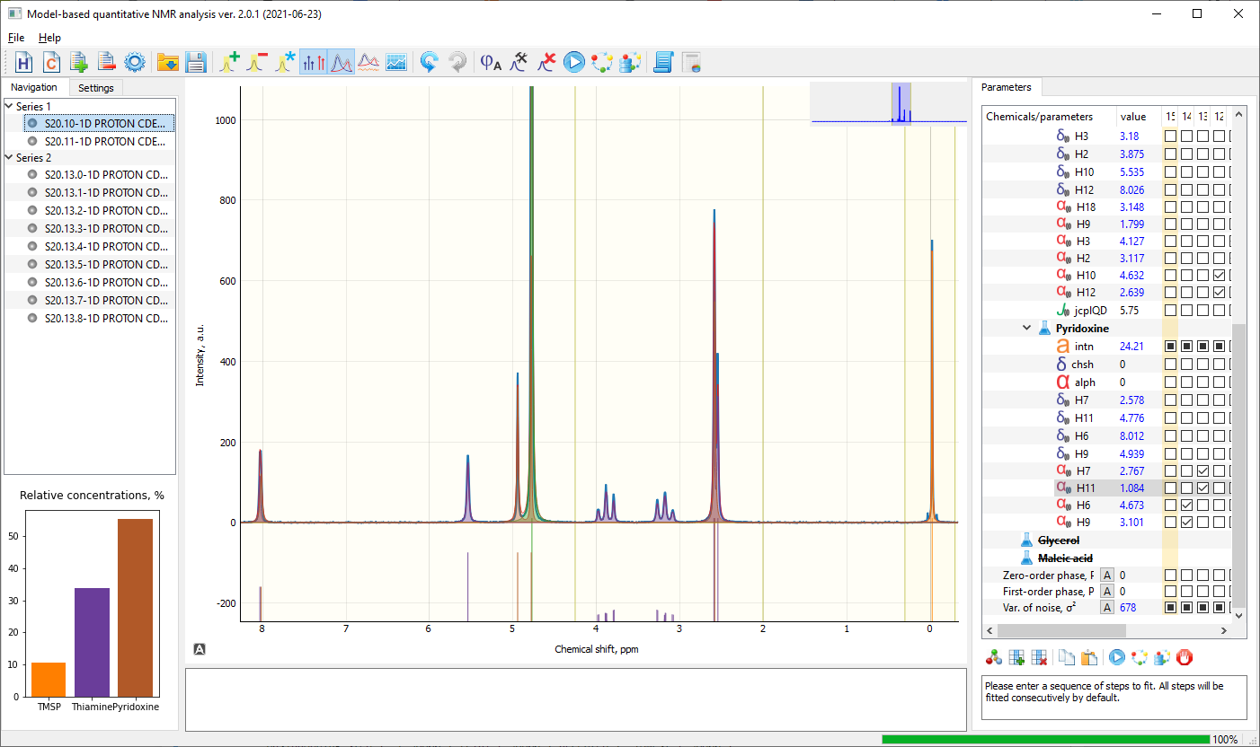
When a sequence of suitable fitting steps is set up, it is possible to add new data files to the Series and fit them all automatically by using the “Fit all files” button (). Any subset of the current values of parameters can be copied and transferred to other Data and Series; for this, select the desired parameters holding either Shift or Ctrl button and choose “Copy parameter values” from the context menu. To paste the parameters, select the desired Data in the Navigation tab and click “Paste as current” in the context menu, which will overwrite the current parameter values in the selected dataset. Alternatively, ALL parameters in the fit can be copied with the corresponding button in the toolbox below the parameter table or using the following command:
# Copy all settings (frequency blocks, priors, and steps) from ser1 to ser2
ser2.copySettings(serFrom=ser1)

The found results can be displayed or output as a text file by using the corresponding buttons in the top menu panel, () and (). Use the following commands to plot and save the original and fitted spectra:
# Evaluate to get the values of amplitudes without recomputing them
dat.evaluate(autoKeys=[], frqBlkIds=[0], returnSignals=True)

# Plot the spectrum and the residual
fig, ax = plt.subplots(2, 1, figsize=(13, 8), sharex=True)
dat.plot(ax_main=ax[0], ax_residual=ax[1], showComponents=True)
fig.show()

# Save the figure
fig.savefig('image.pdf', format='pdf')

It takes some time to optimise all parameters for all components and it is important to develop a fitting procedure that tends to work on your particular set of components before selecting this option. In general we find this is possible though. As a general guideline we found the following fitting procedure useful.
- Load the data and apply autophasing if necessary.
- Load the models for species with their default values.
- Set some initial global relaxation rate, e.g. 2 s⁻¹ (and keep individual relaxation rates for all peaks equal 0).
- Adjust the global chemical shift. Depending on the offset in the experimental data, this can be done automatically, but often is faster to set an approximate value manually.
- If present, adjust the position and width of the solvent peak. Usually this peak is much higher than the rest of the peaks in the spectrum.
- Exclude any unnecessary components not present in the sample from the fitted model.
- By inspection, determine, which peaks of the models are misaligned with the experimental spectrum and adjust them (by dragging with the mouse and/or refining their chemical shifts with automated fit in the parameter table). Normally, we would start with the species in the highest concentration and proceed in decreasing order. Overlapping peaks may require special treatment.
- Once good approximate values for all chemical shifts are achieved, usually it is possible to fit all model parameters (chemical shifts and relaxation rates) automatically. For this select them all in the table of parameters and use the “Fit active step button” in the menu.
- Refine the phasing parameters, if necessary, by selecting them in the parameter table (note that if the zero-order phasing parameter is selected with a black box instead of tick mark in the table, it will be inferred in closed form as a part of the least squares solution).
- Sometimes, it is advised to repeat the fitting iteratively until convergence.
- After all parameters are fitted, additional phase and residual adjustments with a proprietary algorithm can be applied by clicking on the “A” button next to the corresponding parameters in the table.

