Genetic and Structural Analysis of the Basolateral Amygdala Complex in BXD Recombinant Inbred Mice

Khyobeni Mozhui ¹, Kristin M. Hamre ¹, Andrew Holmes ², Lu Lu ^{1, 3, 4}, Robert W. Williams ^{1, 4}
¹ Department of Anatomy and Neurobiology, University of Tennessee Health Science Center, Memphis, Tennessee; ² Section on Behavioral Science and Genetics, Laboratory for Integrative Sciences, NIAAA, Rockville, MD; ³ Nantong University, Key Laboratory of Nerve Regeneration, Jiangsu Province, China.
⁴ To whom correspondence should be addressed at Department of Anatomy & Neurobiology, University of Tennessee Health Science Center, 855 Monroe Avenue, Memphis, TN, 38163, U.S.A. Telephone: 901-448-7050. Fax: 901-448-1716. E-mail: rwilliam@nb.utmem.edu; lulu@nb.utmem.edu.
Running title: Genetic and structural analysis of basolateral amygdala.

Abstract
The amygdala integrates and coordinates emotional and autonomic responses. The genetics that underlie variation in the amygdala structure may be coupled to variation in levels of aggression, fear, anxiety, and affiliated behaviors. We systematically quantified the volume and cell populations of the basolateral amygdala complex across 35 BXD recombinant inbred (RI) lines, the parental strains, C57BL/6J (B6) and DBA/2J (D2) strains, and F1 hybrids (n cases = 199, bilateral analysis). Numbers of neurons and volume vary 1.7- to 2-fold among strains. For example, neuron number ranged from 88,000 to nearly 170,000. Glial and endothelial populations ranged more widely (5- to 8-fold), in part because of higher technical error. A quantitative trait locus (QTL) for the amygdala size is located on chromosome (Chr) 8 near the Large gene. This locus may also influence volume of several other regions including hippocampus and cerebellum. Surprisingly, cell populations in the amygdala are not controlled by the Chr 8 locus, but appear to be modulated more weakly by loci on Chr 11 and Chr 13. Candidate genes were selected on the basis of correlation with amygdala traits, chromosomal location, SNP density, and expression patterns in the Allen Brain Atlas. Neurod2, a gene shown to be significant for the formation of the basolateral complex by knockout studies is among the candidates genes uncovered by the analyses. Other candidates include Large, and Thra.
KEY WORDS: Linkage analysis; comparative analysis; bioinformatics; gene expression.
The amygdala is a composite of functionally distinct nuclear groups in the forebrain. It is neuroanatomically intricate and comprised of as many as 13 different nuclei connected by complex intrinsic, and afferent and efferent connections (Pitkanen et al., 1997). It is a major constituent of the limbic system and is regarded as a crucial neural component underlying the experience of emotions and emotion-related cognitive functions (McGaugh, 2004; McIntyre et al., 2003). Evidence supports its role in the mediation of aversive and rewarding emotions (Rogan and LeDoux, 1996; LeDoux, 2000; Calder et al., 2001; Baxter & Murray, 2002; Lee et al., 2004), and the extensive connections it shares with the dopaminergic reward systems (Friedman et al., 2002) indicates an amygdalar contribution in the neurophysiology of reward, anxiety, motivation, and addiction (Phillips et al., 2003; Ciano & Everitt, 2004).
A number of human psychopathological disorders have been shown to be accompanied by alterations in the size and cytoarchitecture of the amygdala. Examples include abnormal reductions in volume among patients with schizophrenia (Niu et al., 2004), bipolar disorder (Blumberg et al., 2003), depression (Rosso et al., 2005), and Williams Syndrome (Reiss et al., 2004); and abnormal increases in volume and cell density among autistic patients (Abell et al., 1999). Interestingly, recent studies suggest that functional abnormalities in the amygdala of certain patient groups may be partly of genetic origin. For example, polymorphic variants in the human serotonin transporter and monoamine oxidase A genes are associated with trait differences in amygdala volume and/or functional responses to aversive stimuli (Hariri & Holmes, 2006; Meyer-Lindenberg et al., 2006). Thus genetic analysis of the structural variations of the amygdala may provide insights into the functional and behavioral significance of such variances.
Genetic heterogeneity generates significant variations in phenotypes ranging from expression levels of mRNAs and proteins, the size and shape of neurons and of neural structures, through to innate and learned behaviors. We are just beginning to understand relations among sequence differences, environmental factors, and diverse multiscale phenotypes. Mice provide an excellent population model to study such genetic and phenotypic variability. The environment of diverse sets of strains (a test population) can be fixed or systematically varied. In particular, the set of BXD strains (Peirce et al, 2004) has proved to be an extremely valuable reference population to study networks of phenotypes and their modulation by gene variants (Chesler et al., 2003; Chesler, Lu et al., 2005). The parental strains, B6 and D2, have been sequenced, and approximately 2 million single nucleotide polymorphisms (SNPs) between them have been identified.
Complex trait studies with the BXDs are also bolstered by the availability of a broad web-based data compilation of these strains’ genotypes, numerous behavioral and physiological phenotypes, and microarray expression profiles, and integrated analytical tools maintained in GeneNetwork (GN, www.genenetwork.org). Previous studies have used the BXD RI panel to analyze the genetic determinants of differences in size and cell number of brain structures including the cerebellum, hippocampus, neocortex, striatum, and olfactory bulb (Neumann et al., 1993; Rosen and Williams, 2001; Airey et al., 2002; Seecharan et al., 2003; Airey et al., 2005; Li et al., 2005). In the present study, we have undertaken a complex trait analysis of the basolateral complex of the amygdala. Its volume and densities of three cell types— neurons, glia, and endothelial cells—were measured from 35 BXD strains and their parental strains and F1 hybrids. In addition to identifying QTLs that may be significant for the development and structure of the basolateral amygdala complex, we performed correlative analysis with mRNA expression levels in the brain, and with behavioral phenotypes catalogued in GN. Such an integrated study can potentially determine modulatory roles of multiple genetic factors in establishing brain morphology, and their influence on neurophysiology, function, and behavior (Chesler et al., 2003).
Materials and methods
Subjects
Measurements were taken from brain sections of a set of 35 BXD RI strains, the parental B6 and D2 strains, and F1 hybrids. The serial sections used in this study are all part of the Mouse Brain Library (MBL) collection of physical sections. Images of these sections can also be downloaded from http://www.mbl.org (Lu et al, 2001; Seecharan et al., 2003; Rosen et al., 2003). The BXD strains are completely inbred and have been generated by the repeated mating between siblings starting from the F2 stage (Taylor, 1989; Taylor et al., 1999). The animals were purchased from the Jackson Laboratory (Bar Harbor, ME) and housed in a pathogen free colony at the University of Tennessee Health Science Center. Animals were acclimatized for at least two weeks in the University of Tennessee animal facility before use, and number of animals housed in a single cage did not exceed 5. The average cage density was 3 mice per cage. They were maintained on a 14/10h light-dark cycle at 20-24˚ C and fed 5% fat Agway Prolab 3000 rat and mouse chow. The average age of mice from which data were collected was 96 days (ranging from 30 to 500 days), and a total of 96 females and 103 males were used. All procedures followed the guidelines of institutional animal care and use committee.
Fixation and sectioning
As described previously (Lu et al., 2001; Airey et al., 2001; Seecharan et al., 2003), mice were deeply anaesthetized with Avertin, and perfused through the heart with 0.1M phosphate buffered saline. This was followed by solutions of: 1.25% glutaraldehyde and 1.0% paraformaldehyde in phosphate buffer (0.1 M); and 2.5% glutaraldehyde and 2.0% paraformaldehyde in phosphate buffer. Brains were dissected out and weighed. Brain tissues were subsequently embedded in celloidin and sectioned along the coronal or horizontal planes at 30 µm thickness with a sliding microtome, and stained with cresyl violet. Every tenth section was mounted on a slide and coverslipped. An interval thickness of 300 µm separates adjacent sections on each slide (Rosen and Williams, 2001). In the MBL, the majority of the cases have two sets of serial section slides per brain (slide A and slide B).
Volumetric measurement
Volumetric measurements were taken from a total of 199 brains. An average of 5 subjects was used per strain, and with the exception of BXD37, all other strains’ means are representatives of at least four subjects. For BXD37, measurements were taken from only 2 individuals due to limited availability. We include the BXD37 data because its inclusion or exclusion did not have a major affect on the subsequent linkage analysis. Of the 199 cases, 175 were coronal sections and 24 were horizontal sections. The limited use of horizontal sections is because the outline of the amygdala is more clearly definable in the coronal sections.
The amygdala is a complex neural structure that has been divided into distinct nuclear complexes, and further sub-divided into nuclei and sub-nuclei regions (Pitkänen, 2000). For this study, we took measurements from the portion of the basolateral complex of the amygdala that is bordered laterally by the amygdalar capsule (amc) (Swanson & Petrovich, 1998), and medially by the extreme capsule (ec). These clear demarcations and definability would ensure consistent morphometric measurements. This portion of the basolateral amygdala complex includes the lateral nucleus, which is further subdivided into the dorsolateral (LaDL), ventrolateral (LaVL) and ventromedial (LaVM) sub-nuclei, and the basolateral nucleus, which is further subdivided into the anterior magnocellular (BLA) and posterior parvicellular (BLP) sub-nuclei (fig.1a). These divisions have been made according to a standard atlas of the brain of B6 (Franklin and Paxinos, 2001). The basomedial nucleus is also a part of the basolateral complex but it was not included in our measurements because its border is less clearly definable and may have added to data inaccuracy. We will refer to the region we have measured with the more general term “amygdala”.
NIH Image (version 1.63) was used for volumetric analysis. Images from serial sections were captured from a Zeiss light microscope to a computer. After calibrating the instrument to a standard length of 1 mm, the border of the amygdala delineating the basolateral complex was manually traced and area determined. Such manual measurements were taken along the entire rostrocaudal thickness of the basolateral amygdala complex (approximately 6–9 sections for each brain). The volume was calculated by multiplying the sum of the area measurements by the interval thickness of 300 µm. Measurements were taken bilaterally and the final values represent the left-right average. Because the majority of the cases have two sets of serial sections, the average amygdala volume for most individual cases was calculated from a total of four sets of measurements, i.e. bilateral measurement from slides A and B.
To correct for the volumetric shrinkage caused by histological processing, the measured values were divided by the total brain volume and multiplied by the brain volume expected for that brain weight. The brain density of the MBL tissues is taken to be 1.05 mg per mm³ of fixed tissue. The post-processing total brain volume was determined by point counting and the method is described in Williams (2000). After each individual volume measurement was corrected for shrinkage, the strain averages were determined.
Stereological methods
We applied the three-dimensional direct cell counting technique that was developed by Williams and Rakic (1988) to estimate cell density and total number. We used the whole-section method as it gives a relatively unbiased estimate of cell number from a tissue section and avoids the error caused by differential shrinkage along the z-axis (von Bartheld, 2001). A count box of 32 x 33 x 30 µm was superimposed over the live image of the section, and we followed the standard counting rules defined by Gundersen (1977), and Williams and Rakic (1988). The same counting protocol was used as described previously by Seecharan et al. (2003). Distinction between cell populations were based on established criteria (Ling et al., 1973; Satorre et al., 1986) and as used by Seecharan et al (figure 1 of Seecharan et al., 2003). Cells were classified into three groups: neurons, glial cells, and endothelial/other cells. No distinction was made between projection neurons and interneuron. Cells whose identity could not be discerned with certainty were included in the endothelial/other group.
Stereological measurements were limited only to coronal sections from which the volumetric measurements were taken and the horizontal sections were excluded. From each serial section slide, the section that had the most complete representation of the basolateral complex was chosen for cell counting. A total of 10 sites were sampled from each side of the amygdala (2 sites for each sub-nuclei)—the x100 oil objective (NA 1.25) was focused over each sub-nuclei (LaDL, LaVL, LaVM, BLP, BLA) and two counts were taken from each. Counts were taken bilaterally and for each case, the final cell number represents the left and right average. The number of subjects used for each strain is lower for the stereological data at an average of 4 subjects per strain. The data for BXD37 and BXD11 represent the average of only two individuals.
To assess the validity of stereological method we compared counts obtained from right and left sides. While there will be some genuine left-right asymmetry, most variation is likely to be due to sampling and technical errors (Williams et al., 1996). Paired t-test showed no significant difference between the cell counts taken from the left and right amygdala (t165 = 1.72, p = 0.08 for glia; t165 = 1.15, p = 0.25 for endothelial cells; t166 = 1.54, p = 0.13 for neurons). However, amygdala volume—which we consider to be the most reliable data with a low coefficient of error—has a modest but statistically significant left-right asymmetry (t195 = 2.5, p = 0.01).
Statistics
Data were organized using a spreadsheet program (Excel) and most exploratory analysis and statistical tests were performed using Data Desk (www.datadesk.com). To examine effects of cofactors such as brain weight, body weight, age, and sex on the amygdala, we applied multiple linear regression. In the case of the volume data, the plane of section was also included as a factor. In addition, the effect of each variable as a single factor was also examined by simple regression analysis, and the percentage of variance explained by a covariate was computed from the adjusted correlation coefficient. Individual trait values rather than strain means were used in this analysis. Residual values were calculated using only those factors that were significant predictors. The corrected data, adjusted for these effects (residual + mean), were used for linkage. Residuals were used to provide a more accurate estimate of variability specific to the amygdala.
Effect of strain on trait variance was used as an estimate of trait heritability. The intra-class correlation coefficient was computed by performing an analysis of variance (ANOVA) with strain as a single factor and this provides an estimate of strain effect on trait variance.
Genotyping and QTL mapping
The B6 and D2 strains differ significantly in sequence, and approximately 2 million informative SNPs have been defined across the genome (see www.genenetwork.org/beta/snpBrowser.py). A subset of approximately 14,000 of these sequence variants (SNPs and microsatellites) have been used to genotype the BXD strains (Williams et al., 2001; Peirce et al., 2004; Shifman et al., in press; http://www.well.ox.ac.uk/mouse/INBREDS/). The amygdala trait data were entered into GN and QTL mapping was performed using the WebQTL mapping module.
For linkage analysis, WebQTL performs intervals mapping using 3795 SNP and microsatellites as markers. The non-parametric p value (alpha of 0.05) of the linkage ratio statistic (LRS) is computed by performing 1000 or more permutations. This threshold is denoted by the upper horizontal line in linkage maps. A suggestive LRS threshold is set at a genome-wide alpha of 0.63 and is denoted by the lower horizontal line in the linkage map. Two-thousand or more bootstraps are also performed by GN to estimate the confidence limit of the location of the QTL peak interval, and the results are represented as a “frequency of peak LRS value” histogram. Another parameter computed by WebQTL is the additive effect, which is an estimate of the quantitative effect of an allele on the measured phenotype. In the case of the BXDs, a locus can have a B6 allele (B) or a D2 allele (D) and the additive effect is half of the difference between the means of homozygous cases and is calculated as: (mean of BB cases)–(mean of DD cases)/2. The red plot in the linkage graphs denotes a positive effect by the B allele and for computational purpose, GN gives it a nominal negative value; a positive effect by D allele is denoted by the green plot and is assigned a positive value. These values are in the same units as the data, in this case mm³ for volume, and number/mm³ for cell density. Using the additive effect value, the effect size of a QTL and the percentage of variance attributed to a QTL are approximated.
Correlative analysis with gene transcript expression and behavioral phenotypes
The GN analytical tools are integrated with data sets of numerous BXD behavioral and physiological phenotypes, and microarray data of gene expression in the brain (Chesler et al., 2003; Chesler et al., 2005), and this facilitates correlative analyses across a wide range of data sets. Transcript expression levels were treated as complex traits and their covariance with the amygdala neuroanatomical traits analyzed. Both Pearson’s product-moment and Spearman’s rank correlation can be computed. For this study, we calculated the Pearson’s product-moment correlation between the amygdala traits and the mRNA expression level data “INIA Brain mRNA M430 (Jan06)”. We also referred to the in situ gene expression data provided by Allen Brain Atlas (ABA) (www.brain-map.org) to check for the expression levels of the candidate genes within the amygdala. Correlation analysis was also done with BXD neuroanatomical and behavioral traits.
Results
STATISTICAL ANALYSES OF ANATOMICAL TRAITS
Volume of the amygdala
The BXD strains exhibit a wide range of variation in the volume of the amygdala. BXD19 has the largest mean volume at 1.8 ± 0.08 mm³ and BXD29 has the smallest at 1.07 ± 0.03 mm³ (table 1). This amounts to a 1.7-fold difference in the size of amygdala. However, there is no significant difference between the parental strains (B6 at 1.628 ± 0.1 mm³, D2 at 1.55 ± 0.06 mm³). The occurrence of a relatively small difference between the parental strains while the progeny RI strains display a wide range is attributed to random assortment of multiple alleles at different loci (Neumann et al., 1993). Depending on the combination of alleles at multiple loci inherited from the parental strains, a phenotype may be either enhanced or diminished in the offspring. Approximately 35% of the variance in amygdala volume is due to strain genotype (F _{(37, 198)} = 2.16, p = 0.0005).
F1 hybrids have the largest amygdala and this is consistent with the F1s possessing larger traits for the lateral geniculate nucleus (LGN) (Seecharan et al., 2003), olfactory bulb (Williams et al., 2001), body weight, and brain weight. More robust traits in the F1s have been attributed to positive heterosis and hybrid-vigor (Falconer & Mackay, 1996).
While the size of the amygdala may be modulated by specific genetic factors, the amygdala may also be under the influence of genes that have more widespread effects. It is possible that its size variations could partially be accounted for by variations in the overall brain weight, body weight, age, or sex. The degree of covariance of the amygdala volume with these biological factors was evaluated by regression analyses. Multiple linear regression showed brain weight to be a significant predictor of the amygdala volume (t₁₉₅ = 4.96, p ≤ 0.0001). In contrast, body weight, age, and sex of an animal, and the plane of section, are not significant factors for the amygdala volume. However, body weight, when it is used as a single regression factor, correlates significantly with the amygdala volume (t₁₉₅ = 3.1, p = 0.002) but is estimated to account for only ~5 % of the variance. As a single factor, brain weight accounts for ~17% of the variance (t₁₉₇ = 6.27, p ≤ 0.0001). Sex, age and plane of section continue to be insignificant predictors when used as single regression factors. After adjusting the data for the effects of brain weight, and body weight, the corrected data were used for linkage analyses (table 1).
Amygdala cell counts
Neurons account for 80% of the cell population in the amygdala. There is about a 2-fold difference in both the number and density of neurons among the BXD strains. BXD12 has the highest population at 169,200 ± 14,300, whereas BXD6 has the lowest at 88,100 ± 8000 (table 1). As was true for volume, parental strains do not differ (118,800 ± 7,500 in B6 versus 115,600 ± 6,200 in D2). The number and density of non-neuronal cells varied greatly among BXDs, with as much as an 8-fold range in the population of glial cells (lowest for BXD15 at 3,700 ± 1,300 and highest for BXD11 at 26,400 ± 6,500) and a 5-fold range in the population of endothelial cells (lowest for BXD37 at 5200 ± 3500 and highest for BXD27 at 25,200 ± 6400). We suspect that some of this variation must be technical, but we do not find a reciprocal relation between glial cell and endothelial cell counts expecting if cell identification were a major problem. As expected given its large volume, F1 hybrids possess the highest group means for both glial and endothelial cells (table 1). However, the neuron population does not appear to follow this trend and F1s possess average number of neurons and somewhat lower neuron density. The effect of strain on variability in neuron number is over 40% (F _{(37,166)} = 2.88, p < 0.0001). Strain also accounts for 30-40% of the variance in glial cell number (F _{(37, 166)} = 1.87, p = 0.005).
For the neuron population, multiple linear regression with brain weight, body weight, age, and sex showed none of these factors to be significant predictors of the amygdala neuron population. However, regression analysis with body weight as a single factor reveals it to be a statistically significant predictor of the neuron number (t₁₅₈ = 2.34, p = 0.02). Used as single regression factors, brain weight, age, and sex do not show significant covariance with neuron number.
From the regression analyses, we note a great deal of similarity between the amygdala volume and glial cell traits. As in the case of the amygdala volume, when multiple linear regression is done using brain weight, body weight, age, and sex as co-factors, only the brain weight serves as a significant predictor of the glial cell number, but body weight becomes a significant predictor of glial cell number when it is used a single regression factor (t₁₅₈ = 3.28, p = 0.0013) and is estimated to account for 6% of the variance. The brain weight is estimated to account for 7% of variance (t₁₆₄ = 3.52, p = 0.0006). Age and sex are insignificant predictors of the glial cell population. Our analyses indicate the endothelial cell population to be unaffected by variations in brain weight, body weight, age and sex.
We note a rather large coefficient of error (CE = standard error/group mean) in the case of the glial cells (average CE of 0.3) and endothelial cells (average CE of 0.2). This high CE is suggestive of high error rate in data collection, though there is also the possibility that there may be higher within-strain variation for the glial and endothelial cell populations than for neurons. The CE for both the amygdala volume and neuronal population averages at only 0.06.
COMPLEX TRAIT ANALYSIS
QTL analysis for amygdala volume
The genome-wide linkage map for the raw amygdala volume reveals a significant linkage interval on mid-Chr 8 (fig.2a). This linkage interval is located between 65 and 75 Mb, and has a peak LRS of 14, just above the significance threshold. At this locus, the D allele has the positive additive effect and is estimated to increase the amygdala volume by ~10%. Two suggestive linkages are also detected on proximal Chr1 (between 50 and 60 Mb; LRS 9.0) and mid-proximal Chr19 (between 22 and 28 Mb; LRS 9.2). At each of these suggestive linkage intervals, the B alleles increases volume by ~10%.
To assess global effects of the brain weight and body weight on linkage maps, the amygdala data were regressed against brain weight and body weight (individual case, rather than strain), and the adjusted strain means were used for interval mapping. Differences in QTLs would be indicative of the level of specificity of the QTL. Adjusting the amygdala size for differences in brain weight eliminates the suggestive linkages on Chr 1 and Chr 19 (fig. 2b). The linkage to Chr 8, though weakened, persists at a suggestive LRS of 10.7. The location of the linkage interval is unchanged (between 65–75 Mb) and the D allele continues to have the positive additive effect. Regression against body weight also decreases the linkages to Chr 1 and 19, but augments the linkage to mid-Chr 8 to an LRS of 15 (fig. 2c and 2d). Thus the linkage to mid-Chr 8 is consistently detected on all the linkage maps for the amygdala volume, and the significant strength of association (genome-wide p ≤ 0.05) qualifies it as a QTL for the amygdala volume. We will refer to this QTL as Vol8a. However, the reduction in the strength of Vol8a upon adjusting the data for the effect of brain weight indicates a pleiotropic interaction of this QTL with the size of the amygdala and the overall brain weight. Vol8a lies only ~10 Mb proximal to the Cerebellar size 8a (Cbs8a at 45 cM) QTL (Airey et al., 2001).
Simple interval mapping with the stereological data yielded only suggestive QTLs for the neuron (fig. 2e) and glial cell populations (fig. 2f). No linkage interval was uncovered for the endothelial cells. Both the neuron and glial cell densities share suggestive linkages to mid-proximal Chr 13. Though the overlap in not precise, the linkage intervals for both the neuron and glial traits reside at close proximity. The suggestive LRS on Chr13 peaks at 11.4 for the neuron density and at 10.2 for the glial density. It is noted that this linkage interval is also close to the hippocampal volume QTL, HipV13a (Peirce et al., 2003). At this locus, it is the D allele with the positive additive effect for both neuron and glial cell densities and is estimated to increase the neuron density by 12% and the glial density by more than 35%.
Another suggestive association is observed for the density of glial cells on distal Chr 11. The suggestive LRS peaks at ~11.4 between 90 and 105 Mb. Glial density, after correction for the effects of brain weight, maps to this locus at a nearly significant LRS of 14.8. The LRS peaks almost precisely over the NeuroD2 gene located at ~98 Mb. The B allele at this locus is estimated to increase the glial cell density by more than 25%. Other then the effect of increasing the peak over NeuroD2, regression of the cell counts data against brain weight and body weight does not cause major alterations in the linkage maps of these traits.
QTL specificity
Brain weight and body weight are the two most significant predictors of the amygdala structure. A genome wide linkage analysis was performed for both brain weight (fig. 3a) and body weight (fig. 3b) to identify any genetic loci that may primarily modulate these global traits but are also linked with the size, or cell populations of a specific brain structure such as the amygdala. This is a cautionary step to avoid erroneous identification of more a general QTL with widespread effects as being specific for the amygdala.
The brain weight variation is associated with a suggestive QTL on Chr 19. For the body weight, suggestive linkages occur on Chrs 7, 10, and 19. This indicates the linkage interval on Chr 19 to primarily modulate gross structures, with a non-specific association with the amygdala. Weak linkage peaks are also detected on Chr1 for both brain weight and body weight, and though they are both below the suggestive thresholds, this common linkage may account for the suggestive QTL on Chr1 for the amygdala volume that was weakened by regression against brain weight and body weight.
Correlations between amygdala volume and cell populations
The strongest correlation among all amygdala neuroanatomical traits is between volume and glial number (fig. 4a) with a positive Pearson’s product correlation r = 0.5, p = 0.0007. Weaker but significant positive correlations also exists between the volume of the amygdala and its glial cell density (fig. 4b; r = 0.4, p = 0.03) and neuron number (fig. 4c; r = 0.4, p = 0.02). Neuron density in the amygdala has the tendency to correlate negatively with volume, and though this does not reach statistical significance (fig. 4d; r = -0.3, p = 0.1), the negative association between the two traits indicates that smaller amygdala will have slightly higher neuronal density. As expected, strong positive correlations relate cellular densities with number. This is especially true for the near perfect correlation between the density and number of glial cells (fig. 4e; r = 0.9). However, in the case of the neuron population, the density of cells appear to increase at a higher rate with increase in number (fig. 4f; r = 0.7, p = 1.2x10⁻⁶).
To provide an overview of linkage intervals that may be common for the amygdala neuroanatomical traits, a cluster map was generated for, from rows 1 to 6, the raw amygdala volume, body weight adjusted volume, glial number, glial density, neuron number, and neuron density (fig. 4g). In addition to the overlapping linkage interval of Chr 13 for the neuron and glial cell populations, closely aligned linkage intervals can be detected on Chr 1 for all traits, on Chr 3 for the neurons and glial cells, on Chr 5 for the volume and glial cells, and on Chr 6 for the volume and neuron number. These linkages are not of significant strength, but may indicate potential shared QTLs.
The complex trait analysis of the amygdala has uncovered only one significant QTL, Vol8a, associated with its volume, and two suggestive linkage intervals on Chr11 and Chr13 associated with the amygdala cellular traits.
CORRELATIVE AND COMPARATIVE ANALYSIS OF MULTIPLE TRAITS
Neuroanatomical correlates of amygdala and comparative QTL analysis
GN maintains an archive of diverse phenotypes (BXD Published Phenotypes database) previously collected from the BXD strains by different researchers. This makes it possible to search for traits with significant covariance with the amygdala. The “Trait Correlation” tool was use to compute correlations between the amygdala structural traits and a variety of other BXD phenotypes that range from physiology, neuroanatomy of other brain regions, to behavior. This analysis showed that the top 15 strongest correlates to be all neuroanatomical traits. The strongest association is between the amygdala volume and the volume of the hippocampus proper (fig. 5a; r = 0.7, p = 4.5x10⁻⁶, N = 34) and its sub-regions, such as the dentate gyrus (r = 0.5, p = 0.001) and pyramidal cell layer (r = 0.5, p = 0.003). The volume of the amygdala also correlates significantly with the sizes of the striatum (fig. 5b; r = 0.6, p = 1.2x10⁻⁵, N = 36), and the lateral geniculate nucleus (fig. 5c; r = 0.5, p= 4.5x10⁻³, N = 35).
To determine if the linkage intervals identified in this study may be specific for the amygdala, or if common QTLs may be involved in modulating the sizes of different brain structures, we retrieved the volumetric data for the cerebellum and internal granular layer (IGL) (Airey et al., 2001), total hippocampus, hippocampus proper, dentate gyrus and pyramidal cell layer of the hippocampus (Lu et al., 2001; Peirce et al., 2003), LGN (Seecharan et al., 2003), the striatum (Rosen; unpublished phenotype GN trait ID: 10710), and the olfactory bulb weight (Williams et al., 2001), and performed multiple QTL mapping for these traits. To display the overlapping linkage intervals, a cluster QTL map was generated for, from rows 1 to 10, the IGL, IGL adjusted for brain weight, striatum, hippocampus proper, dentate gyrus, amygdala, LGN, olfactory bulb weight, amygdala neuron density, and amygdala glial density (fig. 5d). This analysis confirms Vol8a as a major neuroanatomical QTL but makes it less specific for the amygdala. Vol8a is linked to the volumes of the IGL and the whole cerebellum, striatum, and hippocampus proper, but not with the volumes of the dentate gyrus, and LGN. A hint of linkage is also visible between the olfactory bulb weight and Vol8a. In all these cases, it is the D allele in Vol8a that has the positive additive effect. The Cbs8a QTL reported previously (45 cM; Airey et al., 2001) lies only slightly distal to Vol8a. After the cerebellum and IGL volumes have been adjusted for brain, their linkage interval is shifted from Vol8a to Cbs8a. It is uncertain if Vol8a and Cbs8a are two separate QTLs with Cbs8a specific for the cerebellum, or if they represent the same QTL but appear separate due to low mapping resolution. If the later is the case, then there is consensus for the linkage interval to be located on Vol8a. Vol8a may be selectively modulating the sizes of more than one brain structure but not of other brain structures such as the LGN and the dentate gyrus.
Behavioral correlates of amygdala and comparative QTL analysis
After the neuroanatomical traits, another category of phenotypes that show strong correlations with the amygdala structure is behavioral phenotypes related to addiction, and locomotor activity (fig. 6a; table 2). Among these, cocaine open field center time behavior (GN trait ID 10333), which assesses the effect of an addictive substance on a behavioral measure of locomotor activity and emotionality, shows the most significant correlation with the amygdala volume, and the same trait also correlates significantly with the neuron number (r = -0.5, p = 0.02, N = 23). To search for possible common QTLs shared between the amygdala and its correlated behavioral phenotypes, we performed a cluster QTL analysis. The most striking overlap of QTLs is between the amygdala volume and the cocaine open field behavior. Another correlated behavior that shares a linkage interval on Vol8a, is the locomotor behavioral response measured by Palmer et al. (2002; GN trait ID 10453). A multiple QTL map was generated for these three traits (fig. 6b; red: cocaine open field, green: locomotor response, blue: amygdala volume). Three overlapping linkage peaks are observed for amygdala volume and cocaine open field behavior: (1) though the LRS may only be of suggestive strength, the cocaine open field behavior has a peak LRS that overlaps with Vol8a, (2) significant peak for the behavioral trait on mid-proximal Chr 1 overlaps the peak that was observed for the amygdala traits on Chr 1, (3) though below the suggestive threshold for both traits, another shared peak in LRS is observed on proximal Chr 5. Another region of overlap, but with a much weaker LRS is observed on the distal end of Chr 18. A peak on Vol8a is also present for the trait 10453, which measures the effect of 2-hydroxypropyl-beta-cyclodextrin on locomotor activity (Palmer et al.,2002).
Other significant correlates of the amygdala volume are: distance traveled in open field (r = 0.6, p = 0.003, N = 17; trait ID 10843; Holmes & Yang, 2006); conditioned place preference (r = -0.6, p = 0.003, N = 22; GN trait ID 10093, Cunningham, 1995); baseline locomotor activity in grid test (r = -0.5, p = 0.02, N = 26; GN trait ID 10503, Phillips et al., 1996); saccharin preference (r = -0.5, p = 0.02, N = 22; GN trait ID 10550, Risinger et al., 1998); pentylenetetrazol induced seizure (r = -0.5, p = 0.02, N = 24; GN trait ID 10614, Wakana et al., 2000); ethanol induced locomotor response (r = 0.4, p = 0.02, N = 28; GN trait ID 10790; Demarest et al., 2001); ethanol intake (r = 0.5, p = 0.03, N = 19; GN trait ID 10074, Crabbe et al., 1983).
Candidate genes
To narrow the search for candidate genes located within a linkage interval, we selected only those genes that have SNPs between the parental alleles and whose whole-brain expression levels correlate significantly with the amygdala traits. Cis-acting genes, which self-regulate their own expression, are considered to be stronger candidates for complex traits. The association between trans-acting genes and complex traits tends to be more complicated (Chesler, Lu, et al., 2003; Chesler, Lu, et al., 2005; Kempermann et al., 2006). A criterion for cis-regulated genes is that the genome-wide linkage maps for the expression levels of these genes should have a significant LRS peak within 10 Mbs of its chromosomal location (Chesler et al., 2003; Chesler, Lu, et al., 2005; Bystrykh et al., 2005).
Several cis-acting genes located in Vol8a correlate with the amygdala size and cell counts. Of these, Large (like-glycosyltransferase) shows a very high expression specifically in the basolateral amygdala complex (referred to Alan Brain Atlas, fig.1b). It is implicated in the glycosylation of extracellular matrix (ECM) components such as the glycoprotein α-dystroglycan. The Large mutant mouse serves as a model for muscular dystrophy and exhibits abnormalities in neuronal migration (Brockington, Torelli, et al., 2005). Other Vol8a candidates include Ssbp4, Zfp617, Sfrs14, and Fcho1. Proteoglycan components of the neural ECM are considered to provide the supporting microenvironment vital for proliferation, migration and differentiation of cells in the nervous system (Ida et al., 2005; Oohira et al., 2000). Chondroitin sulfate proteoglycan 3 (Cspg3) or neurocan, and Spock3 or testican3, are two such neural proteoglycan genes located in Vol8a. Both Cspg3 and Spock3 are expressed in the amygdala (ABA), and though neither are cis-acting genes, they are also considered as possible candidates.
The expression of NeuroD2 (neurogenic differentiation 2) correlates significantly with all aspects of the amygdala structure though it is only the glial cell population that maps, at a suggestive LRS, to its locus on Chr 11. The whole-brain expression level of NeuroD2 correlates significantly with the density of neurons in the amygdala (r = 0.5, p = 0.002, N = 29; fig.7a), density of glial cells (r = 0.5, p = 0.007, N = 29; fig. 7b), and volume of the amygdala (r = 0.4, p = 0.03, N = 29; fig. 7c). NeuroD2 belongs to the bHLH transcription factor family, and these transcription factors have been implicated in guiding neuron versus glial fate choice of cortical cells (Cai et al., 2000). Specific loss of the basolateral complex of the amygdala has been shown in NeuroD2-null mice and the heterozygotes develop smaller basolateral amygdala complex and exhibit aggressive and lowered anxiety behaviors (Lin et al., 2005). The top four transcripts that correlate with amygdala volume all belong to GH (Growth Hormone) located on Chr 11 at ~106 Mb (r = 0.7, p = 0.0000009). This may be significant as this is only ~8 Mb from NeuroD2. However, NeuroD2 does not appear to be cis-regulated, and other genes located within this interval also correlate with the amygdala traits. These include Dlgh4, Thra, Igf2bp, and Plxdc1. Based on a higher SNP density and a tendency for cis-regulation, Thra (thyroid hormone receptor alpha), which lies within 1 Mb of NeuroD2, is also a strong candidate gene. Thra is strongly expressed in the amygdala (ABA) and animals with mutant Thra have been reported to have anxiety, memory, and locomotor impairments (Venero et al., 2005), and abnormal fear and open field behaviors (Guadaño-Ferraz et al., 2003).
Discussion
Synopsis
We evaluated the genetic modulation of anatomical variation of the amygdala using a diverse panel of strains. Variation for many key parameters among normal strains is often 2-fold or greater. We uncovered a significant QTL on mid-Chr 8 (Vol8a) strongly linked to amygdala volume. This region of Chr 8 also contains loci that modulate volume of the cerebellum, striatum, and several hippocampal regions (e.g., the pyramidal cell layer), but does not modulate the size of the hippocampal dentate gyrus or the LGN. The most parsimonious explanation is that a single gene variant modulates the size of several regions, but given the size of the Chr 8 QTL interval (~10 Mb) and the large number of candidate genes, this may be a chance colocalization of a set of gene variants with independent mechanisms of affecting the volume of diverse brain regions. A suggestive linkage interval on Chr 13 that may modulate neuron and glial populations in the amygdala also overlaps a hippocampal volume QTL (HipV13a).
The most amygdala-specific linkage interval is located on Chr 11 and it associates specifically with the glial cell population in the amygdala, but the linkage is only suggestive. However, this locus is particularly interesting because it overlaps the chromosomal location of NeuroD2, a gene that is already known to control the basolateral amygdala complex development (Lin et al., 2005). Expression of this gene also correlates significantly with the volume of the amygdala and its glial and neuronal cell populations.
Technical issues
Estimates of glial cell and endothelial cell numbers have comparatively high errors—CE averaging at 0.3 and 0.2 respectively. While there is the possibility that the higher CE reflects greater intra-strain variation among isogenic mice, it may also indicate technical limitations in accurate data collection. A possible factor may be the lower average packing density and cell count of the glial and endothelial cell populations relative to the neuron population. The glial and endothelial cells are also considerably smaller in size than the neurons. Despite these differences, we used the same counting criteria for all three cell types. Thus the volume of tissue through which counts were taken may provide a less adequate representation of the glial and endothelial cell distribution in the amygdala because fewer of these cells would be included, and this may have resulted in a higher sampling variance. A count box of larger dimensions would have reduced the variance observed in these data (Rosen & Williams, 2001).
Another factor that may have contributed to the high CE in glial and endothelial cells data is the low sample sizes from which the cell counts were collected. Adding more subjects may have provided a better representation of a strain’s average trait, and may have lowered the error rate. We used only the coronal sections for stereological measurements as the cell counting process required a more discrete identification of the sub-nuclear regions within the amygdala and this proved to be a difficult task with the horizontal sections. Despite the low sample size, the error rate is indicated to be low for the neuron data with a CE of 0.06. Nevertheless, we consider the volumetric measurements to be the most reliable trait data we have gathered for the amygdala, and it is the linkage map and the QTL yielded by this data that we place more confidence on. However, a concern with the volumetric data is the use of both coronal and horizontal sections. Unlike the cell counting process, the volumetric measurements required the identification of the gross outline of the amygdala from multiple serial sections and summing of these areas to obtain the volume, and measurements could be taken from both coronal and horizontal sections. More coronal sections than horizontal sections were used because the amygdala structure is more clearly distinguishable in the coronal sections, but for the final data, strain means were calculated from both types of sections. The regression analysis does not indicate the inclusion of horizontal sections to have a significant effect on the volume data.
Interactions between QTLs
Are genetic effects on amygdala volume and cell populations specific to this region or are they merely secondary effects of variance in brain weight? Variation in volume of specific brain regions may correlate with variation in brain weight. For example, overall amygdala volume correlates slightly with brain weight (explained variance of 16%). At a finer grain of analysis, we can now begin to resolve the sources of this type of covariance. The strongest and most significant amygdala volume locus, Vol8a, also modulates the volumes of the cerebellum and hippocampus, but does not appear to modulate total forebrain volume (Beatty & Laughlin, 2006). This suggests that the covariance between amygdala volume and brain weight actually can be decomposed into an amygdala-hippocampus-cerebellar shared QTL.
An interesting point from this analysis is the quantitative effects of the B and D alleles on the size of the amygdala. In the case of Vol8a, the D allele has the positive additive effect and contributes to a larger amygdala. In contrast, the suggestive linkage on Chr 19 has the B allele with a positive additive effect for both the amygdala size and brain weight. This may be reflected by the larger brain weight and the generally higher amygdala trait values in B6 compared to D2 mice (table1). However, it is worth noting that after regression correction for brain weight, the relative volume of the B6 amygdala is actually smaller than that of D2, though this difference does not reach statistical significance. This trend is consistent with the surprising finding that despite having a much smaller brain than B6, the area of the neocortical barrel field (rostral and dorsolateral neocortex) of D2 is significantly larger than that of B6 (Airey et al. 2005; Li et al., 2005).
Linkage of variation in glial cell density to Chr 11 appears to be more amygdala specific. In contrast to most other traits, regression of this trait against brain weight strengthens the LRS.

Relations with other CNS structures
The amygdala and hippocampus are two closely associated limbic structures and the covariance in their sizes and possible common genetic linkages is not unexpected. However, the most intense linkage of Vol8a is with the sizes of the amygdala and the raw IGL, and Vol8a lies only slightly proximal of Cbs8a (Airey et al., 2002). Although the cerebellum is not a limbic structure, it has been attributed with emotion related cognitive functions and shares connections with the limbic system (Lee et al., 2004). In addition, both the amygdala and cerebellum have been implicated in the etiology of autism (Abell et al., 1999). Interestingly, in a study on the coordinated evolution of functionally and neuroanatomically related brain regions, the amygdala and cerebellum were the two structures that were unexpectedly indicated to have undergone correlated evolutionary changes in size across animal species (Barton and Harvey, 2000). This points to a more intimate relation between the amygdala and cerebellum.
Implications for behavioral phenotypes
A large literature implicates the amygdala in a range of behavioral processes (McGaugh, 2004; McIntyre et al., 2003), and mediation of behavioral responses to drugs of abuse (Ryabinin et al., 1999; Floyd et al., 2003; Sharpe et al., 2005). Of particular salience to the present findings, Lin et al. (2005) recently found that mutant mice lacking NeuroD2 have reduced cell number and volume of the basolateral amygdala complex, but not other amygdala nuclei. These mice also exhibit low levels of anxiety and impaired emotional learning. This provides an example of how genetically-driven abnormalities in basolateral amygdala volume may translate to disturbances in complex behavioral phenotypes (Rosvold et al., 1954; Prather et al., 2001). In this context, a correlative analysis of amygdala traits with a range of behavioral phenotypes catalogued in GN highlights significant associations between amygdala and responses to drugs of abuse. The association is especially significant between the amygdala volume and cocaine induced behavioral responses as measured by the open field behavior (Jones et al., 1999; GN trait 10333). The shared linkage intervals between the brain structure and behavioral phenotype signify multiple genetic loci that may modulate the formation and structure of a neural substrate, which, in turn, underlies a complex behavior. Several studies have underscored the role of the basolateral amygdala complex in chronic addiction to drugs of abuse and cocaine seeking behavior (See, et al. 2003; Fuchs et al., 2006), and psychostimulants which alter locomotor activity levels in animals have been shown to have specific effects on the basolateral complex (Trinh et al., 2003). A genetic dissection of the amygdala may provide further insights into genetics of these behaviors.

Conclusion
In this study we combined three complimentary methods to study the role of the amygdala: 1. a classic quantitative dissection of the amygdala; 2. an analysis of gene expression across the same BXD strains, as well as high resolution spatial data on gene expression using in situ gene expression data provided by ABA; and 3. a correlative analysis using 30 years of studies on the BXD strains. On the basis of transcript expression covariance with the amygdala size and cell populations, and the presence of SNPs, the following three genes are prime candidates: Large, NeuroD2, and Thra.

Acknowledgement. The authors would like to thank Arthur G. Centeno and Dave J. Seecharan for technical assistance. We thank Dr. Glenn D. Rosen and colleagues for building the Mouse Brain Library that was used in this stereological analysis of the amygdala. We thank Dr. Kenneth J. Manly, Jintao Wang, and Dr. Elissa J. Chesler for their many contributions to GeneNetwork. This study was supported by NIAAA-INIA (grants U01AA13499 and U24AA13513). GN is supported by NIDA, NIMH and NIAAA (grant P20-DA 21131), the NCRR BIRN (U01NR 105417), and the NCI MMHCC (U01CA105417).
REFERENCES
Abell, F., Krams, M., Ashburner, J., Passingham, R., Friston, K., Frackowiak, R., Happe, F., Frith, C., Frith, U. (1999). The neuroanatomy of autism: a voxel-based whole brain analysis of structural scans. Neuroreport. 10:1647-1651.
Airey, D. C., Lu, L., Williams, R. W. (2001). Genetic control of the mouse cerebellum: identification of quantitative trait loci modulating size and architecture.
J. Neurosci. 21 :5099-5109.
Airey, D. C., Robbins, A. I., Enzinger, K. M., Wu, F., Collins, C.E. (2005). Variation in the cortical area map of C57BL/6J and DBA/2J inbred mice predicts strain identity. BMC Neurosci. 6:18.
Barton, R. A., Harvey, P. H. (2000). Mosaic evolution of brain structure in mammals. Nature. 405:1055-1058.
Baxter, M. G. & Murray, E. A. (2002). The amygdala and reward. Nature Rev. Neurosci. 3:563-573.
Beatty, J., Laughlin, R. E. (2006). Genomic regulation of natural variation in cortical and noncortical brain volume. BMC Neurosci. 7:16
Blumber, H. P., Kaufman, J., Martin, A., Whiteman, R., Zhang, J. H., Gore, J. C., Charney, D. S., Krystal, J. H., Peterson, B. S. (2003). Amygdala and hippocampal volumes in adolescents and adults with bipolar disorder. Arch. Gen. Psychiatry. 60:1201-1208.
Bolivar, V. J., Flaherty, L. (2004) Genetic control of novel food preference in mice. Mamm. Genome. 15:193-198.
Bolivar, V., Flaherty, L. (2003) A region on chromosome 15 controls intersession habituation in mice. J. Neurosci. 23:9435-9438.
Brockington, M., Torelli, S., Prandini, P., Boito, C., Dolatshad, N. F., Longman, C., Brown, S. C., Muntoni, F. (2005). Localization and functional analysis of the LARGE family of glycosyltransferase: significance for muscular dystrophy. Hum. Mol. Genet. 14:657-665.
Buck, K. J., Metten, P., Belknap, J. K., Crabbe, J. C. (1997). Quantitative trait loci involved in genetic predisposition to acute alcohol withdrawal in mice. J. Neurosci. 17:3946-3955.
Bystrykh, L., Weersing, E., Dontje, B., Sutton, S., Pletcher, M. T., Wiltshire, T., Su, A. I., Vellenga, E., Wang, J., Manly, K. F., Lu, L., Chesler, E. J., Alberts, R., Jansen, R. C., Williams, R. W., Cooke, M. P., de Haan, G. (2005) Uncovering regulatory pathways that effect hematopoietic stem cell function using ‘genetical genomics’. Nat. Genet., 37:225-232.
Cai, L., Morrow, E. M., Cepko, C.L. (2000). Misexpression of basic helix-loop-helix genes in the murine cerebral cortex affects cell fate choices and neuronal survival. Development. 127:3021-3030.
Calder, A. J., Lawrence, A. D. & Young, A.W. (2001). Neuropsychology of fear and loathing. Nature Rev. Neurosci. 2:352-363.
Chesler, E. J., Lu, L., Shou, S., Qu, Y., Gu, J., Wang, J., Hsu, H. C., Mountz, J. D., Baldwin, N. E., Langston, M. A., Threadgill, D. W., Manly, K. F., Williams, R. W. (2005). Complex trait analysis of gene expression uncovers polygenic and pleiotropic networks that modulate nervous system function. Nat. Genet. 37:233-242.
Chesler, E. J., Wang, J., Lu, L., Qu, Y., Manly, K. F., Williams, R. W. (2003). Genetic correlates of gene expression in recombinant inbred strains: a relational model system to explore neurobehavioral phenotypes. Neuroinformatics. 1:343-357.
Crabbe, J. C., Kosobud, A., Young, E. R., Janowsky, J. S. (1983). Polygenic and single-gene determination of responses to ethanol in BXD/Ty recombinant inbred mouse strains. Neurobehav. Toxicol. Teratol. 5:181-187.
Cunningham, C. L. (1995). Localization of genes influencing ethanol-induced conditioned place preference and locomotor activity in BXD recombinant inbred mice. Psychopharmacology (Berl). 120:28-41.
Demarest, K., Koyner, J., McCaughran, J. Jr., Cipp, L., Hitzemann, R. (2001) Further characterization and high-resolution mapping of quantitative trait loci for ethanol-induced locomotor activity. Behav. Genet. 31:79-91.
Di Ciano, P., Everitt, B. J. (2004). Direct interactions between the basolateral amygdala and nucleus accumbens core underlie cocaine-seeking behavior by rats.
J. Neurosci. 24:7167-7173.
Falconer, D. S., Mackay, T. F. C. (1996). Introduction to quantitative genetics, 4th edn. Prentice Hall, Harlow, UK.
Floyd, D. W., Jung, K. Y., McCool, B. A. (2003). Chronic ethanol ingestion facilitates N-methyl-D-aspartate receptor function and expression in rat lateral/basolateral amygdala neurons. J. Pharmacol. Exp. Ther. 307:1020-1029.
Franklin, K. B. J., Paxinos, G. (2001). The Mouse Brain in Stereotaxic Coordinates. Academic Press, San Diego.
Friedman, D. P., Aggleton, J. P., Saunders, R. C. (2002). Comparison of hippocampal, amygdala, and perirhinal projections to the nucleus accumbens: combined anterograde and retrograde tracing study in the Macaque brain. J. Comp. Neurol. 450:345-365.
Fuchs, R. A., Feltenstein, M. W., See, R. E. (2006) The role of the basolateral amygdala in stimulus-reward memory and extinction memory consolidation and in subsequent conditioned cues reinstatement of cocaine seeking. Eur. J. Neurosci. 23:2809-2813.
Guadaño-Ferraz, A., Benavides-Piccione, R., Venero, C., Lancha, C., Vennström, B., Sandi, C., DeFelipe, J., Bernal, J. (2003). Lack of thyroid hormone receptor α1 is associated with selective alterations in behavior and hippocampal circuits. Mol. Psychiatry. 8:30-38.
Gundersen, H. J.G. (1977). Notes on the estimation of the numerical density of arbitrary profiles: The edge effect. J. Micros. 111:21-23.
Hariri, A. R., Holmes, A. (2006). Genetics of emotional regulation: the role of the serotonin transporter in neural function. Trends Cogn. Sci. 10:182-191.
Hayes, D. M., Knapp, D. J., Breese, G. R., Thiele, T. E. (2005). Comparison of basal neuropeptide Y and corticotropin releasing factor levels between the high ethanol drinking C57BL/6J and low ethanol drinking DBA/2J inbred mouse strains. Alcohol. Clin. Exp. Res. 29:721-729.
Ida, M., Shuo, T., Hirano, K., Tokita, Y., Nakanishi, K., Matsui, F., Aono, S., Fujita, H., Fujiwara, Y., Kaji, T., Oohira, A. (2006). Identfication and function of chondroitin sulfate in the milieu of neural stem cells. J. Biol. Chem. 281:5982-5991.
Jones, B. C., Tarantino, L. M., Rodriguez, L. A., Reed, C. L., McClearn, G. E., Plomin, R., Erwin, V. G. (1999). Quantitative-trait loci analysis of cocaine-related behaviours and neurochemistry. Pharmacogenetics. 9:607-617.
Kempermann, G., Chesler, E. J., Lu, L., Williams, R. W., Gage, F. H. (2006) Natural variation and genetic covariance in adult hippocampal neurogenesis. Proc. Natl. Acad. Sci. U.S.A. 103:780-785.
Koob, G. F. Alcoholism: allostasis and beyond (2003). Alcohol. Clin. Exp. Res. 27:232-243.
LeDoux, J.E. (2000). Emotion circuits in the brain. Annu. Rev. Neurosci. 23:155-184.
Lee, G. P., Meador, K. J., Loring D. W., Allison, J. D., Brown, W. S., Paul, L. K., Pillai, J. J. & Lavin, T. B. (2004). Neural substrates of emotion as revealed by functional magnetic resonance imaging. Cog. Behav. Neurol. 17:9-17.
Li, C. X., Wei, X., Lu, L., Peirce, J. L. Williams, R. W., Waters, R. S. (2005). Genetic analysis of barrel field size in the first somatosensory area (S1) in inbred and recombinant inbred strains of mice. Somatosens. Mol. Res. 22:141-150.
Lin, C. H., Hansen, S., Wang, Z., Storm, D. R., Tapscott, S. J., Olson, J. M. (2005). The dosage of the neuroD2 transcription factor regulates amygdala development and emotional learning. Proc. Natl. Acad. Sci. U.S.A. 102:14877-14882.
Ling, E. A., Paterson, J. A., Privat, A., Mori, S., Leblond, C. P. (1973). Investigation of glial cells in semithin sections. I. Identification of glial cells in the brain of young rats. J Comp. Neurol. 149:43-71.
Lu, L., Airey, D. C., Williams, R. W. (2001). Complex trait analysis of the hippocampus: mapping and biometric analysis of two novel gene loci with specific effects on hippocampal structure in mice. J. Neurosci. 21:3503-3514.
McBride, W. J. (2002). Central nucleus of the amygdala and the effects of alcohol and alcohol-drinking behavior in rodents. Pharmacol. Biochem. Behav. 71:509-515.
McGaugh, J. L. (2003).The amygdala modulates the consolidation of memories of emotionally arousing experiences. Annu. Rev. Neurosci. 27:1-28.
McIntyre, C. K., Power, A. E., Roozendaal, B., McGaugh, J. L. (2003). Role of the basolateral amygdala in memory consolidation. Ann. N. Y. Acad. Sci. 985:273-293.
Meyer-Lindenberg, A., Buckholtz, J. W., Kolachana, B., Hariri, A. R., Pezawas, L., Blasi, G., Wabnitz, A., Honea, R., Verchinski, B., Callicott, J. H., Egan, M., Mattay, V., Weinberger, D. R. (2006). Neural mechanisms of genetic risk for impulsivity and violence in humans. Proc. Natl. Acad. Sci. U. S. A. 103:6269-6274.
Neumann, P. E., Garretson, J. D., Skabardonis, G. P., Mueller, G. G. (1993). Genetic analysis of cerebellar folial pattern in crosses of C57BL/6J and DBA/2J inbred mice. Brain Res. 619:81-88.
Niu, L., Matsui, M., Zhou, S. Y., Hagino, H., Takahashi, T., Yoneyama, E., Kawasaki, Y., Susuki, M., Seto, H., Ono, T., Kurachi, M. (2004). Volume reduction of the amygdala in patients with schizophrenia: a magnetic resonance imaging study.
Psychiatry Res. 132:41-51.
Oohira, A., Matsui, F., Tokita, Y., Yamauchi, S., Aono, S. (2000). Molecular interactions of neural chondroitin sulfate proteoglycans in the brain development. Arch. Biochem. Biophys. 374:24-34.
Palmer, A. A., Miller, M. N., McKinnon, C. S., Phillips, T. J. (2002) Sensitivity to the locomotor stimulant effects of ethanol and allopregnanolone is influenced by common genes. Behav. Neurosci. 116:126-137.
Peirce, J. L., Chesler, E. J., Williams, R. W., Lu, L. (2003). Genetic architecture of the mouse hippocampus: identification of gene loci with selective regional effects.
Genes Brain Behav. 2 :238-252.
Peirce, J. L., Lu, L., Gu, J., Silver,L. M., Williams, R. W. (2004) A new set of BXD recombinant inbred lines from advanced intercross population in mice. BMC Genetics 5: 7.
Phillips, A. G., Ahn, S., Howland, J. G. (2003). Amygdalar control of the mesocorticolimbic dopamine system: parallel pathways to motivated behavior. Neurosci. Biobehav. Rev. 27:543-54.
Phillips, T. J., Huson, M. G., McKinon, C. S. (1998). Localization of genes mediating acute and sensitized locomotor responses to cocaine in BXD/Ty recombinant inbred mice. J. Neurosci. 18:3023-3034.
Phillips, T. J., Lessov, C. N., Harland, R. D., Mitchell, S. R. (1996) Evaluation of potential genetic associations between ethanol tolerance and sensitization in BXD/Ty recombinant inbred mice. J. Pharmacol. Exp. Ther. 277:613-623.
Pitkänen, A. (2000) Connectivity of the rat amygdaloid complex. In Aggleton, J. P. (ed.) The Amygdala, 2nd edn. Oxford University Press Inc., New York.
Pitkanen, A., Savander, V., LeDoux, J. E. (1997). Organization of intra-amygdaloid circuitries in the rat: an emerging framework for understanding functions of the amygdala. Trends Neurosci. 20:517-523.
Prather, M. D., Lavenex, P., Mauldin-Jourdain, M. L., Mason, W. A., Capitanio, J. P., Mendoza, S. P., Amaral, D. G. (2001) Increased social fear and decreased fear of objects in monkeys with neonatal amygdala lesions. Neuroscience. 106:653-658.
Reiss, A. L., Eckert, M. A., Rose, F. E., Karchemskiy, A., Kesler, S., Chang, M., Reynolds, M. F., Kwon, H., Galaburga, A. (2004). An experiment of nature: brain anatomy parallels cognition and behavior in Williams syndrome. J. Neurosci. 24:5009-5015.
Risinger, F. O., Cunningham, C. L. (1998) Ethanol-induced conditioned taste aversion in BXD recombinant inbred mice. Alcohol Clin. Exp. Res. 22:1234-1244.
Rogan, M. T., LeDoux, J. E. (1996). Emotion: systems, cells, synaptic plasticity.
Cell. 85:469-475.
Rosen, G. D., La Porte, N. T., Diechtiareff, B., Pung, C. J., Nissanov, J., Gustafson, C., Bertrand, L., Gefen, S., Fan, Y., Tretiak, O. J., Manly, K. F., Parks, M. R., Williams, A. G., Connolly, M. T., Capra, J. A., Williams, R. W. (2003). Informatics center for mouse genomics: the dissection of complex traits of the nervous system. Neuroinformatics, 1:327–342
Rosen, G. D., Williams, R. W. (2001). Complex trait analysis of the mouse striatum: independent QTLs modulate volume and neuron number. BMC Neurosci. 2:5.
Rosso, I. M., Cintron, C. M., Steingard, R. J., Renshaw, P. F., Young, A. D., Yurgelun-Todd, D. A. (2005). Amygdala and hippocampus volumes in pediatric major depression. Biol. Psychiatry. 57:21-26.
Rosvold, H. E., Mirsky, A. F., Pribram, K. H. (1954). Influence of amygdalectomy on social behavior in monkeys. J. Comp. Physiol. Psychol. 47:173-178.
Ryabinin, A. E., Wang, Y. M., Freeman, P., Risinger, F. O. (1999). Selective effects of alcohol drinking on restraint-induced expression of immediate early genes in mouse brain. Alcohol. Clin. Exp. Res. 23:1272-1280.
Satorre, J., Cano, J., Reinoso-Suarez, F. (1986). Quantitative cellular changes during postnatal development of the rat dorsal lateral geniculate nucleus. Anat. Embryol. 174:321-327.
Schadt, E. E., Monks, S. A., Drake, T. A., Lusis, A. J., Che, N., Colinayo, V., Ruff, T. G., Milligan, S. B., Lamb, J. R., Cavet, G., Linsley, P. S., Mao, M., Stoughton, R. B., Friend, S. H. (2003) Genetics of gene expression surveyed in maize, mouse and man. Nature. 422:297-302.
See, R. E., Fuchs, R. A., Ledford, C. C., McLaughlin, J. (2003). Drug addiction, relapse, and the amygdala. Ann. N. Y. Acad. Sci. 985:294-307.
Seecharan, D. J., Kulkarni, A. L., Lu, L., Rosen, G. D., Williams, R. W. (2003). Genetic control of interconnected neuronal populations in the mouse primary visual system. J. Neurosci. 23:11178-11188.
Sharpe, A. L., Tsivkovskaia, N. O., Ryabinin, A. E. (2005). Ataxia and c-Fos expression in mice drinking ethanol in a limited access session. Alcohol. Clin. Exp. Res. 29:1419-1426.
Shifman, S., Bell, J. T., Copley, R. R., Taylor, M., Williams, R. W., Mott, R., Flint, J. A high resolution single nucleotide polymorphism genetic map of the mouse genome. (In press)
Siggins, G. R., Martin, G., Roberto, M., Nie, Z., Madamba, S., De Lecea, L. (2003). Glutamatergic transmission in opiate and alcohol dependence. Ann. N. Y. Acad. Sci. 1003:196-211.
Swanson, L. W., Petrovich, G. D. (1998). What is the amygdala? Trends Neurosci. 21:323-331.
Taylor, B. A. (1989). Recombinant inbred strains. In Lyon, M.L. & Searle A.G. (eds), Genetic Variants and Strains of the Laboratory Mouse, 2nd edn. Oxford UP, Oxford, pp. 773-796.
Taylor, B. A., Wnek, C., Kotlus, B. S., Roemer, N., MacTaggart, T., Phillips, S. J. (1999). Genotyping new BXD recombinant inbred mouse strains and comparison of BXD and consensus maps. Mamm. Genome. 10:335-348.
Tolliver, B. K., Belknap, J. K., Woods, W. E., Carney, J. M. (1994) Genetic analysis of sensitization and tolerance to cocaine. J. Pharmacol. Exp. Ther. 270:1230-1238.
Trinh, J. V., Nehrenberg, D. L., Jacobsen, J. . R., Caron, M. G., Wetsel, W. C. (2003) Differential psychostimulant-induced activation of neural circuits in dopamine transporter knockout and wild type mice. Neurosci. 118:297-310.
Venero, C., Guadaño-Ferraz, A., Herrero, A. I., Norström, K., Manzano, J., de Escobar, G. M., Bernal, J., Vennström, B. (2005). Anxiety, memory impairment, and locomotor dysfunction caused by a mutant thyroid hormone receptor α1 can be ameliorated by T3 treatment. Genes Dev. 19:2152-2163.
von Bartheld, C. S. (2001). Comparison of 2-D and 3-D counting: the need for calibration and common sense. Trends Neurosci. 24:504-506.
Wakana, S., Sugaya, E., Naramoto, F., Yokote, N., Maruyama, C., Jin, W., Ohguchi, H., Tsuda, T., Sugaya, A., Kajiwara, K. (2000) Gene mapping of SEZ group genes and determination of pentylenetetrazol susceptibility quantitative trait loci in the mouse chromosome. Brain Res., 857:286-290.
Weiss, F., Ciccocioppo, R., Parsons, L. H., Katner, S., Liu, X., Zorrilla, E. P., Valdez, G. R., Ben-Shahar, O., Angeletti, S., Richter, R. R. (2001). Compulsive drug-seeking behavior and relapse. Neuroadaptation, stress, and conditioning factors. Ann. N. Y. Acad. Sci. 937:1-26.
Williams, R. W. (2000). Mapping genes that modulate mouse brain development: a quantitative genetic approach. In Goffinet A. & Rakic P. (eds), Mouse Brain Development. Berlin: Springer, pp. 21-49.
Williams, R. W., Airey, D. C., Kulkarni, A., Zhou, G., Lu, L. (2001). Genetic dissection of the olfactory bulbs of mice: QTLs on four Chrs modulate bulb size. Behav. Genet. 31:61-77.
Williams, R. W., Rakic, P. (1988). Three-dimensional counting: an accurate and direct method to estimate numbers of cells in sectioned material. J. Comp. Neurol. 278:344-352.
Williams, R. W., Strom, R. C., Rice, D. S., Goldowitz, D. (1996). Genetic and environmental control of variation in retinal ganglion cell number in mice. J. Neurosci. 15:7193–7205.

Figure legends
Fig. 1. (a) Nissl stained coronal section from MBL (bregma: -1.8). Outlined is the portion of basolateral complex of the amygdala that includes the lateral nucleus (LaDL, LaVL) and the basolateral nucleus (BLA); amc: amygdalar capsule; ec: extreme capsule. (b) Expression of the Large gene in the amygdala (in situ taken from Alan Brain Atlas; Large_277_030609127-2, position: 6925).
Fig. 2. Linkage maps for the amygdala traits. Blue plot: LRS; green plot indicates positive additive effect for the D allele and red plot indicates positive additive effect for the B allele; yellow histogram: frequency of peak LRS; pink horizontal line: significant LRS threshold at genome-wide p ≤ 0.05; grey horizontal line: suggestive LRS threshold at genome-wide p ≤ 0.63. (a) Genome-wide linkage map for raw amygdala volume has a significant QTL on Chr 8 (LRS 14), and suggestive peaks on Chrs 1 (LRS 9) and 19 (LRS 9.2). (b) Adjusting amygdala volume for effect of brain weight reduces QTL on Chr 8 but linkage remains above suggestive threshold (LRS 10.7); removes linkages to Chrs 1 and 19. (c) Adjusting amygdala volume for effect of body weight increases QTL on Chr 8 (LRS 15). (d) Body weight adjusted amygdala volume linkage map on Chr8. The yellow seismograph track indicates SNP density. (e) Linkage map for neuron density has a suggestive linkage on Chr 13 (LRS 11.4). (f) Glial cell density has suggestive linkages on Chr 11 (LRS 11.4) and 13 (LRS 10.3).
Fig. 3. Genome-wide linkage map for (a) brain weight: suggestive linkage on Chr 19; and (b) body weight: suggestive linkages on Chrs 7, 10, 19. The linkages on Chr 19 overlap with the suggestive linkage for the raw amygdala volume of Chr 19.
Fig. 4. Correlations among amygdala neuroanatomical traits. (a) X-axis: volume, Y-axis: glial number; r = 0.5, p = 7.3x10⁻⁴. (b) X-axis: volume, Y-axis: glial density; r = 0.4, p = 0.03. (c) X-axis: volume, Y-axis: neuron number; r = 0.4, p = 0.02. (d) X-axis: volume, Y-axis: neuron density; r = -0.3, p = 0.1. (e) X-axis: glial number, Y-axis: glial density; r = 0.9, p = 0. (f) X-axis: neuron number, Y-axis: neuron density; r = 0.7, p = 1.1x10⁻⁶. (g) Cluster QTL map to detect common and unique linkages. Rows 1-6: raw volume, body weight adjusted volume, glial number, glial density, neuron number, neuron density. The demarcations along the long-axis represent Chrs 1 to X; red-yellow and blue-green color gradations code for intensity of linkage with higher trait values for D allele, and B allele respectively.
Fig. 5. Significant correlations between amygdala volume (X-axis) and (a) hippocampus proper, r = 0.7, p = 4.5x10⁻⁶, number of cases N = 34; (b) striatum, r = 0.6, p = 1.2x10⁻⁵, N = 36; (c) LGN, r = 0.5, p = 0.004, N = 35. (d) QTL cluster map for volume traits. Rows 1-10: raw IGL, IGL adjusted for brain weight, striatum, hippocampus proper, dentate gyrus, amygdala, LGN, olfactory bulb weight, amygdala neuron density, amygdala glial density. Shared linkage interval on Vol8a for IGL, straitum, hippocampus proper, and amygdala volumes.
Fig. 6. (a) Significant correlations between amygdala neuroanatomical phenotypes and behavioral traits (details in table 2). (b) Multiple genome-wide linkage map for cocaine open field (red), locomotor response (green), and amygdala volume (blue). Ovelapping linkage peaks on Chrs 1, 5, and Vol8a for amygdala volume and cocaine open field, and linkage peak for locomotor response also on Vol8a.
Fig. 7. Whole-brain expression levels of NeuroD2 (x-axis) correlates significantly with amygdala (a) neuron density (y-axis) (r = 0.5, p = 0.002, N = 29), (b) glial density (y-axis) (r = 0.5, p = 0.007, N = 29), and (c) volume (r = 0.4, p = 0.03, N = 29).

FIGURES
(a)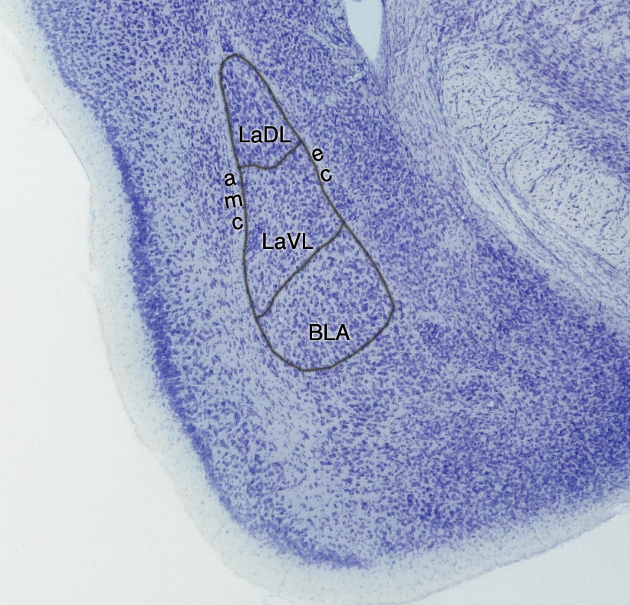
(b)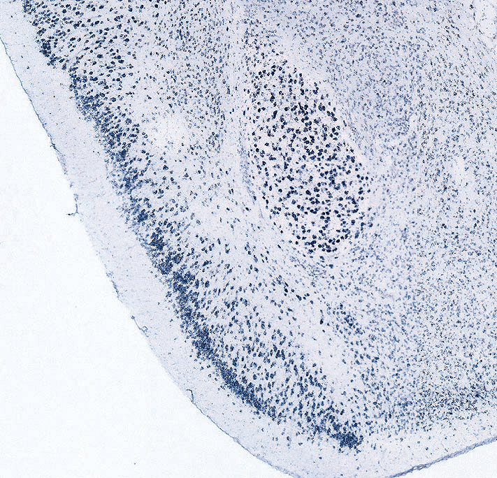
Fig. 1.
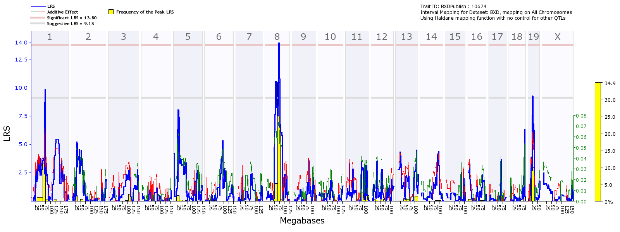
(a)

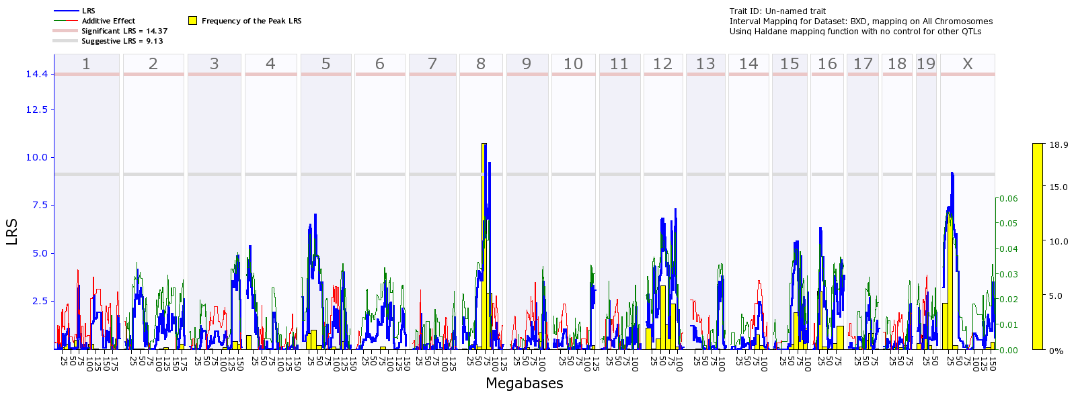
(b)

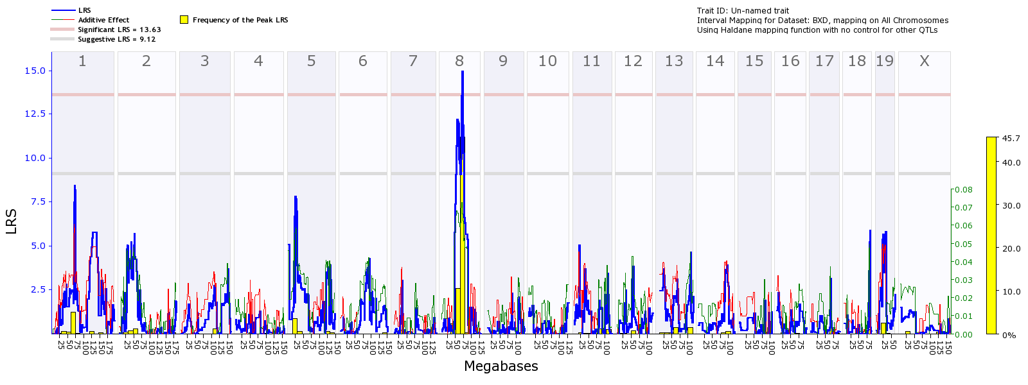
(c)

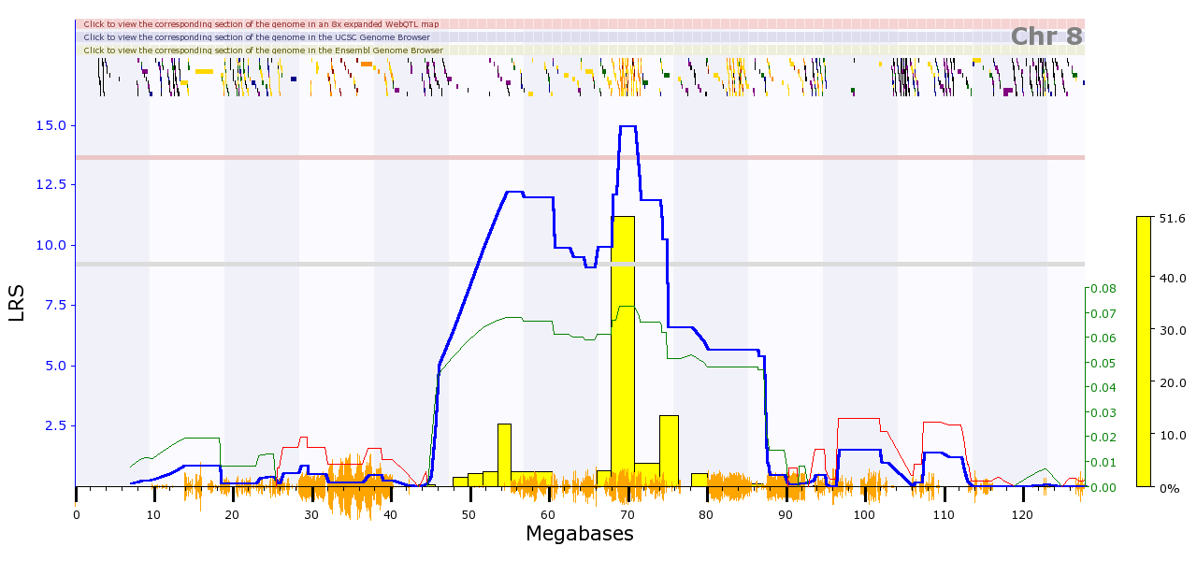
(d)

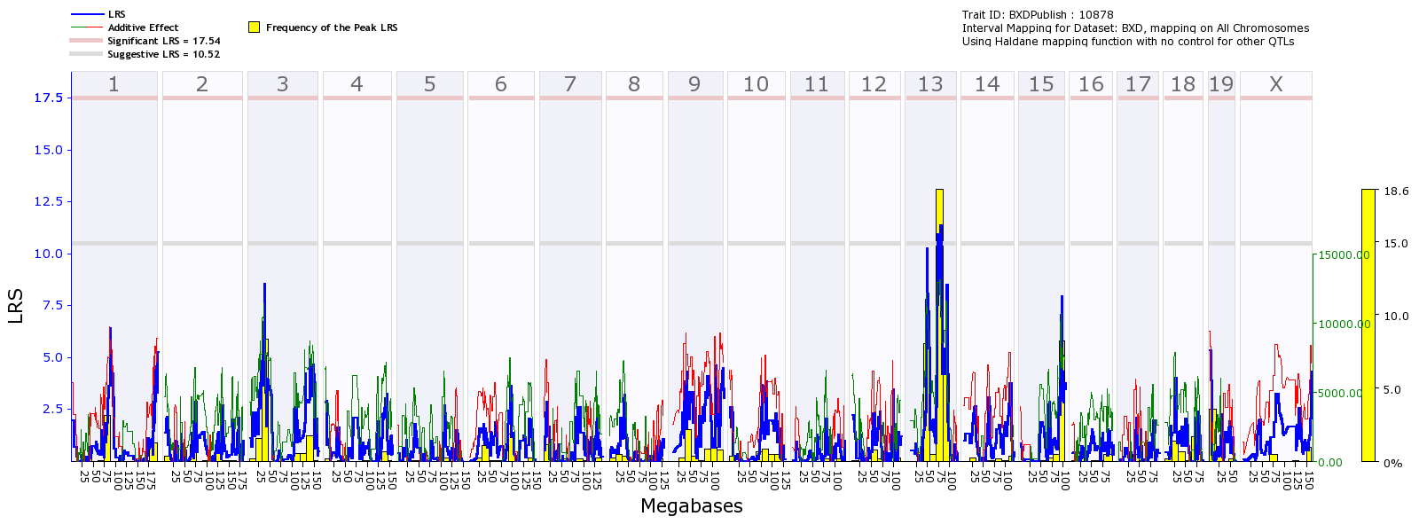
(e)

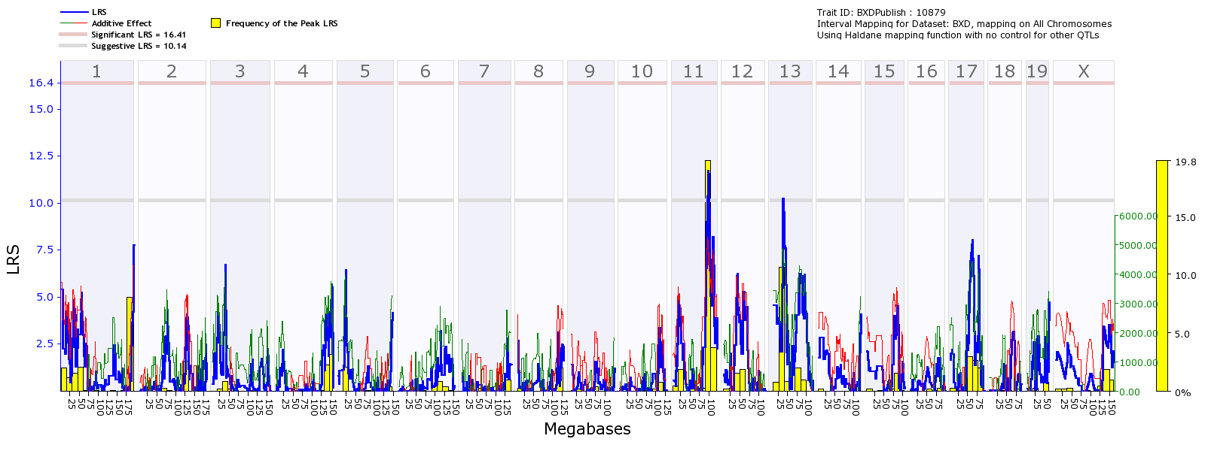
(f)

Fig. 2.

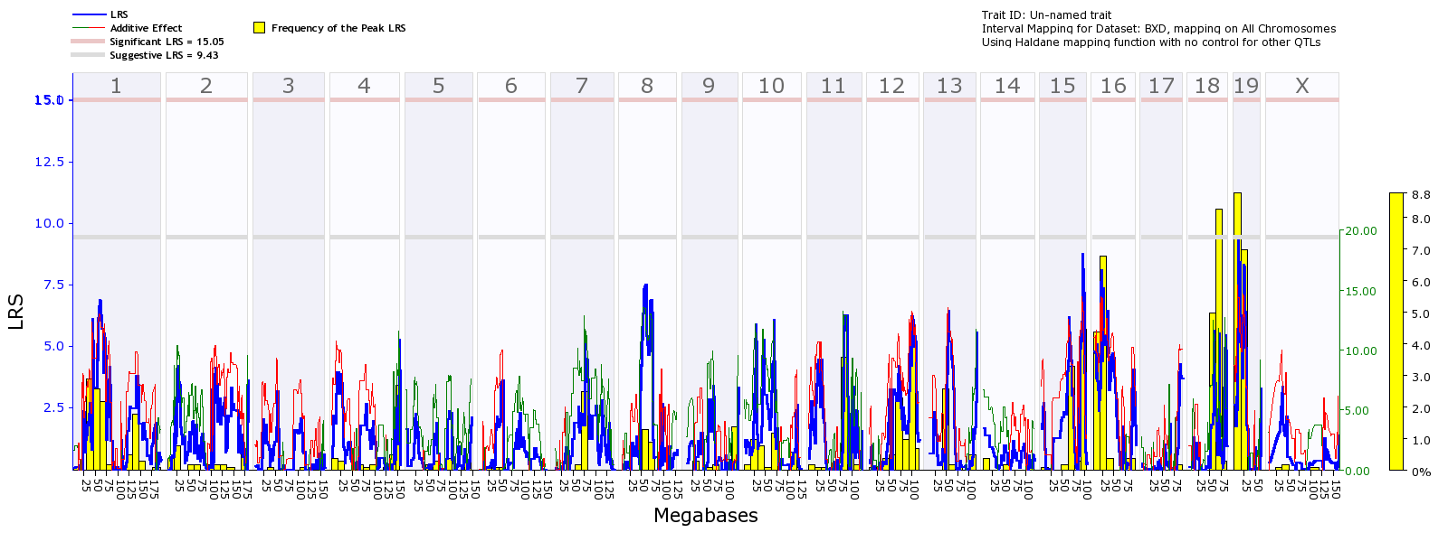
(a)

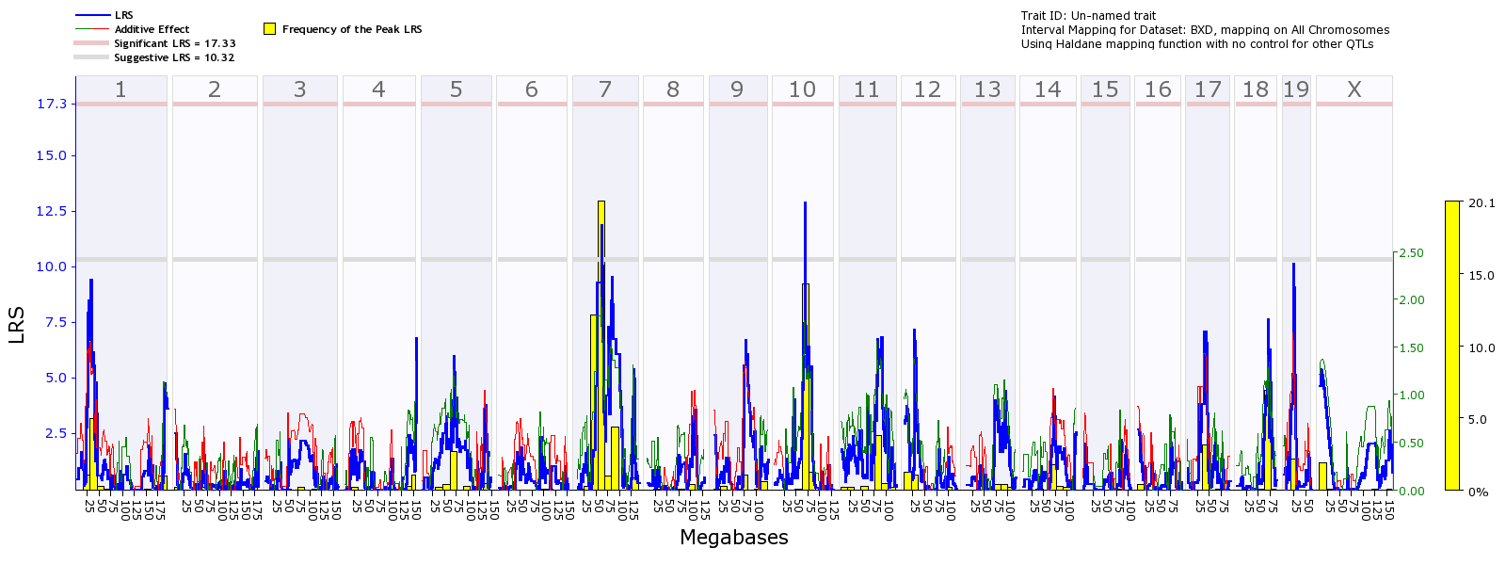
(b)

Fig. 3.

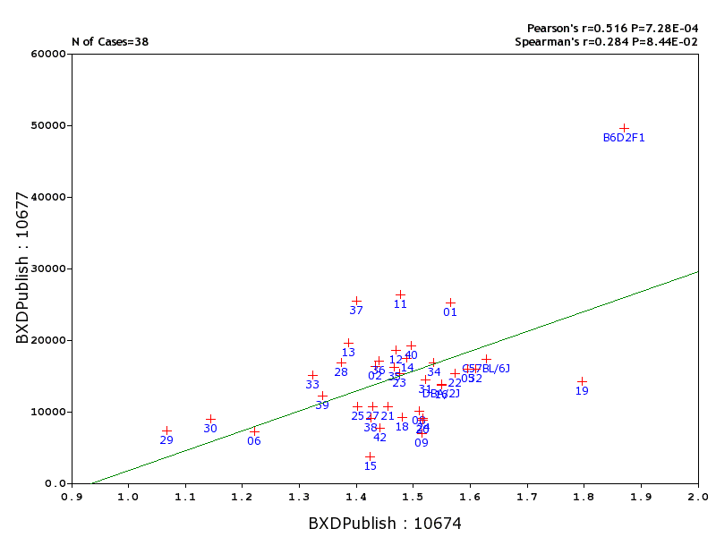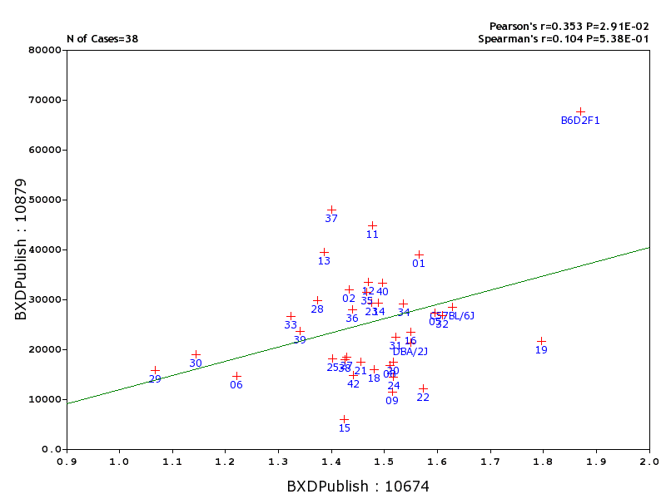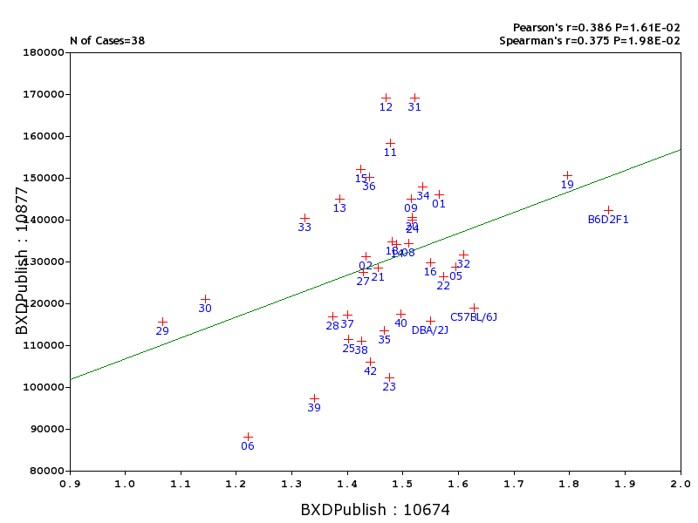
X-axis: Volume; Y-axis: Glial number. X-axis: Volume; Y-axis: Glial density X-axis: Volume; Y-axis: Neuron number

(a) (b) (c)

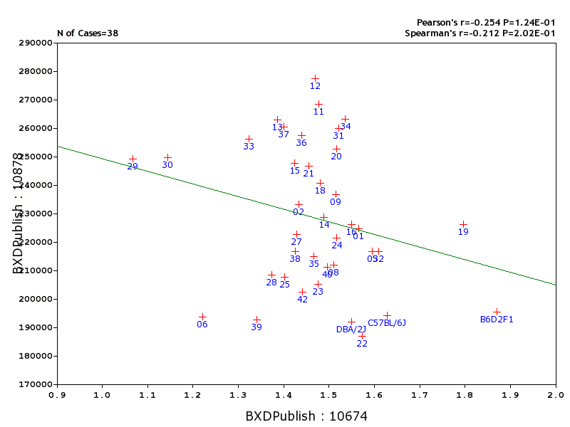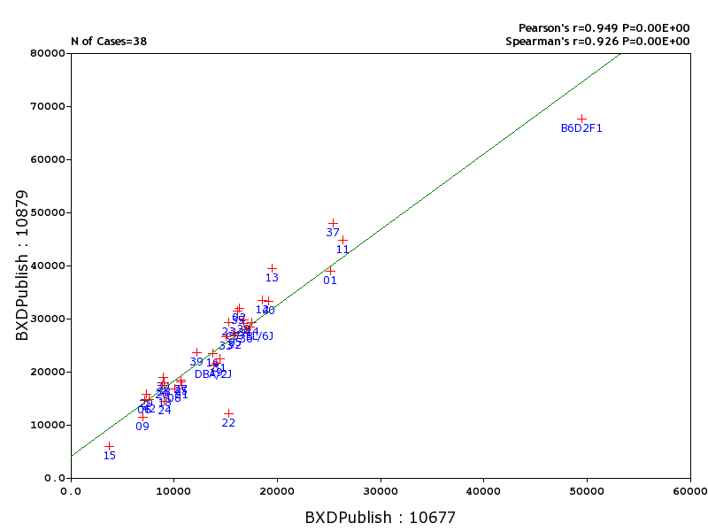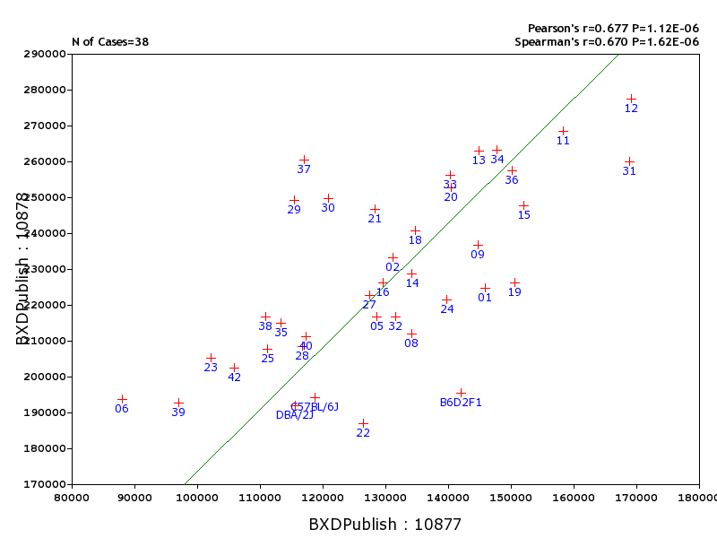
X-axis: Volume; Y-axis: Neuron density X-axis: Glial number; Y-axis: Glial density X-axis: Neuron number; Y-axis: Neuron density
(d) (e) (f)

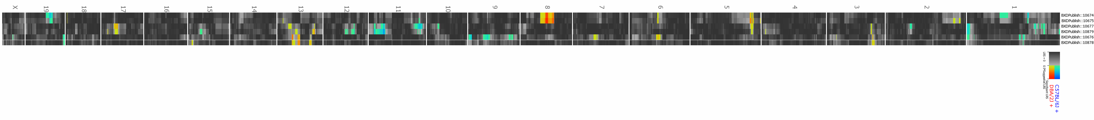
(g)

Fig. 4.

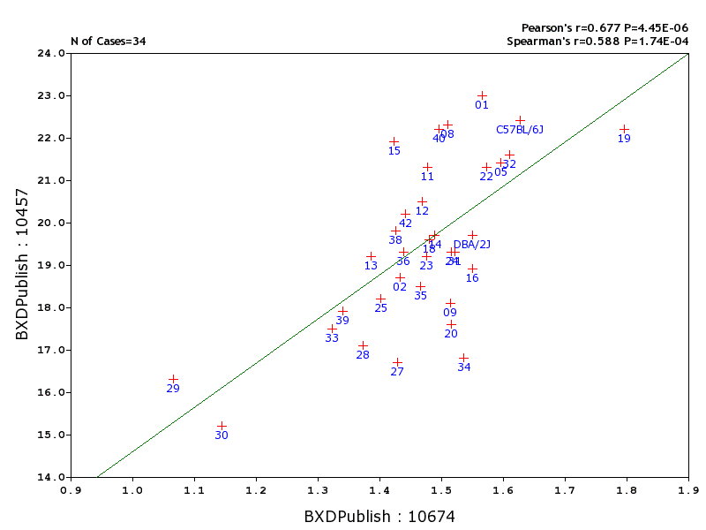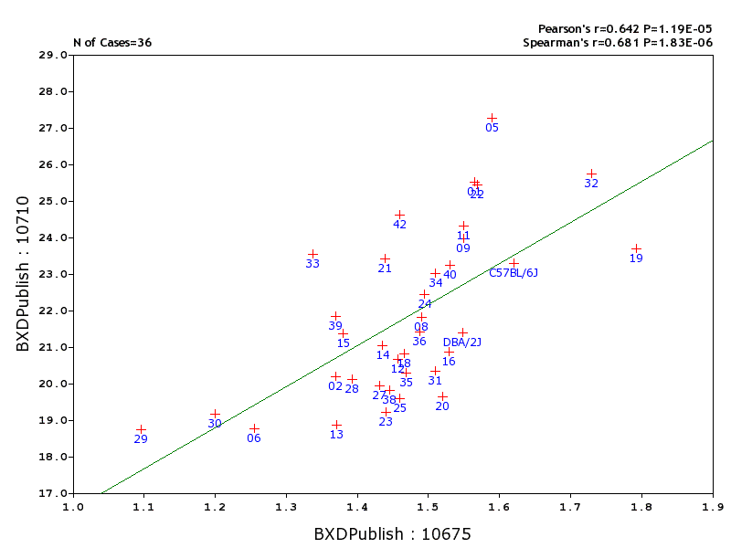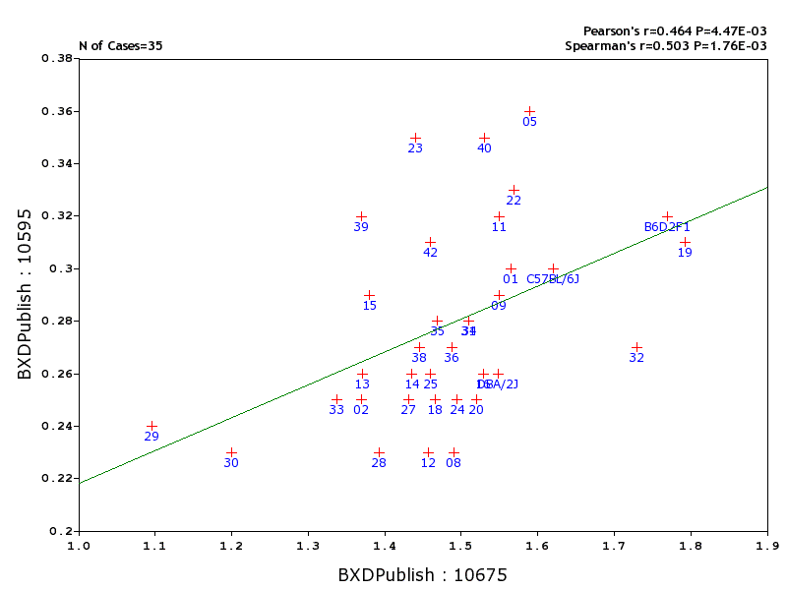
X-axis: Amygdala; Y-axis: Hippocampus proper X-axis: Amygdala; Y-axis: Striatum X-axis: Amygdala; Y-axis: LGN
(a) (b) (c)

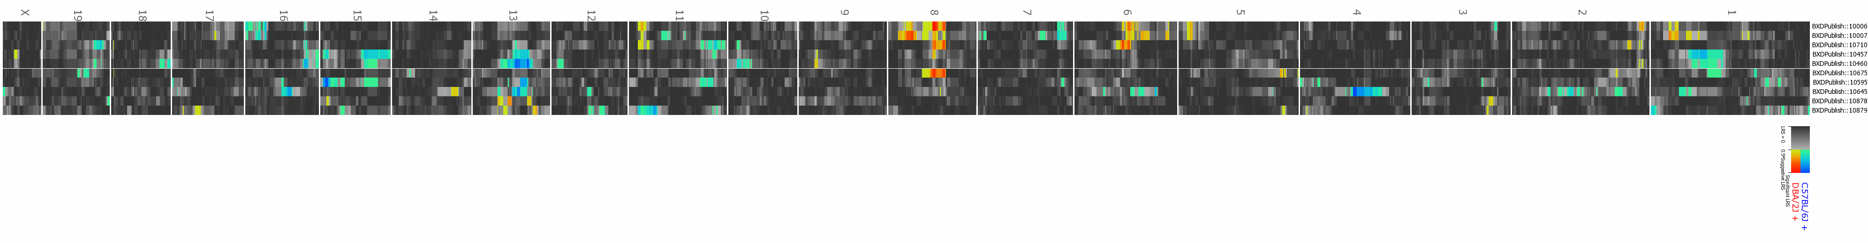
(d)
Fig. 5.

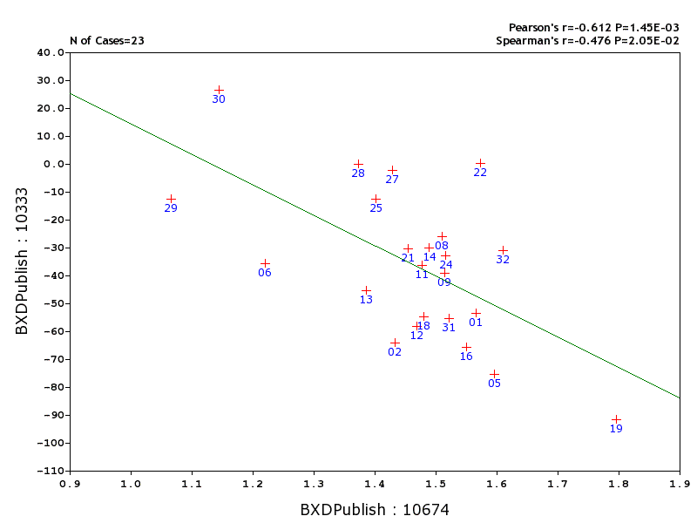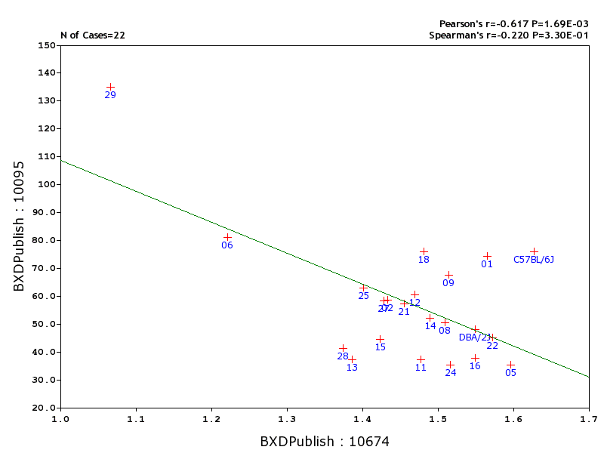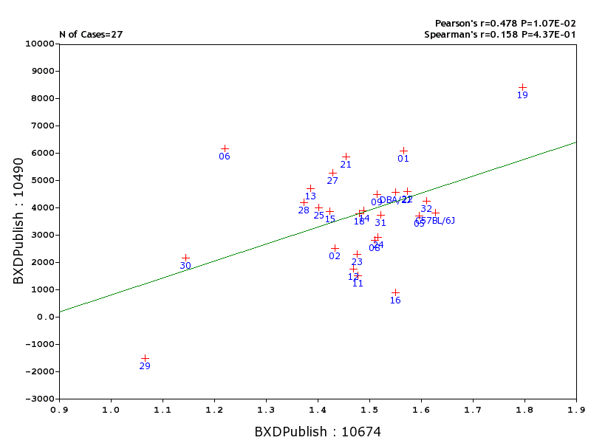
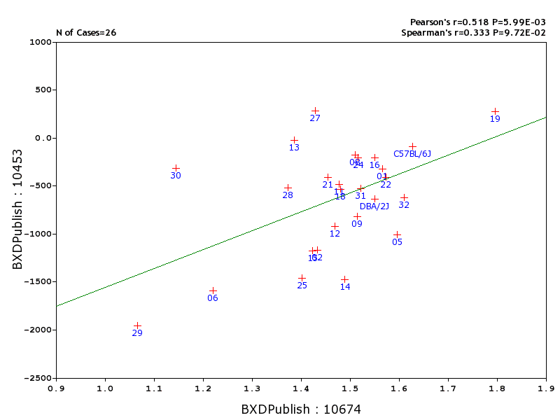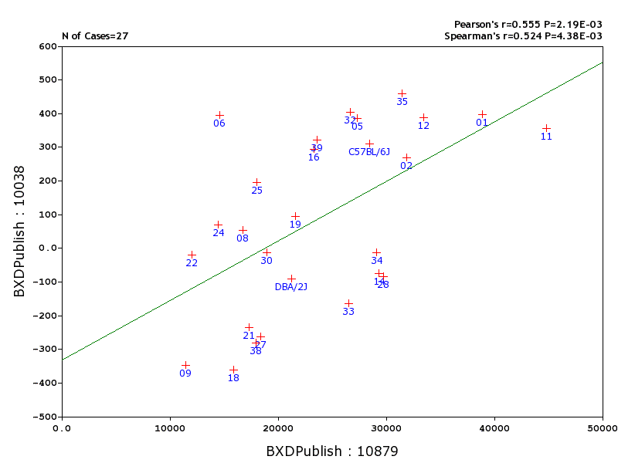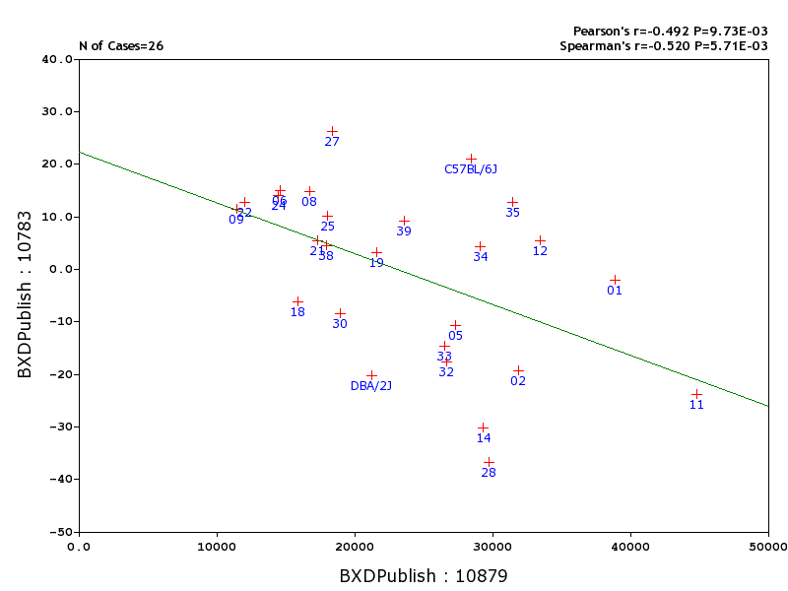

(a)
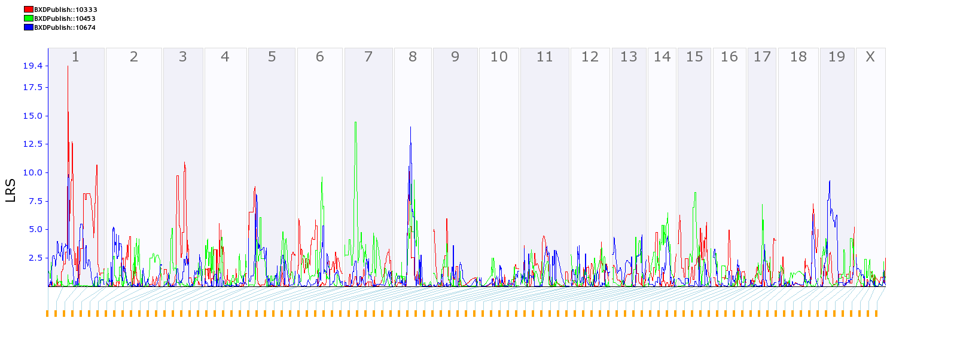
(b)

Fig. 6.

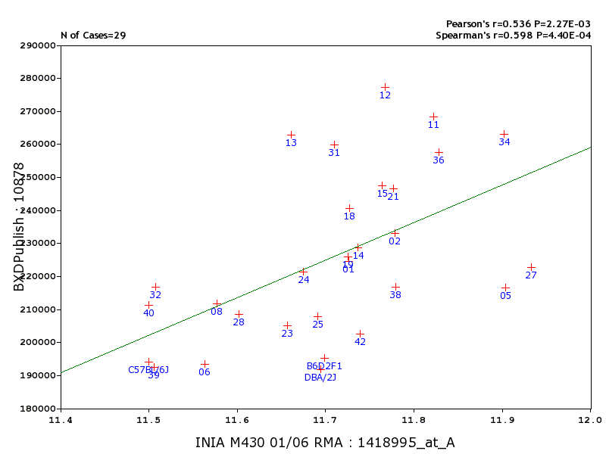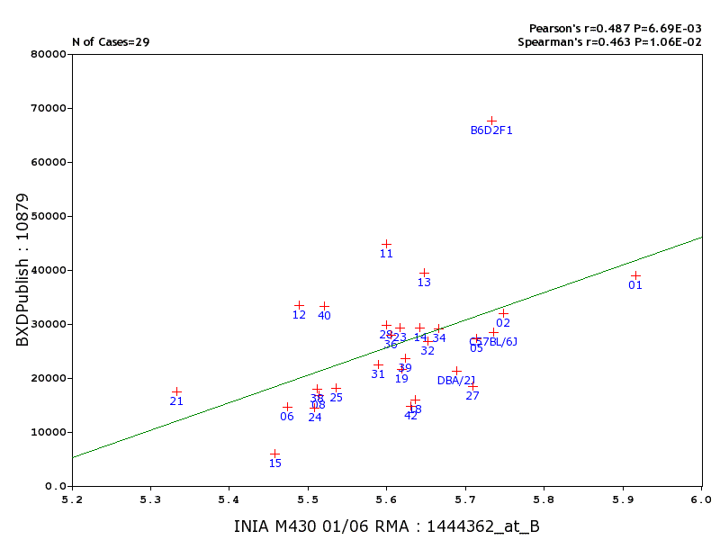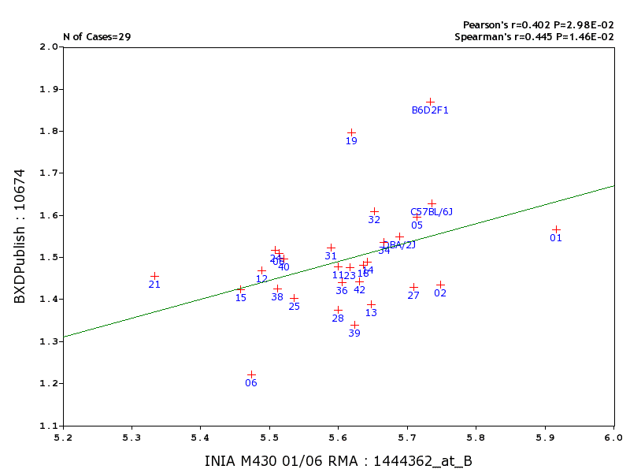
(a) (b) (c)
Fig. 7.

Table 1: Volume of amygdala and cell numbers¹
Group | N | Volume^{A}  (mm³) | V^{B}  (mm³) | V^{C}  (mm³) | N^{D} | Neurons^{E}  (×1000) | Neurons^{F}  (×1000)/ mm³ | Glia^{E}  (×1000) | Glia^{F}  (×1000)/ mm³ | Endthl^{E}  (×1000)
F1  C57BL/6J  DBA/2J  BXD1  BXD2  BXD5  BXD6  BXD8  BXD9  BXD11  BXD12  BXD13  BXD14  BXD15  BXD16  BXD18  BXD19  BXD20  BXD21  BXD22  BXD23  BXD24  BXD25  BXD27  BXD28  BXD29  BXD30  BXD31  BXD32  BXD33  BXD34  BXD35  BXD36  BXD37  BXD38  BXD39  BXD40  BXD42 | 4  6  6  6  5  6  5  5  5  5  6  6  5  5  6  6  6  4  4  8  5  5  5  5  4  5  5  5  6  5  6  5  6  2  5  5  6  5 | 1.87±0.11  1.63±0.10  1.55±0.06  1.57±0.12  1.43±0.15  1.60±0.13  1.22±0.09  1.51±0.10  1.51±0.07  1.48±0.08  1.47±0.12  1.39±0.09  1.49±0.08  1.42±0.11  1.55±0.05  1.48±0.09  1.80±0.08  1.52±0.09  1.45±0.08  1.57±0.06  1.48±0.17  1.52±0.09  1.40±0.07  1.43±0.03  1.37±0.03  1.07±0.03  1.14±0.06  1.52±0.09  1.61±0.16  1.32±0.07  1.54±0.15  1.47±0.10  1.44±0.03  1.40±0.40  1.43±0.04  1.34±0.04  1.50±0.04  1.44±0.04 | 1.75  1.49  1.63  1.46  1.40  1.36  1.32  1.51  1.50  1.47  1.44  1.41  1.44  1.35  1.48  1.50  1.82  1.59  1.45  1.50  1.44  1.55  1.48  1.60  1.45  1.19  1.34  1.56  1.56  1.34  1.56  1.47  1.49  1.42  1.47  1.40  1.50  1.37 | 1.78  1.61  1.56  1.58  1.39  1.60  1.26  1.50  1.52  1.50  1.45  1.38  1.44  1.35  1.54  1.48  1.81  1.53  1.45  1.55  1.45  1.49  1.47  1.43  1.39  1.09  1.19  1.49  1.61  1.35  1.53  1.48  1.48  1.34  1.44  1.38  1.54  1.45 | 4  5  5  5  5  4  4  5  3  2  5  6  5  3  5  5  5  4  5  5  5  4  5  4  3  4  4  3  6  5  6  5  4  2  3  5  5  4 | 142  119  116  146  131  129  88  134  145  158  169  145  134  152  130  135  151  141  128  126  102  140  111  127  117  115  121  169  132  140  148  113  150  117  111  97  117  106 | 195  194  192  225  233  217  194  212  237  268  277  263  229  248  226  241  226  253  247  187  205  221  208  223  208  249  250  260  217  256  263  215  257  260  217  193  211  202 | 50  17  14  25  16  16  7  10  7  26  19  20  17  4  14  9  14  9  11  15  15  9  11  11  17  7  9  14  16  15  17  16  17  25  9  12  19  8 | 68  28  21  39  32  27  15  17  11  45  33  39  29  6  23  16  22  17  17  12  29  14  18  18  30  16  19  22  27  27  29  31  28  48  18  24  33  15 | 30  19  14  23  14  18  15  11  15  7  15  9  14  13  11  13  15  19  15  17  13  13  21  25  24  25  16  24  22  23  22  24  11  5  15  18  22  23
^{s}
N: Number of cases per strain for volumetric data; Volume^{A}: Raw amygdala volume with standard error (SE); V^{B}: Corrected volume after adjusting for brain weight; V^{C}: Corrected volume after adjusting for body weight; N^{D}: Number of cases per strain for stereology; Neurons^{E}: Number of neurons; Neurons^{F}: Density of neurons; Glia^{E}: Number of glial cells; Glia^{F}: Density of glial cells; Endthl^{E}: Number of endothelial/other cells. ¹ These values can be accessed from Genenetwork “BXD Published Phenotypes” database; histograms of these data with error bars can be generated with the “Basic Statistics” tool.

Table 2: Behavioral correlates of amygdala ¹

¹ Correlation plots provided in Fig. 6a.

X-axis  Amygdala Traits | Y-axis  Behavioral Traits | R | P | N
10674: Volume  10674  10674  10674  10879: Glial cells  10879 | 10333: Cocaine open filed-center time  (Jones et al., 1999)  10095: Locomotor activity  (Cunningham, 1995)  10490: Cocaine induced sensitization of locomotor response  (Phillips et al., 1998)  10453: Locomotor response  (Palmer et al., 2002)  10038: Distance traveled  (Bolivar & Flaherty, 2003)  10783: Novel food preference  (Bolivar & Flaherty, 2004 | -0.6  -0.6  0.5  0.5  0.6  -0.5 | 0.001  0.002  0.01  0.005  0.002  0.009 | 23  22  27  26  27  26

