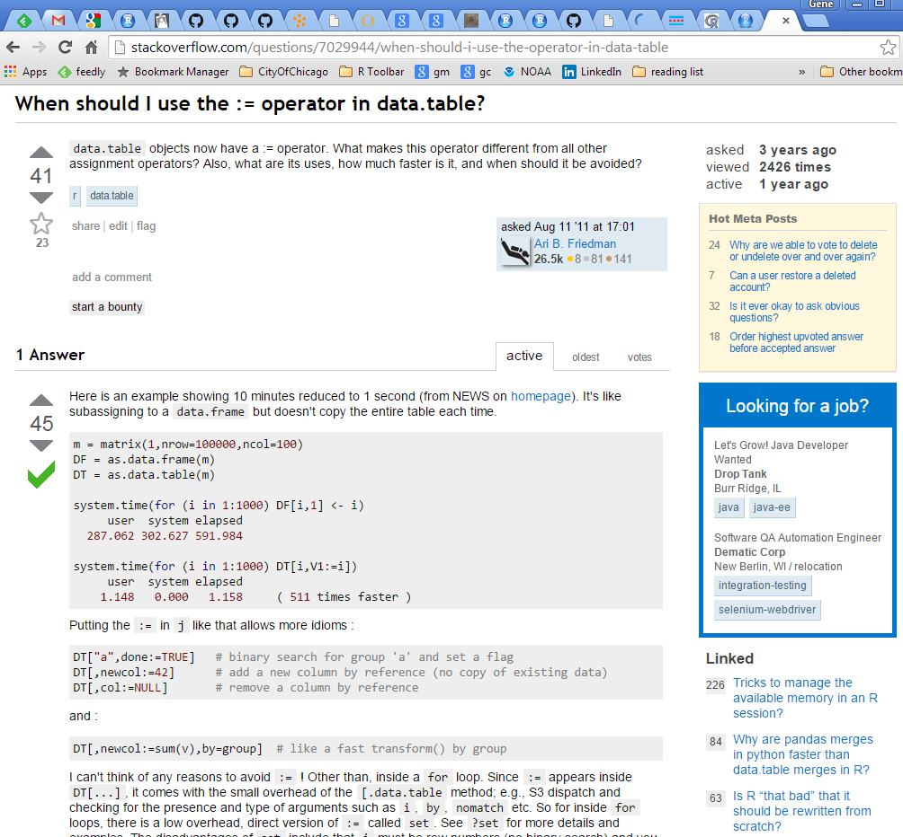
Is this question relevant now
Who wrote it? Are they a beginner?
Words, pictures, and code for a fully reproducible answer, with language specific formatting
Is your question answered somewhere else?
Who answered it? Was the answer edited?
Is this a “good” question worth reading?
Comments…

