GISTIC Documentation

Description: Genomic Identification of Significant Targets in Cancer
Author: Jen Dobson, Rameen Beroukhim, Gad Getz
Date: 2 June 2008
Release: 1.0

Summary
The GISTIC module identifies regions of the genome that are significantly amplified or deleted across a set of samples. Each aberration is assigned a G-score that considers the amplitude of the aberration as well as the frequency of its occurrence across samples. False Discovery Rate q-values are then calculated for the aberrant regions, and regions with q-values below a user-defined threshold are considered significant. For each significant region, a “peak region” is identified, which is the part of the aberrant region with greatest amplitude and frequency of alteration. In addition, a “wide peak” is determined using a leave-one-out algorithm to allow for errors in the boundaries in a single sample. The “wide peak” boundaries are more robust for identifying the most likely gene targets in the region. Each significantly aberrant region is also tested to determine whether it results primarily from broad events (longer than half a chromosome arm), focal events, or significant levels of both. The GISTIC module reports the genomic locations and calculated q-values for the aberrant regions. It identifies the samples that exhibit each significant amplification or deletion, and it lists genes found in each “wide peak” region.

References

- Beroukhim R, Getz G, et al. (2007). “Assessing the significance of chromosomal abberations in cancer: Methodology and application to glioma.” Proc Natl Acad Sci, 104:20007-20012.

Input Parameters

Name | Description
refgene file | The cytoband file to use in the analysis. Allowed values: {Human Hg18, Human Hg17, Human Hg16}. (Default=Human Hg16)
amplifications threshold | Threshold for copy number amplifications. Regions with a log2 ratio above this value are considered amplified. (Default=0.1)
deletions threshold | Threshold for copy number deletions. Regions with a log2 ratio below the negative of this value are considered deletions. (Default=0.1)
join segment size | Smallest number of markers to allow in segments from the segmented data. Segments that contain fewer than this number of markers are joined to the neighboring segment that is closest in copy number. (Default=4)
qv thresh | Threshhold for q-values. Regions with q-values below this number are considered significant. (Default=0.25)
extension | Extension to append to all output files.
remove x | Flag indicating whether to remove data from the X-chromosome before analysis. Allowed values= {1,0}. (Default=1(yes))
seg file  The segmentation file contains the segmented data for all the samples identified by GLAD, CBS, or some other segmentation algorithm. (See GLAD file format in the Genepattern file formats documentation.) It is a six column, tab-delimited file with an optional first line identifying the  The array list file is an optional file identifying the subset of samples to be used in the analysis. It is a one column file with an optional header. The sample identifiers listed in the array list file must match the sample names given in the segmentation file.  There are two options for the cnv file. The first option allows CNVs to be identified by marker name. The second option allows the CNVs to be identified by genomic location. | The segmentation file contains the segmented data for all the samples identified by GLAD, CBS, or some other segmentation algorithm. (See GLAD file format in the GenePattern file formats documentation.) It is a six column, tab-delimited file with an optional first line identifying the columns. Positions are in base pair units.
markers file | The markers file identifies the marker names and positions of the markers in the original dataset (before segmentation). It is a three column, tab-delimited file with an optional header. If not already, markers are sorted by genomic position.
array list file | The array list file is an optional file identifying the subset of samples to be used in the analysis. It is a one column file with an optional header. The sample identifiers listed in the array list file must match the sample names given in the segmentation file.
cnv file | There are two options for the cnv file. The first option allows CNVs to be identified by marker name. The second option allows the CNVs to be identified by genomic location.

Input Files

- Segmentation File REQUIRED

The segmentation file contains the segmented data for all the samples identified by GLAD, CBS, or some other segmentation algorithm. (See GLAD file format in the GenePattern file formats documentation.) It is a six column, tab-delimited file with an optional first line identifying the columns. Positions are in base pair units.

The column headers are:

- Sample (sample name)
- Chromosome (chromosome number)
- Start Position (segment start position, in bases)
- End Position (segment end position, in bases)
- Num markers (number of markers in segment)
- Seg.CN (log2() -1 of copy number)

Example Segmentation File

- Markers File REQUIRED

The markers file identifies the marker names and positions of the markers in the original dataset (before segmentation). It is a three column, tab-delimited file with an optional header. The column headers are:

- Marker Name
- Chromosome
- Marker Position (in bases)

Example Markers File

- Array List File OPTIONAL

The array list file is an optional file identifying the subset of samples to be used in the analysis. It is a one column file with an optional header (array). The sample identifiers listed in the array list file must match the sample names given in the segmentation file.

Example Array List File

- CNV File OPTIONAL

There are two options for the cnv file. The first option allows CNVs to be identified by marker name. The second option allows the CNVs to be identified by genomic location.

Option #1: A two column, tab-delimited file with an optional header row. The marker names given in this file must match the marker names given in the markers_file. The CNV identifiers are for user use and can be arbitrary. The column headers are:
- Marker Name
- CNV Identifier

Option #2: A 6 column, tab-delimited file with an optional header row. The ‘CNV Identifier’, ‘Narrow Region Start’ and ‘Narrow Region End’ are for user use and can be arbitrary. The column headers are:
- CNV Identifier
- Chromosome
- Narrow Region Start
- Narrow Region End
- Wide Region Start
- Wide Region End

Example CNV File

Output Files

1. All Lesions File (all_lesions_file.txt)

The all lesions file summarizes the results from the GISTIC run. It contains data about the significant regions of amplification and deletion as well as which samples are amplified or deleted in each of these regions. The identified regions are listed down the first column, and the samples are listed across the first row, starting in column 10.

Region Data
Columns 1-9 present the data about the significant regions as follows:
- Unique Name: A name assigned to identify the region.
- Descriptor: The genomic descriptor of that region.
- Wide Peak Limits: The “wide peak” boundaries most likely to contain the targeted genes. These are listed in genomic coordinates and marker (or probe) indices.
- Peak Limits: The boundaries of the region of maximal amplification or deletion.
- Region Limits: The boundaries of the entire significant region of amplification or deletion.
- q-values: The q-value of the peak region.
- Residual q-values: The q-value of the peak region after removing (“peeling off”) amplifications or deletions that overlap other more significant peak regions in the same chromosome.
- Broad or Focal: Identifies whether the region reaches significance due primarily to broad events (called “broad”), focal events (called “focal”), or independently significant broad and focal events (called “both”).
- Amplitude Threshold: Key giving the meaning of values in the subsequent columns associated with each sample.

Sample Data
Each of the analyzed samples is represented in one of the columns following the lesion data (columns 10 through end). The data contained in these columns varies slightly by section of the file.

The first section can be identified by the key given in column 9 – it starts in row 2 and continues until the row that reads “Actual Log Value.” This section contains summarized data for each sample. A ‘0’ indicates that the copy number of the sample was not amplified or deleted beyond the threshold amount in that peak region. A ‘1’ indicates that the sample had low-level copy number aberrations (exceeding the low threshold indicated in column 9), and a ‘2’ indicates that the sample had high-level copy number aberrations (exceeding the high threshold indicated in column 9).

The second section can be identified as the rows in which column 9 reads “Actual Log2 Ratio.” The second section exactly reproduces the first section, except that here the exact log2 ratios are provided rather than zeroes, ones, and twos.

The final section is similar to the first section, except that here only broad events (called “broad”) and independently significant broad and focal events (called “both”) are included. A 1 in the samples columns (columns 10+) indicates that the median copy number of the sample across the entire significant region exceeded the threshold given in column 9. That is, it indicates whether the sample had a geographically extended event, rather than a focal amplification or deletion covering little more than the peak region.

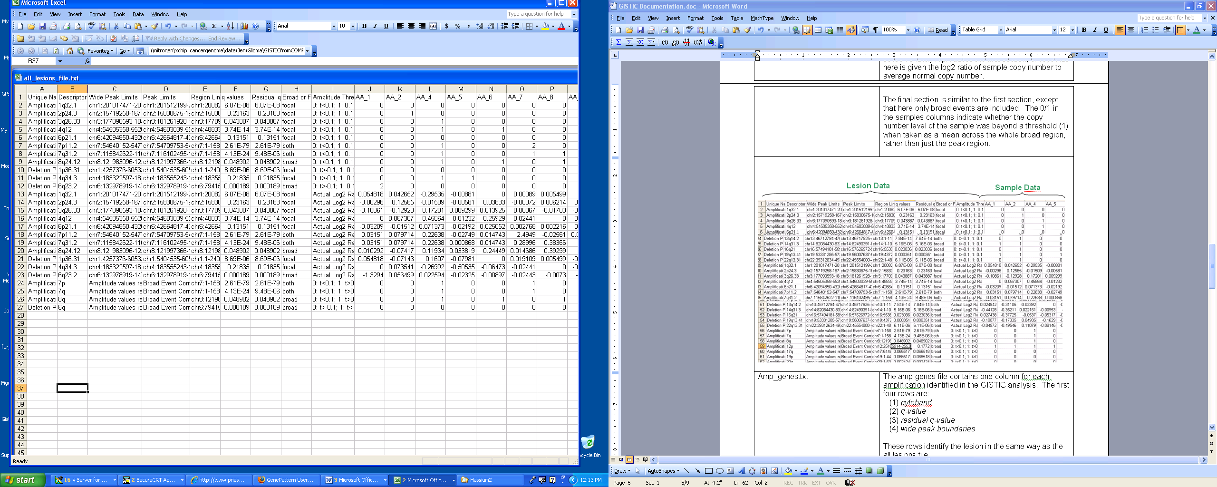
Sample Data
Lesion Data
Section 1
Section 2
Section 3

2. Amplification Genes File (Amp_genes.txt)

The amp genes file contains one column for each amplification identified in the GISTIC analysis. The first four rows are:
- cytoband
- q-value
- residual q-value
- wide peak boundaries

These rows identify the lesion in the same way as the all lesions file.

The remaining rows list the genes contained in each wide peak. For peaks that contain no genes, the nearest gene is listed in brackets.

3. Deletion Genes File (Del_genes.txt)

The del genes file contains one column for each deletion identified in the GISTIC analysis. The file format for the del genes file is identical to the format for the amp genes file.

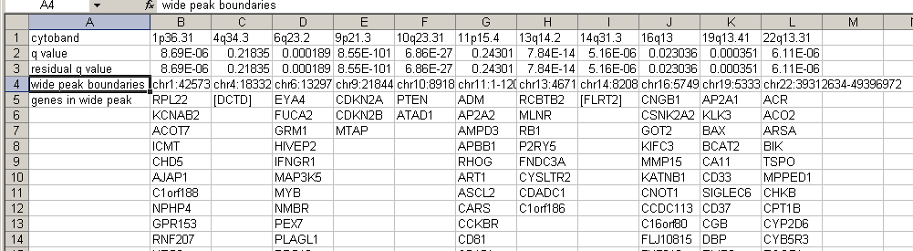

4. Gistic Scores File (scores.gistic.txt)

The scores file lists the q-values [presented as -log10(q)], G-scores, average amplitudes among aberrant samples, and frequency of aberration, across the genome for both amplifications and deletions. The scores file is viewable with the Integrative Genomics Viewer (IGV).

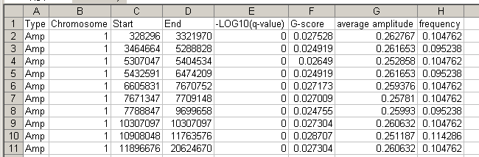

5. Raw Copy Number (Raw_copy_number.xx.pdf)

The raw copy number pdf file is a heat map image of the raw copy number profiles in the input data.

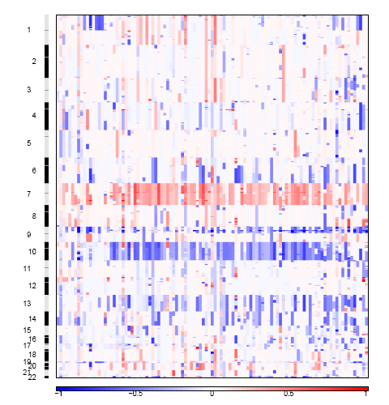

7. Amplification GISTIC plot (amplification.xx.pdf)

The amplification pdf is a plot of the G-scores (top) and q-values (bottom) with respect to amplifications for all markers over the entire region analyzed.

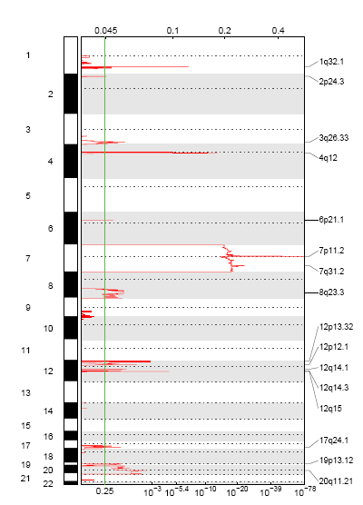

8. Deletion GISTIC plot (deletion.xx.pdf)

The deletion pdf is a plot of the G-scores (top) and q-values (bottom) with respect to deletions for all markers over the entire region analyzed.
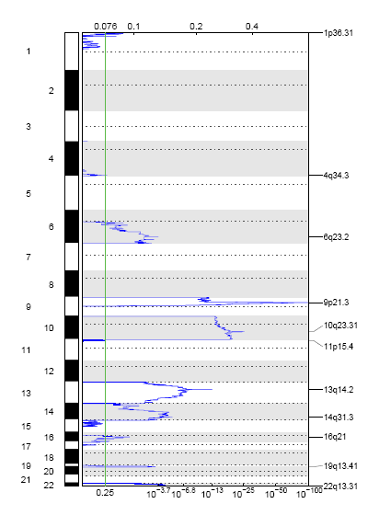

Platform Dependencies

Module type: SNP Analysis
CPU type: x86
OS: 64-bit Linux
Language: MATLAB

