HierarchicalClusteringViewer Documentation

Description: | Views hierarchical clustering results.
Author: | Joshua Gould (Broad Institute), gp-help@broadinstitute.org

Introduction
This module displays a heat map with hierarchical trees, known as dendrograms. The HierarchicalClustering GenePattern module produces output that can be used as input to this module. Files that are always required to run the module are:
- A CDT file, which contains the actual clustered data
- Either a GTR file, which details the gene clusters from an analysis, or an ATR file, which details the sample clusters from an analysis
Values are displayed in a heat map format. Therefore, (by default) the largest values are displayed as the reddest (hot), the smallest values are displayed as the bluest (cool), and intermediate values are a lighter color of either blue or red. This is a common way to display three-dimensional data (samples, genes, and values).
The following figure shows an example of this view.
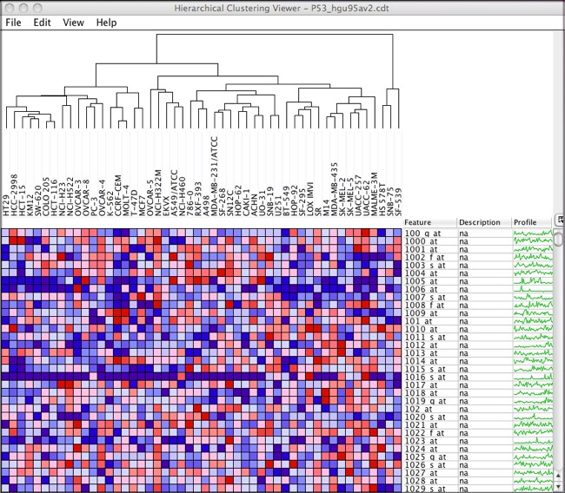

Available Options

Display options
There are a number of options controlling the appearance of the heat map that can be set by selecting View>View Options from the menu:
- You can choose between radio buttons for Relative and Global color schemes. When you select Relative, the heat map converts values to colors based on the mean, minimum, and maximum values in each row. When you select Global, the heat map converts values to colors based on the mean, minimum, and maximum values in the entire dataset. To display the color legend, select View>Color Scheme Legend.
- You can choose between the radio buttons:
- Use Color Gradient: The heat map uses a linear color gradient to convert values to colors
- Use Discrete Colors : The heat map uses a discrete color map to convert values to colors
- You can optionally load a color map by clicking Load Color Map. This color map is a file containing three colors, with one color listed per line:
- First color = the color for the minimum values
- Second color = the color for the mean value
- Third color = the color for the maximum values
The colors can be specified as a decimal, octal, hexadecimal integer, or r:g:b triplet (e.g., #9900FF, 0:0:0, 171). (For more information on numerical color specification, see http://en.wikipedia.org/wiki/RGB_color_model#Numeric_representations)
- The Show Grid checkbox controls whether a grid is drawn around each element.
- The Show Profile checkbox controls whether the profile is shown in the table for each feature.
- The row size and column size sliders control the size of each element in the heat map. When the Maintain Square Aspect checkbox is selected, the row and column sizes are kept in synch.
- You can choose to hide/show feature descriptions, feature names, and sample names by clearing/selecting the corresponding checkbox.
- The Feature Label Width slider controls the size of feature (gene) labels. Similarly, the Sample Label Height slider controls the size of sample labels. These controls do not appear unless you have features and/or samples loaded. To load feature labels, select File>Label Features. To load sample labels, select File>Label Samples.
- You can control the sample or feature (gene) dendrogram height by editing the corresponding text box and pressing RETURN (or ENTER) to apply your changes.
- You can set the sample or feature (gene) dendrogram line thickness by editing the corresponding text box and pressing RETURN (or ENTER) to apply your changes.

Saving images
Users can save the heat map image to a file by selecting File>Save Image from the menu. Supported image formats are BMP, EPS, JPEG, PNG, and TIFF.

Saving datasets
You can use the viewer to create a new dataset.
- Select File>Save Dataset. A window appears.
- Choose the features and samples to include in the dataset by selecting the features and sample names in the viewer.
- Choose a location and name for the new dataset.
- Click Save to save the new dataset.

Dendrogram color
Note: Feature (gene) dendrograms are displayed when a GTR file is provided and sample dendrograms are displayed when an ATR file is provided.
You can set the color of a selected branch in the sample or feature dendrogram branch color by selecting Edit>Sample Dendrogram Branch Color or Edit>Feature Dendrogram Branch Color.
You can also set the color of a dendrogram node by editing the ATR or GTR file. Add a column to the ATR or GTR file that contains the node color. For example (added column shown in bold):
NODE1X GENE78X GENE77X 0.964702 #9900FF
NODE2X GENE25X GENE8X 0.963298 #990000

Dendrogram rotation
You can flip a selected branch in the sample or feature dendrogram by selecting View>Flip Sample Dendrogram or View>Flip Feature Dendrogram.

Feature labels
Feature (gene) labels use color to annotate features in the heat map.
To use feature labels:
- Create a GRP, GMX, or GMT file. (Or download from a site like the Molecular Signatures Database [MSigDB] or from supplementary files for journal articles of interest.)
- Select File>Label Features to open your feature (gene) set file. You have the option to restrict the view to features in your feature set if you did not cluster the features in your dataset. A color bar appears next to each feature in the feature set in the table.
- Select Edit>Feature Labels to edit the color or close the feature set.
- In the Feature Labels window, select your feature set from the drop-down list. The color assigned to that feature list appears in the box to the right.
- To change the color, click the box and select a new color.
- To delete the feature set and remove the color bars from the table, click Delete.
The feature annotations legend can be saved to a file by selecting File>Save Feature Labels Legend.

Sample labels
Sample labels use color to annotate samples in the heat map.
To use sample labels:
- Create a sample info file.
- Select File>Label Samples to open your sample info file. A color bar appears below each sample name.
- Select Edit>Sample Labels to edit the color or close the sample info file.
- In the Sample Labels window, select your sample class from the drop-down list. The color assigned to that sample class appears in the box to the right.
- To change the color, click the box and select a new color.
- To delete the sample class and remove the color bars from the table, click Delete.
The sample annotations legend can be saved to a file by selecting File>Save Sample Labels Legend.

Loading descriptions
GeneCruiser retrieves information about Affymetrix probe identifiers and adds the information to the feature table.
To use GeneCruiser annotations:
- Select File>GeneCruiser.
- Select the features that you want to retrieve annotations for in the table.
- Choose which fields to retrieve from GeneCruiser in the GeneCruiser dialog.
- The annotations appear in additional columns in the table.
You can also load descriptions from a comma separated values (CSV) file. To load descriptions from a CSV file, select File>Load Descriptions From Csv File.

Finding features
To find a feature (gene) in the heat map, select Edit>Find. You can choose whether to match the case of the text you’re searching for by selecting the Match case checkbox at the bottom of the find dialog. You can also choose which column to search from by selecting the desired column name in the dropdown box.

Profile plot
The expression profile for a feature plots expression value per sample.
To display an expression profile:
- Select one or more features and optionally select one or more samples.
- Click View>Profile. Alternatively, right-click and select Profile from the context menu or click the profile plot column in the feature table.

Centroid plot
The centroid plot shows the mean expression value for each sample. The error bars represent the standard deviation.
To display a centroid plot:
- Select two or more features (genes) and optionally select one or more samples.
- Click View>Centroid Plot. Alternatively, right-click and select Centroid Plot from the context menu.

Histogram
The histogram plot shows the distributions of expression values. The vertical axis represents number of occurrences, and the horizontal axis represents the binned expression values.
To display a histogram:
- Select one or more features (genes) and optionally select one or more samples.
- Click View>Histogram. Alternatively, right-click and select Histogram from the context menu.

Nearest neighbors
The nearest neighbors item shows other features (genes) whose expression values follow similar trends to the selected feature. There are four choices for the distance metric (which defines the method used to determine mathematical distance between features):
- Pearson (default): Pearson's correlation coefficient between two variables is defined as the covariance of the two variables divided by the product of their standard deviations. It is a measure for how well a straight line can be fitted to a scatter plot of x and y. If all the points in the scatter plot lie on a straight line, the Pearson correlation coefficient is either +1 or -1, depending on whether the slope of line is positive or negative. If it is equal to zero, there is no correlation between x and y.
- Cosine: A measure of similarity between two features based on the cosine of the angle between the vectors (consisting of the expression values for each) in mathematical space.
- Euclidean: Corresponds to the length of the shortest path between two points. Takes into account the difference between two features directly, based on the magnitude of changes in the sample levels. This distance type is usually used for data sets that are normalized or without any special distribution problem.
- Manhattan: Also known as the city-block or taxi cab distance; the Manhattan distance is the sum of distances along each mathematical dimension between two points.
To display the nearest neighbors:
- Select one feature.
- Click View>Nearest Neighbors. Alternatively, right-click and select Nearest Neighbors from the context menu.

Scatter plot
The scatter plot lets you compare expression values in two samples.
To display a scatter plot:
- Select two samples.
- Optionally select one or more features.
- Click View>Scatter Plot. Alternatively, right-click and select Scatter Plot from the context menu.

Keyboard Shortcuts
You can use your keyboard to quickly accomplish many tasks. To find the shortcuts for common commands, look in the menus or select Help>Keyboard Shortcuts to see a list of available shortcuts.

Parameters
Name | Description
cdt file (required) | A clustered data table (CDT) file contains the original data, but reordered according to clusters.
gtr file | The Gene Tree file (GTR) records the order in which genes (rows) were joined during clustering.  *Either a GTR or an ATR file is required.
atr file | The Array Tree file (ATR) records the order in which samples (columns) were joined.  *Either a GTR or an ATR file is required.

Input Files
- CDT file
Contains the original data reordered according to clusters.
- GTR file or ATR file
Records the order in which genes/rows (GTR) or samples/columns (ATR) were joined during clustering

Example Files
To see an example sample information file for sample labeling, see: ftp://ftp.broadinstitute.org/pub/genepattern/example_files/HierarchicalClusteringViewer/ALLAMLTest_SampleInfo.txt

Platform Dependencies
Module type: | Visualizer
CPU type: | any
OS: | any
Language: | Java

GenePattern Module Version Notes
Version | Release Date | Description
10 | 3/19/2010
11 | 4/3/2013 | Fixed to work with Java 7.

