AAHA Diagnostic Terms – a subset of SNOMED CT®
Overview 1
The XML files 2
Examples…………………………………………………………………………………………………………….…..…5
Additional file formats 9
Issues 9
External links 10
Contact information 10

Overview
The American Animal Hospital Association (AAHA) Diagnostic Terms is a subset of concepts and descriptions from SNOMED CT® selected by mapping a list of terms originally prepared by the AAHA Electronic Health Records Task Force (EHRTF) to SNOMED CT® and to a veterinary extension of SNOMED CT® maintained by the Veterinary Terminology Services Laboratory (VTSL). Intellectual property rights to both core and veterinary extension are subject to existing agreements between VTSL and IHTSDO. AAHA’s intellectual property exists in the means and efforts used to select a 3% portion of SNOMED CT® that has application to general veterinary practice. AAHA reserves the right to collect fees associated with production and automated distribution of this subset.
AAHA chose this terminology development path because SNOMED CT and the VTSL support a number of capabilities important to successful use of medical terminology in veterinary practice systems or important to commercial or regulatory applications. 1) Robust and internet-based methods of distribution should be available. 2) The standard should manage synonymy correctly. 3) The standard should be available internationally through a public license. 4) The standard should support dialect and foreign language translation. 5) The terminology standard should be broadly applicable in veterinary medicine as well as provide the needed content for AAHA and its members.

The XML files
From 2010 to 2013, the subset was released using SNOMED’s standard subset distribution file format. The IHTSDO retracted this distribution format when they migrated to a new release file format (RF2). Up to this point, IHTSDO has not dedicated the resources to develop a replacement for the subset distribution format. Therefore, VTSL has developed its own format for subset distribution. The subset was distributed in the old and new format starting with the October 15, 2013 release of the subset through the April 1, 2018 release. From here forward, only the current release format will be distributed.
The current release format is designed to accommodate distribution of both the full subset as well as a delta version that only contain changes during a given time period. It is important to remember that both of these versions of the distribution format comply with the same XML schema. They differ only in content.

The XML Schema
The root element of the VTSL reference set release file format is the <refsetReleaseFile> element. This contains information about the file itself, including date of release, Snomed CT version on which the release is based and schema information.
<refsetReleaseFile releaseDate="20130412" snomedCTrelease=”SNOMED Clinical Terms version: 20130131 [R] (January 2013 Release)” xmlns:xsi="http://www.w3.org/2001/XMLSchema-instance" xsi:noNamespaceSchemaLocation="releaseFormat2_5.xsd">
The release file element contains 2 child elements. The first element conveys the period of time covered by the release file <timeFrame>.
<timeframe>
<startdate>2012-10-16</startdate>
<enddate>2013-04-12 13:23:12</enddate>
</timeframe>

The second element contains the concept reference set. In this case, the concept reference set is the AAHA Diagnostic Terms refset.
<conceptRefset name="AAHA Diagnostic Terms - Official Release" refsetId="332921000009102">
The <conceptRefset> element has 3 child elements: <addedConceptMembers>, <changedConceptMembers>, and <retiredConceptMembers>. As their names implies these elements group together concepts that have been added, changed, or retired (respectively) within the concept refset during the time frame given. The <addedConceptMembers> element contains all concepts that were added (and are still active) during the given time period. Any changes made to these concepts during the time period will be reflected within the <conceptMember> elements, so these “added” concepts will NOT also be included in the <changedConceptMembers> even if changes were made to the concept during the time frame. The <changedConceptMembers> element contains only concept members that were already active members before the beginning of the time frame and are still active members of the concept refset, but they were changed in some way during the given time frame. The <retiredConceptMembers> element contains all concept members that were retired during the time frame. Each of these grouping elements contains child <conceptMember> elements that convey details for members of the concept refset.
The <conceptMember> element contains the details of membership in the refset, i.e. status (active or inactive) within the refset, effective date of the status within the refset, and to what module within the terminology the concept belongs (specific extension manager, core manager, etc.). The latest schema (2.5) adds a required attribute of “displayTerm”. This attribute is populated with the most current Preferred Term for the concept, and it allows the XML and transforms for display to be more easily human readable.
<conceptMember active="1" displayTerm=”Stomatocytosis” moduleId="332351000009108" refsetEffectiveTime="2012-11-20 12:46:14.0">
Note that in the initial release file format, a status=0 designated an active concept. Here and through this release format, an active element is designated by active=”1”.
The <conceptMember> element contains 1 child element: the <concept> element. This <concept> element provides information about the concept from the base terminology (SNOMED CT and VTSL Veterinary Extension): SCTID of the concept, status of the concept in the terminology, effectiveTime of that status within the terminology, whether or not the concept is fully defined in the terminology, and to what module within the terminology the concept belongs.
<concept active="1" conceptId="3272007" definitionStatusId="900000000000074008" effectiveTime="2002-01-31 00:00:00.0" moduleId="900000000000207008">
The <concept> element has two child elements: <conceptHistory> and <languagePreferences>. The optional child element, <conceptHistory>, as the name implies gives a record of the history of the concept. Each <conceptHistory> element gives a previous state of the given concept. The second child element, <languagePreferences>, is required for each <concept> element. It gives the term preferences for the given concept.
Each concept has terms (descriptions) that have been selected for use within veterinary systems. The selection of these terms creates a language preference reference set that is associated with the concept subset for a given organization or use. In this case, the language reference set is the AAHA Description refset. The <languagePreferences> element denotes the language refset which is being applied as represented by name and refsetId attributes.
<languagePreferences name="AAHA Description Refset" refsetId="332941000009106">
Within the <languagePreferences> element, you will find language preference members that have been added, changed or retired within the language refset during the given time frame for the given concept. These are grouped together within the <addedLanguagePreferences>, <changedLanguagePreferences>, and <retiredLanguagePreferences> elements. Each of these elements may have 0 to many <languagePreference> elements within them. . The <addedLanguagePreferences> element contains all terms that were added (and are still active) during the given time period. Any changes made to these terms or their preferences during the time period will be reflected within the <languagePreference> elements, so these “added” terms will NOT also be included in the <changedLanguagePreferences> even if changes were made to them during the time frame. The <changedLanguagePreferences> element contains only terms that were already active language preference members before the beginning of the time frame and are still active members of the language preference refset, but they were changed in some way during the given time frame. The <retiredLanguagePreferences> element contains all terms that were retired during the time frame. Each of these grouping elements contains child <languagePreference> elements that convey details for the terms and their preference status within the language preference refset.
Each <languagePreference> element contains details of the term or description’s membership in the language preference refset: status of the description’s membership, effective time of the status within the refset, designation of the description within the language refset, and to what module within the terminology the concept belongs (specific extension manager, core manager, etc.). This file only includes descriptions that are used in veterinary medicine as selected by the AAHA EHRTF. Each concept has one description considered to be “preferred” for display in veterinary information systems and zero to many additional descriptions considered to be “acceptable” for display in veterinary systems.
<languagePreference active="1" designation="Preferred" moduleId="332351000009108" refsetEffectiveTime="2012-11-20 12:46:28.0">
The <languagePreference> element has two child elements. The optional child element, <languagePreferenceHistory>, as the name implies gives a record of the history of the description within the language refset. Each <languagePreferenceHistory> element gives a previous state of the given membership. The second child element is required for each <languagePreference>; it is the <description> element. The <description> element provides information about the description from the base terminology: SCTID of the description, status of the description in the terminology, effective time of the status in the terminology, the text string or term of the description, and to what module within the terminology the concept belongs (specific extension manager, core manager, etc.).
<description active="1" descriptionId="6528016" effectiveTime="2002-01-31 00:00:00.0" moduleId="900000000000207008" term="Stomatocytosis">
The <description> element may also contain one or more <descriptionHistory> elements which show the previous states of the description within the base terminology.
When concepts are retired from the concept refset, it is important to be able to designate a replacement, or potential replacement, for that concept. We associate these replacements in the following structure:
<retiredConceptMembers>
<retiredConceptMember>
<conceptMember>…</conceptMember>
<refsetReplacements>…</refsetReplacements>
</retiredConceptMember>
</retiredConceptMembers>
The <conceptMember> element will contain information about the retired concept, its associated descriptions, and refset history.
The <refsetReplacements> element contain one or more of the following elements:
<replacedBy conceptid=”SCTID of replacement concept” />
<sameAs conceptid=”SCTID of replacement concept” />
<mayBeA conceptid=”SCTID of replacement concept” />
<similarTo conceptid=”SCTID of replacement concept” />

Full Release File
The full release version of XML file format contains all concepts and descriptions (text-strings) selected by the AAHA EHRTF for inclusion in their subset. The time frame for a “full release” is from 00-00-0000 (the beginning) to the current release date. Since the <addedConceptMembers> element contains all concepts that were added during the give time frame, all active concept members will be found in the <addedConceptMembers> element. When considering the “Full release,” there are no “changed concepts”. All concepts are either active (i.e. addedConceptMembers) or retired (i.e. retiredConceptMembers), therefore the <changedConceptMembers> element will always be empty in a full release version of the XML file format.
Examples
Examples of the XML file for each main element type (added concepts, changed concepts, and retired concepts) are included here to demonstrate how the schema communicates the subset information. Figure 1 shows a complete entry for a single active subset concept in the <addedConceptMember> element. The concept list includes concept history information as well as description history information. Some of the information not applicable to veterinary medical information systems (ctv3id, inappropriate descriptions) that was included in the previous release format is no longer included in the subset distribution file. Figure 2 shows a complete entry of a <changedConceptMember> in which a subset concept member has been changed during the time period of the delta release file. Figure 3 shows an example of a <retiredConceptMember> where a concept has been retired from the subset and is referred to an active subset member.

A language preference reference set (AAHA Description Refset) is used to designate descriptions for use in veterinary systems. The first language refset member for each concept contains the description that is designated as “preferred”. We hope, with input from users, to provide a set of terms optimized for system display. Subsequent language refset members contain descriptions designated as “acceptable” and include all synonyms selected during content review as accurate (accurately represent the concepts with which they are associated) and appropriate for veterinary systems. Using these lists to select descriptions for inclusion eliminates descriptions used in human systems and not veterinary systems and eliminates descriptions that AAHA and VTSL have determined are not appropriate for the concept being represented. Note that the fully specified name does not appear in the concept or description list. See Figure 1 for an example of descriptions included in the subset.

Figure 1. One SNOMED CT® concept entry from the XML file in the “added concept members” elemennt. Active=1 in the concept Member element means the concept is active in the subset; Active=1 in the concept element means the concept is active in SNOMED. Descriptions nested within the concept element are “strings” used to represent the concept in the AAHA subset, e.g. “Eyes dry” is the preferred description and “Dry eye” and “Xerophthalmia” are acceptable descriptions in this example. Similar to above, the active attribute is used to designate the descriptions status in the subset and in core/extension respectively. Note that separate time entries are provided for when the concept and descriptions were added to the subset and to SNOMED core or extension. The conceptId is used to create relationships between descriptions and the concept. The conceptId is the item stored in the medical record and transmitted to other systems.

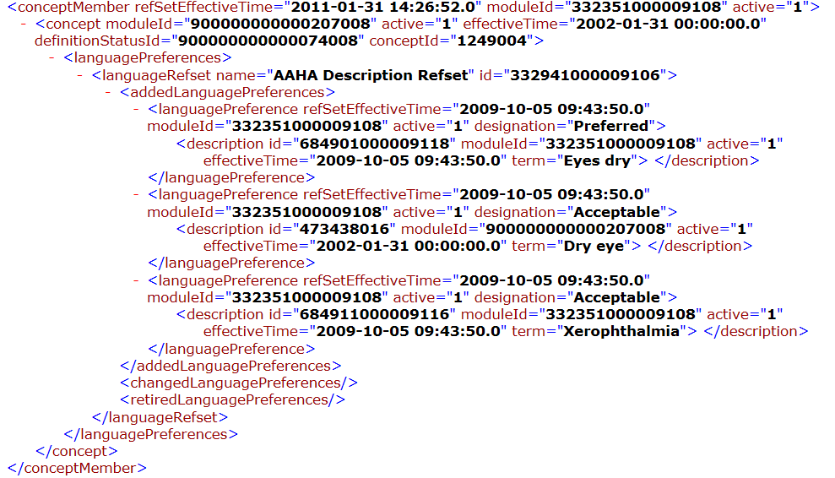

Figure 2. One SNOMED CT® concept entry from the XML file in the “changed concept members” element. This concept has been an active member of the subset since 04/2012 and an active member of the base terminology since 01/2002. The concept was given a description of “Bartonellosis” in 1/2002 in the base terminology. The description “Bartonellosis” was added to the AAHA Description refset in 10/2012 and designated as “Acceptable” in 10/2012. Additional descriptions present in the refset for this concept that were not changed in the time period are not shown here (they will be seen with this concept id in the full release XML file.)

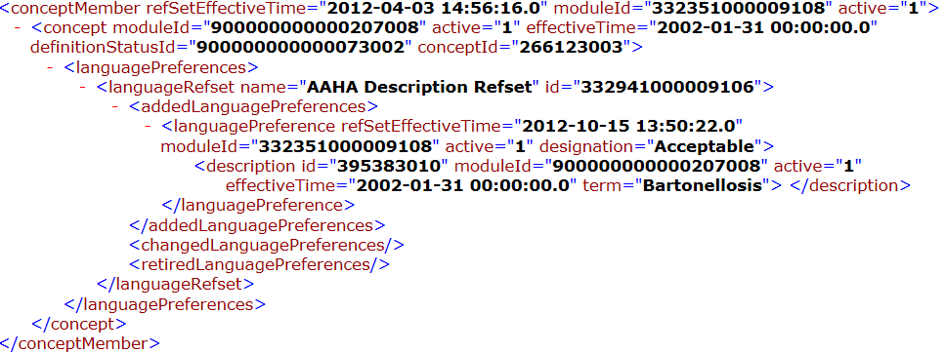

Figure 3. One SNOMED CT® concept entry from the XML file in the “retired concept members” element. This shows a concept which has been inactivated in the subset and replaced by another concept. Active=0 in the concept member element means the concept has been inactivated in the subset. Active=0 in the concept element means the concept is also inactive in SNOMED core/extension. There may be times when the concept is active in core but not in the subset. The history of this concept’s descriptions in the subset the base terminology is included as well. Active=0 is the description element indicates the description has been retired from the base terminology. Active=0 in the languagePreference element means the description has been retired from the refset. The languagePreferenceHistory element shows the description was active and Preferred in the refset in 12/2009. The descriptionHistory element shows the description was added to the base terminology in 02/2011.The “refset replacement” element contains a link to an active subset concept and the type of relationship that exists with this concept (replaced by, same as, maybe a). The “added concepts” element of the full release file will contain information about this replacement concept.

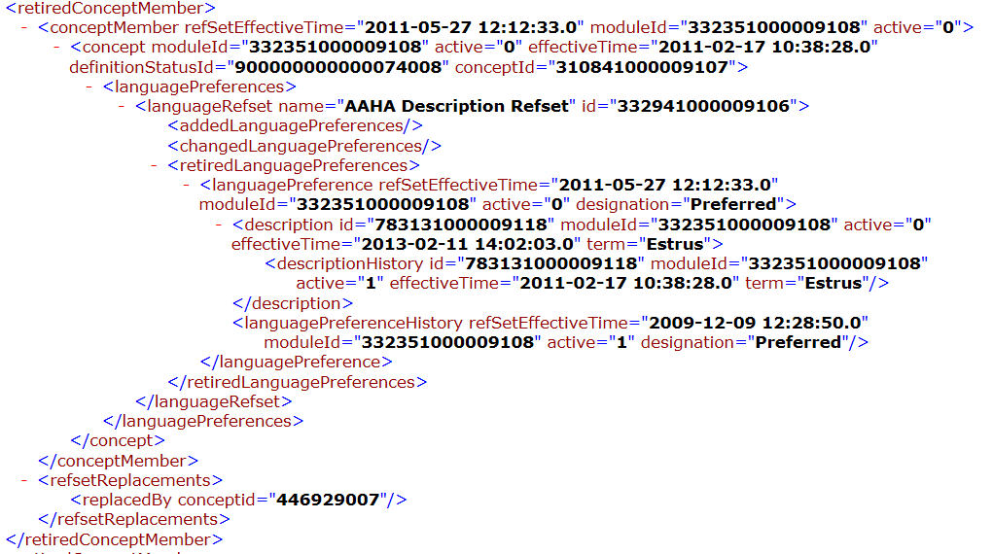

Delta Release File
The delta release file contains a list of changes made (e.g. additions, retirements, changes in designation) in the subset within the time period designated near the beginning of the XML file. Note that the entire subset is not included in this file, only concepts that have been added, changed, or retired during that specific time period. A delta release file allows systems that have already incorporated the AAHA Diagnostic Terms to just apply changes since the last update.

Additional file formats
Additional file formats (e.g. html, txt) of the subset concepts and descriptions are available from the VTSL website.

Issues
Although many of the SNOMED concepts in this list can be used for recording diagnoses of multiple species, in some instances the species of the patient will dictate which SNOMED concept is appropriate. Significant anatomical differences in the areas of the lower segments of both limbs (carpus/tarsus and below) and the gastrointestinal tract in horses are two obvious examples. In these cases, it is important to present veterinary users with the appropriate concepts for the patient they are seeing. For example, in equine practice the large colon is commonly referred to as the large intestine so the AAEP subset includes “large intestine” as a description to the large colon concepts. However, this would be inappropriate and possibly even confusing for veterinarians recording diagnoses for small animals.

External links
- The interested reader is referred to the following IHTSDO links and documents for more detailed explanations of some of the contents of this file.
International Health Terminology Standards Development Organization (IHTSDO) | http://www.ihtsdo.org/
SNOMED CT® Document Library from IHTSDO | https://confluence.ihtsdotools.org/display/DOC

- An Editorial Guide to the AAHA Subset is available for users who have registered with AAHA and obtained a username and password to the AAHA Diagnostic Terms site (https://www.aahanet.org/Library/Diagnostic.aspx) or the VTSL AAHA site (on the AAHA Documents page at vtsl.vetmed.vt.edu). This document contains editorial guidelines and policies for the subset. Topics include term appearance and phrasing, content inclusion, term maintenance, post-coordination and limitations of the subset.
- An information flyer containing a “birds-eye” view of the subset is available at: http://vtsl.vetmed.vt.edu/AAHA/Editorial/Policy/AAHA_DiagnosticTermsFlyer.pdf

Contact information
Veterinary Terminology Services Laboratory
http://vtsl.vetmed.vt.edu/aaha
1880 Pratt Drive, Suite 1129 (0493)
Blacksburg, VA 24061

Jeff R. Wilcke, DVM, MS, DACVCP jwilcke@vt.edu
Julie M. Green, DVM, MS jmgreen@vt.edu

SNOMED considers a "concept" to be a clinical meaning identified by a unique numeric identifier (ConceptId) that never changes
In this context, “language” refers to natural human languages and dialects (e.g. Spanish, American English) as well as phrases of natural languages used in a domain (e.g. small animal veterinarian “dialect” of the medical “dialect” of American English)

