CHAPTER FOUR
RESULTS AND DISCUSSION

4.1 Descriptive Summary of the Dataset
Following the data preparation procedures described in Chapter Three, the final analytical dataset for the supervised Term 3 prediction task comprised 541 student-year observations involving 340 unique students. The dataset contained 121 at-risk observations and 420 not-at-risk observations. The target was the Term 3 academic outcome, while the predictors were drawn from information available in Terms 1 and 2.
The final dataset contained 13 variables. The supervised dataset contained no missing target values. Students without an observed Term 3 academic outcome, including JHS3 trajectories affected by the end-of-period examination structure, were not included in the supervised Term 3 prediction dataset.
Table 4.1. Summary of the final term-level modelling dataset.
Item | Value
Eligible student-year observations | 541
Unique students | 340
Variables | 13
At-risk observations | 121 (22.37%)
Not-at-risk observations | 420 (77.63%)
Missing Term 3 targets | 0
Table 4.1 summarises the final modelling sample used for the early-warning classification experiment.

4.2 Baseline versus Engineered Model Performance (Main Results)
The primary classification experiment compared the individual XGBoost and LightGBM classifiers with the proposed validation-selected weighted ensemble. The individual-model values below are the fixed Seed 42 comparison outputs, whereas the proposed ensemble is reported using the completed ten-seed stability analysis. The locked Seed 42 configuration used a 0.10 XGBoost weight and a 0.90 LightGBM weight with a classification threshold of 0.50; across the ten-seed analysis, weights were selected separately on validation data.
Table 4.2. Classification performance of the component models and the proposed ensemble.
Model / evaluation | Accuracy | Precision | Recall | Macro-F1 | ROC-AUC | PR-AUC | Brier
XGBoost (Seed 42) | 0.9545 | 0.9655 | 0.8750 | 0.9433 | 0.9884 | 0.9741 | 0.0412
LightGBM (Seed 42) | 0.9545 | 0.9655 | 0.8750 | 0.9433 | 0.9912 | 0.9763 | 0.0332
Proposed ensemble (10 seeds) | 0.9545 ± 0.0000 | 0.9655 ± 0.0000 | 0.8750 ± 0.0000 | 0.9433 ± 0.0000 | 0.9898 ± 0.0009 | 0.9763 ± 0.0011 | 0.0361 ± 0.0011
As shown in Table 4.2, the proposed ensemble achieved an accuracy of 0.9545 and Macro-F1 of 0.9433 across the ten seeds. Its mean ROC-AUC was 0.9898, mean PR-AUC was 0.9763 and mean Brier score was 0.0361.

4.3 Ten-Seed Stability and Robustness
Robustness was assessed using ten repeated seeded executions (42–51). For each seed, ensemble weights were selected using the validation set and the resulting configuration was then evaluated on the held-out test set. The ten-seed results are summarised in Table 4.3.
Table 4.3. Ten-seed stability of the proposed XGBoost–LightGBM ensemble.
Metric | Mean ± SD
Accuracy | 0.9545 ± 0.0000
Precision | 0.9655 ± 0.0000
Recall | 0.8750 ± 0.0000
Macro-F1 | 0.9433 ± 0.0000
ROC-AUC | 0.9898 ± 0.0009
PR-AUC | 0.9763 ± 0.0011
Brier score | 0.0361 ± 0.0011
XGBoost weight | 0.2700 ± 0.1059
LightGBM weight | 0.7300 ± 0.1059
The classification metrics were unchanged across the ten seeds, while the probability-based metrics and selected ensemble weights showed small variation. The selected XGBoost weight ranged from 0.10 to 0.40 and the corresponding LightGBM weight ranged from 0.60 to 0.90.

4.4 Ablation Study Confirmation
A three-cell ablation was conducted to assess the attendance-decay representation and the validation-selected ensemble configuration. Cell A used a 50:50 ensemble without attendance decay; Cell B used a 50:50 ensemble with attendance decay; Cell C used the validation-selected ensemble with attendance decay.
Table 4.4. Three-cell ablation results across ten seeds.
Cell | Description | Accuracy | Macro-F1 | ROC-AUC | PR-AUC | Brier
A | 50:50 without attendance decay | 0.9673 ± 0.0047 | 0.9601 ± 0.0056 | 0.9924 ± 0.0004 | 0.9833 ± 0.0011 | 0.0303 ± 0.0010
B | 50:50 with attendance decay | 0.9545 ± 0.0000 | 0.9433 ± 0.0000 | 0.9891 ± 0.0009 | 0.9754 ± 0.0016 | 0.0368 ± 0.0006
C | Validation-selected with attendance decay | 0.9545 ± 0.0000 | 0.9433 ± 0.0000 | 0.9898 ± 0.0009 | 0.9763 ± 0.0011 | 0.0361 ± 0.0011
Cell A recorded the highest mean Macro-F1, ROC-AUC and PR-AUC and the lowest mean Brier score among the three conditions. Cell B did not improve these headline measures relative to Cell A. Cell C retained the attendance-decay feature and used validation-based weight selection; its classification metrics were the same as Cell B, while its probability-based metrics showed small changes.

4.5 Statistical Significance Testing
No inferential significance test was performed for the final locked ten-seed classification experiment. The completed analysis provides descriptive mean ± SD stability results rather than a paired inferential test. Accordingly, no p-value or effect-size claim is reported for the final experiment.
Table 4.5. Statistical significance testing status for the final locked experiment.
Item | Final status
Inferential test | Not performed
Paired observations for significance testing | Not generated
p-value | Not reported
Effect size | Not reported
Basis for final comparison | Descriptive ten-seed results

4.6 Feature Importance and Model Interpretability
SHAP analysis was conducted post hoc on the locked weighted ensemble using the 110 test observations. Table 4.6 presents the global mean absolute SHAP values. The two prior academic-performance variables, score_t1 and score_t2, recorded the largest mean absolute SHAP values.
Table 4.6. Global SHAP feature-importance ranking for the locked ensemble.
Rank | Feature | Mean |SHAP|
1 | score_t1 | 0.162728
2 | score_t2 | 0.154552
3 | academic_year_2022-23 | 0.032533
4 | attendance_decay | 0.026987
5 | age_years | 0.019814
6 | academic_year_2023-24 | 0.016350
7 | attendance_t1 | 0.012412
8 | attendance_t2 | 0.012250
9 | gender_F | 0.002668
10 | class_level_JHS1 | 0.001763
11 | class_level_JHS2 | 0.001372
12 | gender_M | 0.001063
The global ranking is visualised in Figure 4.2, while the distribution and direction of individual feature contributions are shown in Figure 4.3.
Source file: results\shap\Figure_SHAP_Global_Bar.png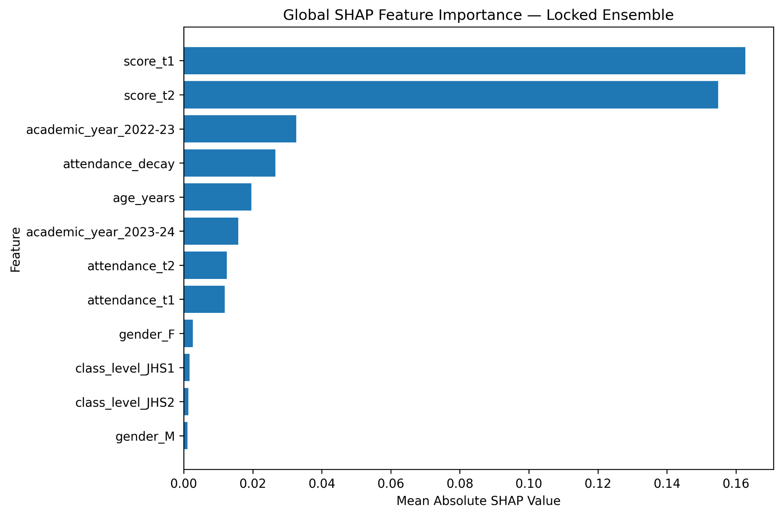
Figure 4.2. Global SHAP feature-importance ranking for the locked XGBoost–LightGBM ensemble.
Source file: results\shap\Figure_SHAP_Beeswarm.png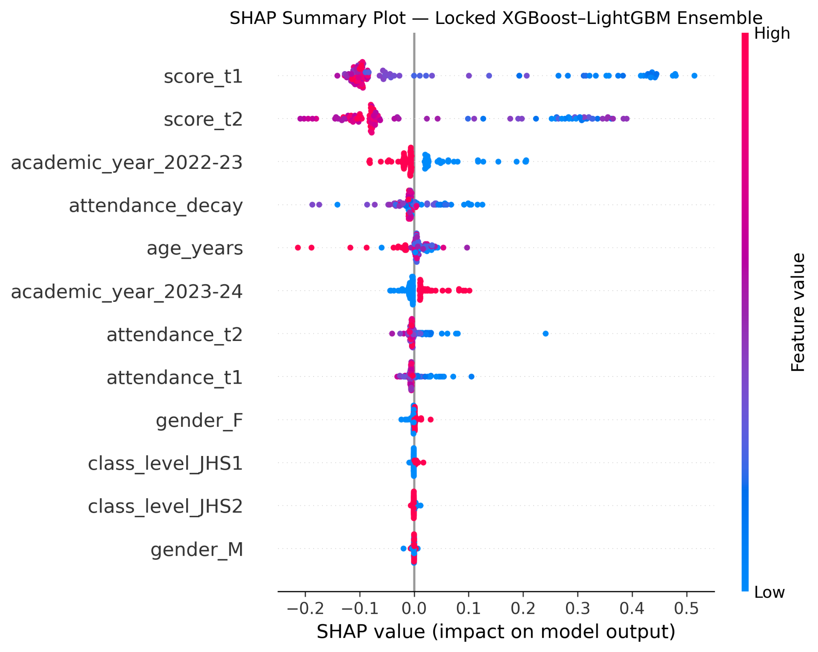
Figure 4.3. SHAP beeswarm summary showing the distribution and direction of feature contributions.
Dependence plots for score_t1, score_t2 and attendance_decay are presented in Figures 4.4–4.6. These plots describe the relationship between feature values and their SHAP contributions in the fitted model.
Source file: results\shap\Figure_SHAP_Dependence_score_t1.png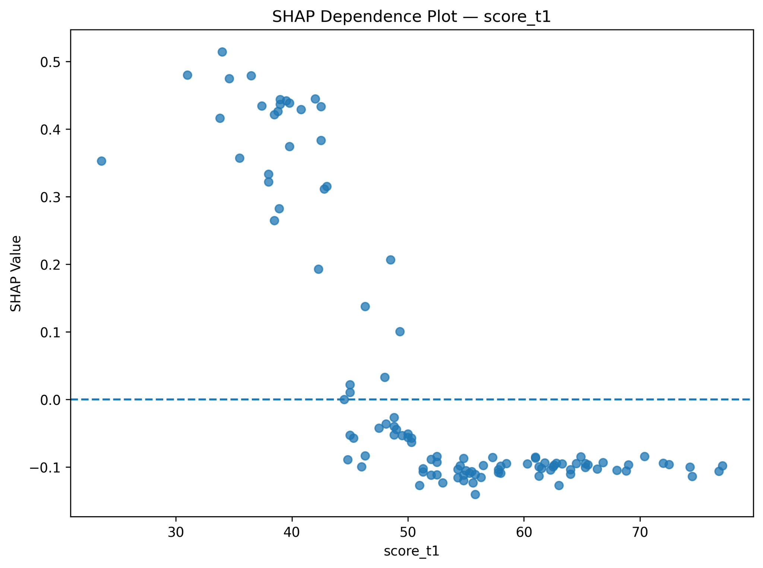
Figure 4.4. SHAP dependence plot for score_t1.
Source file: results\shap\Figure_SHAP_Dependence_score_t2.png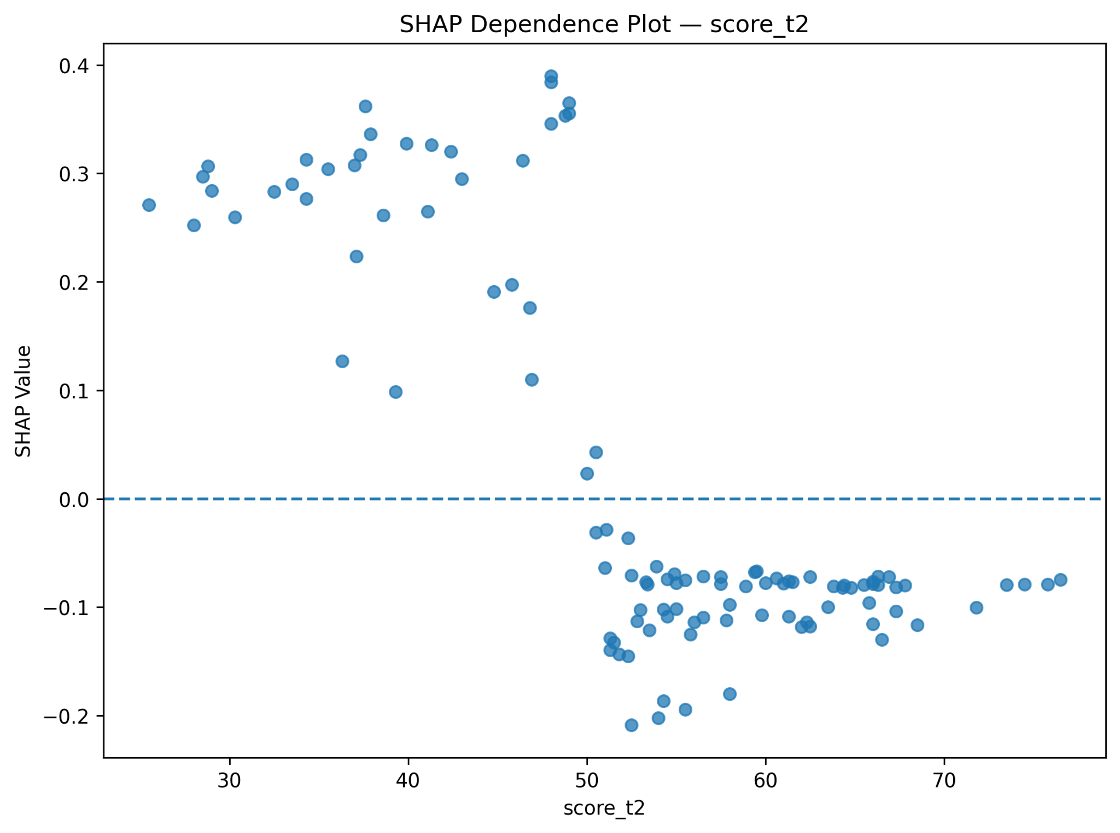
Figure 4.5. SHAP dependence plot for score_t2.
Source file: results\shap\Figure_SHAP_Dependence_attendance_decay.png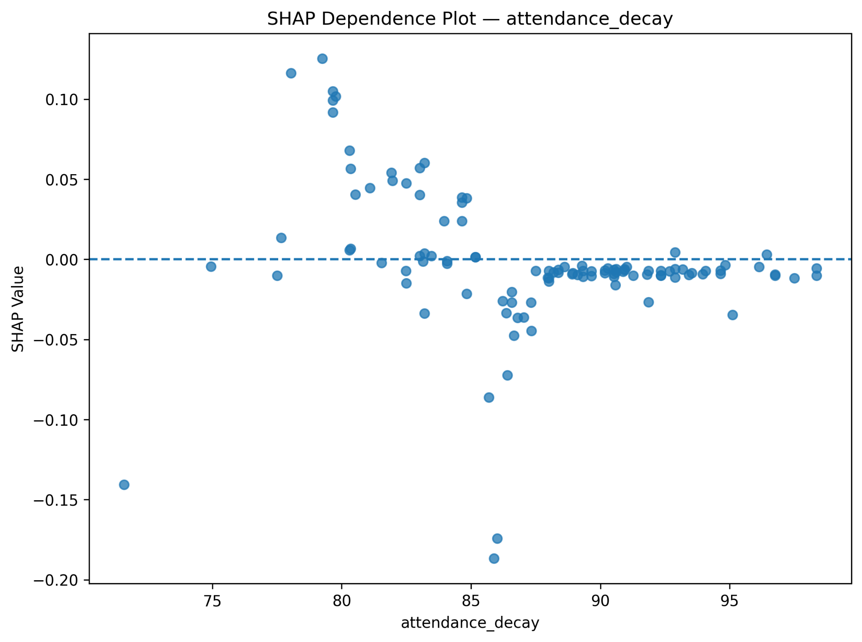
Figure 4.6. SHAP dependence plot for attendance_decay.
Local SHAP explanations were generated for one true-positive, one true-negative and one false-negative test observation. The selected cases and their predicted probabilities are summarised in Table 4.7.
Table 4.7. Selected local SHAP explanation cases.
Case | Test row | Actual at risk | Probability | Prediction
TP | 28 | 1 | 0.999496 | 1
TN | 4 | 0 | 0.000018 | 0
FN | 71 | 1 | 0.368297 | 0
Source file: results\shap\Figure_SHAP_Waterfall_TP.png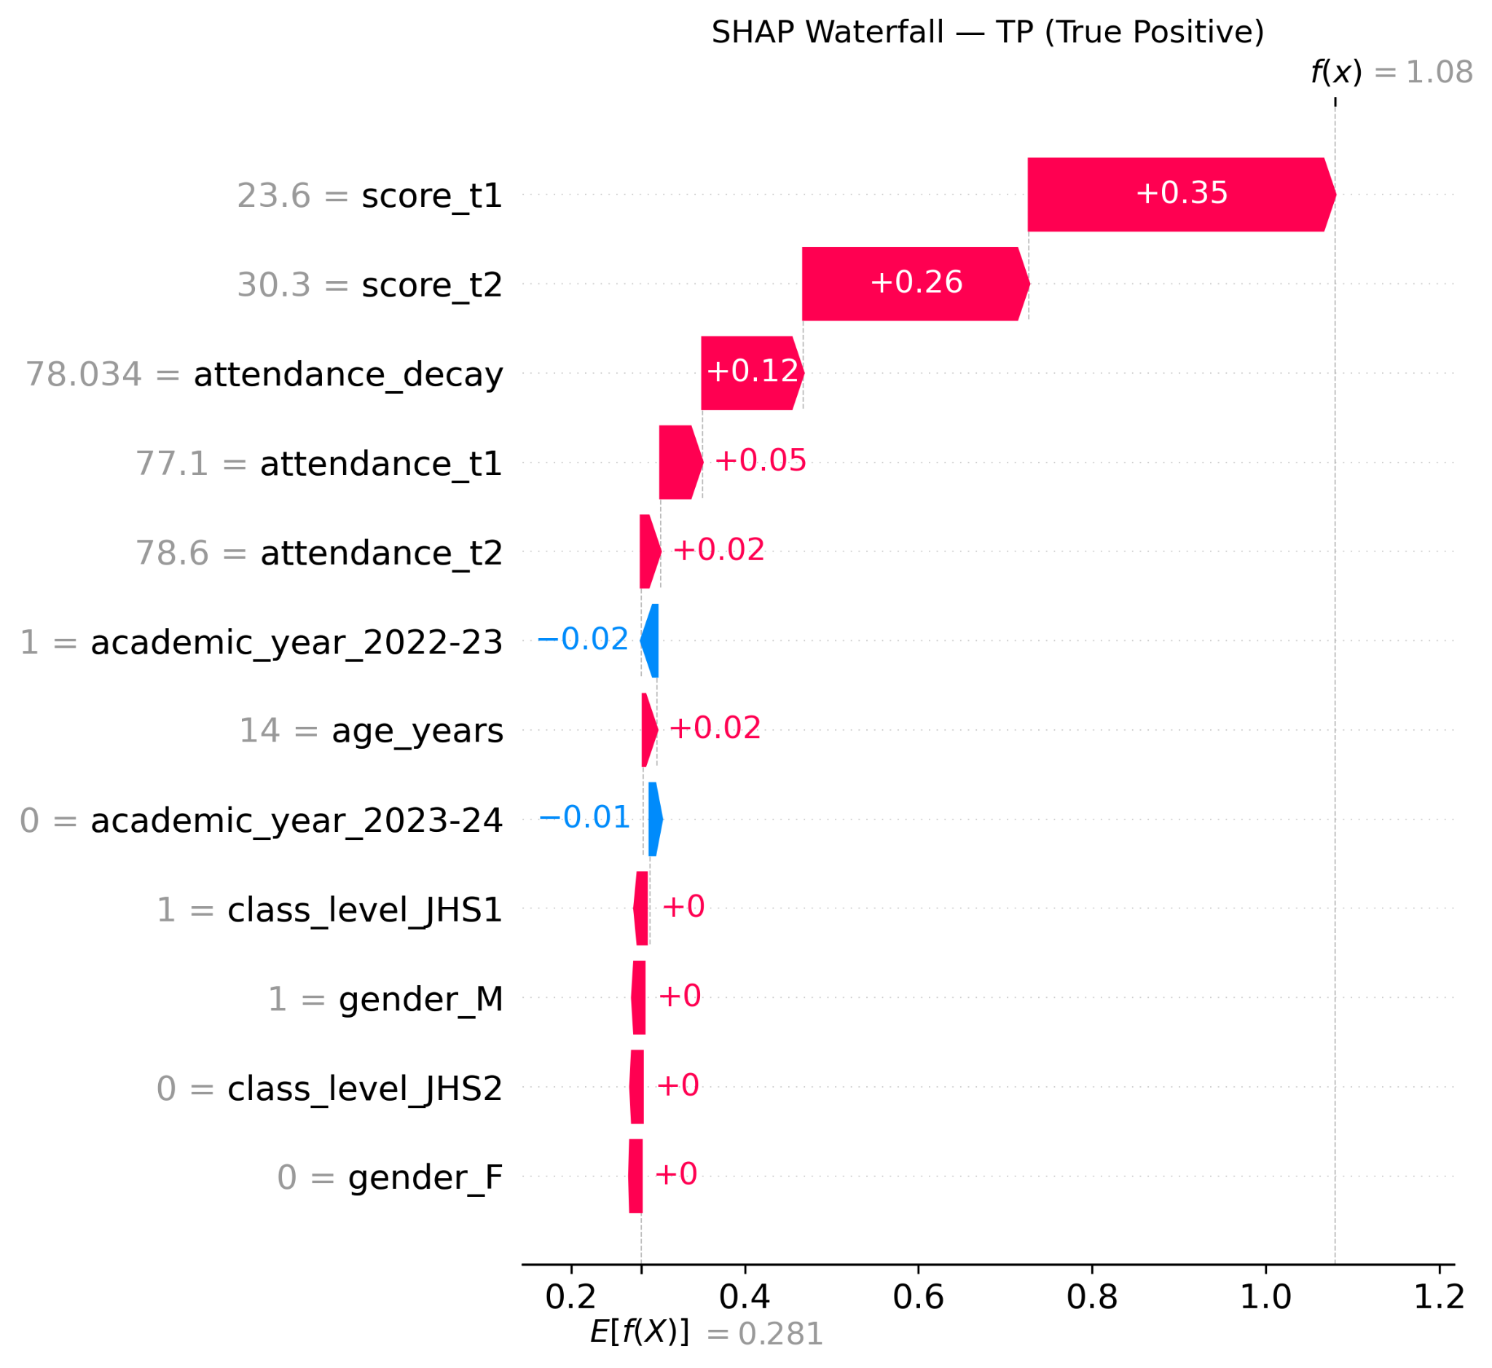
Figure 4.7. Local SHAP waterfall explanation for the selected true-positive case.
Source file: results\shap\Figure_SHAP_Waterfall_TN.png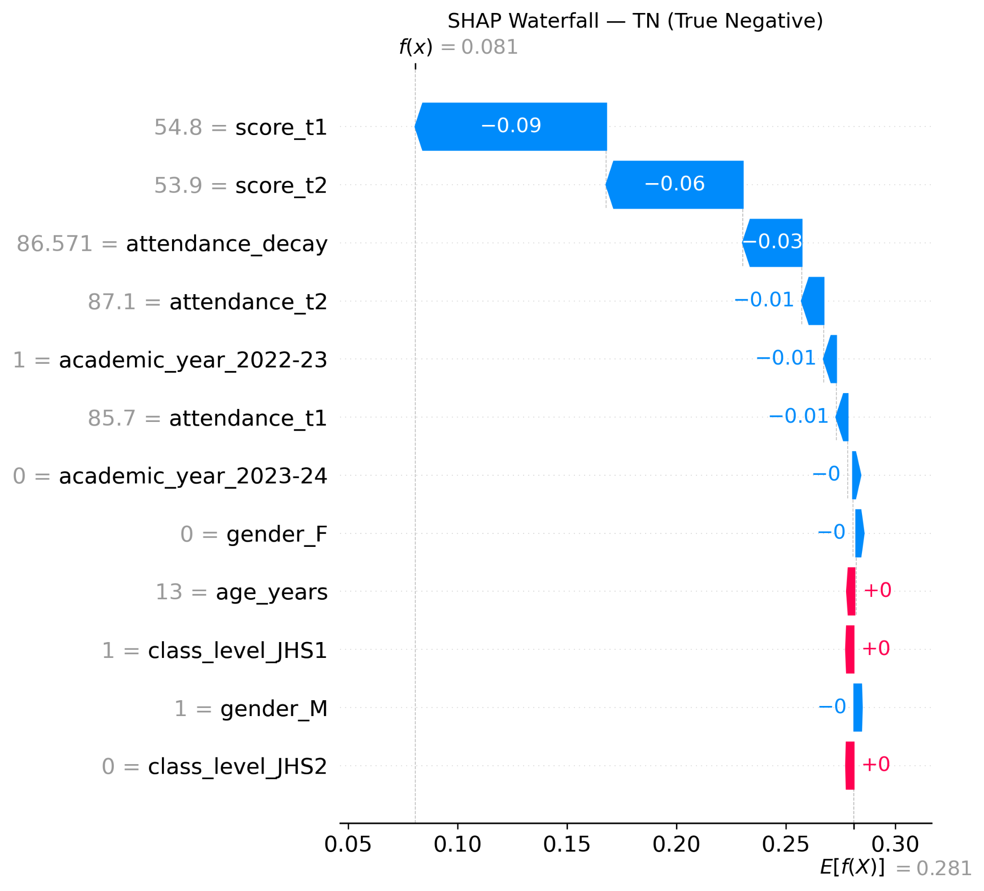
Figure 4.8. Local SHAP waterfall explanation for the selected true-negative case.
Source file: results\shap\Figure_SHAP_Waterfall_FN.png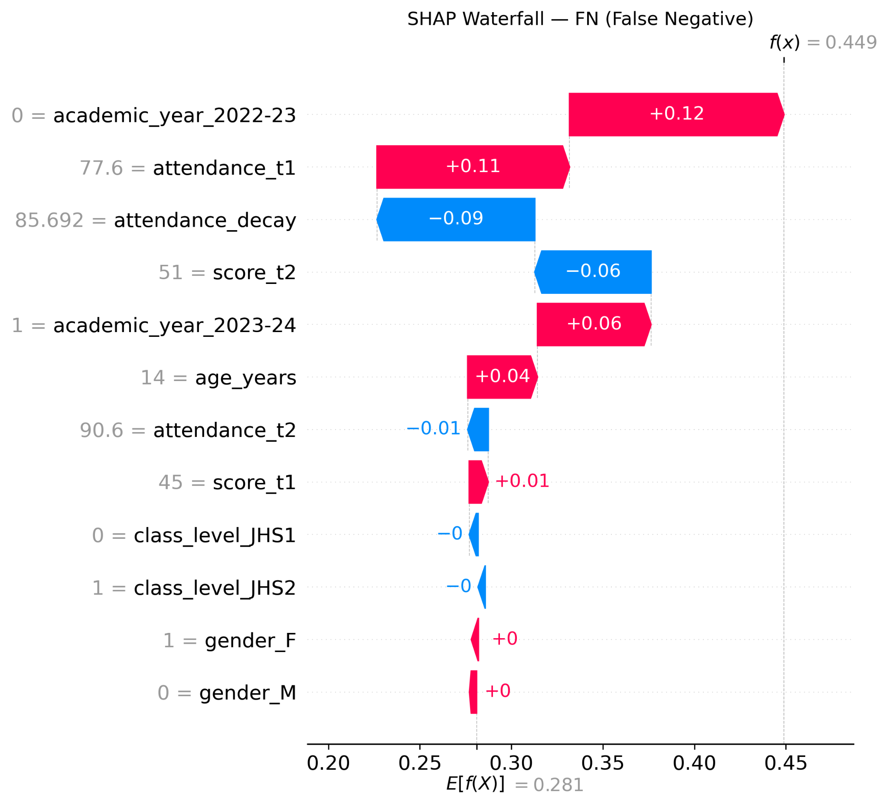
Figure 4.9. Local SHAP waterfall explanation for the selected false-negative case.
The SHAP reconstruction check produced a maximum absolute reconstruction error of 3.33 × 10⁻¹⁵ and a mean absolute reconstruction error of 4.87 × 10⁻¹⁶ across the 110 test observations.

4.7 Error Analysis (Confusion Matrix / Per-Class Metrics)
Error analysis was conducted on the final test set of 110 observations. The locked ensemble produced 77 true negatives, 1 false positive, 4 false negatives and 28 true positives at the 0.50 threshold.
Table 4.8. Overall confusion-matrix counts for the final locked ensemble.
Measure | Count
True Negative (TN) | 77
False Positive (FP) | 1
False Negative (FN) | 4
True Positive (TP) | 28
Total | 110
The subgroup results are reported in Table 4.9. For class level, JHS1 contained 42 test observations, including 23 at-risk cases, while JHS2 contained 68 observations, including 9 at-risk cases. For gender, females accounted for 58 test observations, including 13 at-risk cases, and males accounted for 52 observations, including 19 at-risk cases.
Table 4.9. Final test performance by class level and gender.
Variable | Group | n | At risk | Accuracy | Precision | TPR | FPR | FNR | Macro-F1
Class level | JHS1 | 42 | 23 | 0.9524 | 0.9565 | 0.9565 | 0.0526 | 0.0435 | 0.9519
Class level | JHS2 | 68 | 9 | 0.9559 | 1.0000 | 0.6667 | 0.0000 | 0.3333 | 0.8876
Gender | Female | 58 | 13 | 0.9828 | 1.0000 | 0.9231 | 0.0000 | 0.0769 | 0.9745
Gender | Male | 52 | 19 | 0.9231 | 0.9412 | 0.8421 | 0.0303 | 0.1579 | 0.9150
The absolute gender TPR gap was 0.0810, while the absolute class-level TPR gap between JHS1 and JHS2 was 0.2899. The corresponding FPR gaps were 0.0303 and 0.0526, respectively.
Table 4.10. Predictive disparity gaps across the evaluated subgroups.
Comparison | TPR gap | FPR gap | Precision gap | Accuracy gap
Female vs Male | 0.0810 | 0.0303 | 0.0588 | 0.0597
JHS1 vs JHS2 | 0.2899 | 0.0526 | 0.0435 | 0.0035

4.8 Computational Efficiency and Scalability
The completed experiments were executed using CPU-based computation in the Python environment used for the study. The computational environment included 24 GB RAM and Python 3.10. Exact wall-clock training time, inference time and memory-footprint measurements were not captured in the completed result logs. Therefore, no unsupported numerical claims about computational speed, inference latency or memory efficiency are reported.

4.9 Required Figures and Tables Checklist
Table 4.11. Chapter Four figures and tables completion checklist.
Item | Required content | Status
Table 4.1 | Final modelling dataset summary | Included
Table 4.2 | Main model performance | Included
Table 4.3 | Ten-seed stability | Included
Table 4.4 | Three-cell ablation | Included
Table 4.5 | Statistical significance status | Included
Table 4.6 | SHAP feature importance | Included
Table 4.7 | Local SHAP cases | Included
Table 4.8 | Overall confusion-matrix counts | Included
Table 4.9 | Subgroup performance | Included
Table 4.10 | Predictive disparity gaps | Included
Figures 4.2–4.9 | Eight SHAP figures | Embedded
The eight final SHAP figures are embedded at their indicated positions and correspond to the audited PNG files in results\shap.

4.10 Supervisor Verification Checklist
Table 4.12. Supervisor verification checklist for the final locked experiment.
Verification item | Final result / status
Final supervised analytical sample | 541 student-year observations; 340 unique students
At-risk target | 121 positive; 420 negative
Prediction mechanism | Term 3 predicted from Terms 1 and 2
Train / validation / test | 318 / 113 / 110 observations
Student overlap | 0 across all split pairs
Locked ensemble | 0.10 XGBoost / 0.90 LightGBM
Primary threshold | 0.50
Stability analysis | 10 seeds: 42–51
Final test observations | 110; 68 unique students
Naive comparator | Included
Three-cell ablation | Included
Fairness analysis | Gender and class level
Socioeconomic fairness | Not claimed
SHAP | Post-hoc explanation of locked ensemble
SHAP additivity | Maximum error 3.33 × 10⁻¹⁵
Public-dataset transfer | Not included in primary experiment
Computational timing | Not numerically captured

Chapter Four Summary
The final audited experiment used 541 eligible student-year observations and a student-level train-validation-test partition with no student overlap. The validation-selected XGBoost–LightGBM ensemble achieved 0.9545 accuracy and 0.9433 Macro-F1 across ten seeds, with mean ROC-AUC of 0.9898 and mean PR-AUC of 0.9763. The naive comparator produced substantially lower classification performance and did not identify any at-risk test observations. The ablation analysis recorded lower mean performance for the attendance-decay 50:50 condition than the corresponding 50:50 condition without attendance decay. The subgroup analysis recorded measurable differences in TPR across gender and class level. SHAP analysis ranked Term 1 and Term 2 scores as the two largest contributors to the locked ensemble predictions, and the SHAP additivity check passed at numerical precision.
FINAL SUBMISSION NOTE: The eight SHAP figures are embedded in this document and correspond to the audited files in results\shap.

