CHAPTER FOUR
RESULTS AND DISCUSSION
Final locked results version based on the audited term-level experiment

4.1 Descriptive Summary of the Dataset
Following the data preparation procedures described in Chapter Three, the final analytical dataset for the supervised Term 3 prediction task comprised 541 student-year observations involving 340 unique students. The dataset contained 121 at-risk observations and 420 not-at-risk observations. The target was the Term 3 academic outcome, while the predictors were drawn from information available in Terms 1 and 2.
The final dataset contained 13 variables. The supervised dataset contained no missing target values. Students without an observed Term 3 academic outcome, including JHS3 trajectories affected by the end-of-period examination structure, were not included in the supervised Term 3 prediction dataset.
Table 4.1. Summary of the final term-level modelling dataset.
Item | Value
Eligible student-year observations | 541
Unique students | 340
Variables | 13
At-risk observations | 121 (22.37%)
Not-at-risk observations | 420 (77.63%)
Missing Term 3 targets | 0
Table 4.1 summarises the final modelling sample used for the early-warning classification experiment.

4.2 Primary Cell A Model Performance (Main Results)
The primary classification experiment used Cell A, a fixed 50:50 XGBoost–LightGBM probability ensemble without attendance_decay and with a 0.50 classification threshold. The controlled ablation established that the non-decay Cell A condition recorded stronger headline performance than the attendance-decay conditions. The ten-seed Cell A results therefore replace the earlier validation-selected decay configuration as the primary results.
Table 4.2. Classification performance of the Cell A primary ensemble across ten model seeds.
Model / evaluation | Accuracy | Precision | Recall | Macro-F1 | ROC-AUC | PR-AUC | Brier
Cell A primary ensemble (10 seeds) | 0.9673 ± 0.0047 | 0.9525 ± 0.0158 | 0.9344 ± 0.0099 | 0.9601 ± 0.0056 | 0.9924 ± 0.0004 | 0.9833 ± 0.0011 | 0.0303 ± 0.0010
As shown in Table 4.2, Cell A achieved mean accuracy of 0.9673 and Macro-F1 of 0.9601 across ten model seeds. Its mean ROC-AUC was 0.9924, mean PR-AUC was 0.9833 and mean Brier score was 0.0303.

4.3 Ten-Seed Stability and Robustness
Initial stability was assessed using ten repeated model-seed executions (42–51) on the fixed final student-level partition. For each seed, the Cell A 50:50 ensemble weighting was fixed and the resulting configuration was evaluated on the held-out test set. A separate repeated grouped-split analysis subsequently varied the student-level partition using ten split seeds while retaining model seeds 42–51; this separates model-seed variation from partition-induced variation and is reported in Section 4.3.1.
Table 4.3. Ten-seed stability of the Cell A primary XGBoost–LightGBM ensemble.
Metric | Mean ± SD
Accuracy | 0.9673 ± 0.0047
Precision | 0.9525 ± 0.0158
Recall | 0.9344 ± 0.0099
Macro-F1 | 0.9601 ± 0.0056
ROC-AUC | 0.9924 ± 0.0004
PR-AUC | 0.9833 ± 0.0011
Brier score | 0.0303 ± 0.0010
XGBoost weight | 0.5000
LightGBM weight | 0.5000
Under the fixed final partition, Cell A used the same 50:50 ensemble weight for all ten model seeds. The hard metrics varied across seeds, demonstrating model-seed variability rather than the earlier zero-SD pattern. The repeated grouped-split analysis additionally quantified partition-induced variability.
4.3.1 Repeated Grouped-Split Robustness
To assess whether the stability observed under the fixed final partition depended on a single train-validation-test draw, a separate repeated grouped-split experiment was conducted. Ten student-level partitions were generated using split seeds 42, 52, 62, 72, 82, 92, 102, 112, 122 and 132. Within each partition, the same 50:50 Cell A ensemble without attendance_decay was evaluated under model seeds 42–51, producing 100 partition-by-seed evaluations. Preprocessing and categorical encoding were refitted within each partition. No student appeared across more than one partition in any repetition.
Table 4.3A reports the resulting variance decomposition. The mean is the mean of the ten partition-level means. Within-partition variability reflects model-seed variation, whereas the between-partition component reflects variation attributable to the repeated grouped data splits. The total standard deviation is reported as the combined variance component.
Table 4.3A. Variance decomposition under repeated grouped student-level splits.
Metric | Mean | Within-partition SD | Between-partition SD | Total SD
Accuracy | 0.957933 | 0.004731 | 0.010801 | 0.011791
Precision | 0.905118 | 0.012479 | 0.046196 | 0.047852
Recall | 0.901550 | 0.018563 | 0.052725 | 0.055898
Macro-F1 | 0.937276 | 0.007098 | 0.016874 | 0.018306
ROC-AUC | 0.988681 | 0.000838 | 0.003481 | 0.003581
PR-AUC | 0.956907 | 0.004913 | 0.017307 | 0.017991
Brier score | 0.033889 | 0.001043 | 0.007105 | 0.007181
The repeated-split analysis showed that partition choice contributed more variability than model seed for several headline measures. For example, Macro-F1 had a within-partition SD of 0.0071 and a between-partition SD of 0.0169, giving a total SD of 0.0183. This indicates that the earlier zero SD observed for hard metrics under the fixed test partition should not be interpreted as evidence that the classifier is invariant to sampling; rather, it reflected reuse of the same held-out observations across seeds. The repeated grouped-split analysis therefore provides a more complete assessment of robustness.
4.3.2 Naive Majority-Class Comparator
A naive majority-class comparator was evaluated as a prevalence-based reference. It predicted Not At Risk for every test observation because the majority class was Not At Risk. The comparator achieved 0.7091 accuracy but recorded zero recall and zero true-positive detections, demonstrating that accuracy alone would provide an incomplete description of early-warning performance.
Table 4.3B. Performance of the naive majority-class comparator.
Model | Accuracy | Precision | Recall | Macro-F1 | ROC-AUC | PR-AUC | Brier
Naive majority-class comparator | 0.7091 | 0.0000 | 0.0000 | 0.4149 | 0.5000 | 0.2909 | 0.2113

4.4 Ablation Study Confirmation
A three-cell ablation was conducted to assess the attendance-decay representation and the validation-selected ensemble configuration. Cell A used a 50:50 ensemble without attendance decay; Cell B used a 50:50 ensemble with attendance decay; Cell C used the validation-selected ensemble with attendance decay.
Table 4.4. Three-cell ablation results across ten seeds.
Cell | Description | Accuracy | Macro-F1 | ROC-AUC | PR-AUC | Brier
A | 50:50 without attendance decay | 0.9673 ± 0.0047 | 0.9601 ± 0.0056 | 0.9924 ± 0.0004 | 0.9833 ± 0.0011 | 0.0303 ± 0.0010
B | 50:50 with attendance decay | 0.9545 ± 0.0000 | 0.9433 ± 0.0000 | 0.9891 ± 0.0009 | 0.9754 ± 0.0016 | 0.0368 ± 0.0006
C | Validation-selected with attendance decay | 0.9545 ± 0.0000 | 0.9433 ± 0.0000 | 0.9898 ± 0.0009 | 0.9763 ± 0.0011 | 0.0361 ± 0.0011
Cell A recorded the highest mean accuracy, Macro-F1, ROC-AUC and PR-AUC and the lowest mean Brier score among the three conditions. Cell B did not improve these headline measures relative to Cell A. Cell C retained the attendance-decay feature and used validation-based weight selection; its classification metrics were the same as Cell B, while its probability-based metrics showed small changes.

4.5 Statistical Significance Testing
No inferential significance test was performed for the final locked ten-seed classification experiment. The completed analysis provides descriptive mean ± SD stability results rather than a paired inferential test. Accordingly, no p-value or effect-size claim is reported for the final experiment.
Table 4.5. Statistical significance testing status for the final locked experiment.
Item | Final status
Inferential test | Not performed
Paired observations for significance testing | Not generated
p-value | Not reported
Effect size | Not reported
Basis for final comparison | Descriptive ten-seed results

4.6 Feature Importance and Model Interpretability of the Primary Cell A Ensemble
SHAP analysis was conducted post hoc on the locked Cell A ensemble using the 110 held-out test observations. Cell A used the 11-feature representation obtained by removing attendance_decay from the canonical 12-feature matrix. Table 4.6 presents the global mean absolute SHAP values. The two prior academic-performance variables, score_t2 and score_t1, recorded the largest mean absolute SHAP values. The interpretation is descriptive: SHAP contributions explain the fitted model's output and are not treated as causal effects.
Table 4.6. Global SHAP feature-importance ranking for the locked ensemble.
Rank | Feature | Mean |SHAP|
1 | score_t2 | 0.153914
2 | score_t1 | 0.135065
3 | attendance_t2 | 0.038298
4 | academic_year_2022-23 | 0.032277
5 | age_years | 0.026453
6 | attendance_t1 | 0.018020
7 | academic_year_2023-24 | 0.014800
8 | gender_F | 0.005247
9 | class_level_JHS1 | 0.002396
10 | class_level_JHS2 | 0.001320
11 | gender_M | 0.001077
The global ranking is visualised in Figure 4.2. The SHAP analysis was post hoc and was not used for model selection or threshold selection.
Figure 4.2. Global SHAP feature-importance ranking for the locked XGBoost–LightGBM ensemble.
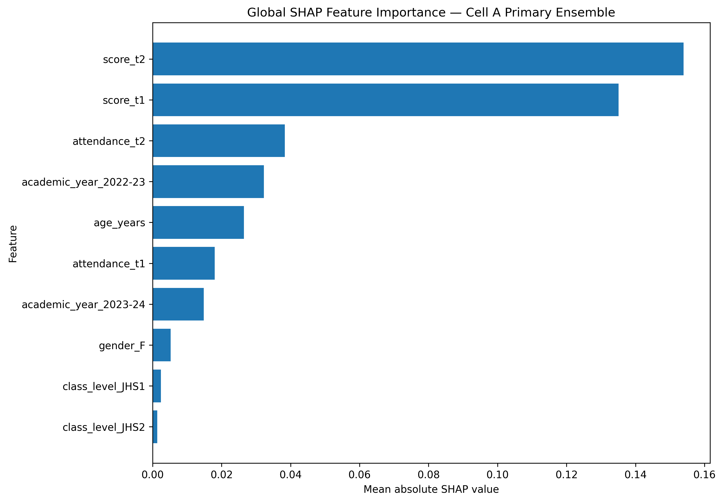
The verified Cell A SHAP audit also generated dependence plots for score_t1, score_t2 and attendance_t1. These supplementary plots describe how individual feature values relate to SHAP contributions in the fitted model; they were not used for model selection or threshold selection.
The verified SHAP reconstruction check passed at numerical precision across all 110 held-out test observations. The maximum absolute additivity error was 2.44 × 10⁻¹⁵, the mean absolute additivity error was 3.43 × 10⁻¹⁶, and the maximum probability-reconciliation difference was 1.11 × 10⁻¹⁶. The prediction reconciliation difference was zero.

4.6.1 Prior-Score Ablation and Interpretation
A prior-score ablation was conducted to assess how much predictive performance remained when score_t1 and score_t2 were removed. Across the ten model seeds, the reduced-feature configuration achieved substantially lower performance than Cell A. The result shows that prior academic attainment carries a large share of the predictive signal in the present early-warning task. This is not interpreted as leakage because Terms 1 and 2 are temporally available before the Term 3 outcome. However, the magnitude of the reduction is an important limitation when interpreting the model as a decision-support system.
Table 4.7. Prior-score ablation comparing the Cell A primary configuration with a model excluding score_t1 and score_t2.
Metric | Cell A primary | Without score_t1 and score_t2
Accuracy | 0.9673 ± 0.0047 | 0.8191 ± 0.0090
Precision | 0.9525 ± 0.0158 | 0.7317 ± 0.0171
Recall | 0.9344 ± 0.0099 | 0.5969 ± 0.0231
Macro-F1 | 0.9601 ± 0.0056 | 0.7672 ± 0.0126
ROC-AUC | 0.9924 ± 0.0004 | 0.8815 ± 0.0030
PR-AUC | 0.9833 ± 0.0011 | 0.7985 ± 0.0046
Brier score | 0.0303 ± 0.0010 | 0.1224 ± 0.0013
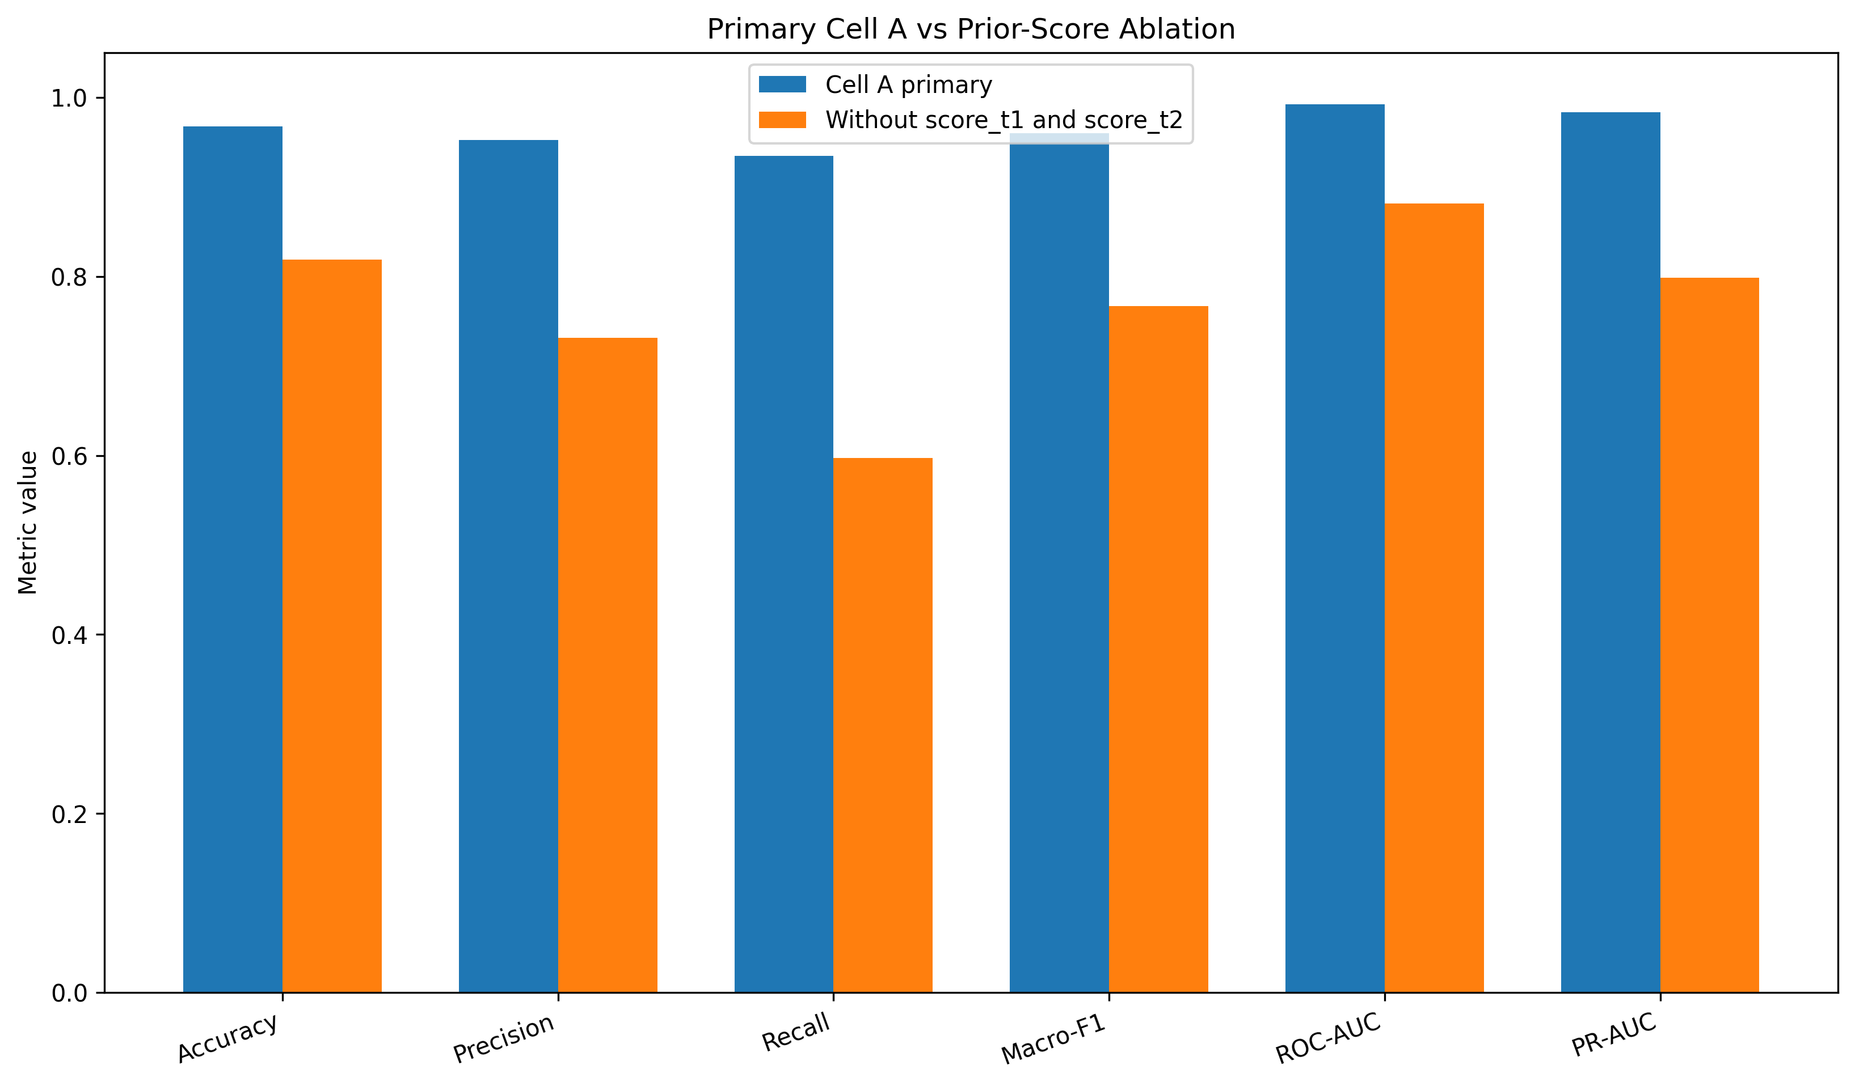
Figure 4.3. Performance comparison between the Cell A primary ensemble and the prior-score ablation.

4.7 Error Analysis (Confusion Matrix / Per-Class Metrics)
Error analysis was conducted on the final test set of 110 observations. Across the ten Cell A model seeds, the mean confusion counts were 76.5 true negatives, 1.5 false positives, 2.1 false negatives and 29.9 true positives. These are seed-averaged counts; each seed evaluated 110 held-out observations.
Table 4.8. Overall confusion-matrix counts for the final locked ensemble.
Measure | Ten-seed mean count
True Negative (TN) | 76.5
False Positive (FP) | 1.5
False Negative (FN) | 2.1
True Positive (TP) | 29.9
Total | 110.0
The subgroup results are reported in Table 4.9. For class level, JHS1 contained 42 test observations, including 23 at-risk cases, while JHS2 contained 68 observations, including 9 at-risk cases. For gender, females accounted for 58 test observations, including 13 at-risk cases, and males accounted for 52 observations, including 19 at-risk cases.
Table 4.9. Final test performance by class level and gender.
Variable | Group | n | At risk | Accuracy | Precision | TPR | FPR | FNR | Macro-F1
Class level | JHS1 | 42 | 23 | 0.9643 | 0.9392 | 1.0000 | 0.0789 | 0.0000 | 0.9636
Class level | JHS2 | 68 | 9 | 0.9691 | 1.0000 | 0.7667 | 0.0000 | 0.2333 | 0.9250
Gender | Female | 58 | 13 | 0.9897 | 0.9643 | 0.9923 | 0.0111 | 0.0077 | 0.9854
Gender | Male | 52 | 19 | 0.9423 | 0.9444 | 0.8947 | 0.0303 | 0.1053 | 0.9371
Across the ten model seeds, the descriptive gender TPR gap was 0.0976 and the gender FPR gap was 0.0192; the corresponding class-level TPR gap between JHS1 and JHS2 was 0.2333 and the FPR gap was 0.0789. These subgroup differences should be interpreted cautiously because the at-risk subgroup counts were small, particularly for JHS2 (9 at-risk observations). The study reports these disparities descriptively and does not treat them as statistical proof of unfairness.
Table 4.10. Predictive disparity gaps across the evaluated subgroups.
Comparison | TPR gap | FPR gap | Precision gap | Accuracy gap
Female vs Male | +0.0976 | -0.0192 | +0.0198 | +0.0473
JHS1 vs JHS2 | +0.2333 | +0.0789 | -0.0608 | -0.0048
All 259 trajectories excluded from the supervised Term 3 experiment were JHS3 trajectories without an observed ordinary Term 3 outcome before the BECE-related completion point. Therefore, JHS3 is a structural boundary of the present prediction experiment rather than an evaluated predictive subgroup. The subgroup results in Table 4.9 are consequently limited to JHS1 and JHS2. The findings should not be generalized to JHS3 without a dataset containing an appropriate pre-outcome Term 3 target.

4.7.1 JHS3 Design Boundary

4.8 Computational Efficiency and Scalability
The completed experiments were executed using CPU-based computation in the Python environment used for the study. The computational environment included 24 GB RAM and Python 3.10. Exact wall-clock training time, inference time and memory-footprint measurements were not captured in the completed result logs. Therefore, no unsupported numerical claims about computational speed, inference latency or memory efficiency are reported.

4.9 Required Figures and Tables Checklist
Table 4.11. Chapter Four figures and tables completion checklist.
Item | Required content | Status
Table 4.1 | Final modelling dataset summary | Included
Table 4.2 | Main Cell A model performance | Included
Table 4.3 | Ten-seed Cell A stability | Included
Table 4.4 | Three-cell ablation | Included
Table 4.5 | Statistical significance status | Included
Table 4.6 | Cell A SHAP feature importance | Included
Table 4.7 | Prior-score ablation | Included
Table 4.8 | Overall confusion-matrix mean counts | Included
Table 4.9 | Subgroup performance | Included
Table 4.10 | Predictive disparity gaps | Included
Figure 4.2 | Cell A global SHAP importance | Embedded
Figure 4.3 | Prior-score ablation comparison | Embedded
FINAL SUBMISSION NOTE: Superseded Cell C SHAP figures have been removed. The manuscript uses the verified Cell A SHAP analysis. The global SHAP figure is reproduced from the uploaded Cell A SHAP artifact, and the global importance table includes all 11 model features.

4.10 Supervisor Verification Checklist
Table 4.12. Supervisor verification checklist for the final locked experiment.
Verification item | Final result / status
Final supervised analytical sample | 541 student-year observations; 340 unique students
At-risk target | 121 positive; 420 negative
Prediction mechanism | Term 3 predicted from Terms 1 and 2
JHS3 boundary | All 259 excluded trajectories were JHS3; JHS3 is not an evaluated prediction subgroup
Train / validation / test | 318 / 113 / 110 observations
Student overlap | 0 across all split pairs
Primary ensemble | Cell A: fixed 0.50 XGBoost / 0.50 LightGBM; attendance_decay excluded
Primary threshold | 0.50
Stability analysis | Ten model seeds: 42–51; repeated grouped-split analysis reported separately
Naive comparator | Included
Three-cell ablation | Included; Cell A selected as primary
Prior-score ablation | Included; score_t1 and score_t2 removed
Fairness analysis | Gender and estimable class level; descriptive subgroup disparities
Socioeconomic fairness | Not claimed
SHAP | Post-hoc model-independent PermutationExplainer for Cell A; global feature importance reported
SHAP reconstruction | Passed at numerical precision across 110 held-out observations
Computational timing | Not numerically captured

Chapter Four Summary
The final audited experiment used 541 eligible student-year observations and a student-level train-validation-test partition with no student overlap. The primary Cell A XGBoost–LightGBM ensemble, using fixed 50:50 weighting without attendance_decay, achieved mean accuracy of 0.9673 and Macro-F1 of 0.9601 across ten model seeds, with mean ROC-AUC of 0.9924 and PR-AUC of 0.9833. The repeated grouped-split analysis demonstrated additional partition-induced variability. The naive comparator achieved 0.7091 accuracy but no true-positive detections. The ablation analysis showed that the attendance-decay conditions did not improve the primary Cell A configuration. The prior-score ablation showed substantially lower performance when score_t1 and score_t2 were removed, indicating that prior attainment carries a large share of the predictive signal. Cell A fairness analysis recorded descriptive differences across gender and JHS1/JHS2, with small at-risk subgroup counts requiring cautious interpretation. The primary Cell A SHAP analysis ranked score_t2 and score_t1 as the two largest contributors, and its additivity check passed at numerical precision.
GitHub repository: https://github.com/generalh018-a11y/Ghana_JHS_Academic_Performance.git
FINAL SUBMISSION NOTE: Superseded Cell C SHAP figures have been removed. The manuscript uses the verified Cell A SHAP analysis. The global SHAP figure is reproduced from the uploaded Cell A SHAP artifact, and the global importance table includes all 11 model features.

