SHAP-DRIVEN FAIRNESS-AWARE XGBOOST–LIGHTGBM ENSEMBLE
for Predicting Junior High School Academic Performance in Ghana
An Explainable Decision Support Study
Osafo Simon Yeboah (22603333)
MSc Cybersecurity and Digital Forensics — KNUST
Supervisor: Dr. Eric Opoku Osei
Combined Chapter Three: Methodology and Chapter Four: Results and Discussion
Selected journal: Computers and Education: Artificial Intelligence (Elsevier)
Final supervisor-resend manuscript — 20 September 2026
CHAPTER THREE
METHODOLOGY
This chapter presents the methodology used to develop and evaluate the explainable, leakage-controlled XGBoost–LightGBM ensemble for Junior High School (JHS) academic-performance early warning in Ghana. The chapter follows the prescribed 16-section Methods order and documents the executed study design, data acquisition and linkage, ethical governance, preprocessing, feature engineering, model specification, training configuration, experimental controls, evaluation metrics, statistical analysis, ablation procedure, reproducibility, required artefacts and supervisor verification. The final modelling design retains the term-level structure of the source records so that Term 3 at-risk status is predicted from information available in Terms 1 and 2.
SHAP-Driven Fairness-Aware XGBoost–LightGBM Ensemble for Predicting Junior High School Academic Performance in Ghana: An Explainable Decision Support Study
PROBLEM STATEMENT
Quality basic education remains a persistent developmental challenge in sub-Saharan Africa, and the research proposal identifies academic underperformance at the Junior High School level in Ghana as an important educational concern. The proposal notes that underperformance in core subjects and the risks associated with the JHS3 transition create a need for data-driven approaches capable of identifying students who may require timely support. Existing machine-learning approaches can provide useful predictions, but many remain difficult for teachers to interpret and translate into practical intervention decisions.
A further problem identified in the proposal is the limited representation of Ghanaian Junior High School settings in the educational machine-learning literature. Existing work has commonly focused on higher-education populations or on contexts outside Ghana, while explainability and demographic subgroup assessment have not been consistently integrated into basic-education performance prediction. The proposal's May 2026 Scopus search using XGBoost/LightGBM, SHAP, Junior High School/basic education and Ghana/sub-Saharan Africa terms returned zero results combining all four dimensions.
SOLUTION STATEMENT
The study addresses this problem by developing and evaluating a leakage-controlled XGBoost–LightGBM soft-voting ensemble that uses academic and attendance information available in Terms 1 and 2 to predict Term 3 at-risk status. SHAP-based global SHAP feature-contribution explanations are used to show how the predictors contribute to the model's predictions, while subgroup-disaggregated evaluation examines whether predictive performance differs by gender and class level. The resulting framework is intended as an explainable decision-support approach for identifying students who may require attention before the Term 3 outcome is observed.
OBJECTIVES
Objective 1: To develop and evaluate a leakage-controlled XGBoost–LightGBM ensemble for predicting Term 3 at-risk status, defined from academic performance, using term-level academic and attendance records available in Terms 1 and 2.
Objective 2: To apply SHAP-based global SHAP feature-contribution explanations to identify and interpret the contributions of academic, attendance, demographic and temporal predictors to the ensemble's Term 3 at-risk predictions.
Objective 3: To evaluate predictive disparities in the ensemble across gender and class-level subgroups using subgroup-disaggregated performance measures.
3.1 Study Design and System Overview
The study adopted a quantitative, experimental machine-learning design. The design was selected to permit numerical evaluation of an early-warning classification task, controlled comparison of XGBoost and LightGBM, construction of a weighted ensemble, post-hoc explainability, and assessment of predictive disparity across gender and class-level subgroups.
A student-year aggregate design using all three terms to predict an end-of-year outcome was not retained because it would make the recency mechanism retrospective and would prevent the system from issuing a Term 3 warning before the outcome was observed. A regression-then-threshold alternative was also not retained because the study defined the operational target directly as a binary Term 3 at-risk status; a direct classifier therefore matched the target definition and the planned early-warning evaluation metrics without introducing an additional continuous-outcome modelling stage. The final design therefore retained the term-level structure of records collected from multiple public JHS, with the study boundary limited to the participating schools and the two observed academic years.
The final analysis unit was a student-year trajectory with term-level measurements retained within the year. For each eligible trajectory, Term 3 academic performance was predicted from Term 1 and Term 2 academic and attendance information. The principal outcome was binary At Risk status, defined from the Term 3 score. Student-level grouping was used when partitioning the data so that the same student could not occur in more than one of the training, validation, and test sets.
The theoretical framing was Student Engagement Theory, with emphasis on the behavioural-engagement dimension represented by observable school attendance. The theory motivated the evaluation of Term 1 and Term 2 attendance measures and the temporal attendance-decay representation. The final ablation evidence, however, showed that the attendance-decay representation did not provide incremental predictive benefit over the non-decay Cell A configuration; therefore, the theory is retained as a contextual interpretive lens rather than as evidence that attendance is the dominant predictive construct. It was used as an interpretive framework rather than as a basis for causal inference. The school records capture observable behavioural engagement more directly than emotional or cognitive engagement; therefore, the theoretical interpretation was restricted to the constructs represented in the available records.
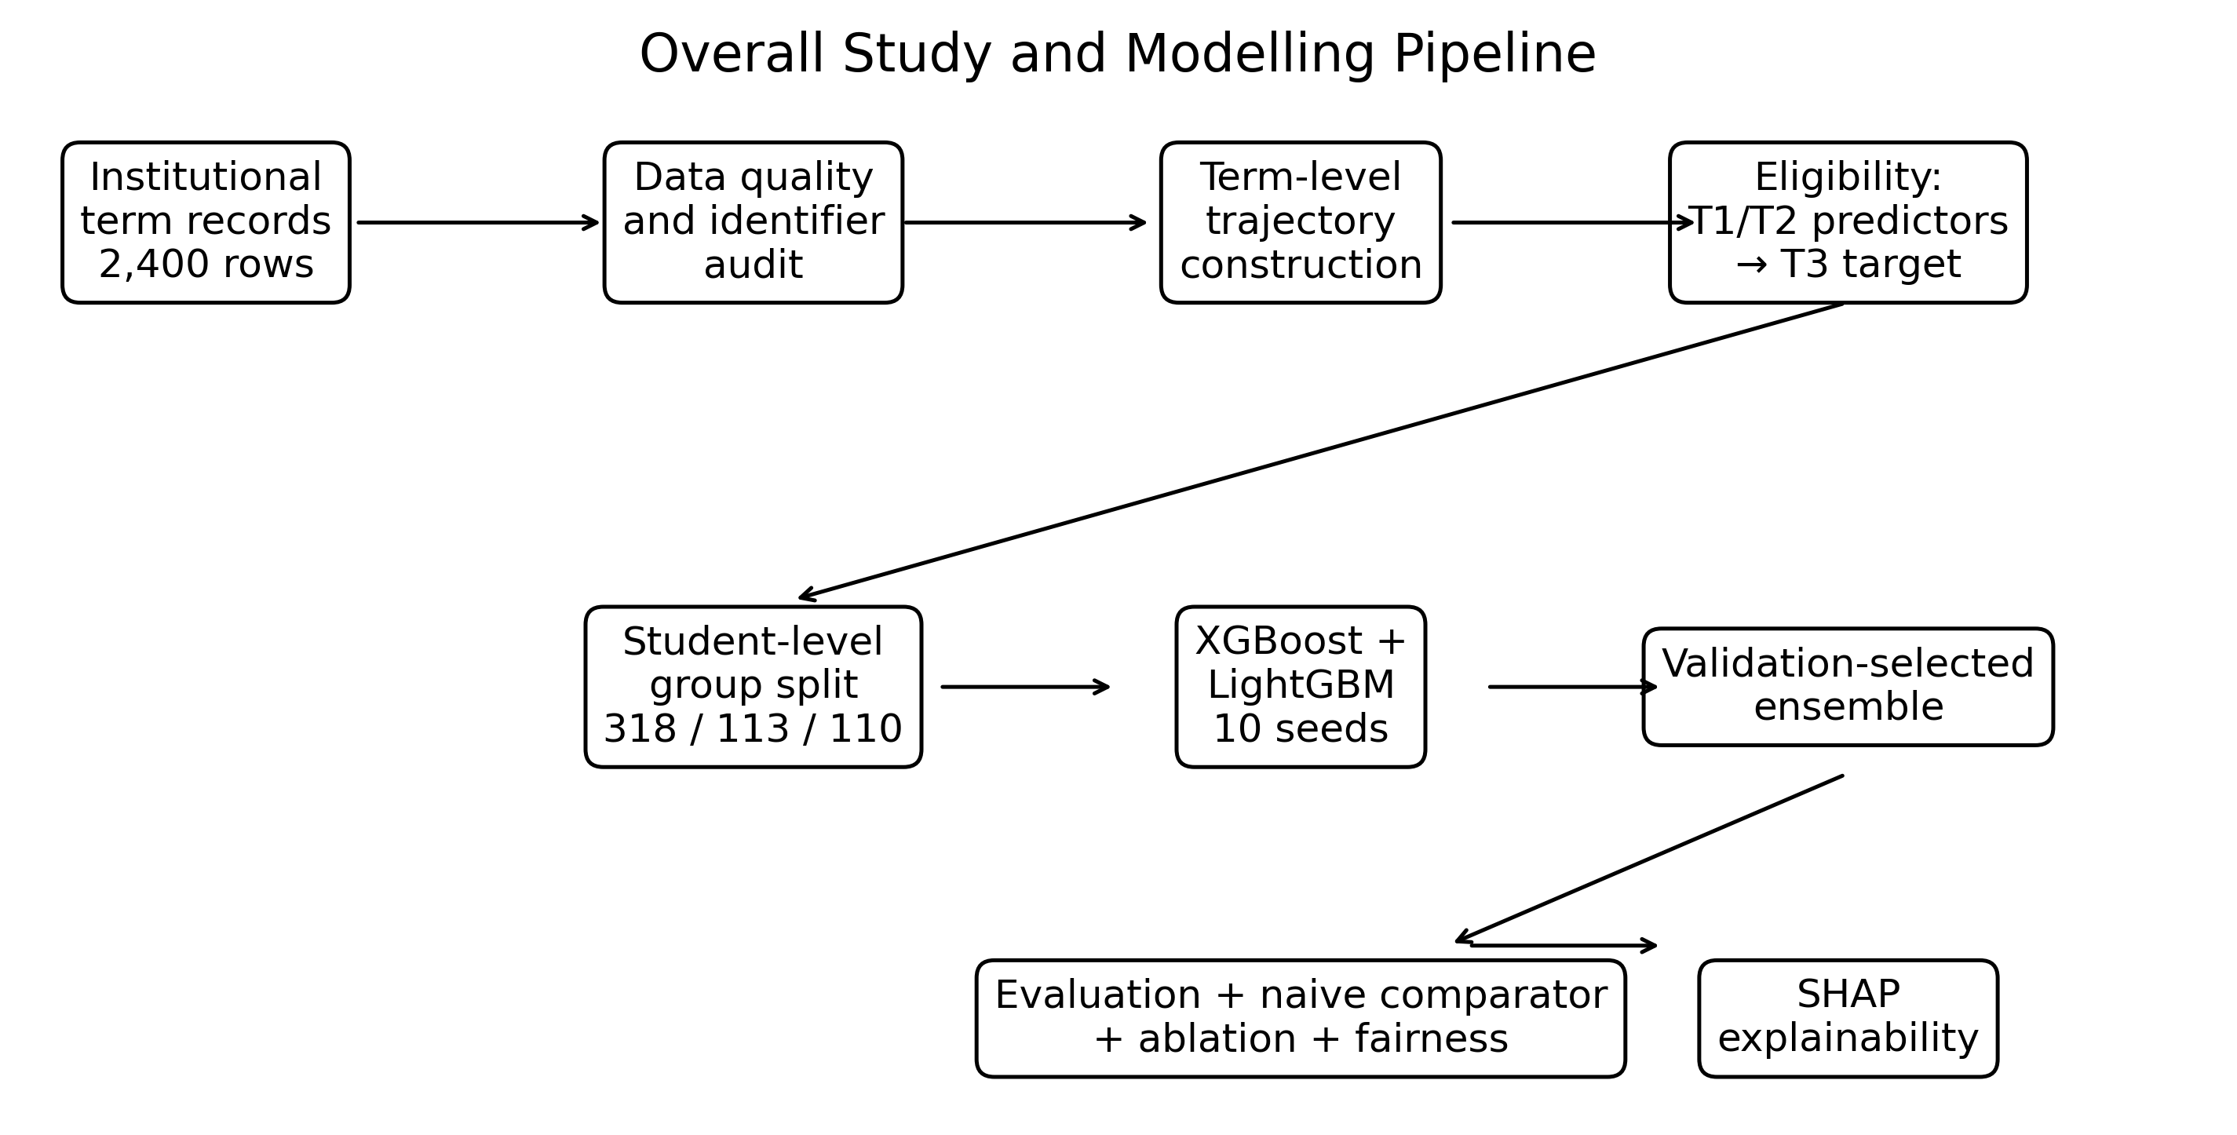
The methodology was explicitly aligned to the three study objectives and their corresponding research questions.
Objective 1: To develop and evaluate a leakage-controlled XGBoost–LightGBM ensemble for predicting Term 3 at-risk status, defined from academic performance, using term-level academic and attendance records available in Terms 1 and 2.
Objective 2: To apply SHAP-based global SHAP feature-contribution explanations to identify and interpret the contributions of academic, attendance, demographic and temporal predictors to the ensemble's Term 3 at-risk predictions.
Objective 3: To assess predictive performance disparities across gender and JHS class-level subgroups using disaggregated classification performance and error-rate measures.
Research questions: RQ1 addresses predictive performance for the Term 3 at-risk outcome; RQ2 addresses feature contributions identified through SHAP; and RQ3 addresses predictive-performance differences across gender and estimable JHS class-level subgroups.
Theory-to-feature traceability: behavioural engagement was operationalised through attendance_t1 and attendance_t2, while attendance_decay represented the temporal pattern of the same observable behavioural construct. Term 1 and Term 2 academic scores represented prior academic indicators used for prediction. The theory did not assign causal meaning to any feature or prediction.
Figure 3.1. Overall study and modelling pipeline.
3.2 Research Setting and Data Acquisition
The study was conducted in Korle Klottey Municipality in the Greater Accra Region of Ghana. The institutional source comprised records from multiple public Junior High Schools. School labels used in the source workbook (for example, coded school fields) were treated as anonymisation/coding labels and not as evidence that the experiment was drawn from a single school. The source population comprised historical records for JHS1, JHS2 and JHS3 students covering the 2022–2023 and 2023–2024 academic years.
The source workbook contained six term-level sheets, with 400 student records per sheet, giving 2,400 term-level records before analytical eligibility filtering. No separate public dataset was merged into the primary experiment. The executed experiment used institutional records from multiple public JHS as its primary source. The term-level records were linked within the same source using the anonymised student identifier and academic year; no separate public dataset was merged into the primary experiment.
The study boundary was therefore multiple public JHS in Korle Klottey Municipality over two academic years, with the supervised prediction population restricted to student-year trajectories having an observed Term 3 outcome. All 259 excluded trajectories were JHS3 trajectories. Consequently, the empirical predictive and subgroup analyses are limited to estimable JHS1 and JHS2 observations; no predictive-performance claim is made for JHS3.
The main variables captured from the institutional records are summarised in Table 3.1.
Variable | Description | Analytical role
student_id | Anonymised student identifier | Record linkage; grouping variable for leakage control
class_level | JHS1, JHS2 or JHS3 | Predictor; fairness subgroup
academic_year | 2022–2023 or 2023–2024 | Predictor
gender | Female or Male | Predictor; fairness subgroup
age_years | Student age in years | Predictor
days_present | Days present during a term | Attendance provenance
total_school_days | School days available during a term | Attendance provenance
attendance_rate_% | Attendance percentage | Primary attendance representation
score_mathematics | Mathematics score | Term outcome input; used in target construction
score_english | English score | Term outcome input; used in target construction
score_science | Science score | Term outcome input; used in target construction
score_social_studies | Social Studies score | Term outcome input; used in target construction
term_average_score | Term-level academic average | Target construction
at_risk | 1 when Term 3 score <50; otherwise 0 | Final classification target
meals_access | Recorded access indicator | Excluded because no variation was observed
distance_km | Distance measure | Excluded because values were unavailable
repeat_student | Repeat indicator | Excluded because no variation was observed

Table 3.1. Variables collected/captured and their analytical roles.
3.3 Within-Source Term-Level Record Linkage and Temporal Data Integration
The term-level records were linked within student and academic year using the verified anonymised student identifier. The analysis did not average Terms 1–3 into a single end-of-year outcome for the final supervised experiment. Instead, the temporal structure was retained so that Terms 1 and 2 supplied predictors and Term 3 supplied the supervised outcome.
Identifier auditing showed 400 records per term sheet and no duplicate student identifiers within any sheet. Within each academic year, the same 400 student identifiers were present across the three terms. Across the two academic years, 340 students appeared in both years, giving 460 unique students across the six term sheets. Year-to-year class progression was consistent with 201 JHS1→JHS2 and 139 JHS2→JHS3 transitions among the 340 students observed in both years.
The attrition cascade for the supervised Term 3 task was therefore: 2,400 term records → 800 student-year trajectories → 259 trajectories without an observed Term 3 academic outcome → 541 eligible supervised student-year observations. The 259 ineligible trajectories comprised 60 JHS3 trajectories in 2022–2023 and 199 JHS3 trajectories in 2023–2024. These records were not imputed because the absence of the Term 3 academic outcome was attributable to the institutional examination/completion structure: JHS3 students did not complete the ordinary Term 3 academic period before the BECE-related completion point.
The final supervised dataset contained 541 observations involving 340 unique students. There were 420 Not At Risk observations and 121 At Risk observations.
3.4 Ethical Compliance and Data Governance
The study involved academic, attendance and demographic information relating to school students. Direct student names were not used in the analytical dataset; anonymised study identifiers were used for record linkage. Results were designed to be reported in aggregate and subgroup form without disclosure of personally identifiable student information.
Ethical clearance through the Kwame Nkrumah University of Science and Technology Humanities and Social Sciences Research Ethics Committee (HUSSREC), together with the relevant institutional/municipal authorisation, was treated as a prerequisite for the study. The official HUSSREC reference number has not yet been received and is therefore not stated in this chapter. It will be inserted exactly as shown on the official approval document when received, together with the relevant institutional authorisation details.
The raw institutional workbook and processed student-level datasets were excluded from the public version-control workflow because of privacy and ethical restrictions. The public reproducibility artefacts consist of code and non-sensitive generated outputs.
3.5 Data Preprocessing Pipeline
Preprocessing followed a documented sequence: source-sheet validation, student-ID consistency checks, duplicate checks, missingness assessment, construction of student-year trajectories, eligibility filtering for observed Term 3 outcomes, target construction, predictor selection, attendance representation, student-level partitioning, and categorical encoding.
The missingness audit identified small numbers of isolated missing subject values in some early terms. More importantly, Term 3 academic scores and Term 3 term-average scores were systematically absent for 60 JHS3 trajectories in 2022–2023 and 199 JHS3 trajectories in 2023–2024. These 259 trajectories were excluded from supervised Term 3 prediction because the target was unavailable. No imputation was used for the missing Term 3 target.
Attendance consistency checks showed that recorded attendance percentages were closely aligned with rates recalculated from days present and total school days. The primary predictor specification therefore retained the normalised attendance rate rather than simultaneously entering the attendance numerator, denominator and rate, avoiding multiple representations of the same construct.
The variables meals_access and repeat_student had no observed variation, while distance_km was unavailable. These variables were excluded because they could not provide discriminating information. Subject scores used to construct the Term 3 academic outcome were not used as predictors for the same Term 3 outcome, thereby preventing target leakage.
The categorical variables gender, class_level and academic_year were one-hot encoded. The canonical feature matrix contained 12 columns: score_t1, score_t2, attendance_t1, attendance_t2, attendance_decay, age_years, gender_F, gender_M, class_level_JHS1, class_level_JHS2, academic_year_2022-23 and academic_year_2023-24. Cell A removes attendance_decay and therefore uses the resulting 11-feature matrix.
3.6 Feature Engineering
One model-engineering operation was retained: FABRICATE. The operation fabricated a temporal attendance-decay feature from Term 1 and Term 2 attendance rates. The feature was constructed to give greater influence to the more recent observed attendance while retaining earlier attendance information.
For the early-warning prediction, the decay feature was calculated from the predictor terms available before the Term 3 outcome. With λ = 0.5, the normalised weights for Terms 1 and 2 were 0.377541 and 0.622459, respectively.
The formulation was:
attendance_decay = Σ(wₜ × attendance_rateₜ), wₜ ∝ exp(λ(t − T))
λ = 0.5; w₁ = 0.377541; w₂ = 0.622459
Equation 3.1. Temporal attendance-decay formulation and normalised Term 1–Term 2 weights.
The value λ = 0.5 was treated as a fixed engineering parameter in the confirmatory experiment and was not selected using the held-out test set. The contribution of the engineered representation was assessed through the three-cell ablation described in Section 3.13. The at-risk score threshold of 50 was treated as an operational study definition rather than as a universal policy threshold. A post-hoc threshold sensitivity analysis at probability thresholds of 0.30, 0.40, 0.50, 0.60 and 0.70 was also conducted as a robustness analysis; the primary decision threshold remained fixed at 0.50 and was not selected from test-set results.
3.7 Base Learner and Primary Ensemble Specification
XGBoost and LightGBM were specified as the two component learners. Both were binary classifiers for the final early-warning task. The models received the same canonical predictor matrix and the same leakage-controlled student-level partitions.
The primary model was Cell A: a fixed 50:50 probability ensemble of XGBoost and LightGBM without the attendance_decay feature, evaluated at a probability threshold of 0.50. This configuration was selected as the primary model because the controlled ablation showed that the attendance-decay conditions did not improve the headline performance measures. The validation-selected decay configuration (Cell C) was retained as a tested alternative rather than as the primary model. The separate ten-seed and repeated grouped-split analyses were used to quantify model-seed and partition-induced variability.
A naive majority-class comparator was included. It always predicted the majority Not At Risk class based on the training distribution. This comparator was used to establish whether the machine-learning system provided predictive value beyond a trivial prevalence-based rule.
3.8 Model Engineering Contribution (ONE operation only: Fabricate OR Modify OR Remove OR Replace)
The single declared model-engineering operation was FABRICATE: construction of the temporal attendance-decay feature. No second engineering operation was claimed. Importantly, the study does not claim that this engineered feature improved predictive performance; it was introduced as a hypothesis-driven representation and then evaluated through controlled ablation. The feature was introduced as an explicit temporal representation of attendance behaviour, with the Term 2 attendance observation receiving greater weight than Term 1.
The engineered feature was included in the evaluated candidate feature set rather than being assumed to improve the final model. The primary Cell A configuration excludes attendance_decay, while Cells B and C retain it for controlled comparison. Its incremental contribution was then examined through the three-cell ablation: (A) standard 50:50 XGBoost–LightGBM without attendance decay, (B) 50:50 ensemble with attendance decay, and (C) validation-selected ensemble with attendance decay.
3.9 Training Configuration and Computing Environment
The models were implemented in Python 3.10 using a dedicated virtual environment. Pandas and NumPy supported data processing, scikit-learn supported preprocessing and evaluation, XGBoost and LightGBM provided the predictive learners, SHAP provided post-hoc explanations, and Matplotlib was used for visualisation.
No hyperparameter search was performed in the final experiment. The two base learners used the same fixed model-development configuration across seeds, and the tuning budget was therefore zero for both arms. This was stated explicitly rather than described as optimisation. The primary Cell A ensemble weight was fixed at 50:50. Validation-based weight selection was used only for Cell C, the tested attendance-decay alternative.
Component | Parameter / setting | Executed value
XGBoost | n_estimators | 300
XGBoost | max_depth | 4
XGBoost | learning_rate | 0.05
XGBoost | subsample | 0.8
XGBoost | colsample_bytree | 0.8
LightGBM | n_estimators | 300
LightGBM | max_depth | 4
LightGBM | learning_rate | 0.05
LightGBM | subsample | 0.8
LightGBM | colsample_bytree | 0.8
Randomisation | Seeds | 42–51
Classification threshold | Probability threshold | 0.50
Ensemble | Cell A fixed weight | 0.50 XGBoost : 0.50 LightGBM
Attendance decay | λ | 0.5; evaluated in ablation, excluded from Cell A

Table 3.2. Key executed modelling and feature-engineering settings.
3.10 Experimental Design and Reproducibility Controls
The final supervised dataset was partitioned at the student level. The 541 eligible observations were allocated to training (318 observations), validation (113 observations) and test (110 observations). These observations represented 340 unique students overall and 68 unique students in the final test set. No student identifier occurred in more than one partition.
Experiment component | Training | Validation | Testing | Control
Final early-warning experiment | 318 | 113 | 110 | Student-level grouping; no overlap
Seeds | 42–51 | 42–51 | 42–51 | Ten repeated seeded executions
Ensemble selection | Fixed 50:50 Cell A | Not applicable for primary model | Frozen 50:50; validation selection only for Cell C | Selection on validation only
Primary threshold | — | 0.50 | 0.50 | Fixed before test evaluation
Naive comparator | Training prevalence | — | Held-out test | No model fitting
Ablation | Same training data | Same validation protocol | Same held-out test | Three predefined cells

Table 3.3. Final train-validation-test partition and reproducibility controls.
For each seed, XGBoost and LightGBM were fitted on the training partition and combined using the fixed 50:50 Cell A weighting. The held-out test partition was evaluated only after the model-development configuration had been fixed. The test set was not used for model or weight selection. Validation-based ensemble-weight selection was retained only for Cell C in the controlled ablation.
Ten repeated model-seed executions, using seeds 42 through 51, were used for the fixed-partition stability analysis. In addition, a separate repeated grouped-split robustness experiment used ten student-level split seeds (42, 52, 62, 72, 82, 92, 102, 112, 122 and 132), with model seeds 42–51 evaluated within each partition. This produced 100 partition-by-model-seed evaluations for Cell A, the 50:50 ensemble without attendance_decay. Preprocessing and categorical encoding were refitted within each repeated partition. The repeated-split analysis was used to estimate within-partition model-seed variability and between-partition variability separately; it did not replace the locked final test evaluation.
The repeated grouped-split analysis generated aggregate-only variance artefacts in results\variance. These outputs contained partition-level and variance-decomposition summaries and did not contain student-level records. The original Step 23 ten-seed results were also independently reconciled on the canonical partition before the repeated-split analysis was accepted.
The repository was organised as sequential scripts and saved result artefacts. For reproducibility, repository documentation is required to use repository-relative paths, identify the canonical data-preparation script, document the execution order, and avoid machine-specific paths.
3.11 Evaluation Metrics
The primary task was binary early-warning classification of the observed Term 3 academic outcome. Performance was evaluated using accuracy, precision, recall/True Positive Rate (TPR), Macro-F1, ROC-AUC, PR-AUC and Brier score. Confusion-matrix components were retained for error and subgroup analysis.
Metric | Definition | Preferred direction / use
Accuracy | Correct classifications divided by all classifications | Higher is better; interpreted with class distribution
Precision | Correct At Risk predictions among all predicted At Risk cases | Higher is better
Recall / TPR | Actual At Risk cases correctly identified | Higher is better; central to early warning
Macro-F1 | Mean F1 across At Risk and Not At Risk classes | Higher is better
ROC-AUC | Area under the receiver operating characteristic curve | Higher is better
PR-AUC | Area under the precision-recall curve | Higher is better; informative for minority class
Brier score | Mean squared error of probabilistic predictions | Lower is better
FPR | False positives among actual Not At Risk cases | Lower is better
FNR | False negatives among actual At Risk cases | Lower is better; operationally important

Table 3.4. Definitions of classification evaluation metrics.
3.12 Statistical Analysis
Statistical analysis comprised descriptive summaries, repeated-seed performance summaries, subgroup disparity calculations, threshold sensitivity assessment and ablation comparisons. The final experiment did not generate a formal inferential significance test such as a Wilcoxon signed-rank test, paired permutation test or parametric hypothesis test. Accordingly, no p-value or statistical-significance claim was assigned to the observed model differences.
For the fixed-partition ten-seed experiment, the mean and standard deviation of each performance metric were calculated across model seeds. For the repeated grouped-split experiment, within-partition variance was estimated from the ten model seeds and between-partition variance was estimated from the variation among the ten partition means. Fairness analysis calculated subgroup performance separately for gender and class level, followed by descriptive gaps between subgroup values.
The final test set contained no eligible JHS3 observations with an observed Term 3 academic outcome because all JHS3 Term 3 academic targets in the source periods were missing under the examination/completion structure. Consequently, JHS3 could not contribute an estimable positive-class fairness result in the final Term 3 prediction experiment and was not assigned a zero performance value.
3.13 Ablation Study
A controlled three-cell ablation was executed using the same data partitions and the same ten-seed framework. Cell A represented the standard 50:50 XGBoost–LightGBM ensemble without attendance_decay. Cell B represented a 50:50 ensemble with attendance_decay. Cell C represented the tested validation-selected ensemble with attendance_decay.
Ablation cell | Attendance decay | Ensemble weighting | Purpose
A | Absent | 50:50 | Primary Cell A reference condition; excludes engineered feature
B | Present | 50:50 | Isolate attendance_decay under fixed weighting
C | Present | Validation-selected | Tested alternative; validation-selected weighting with attendance decay

Table 3.5. Three-cell ablation design for the temporal attendance-decay contribution.
The ablation was compute-matched in the sense that the same seeds, partitions and base-model configurations were used across cells. The ablation was designed to test whether the fabricated temporal representation improved predictive performance rather than assuming that an engineered feature must produce a gain.
3.14 Reproducibility and Open Science Artifacts
The analysis scripts were version-controlled using Git and maintained in the project repository. The repository contains the principal data-quality, term-level dataset construction, student-level splitting, feature preparation, model training, ten-seed stability, the tested validation-based ensemble alternative, naive-comparator, ablation, fairness, SHAP and results-generation workflows.
The GitHub repository is:
https://github.com/generalh018-a11y/Ghana_JHS_Academic_Performance
The raw institutional spreadsheet and processed student-level datasets were excluded from public version control. This separation was maintained to protect student privacy and comply with the study's ethical/data-governance requirements. Non-sensitive code and reproducibility artefacts were retained.
The executed SHAP analysis used a model-agnostic PermutationExplainer on the locked Cell A ensemble because the installed SHAP and XGBoost versions produced a compatibility problem with the tree-specific explainer. SHAP was therefore applied post hoc to held-out observations without using SHAP outputs for model selection.
For reproducibility, the repository documentation is required to use repository-relative paths, identify the canonical data-preparation script, document the execution order, and avoid machine-specific paths. Raw student records are not part of the public reproducibility artefacts.
Objective-to-Method-to-Evidence Traceability Matrix
3.15 Required Figures and Tables Checklist
Objective | Methodological operationalisation | Executed evidence | Chapter 4 evidence | RQ
Objective 1 | §§3.5–3.10: term-level prediction, leakage control, model development, validation-only ensemble selection, ten-seed evaluation and ablation | Steps 17–26: dataset construction, student-level split, canonical features, XGBoost/LightGBM training, validation selection, locked test evaluation, ten-seed stability, naive comparator and threshold sensitivity | §§4.1–4.5: dataset summary, model performance, robustness, ablation and statistical reporting | RQ1
Objective 2 | §§3.6, 3.11 and 3.14: attendance-decay feature and post-hoc SHAP procedure | Steps 28A–28C: model-agnostic permutation SHAP, global importance, dependence plots and individual waterfall explanations | §4.6: global and individual SHAP results | RQ2
Objective 3 | §§3.10–3.12: subgroup mapping, performance metrics, FPR/FNR and descriptive disparity calculations | Steps 27A–27B: mapped test predictions and gender/class-level subgroup metrics and gaps | §4.7: subgroup performance and error-rate results | RQ3
Table 3.6. Objective-to-method-to-evidence traceability matrix.
The engineered attendance-decay contribution is traceable to Objective 1 through §§3.6 and 3.8 and is evaluated in the controlled three-cell ablation. The study does not claim that attendance decay improved predictive performance.
Item | Status in revised methodology
Figure 3.1 — Overall study and modelling pipeline | Included
Table 3.1 — Variables collected/captured and analytical roles | Included
Table 3.2 — Key executed modelling and feature-engineering settings | Included
Table 3.3 — Final train-validation-test partition and reproducibility controls | Included
Table 3.4 — Definitions of classification evaluation metrics | Included
Table 3.5 — Three-cell ablation design | Included
Equation 3.1 — Temporal attendance-decay formulation | Included
GitHub repository and data-governance statement | Included in Section 3.14
HUSSREC and institutional approval references | Pending: official HUSSREC reference number has not yet been received; insert exact approved details before submission
All numerical results | To be reported from saved verified outputs in Chapter 4

Table 3.7. Required Chapter Three figures, tables and reproducibility items.
3.16 Supervisor Verification Checklist
Verification item | Final methodological status
Prescribed Methods order | 16 sections retained in the supervisor-required order
Study setting | Multiple public JHS in Korle Klottey Municipality; workbook school labels treated as coding/anonymisation labels
Source records | 2,400 term-level records across six term sheets
Final supervised sample | 541 eligible student-year observations; 340 unique students
JHS3 boundary | All 259 excluded trajectories were JHS3 without an observed ordinary Term 3 outcome; JHS3 is not an estimable prediction subgroup
Eligibility rule | Term 3 target observed; 259 trajectories without observed Term 3 target excluded without imputation
Prediction mechanism | Term 3 outcome predicted from Terms 1 and 2
Student-level leakage control | No student overlap across training, validation and test
Train / validation / test | 318 / 113 / 110 observations
At-risk target | Term 3 score <50 = At Risk; ≥50 = Not At Risk
Target distribution | 121 At Risk; 420 Not At Risk
Attendance representation | Term 1 and Term 2 attendance rates; numerator and denominator not jointly entered
Engineered operation | FABRICATE: attendance_decay
Decay parameter | λ = 0.5; Term 1 weight 0.377541; Term 2 weight 0.622459
Model learners | XGBoost and LightGBM
Primary ensemble | Cell A: fixed 50:50 XGBoost / LightGBM without attendance_decay
Stability | Ten model seeds: 42–51; repeated grouped splits additionally quantified partition variability
Naive comparator | Included
Ablation | Three-cell controlled ablation included; Cell A selected as primary
Fairness | Gender and estimable class-level subgroups; socioeconomic fairness not claimed
SHAP | Post-hoc model-independent PermutationExplainer on held-out Cell A test data
Inferential significance test | Not executed; no p-value claim
GitHub | https://github.com/generalh018-a11y/Ghana_JHS_Academic_Performance
Raw student data | Excluded from public repository
HUSSREC reference | Pending; insert exact approved reference number before submission

Table 3.8. Supervisor verification checklist for the final Chapter Three methodology.

CHAPTER FOUR
RESULTS AND DISCUSSION
Final locked results version based on the audited term-level experiment

4.1 Descriptive Summary of the Dataset
Following the data preparation procedures described in Chapter Three, the final analytical dataset for the supervised Term 3 prediction task comprised 541 student-year observations involving 340 unique students. The dataset contained 121 at-risk observations and 420 not-at-risk observations. The target was the Term 3 academic outcome, while the predictors were drawn from information available in Terms 1 and 2.
The final dataset contained 13 variables. The supervised dataset contained no missing target values. Students without an observed Term 3 academic outcome, including JHS3 trajectories affected by the end-of-period examination structure, were not included in the supervised Term 3 prediction dataset.
Table 4.1. Summary of the final term-level modelling dataset.
Item | Value
Eligible student-year observations | 541
Unique students | 340
Variables | 13
At-risk observations | 121 (22.37%)
Not-at-risk observations | 420 (77.63%)
Missing Term 3 targets | 0
Table 4.1 summarises the final modelling sample used for the early-warning classification experiment.

4.2 Primary Cell A Model Performance (Main Results)
The primary classification experiment used Cell A, a fixed 50:50 XGBoost–LightGBM probability ensemble without attendance_decay and with a 0.50 classification threshold. The controlled ablation established that the non-decay Cell A condition recorded stronger headline performance than the attendance-decay conditions. The ten-seed Cell A results therefore replace the earlier validation-selected decay configuration as the primary results.
Table 4.2. Classification performance of the Cell A primary ensemble across ten model seeds.
Model / evaluation | Accuracy | Precision | Recall | Macro-F1 | ROC-AUC | PR-AUC | Brier
Cell A primary ensemble (10 seeds) | 0.9673 ± 0.0047 | 0.9525 ± 0.0158 | 0.9344 ± 0.0099 | 0.9601 ± 0.0056 | 0.9924 ± 0.0004 | 0.9833 ± 0.0011 | 0.0303 ± 0.0010
As shown in Table 4.2, Cell A achieved mean accuracy of 0.9673 and Macro-F1 of 0.9601 across ten model seeds. Its mean ROC-AUC was 0.9924, mean PR-AUC was 0.9833 and mean Brier score was 0.0303.

4.3 Ten-Seed Stability and Robustness
Initial stability was assessed using ten repeated model-seed executions (42–51) on the fixed final student-level partition. For each seed, the Cell A 50:50 ensemble weighting was fixed and the resulting configuration was evaluated on the held-out test set. A separate repeated grouped-split analysis subsequently varied the student-level partition using ten split seeds while retaining model seeds 42–51; this separates model-seed variation from partition-induced variation and is reported in Section 4.3.1.
Table 4.3. Ten-seed stability of the Cell A primary XGBoost–LightGBM ensemble.
Metric | Mean ± SD
Accuracy | 0.9673 ± 0.0047
Precision | 0.9525 ± 0.0158
Recall | 0.9344 ± 0.0099
Macro-F1 | 0.9601 ± 0.0056
ROC-AUC | 0.9924 ± 0.0004
PR-AUC | 0.9833 ± 0.0011
Brier score | 0.0303 ± 0.0010
XGBoost weight | 0.5000
LightGBM weight | 0.5000
Under the fixed final partition, Cell A used the same 50:50 ensemble weight for all ten model seeds. The hard metrics varied across seeds, demonstrating model-seed variability rather than the earlier zero-SD pattern. The repeated grouped-split analysis additionally quantified partition-induced variability.
4.3.1 Repeated Grouped-Split Robustness
To assess whether the stability observed under the fixed final partition depended on a single train-validation-test draw, a separate repeated grouped-split experiment was conducted. Ten student-level partitions were generated using split seeds 42, 52, 62, 72, 82, 92, 102, 112, 122 and 132. Within each partition, the same 50:50 Cell A ensemble without attendance_decay was evaluated under model seeds 42–51, producing 100 partition-by-seed evaluations. Preprocessing and categorical encoding were refitted within each partition. No student appeared across more than one partition in any repetition.
Table 4.3A reports the resulting variance decomposition. The mean is the mean of the ten partition-level means. Within-partition variability reflects model-seed variation, whereas the between-partition component reflects variation attributable to the repeated grouped data splits. The total standard deviation is reported as the combined variance component.
Table 4.3A. Variance decomposition under repeated grouped student-level splits.
Metric | Mean | Within-partition SD | Between-partition SD | Total SD
Accuracy | 0.957933 | 0.004731 | 0.010801 | 0.011791
Precision | 0.905118 | 0.012479 | 0.046196 | 0.047852
Recall | 0.901550 | 0.018563 | 0.052725 | 0.055898
Macro-F1 | 0.937276 | 0.007098 | 0.016874 | 0.018306
ROC-AUC | 0.988681 | 0.000838 | 0.003481 | 0.003581
PR-AUC | 0.956907 | 0.004913 | 0.017307 | 0.017991
Brier score | 0.033889 | 0.001043 | 0.007105 | 0.007181
The repeated-split analysis showed that partition choice contributed more variability than model seed for several headline measures. For example, Macro-F1 had a within-partition SD of 0.0071 and a between-partition SD of 0.0169, giving a total SD of 0.0183. This indicates that the earlier zero SD observed for hard metrics under the fixed test partition should not be interpreted as evidence that the classifier is invariant to sampling; rather, it reflected reuse of the same held-out observations across seeds. The repeated grouped-split analysis therefore provides a more complete assessment of robustness.
4.3.2 Naive Majority-Class Comparator
A naive majority-class comparator was evaluated as a prevalence-based reference. It predicted Not At Risk for every test observation because the majority class was Not At Risk. The comparator achieved 0.7091 accuracy but recorded zero recall and zero true-positive detections, demonstrating that accuracy alone would provide an incomplete description of early-warning performance.
Table 4.3B. Performance of the naive majority-class comparator.
Model | Accuracy | Precision | Recall | Macro-F1 | ROC-AUC | PR-AUC | Brier
Naive majority-class comparator | 0.7091 | 0.0000 | 0.0000 | 0.4149 | 0.5000 | 0.2909 | 0.2113

4.4 Ablation Study Confirmation
A three-cell ablation was conducted to assess the attendance-decay representation and the validation-selected ensemble configuration. Cell A used a 50:50 ensemble without attendance decay; Cell B used a 50:50 ensemble with attendance decay; Cell C used the validation-selected ensemble with attendance decay.
Table 4.4. Three-cell ablation results across ten seeds.
Cell | Description | Accuracy | Macro-F1 | ROC-AUC | PR-AUC | Brier
A | 50:50 without attendance decay | 0.9673 ± 0.0047 | 0.9601 ± 0.0056 | 0.9924 ± 0.0004 | 0.9833 ± 0.0011 | 0.0303 ± 0.0010
B | 50:50 with attendance decay | 0.9545 ± 0.0000 | 0.9433 ± 0.0000 | 0.9891 ± 0.0009 | 0.9754 ± 0.0016 | 0.0368 ± 0.0006
C | Validation-selected with attendance decay | 0.9545 ± 0.0000 | 0.9433 ± 0.0000 | 0.9898 ± 0.0009 | 0.9763 ± 0.0011 | 0.0361 ± 0.0011
Cell A recorded the highest mean accuracy, Macro-F1, ROC-AUC and PR-AUC and the lowest mean Brier score among the three conditions. Cell B did not improve these headline measures relative to Cell A. Cell C retained the attendance-decay feature and used validation-based weight selection; its classification metrics were the same as Cell B, while its probability-based metrics showed small changes.

4.5 Statistical Significance Testing
No inferential significance test was performed for the final locked ten-seed classification experiment. The completed analysis provides descriptive mean ± SD stability results rather than a paired inferential test. Accordingly, no p-value or effect-size claim is reported for the final experiment.
Table 4.5. Statistical significance testing status for the final locked experiment.
Item | Final status
Inferential test | Not performed
Paired observations for significance testing | Not generated
p-value | Not reported
Effect size | Not reported
Basis for final comparison | Descriptive ten-seed results

4.6 Feature Importance and Model Interpretability of the Primary Cell A Ensemble
SHAP analysis was conducted post hoc on the locked Cell A ensemble using the 110 held-out test observations. Cell A used the 11-feature representation obtained by removing attendance_decay from the canonical 12-feature matrix. Table 4.6 presents the global mean absolute SHAP values. The two prior academic-performance variables, score_t2 and score_t1, recorded the largest mean absolute SHAP values. The interpretation is descriptive: SHAP contributions explain the fitted model's output and are not treated as causal effects.
Table 4.6. Global SHAP feature-importance ranking for the locked ensemble.
Rank | Feature | Mean |SHAP|
1 | score_t2 | 0.153914
2 | score_t1 | 0.135065
3 | attendance_t2 | 0.038298
4 | academic_year_2022-23 | 0.032277
5 | age_years | 0.026453
6 | attendance_t1 | 0.018020
7 | academic_year_2023-24 | 0.014800
8 | gender_F | 0.005247
9 | class_level_JHS1 | 0.002396
10 | class_level_JHS2 | 0.001320
11 | gender_M | 0.001077
The global ranking is visualised in Figure 4.2. The SHAP analysis was post hoc and was not used for model selection or threshold selection.
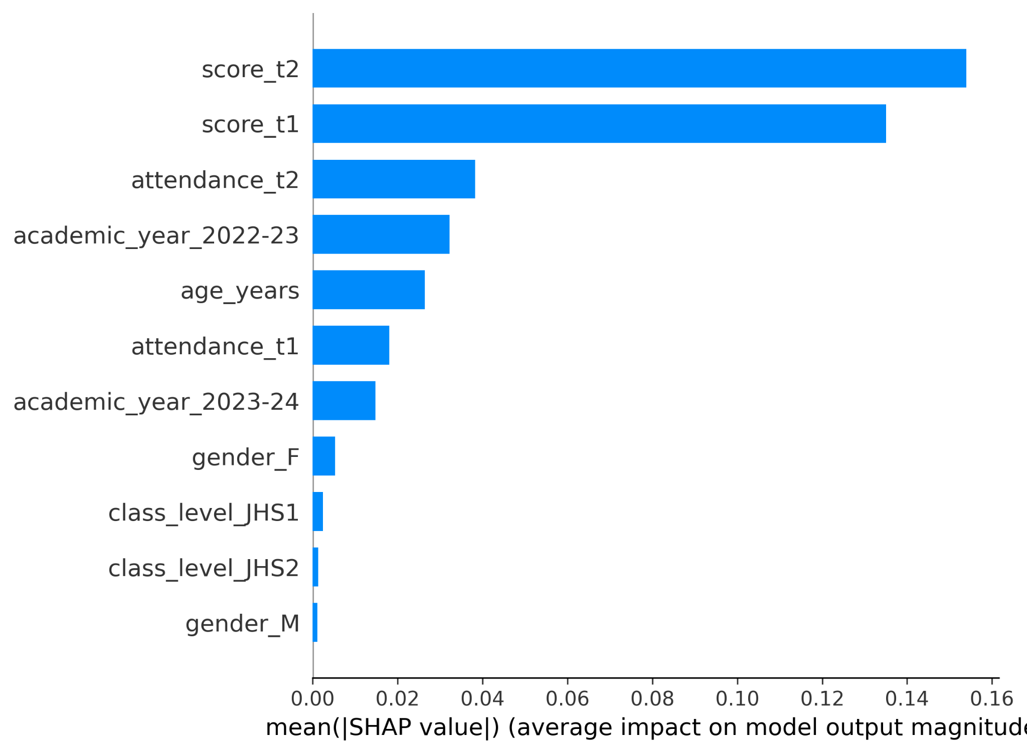
Figure 4.2. Global SHAP feature-importance ranking for the locked XGBoost–LightGBM ensemble.
The verified Cell A SHAP audit also generated dependence plots for score_t1, score_t2 and attendance_t1. These supplementary plots describe how individual feature values relate to SHAP contributions in the fitted model; they were not used for model selection or threshold selection.
The verified SHAP reconstruction check passed at numerical precision across all 110 held-out test observations. The maximum absolute additivity error was 2.44 × 10⁻¹⁵, the mean absolute additivity error was 3.43 × 10⁻¹⁶, and the maximum probability-reconciliation difference was 1.11 × 10⁻¹⁶. The prediction reconciliation difference was zero.

4.6.1 Prior-Score Ablation and Interpretation
A prior-score ablation was conducted to assess how much predictive performance remained when score_t1 and score_t2 were removed. Across the ten model seeds, the reduced-feature configuration achieved substantially lower performance than Cell A. The result shows that prior academic attainment carries a large share of the predictive signal in the present early-warning task. This is not interpreted as leakage because Terms 1 and 2 are temporally available before the Term 3 outcome. However, the magnitude of the reduction is an important limitation when interpreting the model as a decision-support system.
Table 4.7. Prior-score ablation comparing the Cell A primary configuration with a model excluding score_t1 and score_t2.
Metric | Cell A primary | Without score_t1 and score_t2
Accuracy | 0.9673 ± 0.0047 | 0.8191 ± 0.0090
Precision | 0.9525 ± 0.0158 | 0.7317 ± 0.0171
Recall | 0.9344 ± 0.0099 | 0.5969 ± 0.0231
Macro-F1 | 0.9601 ± 0.0056 | 0.7672 ± 0.0126
ROC-AUC | 0.9924 ± 0.0004 | 0.8815 ± 0.0030
PR-AUC | 0.9833 ± 0.0011 | 0.7985 ± 0.0046
Brier score | 0.0303 ± 0.0010 | 0.1224 ± 0.0013
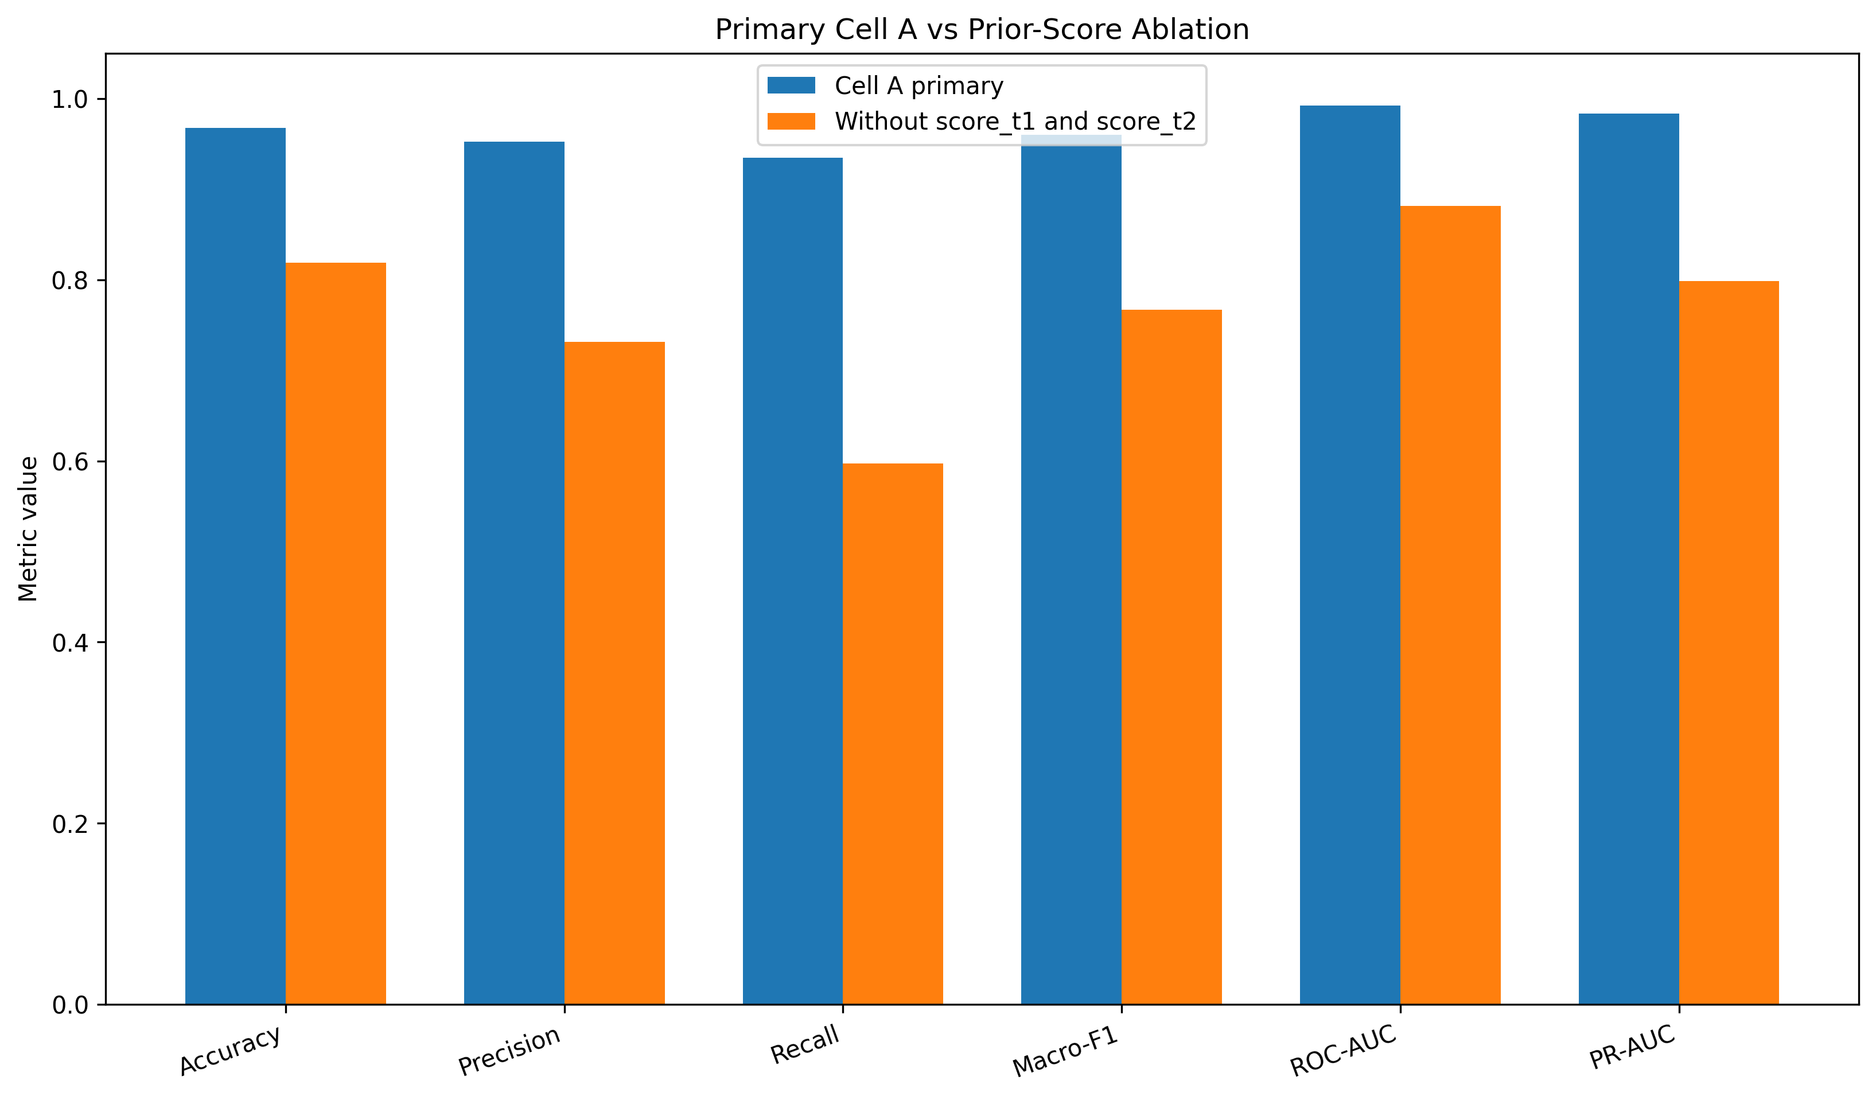
Figure 4.3. Performance comparison between the Cell A primary ensemble and the prior-score ablation.

4.7 Error Analysis (Confusion Matrix / Per-Class Metrics)
Error analysis was conducted on the final test set of 110 observations. Across the ten Cell A model seeds, the mean confusion counts were 76.5 true negatives, 1.5 false positives, 2.1 false negatives and 29.9 true positives. These are seed-averaged counts; each seed evaluated 110 held-out observations.
Table 4.8. Overall confusion-matrix counts for the final locked ensemble.
Measure | Ten-seed mean count
True Negative (TN) | 76.5
False Positive (FP) | 1.5
False Negative (FN) | 2.1
True Positive (TP) | 29.9
Total | 110.0
The subgroup results are reported in Table 4.9. For class level, JHS1 contained 42 test observations, including 23 at-risk cases, while JHS2 contained 68 observations, including 9 at-risk cases. For gender, females accounted for 58 test observations, including 13 at-risk cases, and males accounted for 52 observations, including 19 at-risk cases.
Table 4.9. Final test performance by class level and gender.
Variable | Group | n | At risk | Accuracy | Precision | TPR | FPR | FNR | Macro-F1
Class level | JHS1 | 42 | 23 | 0.9643 | 0.9392 | 1.0000 | 0.0789 | 0.0000 | 0.9636
Class level | JHS2 | 68 | 9 | 0.9691 | 1.0000 | 0.7667 | 0.0000 | 0.2333 | 0.9250
Gender | Female | 58 | 13 | 0.9897 | 0.9643 | 0.9923 | 0.0111 | 0.0077 | 0.9854
Gender | Male | 52 | 19 | 0.9423 | 0.9444 | 0.8947 | 0.0303 | 0.1053 | 0.9371
Across the ten model seeds, the descriptive gender TPR gap was 0.0976 and the gender FPR gap was 0.0192; the corresponding class-level TPR gap between JHS1 and JHS2 was 0.2333 and the FPR gap was 0.0789. These subgroup differences should be interpreted cautiously because the at-risk subgroup counts were small, particularly for JHS2 (9 at-risk observations). The study reports these disparities descriptively and does not treat them as statistical proof of unfairness.
Table 4.10. Predictive disparity gaps across the evaluated subgroups.
Comparison | TPR gap | FPR gap | Precision gap | Accuracy gap
Female vs Male | +0.0976 | -0.0192 | +0.0198 | +0.0473
JHS1 vs JHS2 | +0.2333 | +0.0789 | -0.0608 | -0.0048
All 259 trajectories excluded from the supervised Term 3 experiment were JHS3 trajectories without an observed ordinary Term 3 outcome before the BECE-related completion point. Therefore, JHS3 is a structural boundary of the present prediction experiment rather than an evaluated predictive subgroup. The subgroup results in Table 4.9 are consequently limited to JHS1 and JHS2. The findings should not be generalized to JHS3 without a dataset containing an appropriate pre-outcome Term 3 target.

4.7.1 JHS3 Design Boundary

4.8 Computational Efficiency and Scalability
The completed experiments were executed using CPU-based computation in the Python environment used for the study. The computational environment included 24 GB RAM and Python 3.10. Exact wall-clock training time, inference time and memory-footprint measurements were not captured in the completed result logs. Therefore, no unsupported numerical claims about computational speed, inference latency or memory efficiency are reported.

4.9 Required Figures and Tables Checklist
Table 4.11. Chapter Four figures and tables completion checklist.
Item | Required content | Status
Table 4.1 | Final modelling dataset summary | Included
Table 4.2 | Main Cell A model performance | Included
Table 4.3 | Ten-seed Cell A stability | Included
Table 4.4 | Three-cell ablation | Included
Table 4.5 | Statistical significance status | Included
Table 4.6 | Cell A SHAP feature importance | Included
Table 4.7 | Prior-score ablation | Included
Table 4.8 | Overall confusion-matrix mean counts | Included
Table 4.9 | Subgroup performance | Included
Table 4.10 | Predictive disparity gaps | Included
Figure 4.2 | Cell A global SHAP importance | Embedded
Figure 4.3 | Prior-score ablation comparison | Embedded
FINAL SUBMISSION NOTE: Superseded Cell C SHAP figures have been removed. The manuscript uses the verified Cell A SHAP analysis. The global SHAP figure is reproduced from the uploaded Cell A SHAP artifact, and the global importance table includes all 11 model features.

4.10 Supervisor Verification Checklist
Table 4.12. Supervisor verification checklist for the final locked experiment.
Verification item | Final result / status
Final supervised analytical sample | 541 student-year observations; 340 unique students
At-risk target | 121 positive; 420 negative
Prediction mechanism | Term 3 predicted from Terms 1 and 2
JHS3 boundary | All 259 excluded trajectories were JHS3; JHS3 is not an evaluated prediction subgroup
Train / validation / test | 318 / 113 / 110 observations
Student overlap | 0 across all split pairs
Primary ensemble | Cell A: fixed 0.50 XGBoost / 0.50 LightGBM; attendance_decay excluded
Primary threshold | 0.50
Stability analysis | Ten model seeds: 42–51; repeated grouped-split analysis reported separately
Naive comparator | Included
Three-cell ablation | Included; Cell A selected as primary
Prior-score ablation | Included; score_t1 and score_t2 removed
Fairness analysis | Gender and estimable class level; descriptive subgroup disparities
Socioeconomic fairness | Not claimed
SHAP | Post-hoc model-independent PermutationExplainer for Cell A; global feature importance reported
SHAP reconstruction | Passed at numerical precision across 110 held-out observations
Computational timing | Not numerically captured

Chapter Four Summary
The final audited experiment used 541 eligible student-year observations and a student-level train-validation-test partition with no student overlap. The primary Cell A XGBoost–LightGBM ensemble, using fixed 50:50 weighting without attendance_decay, achieved mean accuracy of 0.9673 and Macro-F1 of 0.9601 across ten model seeds, with mean ROC-AUC of 0.9924 and PR-AUC of 0.9833. The repeated grouped-split analysis demonstrated additional partition-induced variability. The naive comparator achieved 0.7091 accuracy but no true-positive detections. The ablation analysis showed that the attendance-decay conditions did not improve the primary Cell A configuration. The prior-score ablation showed substantially lower performance when score_t1 and score_t2 were removed, indicating that prior attainment carries a large share of the predictive signal. Cell A fairness analysis recorded descriptive differences across gender and JHS1/JHS2, with small at-risk subgroup counts requiring cautious interpretation. The primary Cell A SHAP analysis ranked score_t2 and score_t1 as the two largest contributors, and its additivity check passed at numerical precision.
GitHub repository: https://github.com/generalh018-a11y/Ghana_JHS_Academic_Performance.git
FINAL SUBMISSION NOTE: Superseded Cell C SHAP figures have been removed. The manuscript uses the verified Cell A SHAP analysis. The global SHAP figure is reproduced from the uploaded Cell A SHAP artifact, and the global importance table includes all 11 model features.

