CHAPTER FOUR
RESULTS AND DISCUSSION
Revised to follow the Results Section Table of Contents supplied in the study template.

4.1 Descriptive Summary of the Dataset
Following the data preparation and aggregation procedures described in Chapter Three, the final analytical dataset comprised 800 student-year observations. Each observation represented one student in one academic year after the three term records were aggregated. The dataset covered the 2022–2023 and 2023–2024 academic years and included JHS1, JHS2 and JHS3 observations.
The primary regression analysis used an 80:20 random hold-out split, producing 640 training observations and 160 held-out test observations. The secondary at-risk classification analysis used stratified allocation, with 512 training, 128 validation and 160 test observations. The at-risk target contained 186 positive observations (23.25%) and 614 negative observations (76.75%).
Table 4.1. Descriptive statistics of the final student-year dataset.
Variable | Mean | SD | Min | Max
age_years | 14.562 | 1.563 | 12.000 | 18.000
avg_days_present | 56.444 | 4.107 | 45.000 | 66.333
avg_total_school_days | 62.956 | 4.591 | 56.333 | 67.333
avg_attendance_rate | 89.827 | 4.850 | 74.000 | 99.533
avg_mathematics | 53.885 | 11.796 | 22.000 | 82.333
avg_english | 56.239 | 11.300 | 18.667 | 76.667
avg_science_social | 61.340 | 9.309 | 30.250 | 83.667
overall_average_score | 57.155 | 10.186 | 27.750 | 79.194

The mean overall average score was 57.155 (SD = 10.186), while mean attendance rate was 89.827% (SD = 4.850). The final dataset therefore provided the empirical basis for the regression, classification, explainability and subgroup analyses reported in the subsequent sections.

4.2 Baseline versus Engineered Model Performance (Main Results)
The principal regression experiment compared XGBoost, LightGBM and the XGBoost–LightGBM ensemble on the same held-out test set. XGBoost obtained MAE = 4.9678, RMSE = 6.1265 and R² = 0.6089. LightGBM obtained MAE = 4.9947, RMSE = 6.1359 and R² = 0.6077. The 50:50 XGBoost–LightGBM ensemble produced the lowest MAE and RMSE and the highest R², with MAE = 4.9530, RMSE = 6.0893 and R² = 0.6137.
Table 4.2. Main held-out regression performance comparison.
Model | MAE | RMSE | R²
XGBoost | 4.9678 | 6.1265 | 0.6089
LightGBM | 4.9947 | 6.1359 | 0.6077
XGBoost–LightGBM Ensemble | 4.9530 | 6.0893 | 0.6137

The ensemble reduced MAE by 0.0148 and RMSE by 0.0372 relative to XGBoost alone and increased R² by 0.0047. The 50:50 fusion also produced the strongest result among the tested ensemble weights.
Table 4.3. Ensemble weight comparison.
XGBoost Weight | LightGBM Weight | MAE | RMSE | R²
50% | 50% | 4.9530 | 6.0893 | 0.6137
60% | 40% | 4.9536 | 6.0900 | 0.6136
40% | 60% | 4.9561 | 6.0919 | 0.6133
70% | 30% | 4.9542 | 6.0941 | 0.6130
30% | 70% | 4.9641 | 6.0979 | 0.6126
80% | 20% | 4.9568 | 6.1016 | 0.6121
20% | 80% | 4.9720 | 6.1073 | 0.6114

For the secondary classification task, the final temporal attendance-decay experiment produced accuracy = 0.8625 and Macro-F1 = 0.7900 for both the temporal 50:50 and class-sensitive temporal conditions. The class-sensitive condition recorded AUC-ROC = 0.9143, AUC-PR = 0.7907 and Brier score = 0.0969.
These results indicate that the engineered modelling pathway produced stronger numerical performance on the held-out data than the corresponding standard condition, while the inferential evidence is considered separately in Section 4.5.

4.3 Cross-Validation Stability and Robustness
Robustness was assessed using five-fold stratified cross-validation repeated across five fixed random seeds (42, 123, 456, 789 and 1010), producing 25 paired fold observations. The paired Macro-F1 results were used for the subsequent statistical comparison. The analysis was designed to assess whether the observed performance difference persisted across alternative training and validation partitions rather than relying solely on one held-out split.
The completed cross-validation comparison yielded a Wilcoxon statistic of W = 114 and p = 0.304. The numerical difference was therefore not statistically significant at α = 0.05. The cross-validation results should consequently be interpreted as evidence of observed performance behaviour across repeated folds rather than proof of statistically superior generalisation.

4.4 Ablation Study Confirmation
A three-condition ablation was used to separate the contribution of the attendance-decay representation from the subsequent class-sensitive fusion refinement. The standard 50:50 ensemble served as the baseline condition. The second condition added the attendance-decay representation while retaining 50:50 fusion. The third condition introduced class-sensitive fusion to the temporal representation.
Table 4.4. Ablation comparison of the standard, attendance-decay and class-sensitive conditions.
Condition | Accuracy | Macro-F1 | AUC-ROC | AUC-PR | Brier
Standard 50:50 | 0.8250 | 0.7440 | 0.8640 | 0.7003 | 0.1417
Attendance-decay 50:50 | 0.8625 | 0.7946 | 0.9033 | 0.7643 | 0.1135
Class-sensitive decay | 0.8625 | 0.7946 | 0.9042 | 0.7641 | 0.1134

Adding attendance-decay was associated with the largest numerical change: Macro-F1 increased from 0.7440 to 0.7946, AUC-PR increased from 0.7003 to 0.7643, and Brier score decreased from 0.1417 to 0.1135. The class-sensitive fusion refinement retained Macro-F1 at 0.7946 and produced a small increase in AUC-ROC from 0.9033 to 0.9042 and a small reduction in Brier score from 0.1135 to 0.1134.
A separate final temporal held-out run subsequently yielded Macro-F1 = 0.7900 for both temporal conditions. This later run supersedes the earlier held-out classification values for final interpretation, whereas the three-condition ablation remains the controlled evidence for isolating the modification.

4.5 Statistical Significance Testing
The 25 paired Macro-F1 observations from the baseline and attendance-decay conditions were compared using the Wilcoxon signed-rank test at α = 0.05. The test yielded W = 114 and p = 0.304. Cohen's d was 0.194.
Table 4.5. Statistical comparison of paired cross-validation Macro-F1 results.
Test | Statistic | p-value | Effect size | Decision at α = 0.05
Wilcoxon signed-rank | W = 114 | 0.304 | Cohen's d = 0.194 | Not statistically significant

Because p = 0.304 exceeded the predetermined significance threshold of 0.05, the observed cross-validation Macro-F1 difference was not statistically significant under the specified analysis. The numerical improvement is therefore reported descriptively and is not used to claim statistically established superiority.

4.6 Feature Importance and Model Interpretability
SHAP analysis was conducted on the XGBoost component using the held-out test observations. The latest Step 16.14 run ranked avg_attendance_rate first, followed by avg_days_present, avg_total_school_days, class_level_JHS1 and age_years. The engineered attendance_decay feature was not part of this Step 16.14 SHAP model and is therefore not included in the SHAP ranking reported here.
Table 4.6. Global SHAP feature-importance ranking.
Rank | Feature | Mean |SHAP|
1 | avg_attendance_rate | 4.092980
2 | avg_days_present | 2.114247
3 | avg_total_school_days | 1.823522
4 | class_level_JHS1 | 1.079433
5 | age_years | 0.750508
6 | class_level_JHS2 | 0.406446
7 | gender_F | 0.251063
8 | class_level_JHS3 | 0.091516
9 | gender_M | 0.079488
10 | academic_year_2022-2023 | 0.077789
11 | academic_year_2023-2024 | 0.007197

The prominence of avg_attendance_rate and attendance_decay indicates that attendance-related representations accounted for the largest mean absolute SHAP contributions in the fitted XGBoost component. The SHAP analysis provides model-level evidence about predictive contribution; it does not by itself establish that the ranked features caused academic performance.
Figure 4.6. Local SHAP waterfall explanation for selected at-risk Case 3 (actual score = 49.56; predicted score = 52.91).
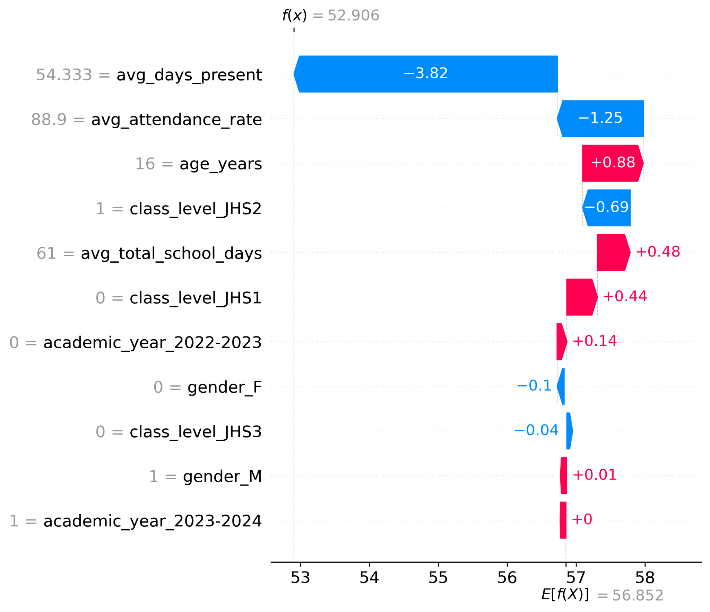
Figure 4.5. Local SHAP waterfall explanation for selected at-risk Case 2 (actual score = 43.44; predicted score = 58.33).
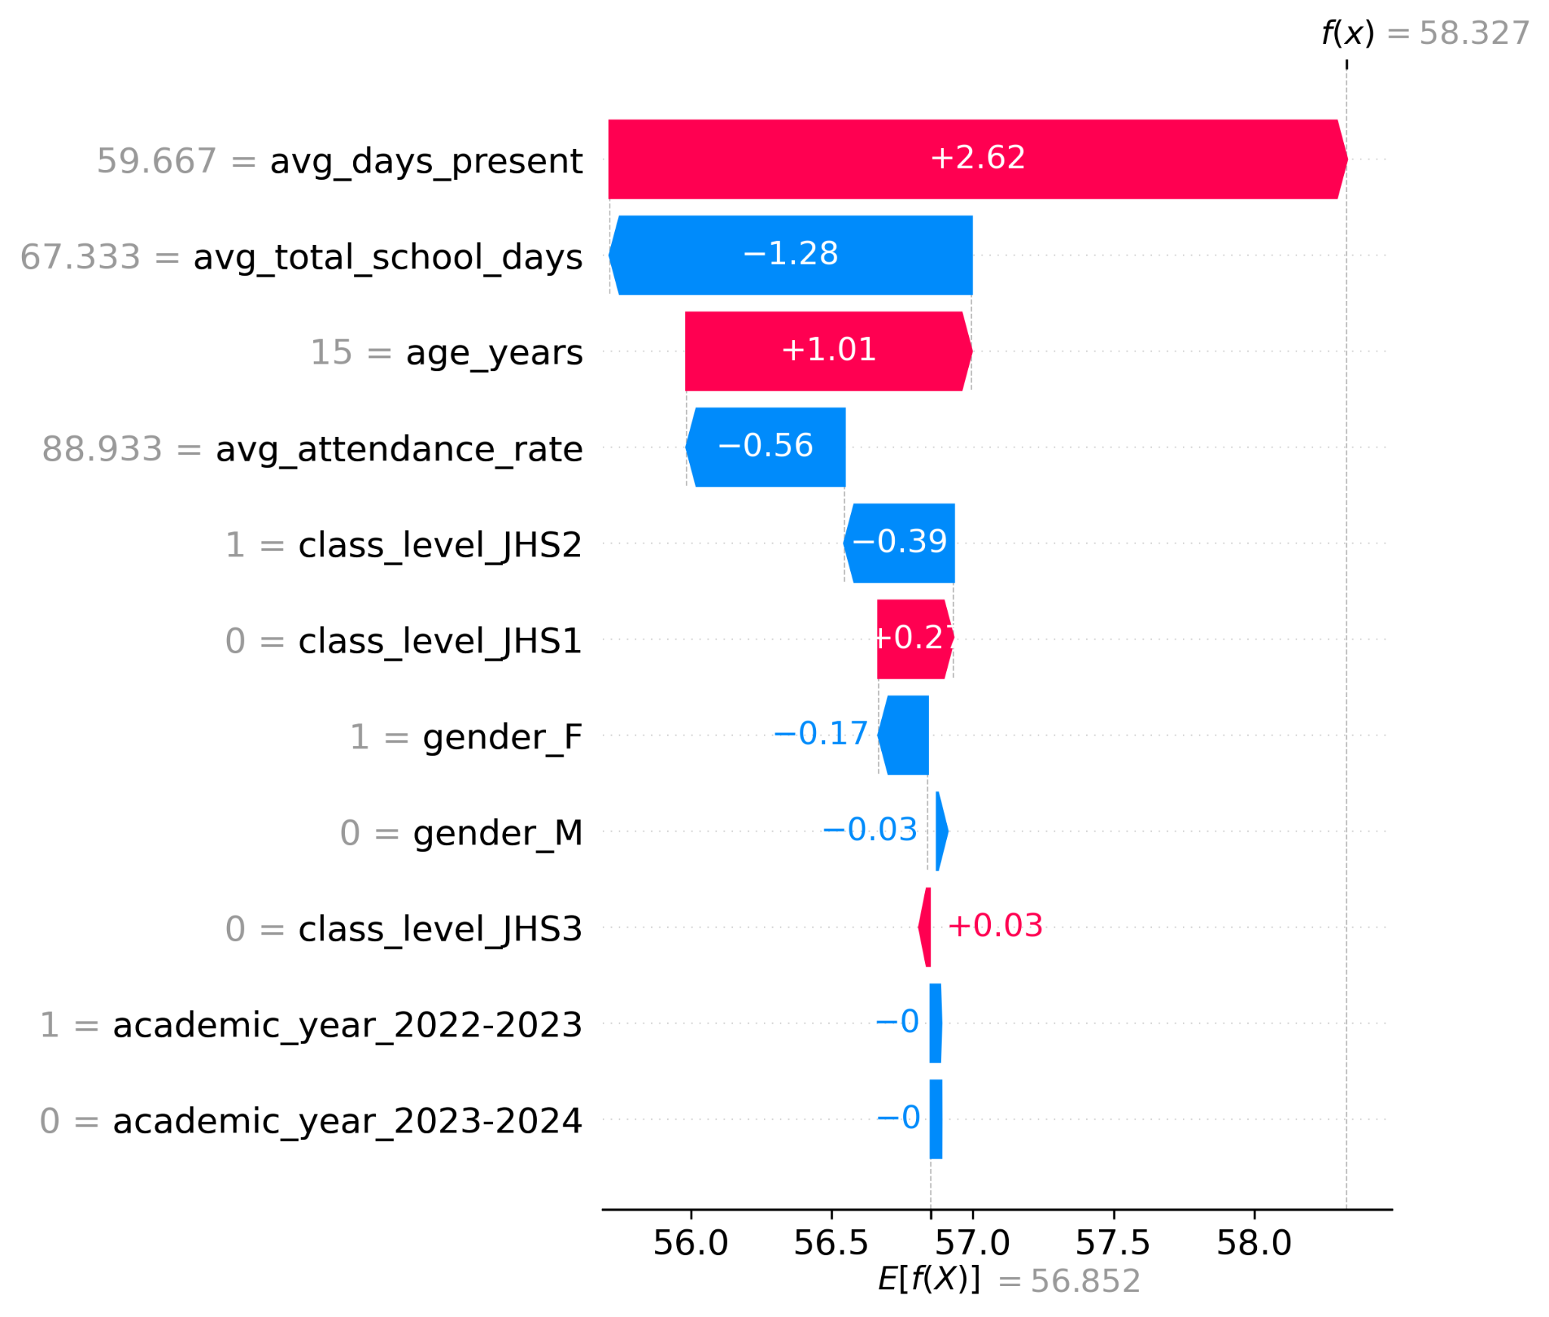
Figure 4.4. Local SHAP waterfall explanation for selected at-risk Case 1 (actual score = 28.69; predicted score = 42.49).
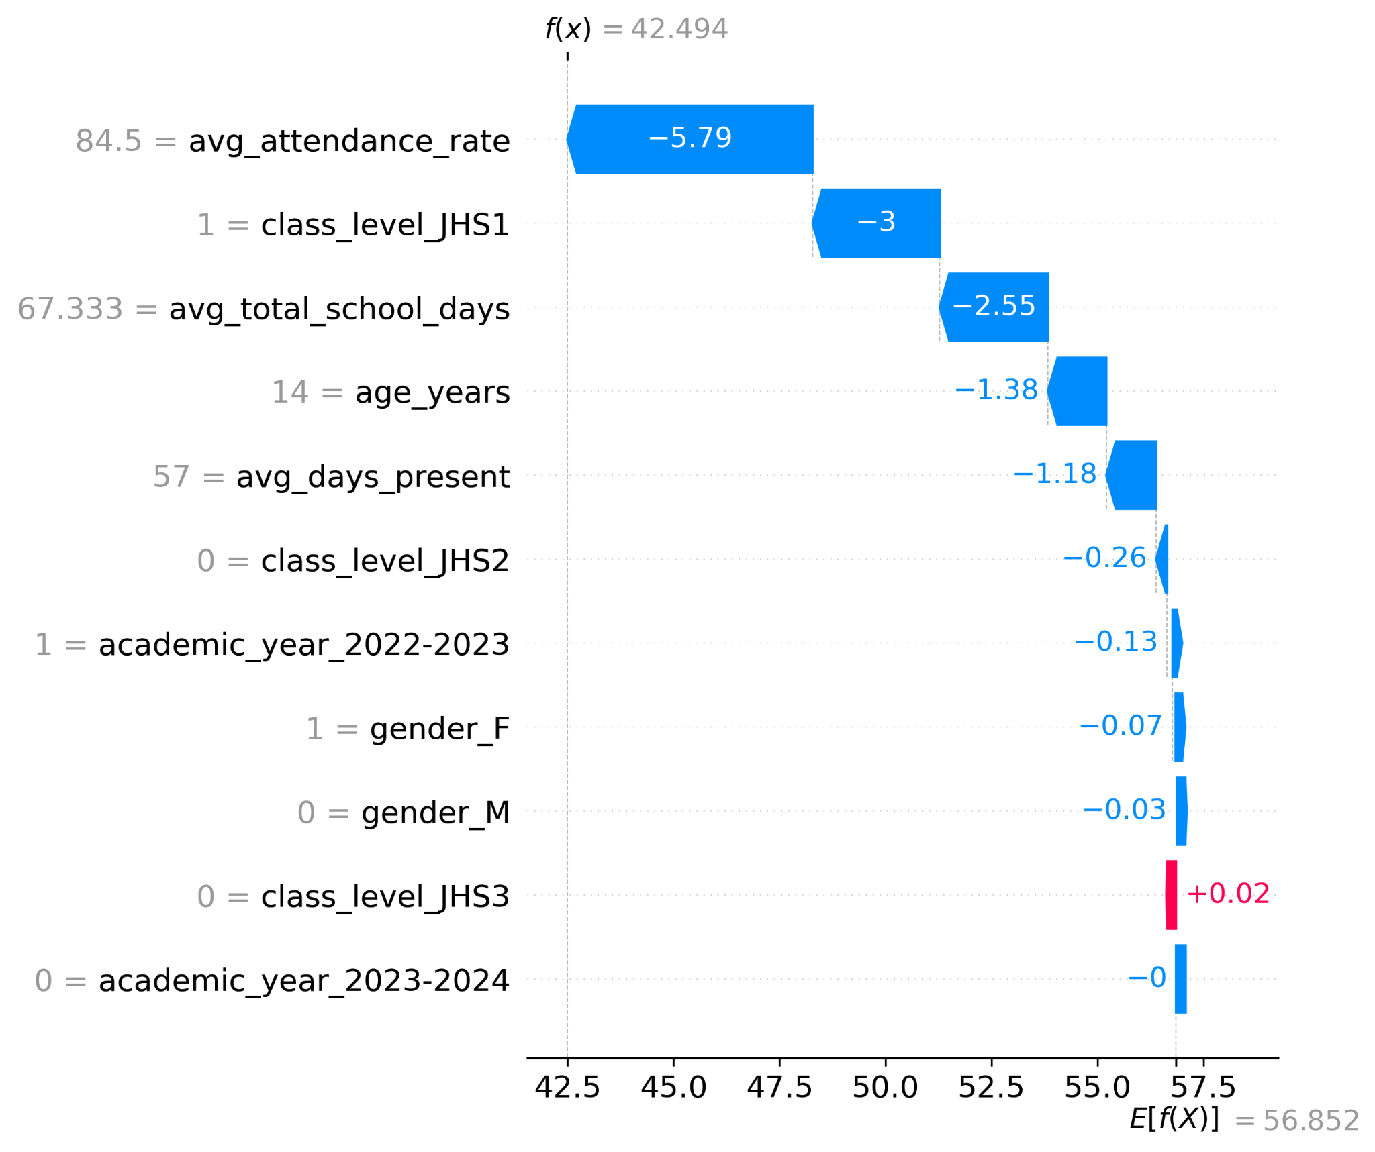
The local explanations demonstrate case-level variation in predictor contributions. Case 1 had the largest negative contribution from avg_attendance_rate, together with negative contributions from class level, total school days, age and days present, resulting in a predicted score of 42.49. Case 2 illustrates a notable prediction–observation discrepancy: the actual score was 43.44, while the model predicted 58.33; avg_days_present and age contributed positively, whereas avg_total_school_days and avg_attendance_rate contributed negatively. Case 3 was close to the operational risk threshold, with an actual score of 49.56 and a predicted score of 52.91. These examples demonstrate how SHAP decomposes individual predictions and can reveal both supporting and opposing feature contributions.

4.7 Error Analysis (Confusion Matrix / Per-Class Metrics)
Error analysis was conducted for the secondary at-risk classification task using subgroup and per-class performance measures. The class-level results showed different levels of accuracy, precision, TPR and FPR across JHS1, JHS2 and JHS3.
Table 4.7. At-risk classification performance by JHS class level.
Class | n | Accuracy | Precision | TPR | FPR | Macro-F1
JHS1 | 36 | 0.8056 | 0.8000 | 0.7500 | 0.1500 | 0.8017
JHS2 | 71 | 0.7887 | 0.7143 | 0.4762 | 0.0800 | 0.7156
JHS3 | 53 | 1.0000 | N/A | N/A | 0.0000 | N/A

JHS1 recorded TPR = 0.7500, while JHS2 recorded TPR = 0.4762. JHS3 recorded accuracy = 1.0000, but its precision, TPR and Macro-F1 were not estimable because the test subset contained no actual at-risk JHS3 cases. Accordingly, the JHS3 accuracy value should not be interpreted as evidence of perfect positive-class performance.
Table 4.8. Class-level performance gaps.
Metric | Maximum group | Minimum group | Gap
Accuracy | JHS3 | JHS2 | 0.2113
Precision | JHS1 | JHS2 | 0.0857
TPR / Recall | JHS1 | JHS2 | 0.2738
FPR | JHS1 | JHS3 | 0.1500
Macro-F1 | JHS1 | JHS2 | 0.0861

4.8 Computational Efficiency and Scalability
The experiments were executed using CPU-based computation on the study laptop with 24 GB RAM and Python 3.10. No GPU was required. The principal regression experiment used 640 training observations and 160 held-out test observations, while the classification experiment used 512 training, 128 validation and 160 test observations.
Exact wall-clock training time, inference time and memory-footprint measurements were not captured in the completed result logs. Therefore, unsupported numerical claims about computational speed or memory efficiency are not made in this chapter. The present result establishes that the completed experiments were executable on the stated CPU-based environment without requiring a GPU.

4.9 Required Figures and Tables Checklist
Table 4.9. Chapter 4 figures and tables completion checklist.
Item | Required content | Status
Figure 4.1 | Cross-validation stability / Macro-F1 distribution | Insert final generated figure
Figure 4.2 | Global SHAP feature-importance plot | Insert final generated figure
Figure 4.3 | SHAP beeswarm summary | Insert final generated figure
Figures 4.4–4.6 | Three local SHAP waterfall plots | Insert final generated figures
Figure 4.7 | Normalized confusion matrix | Insert final generated figure
Table 4.1 | Descriptive statistics | Included
Table 4.2 | Main model performance | Included
Table 4.3 | Ensemble weight comparison | Included
Table 4.4 | Ablation comparison | Included
Table 4.5 | Statistical significance test | Included
Table 4.6 | SHAP feature importance | Included
Table 4.7 | Per-class error analysis | Included
Table 4.8 | Class-level gaps | Included

Before final submission, the generated figures should be inserted at the indicated locations and checked against the final saved analysis outputs. Figure numbering should remain consistent with the thesis-wide numbering scheme.

4.10 Supervisor Verification Checklist
Table 4.10. Supervisor verification checklist.
Verification item | Current result / status
Final analytical sample | 800 student-year records
At-risk target | 186 positive; 614 negative
Promotion_status as target | Excluded because all 800 records were promoted
Principal regression split | 640 training; 160 held-out test
Classification allocation | 512 training; 128 validation; 160 test
Cross-validation | 5 folds × 5 seeds = 25 paired observations
Random state for principal split | 42
Best held-out regression model | 50:50 XGBoost–LightGBM ensemble
Best held-out regression results | MAE 4.9530; RMSE 6.0893; R² 0.6137
Wilcoxon result | W = 114; p = 0.304
Effect size | Cohen's d = 0.194
SHAP analysis | XGBoost component; held-out observations
Top SHAP feature | avg_attendance_rate
Second SHAP feature | attendance_decay
Fairness interpretation | Observed subgroup differences; no unsupported certification
JHS3 positive-class metrics | Not estimable because no actual at-risk JHS3 test cases
Computational timing | Not captured; no unsupported timing claims

Code and reproducibility repository: https://github.com/generalh018-a11y/Ghana_JHS_Academic_Performance
Chapter 4 Summary. The results show that the XGBoost–LightGBM ensemble achieved the strongest held-out regression performance among the evaluated regression models. The attendance-decay representation produced the largest numerical change in the controlled classification ablation, while the repeated cross-validation comparison did not demonstrate statistically significant Macro-F1 superiority (p = 0.304). SHAP analysis ranked attendance-related variables most prominently, and subgroup analysis identified measurable differences across gender and class level. These findings provide the empirical basis for the interpretation and implications developed in the subsequent chapter.

