Flash CO2 Controller PCBA

Download the ESP flash download tool
The ESP flash download tool can be downloaded here:
https://docs.espressif.com/projects/esp-test-tools/en/latest/esp32/production_stage/tools/flash_download_tool.html
Save it in a location of your choice

Connect the ESP PROG to the PCBA
Establish a connection of the UART connector of the ESP PROG to the PCBA.
Connect the ESP PROG to the PC.

Copy the combined bin into the “bin” folder of the flash download tool
Make sure to copy the correct FW into the bin folder o the flash download tool

Open the flash download tool
Open the flash download tool and select “ESP-C2” and “Factory Mode”
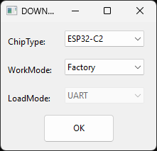

Uncheck “LockSettings”
You must uncheck “Lock Settings” in order to make changes to the settings.

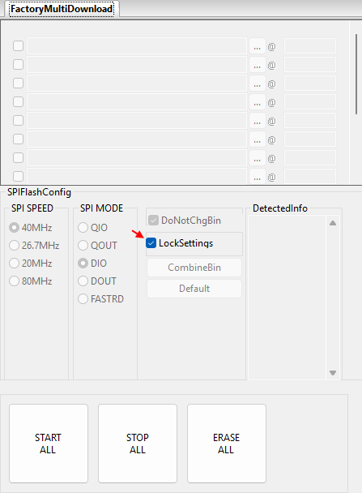

Select the FW
Klick on the three dots (1) and select the firmware you want to flash.
This is the firmware you copied into the bin folder of the flash download tool.
With the combined firmware you only need this file and no additional files.
Type 0x00 at the start address (2) to flash the firmware at the correct location.
Check the box (3) to select the firmware to be flashed.
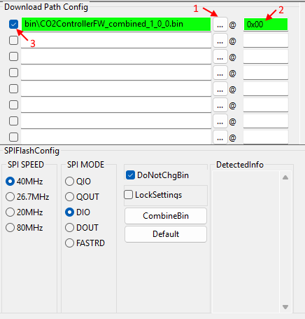

Lock the settings again
You can now lock the settings again to make sure no changes are made accidentally.
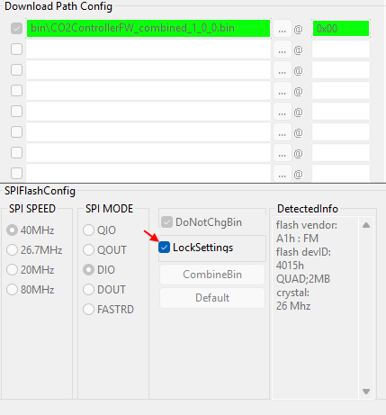

Select the COM Port
Select the correct COM Port to flash the device.
The ESP PROG tool has to COM Ports, please select the UART COM port which is usually the higher number of the two.
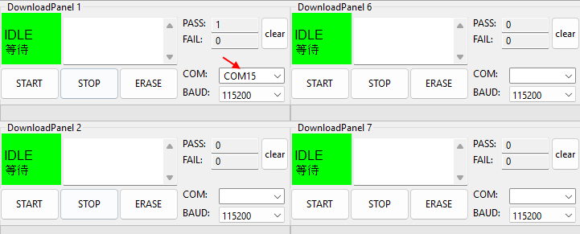
You can flash multiple device at once by using different panels

Start the flash progress
Klick Start to flash the device.
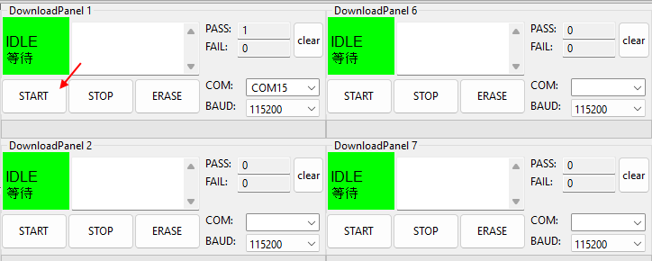
Wait until the flashing is done.
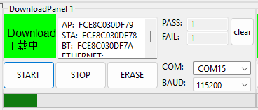
If correctly done the program will show “finish”
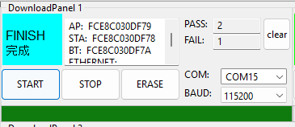

Start the factory setup
Note that the device will not start after flashing until the next reset.
Connect to the device with a terminal software of your choice.
The terminal software will initiate a reset of the device when connecting.
The firmware will now boot for the first time.
Before the factory configuration can start the firmware needs to finish a few processes
It will perform the following steps:
- Verify firmware signature
- Encrypt the flash content
The output of the console will be like shown in this log:
The flash encryption takes a few seconds. Wait until it is done.
When done you will see this message:
I (11291) flash_encrypt: Flash encryption completed
I (11298) boot: Resetting with flash encryption enabled...
After the initial start of the bootloader and after the flash encryption the factory configuration will start automatically.

Note:
- During the factory configuration the console output is always enabled.
- After the factory configuration the log output is disabled.
In case you would want to see the log output you need to restart the device and spam “b” during the bootloader phase
- After flashing the device once it is not possible to flash the device again, because the security keys inside the device cannot be changed anymore and cannot be readout.
Here is an example log of the console output until factory configuration.

