CONFIDENTIAL : INTERNAL USE ONLY
Travel Report: Brasil: Porto Alegre and Brasilia,
November 23-December 01 2008
Partner Visited: Igreja Episcopal Anglicanos do Brasil (IEAB)
Goals:
- To personally meet the Provincial leadership of IEAB, and be met, and begin to learn about the IEAB and Brasil;
- To discuss our respective different contexts , common interests and concerns for mission and justice, and the nature of partnership and mission in the Anglican Communion today;
- To identify ongoing and new areas of partnership collaboration, as possible within and beyond limited staffing and funding resources;
- To gather information specifically about Anglican Service for Diakonia, 2009 July CONFELÍDER gathering and IEAB General Synod; indigenous ministries and indigenous justice
Sunday, November 23 and Monday, November 24: Depart Toronto for San Paolo (10 hours 10 minutes) for transfer to domestic flight to Porto Alegre (1 hour 40 minutes). Allow at least 3 hours in transit in San Paolo to clear immigration, collect bags, await forwarding ticket at the TAM transit desk, and onward security clearance. Arrived Porto Alegre, met by The Rt. Rev. Orlando Santos Olivera, Bishop of Southern Diocese, and settled into Master Hotel, Av. Albert Bins, for a quiet evening and early night. Porto Alegre is 6 hours ahead of Vancouver (PDST), 3 hours ahead of Toronto (EDST)
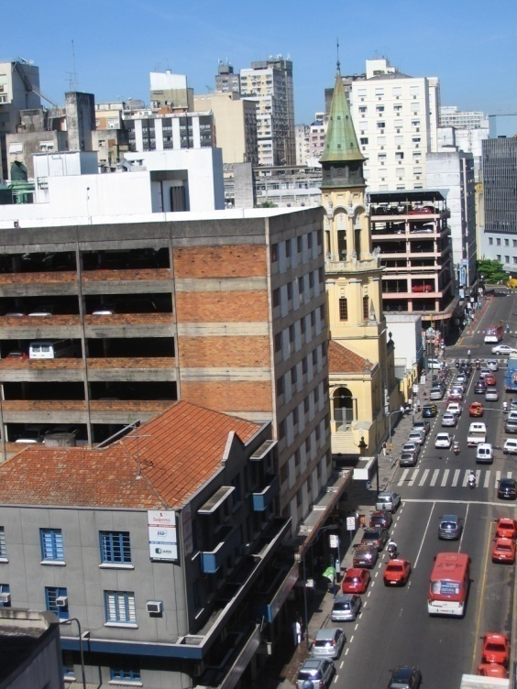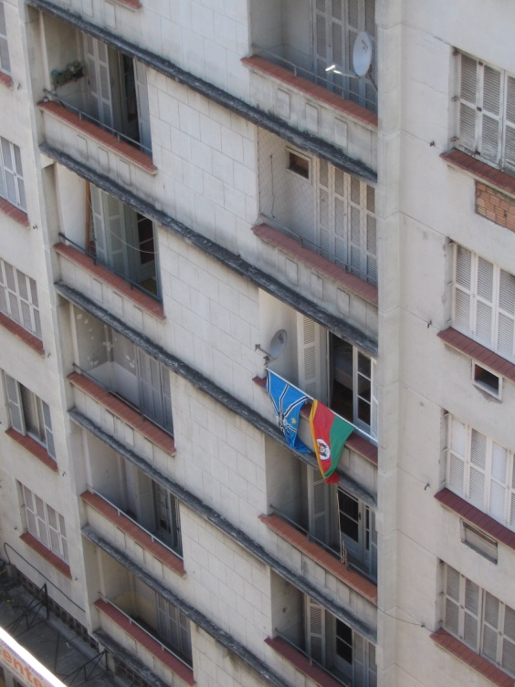
Tuesday, November 25: Seminario Teologico Dom Egmont Machado Krischke (SETEK), IEAB: The Rt. Rev. Luiz Prado, Dean of SETEK, welcomed me to the seminary, which is situated in the beautiful Provincial IEAB compound in Porto Alegre, historic home region of the Episcopal Church in Brasil. The compound is an oasis of bird and plant life, including huge palm and jacaranda trees now in bloom, bougainvilla, lime trees and hydrangea, many small birds and large insects.
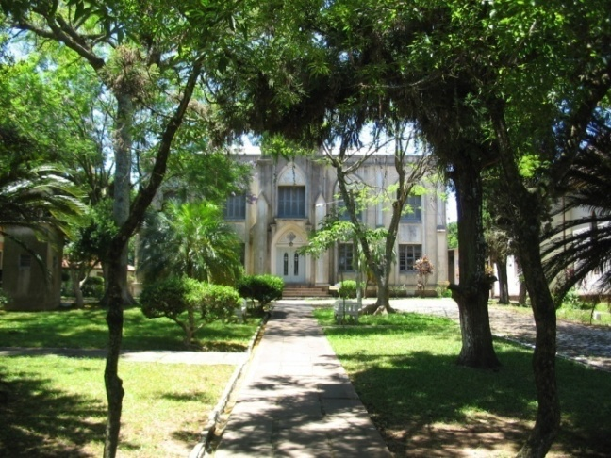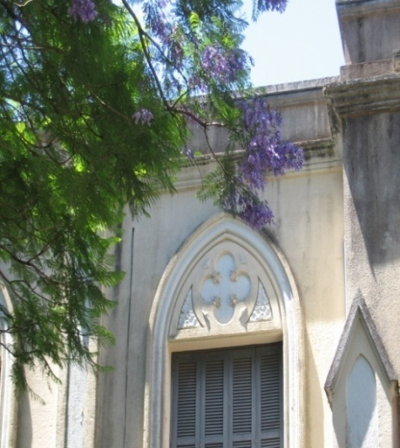
SETEK trains students for lay and ordained parish ministry, through residential and distance education. A 4 year residential Formation in Theology degree program toward ordination is offered both at SETEK in the south and the Seminario Anglicano Education Teologique(SAET), the regional seminary in Recife. Both seminaries also offer this program from over 5 years via distance education. At SETEK presently there are 4 residential and 20 distance students enrolled. SETEK historically has trained smaller numbers of students, in part because of limited financial capacity and physical infrastructure, and because the IEAB is not a large church.
In addition to formation for ordination studies, a 1 year immersion course in Anglicanism is offered to clergy from other denominations seeking to serve in IEAB parishes. A post graduate independent study is offered on an individual basis where student interest can be supported by available faculty expertise. SETEK is also currently developing its capacity for supporting the training of Portuguese-speaking Angola Anglicans, and has a long history of inclusion of Anglican students from the Diocese of Uruguay.
Among SETEK’s principal challenges are:
- lack of financial resources for covering the costs of annual operations, for development of the seminary’s physical plant, technology for better distance education, more paid faculty and funded research and publication; and
- lack of English language fluency among students and generally low levels of general liberal arts education upon entering seminary (a high school diploma is required).
SETEK strives to maintain a high level of academic and spiritual rigour, organizing daily classes within a discipline of community living and Anglo-Catholic spirituality centred in the Eucharist. Formation closely complies with the needs expressed by diocesan bishops for skilled and knowledgeable permanent deacons and priests. Students are also required to work in home dioceses in each year of study, to deepen understanding about local Anglican issues and ethos. These field placements are set up and supervised by a diocesan ministerial group.
At present, SETEK employs 3 fulltime people: Dom Luiz Prado, Dean; Dra. Vera Lucia Semoies Olivera, Director of Administration/Professor of Church History, and Katrina ____, Office Manager. All other faculty are volunteers, receiving enough stipend to cover costs. The whole faculty group is ecumenical, representing Roman Catholic, Lutheran and Presbyterian denominations.
Seminary infrastructure costs are covered from the budget of the Provincial Theological Education Board (PTEB). Investment and rental income is the core source of budget funds, derived from IEAB owned property in San Paulo, once the site of the national seminary, which in 1984 returned to Porto Alegre and in 1992 became regional seminaries in Porto Alegre and Recife. These funds however, have not kept pace with increased costs. Each diocese also receives an equal portion of PTEB funds for allocating to student fees, but again, costs exceed revenue. SETEK has operated with an annual deficit for a number of years, and expects 2008 will be the same.
SETEK is currently in relationship in name only with Curtison Seminary, Church of England, UK and seeking other companions. Initial conversations have taken place with the new dean of Virginia Theological Seminary, which shares a mission history with IEAB. SETEK would be pleased to connect with a Canadian seminary, which shares its values, and to develop deeper relationship with Partnerships through Global Relations and the Theological Student International Internships Program. Perhaps further conversation can take place between SETEK and the Montreal Diocesan College, in the context of current companionship between the Dioceses of Montreal and South Western. SETEK and the Southern Diocese (in which it is situated) would be pleased to host a Canadian intern in 2010, based for part of the time at the seminary and for part of the time in a local parish. Portuguese fluency would be a great asset for this intern, whereas Spanish would not. SETEK would also look for opportunities for IEAB students to visit Canada for cross-cultural learning and exposure.
Global Relations will consider how to financially support: SETEK’s scholarship fund, ship donations of vestments and theological books, support physical plant, distance education technology and faculty development, enable faculty exchanges, and will contact Canadian seminaries likewise interested in relationship and exchange.
The seminary’s matron is Ste. Evelyn Underhill: Adorar não é informar-se a respeito de Deus….A adoraçã o consiste no reconhecimento humilde do espírito humano diante da incomensurável glória de Deus” (Worshipping God is not only knowledge of God. Worship realizes the humble spirit of human beings before the immeasurable glory of God).
Bishop Prado, Doctora Vera Lucia Simones Olivera, Rev. Humberto Eugeinoe, and 6 students met informally with me for a time of questions and discussion, and to hear about the Anglican Church of Canada. Conversation acknowledged the long history of friendship and partnership between IEAB and Partners in Mission, and our common interests and challenges as a historic denomination in vast, secular countries where geography and post-modern culture shape the ways and focus of mission and ministry.
In the course of conversation with SETEK students and faculty on a range of issues, highlights included discussion of the following:
IEAB’s work with indigenous peoples is lightly coordinated at Provincial and diocesan levels, to connect and support indigenous peoples, largely in the central and east regions of Brasil, in advocacy on land issues and protection of traditional cultures. The Indigenous People of Brasil are, for the most part, neither Anglican nor Christian, and IEAB accepts this, though there are Indigenous Anglicans in the western and Amazon regions with particular pastoral needs also (reported on page 6).
IEAB is in solidarity with Indigenous Peoples groups in support of indigenous rights, spirit of life and ancestral law, and brings this solidarity into its role in Brazil’s ecumenical indigenous justice work via the National Council of Christian Churches Brazil (NCCCB) and CLAI. I spoke about the continuing emergence of Anglican Indigenous Peoples spirituality and church, in partnership with the Anglican Church of Canada, about the National Indigenous Bishop and proposed Province, and of launch of the Federal Government’s Truth and Reconciliation Commission.
Greater involvement of youth and young adults in IEAB was noted as a challenge for the church locally and nationally, though strong youth programs, ministries and vocations do exist in a number of parishes dioceses, especially in the south. Also noted was the challenge of involving elders, not present in the church in large numbers; churches are not filled to overflowing, and much more can be done to encourage church involvement among people of all ages: The old are not the church of the past, and the young are not the church of the future. We are all the church of the present.
Session with seminary students and faculty ended with a quick tour of the seminary classrooms and Chapel of Reconciliation, and lunch with Bishop Prado and Dra. Vera Lucia.
Holy Trinity Cathedral Women’s Board: Upon the invitation of Dra. Vera Lucia, I met the Cathedral Women’s Board, gathering for their monthly meeting and to finalize next Saturday’s Christmas Bazaar. I was given an opportunity to introduce the purpose of my visit, which was followed by an informal discussion of the Anglican churches in Brasil and Canada. The Dean of the Cathedral, The Very Rev. Marinez Santos and Bishop Orlando joined us for tea, following their meeting at the NCCCB.
Secretario Geral Rev. Conego Francisco de Assis da Silva, freshly returned with Primate Mauricio Andrade from USPG Partnership meetings in the UK, and his wife Talitha were my hosts for dinner. Before dinner we drove to the look off atop one of the city’s many hills, as the sun set on the city and Rio Gauiba.


Wednesday, November 25: IEAB Provincial Office: Day-long conversation with Secretario Geral Rev. Conego Francisco de Assis da Silva, reviewing the history of the IEAB, and of partnership between IEAB and ACofC over the past 25+ years. Also met the 3 other Provincial office staff responsible for Communications, Finance and Associate to the General Secretary. IEAB Provincial office is comprised of the top floor of a building it shares with SETEK, adjacent to the Church of the Ascension and MEEN House, an on-site hostel for visitors.
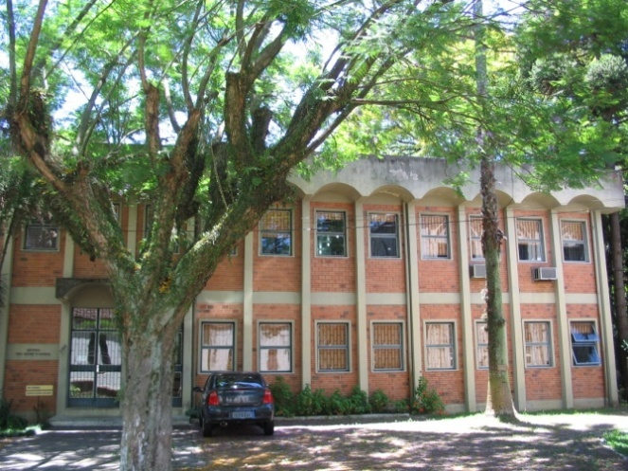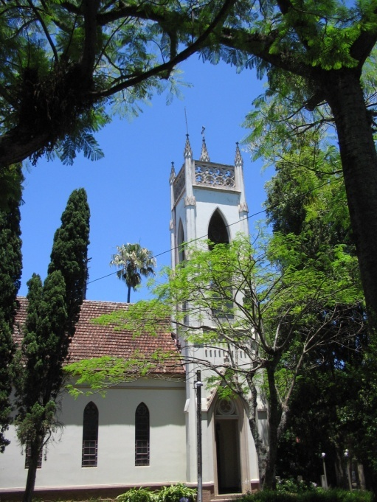
Following a period of ultra nationalism and military rule in Brasil between 1965 and 1980, Brasil and the IEAB emerged from isolationism, seeking to renew and establish relationships with the UK, USA and Canada. The centennial celebration of IEAB in 1990 was a significant moment in this process. Relationships were established not only to rebuild the church with monetary support, but also with Provinces and others of shared values.
Relationship with the ACofC was re-established at this time, and has deepened to the present through the work of the Rev. William Bland, missionary in northeast Belainge (sp) in the early 1980s, the offices of David Hamid and Philip Wadham, Partners in Mission Regional Coordinators, Ellie Johnson, Partnerships’ Director, and Jill Cruse, Volunteers in Mission Coordinator. Dom Glauco Soares, former IEAB Primate was an international partner to the Partners in Mission Committee, 1998-2001. A number of successful diocesan companionships between the dioceses of Ottawa and Pelotas, and Montreal and Southwest have added further depth to the churches’ relationship. In addition to people- to -people encounters, an annual Partnerships grant has historically supported Provincial programs in Communications, Women and Children, Youth, Ecumenical Relationships, and Mission.
In 2008, Partnerships’ Global Relations grant to IEAB (CDN$42,000) represents 15% of the Provincial budget, the largest grant from a single partner to Provincial programs. This grant and efforts to sustain funding levels through almost a decade of declining Partnerships’ resources is acknowledged with sincere thanks and appreciation. Other funds for Provincial programs and infrastructure come from the IEAB, USPG, and TEC. USPG and United Thank Offering also support diocesan projects. Partnership with ERD is emerging through the establishment of Serviço Anglicano de Diaconia (SAD). (See page 8) .
Despite financial support from within Brasil and from Episcopal and Anglican partners in Canada, USA and UK, IEAB is greatly challenged by lack of funds in its development and delivery of services to dioceses and parishes, and to the people of Brasil. It is a small, newer church in a vast country. In 2006 75% of Provincial staff positions were cut, resulting in the current 4 paid positions. Program areas and mandate however, have not been reduced, requiring a radical restructuring of Provincial service delivery and a move to volunteer national working groups in 3 regions determined by cultural and theological fit among clusters of dioceses. This restructuring is ongoing and showing early positive results. Internet communications technology is essential to the Province’s daily work and planning.
IEAB is very interested in COGS’ Governance Working Group as ACofC also revises historic structures and ways of working to enable and enhance the General Synod’s mission. Francisco is particularly interested in how General Synod programs are using new internet and information technology to create and develop volunteer networks and complete program responsibilities in a context of limited and decreasing funding. This technology is currently in use in IEAB Provincial program implementation ie. e-mail, internet conferencing, electronic dockets, and the exploration of web portals.
IEAB is also seeking more substantial financial support for its Provincial operations from TEC’s global partnerships program. TEC’s annual grant for many years has remained at USD$20,000. This is a relatively small grant in comparison to TEC’s contribution to other former Provincial IX mission jurisdictions and now autonomous Latin American Provinces, such as Mexico which is similar in size to IEAB and has historically received a grant of USD$600,000. IEAB’s is not asking for the same grant, but does question why the huge disparity by what criteria. It is currently working with Episcopal American friends to establish a more formal Friends group to lobby for IEAB’s more substantive inclusion in TEC’s partnerships program, having been advised this is the only way to catch TEC’s attention. Unfortunately, TEC’s Latin America Coordinator has recently been terminated from his position and the future of this position is unknown. The coordinator was very much liked and appreciated by IEAB for his commitment to relationship and mission. IEAB received no formal communication from TEC regarding interim or future contacts (neither did we), and is uncertain with what is happening in TEC’s national partnerships program. This change and lack of communication is worrisome. IEAB is planning to invite the new Director of TEC national Partnerships Centre to its General Synod in 2009, and will attend General Convention, June 2009.
IEAB’s Provincial mission priorities include:
- Missionary demands in the west and Amazon regions, among Indigenous Anglicans, where now there are 2 parishes, 2 clergy and 5 mission areas. Anglicans are asking for congregational planting and pastoral supply. This work would be supported from a Provincial Mission Fund yet to be established. A request to TEC earlier this year for USD$60,000 to start the fund has not been answered;
- Serviçio Anglicano de Diaconia (see page 8) ;
- Re-establishment of the Diocese of Recife;
- Lay leadership training with emphasis on Anglicanism, ethos and identity;
- Growth in responsible stewardship of gifts, talents and resources;
- Provincial restructuring toward more flexible, responsive effective systems for delivering Provincial programs.
Francisco would very much like to visit the General Synod offices in Toronto in 2009, to meet national program directors and staff, and learn how we are: i) responding to the need for systems reorganization and new models of service delivery, and ii) using communications and information technology to continue service delivery with fewer resources (staff and funding). He is also interested in meeting Brazilian Anglicans and other Portuguese speaking Anglicans in Canada. He hopes to attend the ACC meeting in Jamaica in May, so could come to Toronto either before or after that meeting. He will attend the TEC General Convention in June 2009 and IEAB will hold their General Convention in July 2009. I will follow up with Michael Pollesel and others, hoping Francisco’s participation in Jamaica will be confirmed as a way of offsetting costs.
Other points:
- Dioceses of Amazon, Recife, and Meridional (Southern) are seeking companionships with dioceses in the Communion. A Canadian companionship would be very welcome.
- Discussion about support for Fr. Ariel Irrazabal, Uruguay, to serve as priest in the Diocese of Recife pending meeting with Primate Mauricio and Fransisco in Brasilia, and more information from Bishop Sebastian, Recife.
- No further discussion of the proposal of Bishop Jubal Pereira Neves, Sul Occidental, to send a clergy couple to the Diocese of Toronto for further theological study and work within St. Sebastion congregation, Toronto.
- Of the @160 clergy within IEAB nationally, 33 are women and 50 are permanent deacons.

Thursday, November 27: A morning of trip report writing and informal conversation about SETEK with Dom Prado, Vera Lucia and Humberto. Afternoon departure for Brasilia, arriving early evening amidst rain and cool weather. Attended Service of Thanksgiving (a national secular holiday) at the Cathedral of the Resurrection, Diocese of Brasilia, with reception following. Met Sandra Andrade, and Mara Manzoni Luz and Mark Storms, 2 IEAB resource people for the weekend SAD event. Sandra Andrade, spouse of Primate Mauricio, is Chair of the Servico Anglicano de Diaconia Commission, and Mara is the Director of Christian Aid UK for Brasil and PWRDF Latin America and Caribbean regional partner.

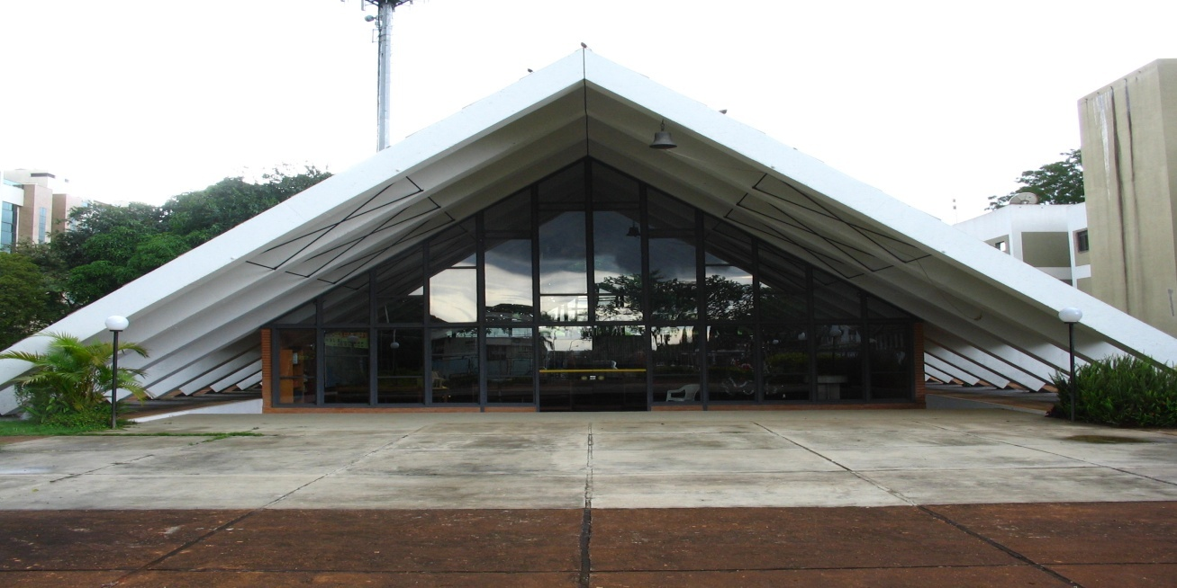

Friday, November 28-30: Serviço Anglicano de Diaconia Consultation: Brasilia Region
The national IEAB Servico Anglicano de Diaconia (SAD) Commission led the 3rd of 3 regional data gathering consultations in Brasilia, with representatives from the Dioceses of Brazil, Recife, and Amazon, and western missionary district. The General Secretary and representatives from USPG and Partnerships also participated. Partners were invited to bring greetings and present information on home contexts as relevant. Regional representatives included 8 men and women of different ages, ethnicities and races involved in diocesan and/or parish diaconia. The series of consultations are the result of a Consulta Nacional de Diaconia Social, organized by IEAB and Episcopal Relief and Development (ERD), September 2007, which determined the importance of identifying and articulating the extent and impact of diaconia within the IEAB. The record of the national consultation was sent to every parish in the Province.
2008 regional consultations have enabled the SAD Commission and all who provide local diaconia, with opportunities to meet, share information, learn, draw encouragement, build networks within and beyond the church, throughout the country and globally. Conversations towards something like SAD had taken place since 1988. Since 2002, where diaconia featured strongly in a Confélider on Mission and Spirituality, and attempts were made to develop contacts in every diocese and parish, the church’s diaconia has grown.
With almost no financial resources to gather people nationally, or to plan consultations through face-to-face meetings, all preparation for the consultations has taken place via web-based communications and document tools. Likewise, SAD has developed a passport access web-based data bank (actually 4 integrated data banks) for recording and sharing information about the many different IEAB diocesan and parish diaconia programs. A great map of what is happening across the length and breadth of the country is being created. SAD’s working definition of diaconia is any activity by a parish or diocese which, without prosyletizing, “responds to human need in local communities with loving service” (4th Mark of Mission). Those living with the realities of the need addressed are centrally included in the development of activities and services. On-line read-only access to this data bank: www.ieab.org.bz/sad with Google Translator to a language of choice is scheduled for February 2009.
In addition to identifying and discussing programs throughout the country, an equally important goal of each consultation has been to gather regional diaconia leaders for a time of community building and skills training in data bank participation.
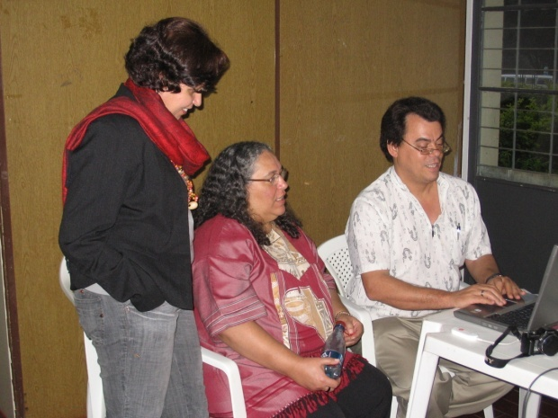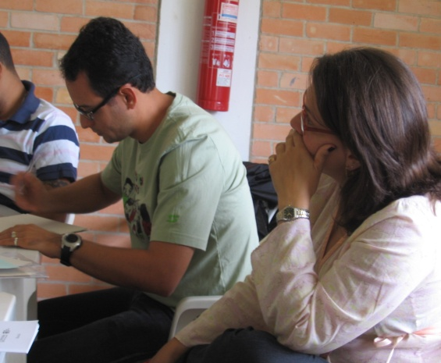
IEAB hopes to initiate a formal relationship between SAD and ERD, so that capacity for diaconia will develop. ERD conversation with local diaconia leadership and funding for programs and projects will take place through the Provincial SAD structure.
Challenges in the delivery of services and programs in Brasil include: great distances between communities, insufficient funding, different indigenous traditions, access barriers for people living with disabilities, low motivation to become involved, need for skills training especially in program planning, need to articulate the church’s pastoral and theological perspectives ie. diaconia is the mission of the church; plethora of NGOs, some small and poorly focused, interested primarily in receiving funding; impression within international development and church community that Brasil is a developed, smoothly running country.
It is hoped that the next General Synod will endorse the formation of regional diaconia councils to carry on the work of the SAD commission ie. Enabling diaconia throughout the church by providing orientation and accompaniment in program methodology, mapping diaconia throughout the country, informing partners, articulating theology and missiology.
Training and information sharing throughout the two days included sessions on methodology in developing, implementing, monitoring and evaluating diaconia programs, on the soon-to-be-launched data bank of existing programs – a very exciting tool! – and sessions for describing current diaconia efforts in each of the 3 dioceses and one missionary district represented. Information from the methodology and data bank sessions is available from Global Relations.
Examples of diaconia included: Play/day centres for children otherwise used to traffic drugs; crèche programs as more and more parents work outside the home; pastoral counselling and solidarity for LGBT rights; pastoral care, counselling and advocacy with people living with HIV and Aids; jewellery and lace making projects with women to generate income and build confidence, skills; day centres serving food, fellowship, music, links to social support services; health clinics using traditional medicine; seed banks; computer banks, helping college students have access to laptops and internet, and variations on drop-in/day centres with different community groups.
Participants greatly appreciated the SAD consultation for providing: opportunity to meet and feel more connected to one another personally, and to the mission of the church; time to identify, compare, discuss local programs in their differences, commonalities and challenges; training on the data bank and methodology for developing good diaconia programs.
The consultation ended with Sunday worship with the parish of the Cathedral of the Resurrection.



Provincial IEAB and Partnerships: The Most Rev. Mauricio Andrade, Archbishop, and CG Francisco de Assis de Silva
Archbishop Mauricio re-iterated sincere thanks for many years of partnership in mission and for efforts to maintain historic levels of funding support for Provincial programs. Warm greetings were conveyed to Primate Fred. +Mauricio spoke seriously about the need for strong relationships between IEAB, TEC and the Anglican Church of Canada, and of hopes for increased personal contacts, conversations, consultations on mission and justice in the Americas. +Mauricio endorsed the possibility of a visit to Canada for Francisco in 2009, citing his own visit to Canada as General Secretary, for 3 weeks in 2002. Also endorsed as partnership priorities were:
- the re-establishment of the Diocese of Recife;
- diocesan companionships between Canadian and Brasilian dioceses;
- support for the multi-lingual Portuguese, Spanish and Italian ministry in the Diocese of Toronto;
- raising the profile of the IEAB through the Anglican Appeal and other prayer and educaiton resources with the Canadian Anglican church;
- financial assistance with Provincial infrastructure and programs
- prayer and financial support with litigation between the IEAB and former Diocese of Recife, Bishop Robinson Cavalcante.

+Mauricio invited me to attend the next IEAB General Synod, July 21-26 2009, and the pre-Synod CONFELÍDER, a 2 day gathering of the church’s leaders to discuss new vision and mission of the IEAB. +Mauricio will end his term as Archbishop at the 2009 Synod.
Note: Begin conversation with Henriette re: invitation of international partners to our next General Synod in 2010. Strongly suggest an invitation to the next Archbishop of the IEAB, and to the General Secretary. Check when a Brazilian partner last attended as invited partner.
Sunday, November 30 – Monday, December 01: Overnight flight from Brasilia to San Paulo to Toronto (10 hours).

Summary: This first visit with the Provincial leadership of the IEAB was an excellent opportunity to meet the Anglican Brasilian church in several locations, engaged in ministries of theological education, diaconia, and central administration. Hospitality was warm and generous, and I look forward to reciprocating, such as hosting General Secretary Francisco de Assis de Silva next year for a time of learning and exposure to the Anglican Church of Canada.
IEAB greatly values its partnership with the Anglican Church of Canada, through diocesan companionships, Volunteers in Mission, staff to staff relationships, and annual grants. IEAB hopes historic relationship will not only continue, but deepen, with us and all Anglican churches in the Americas.
Noted as specific ways in which relationship between IEAB and the Anglican Church of Canada can deepen:
- Sharing the news and mission of the IEAB through Canadian national and diocesan media, and appeal campaigns, such as the Anglican Appeal;
- Encouraging diocesan companionships between Canadian dioceses and the Dioceses of Amazon, Recife, Meriodonal, and the western missionary district;
- Enabling mutual exchanges of theological students, and in 2010, send a Canadian Anglican student to the Diocese of Meriodonal and SETEK for a summer internship;
- Enabling mutual exchanges of information, faculty, publications between Canadian and Brasilian Anglican seminaries;
- Enabling mutual exchange of visits by church leaders: IEAB General Secretary in May 2009 to Canada for learning and exposure, Partnerships represenation at IEAB CONFELIDER and General Synod, July 2009, IEAB partner participation at our General Synod June 2010.
- Prayer and financial support for the mission priorities of the IEAB, including re-establishment of the Diocese of Recife, strengthening of diaconia in every diocese and parish, and strengthening of theological education by extension through acquisition of better communications technologies;
- Participation in mission gatherings of the Anglican churches of the Americas towards stronger representation of the Americas’ mission, ecclesiology, theology within the Anglican Communion.

Respectfully submitted,

Andrea Mann
Global Relations Coordinator, Partnerships
02 December 2008

