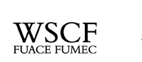
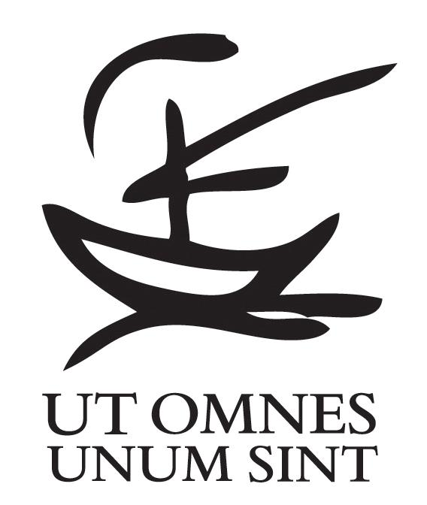

Geneva, July 31, 2009

REPORT about the attack on Christian Churches in IRAQ
In a carefully calculated terrorist attack on Sunday, July 12th, seven (7) churches suffered bombardment by improvised explosive devices (IED), bombs, and cars loaded with explosives. The perpetrators planned these attacks to take place while the faithful celebrated the mass to maximize the pain they could inflict; eight people died and more than 32 people were injured.
The details of this attack are as follows:
On Sunday morning, two bombs hit St. Joseph Chaldean Church. In the afternoon between 1:30 – 2:00 PM/GMT several churches were attacked one after the other using IEDs and bombs: Holy Heart Chaldean Church, St. Petrus & Polus Syraic Orthodox Church, St. Guirguis Chaldean Church, and St. Matthew Syriac Orthodox Church.
Later that day, perpetrators attacked Virgin Mary Chaldean Church with a car bomb. On the next day, Monday, the Virgin Fatima Syriac Catholic Church, a church in Mosel (a city in the north of Iraq), was also targeted. As a result, the Iraqi Police deployed units to guard the churches.
These attacks were a repetition of the same scenario of targeting Iraqi Christians from time to time after the invasion of the country. As usual there is not any concrete reaction from the government, which is supposed to be responsible for security and is still incapable of preventing these attacks.
This incident renews the sting of Iraqi Christians’ bitter memory of similar attacks on their churches, their priests, and their church servants on August 1, 2004, when five churches were attacked by car bombs.
The acts of violence perpetrated on July 12th were carefully organized and planned, with the intention of spreading terror and panic amongst the Christians who are persevering in their churches. Christians in Iraq have received very little media attention, although it has been documented by the United Nations that they have disproportionately been the targets of violence and disproportionate exile since 2003.
The World Student Christian Federation calls upon all our friends and partners regionally and world-wide who believe in peace and justice to break the seal of silence regarding the attacks on the Christians in Iraq.

In God’s peace,
Mr. Horacio Mesones, Rev. Michael Wallace
Chairperson General Secretary

Litany for the Courageous Christians of Iraq
In prayerful response to the seven church bombings at mass time on July 12, 2009
One: Rock of all ages, we mourn the death and destruction afflicting the brave men, women, and children who have persevered in their faith as beacons of Your love and hope in the war-torn nation of Iraq.
Many: We remember in times past that the rock the builders rejected became the cornerstone. As Jesus stood with those who were suffering and afflicted, today we stand in solidarity with our sisters and brothers in all places of conflict, but particularly in Iraq.
One: St. Joseph Chaldean Church
Many: We join with you in prayer for God's restoration and justice.
One: Holy Heart Chaldean Church
Many: We join with you in prayer for God's restoration and justice.
One: St. Petrus & Polus Syriac Orthodox Church
Many: We join with you in prayer for God's restoration and justice.
One: St. Guirguis Chaldean Church
Many: We join with you in prayer for God's restoration and justice.
One: St. Matthew Syriac Orthodox Church
Many: We join with you in prayer for God's restoration and justice.
One: Virgin Mary Chaldean Church
Many: We join with you in prayer for God's restoration and justice.
One: Virgin Fatima Syriac Catholic Church
Many: We join with you in prayer for God's restoration and justice.
ALL: Joining together with Christians all over the world, we hope for peace, restoration and justice to prevail over the ways of violence and destruction. The rock that the builders rejected is now and forever will be the cornerstone! Buildings may crumble and lives may be lost, but the spirits of all who believe in the Source of all Life will never be crushed.
AMEN.

