
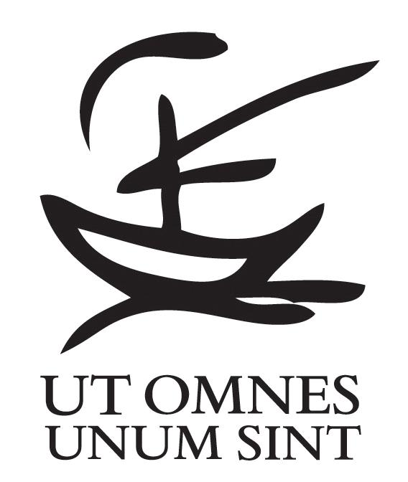

Geneva, July 31, 2009
Brothers and sisters of the Oikoumene International Community
Concerning the coup d’état in Honduras, the World Student Christian Federation (WSCF) recognizes that:

Less than a month ago, a civilian-military coup took place resulting in the overthrow of constitutionally elected President Manuel Zelaya.

We recognize that:

These actions threaten democracy, the established constitutional order, and human rights in Honduras.

The will of the people of Honduras is under direct attack.

Individual rights have been suppressed

The people have received misinformation by the media regarding the recent events.

Demonstrators from movements and organizations in disagreement with the coup and the de facto President Roberto Micheletti have been repressed, often with unreasonable and unmerited brutality and force that violate international norms.

In the Peace of the Lord, we express our solidarity to:

All men and women who experience direct attack on their individual and collective will and their citizenship rights, which have been perpetrated by the neo-liberal economic ideologies, the corporate-driven mass media, and military powers.

All brothers and sisters in faith communities and churches.

All brothers and sisters of the Honduras ecumenical movement, who struggle for a world in which the abundant blessings of our God benefit all, and not just a few.

The students, the flames of hope in our countries -- We hope that the Lord can illuminate and guide you.

To the United Nations, Organisation of American States and World Governments

While noting Resolution 63/301 of the UN General Assembly and ongoing regional efforts,
We are deeply dismayed by the breakdown of crisis negotiations in Costa Rica and call upon the UN, Organisation of American States and other inter-governmental bodies to redouble their efforts and act urgently in defence of the rule of law and the will and security of the people of Honduras.
In the WSCF:

We remain in prayer for all the Honduran people, who in this hour are calling for the restoration of power according to the people´s, will. We ask that the hope of our Lord our God accompanies your lives.

In God’s peace,

Mr. Horacio Mesones, Rev. Michael Wallace
Chairperson General Secretary

Background

On Sunday June 28th at 6 a.m. local time, an armed military command entered President Manuel Zelaya’s residency, kidnapping him together with his family. At first President Zelaya was put in prison in an air force base, and he was later deported to Costa Rica. In addition to Zelaya being forcibly exiled to Costa Rica, the Cuban and Venezuelan ambassadors were also taken hostage.

On the same day, a national referendum was called to install the National Constituent Assembly to reform the country’s Constitution. Part of the reason for the coup d’état was to prolong as well as maintain the neo-liberal agenda of the civilian military clique that installed Micheletti as the interim president.

On June 30th the UN General Assembly passed a resolution condemning the coup. The Organisation of American States gave Honduras’ interim government until July 4th to return President Zelaya to the presidency; hundreds of social movements and organizations rejected the coup and expressed their solidarity with the Honduran people. In the country, social activists called for pacifist demonstrations against the coup. On Sunday 5th of July, the military under the command of de facto President Roberto Micheletti suppressed the demonstrations supporting President Zelaya, with a result of two dead people and hundreds of injured. Honduran people’s civil and political rights were also violated with an imposed curfew nationwide and illegal detention.

Prayer
Let us think of the Honduran people, who look at the eyes of tyranny,
as they grapple with fear, betrayal, instability, anger and loss.

Let us pray and hope together with the Honduran people:

May God wipe away the weariness, uncertainty and feeling of loss in each heart
May the Honduran people find a common voice to denounce what is wrong and to call for a peaceful and just resolution to this situation
May the day of deliverance set forth for the meek and powerless
May all members of the body of Christ be in solidarity with the people of Honduras and speak and act on their behalf
May the builders of oppression be challenged by God’s preferential for the poor and oppressed
May the Liberating Spirit guide the overlooked and silenced, in search for hope, courage, justice and peace.

Amen

