R-11

Report to General Synod
The Primate’s World Relief and Development Fund

Introduction

The Primate’s World Relief and Development Fund is a response by Canadian Anglicans to the Gospel call to bear witness to God’s healing love in a broken world.

The following people served on the
PWRDF Committee 1996-1998

Stephen Toope
Chairperson,
Diocese of Montreal
Rosie Hyde
Diocese of Toronto
Stewart Payne
Diocese of Western Newfoundland
Warren Deacon
Diocese of Cariboo
Douglas Fenton
Diocese of New Westminster
Dirk Rinehart
Diocese of Kootenay
Philip Barnett
Diocese of Rupert’s Land
Marion Saunders
Armed Forces Ordinariate
Penelope Cummine
Diocese of Keewatin
Rod McDowell
Diocese of Niagara
James Merrett
Diocese of Quebec
Esther Wesley
Diocese of Moosonee
Monica McKay
Anglican Council of Indigenous Peoples
Jean Macliing
Philippines
Anivaldo Padilha
Brazil
Khumo Ntlha
South Africa

Inspired by the vision of a spirit filled community of hope, PWRDF walks together with partners in Canada and overseas to share in the creation of a more just and peaceful world.

In joy and struggle, the Primate’s Fund engages in development work, responds to emergencies, works to protect refugees and educates and advocates for change.

“Give Us a Thirst for Justice”

This phrase summed up the PWRDF Strategic Plan for 1996 to 1998. The plan identified five priority goals:
- deepen theological reflection
- strengthen partnerships with dioceses and parishes
- improve advocacy work on justice issues
- support community based development work
- undertake organizational development.

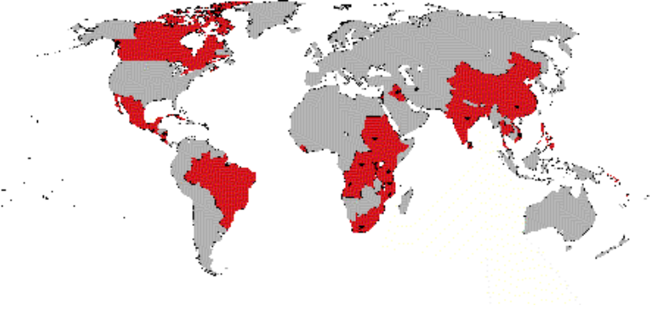
PWRDF responded to emergency and refugee situations in thirty four
countries and supported development work in twenty eight countries.
1). Partnerships with Dioceses and Parishes

Over the past triennium PWRDF has worked to strengthen partnerships with parishes and dioceses. The goal was to enable parishes to see the ministry of PWRDF as an extension of outreach beyond the borders of their parish. PWRDF undertook a number of initiatives.

The Offering Envelope Program invited parishes to include PWRDF in their parish stewardship programs by including twelve PWRDF envelopes in their regular offering boxes. Over 500 parishes are participating in this program and finding that both awareness of, and contributions to, PWRDF are increasing.

PWRDF made efforts to improve communications with parishes by encouraging the appointment of parish representatives for PWRDF and by distributing a newsletter entitled “Under the Sun”. There are PWRDF parish representatives in over 900 parishes and the newsletter has been well received across the country.

This network of volunteers is vital to the ministry of PWRDF. In addition to the parish representatives 40 individuals serve as diocesan or area PWRDF coordinators. There are 25 Diocesan Refugee Coordinators as well as the support provided to PWRDF by parish envelope secretaries and treasurers. These volunteers are the lifeline of PWRDF. The Refugee Coordinators met together in Vancouver in 1995. The PWRDF diocesan coordinators gathered for a national “Making the Connections” Conference in 1996. In 1997, the refugee and diocesan network coordinators met together regionally in St. John’s, Montreal, Winnipeg and at Sorrento in British Columbia.

While fundraising is important, the PWRDF takes seriously the mandate given to it in 1974 to implement a development education program for the Anglican Church of Canada. Each year PWRDF produced educational resources including resources for worship, a Sunday school and youth resource as well as adult bible study/learning kits. In 1996 PWRDF distributed resources focusing on the Philippines. In 1997 the educational theme focused on the ecumenical theme “In Solidarity with Uprooted People”.

Actions of advocacy or solidarity with partners overseas is an important way that Canadian Anglicans can express their partnership. Over the triennium PWRDF encouraged people in parishes to express their concerns about landmines, Cuba, Kenya, Asia Pacific Economic Cooperation (APEC), North Korea, the Sudan, the Head Tax on immigrants and refugees and the decrease in levels of Canadian Official Development Assistance.

PWRDF appointed a staff person as diocesan liaison for each diocese. As part of a pilot project to base staff regionally, a staff person was appointed to work more closely with the six dioceses in the ecclesiastical province of British Columbia and another person was appointed to work with the Diocese of Toronto.

In the Diocese of Huron, the Huron Hunger Fund continues to be the expression of PWRDF in the diocese and in the Diocese of Toronto, PWRDF became a partner in the FaithWorks campaign.
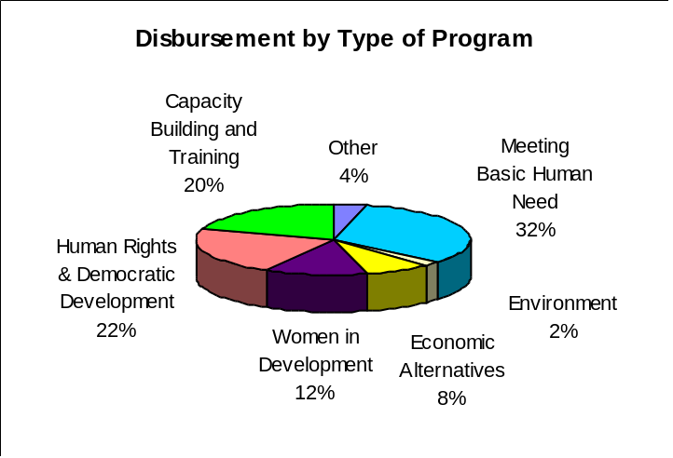
PWRDF Supported Emergency Response and Refugees in:
Angola
Kenya
Mozambique
Liberia
Malawi
Sierra Leone
Somalia
South Africa
Tanzania
Burundi
Rwanda
Zaire
Sudan
Palestine
Iraq
Iran
Costa Rica
Mexico
Cuba
Guatemala
Nicaragua
Montserrat
Burma
North Korea
India
China
Vietnam
Sri Lanka
Bangladesh
Thailand
Papua New Guinea
Chechnya
Albania
Canada

2). Response to Disasters and Refugees

Natural disasters and civil conflict mean that there are 17 million refugees and 24 million people uprooted from their homes and displaced within their countries. PWRDF continued to respond to their needs through support for emergency response and programs which respond to the needs of refugees. PWRDF response to emergencies is facilitated by Action by Churches Together (ACT) which was established in 1995 as a joint effort of the World Council of Churches (WCC) and Lutheran World Federation (LWF). PWRDF also provided support to strengthen prevention and disaster preparedness programs.

The African continent carries the heaviest burden of disasters and refugee producing conflicts. PWRDF continued to respond to the needs of refugees from Rwanda, Burundi and the Sudan as well as internally displaced people in Sierra Leone and Liberia.

In Latin America Guatemalan refugees returned from Mexico but conflicts in Colombia and Peru continue to produce internally displaced people.

In Asia, PWRDF supported refugee programs for Sri Lankan refugees in India and Burmese refugees in Thailand.

In Canada, the PWRDF Refugee network facilitated responses to refugees by Canadian Anglicans including the sponsorship of refugees to settle in Canada. For example parishes in the Diocese of Rupert’s Land sponsored a refugee family from Rwanda and the refugee network in the Diocese of Qu’Appelle raised funds to support this sponsorship. Another response to refugee concerns is to promote actions of solidarity with refugees. Over the last triennium, following a resolution at the 1995 General Synod, individuals wrote letters to the government expressing opposition to government regulations imposing a “Head Tax” of $975 on refugees.

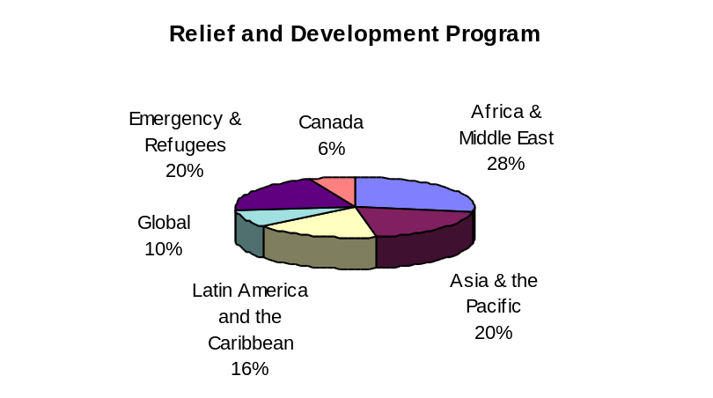
3). International Development

At the heart of the ministry of PWRDF are partnerships focused on promoting global peace and justice -- partnerships between people and communities in and within Canada and with people and communities overseas. PWRDF makes financial and human resources available to support the relief and development initiatives of partners, to strengthen these partnerships and to promote knowledgeable actions of solidarity and advocacy. PWRDF’s partners contribute their skills and capacities to the work they undertake in their communities and to PWRDF’s work in Canada.

3.1 Africa
PWRDF supported partners in:

Kenya
Uganda
Tanzania
South Africa
Mozambique
Burundi
Rwanda
Democratic Republic of Congo
Ethiopia
Sudan
Middle East

1994 was a year of great joy -- the elections in South Africa and tremendous tragedy -- the genocide in Rwanda. Since then, PWRDF has continued in partnership with organizations committed to peace-building. In South Africa the focus of efforts was on community peace building and healing of memories after years of communal and racial violence. In Rwanda and Burundi the focus was on repatriation and reconciliation efforts between Hutu and Tutsi ethnic groups. Support was provided to peace initiatives in Mozambique.

A constant component of the work in Africa has been to strengthen efforts to promote Gender and Development awareness. In East Africa two of the Anglican churches have developed Gender and Development Desks for their community development programs. The partners supported by PWRDF in the Sudan and in Ethiopia have also promoted Gender and Development in their programming.

Working in partnership means strengthening the capacity of partners to undertake development work. Resources from PWRDF have been used for training programs and staff development for many of our partners in Africa.

Much of PWRDF support went to the integrated community development programs of partners in Mozambique, Uganda, Tanzania, Kenya, the Democratic Republic of Congo, Ethiopia and the Sudan.

3.2 Asia and the Pacific
PWRDF supported partners in:

Bangladesh
Burma
India
Sri Lanka
Philippines
Hong Kong
Fiji
Solomon Islands
A critical struggle in Asia is the struggle about economic models. The Philippines and Sri Lanka considers themselves to be one of the Asian economic “Tigers” following the example of Korea and Malaysia but these economies have been showing signs of wear and tear. Job losses, devaluation of currencies and high inflation have all been part of efforts to salvage the model of newly industrialized countries (NICs). PWRDF and partners in the region have gathered around the meetings of APEC (Asia Pacific Economic Cooperation) held in Manila in 1996 and Vancouver in 1997. Their message has been that people, not markets, should dictate government policies.

New governments in both Sri Lanka and the Philippines were welcomed with optimism but over the years this has turned to disappointment. In Sri Lanka the civil conflict between Tamil and Sinhala populations has been waged on military fronts. PWRDF has supported partners’ efforts at peace and reconciliation as well as ongoing community development projects.

In the Philippines, PWRDF continues to work in partnership with the Philippines Advisory Group -- an expression of partnership in which PWRDF’s partners in the region gather to provide direction for PWRDF’s work in the Philippines and discuss how they might help PWRDF’s work in Canada. PWRDF financial support continues for community development work, innovative programs of disaster preparedness and social justice groups.

PWRDF continues to support work in Bangladesh and over the past triennium began to phase out support to programs in China, Burma and India in an effort to focus PWRDF attention and resources in a way that makes a difference rather than being spread too thin.

3.3 Latin America and the Caribbean

In the Latin American region most military governments have been replaced by civilian governments but the new governments have done little to improve the lives of the poorest of the population. In fact, in many ways, they are worse off. The globalization of economies and free trade has resulted in the poor become poorer and more marginalized. They are increasing distant from the decision-making processes that affect their lives. Mexico is a case in point where the gap between the rich and the poor is growing and violence in society has become endemic.
PWRDF supported partners in:

Brazil
Argentina
Peru
Cuba
El Salvador
Guatemala
Nicaragua
Mexico

In Central America, PWRDF has supported peace building initiatives in El Salvador and Guatemala as well as the efforts of partner organizations to develop sustainable alternatives in health care and income generation. Special attention has been given to programs supporting indigenous women, especially in Guatemala and Mexico where they are victims of multi layered violence.

A strong focus for PWRDF has been Brazil -- not one of the world’s poorest countries but a society in which the face of poverty is desperate indeed. Street children, indigenous people and poor rural women have all borne the burden of a society which favours the rich and the powerful. PWRDF’s partners have developed programs to reach out to the poor and the marginalized and strengthen their participation in society.

Due to the significant role played by Cuba’s Protestant churches in opening up new areas of community participation, PWRDF’s support to ecumenical partners in Cuba has become important for housing, health and agricultural programs.

3.4 Global

PWRDF has continued to support a number of global programs. Through the World Council of Churches and ecumenical coalitions such as Inter Church Action, PWRDF has supported programs in many parts of the world focusing on health and sustainable agriculture. PWRDF has also provided supported to south/south exchanges for information and learning through the Frontiers in Mission program. The Anglican Church’s participation in global campaigns such as the landmines campaign and the Fair TradeMark campaign have been supported through global grants.

3.5 Canada

An exciting development over the last triennium has been the strengthening of the Canadian program. This program has focused on strengthening community development initiatives in aboriginal communities across Canada. A full time staff person was appointed, and in 1997, the budget for work in Canada increased and criteria for PWRDF support have been developed.

Exciting work has begun in partnership with the Nuu-Chah-Nulth Economic Development Corporation in British Columbia in an international partnership with Maori in New Zealand and Miskito in Nicaragua developing joint ventures in fisheries and forestry. PWRDF has supported Nets’enelu 97 - a women’s artisan group in NWT - to develop an enterprise incorporating traditional handwork into fashion clothing design. PWRDF has promoted a partnership between the Six Nations International Development Agency and the First Nations Technical Institute to develop both a policy think-tank on aboriginal issues and a newsletter and electronic communications to share the learnings from the think-tank with indigenous and non-indigenous organizations in Canada.

