Instructor’s Guide for PIMA Indian PSA

Objectives:

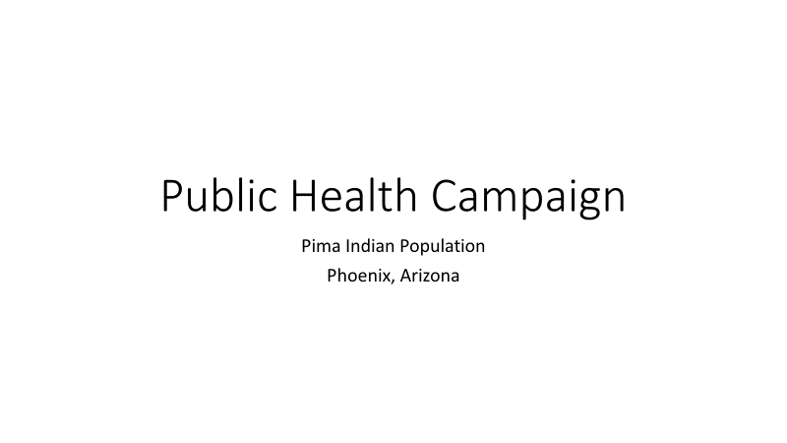

Public Health Campaign

Why are we doing this? What outcomes are we designing to?

What is the task at hand with what we have? – verify the working assumptions of demographics

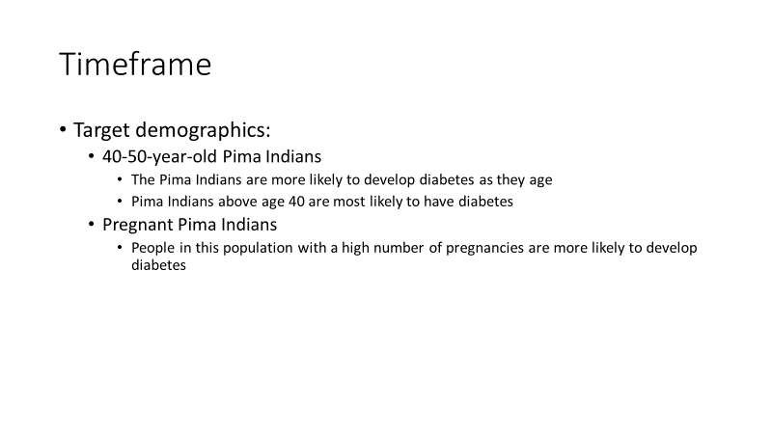

We have a dataset of real clinical measurements.

We are challenged with two clusters of the **target audience**. Maybe AGE & Pregnancy

What other groupings or conditions should we consider?

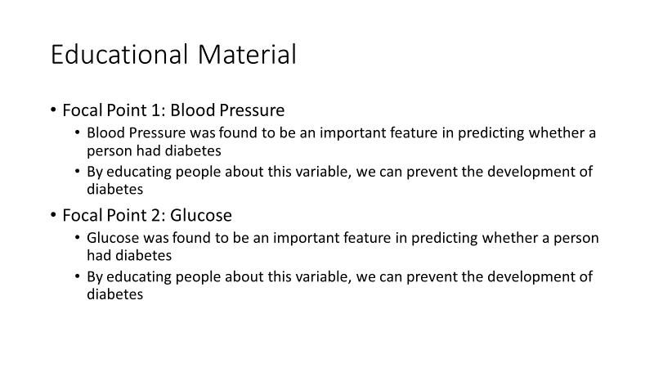

Messaging – we’d like to address clinical measurements before we suggest **call to action**

Here are two parameters (Glucose, BMI) of what we have on hand. Can you think of any others?

What materials should we develop?

>> Data Set

>> Who was examined? What data was collected?

>> EDA

>> Side lesson **Correlations**

>> Side lesson on **BMI**

>>Side lesson on **Diabetes Pedigree Function** => genes & family history

>> What can we predict DM based on the information in this dataset?

>> What model would be useful? Which features are most important to predict DM?

>>What are the limits of this model & assumptions?

Let’s go back to the assumptions and targets of our original Public Health Campaign

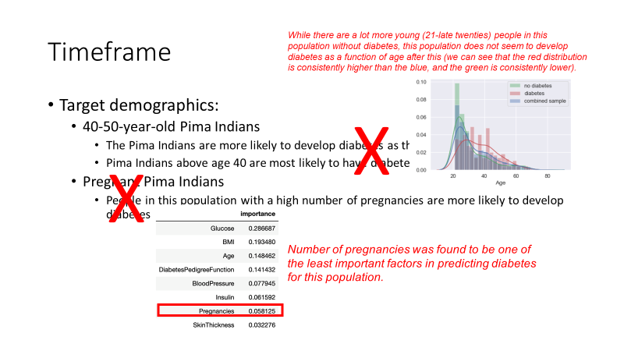

Student’s Guide – 60 over 3 sections

Day 1: 50 min

* Background on PIMA Indians
* Clinical measurements
* Introduce dataset – “features”
* **WORKSHEET**

Day 2: 50 min

* **Groupwork + Worksheet**
* Dataset in detail – BMI; DPF (history)
* Notebook + code + comments
  + Features, outliers/cleaning
  + Correlations – correlation matrix; v. causation
  + Glucose v. DM; BP v. DM scatterplots
  + Predictive modeling – logistic
    - Accuracy
    - limitations
  + Predictive modeling - decision tree
    - Accuracy
* **Design for PS Campaign**
  + Call to action – awareness, choices
  + By segment (AGE?)
  + Evidence-based, behavior-centered design
  + **Questions:**
    - **Use data to justify which BCD to choose**
    - **What could go wrong?**
    - **What is the ideal outcome?**

Day 3: 50 min

* Report out PS Design