Mediterranean Swordfish

Laurence Kell

21/07/2014

Dropbox/swo-med/analysis/tex

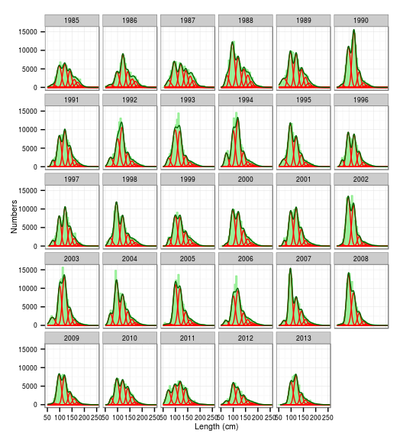 **Figure 1.** Length Frequencies with age modes (red) and total distributions (green) from the statistical estimation overlayed.

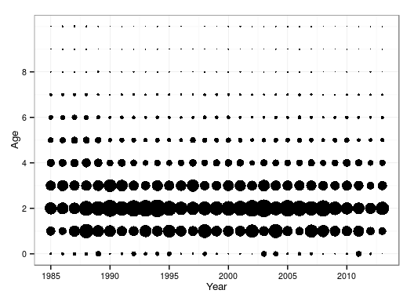 **Figure 2.** Deterministic numbers-at-age from age slicing procedure.

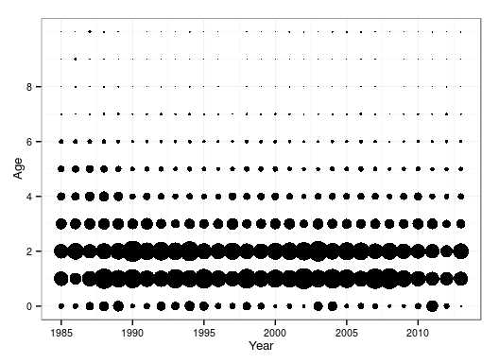 **Figure 3.** Statistical estimates of numbers-at-age from the mixture distribution analysis.

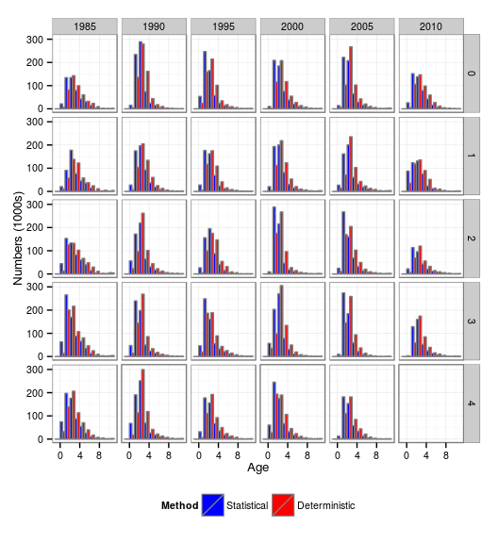 **Figure 4.** A comparison of catch numbers-at-age from the statistical and deterministic ageing procedures.

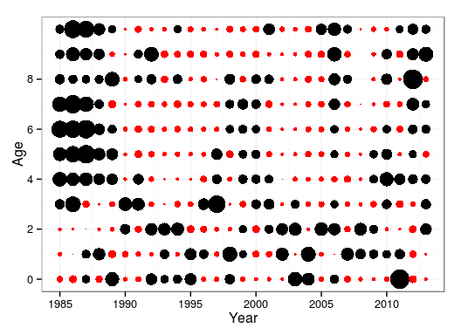 **Figure 5.** Standardised residuals of the proportion of numbers-at-age from the deterministic age slicing procedure (red negative and black positive residuals).

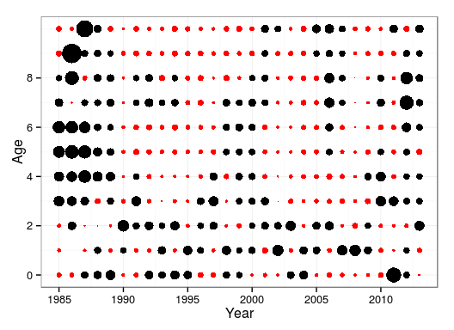 **Figure 6.** Standardised residuals for the proportion of numbers-at-age from the statistical mixture distribution analysis (red negative and black positive residuals).

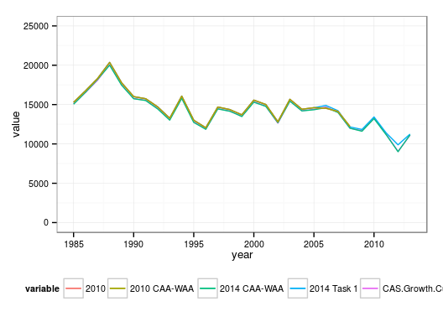 **Figure 7.** Comparison of total catch biomass derived from different procedures.

[1] 1.019

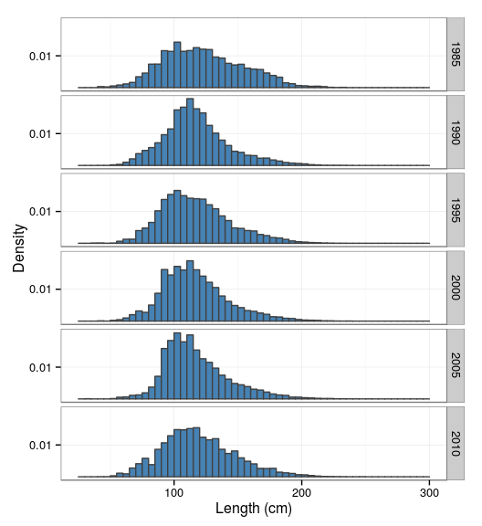 **Figure 8.** Catch-at-size by lustrum (5 year block).

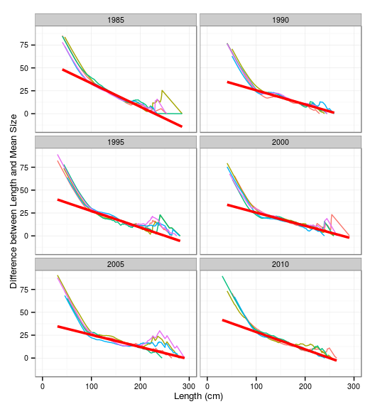 **Figure 9.** Powell-Wheatherall plots

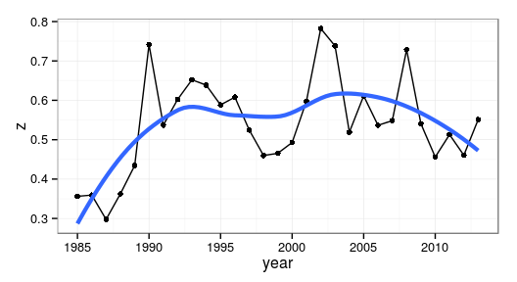 **Figure 10.** Estimates of Z derived from the Powell-Wetherall plots; showing the estimates from each year (black line with points) and a smoother (blue continuous line).

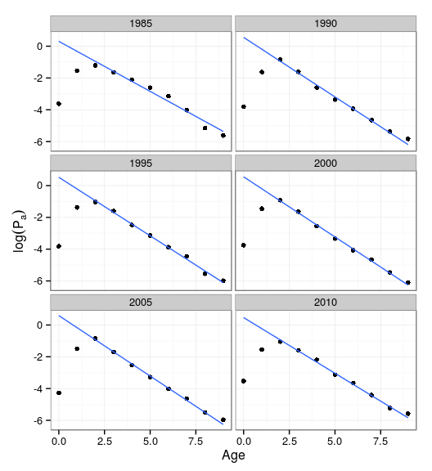 **Figure 11.** Catch curves by lustrum from statisical age estimates.

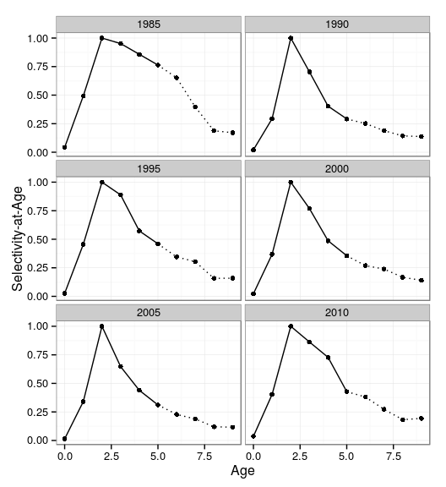 **Figure 12.** Estimated selectivity by lustrum.

## Selectivity by gear

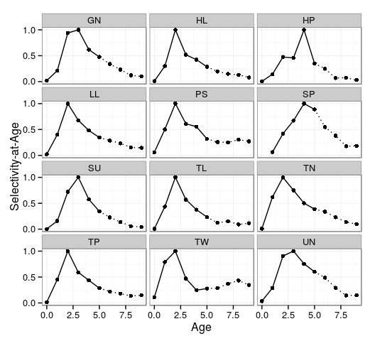 **Figure 13.** Catch curves by gear based on age estimates

## Selectivity by gear and lustrum

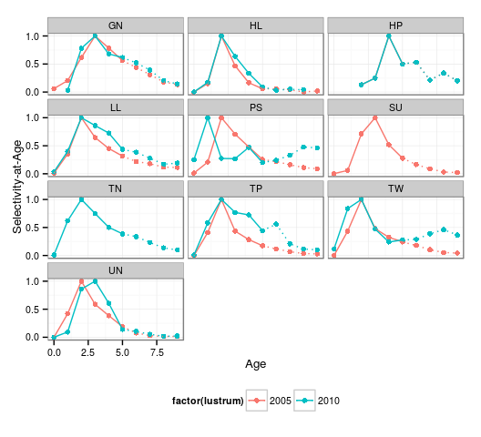 **Figure 14.** Catch curves by gear and lustrum based on statistical age estimates.

## XSA Continuity Run

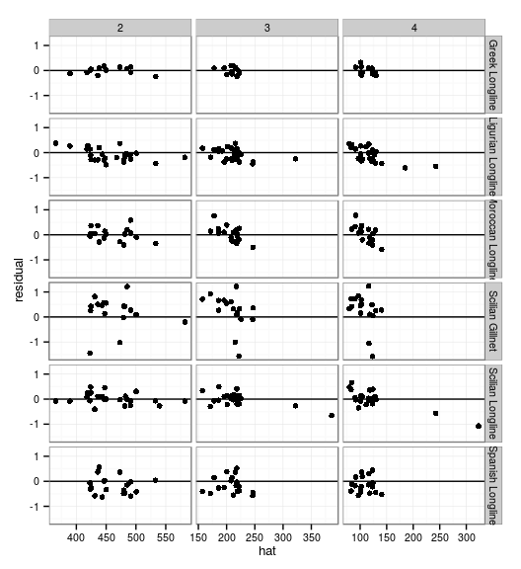 **Figure 15.** XSA diagnostics from continuity run; residuals against fitted value.

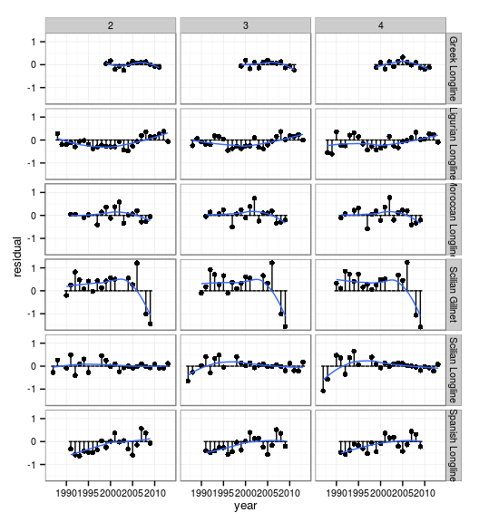 **Figure 16.** XSA diagnostics from continuity run; residuals against year.

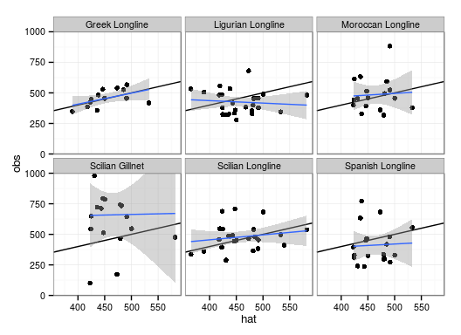 **Figure 17.** XSA diagnostics from continuity run; Calibration regression plots for age 2 (outlier for Scilian gillnet removed).

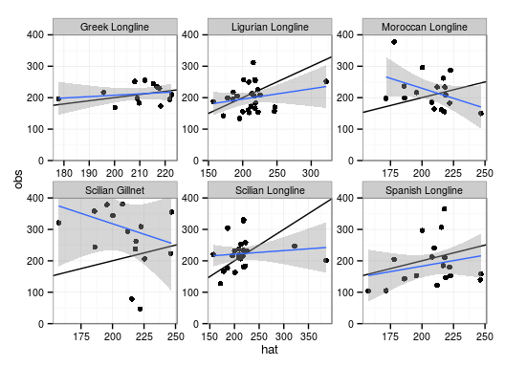 **Figure 18.** XSA diagnostics from continuity run; Calibration regression plots for age 3 (outlier for Scilian gillnet removed).

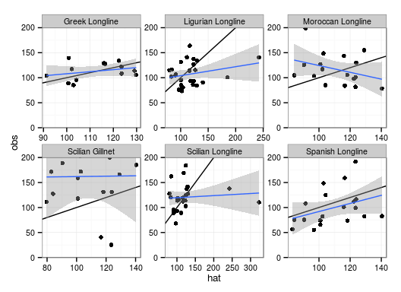 **Figure 19.** XSA diagnostics from continuity run; Calibration regression plots for age 4 (outlier for Scilian gillnet removed).

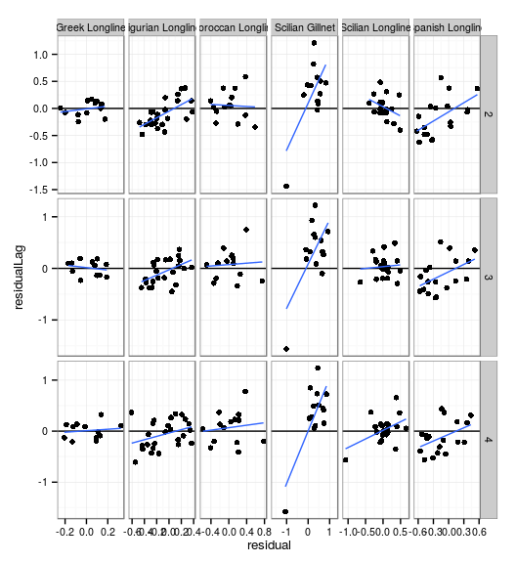 **Figure 20.** XSA diagnostics from continuity run; AR plots of lagged residuals

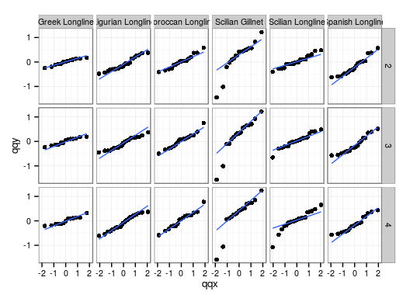 **Figure 21.** XSA diagnostics from continuity run; QQ plots to check for normality

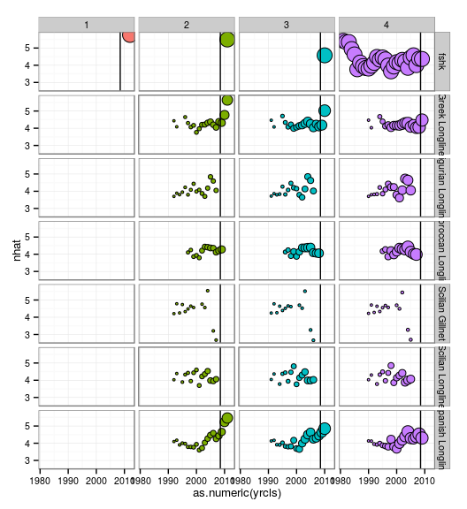 **Figure 22.** XSA diagnostics from continuity run; weights for terminal year Ns for each CPUE observation and shrinkage

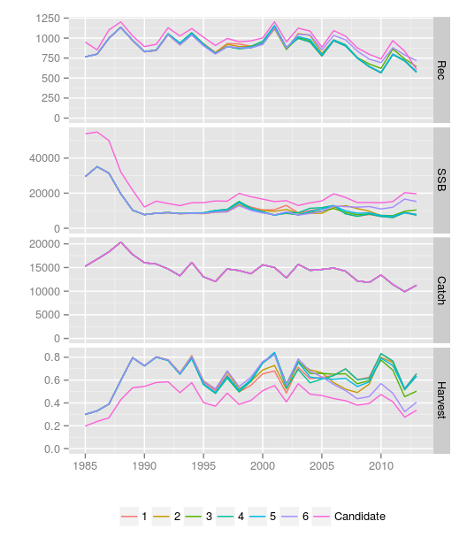 **Figure 23.** XSA time series estimates by CPUE series.

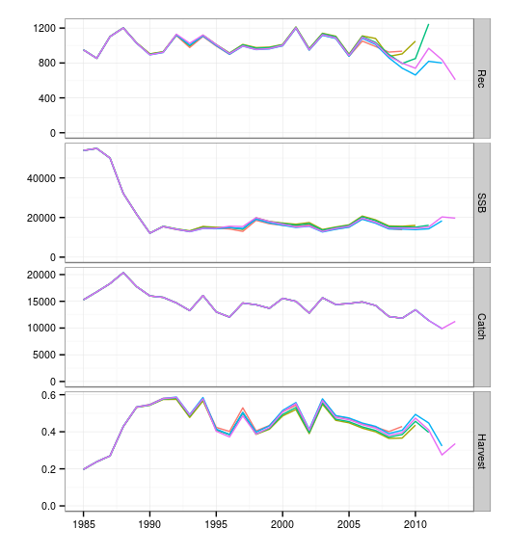 **Figure 24.** Retrospective XSA time series estimates.

## Alternative Run

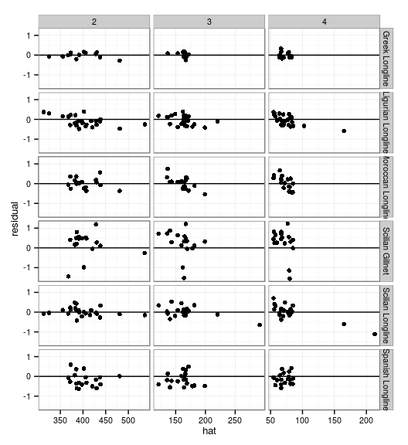 **Figure 25.** XSA diagnostics from alternative run; residuals against fitted value.

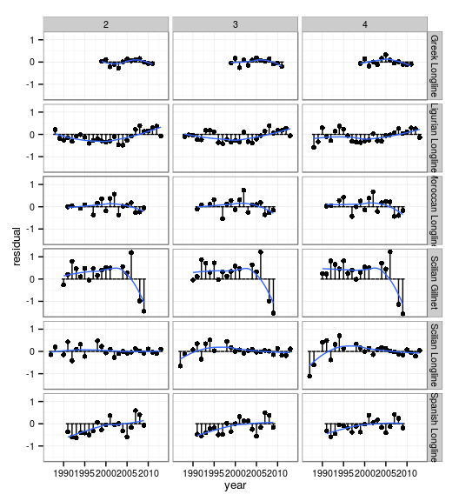 **Figure 26.** XSA diagnostics from from alternative run; residuals against year.

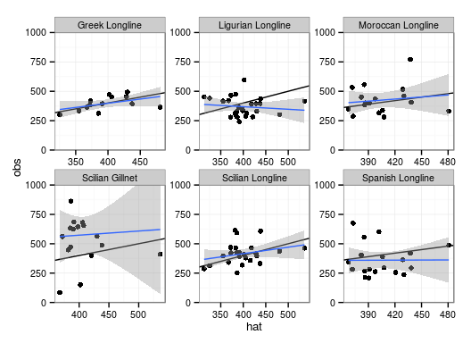 **Figure 27.** XSA diagnostics from from alternative run; Calibration regression plots for age 2.

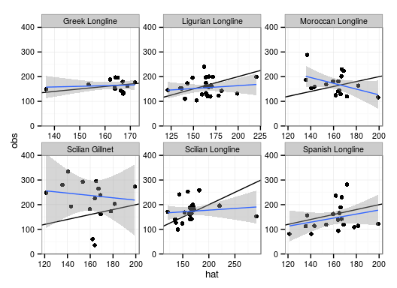 **Figure 28.** XSA diagnostics from alternative run; Calibration regression plots for age 3.

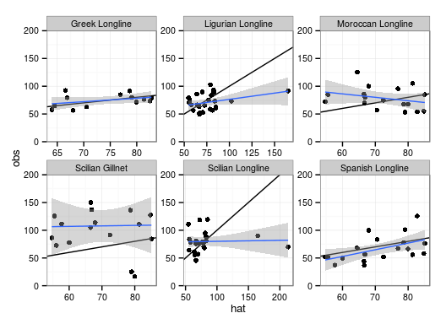 **Figure 29.** XSA diagnostics from alternative run; Calibration regression plots for age 4.

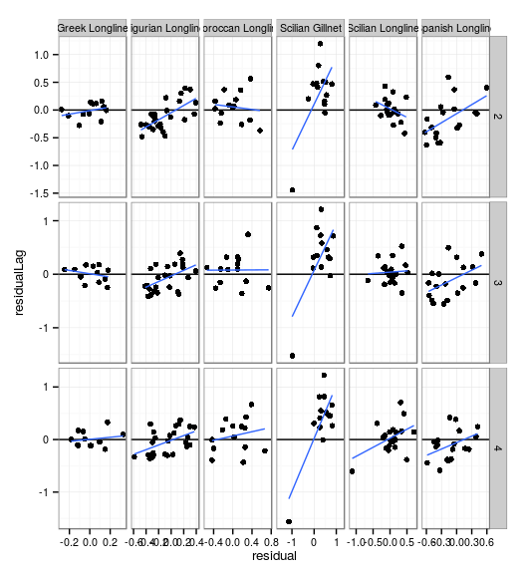 **Figure 30.** XSA diagnostics alternative run; AR plots of lagged residuals

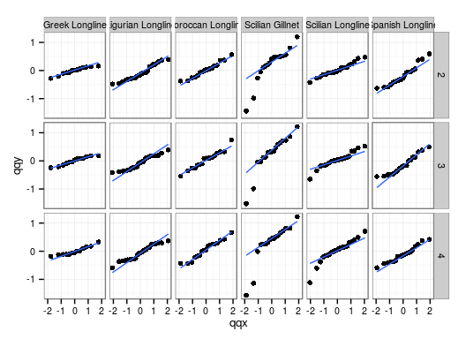 **Figure 31.** XSA diagnostics alternative run; QQ plots to check for normality

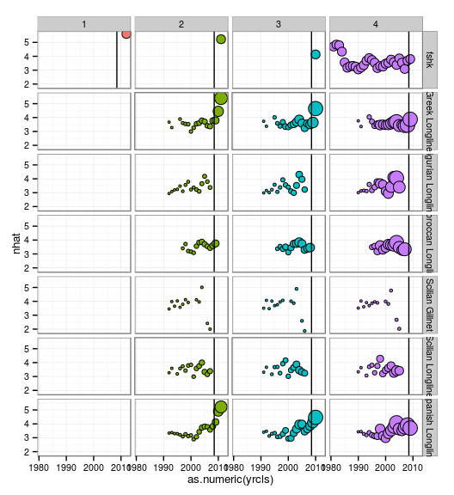 **Figure 32.** XSA diagnostics alternative run; weights for terminal year Ns for each CPUE observation and shrinkage

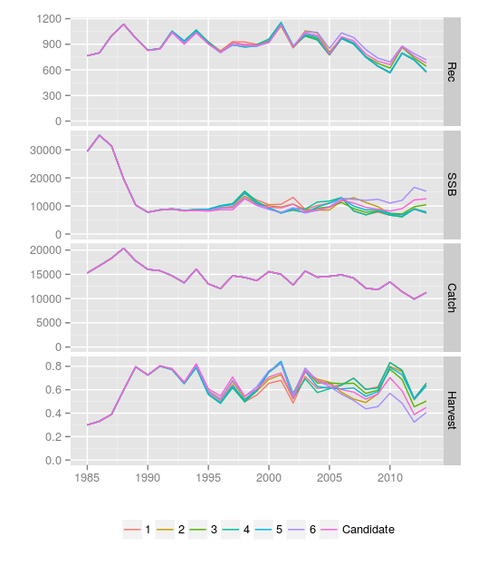 **Figure 33.** XSA time series estimates by CPUE series.

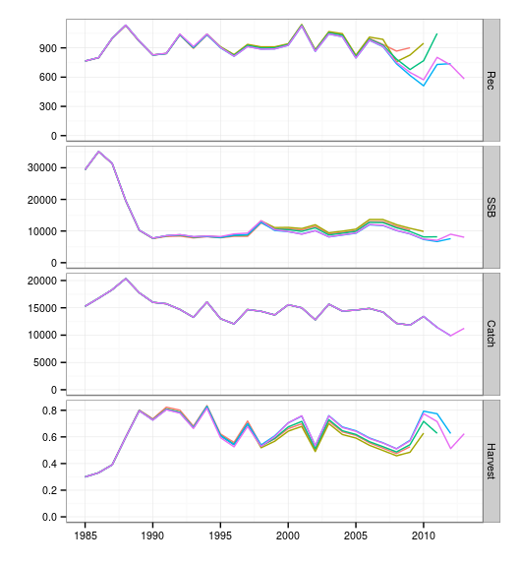 **Figure 34.** Retrospective XSA time series estimates.

## Stock Status

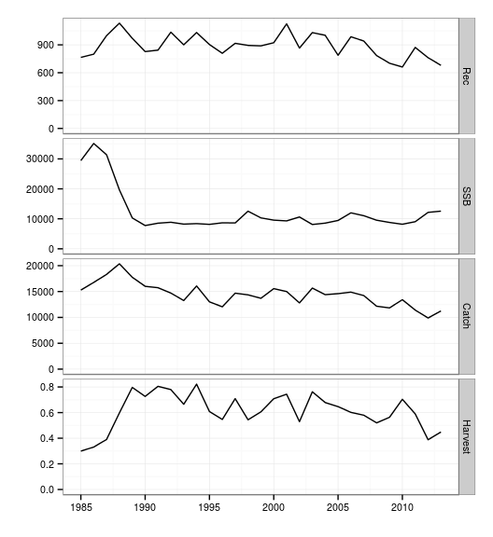 **Figure 35.** XSA alternative run.

## Stock Status

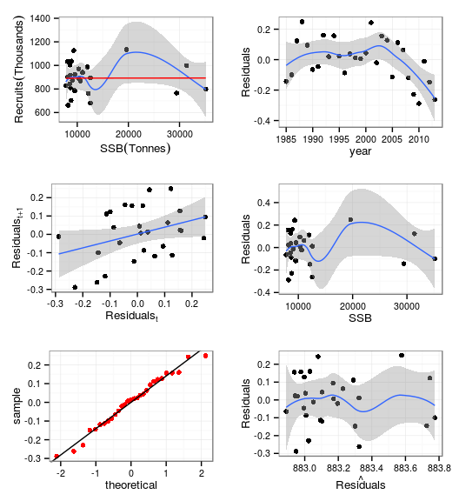 **Figure 36.** Stock Recruitment Relationship

[1] TRUE

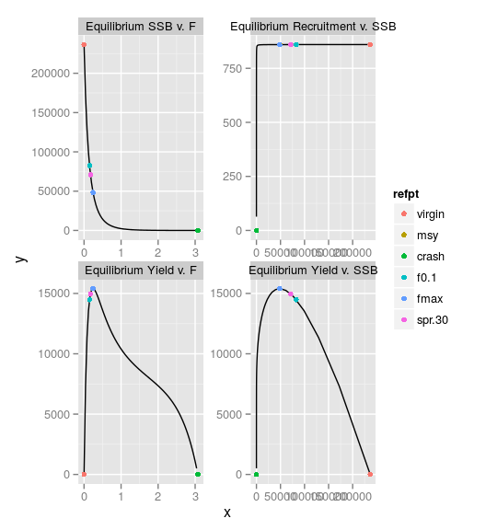 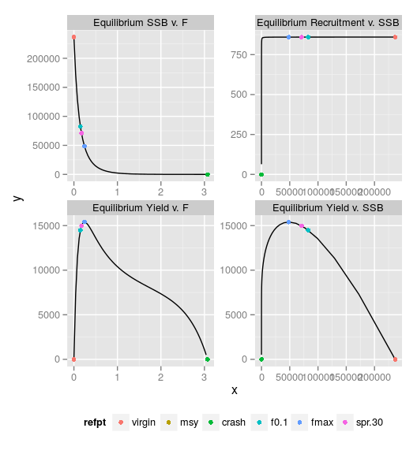 **Figure 37a.** Equilibrium Analysis with reference points.

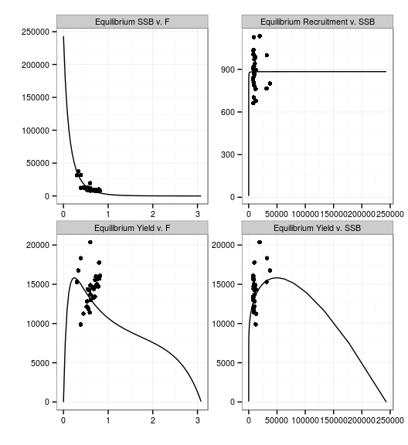 **Figure 37b.** Equilibrium Analysis with observations.

[1] "yellow" "green" "red"

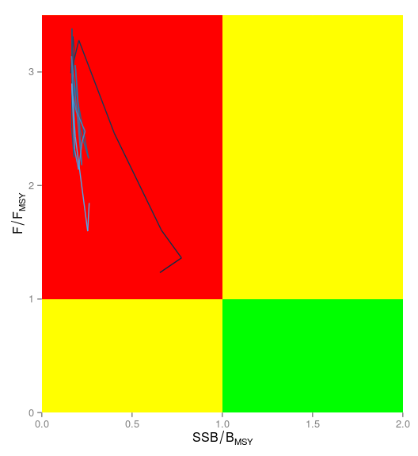 **Figure 38.** Kobe Phase Plot.

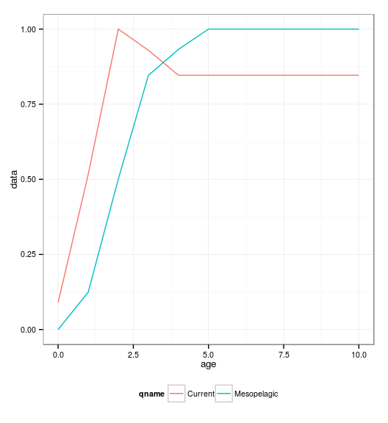 **Figure 39.** Current and mesopelagic selection patterns.

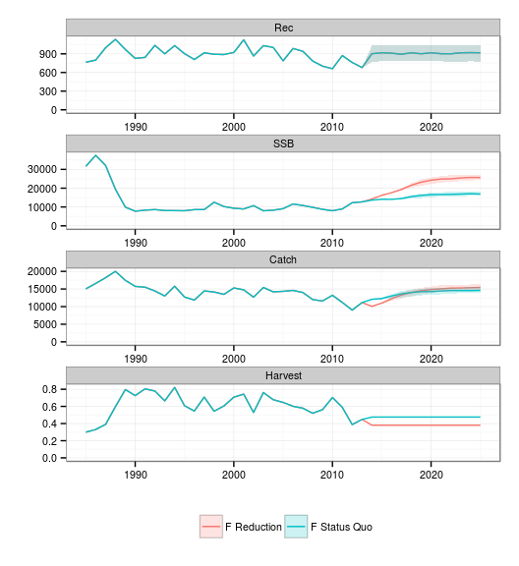 **Figure 40.** Projections for current selection pattern.

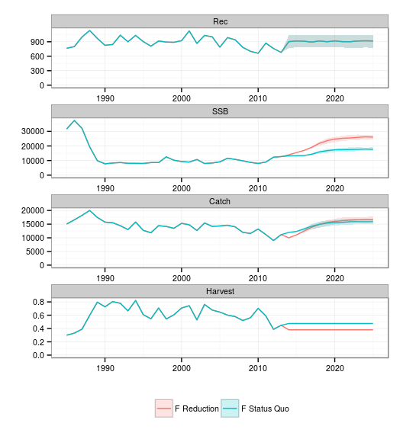 **Figure 41.** Projections for 50:50 current:mesopelagic selection pattern.

# Tables

Table 1a. XSA Control options from continuity run.

tol 1e-09   
maxit 30   
min.nse 0.3   
fse 0.3   
rage 1   
qage 6   
shk.n TRUE   
shk.f TRUE   
shk.yrs 5   
shk.ages 5   
window 100   
tsrange 20   
tspower 3   
vpa TRUE

Table 1b. XSA Control options from alternative run.

tol 1e-09   
maxit 30   
min.nse 0.3   
fse 0.5   
rage 1   
qage 6   
shk.n TRUE   
shk.f TRUE   
shk.yrs 5   
shk.ages 2   
window 100   
tsrange 5   
tspower 1   
vpa TRUE

Table 2a. Reference Points

An object of class "FLPar"  
 quantity  
refpt harvest yield rec ssb biomass   
 virgin 0.0000e+00 0.0000e+00 8.5980e+02 2.3656e+05 2.6656e+05  
 msy 2.4133e-01 1.5605e+04 8.5965e+02 4.8408e+04 7.1497e+04  
 crash 3.1540e+00 2.0284e-03 2.5483e-04 2.9637e-06 1.4898e-03  
 f0.1 1.4688e-01 1.4658e+04 8.5973e+02 8.2931e+04 1.0842e+05  
 fmax 2.4145e-01 1.5605e+04 8.5965e+02 4.8376e+04 7.1462e+04  
 spr.30 1.7287e-01 1.5169e+04 8.5971e+02 7.0960e+04 9.5750e+04  
units: NA

Table 2b. Reference Points with 50% Mesopelagic selection pattern.

An object of class "FLPar"  
 quantity  
refpt harvest yield rec ssb biomass   
 virgin 0.0000e+00 0.0000e+00 8.5980e+02 2.3656e+05 2.6656e+05  
 msy 2.4143e-01 1.6689e+04 8.5965e+02 4.7482e+04 7.1831e+04  
 crash 3.7105e+00 2.2882e-03 2.6212e-04 3.0485e-06 1.8107e-03  
 f0.1 1.4013e-01 1.5574e+04 8.5973e+02 8.3812e+04 1.1032e+05  
 fmax 2.4157e-01 1.6689e+04 8.5965e+02 4.7448e+04 7.1794e+04  
 spr.30 1.6789e-01 1.6184e+04 8.5971e+02 7.0960e+04 9.6844e+04  
units: NA

Table 3. Stock information

An object of class "FLStock"  
Slot "catch":  
An object of class "FLQuant"  
, , unit = unique, season = all, area = unique  
  
 year  
age 1985 1986 1987 1988 1989 1990 1991 1992 1993 1994 1995   
 all 15292 16765 18320 20365 17762 16018 15746 14709 13265 16082 13015  
 year  
age 1996 1997 1998 1999 2000 2001 2002 2003 2004 2005 2006   
 all 12053 14693 14369 13699 15569 15006 12814 15674 14405 14601 14893  
 year  
age 2007 2008 2009 2010 2011 2012 2013   
 all 14227 12164 11840 13430 11423 9888 11254  
  
units: NA   
  
Slot "catch.n":  
An object of class "FLQuant"  
, , unit = unique, season = all, area = unique  
  
 year  
age 1985 1986 1987 1988 1989 1990 1991   
 0 21.4729 20.6035 44.3813 63.1249 74.3797 15.3243 27.4159  
 1 134.5648 90.5752 153.1706 265.5847 197.1327 234.2886 174.9776  
 2 134.6194 177.6181 133.4858 168.8764 176.0136 289.0440 196.6749  
 3 79.1531 76.0513 81.8548 87.5656 86.8658 74.0081 92.0008  
 4 42.6496 45.2544 59.8951 65.5141 54.4569 24.5272 36.7259  
 5 51.0371 58.7734 65.9006 59.3421 45.0798 24.1648 32.4736  
 year  
age 1992 1993 1994 1995 1996 1997 1998   
 0 56.2606 47.2734 67.7528 53.5708 27.6208 26.5902 46.3369  
 1 172.1673 239.6096 190.6157 246.8151 176.5885 156.1288 248.9399  
 2 219.3156 198.0215 251.2519 164.9636 162.4746 195.0504 160.8919  
 3 64.1896 49.8246 69.1512 57.0136 68.1938 87.2302 55.0914  
 4 30.4537 23.7044 26.3690 23.1110 23.1912 40.6634 32.5162  
 5 33.1255 27.0431 35.9536 26.2792 21.6804 24.0022 38.8505  
 year  
age 1999 2000 2001 2002 2003 2004 2005   
 0 31.6699 10.2255 20.6051 9.1971 56.6800 60.4517 14.2259  
 1 177.5012 208.9787 193.4171 288.4701 203.1130 245.1487 221.9711  
 2 155.8745 184.8450 200.5366 215.1277 270.0108 174.7456 207.5041  
 3 66.5933 75.2087 81.1425 46.1867 77.5790 66.1635 64.2196  
 4 35.2808 38.1185 29.4873 17.7672 30.3505 31.7959 28.6761  
 5 33.5977 36.8194 29.8884 20.7071 21.6038 31.4460 29.8566  
 year  
age 2006 2007 2008 2009 2010 2011 2012   
 0 27.1267 24.4187 9.5989 12.7435 26.3902 87.4014 21.9434  
 1 161.6561 267.5342 274.0811 182.0861 151.5678 123.6516 113.8618  
 2 200.6652 160.1002 184.8834 153.2820 138.1137 131.1289 95.5075  
 3 60.1729 68.8383 58.8265 57.7290 78.5488 75.0686 42.5593  
 4 31.3468 31.1331 21.6520 32.8373 42.3556 23.5957 20.2280  
 5 39.2381 28.2827 14.0846 20.9188 28.7229 22.5787 26.3230  
 year  
age 2013   
 0 3.1197  
 1 128.6195  
 2 159.9425  
 3 51.9627  
 4 25.0570  
 5 25.7617  
  
units: NA   
  
Slot "catch.wt":  
An object of class "FLQuant"  
, , unit = unique, season = all, area = unique  
  
 year  
age 1985 1986 1987 1988 1989 1990 1991   
 0 3.5973 3.3550 3.8595 4.1875 3.3635 3.5320 3.6676  
 1 10.7577 10.7182 9.9559 10.2292 10.6368 10.7895 10.9384  
 2 22.8482 23.3794 23.3902 22.3407 22.6277 22.5130 22.9624  
 3 39.9227 39.9683 40.8690 41.1086 40.7663 39.8577 39.8578  
 4 60.2237 61.2643 62.0729 60.7125 59.9180 59.6007 59.5622  
 5 92.5657 94.9294 95.9938 95.6335 95.8431 93.1051 96.6367  
 year  
age 1992 1993 1994 1995 1996 1997 1998   
 0 3.5290 3.7548 3.6669 3.4276 3.7449 3.6454 3.4840  
 1 11.7756 11.0303 11.7135 10.3914 10.4839 10.7970 9.8658  
 2 21.0501 21.0571 21.5953 22.7362 22.7384 23.3870 22.5815  
 3 39.8598 39.8651 39.8655 39.8577 39.8577 39.8577 40.4127  
 4 59.8357 59.9089 59.7883 59.7285 59.5101 59.6189 59.9181  
 5 97.3624 97.3884 98.8695 98.1105 97.6339 91.9874 96.0047  
 year  
age 1999 2000 2001 2002 2003 2004 2005   
 0 4.1242 3.7035 3.7259 3.6340 3.2894 3.4900 3.4467  
 1 11.1596 10.7847 10.9189 10.3710 11.6721 9.9678 11.4007  
 2 21.9276 22.7796 22.7163 21.7204 21.7040 22.5322 21.5889  
 3 39.8610 39.9498 39.8579 39.8577 39.8586 39.8591 39.8795  
 4 59.8914 59.9181 59.4784 59.7334 59.5068 59.8700 59.7541  
 5 94.9498 95.6923 101.7694 101.2668 98.2296 97.4292 101.0340  
 year  
age 2006 2007 2008 2009 2010 2011 2012   
 0 3.3710 3.4884 3.5483 4.1936 4.0896 3.5494 3.6247  
 1 11.7997 10.4942 10.9215 10.5780 10.4251 10.6537 11.3421  
 2 21.7698 22.7073 21.6111 22.0457 22.7801 22.3551 21.9654  
 3 39.8665 40.1303 39.8578 39.8599 39.8629 39.9490 40.2181  
 4 60.0432 59.5603 59.4830 60.3255 59.6308 58.8395 59.6101  
 5 100.9875 101.1686 95.5016 94.6294 95.1012 99.6323 99.8336  
 year  
age 2013   
 0 3.6779  
 1 11.3741  
 2 22.2070  
 3 39.8856  
 4 59.4617  
 5 99.6322  
  
units: NA   
  
Slot "discards":  
An object of class "FLQuant"  
, , unit = unique, season = all, area = unique  
  
 year  
age 1985 1986 1987 1988 1989 1990 1991 1992 1993 1994 1995 1996 1997  
 all 0 0 0 0 0 0 0 0 0 0 0 0 0   
 year  
age 1998 1999 2000 2001 2002 2003 2004 2005 2006 2007 2008 2009 2010  
 all 0 0 0 0 0 0 0 0 0 0 0 0 0   
 year  
age 2011 2012 2013  
 all 0 0 0   
  
units: NA   
  
Slot "discards.n":  
An object of class "FLQuant"  
, , unit = unique, season = all, area = unique  
  
 year  
age 1985 1986 1987 1988 1989 1990 1991 1992 1993 1994 1995 1996 1997 1998  
 0 0 0 0 0 0 0 0 0 0 0 0 0 0 0   
 1 0 0 0 0 0 0 0 0 0 0 0 0 0 0   
 2 0 0 0 0 0 0 0 0 0 0 0 0 0 0   
 3 0 0 0 0 0 0 0 0 0 0 0 0 0 0   
 4 0 0 0 0 0 0 0 0 0 0 0 0 0 0   
 5 0 0 0 0 0 0 0 0 0 0 0 0 0 0   
 year  
age 1999 2000 2001 2002 2003 2004 2005 2006 2007 2008 2009 2010 2011 2012  
 0 0 0 0 0 0 0 0 0 0 0 0 0 0 0   
 1 0 0 0 0 0 0 0 0 0 0 0 0 0 0   
 2 0 0 0 0 0 0 0 0 0 0 0 0 0 0   
 3 0 0 0 0 0 0 0 0 0 0 0 0 0 0   
 4 0 0 0 0 0 0 0 0 0 0 0 0 0 0   
 5 0 0 0 0 0 0 0 0 0 0 0 0 0 0   
 year  
age 2013  
 0 0   
 1 0   
 2 0   
 3 0   
 4 0   
 5 0   
  
units: NA   
  
Slot "discards.wt":  
An object of class "FLQuant"  
, , unit = unique, season = all, area = unique  
  
 year  
age 1985 1986 1987 1988 1989 1990 1991 1992   
 0 3.5973 3.3550 3.8595 4.1875 3.3635 3.5320 3.6676 3.5290  
 1 10.7577 10.7182 9.9559 10.2292 10.6368 10.7895 10.9384 11.7756  
 2 22.8482 23.3794 23.3902 22.3407 22.6277 22.5130 22.9624 21.0501  
 3 39.9227 39.9683 40.8690 41.1086 40.7663 39.8577 39.8578 39.8598  
 4 60.2237 61.2643 62.0729 60.7125 59.9180 59.6007 59.5622 59.8357  
 5 0.0000 0.0000 0.0000 0.0000 0.0000 0.0000 0.0000 0.0000  
 year  
age 1993 1994 1995 1996 1997 1998 1999 2000   
 0 3.7548 3.6669 3.4276 3.7449 3.6454 3.4840 4.1242 3.7035  
 1 11.0303 11.7135 10.3914 10.4839 10.7970 9.8658 11.1596 10.7847  
 2 21.0571 21.5953 22.7362 22.7384 23.3870 22.5815 21.9276 22.7796  
 3 39.8651 39.8655 39.8577 39.8577 39.8577 40.4127 39.8610 39.9498  
 4 59.9089 59.7883 59.7285 59.5101 59.6189 59.9181 59.8914 59.9181  
 5 0.0000 0.0000 0.0000 0.0000 0.0000 0.0000 0.0000 0.0000  
 year  
age 2001 2002 2003 2004 2005 2006 2007 2008   
 0 3.7259 3.6340 3.2894 3.4900 3.4467 3.3710 3.4884 3.5483  
 1 10.9189 10.3710 11.6721 9.9678 11.4007 11.7997 10.4942 10.9215  
 2 22.7163 21.7204 21.7040 22.5322 21.5889 21.7698 22.7073 21.6111  
 3 39.8579 39.8577 39.8586 39.8591 39.8795 39.8665 40.1303 39.8578  
 4 59.4784 59.7334 59.5068 59.8700 59.7541 60.0432 59.5603 59.4830  
 5 0.0000 0.0000 0.0000 0.0000 0.0000 0.0000 0.0000 0.0000  
 year  
age 2009 2010 2011 2012 2013   
 0 4.1936 4.0896 3.5494 3.6247 3.6779  
 1 10.5780 10.4251 10.6537 11.3421 11.3741  
 2 22.0457 22.7801 22.3551 21.9654 22.2070  
 3 39.8599 39.8629 39.9490 40.2181 39.8856  
 4 60.3255 59.6308 58.8395 59.6101 59.4617  
 5 0.0000 0.0000 0.0000 0.0000 0.0000  
  
units: NA   
  
Slot "landings":  
An object of class "FLQuant"  
, , unit = unique, season = all, area = unique  
  
 year  
age 1985 1986 1987 1988 1989 1990 1991 1992 1993 1994 1995   
 all 15292 16765 18320 20365 17762 16018 15746 14709 13265 16082 13015  
 year  
age 1996 1997 1998 1999 2000 2001 2002 2003 2004 2005 2006   
 all 12053 14693 14369 13699 15569 15006 12814 15674 14405 14601 14893  
 year  
age 2007 2008 2009 2010 2011 2012 2013   
 all 14227 12164 11840 13430 11423 9888 11254  
  
units: NA   
  
Slot "landings.n":  
An object of class "FLQuant"  
, , unit = unique, season = all, area = unique  
  
 year  
age 1985 1986 1987 1988 1989 1990 1991   
 0 21.4729 20.6035 44.3813 63.1249 74.3797 15.3243 27.4159  
 1 134.5648 90.5752 153.1706 265.5847 197.1327 234.2886 174.9776  
 2 134.6194 177.6181 133.4858 168.8764 176.0136 289.0440 196.6749  
 3 79.1531 76.0513 81.8548 87.5656 86.8658 74.0081 92.0008  
 4 42.6496 45.2544 59.8951 65.5141 54.4569 24.5272 36.7259  
 5 51.0371 58.7734 65.9006 59.3421 45.0798 24.1648 32.4736  
 year  
age 1992 1993 1994 1995 1996 1997 1998   
 0 56.2606 47.2734 67.7528 53.5708 27.6208 26.5902 46.3369  
 1 172.1673 239.6096 190.6157 246.8151 176.5885 156.1288 248.9399  
 2 219.3156 198.0215 251.2519 164.9636 162.4746 195.0504 160.8919  
 3 64.1896 49.8246 69.1512 57.0136 68.1938 87.2302 55.0914  
 4 30.4537 23.7044 26.3690 23.1110 23.1912 40.6634 32.5162  
 5 33.1255 27.0431 35.9536 26.2792 21.6804 24.0022 38.8505  
 year  
age 1999 2000 2001 2002 2003 2004 2005   
 0 31.6699 10.2255 20.6051 9.1971 56.6800 60.4517 14.2259  
 1 177.5012 208.9787 193.4171 288.4701 203.1130 245.1487 221.9711  
 2 155.8745 184.8450 200.5366 215.1277 270.0108 174.7456 207.5041  
 3 66.5933 75.2087 81.1425 46.1867 77.5790 66.1635 64.2196  
 4 35.2808 38.1185 29.4873 17.7672 30.3505 31.7959 28.6761  
 5 33.5977 36.8194 29.8884 20.7071 21.6038 31.4460 29.8566  
 year  
age 2006 2007 2008 2009 2010 2011 2012   
 0 27.1267 24.4187 9.5989 12.7435 26.3902 87.4014 21.9434  
 1 161.6561 267.5342 274.0811 182.0861 151.5678 123.6516 113.8618  
 2 200.6652 160.1002 184.8834 153.2820 138.1137 131.1289 95.5075  
 3 60.1729 68.8383 58.8265 57.7290 78.5488 75.0686 42.5593  
 4 31.3468 31.1331 21.6520 32.8373 42.3556 23.5957 20.2280  
 5 39.2381 28.2827 14.0846 20.9188 28.7229 22.5787 26.3230  
 year  
age 2013   
 0 3.1197  
 1 128.6195  
 2 159.9425  
 3 51.9627  
 4 25.0570  
 5 25.7617  
  
units: NA   
  
Slot "landings.wt":  
An object of class "FLQuant"  
, , unit = unique, season = all, area = unique  
  
 year  
age 1985 1986 1987 1988 1989 1990 1991   
 0 3.5973 3.3550 3.8595 4.1875 3.3635 3.5320 3.6676  
 1 10.7577 10.7182 9.9559 10.2292 10.6368 10.7895 10.9384  
 2 22.8482 23.3794 23.3902 22.3407 22.6277 22.5130 22.9624  
 3 39.9227 39.9683 40.8690 41.1086 40.7663 39.8577 39.8578  
 4 60.2237 61.2643 62.0729 60.7125 59.9180 59.6007 59.5622  
 5 92.5657 94.9294 95.9938 95.6335 95.8431 93.1051 96.6367  
 year  
age 1992 1993 1994 1995 1996 1997 1998   
 0 3.5290 3.7548 3.6669 3.4276 3.7449 3.6454 3.4840  
 1 11.7756 11.0303 11.7135 10.3914 10.4839 10.7970 9.8658  
 2 21.0501 21.0571 21.5953 22.7362 22.7384 23.3870 22.5815  
 3 39.8598 39.8651 39.8655 39.8577 39.8577 39.8577 40.4127  
 4 59.8357 59.9089 59.7883 59.7285 59.5101 59.6189 59.9181  
 5 97.3624 97.3884 98.8695 98.1105 97.6339 91.9874 96.0047  
 year  
age 1999 2000 2001 2002 2003 2004 2005   
 0 4.1242 3.7035 3.7259 3.6340 3.2894 3.4900 3.4467  
 1 11.1596 10.7847 10.9189 10.3710 11.6721 9.9678 11.4007  
 2 21.9276 22.7796 22.7163 21.7204 21.7040 22.5322 21.5889  
 3 39.8610 39.9498 39.8579 39.8577 39.8586 39.8591 39.8795  
 4 59.8914 59.9181 59.4784 59.7334 59.5068 59.8700 59.7541  
 5 94.9498 95.6923 101.7694 101.2668 98.2296 97.4292 101.0340  
 year  
age 2006 2007 2008 2009 2010 2011 2012   
 0 3.3710 3.4884 3.5483 4.1936 4.0896 3.5494 3.6247  
 1 11.7997 10.4942 10.9215 10.5780 10.4251 10.6537 11.3421  
 2 21.7698 22.7073 21.6111 22.0457 22.7801 22.3551 21.9654  
 3 39.8665 40.1303 39.8578 39.8599 39.8629 39.9490 40.2181  
 4 60.0432 59.5603 59.4830 60.3255 59.6308 58.8395 59.6101  
 5 100.9875 101.1686 95.5016 94.6294 95.1012 99.6323 99.8336  
 year  
age 2013   
 0 3.6779  
 1 11.3741  
 2 22.2070  
 3 39.8856  
 4 59.4617  
 5 99.6322  
  
units: NA   
  
Slot "stock":  
An object of class "FLQuant"  
, , unit = unique, season = all, area = unique  
  
 year  
age 1985 1986 1987 1988 1989 1990 1991 1992 1993 1994 1995 1996 1997  
 all NA NA NA NA NA NA NA NA NA NA NA NA NA   
 year  
age 1998 1999 2000 2001 2002 2003 2004 2005 2006 2007 2008 2009 2010  
 all NA NA NA NA NA NA NA NA NA NA NA NA NA   
 year  
age 2011 2012 2013  
 all NA NA NA   
  
units: NA * NA   
  
Slot "stock.n":  
An object of class "FLQuant"  
, , unit = unique, season = all, area = unique  
  
 year  
age 1985 1986 1987 1988 1989 1990 1991   
 0 765.366 800.120 999.174 1133.759 970.817 827.703 843.546  
 1 820.176 607.241 636.480 777.997 871.280 727.747 663.828  
 2 567.780 550.348 415.591 383.445 398.911 536.111 385.708  
 3 336.816 343.860 291.294 220.539 163.026 169.315 181.574  
 4 181.484 204.613 213.146 165.000 102.201 56.112 72.480  
 5 217.175 265.738 234.518 149.455 84.603 55.283 64.088  
 year  
age 1992 1993 1994 1995 1996 1997 1998   
 0 1036.831 900.886 1032.823 903.839 809.627 916.908 894.445  
 1 665.887 798.116 694.922 784.477 691.663 637.932 726.694  
 2 386.326 390.517 438.423 397.784 420.876 407.636 381.989  
 3 140.475 121.260 143.192 135.565 178.138 199.140 159.672  
 4 66.641 57.682 54.712 55.532 60.009 84.795 85.085  
 5 72.487 65.806 74.599 63.145 56.100 50.052 101.659  
 year  
age 1999 2000 2001 2002 2003 2004 2005   
 0 889.401 923.087 1126.060 865.697 1032.159 1003.277 788.406  
 1 690.493 699.590 746.525 903.333 700.466 793.912 766.868  
 2 371.835 405.865 385.236 437.450 480.855 391.175 430.061  
 3 168.878 165.042 167.197 136.720 166.258 153.506 164.143  
 4 81.352 78.668 67.951 64.492 70.533 66.856 66.536  
 5 77.471 75.987 68.876 75.163 50.206 66.120 69.275  
 year  
age 2006 2007 2008 2009 2010 2011 2012   
 0 987.260 941.323 784.538 702.436 661.855 872.543 762.029  
 1 632.646 783.808 748.643 633.656 563.598 518.060 635.579  
 2 428.611 372.733 401.921 367.438 355.339 325.311 313.015  
 3 166.945 171.768 162.047 163.959 163.751 167.300 149.020  
 4 76.910 82.776 79.037 79.976 82.508 63.971 69.909  
 5 96.272 75.198 51.414 50.948 55.952 61.214 90.974  
 year  
age 2013   
 0 679.782  
 1 604.085  
 2 417.887  
 3 170.581  
 4 83.801  
 5 86.158  
  
units: NA   
  
Slot "stock.wt":  
An object of class "FLQuant"  
, , unit = unique, season = all, area = unique  
  
 year  
age 1985 1986 1987 1988 1989 1990 1991   
 0 3.5973 3.3550 3.8595 4.1875 3.3635 3.5320 3.6676  
 1 10.7577 10.7182 9.9559 10.2292 10.6368 10.7895 10.9384  
 2 22.8482 23.3794 23.3902 22.3407 22.6277 22.5130 22.9624  
 3 39.9227 39.9683 40.8690 41.1086 40.7663 39.8577 39.8578  
 4 60.2237 61.2643 62.0729 60.7125 59.9180 59.6007 59.5622  
 5 92.5657 94.9294 95.9938 95.6335 95.8431 93.1051 96.6367  
 year  
age 1992 1993 1994 1995 1996 1997 1998   
 0 3.5290 3.7548 3.6669 3.4276 3.7449 3.6454 3.4840  
 1 11.7756 11.0303 11.7135 10.3914 10.4839 10.7970 9.8658  
 2 21.0501 21.0571 21.5953 22.7362 22.7384 23.3870 22.5815  
 3 39.8598 39.8651 39.8655 39.8577 39.8577 39.8577 40.4127  
 4 59.8357 59.9089 59.7883 59.7285 59.5101 59.6189 59.9181  
 5 97.3624 97.3884 98.8695 98.1105 97.6339 91.9874 96.0047  
 year  
age 1999 2000 2001 2002 2003 2004 2005   
 0 4.1242 3.7035 3.7259 3.6340 3.2894 3.4900 3.4467  
 1 11.1596 10.7847 10.9189 10.3710 11.6721 9.9678 11.4007  
 2 21.9276 22.7796 22.7163 21.7204 21.7040 22.5322 21.5889  
 3 39.8610 39.9498 39.8579 39.8577 39.8586 39.8591 39.8795  
 4 59.8914 59.9181 59.4784 59.7334 59.5068 59.8700 59.7541  
 5 94.9498 95.6923 101.7694 101.2668 98.2296 97.4292 101.0340  
 year  
age 2006 2007 2008 2009 2010 2011 2012   
 0 3.3710 3.4884 3.5483 4.1936 4.0896 3.5494 3.6247  
 1 11.7997 10.4942 10.9215 10.5780 10.4251 10.6537 11.3421  
 2 21.7698 22.7073 21.6111 22.0457 22.7801 22.3551 21.9654  
 3 39.8665 40.1303 39.8578 39.8599 39.8629 39.9490 40.2181  
 4 60.0432 59.5603 59.4830 60.3255 59.6308 58.8395 59.6101  
 5 100.9875 101.1686 95.5016 94.6294 95.1012 99.6323 99.8336  
 year  
age 2013   
 0 3.6779  
 1 11.3741  
 2 22.2070  
 3 39.8856  
 4 59.4617  
 5 99.6322  
  
units: Tonnes   
  
Slot "m":  
An object of class "FLQuant"  
, , unit = unique, season = all, area = unique  
  
 year  
age 1985 1986 1987 1988 1989 1990 1991 1992 1993 1994 1995 1996 1997 1998  
 0 0.2 0.2 0.2 0.2 0.2 0.2 0.2 0.2 0.2 0.2 0.2 0.2 0.2 0.2   
 1 0.2 0.2 0.2 0.2 0.2 0.2 0.2 0.2 0.2 0.2 0.2 0.2 0.2 0.2   
 2 0.2 0.2 0.2 0.2 0.2 0.2 0.2 0.2 0.2 0.2 0.2 0.2 0.2 0.2   
 3 0.2 0.2 0.2 0.2 0.2 0.2 0.2 0.2 0.2 0.2 0.2 0.2 0.2 0.2   
 4 0.2 0.2 0.2 0.2 0.2 0.2 0.2 0.2 0.2 0.2 0.2 0.2 0.2 0.2   
 5 0.2 0.2 0.2 0.2 0.2 0.2 0.2 0.2 0.2 0.2 0.2 0.2 0.2 0.2   
 year  
age 1999 2000 2001 2002 2003 2004 2005 2006 2007 2008 2009 2010 2011 2012  
 0 0.2 0.2 0.2 0.2 0.2 0.2 0.2 0.2 0.2 0.2 0.2 0.2 0.2 0.2   
 1 0.2 0.2 0.2 0.2 0.2 0.2 0.2 0.2 0.2 0.2 0.2 0.2 0.2 0.2   
 2 0.2 0.2 0.2 0.2 0.2 0.2 0.2 0.2 0.2 0.2 0.2 0.2 0.2 0.2   
 3 0.2 0.2 0.2 0.2 0.2 0.2 0.2 0.2 0.2 0.2 0.2 0.2 0.2 0.2   
 4 0.2 0.2 0.2 0.2 0.2 0.2 0.2 0.2 0.2 0.2 0.2 0.2 0.2 0.2   
 5 0.2 0.2 0.2 0.2 0.2 0.2 0.2 0.2 0.2 0.2 0.2 0.2 0.2 0.2   
 year  
age 2013  
 0 0.2   
 1 0.2   
 2 0.2   
 3 0.2   
 4 0.2   
 5 0.2   
  
units: NA   
  
Slot "mat":  
An object of class "FLQuant"  
, , unit = unique, season = all, area = unique  
  
 year  
age 1985 1986 1987 1988 1989 1990 1991 1992 1993 1994 1995 1996 1997 1998  
 0 0.0 0.0 0.0 0.0 0.0 0.0 0.0 0.0 0.0 0.0 0.0 0.0 0.0 0.0   
 1 0.0 0.0 0.0 0.0 0.0 0.0 0.0 0.0 0.0 0.0 0.0 0.0 0.0 0.0   
 2 0.0 0.0 0.0 0.0 0.0 0.0 0.0 0.0 0.0 0.0 0.0 0.0 0.0 0.0   
 3 0.5 0.5 0.5 0.5 0.5 0.5 0.5 0.5 0.5 0.5 0.5 0.5 0.5 0.5   
 4 1.0 1.0 1.0 1.0 1.0 1.0 1.0 1.0 1.0 1.0 1.0 1.0 1.0 1.0   
 5 1.0 1.0 1.0 1.0 1.0 1.0 1.0 1.0 1.0 1.0 1.0 1.0 1.0 1.0   
 year  
age 1999 2000 2001 2002 2003 2004 2005 2006 2007 2008 2009 2010 2011 2012  
 0 0.0 0.0 0.0 0.0 0.0 0.0 0.0 0.0 0.0 0.0 0.0 0.0 0.0 0.0   
 1 0.0 0.0 0.0 0.0 0.0 0.0 0.0 0.0 0.0 0.0 0.0 0.0 0.0 0.0   
 2 0.0 0.0 0.0 0.0 0.0 0.0 0.0 0.0 0.0 0.0 0.0 0.0 0.0 0.0   
 3 0.5 0.5 0.5 0.5 0.5 0.5 0.5 0.5 0.5 0.5 0.5 0.5 0.5 0.5   
 4 1.0 1.0 1.0 1.0 1.0 1.0 1.0 1.0 1.0 1.0 1.0 1.0 1.0 1.0   
 5 1.0 1.0 1.0 1.0 1.0 1.0 1.0 1.0 1.0 1.0 1.0 1.0 1.0 1.0   
 year  
age 2013  
 0 0.0   
 1 0.0   
 2 0.0   
 3 0.5   
 4 1.0   
 5 1.0   
  
units: NA   
  
Slot "harvest":  
An object of class "FLQuant"  
, , unit = unique, season = all, area = unique  
  
 year  
age 1985 1986 1987 1988 1989 1990 1991   
 0 0.0314273 0.0288087 0.0502063 0.0633297 0.0881848 0.0206317 0.0364953  
 1 0.1989678 0.1792240 0.3067567 0.4679847 0.2856232 0.4348728 0.3413404  
 2 0.3014985 0.4362168 0.4336290 0.6552870 0.6569795 0.8826768 0.8100540  
 3 0.2984136 0.2782570 0.3683882 0.5691284 0.8665624 0.6484455 0.8023506  
 4 0.2984144 0.2782580 0.3683900 0.5691326 0.8665749 0.6484642 0.8023960  
 5 0.2984144 0.2782580 0.3683900 0.5691326 0.8665749 0.6484642 0.8023960  
 year  
age 1992 1993 1994 1995 1996 1997 1998   
 0 0.0616707 0.0595793 0.0750337 0.0675525 0.0383424 0.0325016 0.0587975  
 1 0.3336489 0.3990706 0.3578897 0.4226792 0.3287246 0.3128393 0.4700555  
 2 0.9587446 0.8032840 0.9737336 0.6033505 0.5483310 0.7372503 0.6162156  
 3 0.6900867 0.5958574 0.7472263 0.6149571 0.5423184 0.6503621 0.4743366  
 4 0.6901641 0.5959775 0.7450457 0.6062457 0.5491225 0.7396164 0.5411092  
 5 0.6901641 0.5959775 0.7450457 0.6062457 0.5491225 0.7396164 0.5411092  
 year  
age 1999 2000 2001 2002 2003 2004 2005   
 0 0.0400529 0.0122949 0.0203888 0.0117886 0.0624345 0.0687119 0.0201024  
 1 0.3313849 0.3966375 0.3344656 0.4305262 0.3825903 0.4130462 0.3817659  
 2 0.6122505 0.6868513 0.8359214 0.7674239 0.9418250 0.6684161 0.7462613  
 3 0.5639441 0.6874070 0.7526321 0.4618554 0.7109958 0.6359931 0.5581027  
 4 0.6414244 0.7509032 0.6419700 0.3597564 0.6345456 0.7307663 0.6359317  
 5 0.6414244 0.7509032 0.6419700 0.3597564 0.6345456 0.7307663 0.6359317  
 year  
age 2006 2007 2008 2009 2010 2011 2012   
 0 0.0307690 0.0290247 0.0135882 0.0202127 0.0449558 0.1168759 0.0322696  
 1 0.3290484 0.4679090 0.5117080 0.3784347 0.3495593 0.3038385 0.2193244  
 2 0.7144020 0.6329787 0.6966396 0.6082059 0.5532836 0.5807012 0.4070443  
 3 0.5015237 0.5762266 0.5061593 0.4867182 0.7399226 0.6725922 0.3756363  
 4 0.5893967 0.5299316 0.3573419 0.5952712 0.8183516 0.5166789 0.3815999  
 5 0.5893967 0.5299316 0.3573419 0.5952712 0.8183516 0.5166789 0.3815999  
 year  
age 2013   
 0 0.0050759  
 1 0.2664159  
 2 0.5421825  
 3 0.4062308  
 4 0.3971059  
 5 0.3971059  
  
units: f   
  
Slot "harvest.spwn":  
An object of class "FLQuant"  
, , unit = unique, season = all, area = unique  
  
 year  
age 1985 1986 1987 1988 1989 1990 1991 1992 1993 1994 1995 1996 1997 1998  
 0 0.5 0.5 0.5 0.5 0.5 0.5 0.5 0.5 0.5 0.5 0.5 0.5 0.5 0.5   
 1 0.5 0.5 0.5 0.5 0.5 0.5 0.5 0.5 0.5 0.5 0.5 0.5 0.5 0.5   
 2 0.5 0.5 0.5 0.5 0.5 0.5 0.5 0.5 0.5 0.5 0.5 0.5 0.5 0.5   
 3 0.5 0.5 0.5 0.5 0.5 0.5 0.5 0.5 0.5 0.5 0.5 0.5 0.5 0.5   
 4 0.5 0.5 0.5 0.5 0.5 0.5 0.5 0.5 0.5 0.5 0.5 0.5 0.5 0.5   
 5 0.5 0.5 0.5 0.5 0.5 0.5 0.5 0.5 0.5 0.5 0.5 0.5 0.5 0.5   
 year  
age 1999 2000 2001 2002 2003 2004 2005 2006 2007 2008 2009 2010 2011 2012  
 0 0.5 0.5 0.5 0.5 0.5 0.5 0.5 0.5 0.5 0.5 0.5 0.5 0.5 0.5   
 1 0.5 0.5 0.5 0.5 0.5 0.5 0.5 0.5 0.5 0.5 0.5 0.5 0.5 0.5   
 2 0.5 0.5 0.5 0.5 0.5 0.5 0.5 0.5 0.5 0.5 0.5 0.5 0.5 0.5   
 3 0.5 0.5 0.5 0.5 0.5 0.5 0.5 0.5 0.5 0.5 0.5 0.5 0.5 0.5   
 4 0.5 0.5 0.5 0.5 0.5 0.5 0.5 0.5 0.5 0.5 0.5 0.5 0.5 0.5   
 5 0.5 0.5 0.5 0.5 0.5 0.5 0.5 0.5 0.5 0.5 0.5 0.5 0.5 0.5   
 year  
age 2013  
 0 0.5   
 1 0.5   
 2 0.5   
 3 0.5   
 4 0.5   
 5 0.5   
  
units: prop   
  
Slot "m.spwn":  
An object of class "FLQuant"  
, , unit = unique, season = all, area = unique  
  
 year  
age 1985 1986 1987 1988 1989 1990 1991 1992 1993 1994 1995 1996 1997 1998  
 0 0.5 0.5 0.5 0.5 0.5 0.5 0.5 0.5 0.5 0.5 0.5 0.5 0.5 0.5   
 1 0.5 0.5 0.5 0.5 0.5 0.5 0.5 0.5 0.5 0.5 0.5 0.5 0.5 0.5   
 2 0.5 0.5 0.5 0.5 0.5 0.5 0.5 0.5 0.5 0.5 0.5 0.5 0.5 0.5   
 3 0.5 0.5 0.5 0.5 0.5 0.5 0.5 0.5 0.5 0.5 0.5 0.5 0.5 0.5   
 4 0.5 0.5 0.5 0.5 0.5 0.5 0.5 0.5 0.5 0.5 0.5 0.5 0.5 0.5   
 5 0.5 0.5 0.5 0.5 0.5 0.5 0.5 0.5 0.5 0.5 0.5 0.5 0.5 0.5   
 year  
age 1999 2000 2001 2002 2003 2004 2005 2006 2007 2008 2009 2010 2011 2012  
 0 0.5 0.5 0.5 0.5 0.5 0.5 0.5 0.5 0.5 0.5 0.5 0.5 0.5 0.5   
 1 0.5 0.5 0.5 0.5 0.5 0.5 0.5 0.5 0.5 0.5 0.5 0.5 0.5 0.5   
 2 0.5 0.5 0.5 0.5 0.5 0.5 0.5 0.5 0.5 0.5 0.5 0.5 0.5 0.5   
 3 0.5 0.5 0.5 0.5 0.5 0.5 0.5 0.5 0.5 0.5 0.5 0.5 0.5 0.5   
 4 0.5 0.5 0.5 0.5 0.5 0.5 0.5 0.5 0.5 0.5 0.5 0.5 0.5 0.5   
 5 0.5 0.5 0.5 0.5 0.5 0.5 0.5 0.5 0.5 0.5 0.5 0.5 0.5 0.5   
 year  
age 2013  
 0 0.5   
 1 0.5   
 2 0.5   
 3 0.5   
 4 0.5   
 5 0.5   
  
units: NA   
  
Slot "name":  
[1] "Swordfish MED "  
  
Slot "desc":  
[1] "Imported from a VPA file. ( /home/laurie/Desktop/Dropbox/swo-med/analysis/Inputs/swo.idx ). Wed Jul 30 16:18:38 2014 + FLAssess: + FLAssess: "  
  
Slot "range":  
 min max plusgroup minyear maxyear minfbar maxfbar   
 0 5 5 1985 2013 2 4

Table 4a. XSA diagnostics from continuity run.

FLR XSA Diagnostics 2014-07-30 16:20:14  
  
CPUE data from indices  
  
Catch data for 29 years 1985 to 2013. Ages 0 to 5.  
  
 fleet first age last age first year last year alpha beta  
1 Moroccan Longline 2 4 1999 2011 <NA> <NA>  
2 Spanish Longline 2 4 1988 2013 <NA> <NA>  
3 Scilian Longline 2 4 1991 2009 <NA> <NA>  
4 Scilian Gillnet 2 4 1990 2009 <NA> <NA>  
5 Greek Longline 2 4 1987 2013 <NA> <NA>  
6 Ligurian Longline 2 4 1991 2009 <NA> <NA>  
  
  
 Time series weights :  
  
 Tapered time weighting applied  
 Power = 1 over 5 years  
  
 Catchability analysis :  
  
 Catchability independent of size for ages > 1   
  
 Catchability independent of age for ages > 4   
  
 Terminal population estimation :  
  
 Survivor estimates shrunk towards the mean F  
 of the final 5 years or the 2 oldest ages.  
  
 S.E. of the mean to which the estimates are shrunk = 0.5   
   
 Minimum standard error for population  
 estimates derived from each fleet = 0.3   
  
 prior weighting not applied  
  
Regression weights  
 year  
age 2004 2005 2006 2007 2008 2009 2010 2011 2012 2013  
 all -0.8 -0.6 -0.4 -0.2 0 0.2 0.4 0.6 0.8 1  
  
  
 Fishing mortalities  
 year  
age 2004 2005 2006 2007 2008 2009 2010 2011 2012 2013  
 0 0.073 0.020 0.031 0.029 0.014 0.021 0.048 0.128 0.037 0.006  
 1 0.433 0.415 0.332 0.467 0.523 0.393 0.372 0.332 0.245 0.308  
 2 0.705 0.814 0.829 0.641 0.695 0.631 0.587 0.644 0.464 0.641  
 3 0.676 0.617 0.591 0.779 0.518 0.484 0.797 0.753 0.445 0.497  
 4 0.691 0.715 0.710 0.710 0.606 0.619 0.811 0.595 0.465 0.516  
 5 0.691 0.715 0.710 0.710 0.606 0.619 0.811 0.595 0.465 0.516  
  
  
 XSA population number (Thousand)  
 age  
year 0 1 2 3 4 5  
 2004 942 764 377 147 70 69  
 2005 783 717 406 152 61 64  
 2006 988 628 388 147 67 84  
 2007 927 785 369 139 67 61  
 2008 761 737 403 159 52 34  
 2009 667 615 358 165 78 49  
 2010 615 535 340 156 83 56  
 2011 800 480 302 155 58 55  
 2012 674 576 282 130 60 78  
 2013 617 532 369 145 68 70  
  
  
 Estimated population abundance at 1st Jan 2014   
 age  
year 0 1 2 3 4 5  
 2014 33 503 320 159 72 33  
  
  
 Fleet: Moroccan Longline   
  
 Log catchability residuals.  
  
 year  
age 1999 2000 2001 2002 2003 2004 2005 2006 2007 2008 2009  
 2 0.107 0.228 -0.152 -0.136 -0.268 0.043 0.205 0.191 0.113 0.141 0.013  
 3 0.053 0.414 0.109 0.288 -0.123 0.206 0.336 0.292 0.387 0.226 -0.041  
 4 -0.048 0.261 0.254 0.626 0.191 0.153 0.482 0.320 0.281 0.576 -0.038  
 year  
age 2010 2011  
 2 -0.023 0.011  
 3 0.080 -0.040  
 4 -0.092 0.074  
  
  
 Mean log catchability and standard error of ages with catchability   
 independent of year class strength and constant w.r.t. time   
  
 2 3 4  
Mean_Logq -1.4879 -0.7222 0.0850  
S.E_Logq 0.2013 0.2013 0.2013  
  
  
 Fleet: Spanish Longline   
  
 Log catchability residuals.  
  
 year  
age 1988 1989 1990 1991 1992 1993 1994 1995 1996 1997  
 2 -0.032 -0.442 -0.497 -0.406 -0.571 -0.361 -0.301 -0.436 -0.683 -0.560  
 3 -0.393 -0.187 -0.251 -0.396 -0.409 -0.010 -0.077 -0.148 -0.666 -0.668  
 4 -0.777 -0.668 0.235 -0.291 -0.310 0.065 0.240 -0.046 -0.350 -0.635  
 year  
age 1998 1999 2000 2001 2002 2003 2004 2005 2006 2007  
 2 -0.471 -0.481 -0.501 -0.513 -0.400 -0.727 -0.716 -0.464 -0.220 -0.053  
 3 -0.494 -0.571 -0.350 -0.287 -0.012 -0.618 -0.588 -0.369 -0.155 0.185  
 4 -0.597 -0.652 -0.485 -0.122 0.345 -0.285 -0.622 -0.203 -0.107 0.098  
 year  
age 2008 2009 2010 2011 2012 2013  
 2 0.104 -0.117 -0.069 0.119 0.213 -0.190  
 3 0.154 -0.206 -0.002 0.033 0.179 -0.121  
 4 0.523 -0.185 -0.154 0.166 0.177 -0.143  
  
  
 Mean log catchability and standard error of ages with catchability   
 independent of year class strength and constant w.r.t. time   
  
 2 3 4  
Mean_Logq -0.7174 0.084 0.8719  
S.E_Logq 0.2980 0.298 0.2980  
  
  
 Fleet: Scilian Longline   
  
 Log catchability residuals.  
  
 year  
age 1991 1992 1993 1994 1995 1996 1997 1998 1999 2000 2001  
 2 0.057 0.086 NA -0.063 0.088 NA -0.359 0.201 0.471 -0.027 0.461  
 3 0.157 0.337 NA 0.251 0.464 NA -0.377 0.267 0.471 0.213 0.776  
 4 0.240 0.414 NA 0.546 0.545 NA -0.366 0.142 0.368 0.057 0.919  
 year  
age 2002 2003 2004 2005 2006 2007 2008 2009  
 2 0.569 -0.325 0.095 0.169 0.353 -0.229 -0.222 0  
 3 1.047 -0.127 0.312 0.354 0.508 0.099 -0.083 0  
 4 1.382 0.185 0.256 0.498 0.533 -0.010 0.265 0  
  
  
 Mean log catchability and standard error of ages with catchability   
 independent of year class strength and constant w.r.t. time   
  
 2 3 4  
Mean_Logq -0.8963 -0.1843 0.6255  
S.E_Logq 0.3519 0.3519 0.3519  
  
  
 Fleet: Scilian Gillnet   
  
 Log catchability residuals.  
  
 year  
age 1990 1991 1992 1993 1994 1995 1996 1997 1998 1999 2000  
 2 1.186 1.649 2.239 1.873 1.506 1.869 1.361 1.872 1.585 1.911 2.058  
 3 1.521 1.749 2.491 2.313 1.819 2.245 1.468 1.854 1.651 1.911 2.297  
 4 1.986 1.832 2.568 2.366 2.115 2.325 1.761 1.864 1.526 1.808 2.141  
 year  
age 2001 2002 2003 2004 2005 2006 2007 2008 2009  
 2 1.979 NA NA 2.020 1.764 2.751 NA 0.422 0  
 3 2.294 NA NA 2.237 1.949 2.905 NA 0.561 0  
 4 2.437 NA NA 2.181 2.093 2.931 NA 0.908 0  
  
  
 Mean log catchability and standard error of ages with catchability   
 independent of year class strength and constant w.r.t. time   
  
 2 3 4  
Mean_Logq -4.8146 -4.1026 -3.2928  
S.E_Logq 0.6705 0.6705 0.6705  
  
  
 Fleet: Greek Longline   
  
 Log catchability residuals.  
  
 year  
age 1987 1988 1989 1990 1991 1992 1993 1994 1995 1996 1997  
 2 -0.303 0.102 NA -0.237 0.340 -0.524 -0.045 0.185 -0.375 NA NA  
 3 -0.708 -0.259 NA 0.008 0.351 -0.362 0.305 0.409 -0.087 NA NA  
 4 -1.136 -0.643 NA 0.495 0.455 -0.263 0.381 0.726 0.015 NA NA  
 year  
age 1998 1999 2000 2001 2002 2003 2004 2005 2006 2007  
 2 0.362 0.189 -0.067 0.038 -0.424 -0.207 -0.081 -0.131 -0.021 0.003  
 3 0.338 0.099 0.084 0.263 -0.036 -0.098 0.046 -0.035 0.044 0.241  
 4 0.235 0.018 -0.051 0.428 0.321 0.235 0.013 0.131 0.091 0.153  
 year  
age 2008 2009 2010 2011 2012 2013  
 2 -0.124 -0.171 0.033 -0.072 -0.091 0.137  
 3 -0.075 -0.261 0.100 -0.159 -0.125 0.207  
 4 0.295 -0.239 -0.052 -0.026 -0.126 0.185  
  
  
 Mean log catchability and standard error of ages with catchability   
 independent of year class strength and constant w.r.t. time   
  
 2 3 4  
Mean_Logq -0.6513 0.1502 0.9381  
S.E_Logq 0.2979 0.2979 0.2979  
  
  
 Fleet: Ligurian Longline   
  
 Log catchability residuals.  
  
 year  
age 1991 1992 1993 1994 1995 1996 1997 1998 1999 2000  
 2 -0.288 -0.533 -0.602 -0.375 -0.403 -0.463 -0.291 0.109 -0.145 0.120  
 3 -0.188 -0.281 -0.162 -0.062 -0.027 -0.356 -0.310 0.175 -0.145 0.360  
 4 -0.105 -0.204 -0.109 0.234 0.054 -0.062 -0.299 0.050 -0.248 0.204  
 year  
age 2001 2002 2003 2004 2005 2006 2007 2008 2009  
 2 0.474 -0.028 0.073 -0.241 -0.472 0.017 0.638 0.432 0  
 3 0.789 0.449 0.271 -0.025 -0.287 0.171 0.965 0.571 0  
 4 0.932 0.785 0.582 -0.080 -0.143 0.197 0.856 0.919 0  
  
  
 Mean log catchability and standard error of ages with catchability   
 independent of year class strength and constant w.r.t. time   
  
 2 3 4  
Mean_Logq -0.6773 0.0347 0.8445  
S.E_Logq 0.3981 0.3981 0.3981  
  
  
 Terminal year survivor and F summaries:   
   
 ,Age 0 Year class =2013   
  
source   
 scaledWts survivors yrcls  
fshk 0.03 55 2013  
nshk 0.97 538 2013  
  
 ,Age 1 Year class =2012   
  
source   
 scaledWts survivors yrcls  
fshk 1 255 2012  
  
 ,Age 2 Year class =2011   
  
source   
 scaledWts survivors yrcls  
Spanish Longline 0.373 132 2011  
Greek Longline 0.373 183 2011  
fshk 0.255 172 2011  
  
 ,Age 3 Year class =2010   
  
source   
 scaledWts survivors yrcls  
Spanish Longline 0.386 64 2010  
Greek Longline 0.386 89 2010  
fshk 0.228 57 2010  
  
 ,Age 4 Year class =2009   
  
source   
 scaledWts survivors yrcls  
Spanish Longline 0.384 29 2009  
Greek Longline 0.384 40 2009  
fshk 0.232 29 2009

Table 4b. XSA diagnostics from alternative run.

FLR XSA Diagnostics 2014-07-30 16:20:16  
  
CPUE data from indices  
  
Catch data for 29 years 1985 to 2013. Ages 0 to 5.  
  
 fleet first age last age first year last year alpha beta  
1 Moroccan Longline 2 4 1999 2011 <NA> <NA>  
2 Spanish Longline 2 4 1988 2013 <NA> <NA>  
3 Scilian Longline 2 4 1991 2009 <NA> <NA>  
4 Scilian Gillnet 2 4 1990 2009 <NA> <NA>  
5 Greek Longline 2 4 1987 2013 <NA> <NA>  
6 Ligurian Longline 2 4 1991 2009 <NA> <NA>  
  
  
 Time series weights :  
  
 Tapered time weighting applied  
 Power = 1 over 5 years  
  
 Catchability analysis :  
  
 Catchability independent of size for ages > 1   
  
 Catchability independent of age for ages > 4   
  
 Terminal population estimation :  
  
 Survivor estimates shrunk towards the mean F  
 of the final 5 years or the 2 oldest ages.  
  
 S.E. of the mean to which the estimates are shrunk = 0.5   
   
 Minimum standard error for population  
 estimates derived from each fleet = 0.3   
  
 prior weighting not applied  
  
Regression weights  
 year  
age 2004 2005 2006 2007 2008 2009 2010 2011 2012 2013  
 all -0.8 -0.6 -0.4 -0.2 0 0.2 0.4 0.6 0.8 1  
  
  
 Fishing mortalities  
 year  
age 2004 2005 2006 2007 2008 2009 2010 2011 2012 2013  
 0 0.073 0.020 0.031 0.029 0.014 0.021 0.048 0.128 0.037 0.006  
 1 0.433 0.415 0.332 0.467 0.523 0.393 0.372 0.332 0.245 0.308  
 2 0.705 0.814 0.829 0.641 0.695 0.631 0.587 0.644 0.464 0.641  
 3 0.676 0.617 0.591 0.779 0.518 0.484 0.797 0.753 0.445 0.497  
 4 0.691 0.715 0.710 0.710 0.606 0.619 0.811 0.595 0.465 0.516  
 5 0.691 0.715 0.710 0.710 0.606 0.619 0.811 0.595 0.465 0.516  
  
  
 XSA population number (Thousand)  
 age  
year 0 1 2 3 4 5  
 2004 942 764 377 147 70 69  
 2005 783 717 406 152 61 64  
 2006 988 628 388 147 67 84  
 2007 927 785 369 139 67 61  
 2008 761 737 403 159 52 34  
 2009 667 615 358 165 78 49  
 2010 615 535 340 156 83 56  
 2011 800 480 302 155 58 55  
 2012 674 576 282 130 60 78  
 2013 617 532 369 145 68 70  
  
  
 Estimated population abundance at 1st Jan 2014   
 age  
year 0 1 2 3 4 5  
 2014 33 503 320 159 72 33  
  
  
 Fleet: Moroccan Longline   
  
 Log catchability residuals.  
  
 year  
age 1999 2000 2001 2002 2003 2004 2005 2006 2007 2008 2009  
 2 0.107 0.228 -0.152 -0.136 -0.268 0.043 0.205 0.191 0.113 0.141 0.013  
 3 0.053 0.414 0.109 0.288 -0.123 0.206 0.336 0.292 0.387 0.226 -0.041  
 4 -0.048 0.261 0.254 0.626 0.191 0.153 0.482 0.320 0.281 0.576 -0.038  
 year  
age 2010 2011  
 2 -0.023 0.011  
 3 0.080 -0.040  
 4 -0.092 0.074  
  
  
 Mean log catchability and standard error of ages with catchability   
 independent of year class strength and constant w.r.t. time   
  
 2 3 4  
Mean_Logq -1.4879 -0.7222 0.0850  
S.E_Logq 0.2013 0.2013 0.2013  
  
  
 Fleet: Spanish Longline   
  
 Log catchability residuals.  
  
 year  
age 1988 1989 1990 1991 1992 1993 1994 1995 1996 1997  
 2 -0.032 -0.442 -0.497 -0.406 -0.571 -0.361 -0.301 -0.436 -0.683 -0.560  
 3 -0.393 -0.187 -0.251 -0.396 -0.409 -0.010 -0.077 -0.148 -0.666 -0.668  
 4 -0.777 -0.668 0.235 -0.291 -0.310 0.065 0.240 -0.046 -0.350 -0.635  
 year  
age 1998 1999 2000 2001 2002 2003 2004 2005 2006 2007  
 2 -0.471 -0.481 -0.501 -0.513 -0.400 -0.727 -0.716 -0.464 -0.220 -0.053  
 3 -0.494 -0.571 -0.350 -0.287 -0.012 -0.618 -0.588 -0.369 -0.155 0.185  
 4 -0.597 -0.652 -0.485 -0.122 0.345 -0.285 -0.622 -0.203 -0.107 0.098  
 year  
age 2008 2009 2010 2011 2012 2013  
 2 0.104 -0.117 -0.069 0.119 0.213 -0.190  
 3 0.154 -0.206 -0.002 0.033 0.179 -0.121  
 4 0.523 -0.185 -0.154 0.166 0.177 -0.143  
  
  
 Mean log catchability and standard error of ages with catchability   
 independent of year class strength and constant w.r.t. time   
  
 2 3 4  
Mean_Logq -0.7174 0.084 0.8719  
S.E_Logq 0.2980 0.298 0.2980  
  
  
 Fleet: Scilian Longline   
  
 Log catchability residuals.  
  
 year  
age 1991 1992 1993 1994 1995 1996 1997 1998 1999 2000 2001  
 2 0.057 0.086 NA -0.063 0.088 NA -0.359 0.201 0.471 -0.027 0.461  
 3 0.157 0.337 NA 0.251 0.464 NA -0.377 0.267 0.471 0.213 0.776  
 4 0.240 0.414 NA 0.546 0.545 NA -0.366 0.142 0.368 0.057 0.919  
 year  
age 2002 2003 2004 2005 2006 2007 2008 2009  
 2 0.569 -0.325 0.095 0.169 0.353 -0.229 -0.222 0  
 3 1.047 -0.127 0.312 0.354 0.508 0.099 -0.083 0  
 4 1.382 0.185 0.256 0.498 0.533 -0.010 0.265 0  
  
  
 Mean log catchability and standard error of ages with catchability   
 independent of year class strength and constant w.r.t. time   
  
 2 3 4  
Mean_Logq -0.8963 -0.1843 0.6255  
S.E_Logq 0.3519 0.3519 0.3519  
  
  
 Fleet: Scilian Gillnet   
  
 Log catchability residuals.  
  
 year  
age 1990 1991 1992 1993 1994 1995 1996 1997 1998 1999 2000  
 2 1.186 1.649 2.239 1.873 1.506 1.869 1.361 1.872 1.585 1.911 2.058  
 3 1.521 1.749 2.491 2.313 1.819 2.245 1.468 1.854 1.651 1.911 2.297  
 4 1.986 1.832 2.568 2.366 2.115 2.325 1.761 1.864 1.526 1.808 2.141  
 year  
age 2001 2002 2003 2004 2005 2006 2007 2008 2009  
 2 1.979 NA NA 2.020 1.764 2.751 NA 0.422 0  
 3 2.294 NA NA 2.237 1.949 2.905 NA 0.561 0  
 4 2.437 NA NA 2.181 2.093 2.931 NA 0.908 0  
  
  
 Mean log catchability and standard error of ages with catchability   
 independent of year class strength and constant w.r.t. time   
  
 2 3 4  
Mean_Logq -4.8146 -4.1026 -3.2928  
S.E_Logq 0.6705 0.6705 0.6705  
  
  
 Fleet: Greek Longline   
  
 Log catchability residuals.  
  
 year  
age 1987 1988 1989 1990 1991 1992 1993 1994 1995 1996 1997  
 2 -0.303 0.102 NA -0.237 0.340 -0.524 -0.045 0.185 -0.375 NA NA  
 3 -0.708 -0.259 NA 0.008 0.351 -0.362 0.305 0.409 -0.087 NA NA  
 4 -1.136 -0.643 NA 0.495 0.455 -0.263 0.381 0.726 0.015 NA NA  
 year  
age 1998 1999 2000 2001 2002 2003 2004 2005 2006 2007  
 2 0.362 0.189 -0.067 0.038 -0.424 -0.207 -0.081 -0.131 -0.021 0.003  
 3 0.338 0.099 0.084 0.263 -0.036 -0.098 0.046 -0.035 0.044 0.241  
 4 0.235 0.018 -0.051 0.428 0.321 0.235 0.013 0.131 0.091 0.153  
 year  
age 2008 2009 2010 2011 2012 2013  
 2 -0.124 -0.171 0.033 -0.072 -0.091 0.137  
 3 -0.075 -0.261 0.100 -0.159 -0.125 0.207  
 4 0.295 -0.239 -0.052 -0.026 -0.126 0.185  
  
  
 Mean log catchability and standard error of ages with catchability   
 independent of year class strength and constant w.r.t. time   
  
 2 3 4  
Mean_Logq -0.6513 0.1502 0.9381  
S.E_Logq 0.2979 0.2979 0.2979  
  
  
 Fleet: Ligurian Longline   
  
 Log catchability residuals.  
  
 year  
age 1991 1992 1993 1994 1995 1996 1997 1998 1999 2000  
 2 -0.288 -0.533 -0.602 -0.375 -0.403 -0.463 -0.291 0.109 -0.145 0.120  
 3 -0.188 -0.281 -0.162 -0.062 -0.027 -0.356 -0.310 0.175 -0.145 0.360  
 4 -0.105 -0.204 -0.109 0.234 0.054 -0.062 -0.299 0.050 -0.248 0.204  
 year  
age 2001 2002 2003 2004 2005 2006 2007 2008 2009  
 2 0.474 -0.028 0.073 -0.241 -0.472 0.017 0.638 0.432 0  
 3 0.789 0.449 0.271 -0.025 -0.287 0.171 0.965 0.571 0  
 4 0.932 0.785 0.582 -0.080 -0.143 0.197 0.856 0.919 0  
  
  
 Mean log catchability and standard error of ages with catchability   
 independent of year class strength and constant w.r.t. time   
  
 2 3 4  
Mean_Logq -0.6773 0.0347 0.8445  
S.E_Logq 0.3981 0.3981 0.3981  
  
  
 Terminal year survivor and F summaries:   
   
 ,Age 0 Year class =2013   
  
source   
 scaledWts survivors yrcls  
fshk 0.03 55 2013  
nshk 0.97 538 2013  
  
 ,Age 1 Year class =2012   
  
source   
 scaledWts survivors yrcls  
fshk 1 255 2012  
  
 ,Age 2 Year class =2011   
  
source   
 scaledWts survivors yrcls  
Spanish Longline 0.373 132 2011  
Greek Longline 0.373 183 2011  
fshk 0.255 172 2011  
  
 ,Age 3 Year class =2010   
  
source   
 scaledWts survivors yrcls  
Spanish Longline 0.386 64 2010  
Greek Longline 0.386 89 2010  
fshk 0.228 57 2010  
  
 ,Age 4 Year class =2009   
  
source   
 scaledWts survivors yrcls  
Spanish Longline 0.384 29 2009  
Greek Longline 0.384 40 2009  
fshk 0.232 29 2009