# **BILINGUAL DEBATE:-**



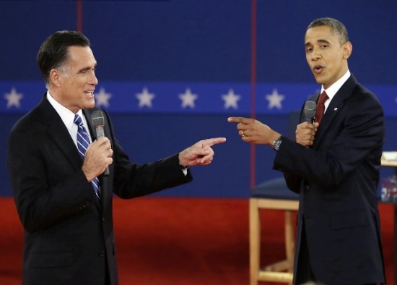

# **RULES:-**

Topic-

Proposed Venue: Seminar Hall, Raman Block

1. This will be an individual contest.
2. Each speaker will present his/her perspective/opinion then they have to encounter an interjection round from the audience/judges. The mode of expression can be either in ENGLISH or in HINDI. The speaker will be judged on the following criteria, and will be awarded marks accordingly.
3. Interpretation of the Motion
4. Logical Presentation of Argument
5. Evidences and Examples
6. Audibility
7. Stance and Gestures
8. Address and Format
9. Elocution / Diction / Fluency
10. Rebuttal of Interjection
11. Time limit- The speaker will speak for **3 minutes.** A **warning bell** will be rung after **2½ minutes**, and a final bell will be rung after the third minute. On exceeding the prescribed time, negative marks will be awarded.

# **QUIZ:-**

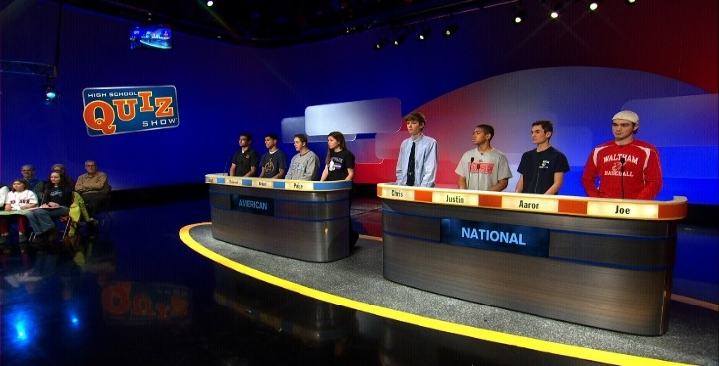  
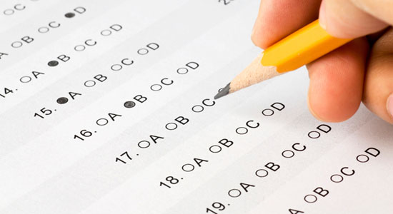

Proposed Venue: Seminar Hall, Raman Block

**General Rules**

* Either individual or team entries will be allowed.
* A team shall consist of two persons.
* Use of any electronic devices will result in immediate disqualification.
* The questions shall be in the form of True / False statement, Specific-answer question etc.
* The decision of the quiz-master will be final and will not be subjected to any change.
* The quiz will be in both Hindi and English languages.

This quiz will be held in 2 rounds.

-Preliminary round

-Mains round

**Preliminary Round**

1. Each team would be given 30 questions each to answer.
2. Time limit - 30 minutes.
3. Only 10 Teams would be selected for MAINS ROUNDS.
4. There will be negative marking in this round.
5. All the questions in this round will be of objective type only.

**Mains Round**

In this round, there will be only subjective questions in Hindi and English

languages. Winners will be decided on the basis of scores of this round.

# **Image result for creative writingCREATIVE WRITING:-**



Proposed Venue:- Seminar Hall,Raman Block

# **RULES:-**

* Entries must be written in English.
* Only one entry per person.
* All work must be original and unaided.
* The word count per entry is 500-1,000 words, please aim to keep within this.

# **JUDGING:-**

* Organizers will form a panel of highly qualified people to serve as competition judges.
* The decision of the judging panel is final and no correspondence will be entered into regarding the decision.

# **JUST A MINUTE(JAM)**



Proposed Venue:- Seminar Hall, Raman Block

# **RULES:-**

1. The decision made by JAM master will be final. No objection or argument should be there on the decision of JAM master.  
  
2. To object, slam the table and say “JAM”. The JAM master decides when you are allowed to put forth your objection.  
  
3. You get a penalty if the competition objects on any of the following counts:  
    a. You object out of turn.  
    b. You stutter, stammer, and generally indulge in “time-wasting tactics”. These include efforts to buy time like interspersing your talk with “uhh”, “aah” etc...  
    c. Early start and late start.  
    d. Speaking too fast or too slow.  
    e. Grammatical errors.  
    f. Undue stress on words, undue emphasis in the sentences.  
    g. Repetition of a previously used idea.

4. The total time is sixty seconds, inclusive of all the time that all the speakers in a given round are allowed to speak.  
  
5. Points are given in the following manner:  
    a. Positive points for every second that you speak.  
    b. Positive points for every correct objection.  
    c. Negative points for every incorrect objection.  
    d. Bonus points for being the last speaker.  
  
6. The winner is the person with the maximum number of points at the end of the round.

# **TREASURE HUNT:-**

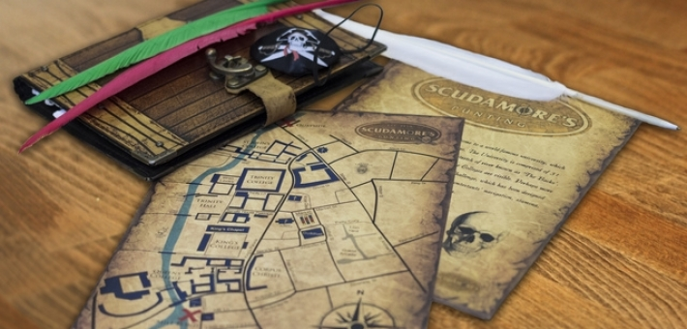

Proposed Venue:- Seminar Hall, Raman Block

# **RULES:-**

* Maximum of five members per team.
* Prelims will be conducted on the basis of number of registrations.
* The Treasure Hunt consists of 4-5 clues, each one leading to the next clue. Each correctly solved clue carries 10 points and final Treasure carries 50 points.
* The clues are to be found in a particular order. A team cannot skip a clue. Skipping a clue leads to disqualification of the team.
* Do not search for clues in off-limit areas.
* If you found other team’s clue by any chance never tamper it. A violation of this rule could cause disqualification of your team.
* You move any object to search the clue, kindly replace it back.
* All the clues of the teams are different and located at different places but the final destination i.e. the treasure is same. The team which finds the treasure wins first.

# **YOUTH PARLIAMENT:-**

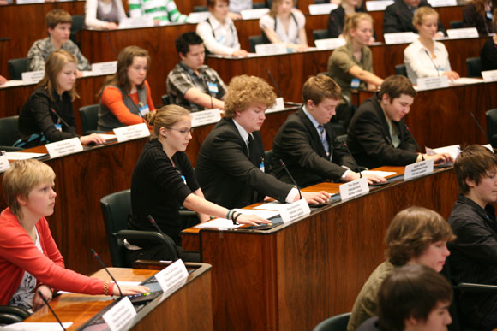

# **RULES:-**

Proposed Venue: Seminar Hall, Raman Block

Format of Proceedings:

1. The Youth Parliament is a simulation of the Indian Parliament wherein the participants appear as MPs and debate on issues of national importance. The MPs will be forming the government and the opposition with the government being a coalition of two or more parties. A party can leave the coalition on grounds of conflict of principles, or any other reasonable grounds but the decision should be rational. The Speaker will be evaluating each and every move of the MPs.

2. The Speaker will chair the House .There will also be a Deputy Speaker as per the wish of the Speaker of the House.

3. The Parliament will have 1 house- the Lok Sabha. A bill has to be passed in the house after which it will be sent to the President for his assent. The government shall send 3 representatives to present their case before the President after the bill is passed in both the Houses explaining the reasons for their bill to be passed. Its upto the discretion of the President to give his assent to the bill or not.

4. The government shall present the bill in its real original form as in the present day. However, amendments in the draft will come in after progressive debate with opposition in the House.

5. Its not binding on the MPs to take their government‘s stand on every issue. They may cast a negative vote or abstain from voting if they are unsatisfied with their party‘s decision.

6. A bill introduced in one house of the Parliament shall be discussed in the other House only when it is passed in the first House.

7. All bills require a simple majority to pass except Article 370, which will require a 2/3 majority as it involves an amendment of the constitution.

8. In case of a disagreement between the two houses over a bill, a joint session will be summoned to resolve the deadlock.

9. Apart from the bills, regular updates will be introduced in the houses to facilitate quick responses and actions in exigencies which will be a great learning process for the participants.