

**In-silico study on interaction between the potent endocrine**

**disruptor 4-Nonylphenol with plant extract to establish**

**it’ s therapeutic potential.**

A dissertation report submitted in partial fulfilment of the

requirement of the degree of

**Master of Science**

**In**

**Bioinformatics**

**May 2024**

**Supervised by:** **Submitted by:**

**Dr. Gautam Geeta J.** **Megha Joshi**

**Department of Zoology** **22428BIF011**

**Mahila Mahavidyalaya** **M.Sc. Bioinformatics**

**Banaras Hindu University Banaras Hindu University**

**Table of Content**

|  |  |  |
| --- | --- | --- |
| S.No. | Contents |  |
| 1 | Abstract |  |
| 2 | Abbreviation |  |
| 3 | Introduction |  |
| 4 | Material and Method |  |
| 5 | Result and Discussion |  |
| 6 | Conclusion |  |
| 7 | References |  |
| 8 | Supplementary files |  |

**In-silico study on interaction between the potent endocrine disruptor 4-Nonylphenol with plant extract to establish it’ s therapeutic potential.**

**Abstract**

Introduction : Endocrine disruptors are the chemicals which are either present in skin care products, detergents or formed as a byproduct in sewage treatment plant[8].one of a kind is 4-Nonylphenol it is hydrophobic, lipophilic non-ionic surfactant which is formed by degradation of nonylphenol ethoxylates[8][18]. It mimics steroidogenic enzymes and thereby disrupting steroidogenesis process[1][16]. It causes oxidative stress in the body by creating Reactive Oxygen Species[1][7][11]

Objective: To find out interaction of 4-Nonylphenol with reproductive markers in catfishes and predicting therapeutics like plant extracts to decrease the oxidative stress created by this ligand.

Methodology: I performed molecular docking where the ligand was taken as 4-Nonylphenol and receptors were all the steroidogenic enzymes and aromatase, interactions were seen and the enzyme which had highest binding affinity with 4-Nonylphenol was selected side by side interaction of antioxidant enzymes and 4-Nonylphenol was also done.

Now the enzyme which showed highest binding affinity with 4-Nonylphenol was interacted with all the antioxidant plant extracts and the plant extract which had highest binding affinity was selected.

Then literature review was done to select which plant extract to go with further but none of the literature review could summarise which plant extract had better antioxidant property as compared to other so these two plant extracts were interacted with antioxidant enzymes like Superoxide dismutase (SOD) and Catalase (CAT).

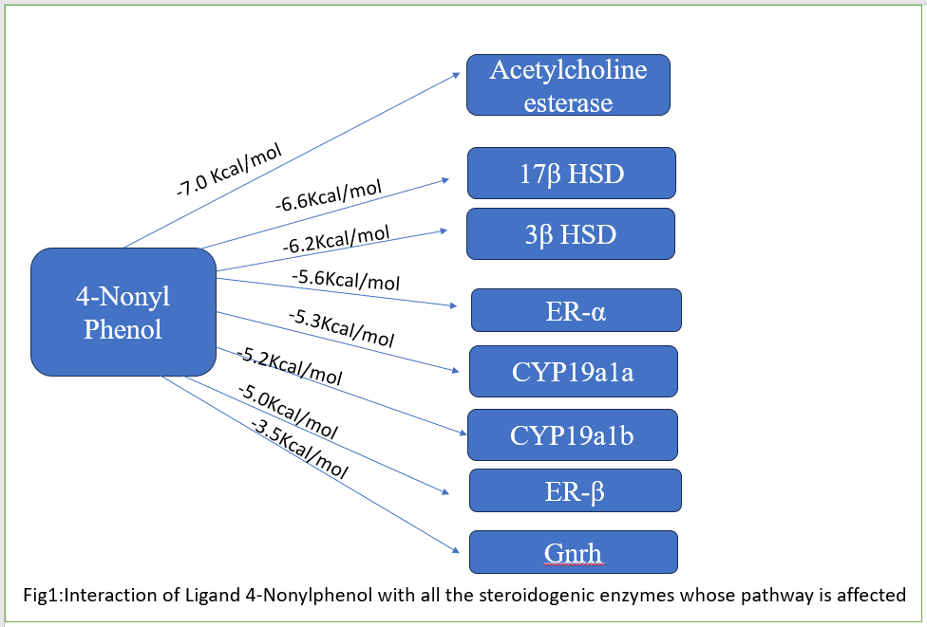Now among the 2 plant-extract the one which interacted more with SOD and CAT was selected.

Result: luteolin was the plant-extract which showed more interaction with SOD and CAT and according to [38][39] it was already proven in vitro how plant extracts work by increasing expression of these antioxidant enzymes so relying on their result I predict the use of Luteolin as therapeutic against 4-Nonylphenol.

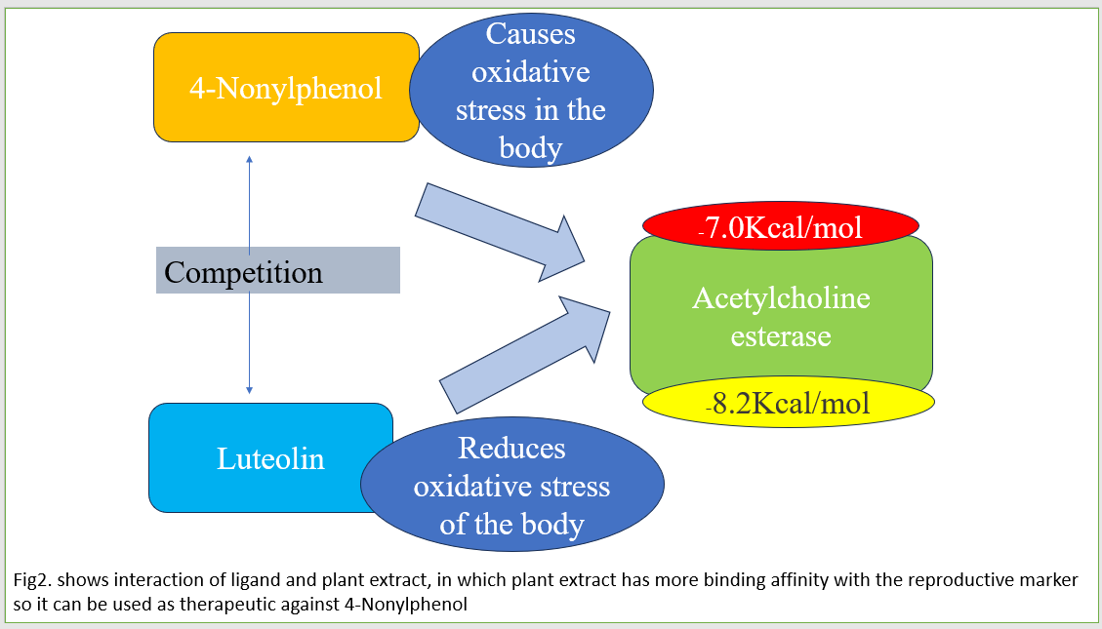

**Abbreviation:**

|  |  |
| --- | --- |
| 4-NP | 4-NonylPhenol |
| BPA | Bisphenol A |
| 17β-HSD | 17-beta Hydroxysteroid Dehydrogenase |
| 3β-HSD | 3-beta Hydroxysteroid |
| Cyp19a1a | Cytochrome P450 Family 19 Subfamily A Member 1A |
| Cyp19a1b | Cytochrome P450 Family 19 Subfamily A Member 1B. |
| ER-α | Endocrine Receptor alpha |
| ER-β | Endocrine Receptor beta |
| Ache | Acetylcholine esterase |
| SOD | Superoxide Dismutase |
| CAT | Catalase |
| GI-tract | Gastrointestinal tract |

**Introduction:**

Endocrine disruptors (EDCs) are exogenous chemicals as defined by US Environmental Protection Agency (EPA) “an agent that interferes with the synthesis, secretion, transport, binding, or elimination of natural hormones in the body that are responsible for the maintenance of homeostasis, reproduction, development and/or behaviour” (<https://www.epa.gov>). This compound can mimic, block, alter the actions of natural hormones disrupting the body’s regulatory processes[8][18]. Among the numerous EDC’s the one which is of particular concern is 4-Nonylphenol (4-NP ) due to its widespread presence and persistence in the environment[2][4][7][8][19].

4-NP is the degradation product of nonylphenol ethoxylates which are non-ionic surfactant[2][8][18], used extensively in industrial applications including as surfactants in detergents, pesticide emulsifiers and dispersing agent, cleaning products, plastic and elastomer manufacturing, textile processing, pulp and paper production, personal-care products, antioxidants for rubber manufacture and lubricant oil additives, as well as household sector and food processing, wetting and stablising agents [3][5][6][17]. It is released into aquatic ecosystem through sewage treatment plant discharges, agricultural runoffs, industrial effluents, municipal water discharges, not properly treated domestic waste water [2][3][7] and its hydrophobic property results in its pervasive presence in the environment as particulate matter which increase bioaccumulation [2][8][35][36] at each tropic level [31] as well as in surface waters, the concentration range is 0.004–24.3 μg/L [16][18]. [5] conducted a field study to check degradation of 4-NP in soil and even after 301-322 days after it was still detected. Its lipophilic nature also leads to accumulation in animal tissue, cell, organic materials etc [8][17]. 4-NP mode of action involves mimicking estrogen hormone by binding to its receptor [1], alter the expression of gene involved in hormone synthesis [4], metabolism and signaling pathways and induce oxidative stress by making reactive oxygen species which leads to oxygen deficiency in the body and leading to damage of cell and inflammation [12] due to which Europian Union has listed it in the priority of hazardous substance [4]. Many countries have banned the use as it was found out that it can transfer across the placenta, affects growth, development and reproduction in many ovarian-biota and causes apoptosis of cells [18][22][23][29]. Not only it causes reproductive disorders but other disorders like thyroid diseases, increase in diabetes, obesity etc [22]. Its Ecological and Environmental effects in aquatic ecosystem leads to damage among aquatic species like fishes [8][11].

In fishes 4-NP has been shown to disrupt steroidogenesis pathway, which is responsible for steroid hormone synthesis in the body like androgens and estrogens which regulate reproduction, growth and development to maintain homeostasis in the body.[7] conducted an experiment by intoxicating fishes with 4-NP found respiratory stress among fishes, they showed jerky movement and preferred upper layer for gulping air. [1] conducted an experiment where increase in the dosage of 4-NP causes increase in antioxidant enzymes like SOD. 4-NP increases ROS species in the body and brain is most vulnerable to free radical attacks so homeostasis needs to be maintained as it contains 60 percent of the polyunsaturated fatty acid [12] from literature it was noticed that increase in oxidative stress is responsible for altering expression of certain enzymes like Ache, SOD, CAT [11][12]. To study all the effects of 4-NP in catfishes we selected certain enzymes as reproductive markers, brain markers and oxidative markers to predict the interaction of 4-NP with all of them. Table 1. Mentions all the enzymes and their functions and how their concentration is altered when 4-NP is administered in fishes.

Table 1. shows reproductive markers and their functions

|  |  |  |
| --- | --- | --- |
| **Biomarkers** | **Function** | **3D structures** |
| Ache: | This enzyme plays a crucial role in the central nervous system, including functions such as neurotransmitter release, synaptic plasticity, and the regulation of neuronal electrical activity. According to [12], an increase in the concentration of 4-nonylphenol leads to a decrease in the concentration of Ache enzyme. |  |
| Cyp19a1b: | According to [40] it is a brain form of aromatase in fish. It has been found that it is regulated by sexual steroid like oestrogen that’s why it is a target for Endocrine Disruptors. |  |
| Cyp19a1a: | It is responsible for conversion of androgen into oestrogen in the steroidogenesis process, this process is known as aromatization.  [41]conducted an experiment on catfish *Clarias* *gariepinus* and found an increase of Cyp19a1a transcripts when an EDC was introduced. |  |
| 3βhsd: | It is responsible for catalytic conversion of pregnenolone to progesterone. It is also involved in further steroidogenesis pathway.  [42- check]  [36] |  |
| 17βhsd: | It converts androgen like androstenedione to the more potent testosterone and converts estrone into the more potent estradiol [43].  4-Nonylphenol shares structural similarity with this enzyme and therefore affecting the steroidogenesis process. It contains a benzene ring with a hydrophobic group that mimics the rings found in this enzyme. [8]. |  |
| ERα: | It is a nuclear receptor which functions as transcription factor. it is highly expressed in reproductive tissues and controls development and function [44][45]. |  |
| ERβ: | It is a nuclear receptor often expressed with Erα. It has anti-proliferative and anti- inflammatory effects. It is expressed in ovaries, central nervous system, GI tracts [45]. |  |
| GnRH: | It acts as the master regulator of puberty and adult reproductive cycle. It is responsible for synthesis, release, and control of sex hormones such as follicle stimulating hormone (FSH), luteinizing hormone (LH), and 17β-estradiol[11] |  |
| CAT & SOD | Superoxide dismutases are a group of metalloenzymes responsible for catalyzing the conversion of reactive oxygen species into hydrogen peroxide and oxygen molecules .This process helps decrease oxidative stress in the body. The expression of these enzymes can be influenced by the presence of endocrine disruptors, leading to either an increase or decrease in their activity.[20][21][22][38][39][30] | Catalase above and Superoxide dismutase below |

**Impact on fish population:**

Fishes play role as bioindicator for aquatic ecosystem increase in pollutant can be easily detected [23][35]. Similarly role of 4-NP had been calculated, according to some researchers [7] mortality has been increased with time dependent on the dose of 4-NP. It affects immune system of fishes, leads to several physiological problems which ultimately leads to death [8]. Interference of 4-NP with steroidogenesis has profound implications for their reproductive health and population sustainability. It causes alteration in the genes encoding proteins/ enzymes which are responsible for steroidogenic pathways , disturbs the level of hormones which can lead to impaired gametogenesis, reduced fertility, development. It . It mimicks hormones like oestrogen and 17β-HSD where it may affect gene expression level of such hormones and enzymes. Histological changes in gonadal structure, hepatocytes, gills, kidneys and other organs [11]. It causes inhibition of testicular growth, increase in serum vitellogenin levels and other gonadal abnormalities [11]. in fish such as Zoarces viviparous delay of spermatogenesis and increase in vitellogenesis had occurred [8]. in African catfish (Clarias gariepinus) embryonic development had severely affected due to 4-NP exposure and motility of sperm decreased [8]. Among different tissues of fish, the brain has been reported to accumulate the highest concentration of 4-nonylphenol (4-NP), while muscles show the least accumulation. The gills, liver, kidney, and ovary exhibit intermediate levels of accumulation. It has also been revealed that all tissues, except muscle, are involved in the metabolism of 4-NP uptake [8][11]. Fish can combat high concentrations of reactive oxygen species (ROS) through the action of ROS-scavenging enzymes such as superoxide dismutase (SOD), catalase (CAT), and glutathione reductase (GR) [12]. These antioxidant defense enzymes are induced by slight oxidative stress as a compensatory response; however, more severe oxidative stress suppresses enzyme activities due to oxidative damage [8]. As the dose of 4-NP increases, spermatozoa motility decreases significantly in the experimental groups exposed to NP. Investigations into the toxic effects of 4-NP on the embryonic development of African catfish (Clarias gariepinus) have also been conducted [33]. The study of haematological parameters in fish provides insights into the internal conditions of the fish long before any external manifestations of the effects of unfavorable environmental contaminants are observed [4]. Therefore, fish haematology is a crucial tool for assessing nutrition, health, diseases, and stress in response to changing environmental conditions. In fish, changes in blood cell distribution are correlated with environmental changes. Thus, in the presence of toxicants or other stressors, blood parameters can serve as standard laboratory test criteria for determining diseased conditions and metabolic disturbances [4][7]. Alterations in environmental conditions can harm hematopoietic organs in fish, leading to changes in the quantity and appearance of blood cells. Factors such as fish species, age, sex, season, and rearing methods can influence the differential leukocyte count and other hematological parameters. Studies have demonstrated that exposing fish to 4-nonylphenol (4-NP) increases the levels of damaged DNA and RNA, indicating its cytogenetic impact on Oreochromis spilurus. [7][8].

Table 2. shows plant extracts and their functions

|  |  |  |
| --- | --- | --- |
| **Plant extracts** | **Function** | **Structure** |
| 3,5-Difluoro-2-hydroxybenzaldehyde | This secondary  Metabolite shows  Antioxidative property  ( https://pubchem.ncbi.nlm.nih.gov/). |  |
| L- tyrosine | L-Tyrosine can act as promising antioxidant, antidiabetic and anticancer agents, and they can also be efficiently transported and eliminated in the body, making them useful candidates for drug designs[46]. |  |
| 3’-Bromo-6-hydroxy-2’,4,4’-trimethoxychalcone | This secondary  Metabolite has  Antioxidative property which is reduces oxidative  Stress caused by  Certain Endocrine  Disruptors  ( https://pubchem.ncbi.nlm.nih.gov/). |  |
| L-Acetyl carnitine | This compound acts as an antioxidant, alleviating metabolic stress within cells. It exhibits properties such as scavenging free radicals, superoxide anions, and hydrogen peroxide, as well as demonstrating total reducing power. [47]. |  |
| D-Pantothenic acid | protect cells against oxidative stress by increasing the amount of glutathione and promoting cellular repair mechanisms by potentiating synthesis of membrane phospholipids [48]. |  |
| Betaine | BET demonstrates protective effects against oxidative stress inducers like ethanol and levodopa in multiple organs, including the liver, brain, kidney, stomach, and ovaries. Its antioxidant properties suggest potential applications in agriculture and human health.[49]. |  |
| (E)-Ferulic acid | It traps free radicals, but also can increase the scavenging free-radicals activity of enzymes and inhibit the production of superoxide ions which are free radicals catalysed by the enzymes [50]. |  |
| Caffeic acid | Anti oxidative property helps in prevent the oxidation of other molecules in the body. such as effective mitigation of methanol-induced oxidative stress [51]. |  |
| 2’-Hydroxyfurano[2’’,3’’:4’,3’]chalcone | a flavonoid  Which has one hydrogen bond  Donor and acceptor. It is responsible for  Lessening oxidative stress in organism’s body ( https://pubchem.ncbi.nlm.nih.gov/). |  |
| Luteolin | play a wide range of pharmacological functions such as anticancer, anti-inflammatory, antioxidant, antiviral, hepato and neuroprotective properties [52]. |  |
| Pinellic acid | has a role as an antioxidant and an anti-inflammatory agent[53]. |  |
| 4-Methoxycinnamic acid | antibacterial, antifungal, anti-inflammatory, neuroprotective, and inhibiting cancer [54]. |  |
| 6-Gingerol | 6-Gingerol is recognized for its diverse biological effects, including anti-cancer, anti-inflammatory, and antioxidant properties. Studies have revealed its anticancer potential through actions on various biological pathways, such as apoptosis, cell cycle regulation, cytotoxicity, and angiogenesis inhibition [55]. |  |

**Objective:** To investigate the interaction of 4-nonylphenol with specific biological markers, namely genes or enzymes with known relevance to a particular biological process or disease state. Subsequently, goal is to evaluate how different plant extracts can influence the activity or expression of these markers when exposed to 4-nonylphenol. This investigation is motivated by another goal of identifying plant extracts that demonstrate therapeutic potential by influencing the behavior or function of these biological markers, which may provide insights into the potential therapeutic use of these plant extracts.

**Material and Methodology:**

Software and tools:

UNIPROT :Biological markers (enzymes) were downloaded from UNIPROT database (https://www.uniprot.org/ ).

PUBCHEM: ligand which is 4-NonylPhenol is downloaded from PUBCHEM (https://pubchem.ncbi.nlm.nih.gov/) .

Auto Dock Vina: The Molecular Docking interactions was conducted using Auto Dock Vina (https://vina.scripps.edu/)

PyMOL (version 4.6.0 ): was used for visualisation of protein structure, for addition of missing residue in the structure and for removal of water molecules (Schrödinger, L., & DeLano, W. (2020). *PyMOL*. Retrieved from http://www.pymol.org/pymol).

CASTp :analysis used for prediction of active sites (**Tian et al., Nucleic Acids Res. 2018. PMID:**[29860391](https://www.ncbi.nlm.nih.gov/pubmed/29860391)**DOI:**[10.1093/nar/gky473](https://doi.org/10.1093/nar/gky473)).

CHIMERA: used for analysis of docking result (https://www.cgl.ucsf.edu/chimera/).

DISCOVERY STUDIO VISUALIZER (version 24.1.): used for analysis of all the interactions between ligand and receptors ([BIOVIA Discovery Studio](https://www.3ds.com/products/biovia/discovery-studio)).

**Docking Process:**

Preparation of PDB file before docking

1. Download a protein crystal structure from PDB and if the structure is not predicted download alpha fold structure PDB file of your proteins from uniport. The proteins used here were obtained among different group of species of cat fishes which are :17 beta hydroxysteroid dehydrogenase (17β-HSD) of *Clarias batrachus*, 3-beta hydroxysteroid dehydrogenase (3β-HSD) of *Clarias batrachus*, Oestrogen receptor alpha of *Clarias gariepinus*, Oestrogen receptor beta of *Clarias magur*, Gonadotrophin releasing hormone – 2 (GnRH-2) of *Heteropneustes fossilis*, Cytochrome P450 aromatase (Cyp19a1) of *Tachysurus* *fulvidraco*.
2. Empty all the binding pockets by removing the bound ligand which can be done by deleting all hetatoms from the PDB file. In alpha fold structures this problem does not occurs.
3. We will keep only one chain among all other chains and save the file as “protein_name.pdb” as many chains would have created complexity but from literature make note of the chains which are involved more in the protein function.
4. After all these steps our protein structure is prepared now, we need to prepare the ligand which will be docked with these proteins and the interactions will be noted and observed.

Preparation of ligand before docking

1. For ligand we have two options either we can download the structure from ZINC database or PubChem(https://pubchem.ncbi.nlm.nih.gov/).
2. Open PubChem and write 4-NonylPhenol and look for tab which has 3-dimensional structure of ligand. Click on “Download” among different formats here .SDF format is used.[56]
3. To work on Autodock vina both files should be in PDBQT formats so convert this .SDF file into .PDBQT file.
4. Download “Open Babel GUI” from internet which I used as a tool to convert any file format into another file format, here we will be converting .SDF into .PDBQT.

Insert .SDF file into left side section where input option is clearly mentioned then save the file in your respective folder now click on output tab which will convert the file and save in that respective folder in .PDBQT format or using PyMol we can convert our file too, tap on “FILE” - > “Save Molecule” - > select the molecule - > click “OK” but that would be an indirect conversion .SDF - > .PDB - > use Auto Dock Vina to convert into .PDBQT.

1. Now rename the ligand as “ligand_name.pdbqt” .

For each protein make a folder and keep a copy of ligand_name.pdbqt file in each.[19]

We have prepared a .pdbqt file of the ligand and now we will prepare the protein file.

1. Open Auto Dock Vina, click “FILE” - > click “Read Molecule” - > select protein.pdb.
2. Remove water molecules. Click “Edit” and click on “Delete water”.
3. We will add polar hydrogens in order to avoid any empty group/atom left in the protein. Click “Edit” - > click “Add Hydrogens” - > click “Polar only”.
4. We will save this file as .pdbqt, click “Grid” - > click “Macromolecule” - > click “Choose”

- > select the “protein.pdb” - > click “OK”. After this step it will ask for saving the file, click the same folder where .pdb file was saved, rename the file by adding qt with pdb so it turns to a protein.pdbqt file.

Till now we have completed conversion of file formats now the task is to find active sites or pockets where ligand will bound.

An online tool called “CASTp- Computed Atlas of Surface Topography of proteins” which is also available in offline mode, it suggests all the possible active sites of a particular protein.

Use of CASTp for active site prediction

1. Click on “calculation” tab a different window will open , click on “FILE” upload your protein file, let the default radius ignore email.id information. Click on SUBMIT button
2. A pop-up will show which gives link to a new window where the result can be seen. Click on that link and download the file.
3. Downloaded file will be available in downloads it will be a zip file so we need to extract it, right click on that and select extract all option.
4. Inside a folder 6 files will be available among them we only need the one which has “.poc” extension on it.

Next task is to visualize the active site, note down all the amino acids involved and find out the coordinates so that grid box can be made and docking can be specific.

Use of Chimera and PyMol

1. Open google type chimera and download latest version which is 1.17.3, after all the set up is done click on file and below on the left side select format as “.poc” among respective folder select your protein.
2. 2 pop-up windows will open one with the protein structure and one with the table in which all the active pockets available on that protein are mentioned
3. Select the first one and then click on pop-up with protein structure and click on “Favourites” tab - > click on Sequence. A new pop-up window appears which consists of all the amino acids of protein written in sequence and an amino-acids are highlighted by green colour which shows they are part of active site.
4. Note down those active site amino acids.
5. Now open PyMol and drag your protein in it, select all the amino acids which you noted before and create a variable to store it.
6. Then type on command line “Centreofmass _variablenamehere” so it gives the coordinates for amino acids location in the whole protein.
7. Note down all the coordinates for each protein. These coordinates will be used while Grid box formation.

Defining Grid Box for docking

We are performing specific- docking, we have noted active sites coordinates now we enclose only that part of protein inside grid box.[37][19]

1. Click “Grid” - > “Grid Box”.

A small window pops up in which x, y and z coordinates can be seen.

1. Now adjust spacing to be 1.0
2. Write all the coordinates in respective spaces below spacing.
3. Note down the number of points in x, y and z dimension.
4. After adjusting the grid box, click “file” - > click “Output Grid Dimension File” - > save this file as grid.txt in the same folder where protein and ligand pdbqt files are saved.
5. Click “file” - > Click “Close saving current”.
6. Now close the Autodock Vina.

You will get the grid file as follows: **grid.txt**

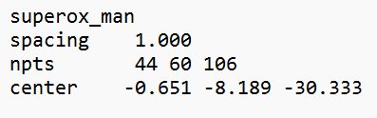

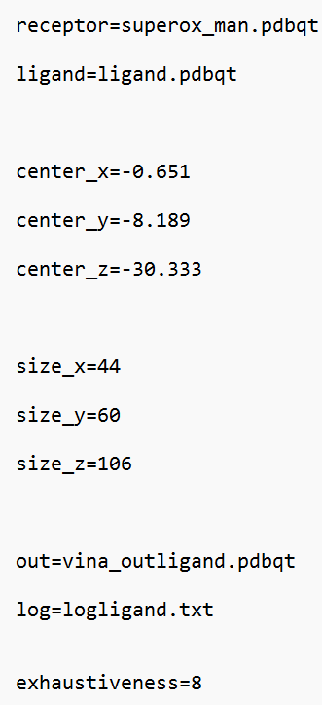Preparation of Configuration file

Auto-Dock Vina requires an input configuration file which contains all the information of the parameters used in configuring the docking including the name of the protein and the ligand. The configuration is as follows:

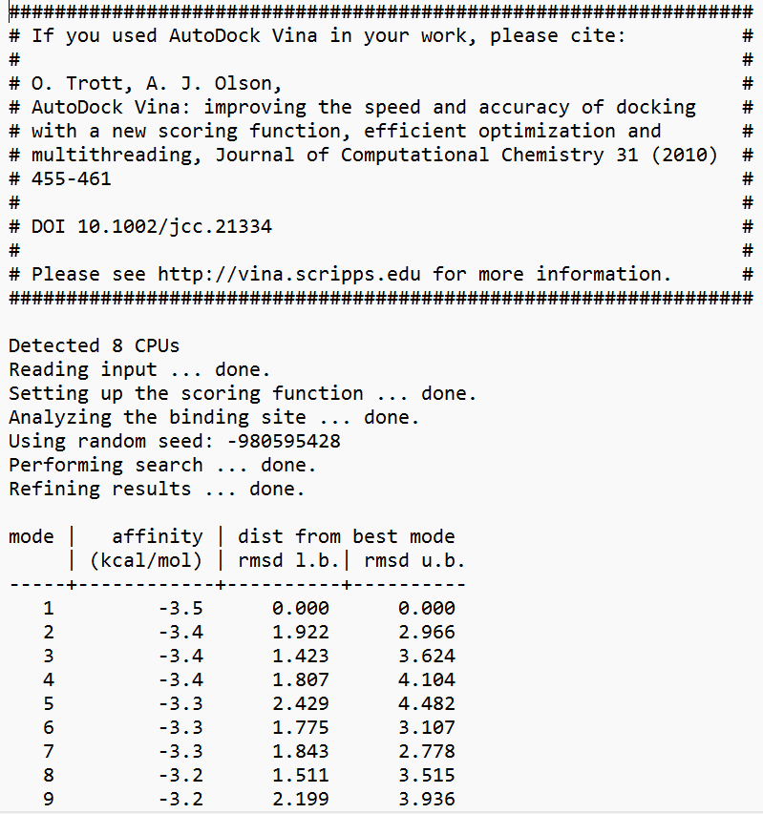 **conf.txt**

Rename grid.txt file as “conf.txt”.

Perform Docking

Files such as:

1.protein_name.pdbqt

2.ligand.pdbqt

3.conf.txt

4.All the MGL_Tools, Auto-dock Tools, and Auto-dock Vina setup files.

My operating system :I work in is Windows so accordingly the commands were used for command prompt.

1. Open the command prompt and enter the folder where all the docking files are placed.
2. Type the following command:

vina --config conf.txt --log logligand.txt

Vina Output[19]

After the successful docking, you will get a log file, which in this case is named “logligand.txt”.

The log file will look like this:

**Result and Discussion:**

4-Nonylphenol an endocrine disruptor is responsible for affecting steroidogenic enzymes, it resembles structure similar to those enzymes or it mimics their function so it binds to the natural receptors and increases oxidative stress inside body of catfishes and alters gene expression causes apoptosis of cell.

Three types of markers were taken to analyse the activity of 4-NP in fishes. Reproductive markers like Cyp19a1a, Cyp19a1b, 3β-HSD, 17β-HSD to analyse the effect of 4-NP on reproductive system in fishes, Brain biomarker like Ache to analyse the effect of ROS caused by 4-NP and Antioxidant biomarkers like SOD and CAT to check the expression of these enzyme whether it increases or decreases when 4-NP interacts with it.

Molecular docking was performed to check which biomarker binds to the ligand more so that further analysis with the plant extracts can be proceeded.

Acetylcholine esterase was found to be the one with highest binding affinity out of all other plant extracts which was -7.0Kcal/mol as mentioned in Table3. Brain is most vulnerable to attacks by superoxide ions basically the reactive oxygen species, increase in the expression of Ache was seen in brain the most and least in muscle when 4-NP was administered [8] [12]. Therefore this in vitro experiment proves the more binding affinity of Ache towards 4-NP. Binding affinity of all the other biomarkers is also available in Table3.

From here all these pictures will represent a 3-Dimensional and 2-Dimensional interactions of all the Biomarkers with ligand 4-NP.

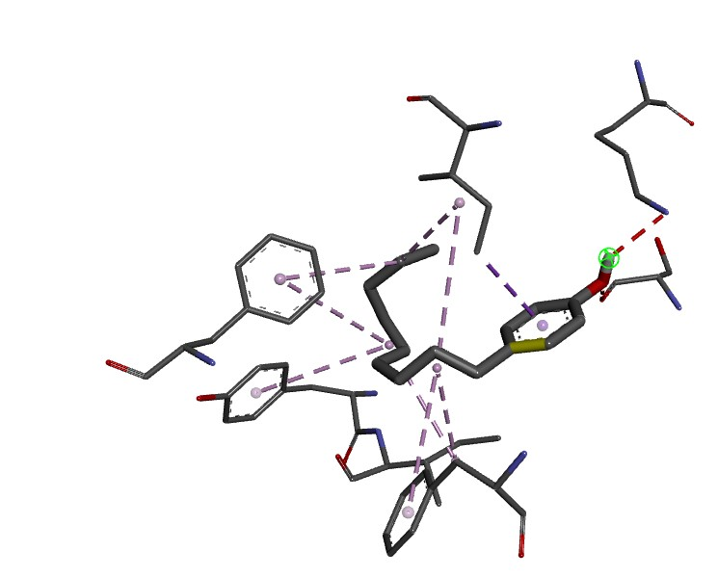

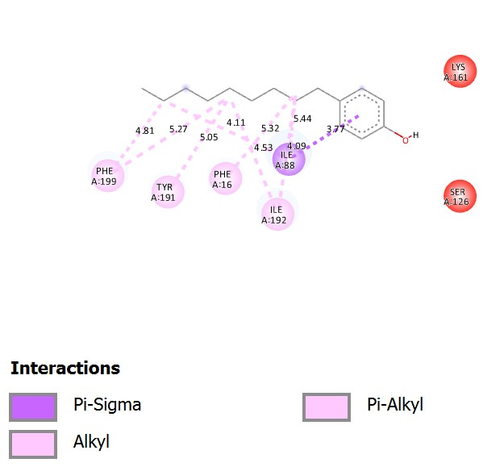

3β-HSD 2D as well as 3D interaction images

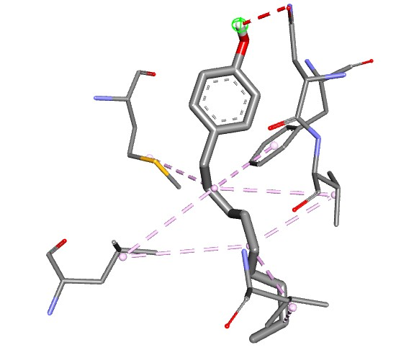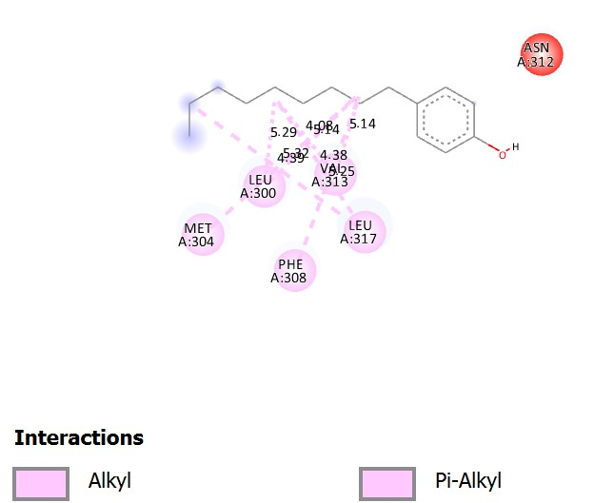

Oestrogen receptor beta 2D as well as well as 3D interaction images

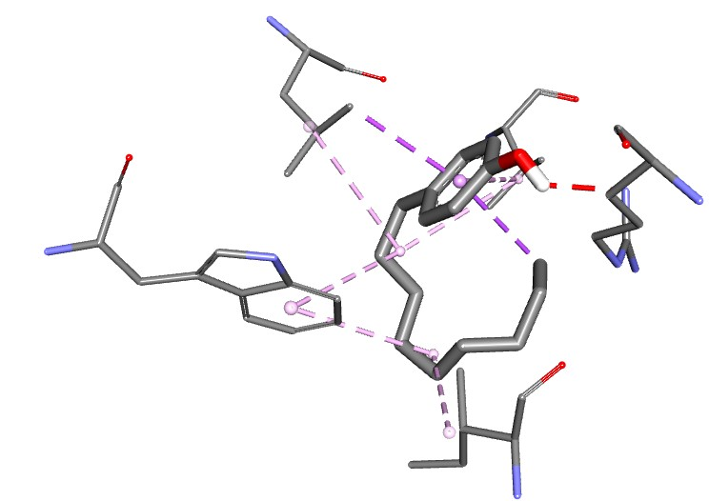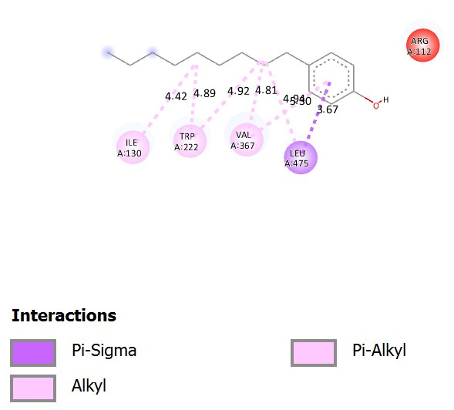

Cyp19a1b 2D as well as 3D interaction images

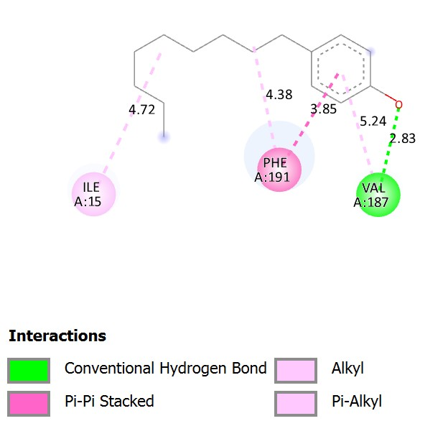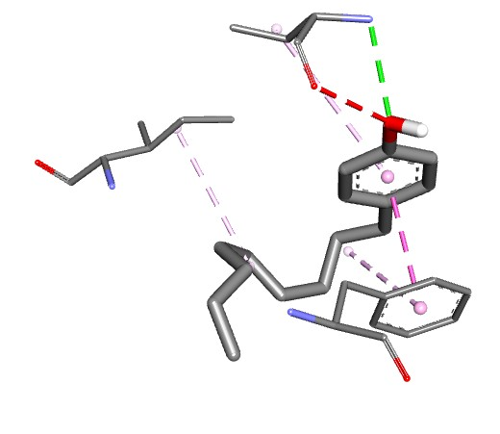

17β-HSD 2D as well as 3D interaction images

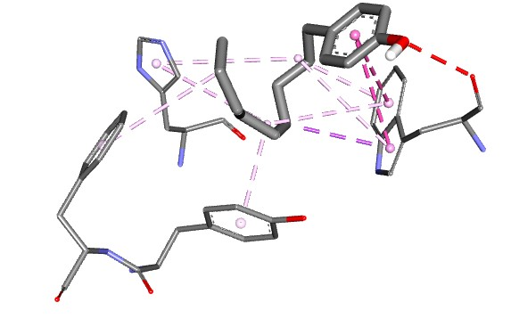

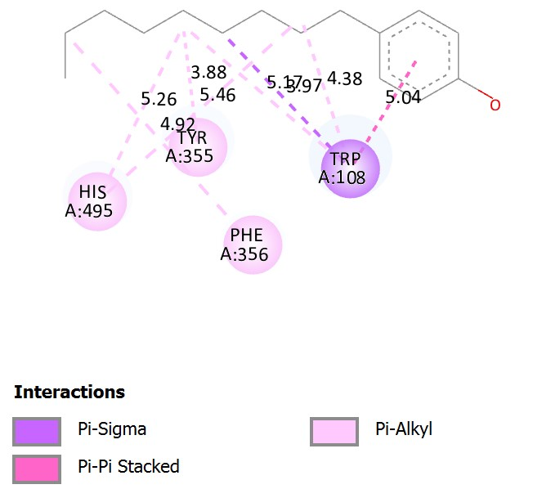

Acetylcholine esterase 2D as well as 3D interaction images

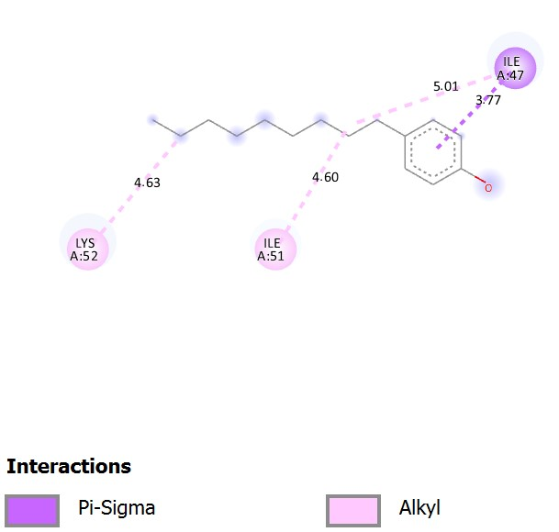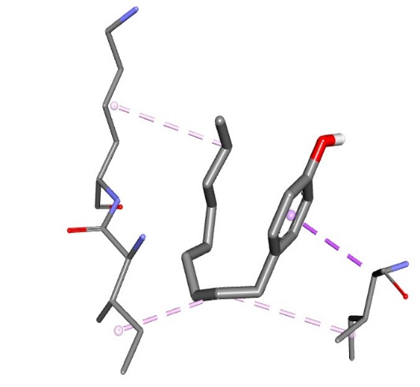

Gonadotrophin releasing hormone 2D and 3D interaction pictures

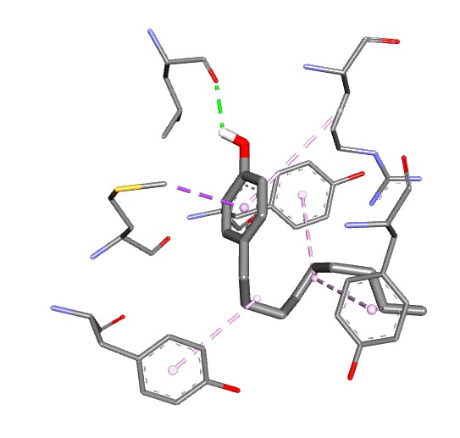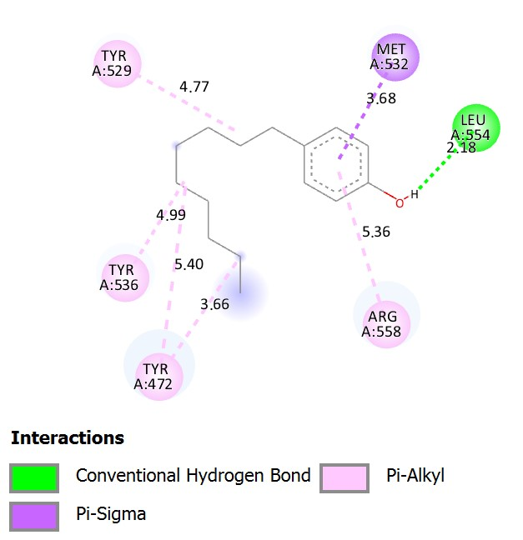

Oestrogen receptor alpha 2D as well as 3D interaction pictures

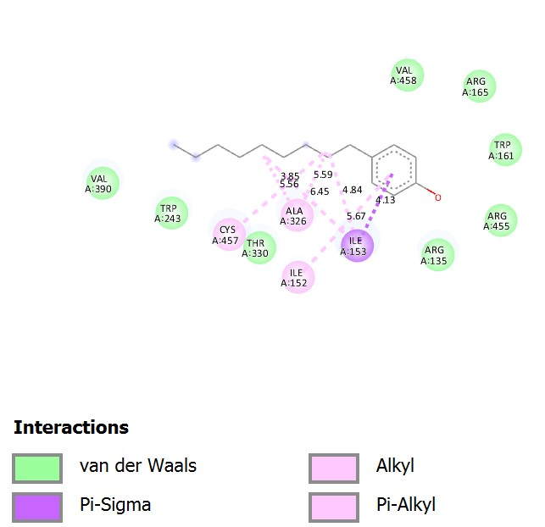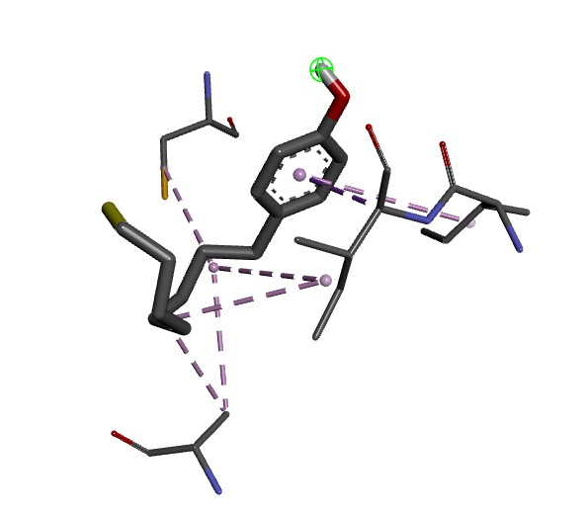

Cyp19a1a 2D as well as 3D interaction pictures

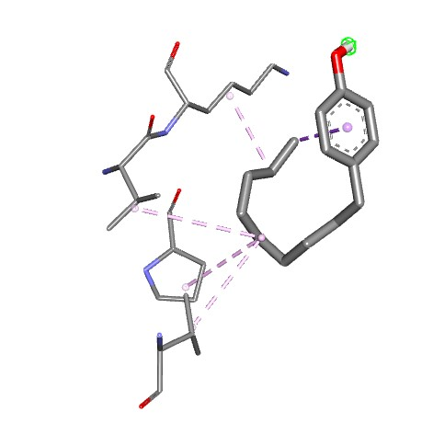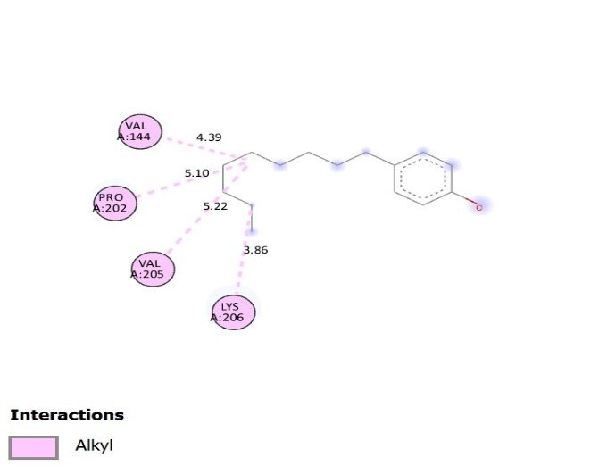

Superoxide dismutase 2D as well as 3D interaction images

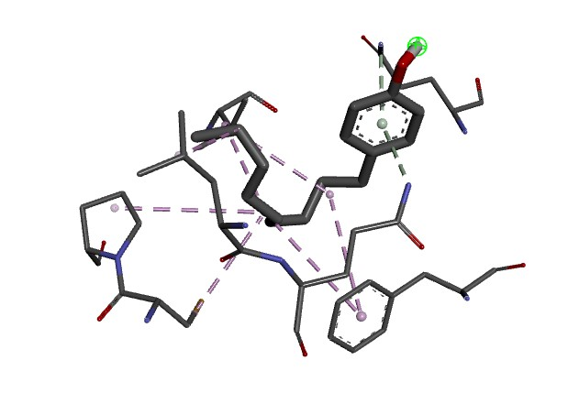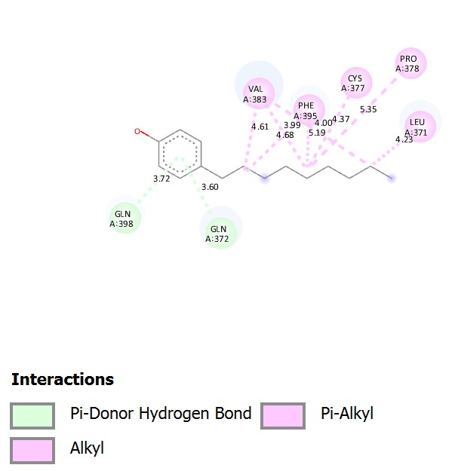

Catalase 2D as well as 3D interaction images

Table 3. shows binding affinity of all the Reproductive Markers with ligand 4-Nonylphenol

|  |  |  |  |  |
| --- | --- | --- | --- | --- |
| **Enzyme** | **Ligand** | **Binding affinity**  **(kcal/mol)** | **No. of H bonds** | **Amino acid involved in interaction** |
| SOD | 4-NP | -4.3 | 0 | ValA144,ProA202,ValA205,LysA206 |
| CAT | 4-NP | -6.1 | 0 | ValA383,PheA395,CysA377,ProA378,LueA371 |
| Ache | 4-NP | -7.0 | 0 | HisA495,TyrA355,PheA356,TryA108 |
| 3β-HSD | 4-NP | -6.2 | 0 | PheA199,TyrA191,PheA16,IleA88,IleA192 |
| Cyp19a1b | 4-NP | -5.2 | 0 | IleA130,TryA222,ValA367,LeuA475 |
| Cyp19a1 | 4-NP | -5.3 | 0 | CysA457,AlaA326,IleA152,IleA153 |
| 17β-HSD | 4-NP | -6.6 | 0 | IleA15,PheA191,ValA187 |
| ER-α | 4-NP | -5.6 | 1 | TyrA529,TyrA536,TyrA472,ArgA558,LeuA554,MetA532 |
| ER-β | 4-NP | -5.0 | 0 | LeuA300,MetA304,PheA308,LeuA317,ValA313 |
| GnRH | 4-NP | -3.5 | 0 | LysA52,IleA51,IleA47 |

Now the task was to check whether the plant extracts which I have selected which shows antioxidant property can be predicted to be used as therapeutic, whether they can decrease the oxidative stress caused by 4-NP. These plant extracts which are basically flavonoids have been in trend since the distant past and have not been worked upon against 4-NP. We decided to check interaction of these plants extracts with biomarker Ache of catfish and find out which flavonoid shows highest interaction with Ache.

Molecular Docking was done and 2 flavonoids 3,5-difluoro-2-hydroxybenzaldehyde and Luteolin showed highest similar binding affinity of -8.2 Kcal/mol as it can be seen in Table 4.

Table 4. shows binding affinity between plant extracts and Acetylcholine esterase

|  |  |  |
| --- | --- | --- |
| Serial No | Plant Extract | Binding affinity for Acetylcholine esterase (Kcal/mol) |
| 1 | 3,5-difluoro-2-hydroxybenzaldehyde | -8.2 |
| 2 | L-tyrosine | -6.4 |
| 3 | 3’Bromo-6’-hydroxy-2’4,4’-trimethoxychalcone | -6.0 |
| 4 | L-Acetyl carnitine | -5.1 |
| 5 | D-pantothenic acid | -5.4 |
| 6 | Betaine | -3.7 |
| 7 | (E)-ferulic acid | -5.9 |
| 8 | Caffeic acid | -6.5 |
| 9 | 2’-Hydroxyfurano[2’’,3’’:4’,3’] chalcone | -6.0 |
| 10 | Luteolin | -8.2 |
| 11 | Sedanolide (3-butyl-3a,4,5,6-tetrahydro-3H-2-benzofuran-1-one) | -6.7 |
| 12 | Pinellic acid | -6.9 |
| 13 | 4-Methoxycinnamic acid | -6.2 |
| 14 | 6-Gingerol | -6.8 |

Now it became tedious to analyse which plant extract among these two shows more antioxidant property. Exhaustive literature search was done and any paper which conclude which flavonoid has more power in decreasing oxidative stress was not found so I performed interactions of both flavonoids with SOD and CAT and the binding affinity as can be seen in Figure3. Of Luteolin is highest.

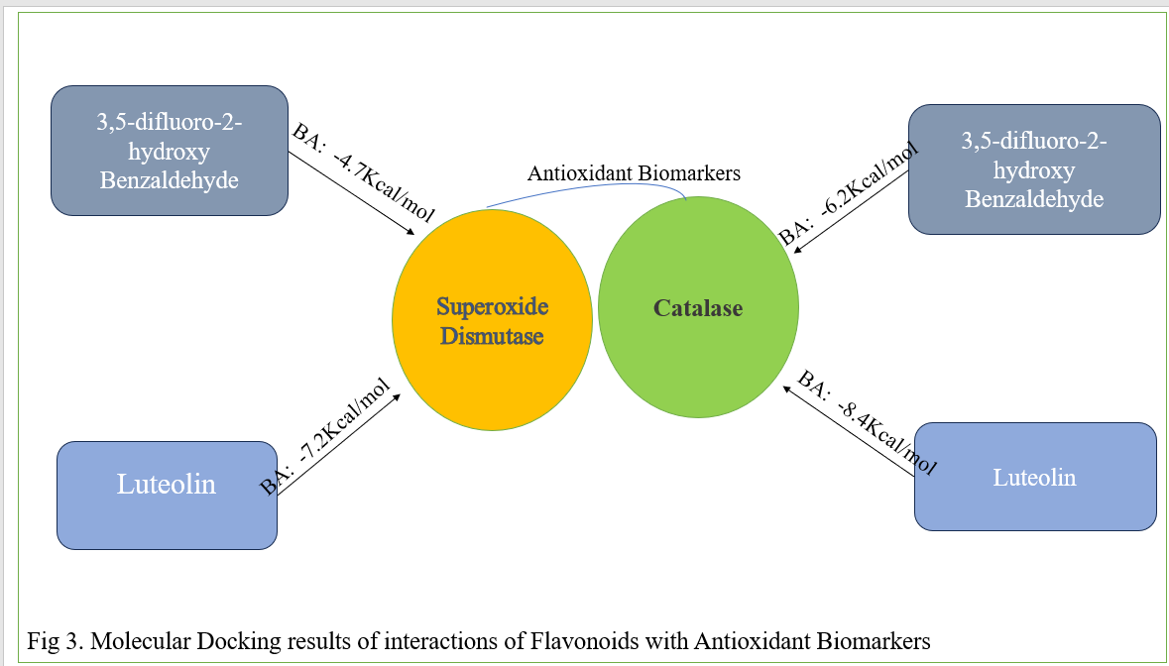

[56] conducted an experiment with Bisphenol A (BPA) an endocrine disruptor similar to 4-NP which mimics the hormone oestrogen, experimental results showed that when BPA activity was increased up-to a level use of Quercetin a Flavonoid increases the expression of SOD and CAT to help combat oxidative stress which was caused by BPA. I conclude that Luteolin which showed most binding affinity with SOD and CAT can be used as therapeutic against 4-NP which will help in depleting oxidative stress caused by 4-NP.

**Conclusion:**

4-Nonylphenol (4-NP) is an organic compound primarily used as a precursor to nonylphenol ethoxylates, which are surfactants in detergents, emulsifiers, and industrial cleaners. It is an endocrine disruptor, affecting hormone systems and posing ecological risks by accumulating in aquatic environments. Superoxide dismutase (SOD) and catalase are enzymes that protect cells from oxidative damage. SOD catalyzes the dismutation of superoxide radicals into oxygen and hydrogen peroxide, while catalase further breaks down hydrogen peroxide into water and oxygen, reducing oxidative stress and preventing cellular damage. Using computational tools and methods it is predicted that 3,5-difluoro-2-hydroxy Benzaldehyde and Luteolin can produce therapeutic effect by increasing the expression of SOD and CAT in decreasing oxidative stress in the body.

**References:**

1. Tao, S., Yao, Z., Li, H., Wang, Y., Qiao, X., Yu, Y., ... & Li, S. (2023). Exposure to 4-nonylphenol compromises Leydig cell development in pubertal male mice. *Ecotoxicology and Environmental Safety*, *266*, 115612.
2. Mao, Z., Zheng, X. F., Zhang, Y. Q., Tao, X. X., Li, Y., & Wang, W. (2012). Occurrence and biodegradation of nonylphenol in the environment. *International journal of molecular sciences*, *13*(1), 491-505.
3. Reshmi, S., Remya, V. S., Anjali, V. R., Mahim, S. S., & Devi, C. A. (2019). Alterations in Hepatic Antioxidant Systems and Lipid Peroxidation Products in a Freshwater Fish, Labeo rohita, Exposed to 4-Nonylphenol, an Endocrine Disruptor. *Journal of Endocrinology and Reproduction*, *23*(1), 13-24.
4. Sharma, M., & Chadha, P. (2019). Immunological impairment as a marker of 4-nonylphenol induced stress. *Indian Journal of Animal Sciences*, *89*(6), 695-698.
5. De Bruin, W., Kritzinger, Q., Bornman, R., & Korsten, L. (2019). Occurrence, fate and toxic effects of the industrial endocrine disrupter, nonylphenol, on plants-a review. *Ecotoxicology and Environmental Safety*, *181*, 419-427.
6. Abd-Elkareem, M., Abou Khalil, N. S., & Sayed, A. H. (2018). Hepatotoxic responses of 4-nonylphenol on African catfish (Clarias gariepinus): antixoidant and histochemical biomarkers. *Fish physiology and biochemistry*, *44*, 969-981.
7. Sharma, M., Chadha, P., & Borah, M. K. (2015). Fish behaviour and immune response as a potential indicator of stress caused by 4-nonylphenol. *American Journal of Biosciences*, *3*(6), 278-283.
8. Sharma, M., Chadha, P., & Madhu Sharma, C. (2018). Toxicity of non-ionic surfactant 4-nonylphenol an endocrine disruptor: A review. *International Journal of Fisheries and Aquatic Studies*, *6*(2), 190-197.
9. Ballante, F., Kooistra, A. J., Kampen, S., de Graaf, C., & Carlsson, J. (2021). Structure-based virtual screening for ligands of G protein–coupled receptors: what can molecular docking do for you?. *Pharmacological Reviews*, *73*(4), 1698-1736.
10. Ferreira, L. G., Dos Santos, R. N., Oliva, G., & Andricopulo, A. D. (2015). Molecular docking and structure-based drug design strategies. *Molecules*, *20*(7), 13384-13421.
11. Sayed, A. E. D. H., & Ismail, R. F. (2017). Endocrine disruption, oxidative stress, and testicular damage induced by 4-nonylphenol in Clarias gariepinus: the protective role of Cydonia oblonga. *Fish physiology and biochemistry*, *43*, 1095-1104.
12. Eid, Z., Mahmoud, U. M., Mekkawy, I. A., Abdel-Tawab, H. S., & Sayed, A. E. D. H. (2021). 4-Nonylphenol induced brain damage in juvenile African catfish (Clarias garepinus). *Toxicology and Environmental Health Sciences*, *13*, 201-214.
13. Jairajpuri, D. S., Hussain, A., Nasreen, K., Mohammad, T., Anjum, F., Rehman, M. T., ... & Hassan, M. I. (2021). Identification of natural compounds as potent inhibitors of SARS-CoV-2 main protease using combined docking and molecular dynamics simulations. *Saudi Journal of Biological Sciences*, *28*(4), 2423-2431.
14. Meng, X. Y., Zhang, H. X., Mezei, M., & Cui, M. (2011). Molecular docking: a powerful approach for structure-based drug discovery. *Current computer-aided drug design*, *7*(2), 146-157.
15. Werkneh, A. A., Gebru, S. B., Redae, G. H., & Tsige, A. G. (2022). Removal of endocrine disrupters from the contaminated environment: public health concerns, treatment strategies and future perspectives-A review. *Heliyon*, *8*(4).
16. Paolella, G., Romanelli, A. M., Martucciello, S., Sposito, S., Lepretti, M., Esposito, C., ... & Caputo, I. (2021). The mechanism of cytotoxicity of 4‐nonylphenol in a human hepatic cell line involves ER‐stress, apoptosis, and mitochondrial dysfunction. *Journal of Biochemical and Molecular Toxicology*, *35*(7), e22780.
17. Chung, S. W. (2021). The development of isomer-specific analysis of branched 4-nonylphenol in food for dietary exposure-a critical review of analytical methods and occurrence in foodstuffs. *Food Additives & Contaminants: Part A*, *38*(5), 842-855.
18. Noorimotlagh, Z., Mirzaee, S. A., Ahmadi, M., Jaafarzadeh, N., & Rahim, F. (2018). The possible DNA damage induced by environmental organic compounds: The case of Nonylphenol. *Ecotoxicology and environmental safety*, *158*, 171-181.
19. Ferreira, L. G., Dos Santos, R. N., Oliva, G., & Andricopulo, A. D. (2015). Molecular docking and structure-based drug design strategies. *Molecules*, *20*(7), 13384-13421.
20. Zhao, H., Zhang, R., Yan, X., & Fan, K. (2021). Superoxide dismutase nanozymes: an emerging star for anti-oxidation. *Journal of Materials Chemistry B*, *9*(35), 6939-6957.
21. Touati, D. (1989). The molecular genetics of superoxide dismutase in E. coli. An approach to understanding the biological role and regulation of SODS in relation to other elements of the defence system against oxygen toxicity. *Free Radical Research Communications*, *8*(1), 1-9.
22. Bunton-Stasyshyn, R. K., Saccon, R. A., Fratta, P., & Fisher, E. M. (2015). SOD1 function and its implications for amyotrophic lateral sclerosis pathology: new and renascent themes. *The Neuroscientist*, *21*(5), 519-529.
23. Rajakumar, A., & Senthilkumaran, B. (2020). Steroidogenesis and its regulation in teleost-a review. *Fish Physiology and Biochemistry*, *46*(3), 803-818.
24. Zelko, I. N., Mariani, T. J., & Folz, R. J. (2002). Superoxide dismutase multigene family: a comparison of the CuZn-SOD (SOD1), Mn-SOD (SOD2), and EC-SOD (SOD3) gene structures, evolution, and expression. *Free radical biology and medicine*, *33*(3), 337-349.
25. Brioukhanov, A. L., & Netrusov, A. I. (2004). Catalase and superoxide dismutase: distribution, properties, and physiological role in cells of strict anaerobes. *Biochemistry (Moscow)*, *69*, 949-962.
26. Yadetie, F., Arukwe, A., Goksøyr, A., & Male, R. (1999). Induction of hepatic estrogen receptor in juvenile Atlantic salmon in vivo by the environmental estrogen, 4-nonylphenol. *Science of the total environment*, *233*(1-3), 201-210.
27. Laws, S. C., Carey, S. A., Ferrell, J. M., Bodman, G. J., & Cooper, R. L. (2000). Estrogenic activity of octylphenol, nonylphenol, bisphenol A and methoxychlor in rats. *Toxicological Sciences*, *54*(1), 154-167.
28. Pachura, S., Cambon, J. P., Blaise, C., & Vasseur, P. (2005). 4‐nonylphenol‐induced toxicity and apoptosis in Hydra attenuata. *Environmental Toxicology and Chemistry: An International Journal*, *24*(12), 3085-3091.
29. Balakrishnan, B., Thorstensen, E., Ponnampalam, A., & Mitchell, M. D. (2011). Passage of 4-nonylphenol across the human placenta. *Placenta*, *32*(10), 788-792.
30. López-Pacheco, I. Y., Salinas-Salazar, C., Silva-Núñez, A., Rodas-Zuluaga, L. I., Donoso-Quezada, J., Ayala-Mar, S., ... & Parra-Saldívar, R. (2019). Removal and biotransformation of 4-nonylphenol by Arthrospira maxima and Chlorella vulgaris consortium. *Environmental research*, *179*, 108848.
31. Brown, R. J., Conradi, M., & Depledge, M. H. (1999). Long-term exposure to 4-nonylphenol affects sexual differentiation and growth of the amphipod Corophium volutator (# Pallas, 1766). *Science of the Total Environment*, *233*(1-3), 77-88.
32. Yang, L., Zha, J., & Wang, Z. (2017). Pentachlorophenol affected both reproductive and interrenal systems: In silico and in vivo evidence. *Chemosphere*, *166*, 174-183.
33. Sutha, J., Anila, P. A., Gayathri, M., & Ramesh, M. (2022). Long term exposure to tris (2-chloroethyl) phosphate (TCEP) causes alterations in reproductive hormones, vitellogenin, antioxidant enzymes, and histology of gonads in zebrafish (Danio rerio): In vivo and computational analysis. *Comparative biochemistry and physiology part C: toxicology & pharmacology*, *254*, 109263.
34. Jeong, J., Kim, H., & Choi, J. (2019). In silico molecular docking and in vivo validation with caenorhabditis elegans to discover molecular initiating events in adverse outcome pathway framework: Case study on endocrine-disrupting chemicals with estrogen and androgen receptors. *International journal of molecular sciences*, *20*(5), 1209.
35. Saravanan, M., Nam, S. E., Eom, H. J., Lee, D. H., & Rhee, J. S. (2019). Long-term exposure to waterborne nonylphenol alters reproductive physiological parameters in economically important marine fish. *Comparative Biochemistry and Physiology Part C: Toxicology & Pharmacology*, *216*, 10-18.
36. Kortner, T. M., Vang, S. H., & Arukwe, A. (2009). Modulation of salmon ovarian steroidogenesis and growth factor responses by the xenoestrogen, 4-nonylphenol. *Chemosphere*, *77*(7), 989-998.
37. Ferreira, L. G., Dos Santos, R. N., Oliva, G., & Andricopulo, A. D. (2015). Molecular docking and structure-based drug design strategies. *Molecules*, *20*(7), 13384-13421.
38. Chen, H., Lu, C., Liu, H., Wang, M., Zhao, H., Yan, Y., & Han, L. (2017). Quercetin ameliorates imiquimod-induced psoriasis-like skin inflammation in mice via the NF-κB pathway. *International immunopharmacology*, *48*, 110-117.
39. Hu, Q., Liu, Z., Guo, Y., Lu, S., Du, H., & Cao, Y. (2021). Antioxidant capacity of flavonoids from Folium Artemisiae Argyi and the molecular mechanism in Caenorhabditis elegans. *Journal of ethnopharmacology*, *279*, 114398.
40. Mouriec, K., Lareyre, J. J., Tong, S. K., Le Page, Y., Vaillant, C., Pellegrini, E., ... & Anglade, I. (2009). Early regulation of brain aromatase (cyp19a1b) by estrogen receptors during zebrafish development. *Developmental dynamics: an official publication of the American Association of Anatomists*, *238*(10), 2641-2651.
41. Adeogun, A. O., Ibor, O. R., Imiuwa, M. E., Omogbemi, E. D., Chukwuka, A. V., Omiwole, R. A., & Arukwe, A. (2018). Endocrine disruptor responses in African sharptooth catfish (Clarias gariepinus) exposed to di-(2-ethylhexyl)-phthalate. *Comparative Biochemistry and Physiology Part C: Toxicology & Pharmacology*, *213*, 7-18.
42. Anna, C. K., Lau, K. Y., Ge, W., & Wu, R. S. (2013). A rapid screening test for endocrine disrupting chemicals using primary cell culture of the marine medaka. *Aquatic toxicology*, *144*, 50-58.
43. Prehn, C., Möller, G., & Adamski, J. (2009). Recent advances in 17beta-hydroxysteroid dehydrogenases. *The Journal of Steroid Biochemistry and Molecular Biology*, *114*(1-2), 72-77.
44. Shanle, E. K., & Xu, W. (2011). Endocrine disrupting chemicals targeting estrogen receptor signaling: identification and mechanisms of action. *Chemical research in toxicology*, *24*(1), 6-19.
45. Li, Y., Burns, K. A., Arao, Y., Luh, C. J., & Korach, K. S. (2012). Differential estrogenic actions of endocrine-disrupting chemicals bisphenol A, bisphenol AF, and zearalenone through estrogen receptor α and β in vitro. *Environmental health perspectives*, *120*(7), 1029-1035.
46. Joondan, N., Laulloo, S. J., Caumul, P., & Kharkar, P. S. (2019). Antioxidant, antidiabetic and anticancer activities of L-Phenylalanine and L-Tyrosine ester surfactants: in vitro and in silico studies of their interactions with macromolecules as plausible mode of action for their biological properties. *Current bioactive compounds*, *15*(6), 610-622.
47. Li, J. L., Wang, Q. Y., Luan, H. Y., Kang, Z. C., & Wang, C. B. (2012). Effects of L-carnitine against oxidative stress in human hepatocytes: involvement of peroxisome proliferator-activated receptor alpha. *Journal of biomedical science*, *19*, 1-9.
48. Tang, J., Zhang, B., Liang, S., Wu, Y., Feng, Y., Guo, Z., ... & Hou, S. (2020). Effects of pantothenic acid on growth performance and antioxidant status of growing male white Pekin ducks. *Poultry science*, *99*(9), 4436-444.
49. Zhang MengMeng, Z. M., Zhang Hong, Z. H., Li HuiXian, L. H., Lai FuRao, L. F., Li XiaoFeng, L. X., Tang YuQian, T. Y., ... & Wu Hui, W. H. (2016). Antioxidant mechanism of betaine without free radical scavenging ability.
50. Srinivasan, M., Sudheer, A. R., & Menon, V. P. (2007). Ferulic acid: therapeutic potential through its antioxidant property. *Journal of clinical biochemistry and nutrition*, *40*(2), 92-100.
51. Purushothaman, A., Babu, S. S., Naroth, S., & Janardanan, D. (2022). Antioxidant activity of caffeic acid: thermodynamic and kinetic aspects on the oxidative degradation pathway. *Free Radical Research*, *56*(9-10), 617-630.
52. Xu, H., Linn, B. S., Zhang, Y., & Ren, J. (2019). A review on the antioxidative and prooxidative properties of luteolin. *React. Oxyg. Species*, *7*, 136-147.
53. Doi, M., Morita, N., Okuzawa, T., Ohgiya, S., Okamoto, D., Sato, K., ... & Hashidoko, Y. (2022). Pinellic acid isolated from quercetin-rich onions has a peroxisome proliferator-activated receptor-alpha/gamma (PPAR-α/γ) transactivation activity. *Planta medica*, *88*(06), 440-446.
54. Yamamoto, I., Seki, K., & Yagi, M. (2002). Time‐resolved EPR studies of the excited triplet states of p‐methylcinnamic acid and its deprotonated anion. In *EPR in the 21st Century* (pp. 344-348). Elsevier Science BV.
55. Wang ShaoPeng, W. S., Zhang CaiHua, Z. C., Yang Guang, Y. G., & Yang YanZong, Y. Y. (2014). Biological properties of 6-gingerol: a brief review).
56. Sangai, N. P., Patel, C. N., & Pandya, H. A. (2018). Ameliorative effects of quercetin against bisphenol A-caused oxidative stress in human erythrocytes: an in vitro and in silico study. *Toxicology research*, *7*(6), 1091-1099.