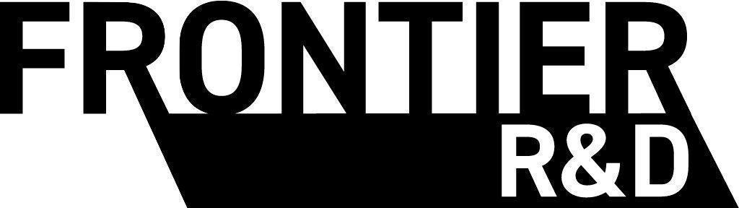
Statement
of Work
Service: 90-Day Aquilla Rollout and Annual Aquilla Platform License
Package: Rollout + License
Customer: [Client legal name] (“[Client short name]” in this document)
Date: [SOW date]
Quoted portfolio: [Quoted language range] active languages

Engagement summary
This SOW authorizes Frontier R&D Ltd. (“Frontier”) to implement Aquilla for [Client legal name] and provide the ongoing platform license and enterprise support.

Services selected
- Schedule A: 90-Day Aquilla Rollout (Implementation Services)
- Schedule B: Annual Aquilla Platform License

Schedule A: 90-Day Aquilla Rollout

Purpose
Frontier will lead a 90-day implementation program to configure Aquilla, prepare the agreed initial content, train key users, and activate the agreed core workflow. The target kickoff date is [Kickoff date].

Included implementation services
- Discovery and rollout plan: Confirm the initial workflow, roles, language portfolio, source assets, and measurable activation plan.
- Organization setup: Configure the client organization, user roles, permissions, projects, and agreed working conventions.
- Content preparation: Support preparation and import of the agreed initial source and target-language materials.
- Workflow configuration: Configure the agreed translation, review, multimedia, and export workflows using existing Aquilla capabilities.
- Training: Provide role-based enablement for administrators, project managers, reviewers, and translators.
- Launch support: Support pilot work, resolve launch blockers, and guide the client through activation and handoff to ongoing support.

90-day rollout plan
Phase | Approx. timing | Focus | Expected outcome
Phase 1a | Days 1-15 | Discover and configure | Approved rollout plan, organization setup, and initial content plan.
Phase 1b | Days 16-45 | Prepare and pilot | Initial projects and workflows configured; pilot users begin real work.
Phase 2a | Days 46-75 | Expand and train | Key roles trained and the agreed core workflow operates with client content.
Phase 2b | Days 76-90 | Activate and hand off | Activation criteria reviewed; ongoing support cadence begins.

Client responsibilities
- Name an executive sponsor and an implementation lead with authority to make timely decisions.
- Provide complete and lawful source content, user lists, workflow decisions, and required access on the agreed dates.
- Make key users available for discovery, training, pilot work, acceptance review, and issue resolution.

Activation criteria
The rollout is activated when the parties confirm that the following criteria are met for the scope agreed in the rollout plan:
- The client organization, user roles, and permissions are configured.
- At least one agreed live project or language workflow contains client-provided content and is ready for productive use.
- The client implementation lead and designated key users have completed the agreed enablement sessions.
- The agreed core workflow can move content through preparation, translation or adaptation, review, and export without a launch-blocking defect.

Activation Guarantee
Guarantee. If the activation criteria are not met by the end of Day 90, Frontier will continue the included implementation services at no additional implementation fee until the activation criteria are met. The annual platform term and annual platform billing begin on the Activation Date, not before.
Conditions. This guarantee applies only while the client meets its responsibilities and provides required decisions, content, access, and personnel on time. The rollout timeline extends for client-caused delay, third-party delay outside Frontier's reasonable control, force majeure, or a mutually approved scope change.
Exclusive remedy. Continued implementation services and delayed annual platform billing are the client's sole remedies under this Activation Guarantee. The guarantee does not create a cash refund right.

Schedule A fee
Item | Fee
90-Day Aquilla Rollout | [Implementation fee]
The implementation fee is a one-time fixed fee. Frontier invoices it at engagement kickoff under the payment terms below.

Schedule B: Annual Aquilla Platform License

Platform scope
This schedule covers ongoing use of Aquilla and applicable use of Codex Translation Editor across [Client short name]'s active program. The quote covers approximately [Quoted language range] active language projects. The expected active count at signing is [Current active language count].

Included platform capabilities
- Data egress: The client can export source text, target text, and multimedia in supported platform formats.
- Infrastructure: Frontier operates hosting, compute, storage, and AI services, subject to fair-use and abuse-prevention controls.
- Unlimited users: The license does not cap the number of client user seats.
- Permissions: The client controls user roles, asset visibility, and export permissions supported by the platform.
- Project management: The client may use supported AI chat tools for project management. Third-party AI subscriptions are not included.
- Backups and restoration: Frontier maintains rolling point-in-time and daily database backups under its current production operating policy.

Enterprise support
Frontier responds to support requests through the agreed support channel within 24 hours on business days and 48 hours on weekends. Support is not capped by ticket volume.
- Named liaison: One dedicated contact on the Aquilla team.
- Priority handling: Front-of-queue handling for enterprise support requests.
- Biweekly check-ins: Review open issues, new languages, utilization, and upcoming work.
- Workflow support: Assist with project setup, supported import and processing, multimedia workflows, and export formatting.
- Escalation: Frontier starts with an asynchronous resolution when practical and escalates to live troubleshooting when needed.

Outside platform support
Platform support excludes custom integrations, post-production and delivery work, extraordinary infrastructure usage outside the agreed workflow, and client-commissioned features beyond existing application capabilities or work already on Frontier's internal product roadmap. The parties may scope excluded work under a separate written engagement.

Schedule B fees
Item | Fee
Enterprise Program Support ([Monthly support equivalent] monthly equivalent) | [Annual support fee]
Annual Aquilla Platform License for the quoted language range, without per-word or per-task metering | [Annual license fee]

Platform term
The initial twelve-month platform term begins on the Activation Date under Schedule A. The platform license and enterprise support renew annually unless either party gives 60 days' written notice.
The fees are fixed for the current term. Frontier does not meter tokens, languages, projects, users, words, or tasks within the quoted portfolio. If actual usage materially exceeds the quoted range, Frontier completes the current term at the agreed price. The parties may adjust the allocation and fees only at renewal by mutual written agreement.

Project and language counting
A project, also called a language for pricing purposes, is one active target-language translation initiative. If a single application project contains three active target languages, it counts as three active language projects. Archived languages do not count as active. Test and example projects used reasonably for training or evaluation are included.

Commercial terms
- All amounts are quoted in USD unless the applicable fee field states otherwise.
- Payment terms are Net 30 from invoice date.
- Annual fees are billed at the start of each annual platform term.
- Frontier and the client will conduct quarterly reviews of support effectiveness, platform utilization, active language projects, and expected renewal scope.

Terms and conditions
Aquilla and Codex Translation Editor are owned by Frontier R&D Ltd. and made available to [Client legal name] under this SOW. Client-provided source materials and client-created translated content, recordings, scripts, editorial materials, and ancillary materials remain the client's property.
Each party will keep confidential the other party's non-public business, technical, financial, language-specific, and content information. A party may disclose confidential information to personnel and professional advisers who need it and are bound by confidentiality obligations.
Either party may end the ongoing platform engagement with 60 days' written notice. Both parties will fulfill obligations through the notice period. Frontier will provide any applicable pro-rated credit or refund for prepaid annual platform and support fees after the notice period, less valid service credits already applied.
Termination of Schedule B does not create a refund right for the Schedule A implementation fee. The Activation Guarantee provides the exclusive remedy for a failure to meet the Schedule A activation criteria.
Frontier will retain and provide access to client data at no charge for up to one year after termination, unless the parties agree otherwise. After cancellation, the client may be moved to any generally available free tier, subject to its limits.
Neither party makes warranties beyond those stated in this SOW. To the maximum extent permitted by law, Frontier's total liability under this SOW is limited to the fees paid under this SOW during the twelve months before the event giving rise to the claim.
AI usage and storage are unmetered within fair use for the quoted language range. Frontier may throttle non-critical workloads or propose an add-on license for extraordinary automated traffic, materially larger storage patterns, or other use far outside the agreed portfolio and workflow.

Service Level Agreement (SLA)
Frontier targets 99.5% uptime for core platform services, measured by Frontier's monitoring systems. Service credits are the sole remedy for downtime, apply to future invoices only, and are capped at 50% of the affected monthly platform and support fees. The client must request a credit in writing within 30 days.
- 99.0% to less than 99.5%: 10% credit.
- 95.0% to less than 99.0%: 25% credit.
- Less than 95.0%: 50% credit.
Exclusions: Scheduled maintenance, force majeure, third-party infrastructure failures, client misuse, and client network connectivity issues.
Use of Aquilla is also subject to Frontier's then-current published terms of use and privacy policy. Use of Codex Translation Editor is subject to its then-current privacy policy.

Acceptance
By signing below, both parties agree that Frontier R&D Ltd. is authorized to provide the services described in this SOW under its terms.
[Client legal name] | Frontier R&D Ltd.
(Signature) | (Signature)
(Print name) | (Print name)
(Title) | (Title)
(Date) | (Date)

