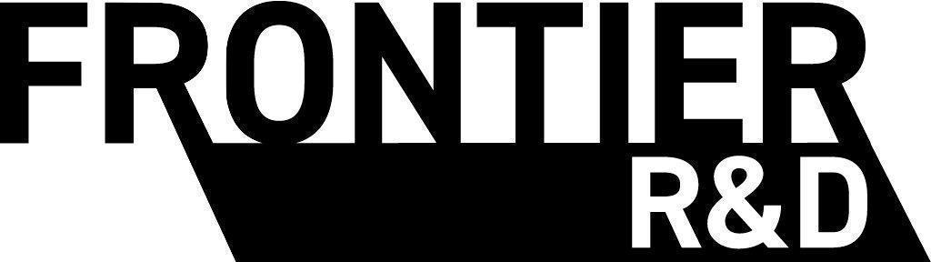
Statement
of Work
Service: Annual Aquilla Platform License
Package: License only
Customer: [Client legal name] (“[Client short name]” in this document)
Date: [SOW date]
Quoted portfolio: [Quoted language range] active languages

Engagement summary
This SOW authorizes Frontier R&D Ltd. (“Frontier”) to provide [Client legal name] with the annual Aquilla platform license and enterprise support described in Schedule B.

Service selected
- Schedule B: Annual Aquilla Platform License

Schedule B: Annual Aquilla Platform License

Platform scope
This schedule covers ongoing use of Aquilla and applicable use of Codex Translation Editor across [Client short name]'s active program. The quote covers approximately [Quoted language range] active language projects. The expected active count at signing is [Current active language count].

Included platform capabilities
- Data egress: The client can export source text, target text, and multimedia in supported platform formats.
- Infrastructure: Frontier operates hosting, compute, storage, and AI services, subject to fair-use and abuse-prevention controls.
- Unlimited users: The license does not cap the number of client user seats.
- Permissions: The client controls user roles, asset visibility, and export permissions supported by the platform.
- Project management: The client may use supported AI chat tools for project management. Third-party AI subscriptions are not included.
- Backups and restoration: Frontier maintains rolling point-in-time and daily database backups under its current production operating policy.

Enterprise support
Frontier responds to support requests through the agreed support channel within 24 hours on business days and 48 hours on weekends. Support is not capped by ticket volume.
- Named liaison: One dedicated contact on the Aquilla team.
- Priority handling: Front-of-queue handling for enterprise support requests.
- Biweekly check-ins: Review open issues, new languages, utilization, and upcoming work.
- Workflow support: Assist with project setup, supported import and processing, multimedia workflows, and export formatting.
- Escalation: Frontier starts with an asynchronous resolution when practical and escalates to live troubleshooting when needed.

Outside platform support
Platform support excludes custom integrations, post-production and delivery work, extraordinary infrastructure usage outside the agreed workflow, and client-commissioned features beyond existing application capabilities or work already on Frontier's internal product roadmap. The parties may scope excluded work under a separate written engagement.

Schedule B fees
Item | Fee
Enterprise Program Support ([Monthly support equivalent] monthly equivalent) | [Annual support fee]
Annual Aquilla Platform License for the quoted language range, without per-word or per-task metering | [Annual license fee]

Platform term
The initial twelve-month platform term begins on the SOW date. The platform license and enterprise support renew annually unless either party gives 60 days' written notice.
The fees are fixed for the current term. Frontier does not meter tokens, languages, projects, users, words, or tasks within the quoted portfolio. If actual usage materially exceeds the quoted range, Frontier completes the current term at the agreed price. The parties may adjust the allocation and fees only at renewal by mutual written agreement.

Project and language counting
A project, also called a language for pricing purposes, is one active target-language translation initiative. If a single application project contains three active target languages, it counts as three active language projects. Archived languages do not count as active. Test and example projects used reasonably for training or evaluation are included.

Commercial terms
- All amounts are quoted in USD unless the applicable fee field states otherwise.
- Payment terms are Net 30 from invoice date.
- Annual fees are billed at the start of each annual platform term.
- Frontier and the client will conduct quarterly reviews of support effectiveness, platform utilization, active language projects, and expected renewal scope.

Terms and conditions
Aquilla and Codex Translation Editor are owned by Frontier R&D Ltd. and made available to [Client legal name] under this SOW. Client-provided source materials and client-created translated content, recordings, scripts, editorial materials, and ancillary materials remain the client's property.
Each party will keep confidential the other party's non-public business, technical, financial, language-specific, and content information. A party may disclose confidential information to personnel and professional advisers who need it and are bound by confidentiality obligations.
Either party may end the ongoing platform engagement with 60 days' written notice. Both parties will fulfill obligations through the notice period. Frontier will provide any applicable pro-rated credit or refund for prepaid annual platform and support fees after the notice period, less valid service credits already applied.
Frontier will retain and provide access to client data at no charge for up to one year after termination, unless the parties agree otherwise. After cancellation, the client may be moved to any generally available free tier, subject to its limits.
Neither party makes warranties beyond those stated in this SOW. To the maximum extent permitted by law, Frontier's total liability under this SOW is limited to the fees paid under this SOW during the twelve months before the event giving rise to the claim.
AI usage and storage are unmetered within fair use for the quoted language range. Frontier may throttle non-critical workloads or propose an add-on license for extraordinary automated traffic, materially larger storage patterns, or other use far outside the agreed portfolio and workflow.

Service Level Agreement (SLA)
Frontier targets 99.5% uptime for core platform services, measured by Frontier's monitoring systems. Service credits are the sole remedy for downtime, apply to future invoices only, and are capped at 50% of the affected monthly platform and support fees. The client must request a credit in writing within 30 days.
- 99.0% to less than 99.5%: 10% credit.
- 95.0% to less than 99.0%: 25% credit.
- Less than 95.0%: 50% credit.
Exclusions: Scheduled maintenance, force majeure, third-party infrastructure failures, client misuse, and client network connectivity issues.
Use of Aquilla is also subject to Frontier's then-current published terms of use and privacy policy. Use of Codex Translation Editor is subject to its then-current privacy policy.

Acceptance
By signing below, both parties agree that Frontier R&D Ltd. is authorized to provide the services described in this SOW under its terms.
[Client legal name] | Frontier R&D Ltd.
(Signature) | (Signature)
(Print name) | (Print name)
(Title) | (Title)
(Date) | (Date)

