M-L-1: Notes of scientific papers on SSVEP and cVEP paradigms
- Zhu et al., 2010: A Survey of Stimulation Methods Used in SSVEP-Based BCIs
Meta research on how researchers flicker stimuli in SSVEP-based BCIs - what type of repetitive stimulus they use, on what device, with which frequencies, colors and stimulus designs. Focus is on how these choices affect performance, comfort and safety.

Identified main stimulus types
They define three visual stimuli categories:
- Light stimuli (driven by custom electronics, out of scope for purposes of toolbox development)
  - Elicit stronger SSVEP responses than screen stimuli in matched conditions.
- Single graphic stimuli on monitor
  - Rectangels, squares, arrows, circles, letters or symbols
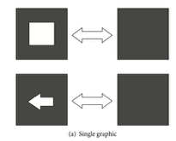
  - Easily implemented in software but limited by refresh rate and OS.
- Pattern reversal stimuli on monitor
  - Checkboards, lineboxes
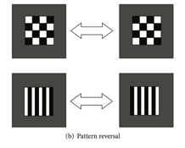
  - Often give stronger VEPs than simple on-off graphics at the same nominal frequency.
Devices and performance
LEDs: 24 papers
Single graphic stimuli: 19 papers
Checkerboards: 14 papers
The trend is that LEDs have higher SNR and bitrates than monitor based stimuli (but hard to compare because of different subjects and analysis methods).

Frequency bands
They split frequencies into three bands:
- Low: 1-12Hz
- Medium: 12-30Hz
- High: 30-60Hz
Findings: largest amplitudes are observed at around 10Hz, after that in 16-18Hz band, smallest in high band. Low and medium bands have issues:
  - 5-25Hz is more visually annoying and fatiguing.
  - 15-25Hz has higher risk of seizures
  - Low band overlaps with alpha (8-13Hz) which means more noisy measurments.
High frequencies have less spontaneous brain activity so are candidates for decent SNR with spatial filters. They are more confortable and safer.
Color effects
- Red: very strong peak around 11Hz.
- Blue: slightly weaker peak at around 13Hz.
- Yellow: generally weaker.
Black and white dominate in researches on monitors. They conclude that color effects are under researched.
Ideas for additonal research
- Make flickering checkboard patches move together with the object
- Use phase coding to increase number of distinct commands
- Use dual frequency stimulation where each stimulus combines F1 and F2. We can achieve extra peaks at F1, F2, F1+F2 and more commands from same set of base frequencies.
Toolbox implications
Parameter | Possible values | Default value | Description
stim_type | ON_OFF, PATTERN_REVERSAL | ON_OFF | Stimulus flickering type
layout_type | GRID, CUSTOM_POSITIONS | GRID | How to position stimuli on screen
positions | List[(x, y)] |  | Only used if layout_type == CUSTOM_POSITIONS
target_freqs_hz | List[float] | [] | List of desired frequencies. Only used if freq_band_mode == CUSTOM
min_frames_per_cycle | int | 1 | F_max=refresh_rate / min_frames_per_cycle. It bounds maximum flicker frequency.
freq_band_mode | LOW, MEDIUM, HIGH, ALL, CUSTOM | ALL | Auto generate frequencies from selected band.
frequency_realization_strategy | ROUND, SNAP_TO_HARMONIC | ROUND | ROUND means that closest integer number of frames per cycle is chosen. SNAP_TO_HARMONIC enforces that frequencies are divisors / submultiples of refresh rate.
on_luminance | Float (0-1)
off_luminance | Float (0-1)
freq_coding_type | FREQUENCY_ONLY | FREQUENCY_ONLY | Placeholder for additonal coding types (same frequency different phase, dual frequency)

- Wolpaw et al., 2002: Brain-computer interfaces for communication and control
The article reviews how BCIs work, what types exist (SCP, P300, mu/beta, invasive), what limits them, and what must be solved to make BCIs practical for people with severe paralysis.
BCI use is a skill - user must learn to modulate brain signals; system must learn to decode them. This is a continous mutual adaptation: user - algorithm.
Five families of BCI:
- Visual evoked potentials
- Slow cortical potentials
- P300 based
  - Odball response when desired row/column flashes.
- Beta rythms from Sensorimotor cortex
- Intracortical neuron BCIs (invasive)
Toolbox implications
Make sure that parameters allow to maximize SNR and minimize artifacts:
- Frequencies outside of alpha range
- Stimuli should minimize eye movements artifacts stimulus spacing
- Avoid overlapping attentional fields use correct size of shapes

- Parini et al., 2009: A Robust and Self-Paced BCI System Based on a Four Class SSVEP Paradigm: Algorithms and Protocols for a High-Transfer-Rate Direct Brain Communication
The paper presents a fast, reliable, self-paced SSVEP-based BCI that uses four flicker frequencies to control four directional commands (up, down, left, right) plus a “no-control” state. The goal is to combine high information transfer rate with low false positives and minimal calibration time. Users first complete a very short screening session to determine their best personal SSVEP frequencies (6-17 Hz). A training session then collects data for calibration, and a testing session evaluates real self-paced control. The authors highlight that subject-specific frequencies and automated spatial filtering are crucial for strong performance, and that the system enables fast communication with minimal training.
They used 4 cubic LED spotlights mounted on LCD monitor. Each LED represented one of the four directional commands (left, right, up, down).
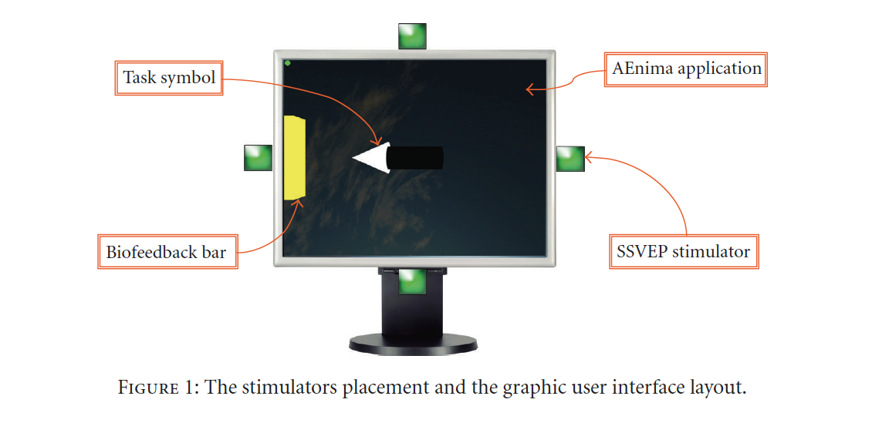
They were testing frequency range 6-17Hz with 1 Hz step. The paper shows that no universal frequency pattern exists, subjects vary significantly, 6Hz is weak for most and frequencies 12-17Hz were most commonly selected.
Toolbox implications
Researchers should have a quick way to change the parameters, so that they can retry the experiment with different values and find settings that give best results. It should allow them to programatically setup a learning session to figure out correct parameters.

- Herrmann, 2001: Human EEG responses to 1-100 Hz flicker: resonance phenomena in visual cortex and their potential correlation to cognitive phenomena
This study investigated how the human visual cortex responds to flickering light across a very wide frequency range (1-100 Hz) and whether certain frequencies produce resonance phenomena - that is, unusually strong EEG responses.
Participants viewed full-field LED flicker at all frequencies in 1-Hz steps. The EEG reliably showed steady-state visual evoked potentials (SSVEPs) not only at low and medium frequencies but up to at least 90 Hz, even when subjects could no longer consciously perceive flicker.
The EEG amplitude was not uniform. It showed strong response peaks at around:
- 10 Hz (the classical alpha resonance)
- 20 Hz
- 40 Hz (in the gamma band)
- 80 Hz (approx. double-gamma)
These peaks indicate that the visual cortex has preferred oscillation frequencies to which it responds more strongly. The recorded EEG did not only show responses at the stimulation frequency, but also: harmonics (e.g., 10 → 20 Hz) and subharmonics (e.g., 30 → 15 Hz).
The author suggests that the 40-Hz resonance observed in SSVEPs may reflect the same neuronal mechanisms responsible for gamma oscillations seen in cognitive tasks (attention, gestalt processing, priming).
Toolbox implications
Include a comfort mode that suggest frequencies > 35Hz - users do not perceive flicker but response still seen in the eeg signal. Those also reduce spontaneous EEG interference.
Use a dual frequency simulation where one stimulus carries 2 different flicker frequencies. Instead of flickering at a single rate (e.g., 12 Hz), the stimulus is modulated by two sinusoidal or rectangular frequency components, such as F₁ = 15 Hz and F₂ = 20 Hz. This produces new EEG responses at F₁, F₂, their harmonics, and combination frequencies (F₁ ± F₂). This is usefull because we can encode more targets without requiring more frequencies. Maybe the signal is also more robust. Not sure if this is possible to implement on LCDs.

- Hwang et al., 2013: A new dual-frequency stimulation method to increase the number of visual stimuli for multi-class SSVEP-based brain-computer interface (BCI)
SSVEP is a periodic brain electrical response induced by the repetitive presentation of a visual stimulus, flickering or reversing at a certain frequency ranging from 1 Hz to 60 Hz (Zhu et al., 2010). Although SSVEP can be elicited by a broad range of frequencies, the available frequencies in practical BCI applications are often restricted by several factors. First, all available stimulation frequencies do not always evoke high SSVEP responses. The frequencies that elicit strong SSVEP responses are highly dependent upon the participants, as well as various properties of the visual stimuli, such as color, size, and contrast (Zhu et al., 2010). Second, the use of two frequencies, F1 and F2, in the same experiment has been typically avoided when F1 is a multiple of F2 or vice versa because of the harmonic SSVEP responses (Bakardjian et al., 2010; Cheng et al., 2002; Shyu et al., 2010); simultaneous use of those frequencies could significantly decrease the performance of SSVEP-based BCI systems. Third, the frequencies in the alpha band (8-13 Hz) should be carefully selected because its use has been attributed to a considerable number of false positives (Cheng et al., 2002; Zhu et al., 2010). Fourth, it is rare but sometimes possible that some visual stimuli with flickering frequencies in the 15-25 Hz frequency band may provoke epileptic seizures (Fisher et al., 2005). Most importantly, when using a monitor as a rendering device, stimulation frequencies have to be set as sub-harmonics of the monitor refresh rate (usually 60 Hz) to attain accurate SSVEP responses (Yan et al., 2009; Zhu et al., 2010). Therefore, one of the challenging issues in SSVEP-based BCI studies is to make the best use of available frequencies, particularly when using the computer monitor to implement a multi-class SSVEP-based BCI system.
First option for dual frequency stimulation is such that each square flickers with distinct frequencies, subject looks into the middle. Problems is that subjects have difficulties in consistently maintaining concentration.
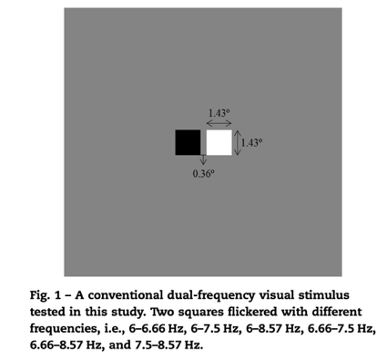
Proposed stimuli design:
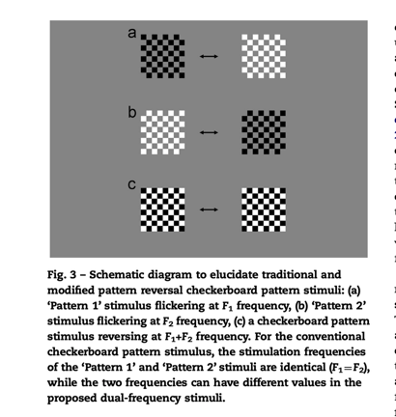
If both patterns flicker at same frequency (standard checkerboard stimulus), then strong SSVEP response is evoked at a frequency of 2 xF1 (=F1+F1).
Inspired by this observation, they tried to slightly modify the traditional pattern-reversal checkerboard stimulus by giving different modulation frequencies to ‘Pattern 1’ and ‘Pattern 2’ stimuli, and investigated the SSVEP responses elicited by the modified checkerboard stimulus. Results:
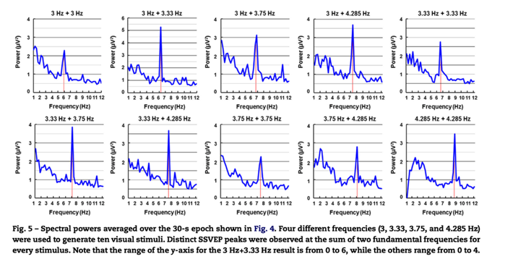
Toolbox implications
Add an option to setup flickering with dual frequencies as proposed in this research.

- Wang et al., 2008: Brain-computer interfaces based on visual evoked potentials: Feasibility of practical system designs
The article provides a broad overview of VEP-based BCIs, explaining how they work, how they are designed, and what challenges remain in making them practical systems.
VEP BCIs rely on the brain’s electrical responses to visual flicker. Two types of responses are used:
- Transient VEPs (TVEPs) - responses to slow, discrete flashes.
- Steady-State VEPs (SSVEPs) - responses to rapid, periodic flicker, creating stable frequency components in EEG.
Two main stimulus types:
- Monitors (LCD/CRT) - easy to configure but limited in number of distinct frequencies because of refresh rate.
- LED arrays - allow many precise frequencies and support large target sets (e.g., 48-target systems).
More targets → higher potential bit rate, but also greater fatigue and design complexity.
Harmonics (2nd, 3rd) often carry strong information and improve classification.
Examples
- Frequency-coded system
  - Uses 1 bipolar occipital lead
  - Incorporates harmonics for robust detection
  - Achieved ~46.7 bits/min in a dialing-task demo
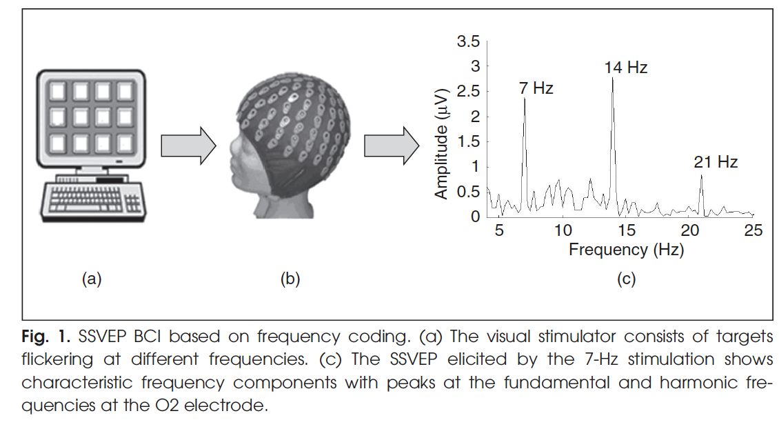
- Phase-coded system
  - Six targets flickering at the same frequency (10 Hz) but different phases
  - Achieved 86.7% accuracy
  - Demonstrates feasibility of increasing number of targets without increasing frequency range
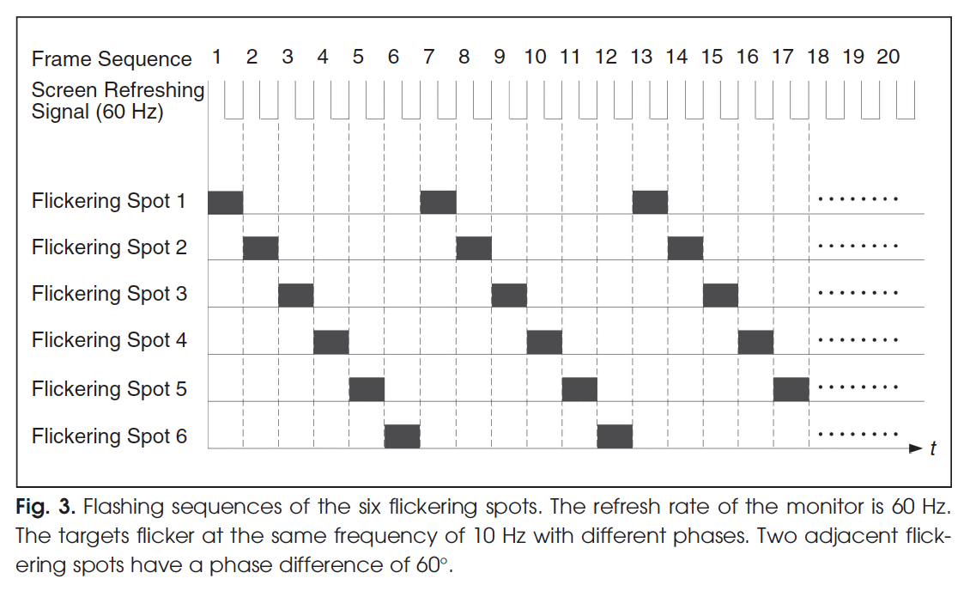
Toolbox implications
Parameter | Possible values | Default value | Description
allow_harmonics | true, false | true | Choose frequencies that are not in harmonic relationship so that harmonics can be used in classification.
freq_coding_type | FREQUENCY_ONLY, FREQUENCY_WITH_PHASE | FREQUENCY_ONLY
base_freq_hz | float |  | Frequency used if freq_coding_type == FREQUENCY_WITH_PHASE
phase_deg | Float (0-360) | 0 | Phase offset used if freq_coding_type == FREQUENCY_WITH_PHASE
log_freq_conflict | True, false | True | Log warning if user chose frequencies that are harmonics of each other.

- Wua et al., 2008: Stimulator selection in SSVEP-based BCI
The study compares three types of visual stimulators used to elicit SSVEPs: LEDs, CRT monitors, and LCD screens. The goal is to understand how their physical flicker properties affect the strength and quality of the SSVEP, and therefore how to choose the best stimulator for different BCI setups.
The authors measured the physical flicker of each device:
- LEDs:
  - Cleanest signal; only fundamental + harmonics.
  - Fast rise time → sharp transitions.
  - Strongest fundamental power.
- CRT monitors:
  - Very complex spectrum (because of refresh scanning).
  - Includes additional frequency components (sum/difference frequencies, refresh artifacts at ~85 Hz).
  - Can cause more visual fatigue.
- LCD screens:
  - Strong low-frequency components.
  - Weaker fundamental stimulation power.

- Wang et al., 2006: A practical VEP-based brain-computer interface
This paper presents the development of a practical, real-time BCI system based on steady-state visual evoked potentials (SSVEPs), designed to be high-speed, reliable, and usable by most people. The system uses frequency-coded SSVEPs: multiple visual targets flicker at different frequencies, and the system determines which frequency the user is gazing at by analyzing the EEG. That frequency corresponds to a command (e.g., selecting a button).
A major problem in SSVEP BCIs is that people respond differently to different frequencies and electrode positions. The authors solve this through a short personalized calibration, determining for each user:
- Optimal electrode pair (signal + reference), usually around PO2 - Poz
- Optimal stimulus frequencies to avoid:
  - subject-specific low SNR bands
  - interference with alpha rhythms (8-13 Hz) that cause false positives
- Optimal selection speed (data length required for reliable classification)
Results:
- Laboratory tests (16 subjects):
  - 100% usability—all completed tasks
  - Average ITR ≈ 43 bits/min (range 29–63)

- Clinical environment (Rehabilitation Center) with spinal-cord-injury patients:
  - 10 of 11 patients operated successfully
  - Average ITR ≈ 21 bits/min
Toolbox implications
Include predefined presets (set of configuration values) that follow the results of the study. Make it easy to iterate through different configuration values to find correct ones.

Sources
Zhu, D., Bieger, J., Garcia Molina, G., & Aarts, R. M. (2010). A Survey of Stimulation Methods Used in SSVEP-Based BCIs [Journal Article]. Computational Intelligence and Neuroscience, 2010(2010), 239-250. https://doi.org/10.1155/2010/702357
Wolpaw, J. R., Birbaumer, N., McFarland, D. J., Pfurtscheller, G., & Vaughan, T. M. (2002). Brain-computer interfaces for communication and control [Book Review]. Clinical Neurophysiology, 113(6), 767-791. https://doi.org/10.1016/S1388-2457(02)00057-3
Parini, S., Maggi, L., Turconi, A. C., & Andreoni, G. (2009). A Robust and Self-Paced BCI System Based on a Four Class SSVEP Paradigm: Algorithms and Protocols for a High-Transfer-Rate Direct Brain Communication [Journal Article]. Computational Intelligence and Neuroscience, 2009(1), 191-201. https://doi.org/10.1155/2009/864564
Herrmann, C. S. (2001). Human EEG responses to 1-100 Hz flicker: resonance phenomena in visual cortex and their potential correlation to cognitive phenomena [Journal Article]. Experimental Brain Research, 137(3-4), 346-353. https://doi.org/10.1007/s002210100682
Hwang, H.-J., Hwan Kim, D., Han, C.-H., & Im, C.-H. (2013). A new dual-frequency stimulation method to increase the number of visual stimuli for multi-class SSVEP-based brain-computer interface (BCI). Brain Research, 1515, 66-77. https://doi.org/10.1016/j.brainres.2013.03.050
Wang, Y., Gao, X., Hong, B., Jia, C., & Gao, S. (2008). Brain-computer interfaces based on visual evoked potentials: Feasibility of practical system designs [Journal Article]. IEEE Engineering in Medicine and Biology Magazine, 27(5), 64-71. https://doi.org/10.1109/MEMB.2008.923958
Wu, Z., Lai, Y., Xia, Y., Wu, D., & Yao, D. (2008). Stimulator selection in SSVEP-based BCI [Journal Article]. Medical Engineering & Physics, 30(8), 1079-1088. https://doi.org/10.1016/j.medengphy.2008.01.004
Wang, Y., Wang, R., Gao, X., Hong, B., & Gao, S. (2006). A practical VEP-based brain-computer interface [Journal Article]. IEEE Transactions on Neural Systems and Rehabilitation Engineering, 14(2), 234-240. https://doi.org/10.1109/TNSRE.2006.875576

