Chronic disseminated candidiasis in acute leukaemia: a full-text-verified literature-derived case series of 10 cases from 7 sources
Draft manuscript v0.2 — CARE-compliant case-series synthesis. Cohort restricted to sources with retrievable full text (see Methods). Prepared with AI-assisted search, screening, extraction and drafting; requires full author review (see human_review.md).

Abstract
Background: Chronic disseminated candidiasis (CDC; formerly hepatosplenic candidiasis) is a distinctive invasive fungal infection occurring predominantly in patients with acute leukaemia during or after prolonged neutropenia. Evidence remains limited to single case reports. Methods: We searched Europe PMC and PubMed (2000–2026) for case reports of CDC in acute leukaemia. Of 48 unique records screened, 19 met the case definition; following a full-text availability gate, the final cohort was restricted to the 7 sources with retrievable full text (10 cases; 3 Chinese-language cases pending extraction), each analysed individually at full-text level. Case-level data were extracted into a structured dataset and analysed descriptively following CARE guidelines. Results: Reported ages ranged 2–47 years (median 16; 6 of 10 cases age-reported): 3 paediatric, 3 adult. Leukaemia was ALL in 4 cases, AML in 3, unspecified in 3. Candida species were identified in 5 of 8 fully extracted cases — Candida tropicalis in 4 (by culture, tissue PCR or blood metagenomic next-generation sequencing) and Candida albicans in 1. Immune reconstitution inflammatory syndrome (IRIS) complicated 2 paediatric ALL cases; both resolved with adjuvant corticosteroids plus continued antifungals. Surgical intervention was used in 4 cases (splenectomy in 3, incision and drainage in 1), all with reported success. No deaths occurred among fully extracted cases, and 6 of 8 were reported resolved or in leukaemia remission. Conclusions: In this full-text-verified series, CDC in acute leukaemia — including culture-negative, PCR/mNGS-diagnosed and azole-resistant cases — had favourable reported outcomes with prolonged combination antifungal therapy, adjuvant corticosteroids for IRIS, and surgical salvage for refractory disease. Reporting heterogeneity remains high; a systematic registry is needed.

Introduction
Chronic disseminated candidiasis (CDC) is a subacute invasive candidal infection involving liver, spleen and other organs, classically described in patients with acute leukaemia recovering from prolonged chemotherapy-induced neutropenia, with an estimated incidence below 5% of treated acute leukaemia patients. Persistent fever after neutrophil recovery, negative blood cultures and characteristic target-like hepatic and splenic lesions form the typical presentation. Individual case reports describe a wide spectrum of presentations (muscular and subcutaneous abscesses), diagnostic approaches (PET/CT, mannan antigen, beta-D-glucan, metagenomic next-generation sequencing (mNGS)) and treatments (prolonged echinocandin or azole therapy, adjuvant corticosteroids for IRIS, splenectomy). Because no single centre accumulates enough cases, each report contributes one fragment of the clinical picture. We hypothesised that aggregating published case-level data, restricted to sources verifiable at full text, would yield a stronger descriptive evidence base than any individual report.

Methods
This systematic aggregation of published case reports followed CARE guidelines. We searched Europe PMC and PubMed (E-utilities) on 30 September 2026 (exact query strings in the project search log) for CDC/hepatosplenic candidiasis in leukaemia, 2000–2026. Of 48 unique records, 19 sources met the case definition. A full-text availability gate was then applied: only sources whose full text could be retrieved and analysed (PubMed Central deposit or publisher open access) entered the final cohort — 7 sources contributing 10 cases. Three cases within one Chinese-language source were retrieved but not yet individually extracted (flagged for author verification). Each included source's full text was read and case-level data extracted independently (demographics, leukaemia subtype and phase, prophylaxis, Candida species and identification method, organs, diagnostic basis, antifungal regimen, surgery, IRIS, outcome). Fields unavailable in full text were marked UNVERIFIED; none were imputed. Descriptive statistics were computed in Python; no inferential pooling was attempted given heterogeneity and incomplete reporting.

Results
The final cohort comprised 10 cases from 7 full-text-analysed sources (Table 1). Ages ranged 2–47 years (median 16; age reported in 6 of 10): 3 paediatric and 3 adult. Leukaemia subtype was ALL in 4 cases (three B-cell, one common ALL) and AML in 3 (including one AML-M3 and one AML-M5b in complete remission); 3 cases (Chinese-language source) had unspecified subtype. Antifungal prophylaxis before CDC diagnosis was documented in 2 cases (fluconazole; posaconazole) and micafungin prophylaxis in a third. Candida species were identified in 5 of 8 fully extracted cases: C. tropicalis in 4 (skin/aspirate culture, repeated blood cultures including one pan-azole-resistant isolate, blood mNGS, and hepatic tissue PCR/sequencing) and C. albicans in 1 (aspirate culture with cytopathology). Diagnosis was culture-negative in at least 2 cases, relying on mannan antigen, histopathology (PAS/Gomori methenamine silver/FISH) or mNGS. IRIS complicated 2 paediatric ALL cases during immune recovery; both received corticosteroids with rapid defervescence (within 72 hours to 3 days) while continuing antifungals. Surgery was performed in 4 cases: laparoscopic splenectomy in 3 (all after antifungal failure, including one pan-azole-resistant C. tropicalis infection) and incision/drainage of persistent abscesses in 1; fever resolved immediately post-splenectomy where reported. No deaths were reported among fully extracted cases; 6 of 8 cases were reported resolved or in leukaemia remission at last follow-up (up to 25 months). Figure 1 summarises case characteristics.
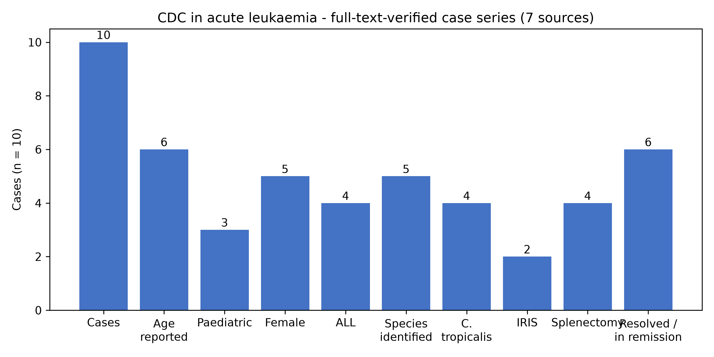
Figure 1. Characteristics of the full-text-verified case series (n = 10 cases from 7 sources; 3 Chinese-language cases not yet individually extracted and excluded from denominators).

Discussion
This full-text-verified series makes three practical points. First, microbiological documentation is achievable more often than the classical teaching suggests when modern methods are used — species were identified in 5 of 8 fully extracted cases, including by mNGS and tissue PCR in culture-negative disease — and one documented pan-azole-resistant C. tropicalis infection underlines the value of susceptibility testing. Second, IRIS is a recurring complication in children with ALL during immune recovery and responds rapidly to corticosteroids, but diagnosis requires excluding concurrent infection, and steroids may theoretically blunt the antileukaemic inflammatory effect. Third, surgical salvage (splenectomy after antifungal failure, or drainage of persistent abscesses) achieved resolution in all 4 surgical cases. Limitations: this synthesis includes only published, full-text-accessible cases and inherits publication bias favouring successful outcomes (no deaths were reported); the abstract-level screening pool (12 further sources without open full text) was excluded rather than verified, and may contain outcome-discordant cases; and a 2025 systematic review already covers paediatric CDC, so our contribution is the adult+paediatric, full-text-verified aggregation. All extracted values require author verification against source PDFs before submission (see human_review.md, Gates 2–3).

AI-assistance disclosure (draft — adapt to target journal policy)
Literature search, screening, full-text retrieval, data extraction and initial drafting were assisted by an AI agent (Hermes Agent, Nous Research) under the supervision of the authors. All included records are cited with PubMed identifiers and PMC identifiers; the screening decision trail and extraction dataset are provided as supplementary files. The authors verified the search strategy and take full responsibility for the content. AI tools do not qualify for authorship per ICMJE criteria.

References (full citations to be completed and verified at Gate 2)
- S32 Eur J Case Rep Intern Med 2016; PMID 27408899; PMC4938872 (HSC detected by 18F-FDG PET/CT; 47F AML)
- S33 Postepy Dermatol Alergol 2016; PMID 27800196; PMC5075288 (CDC+IRIS in child with ALL; journal to verify)
- S38 Zhonghua Xue Ye Xue Za Zhi 2022; PMID 35968598; PMC9800221 (3 cases, mNGS; Chinese-language)
- S39 Cureus 2023; PMID 37750159; PMC10518137 (CDC-induced IRIS, 2F with ALL, C. tropicalis)
- S40 Heliyon 2023; PMID 37089309; PMC10113846 (splenectomy, 2 cases; DOI 10.1016/j.heliyon.2023.e15114)
- S42 Clin Case Rep 2023; PMID 37476594; PMC10354359 (muscular + hepatosplenic candidiasis, 14M AML-M3, C. albicans)
- S46 BMC Infect Dis 2024; PMID 38448809; DOI 10.1186/s12879-024-09172-9 (18F relapsed B-ALL, C. tropicalis, splenectomy)

Supplementary files
- screening_review.csv — 48 screened records with AI screening decisions and blank human-review columns
- extraction/case_extraction_fulltext.csv — full-text-verified case-level dataset (final cohort)
- extraction/case_extraction.csv — earlier abstract-level extraction of all 19 included sources (superseded; retained for audit)
- search_log.md — exact queries, dates and hit counts
- papers/ — retrieved full texts (XML/HTML→text) for all 7 final sources
- figures/fig1_characteristics.png — Figure 1 source

