CSE 220 – Programming in C

Quiz #1

Fall 2016

Name: ______________________________________

Section: ______

1. What is the output of the following C programs? (24 pts)

Program A

#include <stdio.h>

int main() {

int x = 5, y = 6, z = 0;

int result1 = (x && y) || (z && y);

float result2 = result1 ? x / y : y / x;

printf("%.5f", result2);

return 0;

}

Program B

#include <stdio.h>

int main() {

int z = 5;

for (;;) {

printf("%d ", ++z);

if (z == 8)

break;

}

return 0;

}

Program C

#include <stdio.h>

int main(){

int x = 7;

int y = x >> 1;

switch(y) {

case 1:

printf("One\n");

break;

case 2:

printf("Two\n");

break;

case 3:

printf("Three\n");

default:

printf("Too large\n");

}

return 0;

}

Program D

#include <stdio.h>

int main() {

int x = 5, y = 2;

float z = ++x + 12 / 5 + y--;

printf("%.2f, %d, %d", z, x, y);

return 0;

}

1. Write a loop to print integers between 20 and 50 in decreasing order. The output should be as follows: 50 49 48 47 … 21 20 (15pts):
2. The program below reads two integers from the user representing the x- and y-coordinates of a point and outputs which quadrant the point belongs to (as shown in figure). Complete the code. (15 pts)

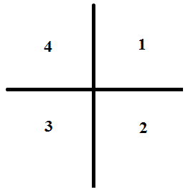

#include <stdio.h>

int main(){

float value1, value2, value3;

printf(“Enter three numbers:\n”);

scanf(“%f %f %f”, &value1, &value2, &value3);

return 0;

}

1. The following program asks the user to enter 20 integers and prints out the largest one. There are a number of errors in the program. Fix 5 of them. (25 pts)

int main(void ) {

int largest, number;

printf(“Enter 20 numbers:\n”);

for (total = 1; total < 20; total++) {

scanf(“%d”, number);

if (number > largest) {

largest = number;

}

total++;

}

printf(“The largest is: \n”, largest);

return 0;

}

1. Write a program that reads numbers from the user until the number 0 is encountered. The program must compute the ratio of the sum of positive numbers to the sum of negative numbers and output the ratio with up to 4 decimal digits, using scientific notation. (30 pts)