Train 2015-2021

Train 2015-2020

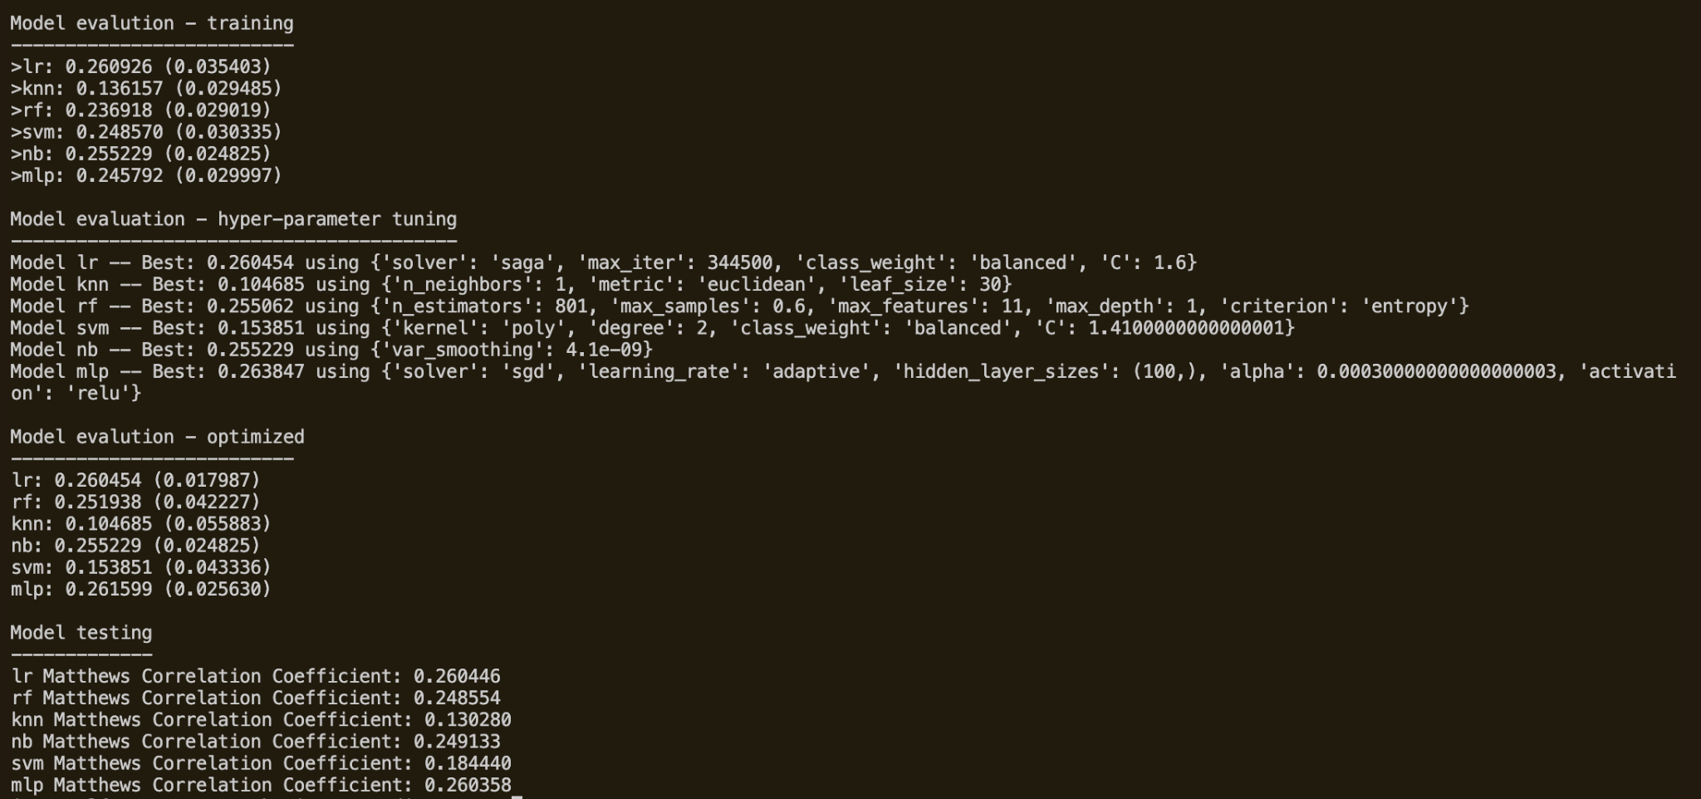

Train 2015-2019

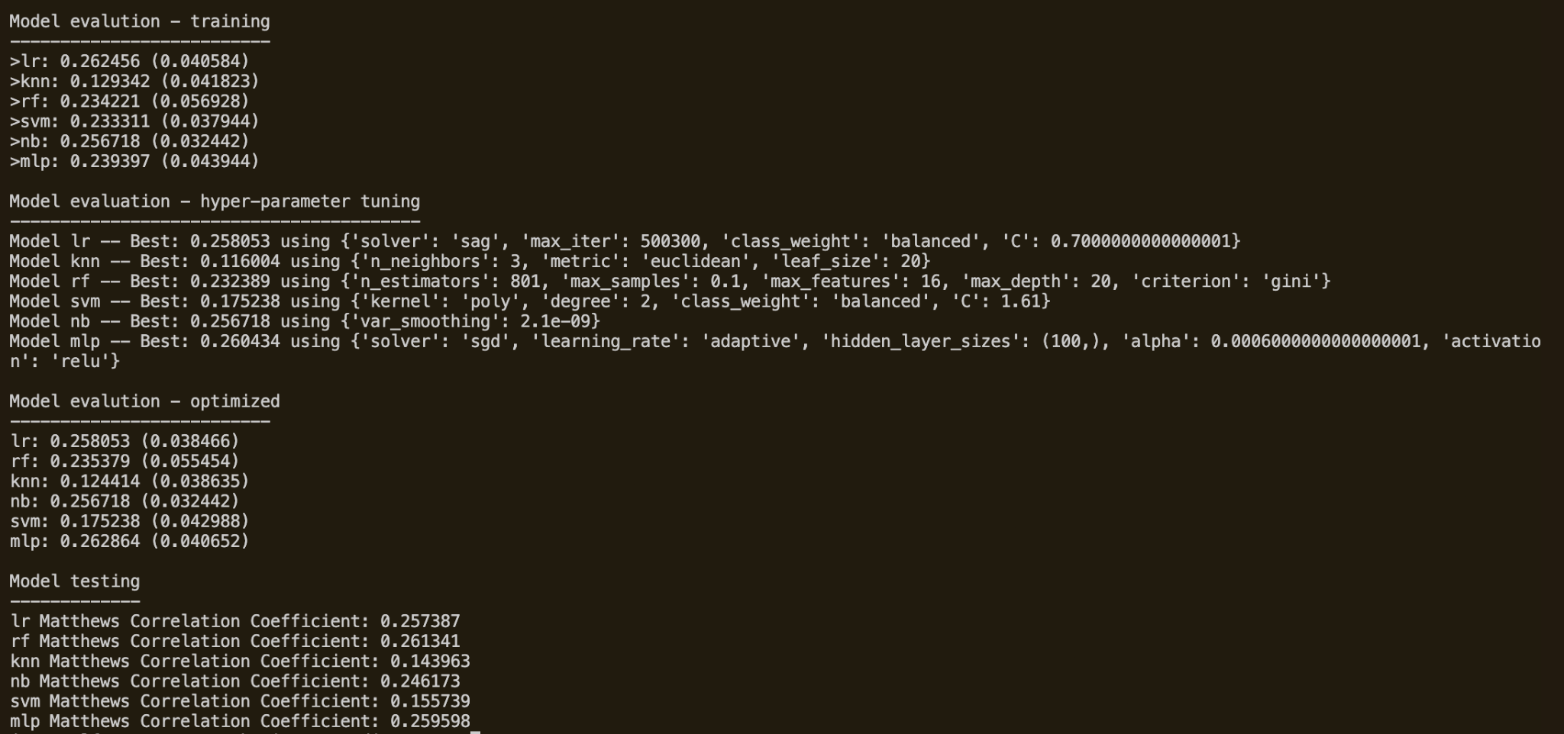

Train 2015-2018

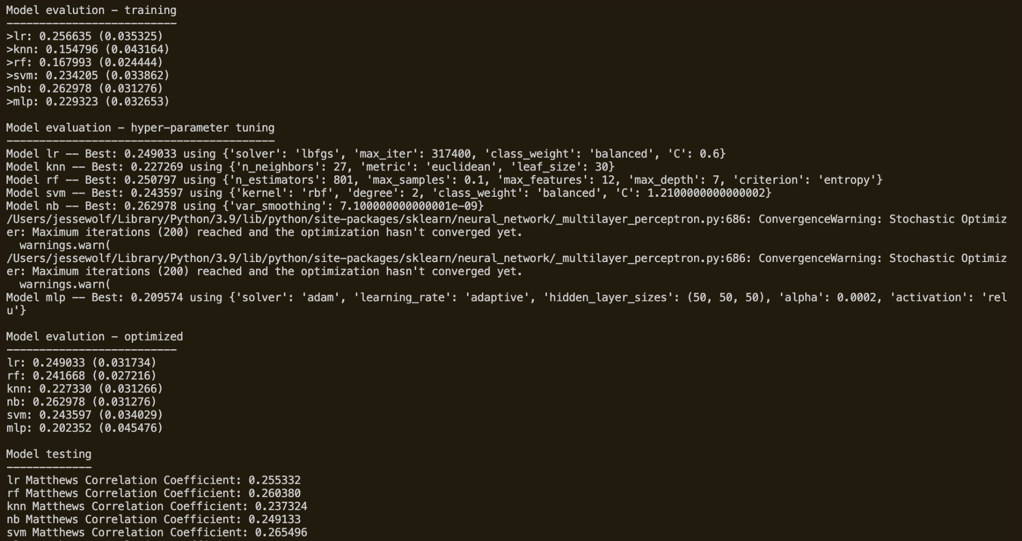

Train 2015-2017

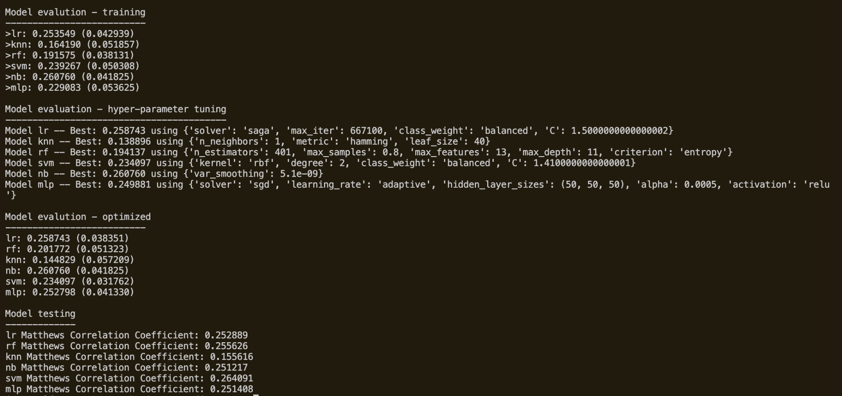

Train 2015-2016

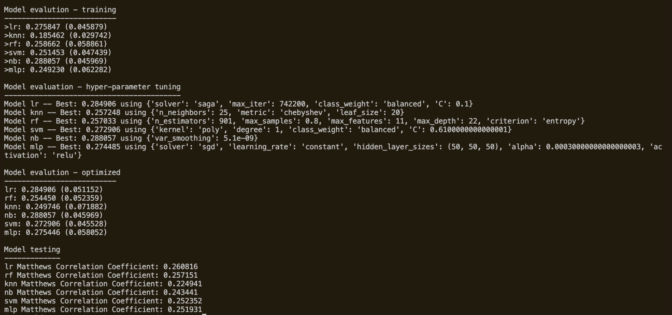

Train 2015-2021 with 9 COMMON RFE FEATURES

