

Dear Editor of ESWA,

I am submitting the manuscript “Comparing individual representation and evaluation for automatic rule extraction using GP in a BYOD scenario” for consideration of publication in Expert Systems with Applications.

All authors have reviewed and gave their approval of the final submitted manuscript.
No portion of the work has been previously published or has been submitted simultaneously for publication elsewhere.

To whom correspondence should be addressed:

Paloma de las Cuevas Delgado
CITIC-UGR, C/Periodista Rafael Gómez Montero 2, D1-7
18071 Granada

Email: palomacd@ugr.es
Tel: +34686056279

Sincerely yours,
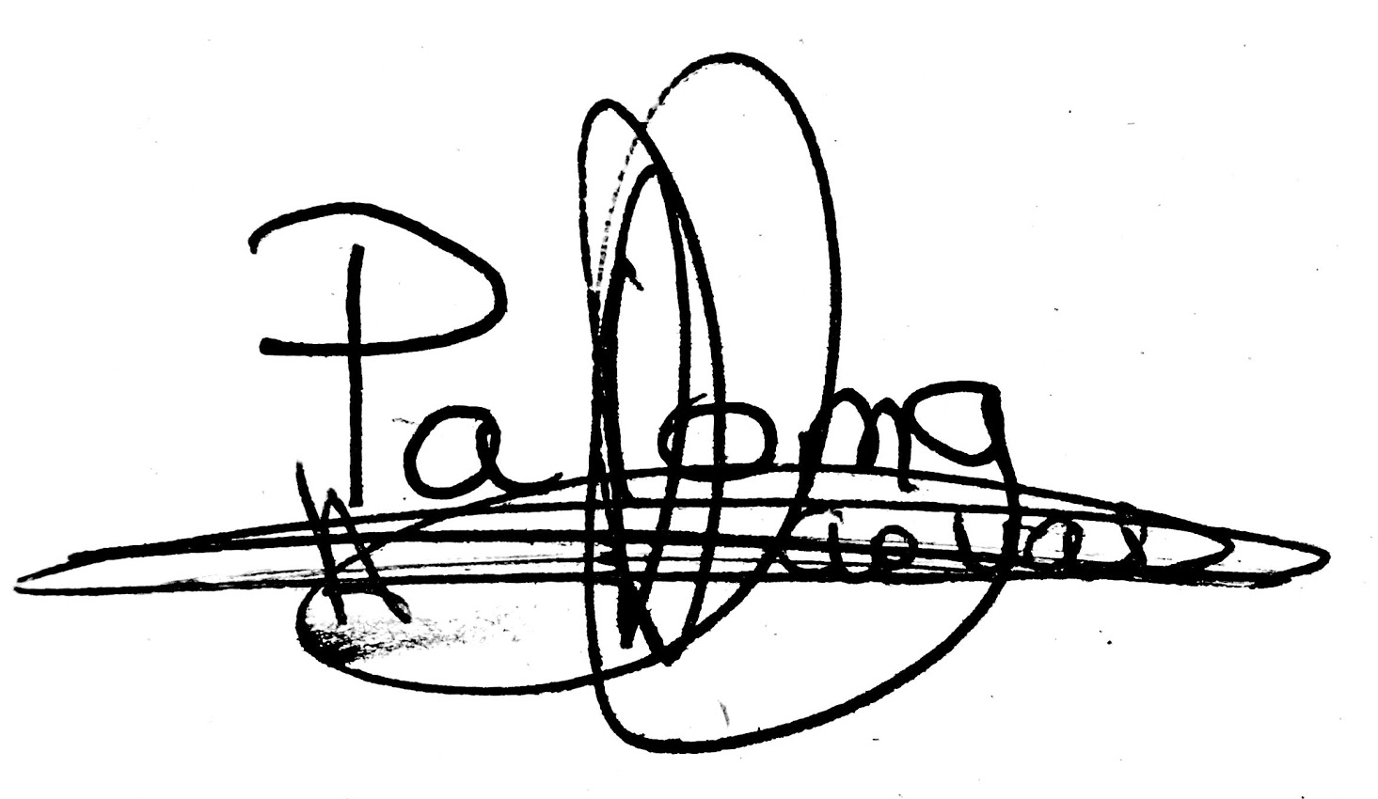

Paloma de las Cuevas Delgado

