The making of MADE (Part 1): It’s all about backstories
The aim of MADE is to create coherent and interesting massive basktories in an open world context that lead to a more immersive and realistic game experience.
Following the definition by the Wikipedia [1], the backstory, also called background story, back-story or background, is a ‘set of events invented for a plot, presented as preceding and leading up to that plot. It is a literary device of a narrative history all chronologically earlier than the narrative of primary interest’.
Following this definition, creating the backstories of the inhabitants of a virtual world consists on creating those events, that may contain information about characters, places, actions, and time.
References
[1] Wikipedia contributors. (2015, June 13). Backstory [Online]. Available: https://en.wikipedia.org/w/index.php?title=Backstory&oldid=666312396
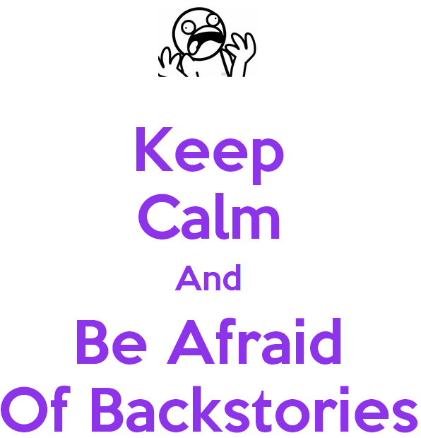
Keep calm and be afraid of backstories (by pikachu-jenna)

The making of MADE (Part 2): Events that tell stories
June 13, 2015
Kim [1] theorized that the term ‘event’ usually implies a change, and most changes are changes in a substance (an individual, an object, a living thing or a system), that occur when ‘it acquires a property it did not previously have, or loses a property it previously had’. Formerly, Kim defined the events in his theory of the structured complexes using the canonical notation [x, P, t], where x is the substance, P is the property it exemplifies and t is the time. The existence condition implies that Event [x, P, t] exists just in case that substance x has the property P at the time t.
In MADE, the events that compound the backstories are defined as meaningful logical predicates with notation Predicate(t,x​0​​,/dots,x​n​​) where t is the time, and each x is an element of the world (a character, a cell, a time, the property of an element or a value). Each predicate has a name, a signature (or arguments) and an interpretation, that is a description of the event in natural language.
For instance, the classical predicate Born could be defined as Born(t,x​0​​,x​1​​,x​2​​) where t is the time, x​0​​ is the character that has born, x​1​​ is his/her father and x​2​​ is his/her mother. The predicate has a name, a signature and an interpretation (“<x​0​​> was born in <t>. His/her father was <x​1​​> and his/her mother was <x​2​​>”).
References:
[1] Kim, Jaegwon, “Events as Property Exemplifications” in Action Theory, ser. Synthese Library, M. Brand and D. Walton, Eds., 1976, vol. 97.

Calendar, by studio curve. CC License

The making of MADE (Part 3): world’s facts, world’s deductions and world’s backstories
June 14, 2015
In MADE, the collection of events generated in the virtual world and that relate to all the characters is called the world’s facts. As they are expressed as logical predicates, deductive reasoning mechanisms can be used to extract knowledge from the world. As opposed to the world’s facts, the collection of deduction rules and Predicates is called the world’s deductions.
Deductions can be expressed as Expression​0​​→Expression​1​​, where Expression​0​​ is the premise and Expression​1​​ the conclusion, and both are logical expressions on predicates from the world’s facts and from the world’s deductions.
For instance, based on the event “Born”, we could add Father(x​0​​,x​1​​) to the world’s deductions. Its interpretation could be “<x​0​​> was the father of <x​0​​>”. In this case we could express the deduction rule as ∀t,x​0​​,x​1​​,x​2​​(Born(t,x​0​​,x​1​​,x​2​​)→Father(x​1​​,x​0​​)).
MADE uses the declarative programming language PROLOG [1] to perform the logical reasoning of the World’s deductions over the World’s facts. Both, facts and deductions derived from them, form together the world’s backstories.
References:
[1] W. Clocksin and C. S. Mellish, Programming in PROLOG. Springer Science & Business Media, 2003.

knowledge enlightens. By MD. Hasibul Haque Sakib in Flickr (https://www.flickr.com/photos/insane_capture/)

The making of MADE (Part 4): A very simple approach to tell stories
June 15, 2015
Imagine that we could produce the world’s backstories (world’s facts and world’s deductions, both with their own interpretations in natural language) as a set of Predicates. They would be enough to write sentences. MADE “only” needs to create the proper collection of predicates and use the proper deductions, and then, write their interpretations concatenated in the proper order (grouped by character and ordered by time, for example). This very simple approach can procedurally generate text. Moreover, if we can manage to have more than one interpretation for a predicate, then we could reduce the duplicity of text patterns. Obviously, the quality of the text won’t be good if we do not apply some natural language extra-techniques and it will depend on the quality and coherence of the predicates generated.
In the next posts of the series, we will design and program a very simple approach that is able to write very simple stories. And you’ll be able to download and run it.
As an advance, following this line of argument, how will MADE create the proper collection of predicates? How will MADE adapt the predicates to the target videogame’s setting? They are complex question that will be explained using agent-based models, evolutionary computation and literary devices.

The Face of a Machine, by Bachtiar Rahady

The making of MADE (Part 5): Redesign from the TDD and Clean code philosophy
June 16, 2015
Since January of 2015 I have been programming with pure TDD and Clean Code premises. I can only say that I have undergone a profound transformation as a programmer and now I feel a bit “dirty” if I write production code without having a test in red colour before :-). I am a “solid” defender of the SOLID principles, TDD, KISS approach, dependency injection, and mocking/stubbing.
Martin [1] says ‘You will not make the deadline by making the mess. Indeed, the mess will slow you down instantly, and will force you to miss the deadline. The only way to make the deadline—the only way to go fast—is to keep the code as clean as possible at all times’. MADE’s source code was turning into a mess. I wrote the core two years ago for my master’s thesis and I realized that I was making improvements over code that needed to be refactored from the base. For this reason, I decided to redesign MADE from the TDD and Clean Code approach, with a good structure and a good test coverage. I moved from Java7 to Java8 because I love lambda-expressions and java streams.
Current branch of made can be found in github, and can be downloaded as a zip, using git, using subversion or using github desktop (in windows)
I have integrated MADE’s project with the Continuous Integration platform Travis CI in order to publish the compilation status of the project in real time. Moreover, thanks to Codecov I can know the code coverage of my unit and integration tests (currently 91%, not that bad). If you want to view the summarized status, please look at the badges.
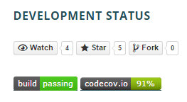
Current development status

Any collaboration is welcomed. Github provides an excellent guide on how to clone a repository. Don’t hesitate to contact if you have any questions or comments about cloning MADE.
Finally, more technical posts are coming (any Java enthusiastic in the room?).
References:
[1] Martin, Robert C. Clean Coder. mitp Verlags GmbH & Co. KG, 2014.

Hope, A single ray of light destroys the darkness, by David Melchor Díaz.

The making of MADE (Part 6): Requirements by example in Unit Tests
June 19, 2015
Martin[1] defines three rules of TDD related to the nature of the tests:
- You may not write production code until you have written a failing unit test.
- You may not write more of a unit test than is sufficient to fail, and not compiling is failing.
- You may not write more production code than is sufficient to pass the currently failing test.
MADE’s tests follow these rules and reflect the requirements by example using clear names and a standard nomenclature. This simplifies the documentation and allows the final user (you) to download and test every improvement. Furthermore, I “do” believe that writing tests is funny: instead of having one program, with TDD I can have many small programs that simply work. If I have a new requirement I can write some more programs, and all together are used to check the validity of the software. Isn’t it great?
MADE has currently 74 tests implemented. The rule followed in MADE for the test names is to use readable names that explain the conditions and the results of executing a method. For this reason, test methods use underscores and long names.
Running the tests (the boring way)
If you are not afraid of the code and the shell, you can download the source code and test the project with a maven goal.
> git clone https://github.com/raiben/made
> cd made
> mvn test
Running the tests (the easy way)
To simplify the test of the different requirements (specially the future ones, the interesting ones) I have created a project called “prettytestrunner”. It is just an application that simply runs the tests and displays their names in a pretty way (as requirements by example). Basically, if you run the program, you get a list of real examples and their result in the current version of MADE.
You can compile the program with the command “mvn assembly:assembly” but it is easier to download it and execute it in a shell. Here is the link (courtesy of Dropbox).
After downloading you only have to run:
> java -jar prettytestrunner-0.1-jar-with-dependencies.jar
Listing the current tests
(remember that the following names are extracted and transformed from the tests names, so the syntax and grammar of the English may not be correct in some cases).
Requisites of the World Integration
1: OK -> AntMite is alive
Requisites of the Ant Mite
1: OK -> GetName must return the name of the agent when set
2: OK -> GetName must return the default name when not set
3: OK -> GetFiniteStateAutomaton must return a valid instance
Requisites of the Evaluator
1: OK -> Prolog engine can be used
2: OK -> Evaluator uses a list of events as input
3: OK -> Evaluator must be configured with tropes
Requisites of the Event
1: OK -> Event returns correct Predicate when two arguments provided
2: OK -> Event returns correct Predicate when no arguments provided
3: OK -> Event returns correct Predicate when one argument provided
4: OK -> Event returns correct Predicate with numbers and strings
Requisites of the Events Log
1: OK -> EventEntity getters must return set values
2: OK -> DayLog getters must return set values
3: OK -> EventsLog getters must return set values
4: OK -> BoardEntity getters must return set values
5: OK -> EventsLog is converted to json
6: OK -> PositionEntity getters must return set values
7: OK -> CharacterEntity getters must return set values
8: OK -> fromJson must return EventsLog when Json is valid
Requisites of the Finite State Automaton
1: OK -> run directs to first state when condition accomplished and random lower than probability
2: OK -> FiniteStateAutomaton is not correct when initial state does not exist
3: OK -> FiniteStateAutomaton is not correct when no initial state is provided
4: OK -> run directs to second state when first condition did not accomplish
5: OK -> FiniteStateAutomaton can use transitions
6: OK -> getTargetStates must return states in order
7: OK -> FiniteStateAutomaton launches action of initial state
8: OK -> run directs to the same state when no condition accomplish
9: OK -> FiniteStateAutomaton is not correct when no states are provided
10: OK -> FiniteStateAutomaton is not correct when world is not set
11: OK -> run directs to the same state when no random under probabilities
Requisites of the Map
1: OK -> newMap: allCells must be land
2: OK -> newMap: allCells must be empty
3: OK -> getCellByPosition: cell retrieved by position and retrieved by coords must be the same
4: OK -> getPositionByCell: position retrieved by cell and coords retrieved by cell must be the same
5: OK -> moveCharacter: source with character and target empty must move character to target
6: OK -> getCellByCharacter: when character is moved to target the returned cell must be the target
7: OK -> getPositionsToMove: When movement is 1 and from 0x 0y then position 2x 2y must not be included
8: OK -> getCell: allCells must have the same position than the one used to get them
9: OK -> removeCharacter: cell with character must remove the character from the map
10: OK -> putCharacter: putting the same character in two cells must throw exception
11: OK -> moveCharacter moving to a non empty location must throw exception
12: OK -> newMap: allCells must have different position
13: OK -> getCell: position out of bounds must be moduled
14: OK -> newMap: 20×20 must contain 400 cells
15: OK -> getPositionsToMove When movement is 2 from 0x 0y and obstacles then must not include unreachable cells
16: OK -> putCharacter: in empty cell must put the character
17: OK -> moveCharacter: moving to the same location must throw exception
18: OK -> moveCharacter moving from an empty location must throw exception
19: OK -> putCharacter: in non empty cell must throw exception
20: OK -> getCellByCharacter: character in map must return a cell
21: OK -> getCellByCharacter character not in map must return null
22: OK -> getPositionsToMove: When movement is 2 and from 0x 0y then position 2x 2y must be included
23: OK -> getPositionsToMove: When movement is 2 and from 0x 0y then position 18x 2y must be included
24: OK -> getPositionsToMove: When movement is 2 and from 0x 0y then position 2x 18y must be included
25: OK -> getPositionsToMove: When movement is 2 and from 0x 0y then position 18x 18y must be included
Requisites of the Random Number Factory
1: OK -> getNextProbability returns a random number
2: OK -> getNextProbability returns the sequence provided
3: OK -> getNextProbability returns a: number when seed is 0
Requisites of the String Util
1: OK -> doubleTicksToQuote must convert each double tic to quote
Requisites of the World
1: OK -> World with no inhabitants must not return pupulated list of inhabitants
2: OK -> World with one inhabitant must return a pupulated list of inhabitants
3: OK -> World must have empty events when never run
4: OK -> World must set id 0 to the first inhabitant
5: OK -> World can tell a story about itselft
6: OK -> World default time unit must be days
7: OK -> World must set id to inhabitants
8: OK -> World must set correlative ids to two correlative inhabitants
9: OK -> World must set a different id to each inhabitant
10: OK -> World must return 0 run time units when never run
11: OK -> World must use custom time unit when configured
12: OK -> World must be able to run a number of time units
13: OK -> World must have non empty events after running
14: OK -> AddInhabitant must insert an event when called
15: OK -> World must have events
References
[1] Martin, Robert C. Clean Coder. mitp Verlags GmbH & Co. KG, 2014.
And remember, testing is better when a machine can do it for you

Unknown author. From http://www.boomviral.net

The making of MADE (Part 7): The roadmap
The following roadmap presents MADE short-term objetives (before the end of july).
- Narration engine: Writing events (to text).
- Inference engine: Inference of new events from the world events.
- Inference engine: Formalize the base predicates for the monomyth:
  - Adventure.
  - Hero.
  - Shadow.
  - Herald.
  - Ally.
  - Mentor.
  - Shapeshifter.
  - Shadow.
  - Trickster.
- Narration engine: Writing the monomyth predicates (to text).
- ABM engine: Components of the self-organisation: ABM Layer:
  - Map.
  - Agent.
  - Passage of time.
- ABM engine: Basic agent behavior as a “living thing”:
  - Movement.
  - Food and energy.
  - Competitions.
  - Collaborations.
  - Relationships.
- ABM engine: Inference from the world events to base predicates:
  - Adventure.
  - Hero.
  - Shadow.
  - Herald.
  - Ally.
  - Mentor.
  - Shapeshifter.
  - Shadow.
  - Trickster.
- Narration egine: generate personal stories and world story.
- EC engine: Assign fitness of the world’s backstories.
- EC engine: Define metrics of interest.
- EC engine: Extract execution parameters and codify the chromosome.
- EC engine: Apply a canonical genetic algorithm to find the fittest chromosome.
- EC engine: Define parameter configurations.
- Test the EC engine:
  - Perform tests with different configurations.
  - Analise the data.
  - Extract conclussions.
- Customization engine: Contextualise to different literary settings:
  - Futuristic
  - Fantasy
  - Steampunk
- Customization engine: Conditions on the predicates in the optimization phase.
- Customization engine: Conditions on predicates relevance in the writing phase.

The road, by Erik Schepers. License CC BY-NC 2.0

The making of MADE (Part 8): Component stack and dataflow
June 27, 2015
MADE has two main applications (MADE optimizer and MADE simulator) and five components (Customization engine, EC engine, ABM engine, Narration engine and Inference engine).
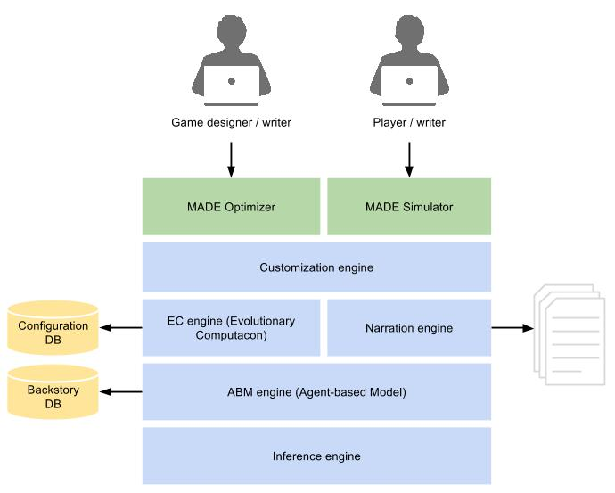
MADE’s component stack
Description of MADE’s components:
- MADE Optimizer can be used by a game designer or a screenwriter. Its goal is to generate the configuration for the correct emergence of the backstories when running the simulator. It uses an hibrid EC-ABM approach (Evolutionary Computation / Agent-based Model) with and predicate-based inference engine that can extract knowledge from the events.
- MADE Simulator can be used by the end-users (also a writer) and the videogame themselves, to simulate a virtual world with backstories according to the parameters provided. The backstories can be used directly by the narrator engine, that produces a written story in natural language, or by third party integration tools.
- The ABM Engine provides a virtual world generated according to given parameters and inhabited by autonomous agents that interact to produce events. Those events form the world backstories and can be translated to natural language.
- The Inference engine is able to infer new events from the events generated in a virtual world. It provides high-level predicates related to tropes, archetypes and other literary artefacts.
- The EC engine is able to calculate the fitness value for the world’s backstories and uses an Evolutionary Algorithm to find the configuration for the ABM engine with the higher fitness value.
- The Narration engine is used by MADE Simulator and translates the world’s backstories of a simulation with the best configuration to written stories in natural language.

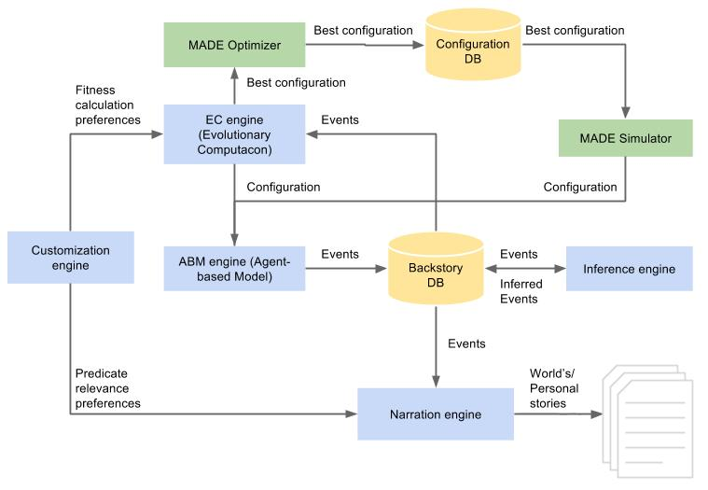
MADE’s data flow

The making of MADE (Part 9): Implementing a narration engine
July 11, 2015
As we mentioned before, the world’s events and the world’s deductions form, together, the world’s backstories. Each event or deduction is considered as a fact in the virtual world, an is expressed as a logical predicate, with name, arguments and an interpretation, or a phrase, expressed in natural language, that uses the arguments. Our assumption is that, if we group the set of predicates (events and deductions) present in the world’s backstories, we order them by date and concatenate all their interpretations, then we are able to generate a very simple story.
Requirements:
- The Narration engine must receive the world’s backstories to produce a narration in natural language.
- The Narration engine can be customized to produce specific phrases from specific predicates. This customization is independent from the world’s backstories.
Modelling by example:
Precondition 1: The world’s stories generated by the simulator are:
Conflict (0, 0, 'Iñigo Montoya', 1, 'the "six-fingered man"', '4', 'the death of Iñigo's father')
Helps (1, 0, 'Iñigo Montoya', 2, 'Westley', '20', 'his plan to enter into the castle.')
Precondition 2: The customization file must include the rules to generate the desired narration:
Post-condition: The narration generated must be: “The day 0, there was a conflict between Iñigo Montoya and the “six-fingered man” because of the death of Iñigo’s father. The day 1, Iñigo Montoya helped Westley with his plan to enter into the castle.”
Implementation:
The class diagram in figure 1 describes the Narrator class and its components. Narrator implements INarrator interface and uses an EventsLogEntity and and ICustomization.
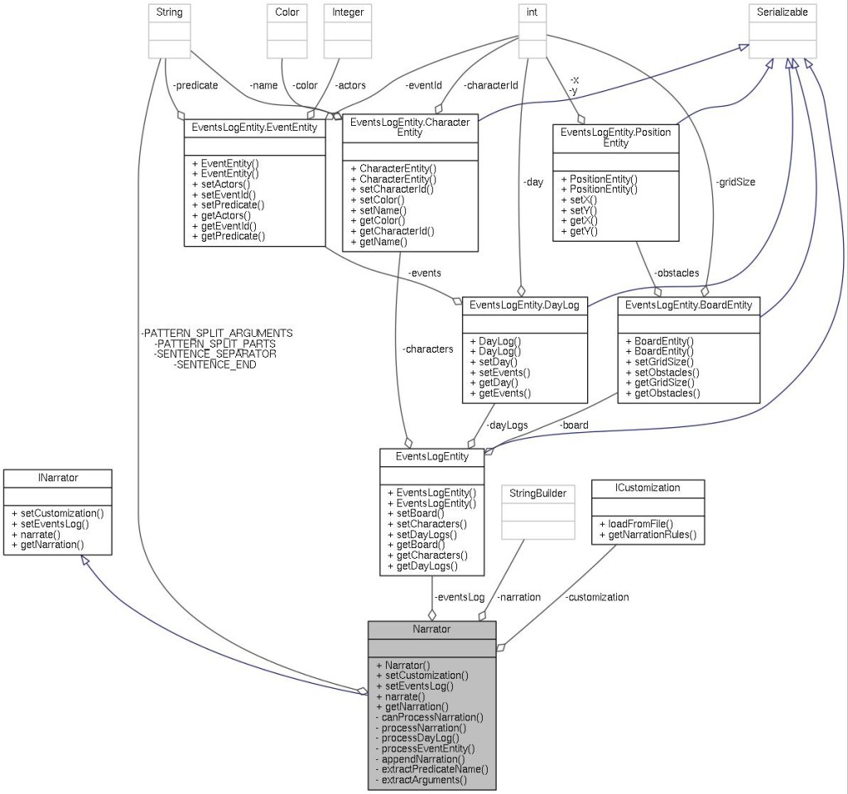Figure 1: Narrator class sub-components
The Customization class is constructed using a json with an array of predicate interpretations (see example monomyth_narration_rules_en.json):
[
{
"predicateName": "Conflict",
"_help": "day, id_0, name_0, id_1, name_1, source_of_conflict_id, source_of_conflict_name",
"numberOfArguments": 7,
"naturalLanguageTemplate": "The day {0}, there was a conflict between {2} and {4} because of {6}"
}, {
"predicateName": "Helps",
"_help": "day, day, id_0, name_0, id_1, name_1, source_of_help_id, source_of_help_name",
"numberOfArguments": 7,
"naturalLanguageTemplate": "The day {0}, {2} helped {4} with {6}"
}
]
A narrator uses this customization and an EventsLogEntity to produce the narration. The EventsLogEntity has the structure displayed in figure 2.
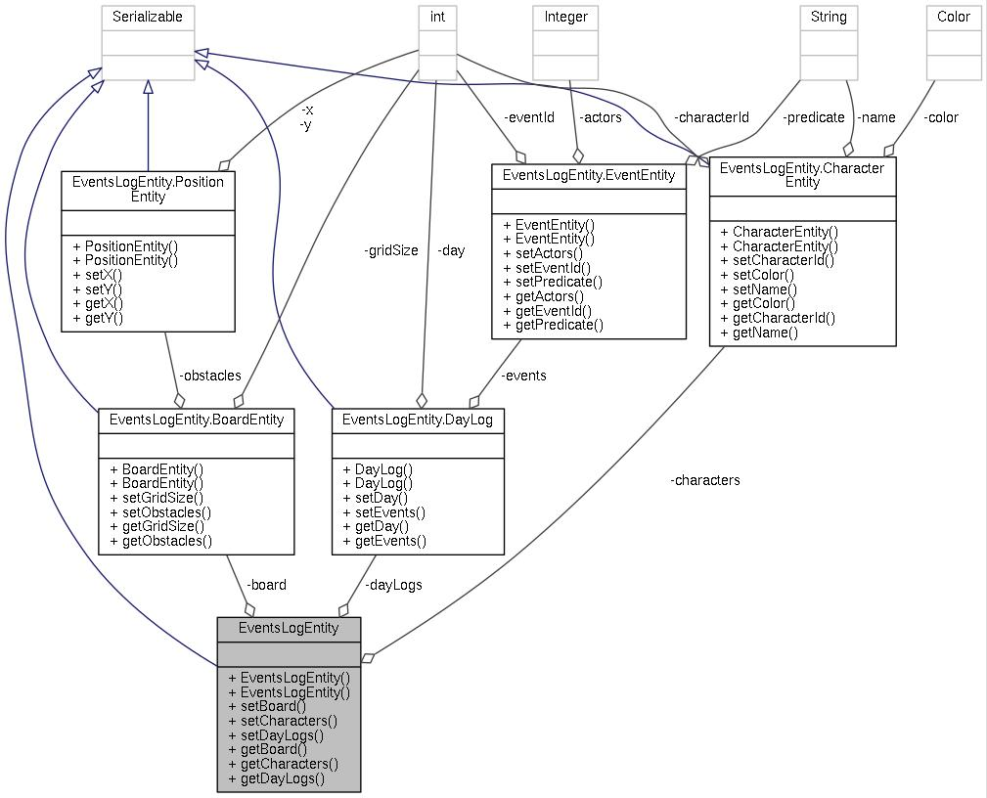Figure 2: EventsLogEntity class sub-components
As result, the narrator generates the following output:
The day 0, there was a conflict between Iñigo Montoya and the “six-fingered man” because of the death of Iñigo’s father. The day 1, Iñigo Montoya helped Westley with his plan to enter into the castle.
More tests can be found in NarrationRuleEntityTest.java and MonomythNarrationIntegrationTest.java. Feel free to visit the source code and comment in the blog. In the next posts we will study some more interesting predicates.

“Hello, My name is Inigo Montoya. You killed my father. Prepare to die”, by Ken Whytock. License CC BY-NC 2.0

The making of MADE (Part 10): Looking for heroes (the monomyth)
July 12, 2015
In narratology and comparative mythology, the monomyth (or the hero’s journey) is a common literary pattern found in classic myths but also in contemporary book, films and comics. Firstly introduced by Campbell in 1949 in The Hero with a Thousand Faces [1], the monomith is summarised as ‘A hero ventures forth from the world of common day into a region of supernatural wonder: fabulous forces are there encountered and a decisive victory is won: the hero comes back from this mysterious adventure with the power to bestow boons on his fellow man‘.
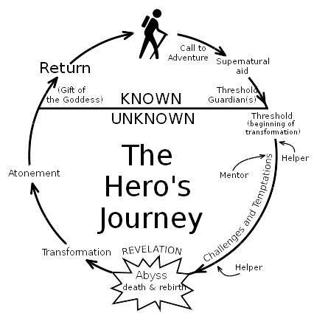
The Hero’s Journey, from the wikipedia. Public domain
We’ll talk more about the monomyth in future post. By now, we only introduce the concept and use some of the definitions by Vogler [2] to guide next MADE’s requisites related to the deduction and narration engine. Remenber that, in The making of MADE (Part 3), we defined the world’s deductions as if-then sentences.
Deductions can be expressed as Expression​0​​→Expression​1​​, where Expression​0​​ is the premise and Expression​1​​ the conclusion, and both are logical expressions on predicates from the world’s facts and from the world’s deductions.
Following [3], Vogler defined in 8 archetypes in the monomyth:
- The hero is the central figure of the journey. ‘The hero is the person who goes out and achieves great deeds on behalf of the group, tribe, or civilization’.
- The mentor is the hero’s guide and protector.
- The threshold Guardians are the the forces that the hero must overcome along the journey, including enemies and own fears.
- The herald is the caller to the adventure for the hero.
- The shapeshifters are characters who change along the journey.
- The shadow is the villain, the dark side.
- The allies help the hero through the journey.
- The tricksters are mischief-makers.
The monomyth can be found in a multitude of movies, TV shows, books, songs, and videogames, from Skyrim and Mass effects [4] to The legend of Zelda [5] and Assassin’s creed [6]. In future posts, we will model these archetypes as predicates in the world’s deductions, and MADE will logically infer them from simple predicates, since one of the the main goals of our project is to generate interesting backstories.
References
[1] Campbell, Joseph. The Hero with a Thousand Faces. Princeton: Princeton University Press, 1949. p.23
[2] Vogler, Christopher. The Writer’s journey. Michael Wiese Productions, 2007.
[3] Vogler, Christopher. (2015, July 12). Hero’s journey [Online]. Available: www.thewritersjourney.com/hero’s_journey.htm
[4] Knopf, Ehsan. The Rationalist’s Spirituality: Campbell’s Monomyth in Single-Player Role-Playing Videogames Skyrim & Mass Effect. 2013.
[5] Wrisinger, Carli. “Link” ing monomyth and video games: how The Legend of Zelda connects myth to modern media. Diss. 2014.
[6] Ngamgamol, Apirath. A NARRATIVE ANALYSIS OF ASSASSIN’S CREED GAMING SERIES. Diss. National Institute of Development Administration, 2014.

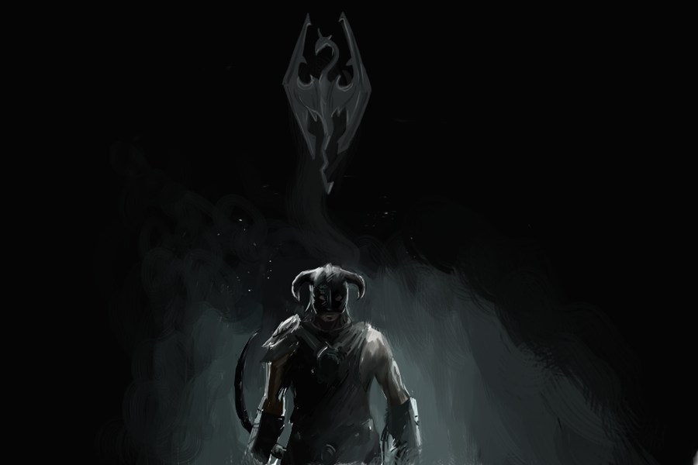
“Skyrim” by Super-Cute from Deviantart.com

The making of MADE (Part 11): Predicate dependency graph for the archetypes
A first analysis of the archetypes in the monomyth have a revealed the existence of simple predicates (base predicates) that are used to deduce more complex predicates (archetypes). In our mental diagram, we have the following predicate names and dependencies in our world’s deductions:
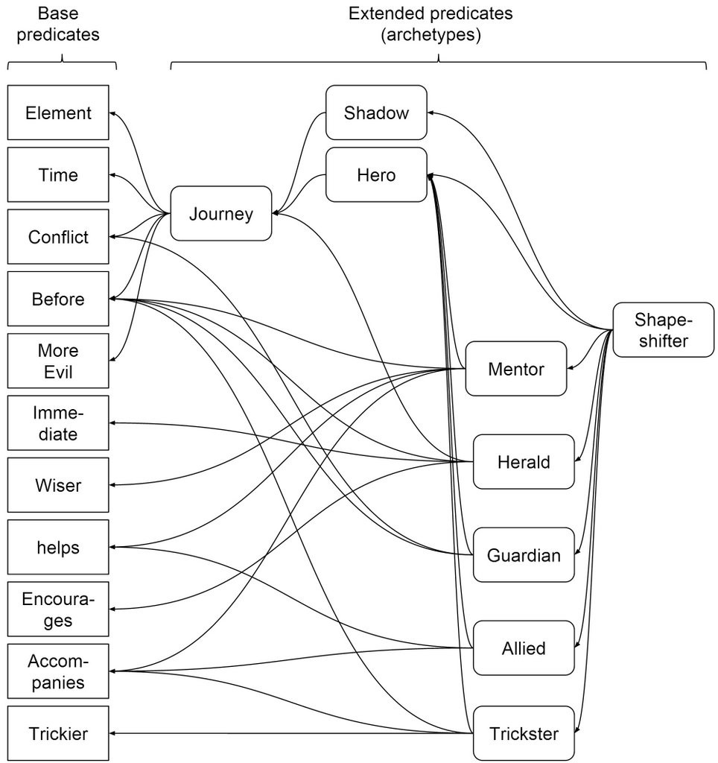
Monomyth MADE World’s deductions
Following this diagram, if we have very basic predicates (for example, what is an element or when we consider that one moment is previous or later to other) we are able to construct more complex predicates (our archetypes).
For example, we can define the journey with two elements (the future hero and his/her future shadow, that will be more evil) and two conflicts between them (In the first one one element is the winner, the evil, and in the second one the other elements is the winner, the good guy). Once we have a journey, we can deduce a predicate that tell us who is the hero and who is the shadow. Then, some more predicates can be deduced: the mentor, the herald, the guardian, the allied and the trickster also take part on the journey, by helping, encouraging or accompanying the hero along the journey.
Let’s keep in mind this diagram although it may vary along the definition process. To finish the Step 3 of our roadmap (“Inference engine: Formalize the base predicates for the monomyth“) it could be good to move forward to step 5 (“ABM engine: Components of the self-organisation: ABM Layer“) and try to briefly define a virtual world able to generate the set of predicates in the world’s deductions that lead to all the predicates defined in the world’s events.

The making of MADE (Part 12): A simple, but powerful virtual world
July 18, 2015
In previous designs of MADE [1] our virtual world was inhabited by virtual rats: ‘A number of rats live, eat, reproduce, compete for food and death within the walls of the Invisible University of Ankh-Morpork . As the University professors, these rats are very vindictive and territorial‘.
We have analysed the design of these agents and discovered that they are not valid for our new implementation of MADE. They don’t implement a feeling-driven behaviour, and without affectivity networks we cannot reach archetypes related to love, hate, fear or shame… We need to design a simpler but more powerful behaviour… let’s remove the discworld context and let the Narration and Customization engines contextualize the backstories to the target literary setting .

The rules of the virtual world
The elements of the virtual world are the map, the pieces, the colours spots and the turns. Each piece will try to maximize its own joy and also its friends’ joy. In this virtual world, pieces will compete and collaborate to reach their desired colour :-).

Map and pieces
- The world map is a board of 10×10 square cell.
- There are three kind of pieces: circle, triangle and square.
- Each piece can occupy only one cell. Every can be occupied by only one piece.
- Every piece has a border colour (desired) and a background colour (actual).

Turns
- Every turn, each piece can move to an adjacent empty cell.
- A piece can move other piece and occupy its cell under certain conditions*. Both cells change their background colour (actual) to their opposite.
- The priority of movements is randomly calculated each turn
- Every turn, the background colour (actual) of every cell changes randomly a given percentage (%).
- Every (n) turns, a random colour spot appears into a random cell. The spot disappears before a new spot is placed.

Colours
- When a piece is over a cell with a colour spot, the background colour (actual) turns to the spot colour in a given percentage (%).
- A piece can transfer a given percentage (%) of background colour (actual) to a target piece if its background colour (actual) gets closer to the border colour (desired).
- A piece can steal a given percentage (%) of background colour (actual) to a target piece under certain conditions*.
* A circle can move/steal to a triangle. A triangle can move/steal to a square. A square can move/steal to a circle.

Strategies
Every piece’s turn can consist in one of the following strategies:
- Skip turn
- Move closer to other piece
- Move away from other piece
- Move closer to a spot
- Move away from a spot
- Move other piece
- Transfer colour to other piece
- Steal colour from other piece
- Move in a random direction

Feelings-based behaviour
Every piece has 8 basic feelings, based in the works of Plutchik in [2]. In MADE, every feeling can have a real value, from 0 to 1:
Joy / sadness
Every piece has a joy level, proportional to:
- The similarity between the border colour (desired) and background colour (actual),
- the similarity between the border colour (desired) and background colour (actual) of its friends.
- and the difference between the border colour (desired) and background colour (actual) of its enemies.
In its turn, the piece will try to increase its joy level by changing its colour or its friends colour, by applying any of the nine strategies.
Trust / disgust (regarding to every other piece)
Every piece has a grade of trust / disgust related to every other piece. The trust on the target piece is directly proportional to:
- The similarity of the border colour (desired),
- the similarity of the background colour (actual),
- and the similarity of the shape
The friends of a piece are all the pieces that the piece trust on over a certain value. The enemies of a piece are all the pieces that the piece trust on bellow a certain value.
The trust / disgust levels will be used to calculate the joy level of every piece.
Fear
Every piece has a grade of fear proportional to the joy level that it will get due to the action of other pieces. When this level is high, it will apply the strategy 3 “Move away from other piece”.
Surprise
Every piece has a grade of surprise that will be high when a piece changes suddenly of colour. The strategy applied will be 9 “Move in a random direction”.
Anticipation
Every piece has a grade of anticipation that will be high when a piece can experiment a big increment of joy. The strategies applied can be all but 1, 3 and 5 (skip turn and move away).
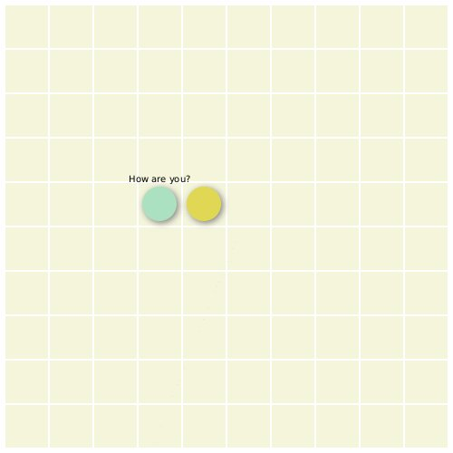
Sample of MADE Player project execution
Do you like the virtual world? How would you call it? Suggestions are accepted.
References
[1] Garcia-Ortega, Ruben H., et al. “My life as a sim: evolving unique and engaging life stories using virtual worlds.” ALIFE 14: The Fourteenth Conference on the Synthesis and Simulation of Living Systems. Vol. 14. 2014.
[2] Plutchik, Robert. “Emotions: A general psychoevolutionary theory.” Approaches to emotion 1984 (1984): 197-219.

The making of MADE (Part 13): Feelings-driven IA for our agents
July 24, 2015
In previous posts we defined the rules of virtual world and the world’s deductions that we will need for the emergence of different archetypes related to the monomyth. We need to design the IA of our pieces in order to make them compete/cooperate and generate conflicts. Currently, the most extended and popular technique to define IAs in videogames is called “behaviour tree” and is used by game engines like Unreal or Unity. As defined by Llansó in [1], ‘Behaviour Trees are an expressive mechanism that let designers create complex behaviours by defining an AI driven by goals, in which complex behaviours can be created combining simpler ones using a hierarchical approach’.
Our behaviour tree reflects the feelings-based philosophy described in previous posts:
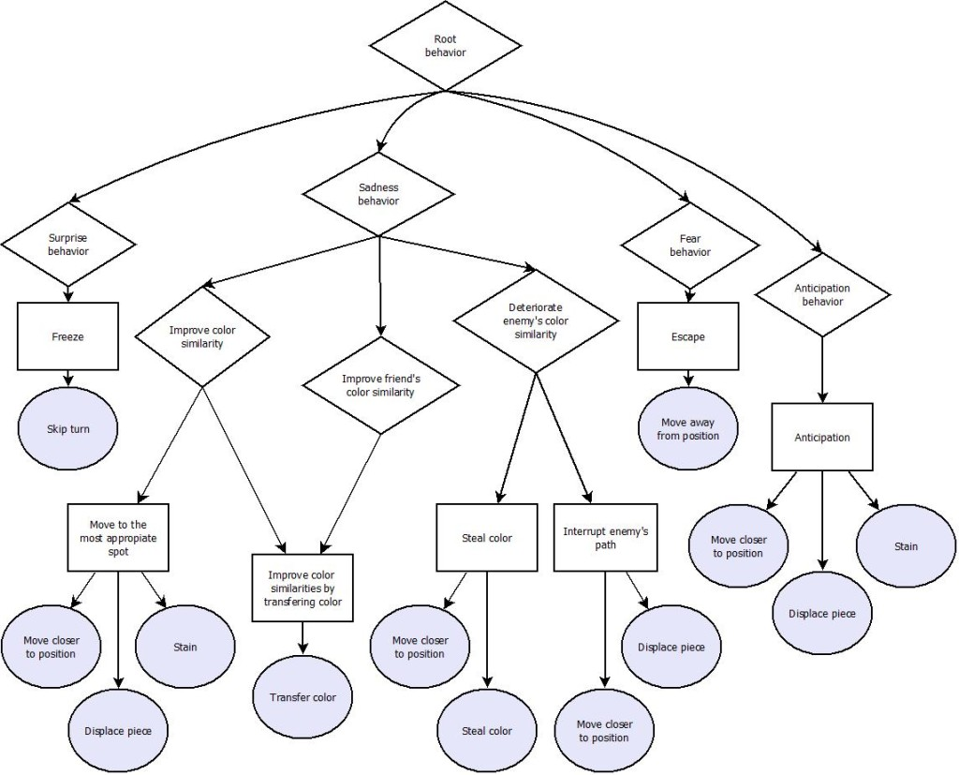
MADE Piece’s behaviour tree
Our next step is to define the predicates that will form the world’s stories with this behaviour tree and try to define the inference rules to obtain the monomyth base predicates.

