Studying individualized transit indicators using a new low-cost information system
P.A. Castillo, A. Fernández-Ares, P. García-Fernández, P. García-Sánchez, M.G. Arenas, A.M. Mora, G. Romero, V. Rivas, J.J. Merelo
Department of Architecture and Computer Technology. CITIC. University of Granada. Spain

Abstract
A new low-cost information system to monitor the traffic in real-time is proposed. Current information systems used for data collection and to generate information on the state of the roads have two drawbacks: the first is that they have no ability to identify and target the vehicles detected. The second is their high cost, which makes them expensive to cover the secondary road network, so they are usually located just on main routes. Proposed system is based on scanning Bluetooth devices that are near the detection node. A large amount of data from passes of Bluetooth devices by different nodes (movements or displacements) have been collected. Thus we can determine the frequency of appearance, calculate average speed, or calculate the number of devices that pass certain site each day (on both working or non-working days). The analysis of collected data has given statistics and indicators about the use of vehicles by the population of the monitored area. Specifically, we have obtained information about the total number of vehicles that each node has detected, on weekdays or holidays, information on traffic density by time range on individual movements, and the average speed on a section delimited by two consecutive nodes.

INTRODUCTION
Having a system of information on traffic conditions and the use of roads by vehicles seems key in the current context. With a population increasingly informed, provided with communication devices ubiquitous commonly used about 90 % of the population, obtaining information about the traffic would mean to optimally manage a communications network vital for a high percentage of users.

Current technologies used in traffic monitoring include pneumatic tubes, loop detectors, floating vehicles or automatic recognition systems, among others. The main disadvantage of these systems is that they are unable to identify vehicles detected, in order to obtain origin/destination matrixes. Just the number of vehicles and their type can be calculated, but does not allow to obtain moves flow, nor to determine whether a certain vehicle passes repeatedly. In addition, its high cost makes it unprofitable covering secondary roads with them, so they are often located on major roads. Moreover, technologies based on video image detection are very costly compared to the previous and can be sensitive to meteorological conditions.

This work presents a new low-cost information system to monitor traffic on different road types and in real time.

Our ultimate goal is to have information about traffic flows that occur in a certain area, allowing to optimally manage motion decisions by citizens. Therefore, various needs from the viewpoint of the transport management have been found:
- A versatile and autonomous data collection and monitoring device is needed.
- It is also necessary to collect traffic data in real time.
- Once the data has been collected, it has to be processed properly.
- And finally, a system that allows sharing data and information with those who make decisions about mobility is needed, both from the institutional and personal points of view.

Proposed system is based on Bluetooth (BT) device discovery. Specifically, it catches waves emitted by different technological components incorporated on vehicles (hands-free, GPS), accessories that the users incorporate to their vehicles, as well as their mobile phones. The main data that is collected is the MAC address of the device BT card. This is an unique identifier for each device, allowing us to identify passing vehicles. From the point of view of data privacy, it is noteworthy that the data collected is not associated to any user because there is no information that enables the identification of the information we collect with a specific person. Encryption technology unidirectional with nonstandard characters that preclude identifying the MAC of the wireless device is used. Thus, intrusiveness is minimal. A large amount of data related to passing BT devices will be collected, to calculate statistics and to study several indicators about the use of vehicles by the monitored area population.

The main objective is building a low-cost system, with a fast implantation and highly reliable.
It provides real-time information about the traffic status, not only to the official organisms and agencies in charge of the traffic controlling, but also to any person who requests it (available as web services).

Our aim is getting exposure indicators using a new system based on the BT devices detection using several collecting nodes. Thus, we are able to monitor the traffic density and car journeys, identifying the vehicles when they move from one node to another inside the monitored zone.

Proposed system is part of a future prediction system that helps to make decisions, and able to apply knowledge in applications related to mobility. It is expected that the development and deployment of these systems will offer a set of information services with added value that are not achieved with current technologies.

The rest of the chapter is organized as follows: Following section reviews current technologies to monitor the traffic that passes through a certain area, as well as similar commercial products. Section “Objectives and expected results” details the goals of this chapter. In Section “Data-collecting hardware device”, the Intelify device is presented. In Section “Data analysis” several analysis and statistics are reported from the data obtained. Finally, we present some conclusions and future work.

CURRENT TECHNOLOGIES
Information systems applied to data collection and generation of information on the state of the roads are classified according to the immediacy of data, completeness in the collection and intrusiveness.

According to the immediacy of data collection, systems are classified into direct data collection (the source obtains data experimentally), and indirect data collection (the data is obtained by further processing algorithms).

Taking into account the completeness of data collection, systems can be making nearly exhaustive (the number of measurements taken match the number of users), or non-exhaustive data collection (measurements related to a limited number of users are taken).

Finally, current monitoring technologies can be classified as intrusive technologies (installed in the pavement), not-intrusive technologies (no contact with the road, causing minimal effect on traffic flow), and floating vehicle technologies.

Figure 1 shows a classification of information systems according to the intrusiveness of the technology.

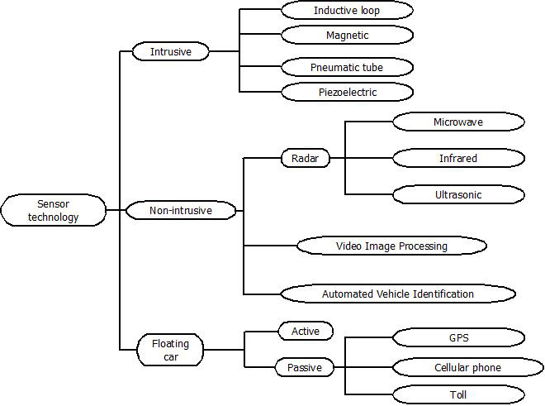
Figure 1. Information systems classification, according to the intrusiveness of the technology.

Main technologies currently used in traffic monitoring include pneumatic tubes, loop detectors, floating vehicles or automatic recognition systems, among others.

Pneumatic road tubes are placed across the road lanes to detect vehicles from pressure changes that are produced when a vehicle passes over the tube. They can be used to count vehicles but the main drawback of this technology is that it has limited lane coverage and its efficiency is subject to weather, temperature and traffic conditions.

Loop detectors is the most conventional technology used to collect traffic data. The loops are embedded in roadways in a square formation that generates a magnetic field. The information is then transmitted to a counting device placed on the side of the road. The implementation and maintenance costs can be expensive.

The use of so-called floating vehicles consists on a vehicle provided with sensors to collect information while driving on a predefined route. This active device data collection is one of the most popular among operators of roads, used especially for the collection of travel time and for loop detector calibration. Depending on the level of automation in the data collection, the cost can vary.

The main disadvantage of these systems is that they are unable to identify vehicles detected, in order to obtain origin/destination matrixes. Just the number of vehicles and their type can be calculated, but does not allow to obtain moves flow, nor to determine whether a certain vehicle passes repeatedly. In addition, its high cost makes it unprofitable covering secondary roads with them, so they are often located on major roads.

Finally, the automatic recognition technology has experienced an increase in recent years due to its ability to detect individual vehicles without relying on in-vehicle systems. Video image detection is a good example: video cameras record vehicle numbers, type and speed by means of different video techniques e.g. trip line and tracking. Furthermore, they are used for automatic detection of incidents on the road. That is the main advantage over previous information systems. However, system reliability might not be the best, as the system can be sensitive to meteorological conditions. Moreover, these systems are very costly compared to the previous. Finally, from a privacy point of view, the Spanish Data Protection Agency (Agencia de Protección de Datos) considers the car license plate as a personal data, so that it would require the user consent.

Commercial products
There are different companies working in the traffic information area using approaches similar to the presented in this work:
- Bit Carrier (Falcato Mendez, 2013; BitCarrier, 2013): It offers a traffic management system based in BT to count people and commercial routes (pathsolver). Its technology was implanted in highways managed by Abertis for traffic control and monitoring. Actually it has a 150 devices network in Catalonia, so it allows count the traffic times of 200.000 persons each day.
- Trafficnow (Trafficnow, 2013): Another BT system product. A pilot experience has been implanted in Vigo.
- Traffax Inc (TraffaxInc, 2013): It is a company that also has used BT for calculating origin-destination and transport time matrixes.
- Savari Networks (SavariNetworks, 2013): It offers the commercial product StreetWAVE for traffic monitoring to know in real time the traffic status.
- TrafficCast (TrafficCast, 2013): They have developed prediction models in different cities based on different technologies, such as cameras, BT and RFID included in the vehicles.

The proposal presented in this work has some common features with the previous approaches, offering similar functionalities with reduced cost.

OBJECTIVES AND EXPECTED RESULTS
The main objective was building a low-cost system, with a fast implantation and highly reliable. It provides real-time information about the traffic status, not only to the official organisms and agencies in charge of the traffic controlling, but also to any person who requests it (available as web services).

Several features have been developed:
- Data collection component: it includes several sensors to continuously scanning and identifying BT devices. It uses a 3G connection to send data the storage server. It is enclosed in hermetic boxes, with a power line (220volt).
- Data processing component: it stores the obtained data, and offers some tools to serve them (through web services).
- Information service: it provides the users the requested information related to the traffic status.

Six devices were installed for data collection. They send obtained data to servers for further data processing. Node locations are shown in the map on Figure 2. Locations were set according to the suggestions of DGT staff, looking for an adequate place, with a continuous flow of vehicles, and also taking into account the assembly difficulty of the monitoring devices.

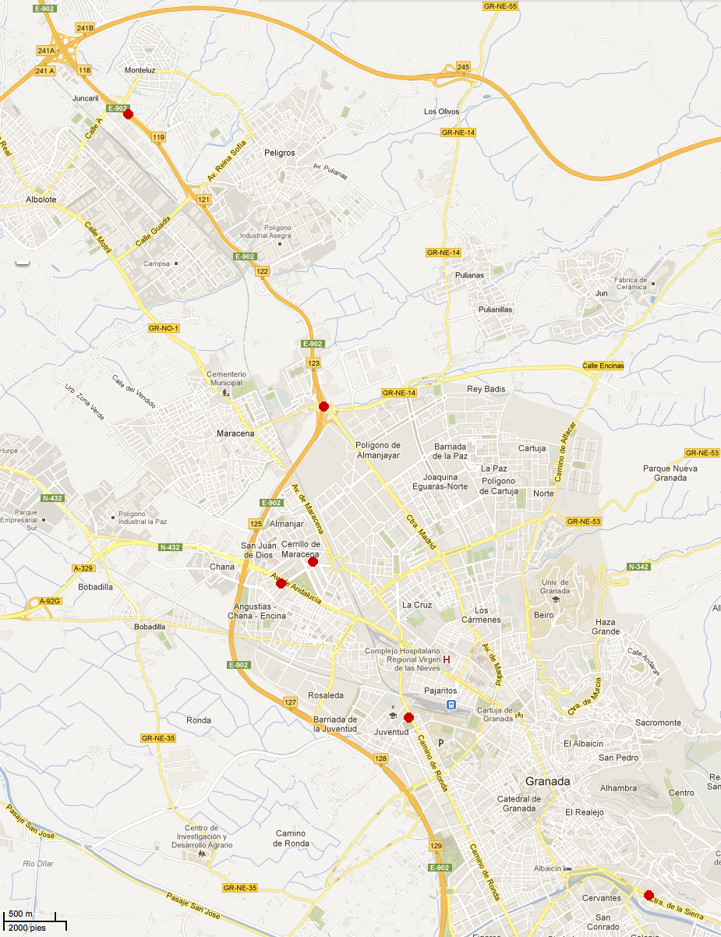
Figure 2. Geographical node locations in the metropolitan area of Granada. Source http://bit.ly/SQdQkH

A large amount of data corresponding to passing BT devices are collected, to populate a big database and to compute different statistics and indicators on the use of vehicles on the monitored area, driving habits and even the effect of important factors or events (key dates, nonworking days, etc).

Specifically, following statistics will be reported:
- Total amount of vehicles detected by every node.
- Total amount of vehicles detected in working days.
- Total amount of vehicles detected in non-working days.
- Number of times each vehicle is detected.
- Type of path that the vehicles follow.
- Traffic density by time range and road type.
- Average speed in the road where two devices where set.

Data-collecting hardware device
The first step of the study was to choose between several hardware devices to scan for BT devices in range. First test were conducted on a PC with Linux and a BT module. This solution was quickly discarded because of its high size and power consumption.

Another possible solution studied was using cell phones with Android due to its high autonomy based on low power consumption, high connectivity, highly available development tools and processor been powerful enough.

A prototype application (available for download at http://www.bit.ly/Tt0Y0S) was developed for Android. The application was limited to three tasks: BT device discovery, BT identification data saving to a text file in the cell phone memory and data sending to a server thorough its 3G connection. The server finally stored the information about the BT devices on a database.

Despite the advantages of the cell phone, the integrated BT devices are low power and small antennas are used because of the power limits. Thus, due to the limited detection capability, using cell phones was discarded.

Finally the Intelify (Intelify, 2013) (see Figure 3) was chosen due to its low power consumption and high detection range.

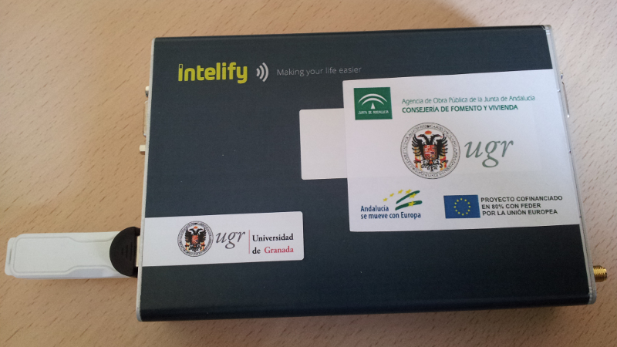
Figure 3. Intelify device with a connected USB 3G dongle.

Intelify is a hardware detection device based on technology developed by Ciudad 2020 (CityAnalytics, 2013; Ciudad2020, 2013). It is an autonomous unit that scan the environment and sends the information to a central server for further processing and interpretation. Table 1 shows main features of the device.

Dimensions | 113x163x30mm
LEDs | Power; 3G activity; Ethernet activity
Networking | Ethernet; Wireless; Bluetooth; 3G
USB ports | City Analytics Antenna; 3G dongle
Other ports | RS-232; VGA
Power | 18v - 1200mA; external jack - 5.5mm; internal jack - 2.1mm
Network connections | Ethernet RJ45; 3G USB Modem
Antennas | City Analytics USB antenna; wireless antenna
Microphone | noise sensor
Temperature | main board temperature sensor with extrapolation
Box | 1.5mm aluminum box; external use possible
Operating System | Debian 6.0 Squeeze

Table 1. Main features of the Intelify device.

Intelify is a small autonomous computer that can be installed in any area to be monitored. It has several sensors that let you discover what is happening in its surroundings like the flow of people and vehicles.

Device operation is based on scanning devices that are in the area of the BT antenna range using the hcitool operating system tool. This tool is used to configure BT connections and send special commands to BT devices. For example, to discover the BT-enabled devices within range, we can use the scan command. hcitool will display the list of MAC addresses of the discovered devices.

Technology was developed by Ciudad 2020 and the services offered are based on a net of monitoring devices with the capacity to discover information about the physical environment and help with decision making to any kind of organization based on people flow and behavior.

Valuable information about tourism, trade and mobility can be gathered through the deployment of autonomous devices around a city.

The cost of this solution is under $ 1000 per device, including maintenance of remote computer, communications using a 3G telephony service and storage and data management.

Data accuracy is very representative, compared against other technologies. In (Blobject, 2013) it was obtained an a priori error estimation of 8.5% of detections.

Sharing data and information using web services
To allow the integration with other systems, the Service Oriented Paradigm (Papazoglou et al., 2007; García-Sánchez et al., 2010) has been used. This paradigm allows the usage of available "service interfaces" (usually over Internet) to access to required information.

These interfaces allow the "service consumers" to interact "service implementations" with independence of the programming language or operating systems (Arsanjani, 2008; Castillo, 2012). Implementations can be changed and updated, allowing the interoperability and integration with other systems.

Whatever the technology used to deploy web services, they provide several advantages, like language independence and distribution mechanisms; it also increases the interoperability between different software elements (for example, it is possible to add communication libraries without modifying existing code), and facilitates code distribution (it is not required the use of a concrete implementation or library) among geographically distributed work teams (Castillo, 2013).

In this case, our platform uses Representational State Transfer (REST) web services (Fielding, 2000; Fielding et al., 2002; Vinoski, 2008), as this paradigm adheres much more closely to a web-based design. REST is an alternative method for building web services. This technology was proposed and defined by Roy Fielding (Fielding, 2000; Fielding et al., 2002). In a REST-style architecture, a client sends requests to the server who process them and return responses to the client. Requests and responses represent resources that can be addressed by an Uniform resource identifier (URI). Usually, resources are documents or programs the client need to access to.

REST web services are simple and lightweight (as no extra XML markup is needed), their message format is readable by humans, they are easy to build, and finally, developments achieve a high performance (Daigneau, 2011).

Developed services have been designed to extract/insert information in the database taking into account security and availability requirements. This way, users can access our database with an extra layer of security and management (instead accessing the database directly).

Using this mechanism, and therefore allowing the usage of our system data by third parties, will facilitate the easy creation of webpages, mobile apps and others, serving useful information to the users.

DATA ANALISYS
In this section the analysis of collected data during the monitoring period (November 8 to December 9, 2012) to obtain statistics and so study the use of vehicles is carried out.

Specifically, the following subsections report information about the total number of vehicles detected by each node, on weekdays or holidays, information on traffic density by time range on individual movements, and the average speed on a section delimited by two consecutive nodes.

Total number of vehicles detected (weekdays and holidays)
The first analysis consisted in calculating the number of devices detected by each node.

Node Id. | Number of devices detected
1 | 31408
2 | 45032
3 | 33165
4 | 358494
5 | 297874
6 | 7872

Table 2. Number of BT devices detected per node.

About 773845 BT devices have been detected in total. As shown in Table 2, nodes located in the Sierra Nevada Highway (A44, nodes 4 and 5) have collected a higher number of data, while the node located in a side street (node 6) has detected the smallest number of devices.

Total vehicles detected on non-working days
To compare the traffic intensity between working and non-working days, the number of pass on holidays and non-working days have been obtained.

Node Id. | Number of devices detected
1 | 2149
2 | 2804
3 | 2832
4 | 32182
5 | 24166
6 | 1269

Table 3. Total number of BT devices detected per node (only on non-working days).

Table 3 shows how the number of detected devices lowers by all nodes on non-working days, compared to the number of detections on weekdays. Nodes located in the Sierra Nevada Highway still collected much more data than the remainder, due to the traffic this road supports on holidays.

Traffic density on the road by time range
Traffic density can be calculated taking into account the total number of detected devices by time range.

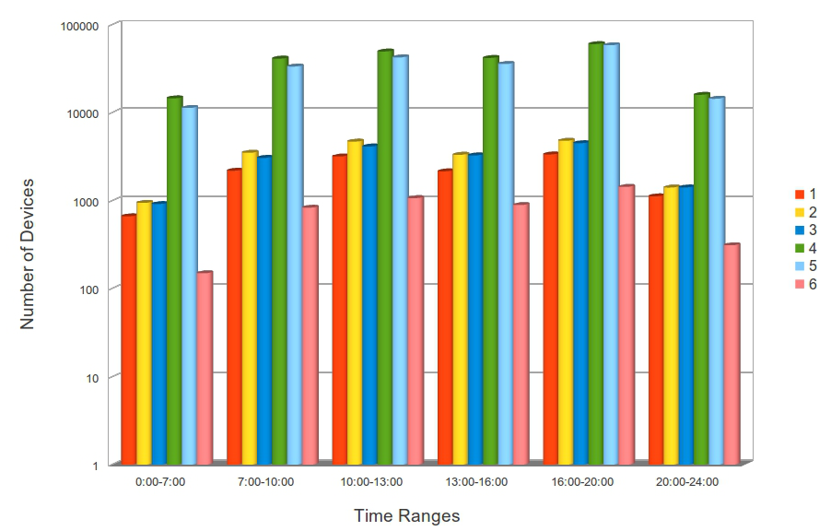
Figure 4. For each node, the total number of different detected devices by time range is shown. Figure is shown in logarithmic scale.

Figure 4 shows higher density on all nodes, at peak times or out of work and school.

Total detections by time range
Additionally we can calculate for each node, the number of detected devices by time range, without differentiating whether the device is the same or not (repeated passes). Thus, repeated passes of the same vehicle are counted.

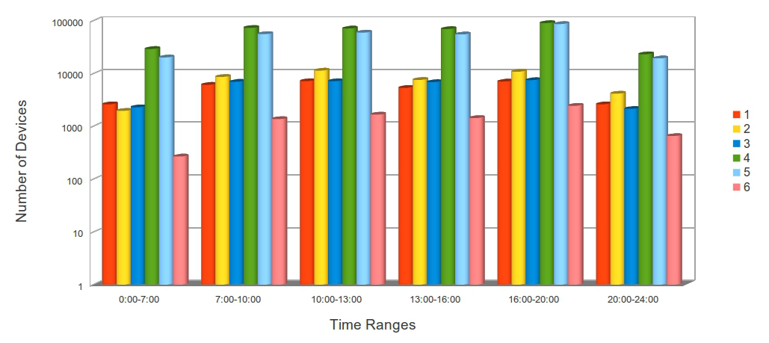
Figure 5. For each of the six nodes, the total number of detected devices by time range is shown. Figure is shown in logarithmic scale.

As in the previous case, a greater traffic density can be observed on all nodes, at peak times or out of work and school (see Figure 5).

Number of individual vehicles detections
We can take advantage of the proposed system's ability to identify BT devices. Thus, it can be detected whether vehicles pass by different nodes.

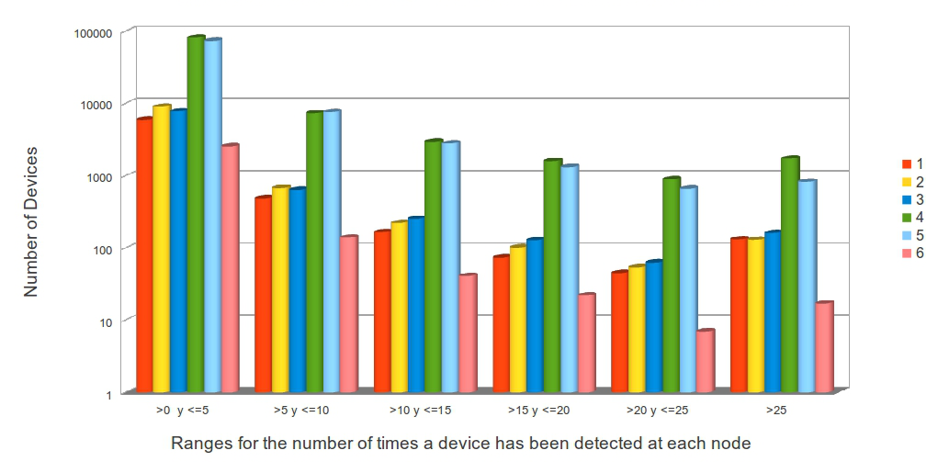
Figure 6. For each of the six nodes, the total number of detected devices N times (repeated occurrences of the same device) are shown. Figure is shown in logarithmic scale.

Figure 6 shows a large number of vehicles that pass repeated times (up to 10 times) by some of the nodes (mainly those located in the A44). Even it can be seen that nodes 4 and 5 detect about 1,000 vehicles passing more than 25 times repeated. On the other nodes, over 25 repetitions of the same device have been detected only around 120 times.

Complexity of displacements
To study the complexity of displacements, the number of vehicles that have passed through two nodes, 3 nodes and up to 6 nodes were calculated. Table 4 also shows the average number of times that vehicles have passed through 2, 3, 4, 5 or 6 nodes.

Number of nodes | Number of devices | Total number of passes | Mean ± std. dev.
1 | 72989 | 165033 | 2.26 ±31.16
2 | 53947 | 425667 | 7.89 ± 11.48
3 | 8125 | 131570 | 16.19 ± 24.71
4 | 1359 | 39241 | 28.88 ± 140.82
5 | 254 | 8603 | 33.87 ± 59.51
6 | 61 | 3731 | 61.16 ± 94.78

Table 4. Total number of vehicles that have passed through two nodes, 3 nodes and up to 6 nodes, and average number of times that vehicles have passed through 2, 3, 4, 5 or 6 nodes. In some cases the deviations are high because some devices have a very high number of occurrences for some nodes.

The above information is complemented with Figure 7 that shows how many cars pass by only one node, two nodes, three nodes, etc.

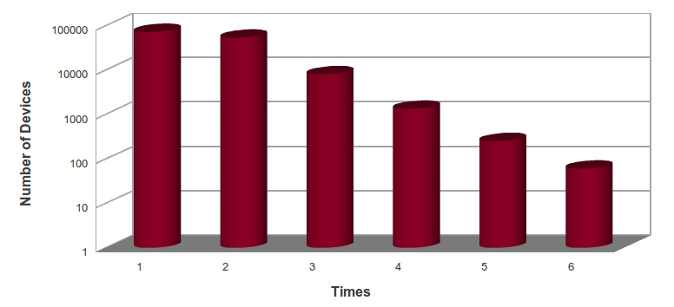
Figure 7. Figure shows how many cars pass by only one node, two nodes, three nodes, etc. Figure is shown in logarithmic scale.

As expected, most of the BT devices rarely passed by all nodes, while most of devices pass only by one or two of nodes (their displacements are focused on a small part of the monitored area).

Analysis of vehicles speed between two consecutive nodes
Finally, taking two consecutive nodes, located on the A44 highway, average speeds in the section bounded by nodes 4 (located at km 119.550) and 5 (located at km 123.250) can be calculated. This highway section where the study takes place is of 3700 meters long. Actually, we can calculate the average speed in the global section, not the speed at which each vehicle has at each instant within the section.

Speed range (km/h) | Number of passes
v≤60 | 1495
60<v≤70 | 2585
70<v≤80 | 7421
80<v≤90 | 16339
90<v≤100 | 20144
100<v≤120 | 14384
120<v≤140 | 5434
v≥140 | 1326

Table 5. Average speeds (globally) in the section bounded by nodes 4 and 5.

In that section, the speed is limited to 100 km/h. However, although most of the vehicles respect this limit, a lot of cars exceed this limitation.

FuTURE rESEARCH dIRECTIONS
Among future improvements to the system, as hardware device, one based on the architecture of RaspberryPi will be used, as it is more energy efficient and cheaper. Thus, reducing costs installing new nodes is expected. The hardware team may perform this hardware device evolution and migration to the new model with minimal effort and independently of the work of software development team project.

Several future research lines have been opened. They are mainly focused on processing the collected data using data mining algorithms (Hastie et al., 2009), evolutionary computation methods (Eiben, 2003; Michalewicz, 2004; Yang, 2010), artificial neural networks (Castillo, 2001; Rivas, 2003; Castillo, 2007), machine learning models (Arenas, 2005) and statistical methods (Jiawei, 2006; Hill, 2007; Nisbet, 2009), which will be included and integrated as web services (Papazoglou, 2007; Garcia-Sanchez, 2007) in the system.

A critical task that any new intelligent transportation systems should face is short-term traffic flow prediction. Thus, our purpose is to develop in the future a prediction system that helps to make decisions, and able to apply knowledge in applications related to mobility. In this sense, different time series prediction methods will be used in order to estimate the vehicle passing. Time series forecasting is usually tackled trying to find out an underlying model that describes the series behaviour. Our system will test a variety of methods and include some of them to perform forecast, using both linear and nonlinear models (Brown, 1959; Winters, 1960; Box and Jenk, 1976; Tong, 1978; Qiu et al., 2011; Wang, 2011; Rivas, 2004).

It is expected that the development and deployment of these systems will offer a set of information services with added value that are not achieved with current technologies.

Conclusion
The information systems currently used for collecting data about the road conditions are not able to uniquely identify detected vehicles, and if they do, these information systems have a high cost.

This paper presents a new low-cost information system to monitor traffic on different road types and in real time.

The main goal was getting exposure indicators using a new system based on the BT devices detection using several collecting nodes.

Thus, we are able to monitor the traffic density and car journeys, identifying the vehicles when they move from one node to another inside the monitored zone.

Moreover, different hardware solutions have been studied to carry out device detection, and we have rejected some of them for its high prices, for its energy inefficiency or for their short-range for detection.

Also we have taken into account different road types, with different traffic type. Statistical data have also been obtained grouped by days of the week and hours of day.

Several statistics of the collected data have been calculated during the monitoring period (November 8th to December 9th, 2012).

Specifically, the total number of BT detected devices by each node has been analyzed, on holidays or working days. We also have analyzed the traffic density by time range, and the journeys of the drivers in the monitored zone.

Then, average speed of some journeys has been calculated for a set of drivers that were detected by two consecutive nodes in the highway.

Finally, the power and features of the system have been demonstrated. This has been complemented by developing a set of web services for easy access to the data in real time, including different statistics.

ACKNOWLEDGEMENTS
This work is supported in part by the 0100DGT21285 project of the Spanish Dirección General de Tráfico, and the FEDER of European Union project "Sistema de Información y Predicción de bajo coste y autónomo para conocer el Estado de las Carreteras en tiempo real mediante dispositivos distribuidos – SIPEsCa – G-GI3000/IDIF” (Programa Operativo FEDER de Andalucía 2007-2013). We also thank all Agency of Public Works of Andalusia Regional Government staff and researchers for their dedication and professionalism.


Figure 8. Research supporters.

REFERENCES
Falcato Mendez (2013). System and method for monitoring people and/or vehicles in urban environments. US Patent Application No: 2011/0128,127. Serial no 13/56,068. Retrieved May 30, 2013, from http://www.google.com/patents/US20110128127
BitCarrier (2013). Retrieved June 30, 2013, from http://www.bitcarrier.com/
Trafficnow (2013). Retrieved June 30, 2013, from http://www.trafficnow.eu/es
TraffaxInc (2013). Retrieved June 30, 2013, from http://www.traffaxinc.com/
SavariNetworks (2013). Retrieved June 30, 2013, from http://www.savarinetworks.com/index.html
TrafficCast (2013). Retrieved June 30, 2013, from http://trafficcast.com/products/
Intelify (2013). Intelify. Do it social. CityAnalytics. Retrieved May 20, 2013, from http://www.intelify.net
CityAnalytics (2013). Retrieved May 20, 2013, from http://www.cityanalytics.net/?act=faq
Ciudad2020 (2013). Ciudad2020. Blobject S.L. Retrieved May 20, 2013, from http://www.cityanalytics.net/?act=nosotros
Blobject (2013). CityAnalytics. Estudio estadístico. Retrieved May 20, 2013, from http://bit.ly/TtnmLn
Trevor Hastie, Robert Tibshirani, and Jerome Friedman (2009). The Elements of Statistical Learning: Data Mining, Inference, and Prediction. Springer Series in Statistics. Second Edition. Springer.
A.E. Eiben and J.E. Smith (2003). Introduction to Evolutionary Computing. Springer, ISBN 3-540-40184-9.
Z. Michalewicz and D.B. Fogel (2004). How to Solve It: Modern Heuristics. Springer-Verlag, 2 edition.
Yang X. S (2010). Nature-Inspired Metaheuristic Algorithms. 2nd Edition, Luniver Press.
P.A. Castillo, M.G. Arenas, J.G. Castellano, M.Cillero, J.J. Merelo, A. Prieto, V. Rivas, and G. Romero (2001). Function approximation with evolved multilayer perceptrons. Advances in Neural Networks and Applications. Artificial Intelligence Series. Nikos E. Mastorakis Editor. ISBN:960-8052-26-2, pp.195-200, Published by World Scientific and Engineering Society Press.
V.M. Rivas, J.J. Merelo, I. Rojas, G. Romero, P.A. Castillo, and J. Carpio (2003). Evolving 2-dimensional fuzzy systems. Fuzzy Sets and Systems, 138(1):381-398.
P.A. Castillo, J.J. Merelo, M.G. Arenas, and G. Romero (2007). Comparing evolutionary hybrid systems for design and optimization of multilayer perceptron structure along training parameters. Information Sciences, 177:2884-2905.
M.G. Arenas, P.A. Castillo, G. Romero, F. Rateb, and J. J. Merelo (2005). Coevolving multilayer perceptrons along training sets. In Advances in Soft Computing: 8th Fuzzy Days Proceedings, pages 503-513.
Jiawei Han and Micheline Kamber (2006). Data Mining: Concepts and Techniques. 2nd edition, Morgan Kaufmann, ISBN 1558609016.
T. Hill and P. Lewick (2007). STATISTICS Methods and Applications. StatSoft,Tulsa, Ok.
R. Nisbet, J. Elder, and G. Miner (2009). Handbook of Statistical Analysis and Data Mining Applications. Academic Press. ISBN 978-0123747655.
M. P. Papazoglou and W. Van Den Heuvel (2007). Service oriented architectures: Approaches, technologies and research issues. VLDB Journal, 16(3):389-415.
P. García-Sánchez, J.J. Merelo, J.P. Sevilla, P.A. Castillo, M. Martín, and M. López (2007). Plataforma de integración de servicios para la administración basada en BPEL y SOA. In E. B. Lopez de Roda et al., editor, Actas de las III Jornadas en Servicios Web Y Soa (JSWEB 2007), pages 111-118. Thomsom Editores Spain S. A.
R. Brown. 1959. Statistical forecasting for inventory control, McGraw-Hill.
P. Winters. 1960. Forecasting sales by exponentially weighted moving averages, Management Science 6 (3) 324-342.
G. Box, G. Jenkins. 1976. Time series analysis: forecasting and control, San Francisco: Holden Day.
H. Tong. 1978. On a threshold model, Pattern recognition and signal processing, NATO ASI Series E: Applied Sc. 29, 575-586.
W. Qiu, X. Liu, H. Li. 2011. A generalized method for forecasting based on fuzzy time series, Expert Systems with Applications 38 (8) 10446-10453.
C. Wang. 2011. A comparison study between fuzzy time series model and arima model for forecasting taiwan export, Expert Systems with Applications 38 (8), 9296-9304.
V. Rivas, J. Merelo, P. Castillo, M. Arenas, J. Castellano. 2004. Evolving RBF neural networks for time-series forecasting with EvRBF, Information Sciences 165 (3-4), 207-220.
M. Papazoglou and W. van den Heuvel. (2007). Service oriented architectures: approaches, technologies and research issues. The VLDB Journal, 16:389–415. 10.1007/s00778-007-0044-3
P. García-Sánchez, J. González, P.A. Castillo, J.J. Merelo, A.M. Mora, J.L.J. Laredo, and M.G. Arenas. (2010). A distributed service oriented framework for metaheuristics using a public standard. In Nature Inspired Cooperative Strategies for Optimization, NICSO 2010, May 12-14, 2010, Granada, Spain. Studies in Computational Intelligence, volume 284, pages 211–222.
A. Arsanjani, S.Ghosh, A.Allam, T.Abdollah, S.Ganapathy and K.Holley. (2008). SOMA: A method for developing service-oriented solutions. IBM Systems Journal, 47(3):377-396.
R.T. Fielding. (2000). Architectural Styles and the Design of Network-based Software Architectures. Doctoral dissertation, University of California, Irvine.
R.T. Fielding and R.N. Taylor. (2002). Principled Design of the Modern Web Architecture. ACM Transactions on Internet Technology (TOIT) (New York: Association for Computing Machinery) 2 (2): 115-150.
S. Vinoski. (2008). Serendipitous reuse. IEEE Internet Computing, 12(1):84-87.
R. Daigneau. 2011. Service Design Patterns: Fundamental Design Solutions for SOAP/WSDL and RESTful Web Services . Addison-Wesley Professional. 1 Ed. ISBN 978-0321544209.
P.A. Castillo, P. García-Sánchez, M.G. Arenas, A.M. Mora, G. Romero, J.J. Merelo. (2013). Using SOAP and REST web services as communication protocol for distributed evolutionary computation. International Journal of Computers & Technology, Vol 10, No 6, ISSN 22773061, pp. 1659-1677
Pedro A. Castillo, Maribel García-Arenas, Pablo García Sánchez, JJ Merelo and José Luís Bernier. (2012). Distributed Evolutionary Computation using SOAP and REST Web Services. Advances in Intelligent Modelling and Simulation. Artificial Intelligence-Based Models and Techniques in Scalable Computing. Series: Studies in Computational Intelligence, Vol. 422. pp. 89-112. Kolodziej, Joanna; Khan, Samee Ullah; Burczynski, Tadeusz (Eds.). ISBN 978-3-642-30154-4

ADDITIONAL READING SECTION
Rafael Marcos Luque-Baena, Ezequiel López-Rubio, Enrique Domínguez, Esteban José Palomo, José Manuel Jerez. 2013. A Self-organizing Map for Traffic Flow Monitoring. Advances in Computational Intelligence. Lecture Notes in Computer Science Volume 7903, 2013, pp 458-466
Göppert, J., Rosenstiel, W. 1997. The continuous interpolating self-organizing map. Neural Processing Letters 5, pp.185-192
Walter, J., Ritter, H. 1996. Rapid learning with parametrized self-organizing maps. Neurocomputing 12, pp.131-153
Daniel H. Stolfi and Enrique Alba. 2013. Red Swarm: smart mobility in cities with EAS. In Proceeding of the fifteenth annual conference on Genetic and evolutionary computation conference (GECCO13), Christian Blum (Ed.). ACM, New York, NY, USA, 1373-1380. DOI=10.1145/2463372.2463540
Järv O, Ahas R, Saluveer E, Derudder B, Witlox F. 2012. Mobile Phones in a Traffic Flow: A Geographical Perspective to Evening Rush Hour Traffic Analysis Using Call Detail Records. PLoS ONE 7(11): e49171. Editor: Renaud Lambiotte, University of Namur, Belgium. doi:10.1371/journal.pone.0049171
Ahas R, Mark Ü. 2005. Location based services - new challenges for planning and public administration? Futures 37: 547-561. doi: 10.1016/j.futures.2004.10.012.
E. Parras and V. Rivas and M.J. del Jesus. 2009. E-tsRBF: Preliminary Results on the Simultaneous Determination of Time-Lags and Parameters of Radial Basis Function Neural Networks for Time Series Forecasting. International Conference on Intelligent Systems Design and Applications ISDA2009. pp.1445-1449. isbn 978-0-7695-3872-3. IEEE Computer Society, Los Alamitos, CA, USA. DOI 10.1109/ISDA.2009.234
Ahas R. 2010. Mobile positioning in mobility studies. In: Büscher M, Urry J, Witchger K, editors. Mobile Methods. London: Routledge. 183-199.
Ahas R, Silm S, Järv O, Saluveer E, Tiru M. 2010. Using Mobile Positioning Data to Model Locations Meaningful to Users of Mobile Phones. J Urban Technol 17: 3-27. doi: 10.1080/10630731003597306.
Calabrese F, Colonna M, Lovisolo P, Parata D, Ratti C. 2011. Real-Time Urban Monitoring Using Cell Phones: A Case Study in Rome. IEEE Trans Intell Transp Syst 12: 141-151. doi: 10.1109/TITS.2010.2074196.
Friedrich M, Immisch K, Jehlicka P, Otterstätter T, Schlaich J. 2010. Generating Origin-Destination Matrices from Mobile Phone Trajectories. Trans Res Rec 2196: 93–101. doi: 10.3141/2196-10.
Kwan M-P. 2002. Time, Information Technologies, and the Geographies of Everyday Life. Urban Geogr 23: 471–482. doi: 10.2747/0272-3638.23.5.471.
OECD. 2007. Managing urban traffic congestion. OECD, European Conference of Ministers of Transport, Transport Research Centre. Paris: OECD. pp. 294
E. Parras, M. J. del Jesus, J.J. Merelo, V.M. Rivas. 2008. A Symbiotic CHC Co-evolutionary Algorithm for Automatic RBF Neural Networks Design. International Symposium on Distributed Computing and Artificial Intelligence 2008 (DCAI 2008). Advances in Soft Computing Volume 50, 2009, pp 663-671
Arnott R, Rave T, Schöb R. 2005. Alleviating urban traffic congestion. Cambridge: MIT Press. pp. 250
Parry IWH. 2002. Comparing the efficiency of alternative policies for reducing traffic congestion. J Public Econ 85: 333–362. doi: 10.1016/S0047-2727(00)00163-8.
Van Nuffel N. 2007. Determination of the Number of Significant Flows in Origin–Destination Specific Analysis: The Case of Commuting in Flanders. Reg Stud 41: 509–524. doi: 10.1080/00343400701281808.
Leduc G. 2008. Road Traffic Data: Collection Methods and Applications. Working Papers on Energy, Transport and Climate Change. Available: ftp.jrc.es/EURdoc/JRC47967.TN.pdf
Kumapley R. 2002. Updating Procedures to Estimate and Forecast Vehicle-Miles Traveled, Final Report, FHWA/IN/JTRP-2002/10, Purdue University, December 2002. http://docs.lib.purdue.edu/jtrp/214
Astarita, V., Bertini, R. L., d'Elia, S., Guido, G. 2006. Motorway traffic parameter estimation from mobile phone counts, European Journal of Operational Research, Vol.175, pp.1435-1446
Shastry, A.C. ; Gen. Electr. Global Res., Bangalore, India ; Schowengerdt, R.A. 2005. Airborne video registration and traffic-flow parameter estimation. IEEE Transactions on Intelligent Transportation Systems Volume:6, Issue:4, pp. 391-405 ISSN 1524-9050. DOI 10.1109/TITS.2005.858621
Matt Brian. 2013. Smart trash can knows how fast you walk and which smartphone you use. The Verge. Retrieved August 9, 2013 http://www.theverge.com/2013/8/9/4604980/smart-uk-trash-cans-smartphone-speed-proximity-wifi
E. Parras, M.G. Arenas, V. M. Rivas, M. J. del Jesus. 2012. Coevolution of lags and RBFNs for time series forecasting: L-Co-R algorithm. Soft Comput. Vol.16(6) pp.919-942. DOI 10.1007/s00500-011-0784-2
Carlos R. Cabeio. 2013. Smart Cities, un sector con gran potencial de crecimiento. Magazine ActiBva. Retrieved 14 de agosto de 2013. http://www.actibva.com/magazine/mas-que-economia/smart-cities-un-sector-con-gran-potencial-de-crecimiento
E. Parras, V. M. Rivas. 2010. Time series forecasting: Automatic determination of lags and radial basis neural networks for a changing horizon environment. IJCNN2010, pp.1-7. DOI 10.1109/IJCNN.2010.5596797

Key Terms
Keyword: traffic monitoring, exposure indicators, transit indicators, surveillance systems, new technologies, Bluetooth.

