 |  | Last Flap
 | Last Flap | Partially connected topologies for particle swarms  Fernandes, Rosa, Laredo, Merelo, Cotta | Last Flap
 | Flap  1a | 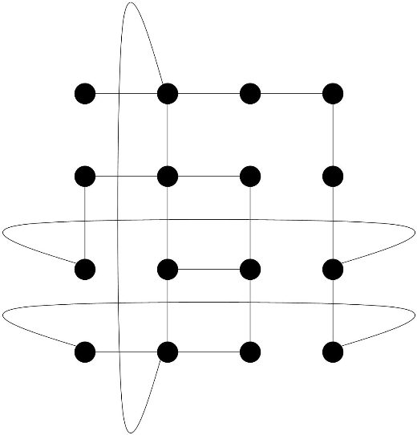  Objective: InvestigatePSO with these topologies | Flap  1b
Flap  2a | http://geneura.wordpress.com  @geneura  jmerelo@ugr.es  cfernandes@laseeb.org | Method: use dynamic random grid + von Neuman neighborhood.  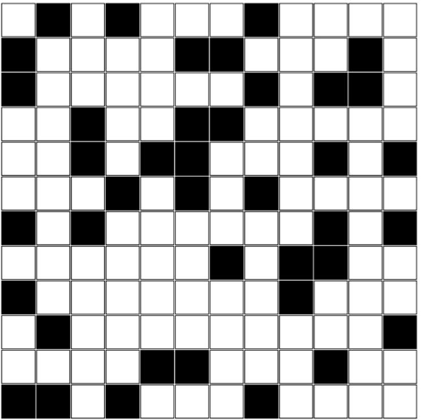 | 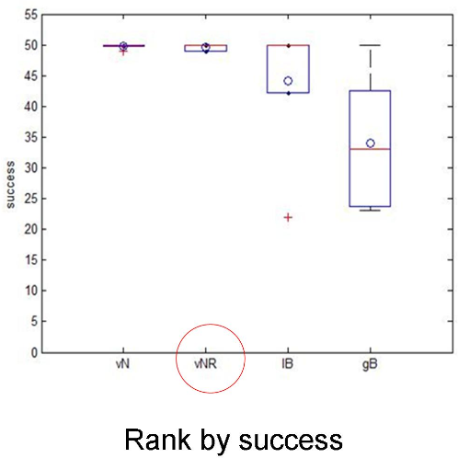 | Flap  2b
 | Flap  1a | Results  - Better than lbest and gbest.  - The partially connected topology obtains more consistent results.  - Speed much better than lbest, not much worse than gbest. | Flap  1b
 | http://donnayoung.org/art/cube-template.htm | Flap 3 | 2.3 inch cube template

