

Genevieve McNeil
04/19/2025
Dr. Bloodworth
Lab 03 - Log File Analysis

Executive Summary

The following lab report includes a thorough review of log files located within Windows and Kali Linux, their log file utility tools, and the actions of multiple scripts. Part 1 explains the purpose and significance of log files in cybersecurity within both Windows and Kali Linux systems. The log types such as Authentication logs, Application logs, and System logs (and more) all play a crucial role in finding anomalies, unauthorized actions, and system changes. In Part 2, I analyze log file utility tools such as Windows Event Viewer, Logwatch, and Wazuh. Each tool offers benefits in pinpointing threats, monitoring system activity, and providing automatic incident response. In Part 3, I review the scripts executed on both Windows and Kali Linux Virtual Machines, which imitate malicious activity. After reviewing the logs on the VMs, I discovered that the scripts created users, deleted users (after the fact), changed user privileges, cleared system logs, and more. These actions are all highly concerning and can be associated with exploitation.
As I explain throughout the report, logs are a crucial component in cybersecurity, but can also be lengthy and time consuming to review. However, tools such as Logwatch and Wazuh, make it much easier for cybersecurity professionals to monitor and respond to threats with accuracy. Altogether, I am grateful for the opportunity to review logs, explore log-management tools, and analyze script actions.

Table of Contents
Executive Summary 2
Part 1 - Log File Research 4
Part 2 - Evaluation of Log File Analysis Tools 10
Part 3 - Analyze the Actions of a Shell Script 15
Conclusion 19
References 20
Appendix 21

Part 1 - Log File Research

As shown in Figure 1, I opened my Event Viewer on my laptop to review the Windows logs. The Windows logs are Application, Security, Setup, System, and Forwarded Events. The Windows logs are categorized based on their source and their function. The Application log is classified as Administrative, contains 7,035 events, and is 5.07 MB in size. The Security log, also Administrative, has 33,459 events, and is 20 MB in size. The Setup log is considered Operational, has 2,046 events, and is 1 MB in size. The System log contains over 42,855 events, is 20 MB in size, and is Administrative. Finally, the Forwarded Events log is Operational, but contains 0 events and 0 bytes.
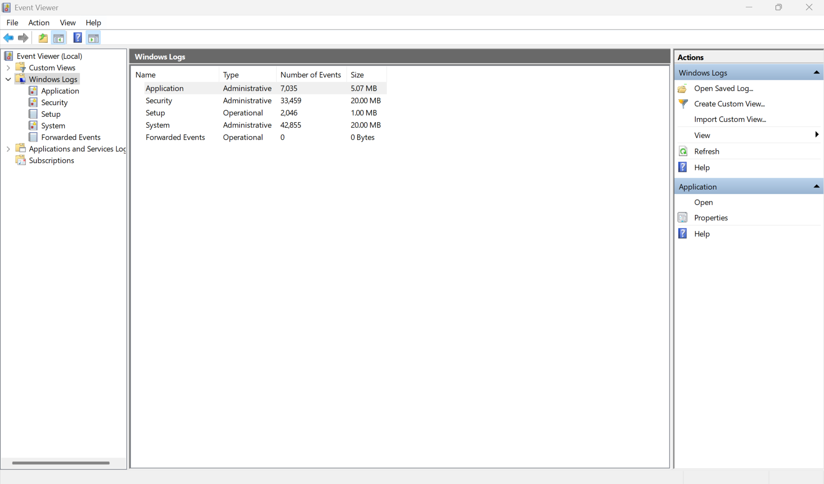
Figure 1: The photo above is of my Event Viewer on my Windows computer.

The application log includes system component logs and alternative logs that are related to drivers (Golden). It also records events from software programs and applications such as app errors. For example, a processor crash would be notated in this log (Chat GPT). As shown in Figure 2, the Application log displays Windows Error Reports, updates, Msinstallers, and more. The Application log is essential within the field of cybersecurity since it can reveal vulnerabilities such as malfunctioning applications, evidence of injected code, and potential exploits. These vulnerabilities can be utilized by attackers for their advantage (Chat GPT).
The Security logs are related to a variety of authentication requests as well as failed and successful logins (Golden). Furthermore, this captures security-related events, such file access permissions and privilege usage (Chat GPT). In Figure 3, the Security log in my Windows Event Viewer reports a variety of User Account Management and logon actions. The reason this log is important in cybersecurity is because it is used for detecting threats/attacks like brute-force attacks, privilege escalation, and insider threats (Chat GPT). For example, a large amount of failed login attempts followed by a successful admin login attempt could indicate that there is a credential compromise that needs to be evaluated (Chat GPT).
The Setup logs include updates, system configurations, and installation processes on the Windows system (Golden). In Figure 4, there are successful system updates. A Windows Update package (KB5055523) was successfully installed. In regards to cybersecurity, the Setup log is helpful because it documents any unauthorized or suspicious software installed on the system (ChatGPT).
The System log includes logs that are created by the operating system (OS), uptime, and status changes of a variety of services (Golden). Furthermore, it records events from Windows system components such as the services, drivers, as well as the kernel (ChatGPT). Figure 5 includes logs that are sourced from hcom that notate: “Detected unrecognized USB driver” multiple times. I also received various updates in regards to Kernel-Power, Netwtw14, and the Service Control Manager. This log is important in regards to cybersecurity because it can record (and essentially reveal) unexpected reboots, odd startup activity, and service crashes. These activities could indicate malicious tampering (ChatGPT).
The Forwarded Events logs are created on remote systems. Afterwards, they are forwarded to the local server for review (Golden). These logs hold entries received from other systems on the network only when Windows Event Forwarding (WEF) is accurately configured (ChatGPT). In Figure 6, it is reported that there are no forwarded events on my computer. This log is useful in cybersecurity particularly for larger organizations because it allows for centralized log monitoring and incident correlation (ChatGPT). Just as Windows systems have log files, so does Kali Linux. Kali Linux’s log files are stored under the /var/log/ directory and accessed using journalctl. Unlike Windows, Kali Linux does not have a GUI-based viewer for the logs. In Figure 7, I discovered that I was unable to access the logs through /var/log as I had expected at first. However, I still believe that it is important to mention what those logs would show if the access had been successful.
The /var/log/auth.log contains authentication-related messages such as sudo access, login attempts, and SSH logins (ChatGPT). This log is important in regards to cybersecurity as it assists in detecting brute-force attacks, remote logins, and unauthorized sudo commands (ChatGPT). For example, if this log includes “Failed password” entries for SSHD, it could be evidential for a SSH brute-force attack (ChatGPT).
The /var/log/syslog log contains kernel events, service logs, and alternative activity that is system-wide (ChatGPT). The reason why this log is important within cybersecurity is because it can be used to find daemon crashes, service failures, and behavior that is unusual for the system (ChatGPT). For example, if the log contains service restarts that are unexpected, this may be evidence of malware interference or tampering (ChatGPT).
The /var/log/dpkg.log includes removal, installation, and upgraded events that are managed by dpkg (ChatGPT). This log is useful in regards to cybersecurity because it can trace the presence of backdoors and software changes that are unauthorized. If a malicious actor installed a rootkit via a .deb package, this log would record it (ChatGPT).
The /var/log/kern.log notates low-level hardware interactions and kernel-related messages (ChatGPT). In relation to cybersecurity, it assists with detecting odd module and driver activity. It also detects rootkits (ChatGPT). For example, this log would detect an instance where a custom kernel module was loaded without notice.
The ~/.bash_history log stores shell commands that were executed by the user within the terminal (ChatGPT). This log is important in regards to cybersecurity because it can reveal dangerous and unauthorized command-line activity. It is noteworthy to mention that attackers may be able to clear the logs since it saves after log out (ChatGPT).
I would like to note that within my Kali Linux VM, I access logs through journalctl only, I cannot access them via /var/log like in other Kali Linux systems. Figure 8 provides the output for the command “sudo journalctl” on my Kali Linux VM. This command displays all logs on my Kali Linux system (systemd journal logs). Furthermore, the journalctl logs are stored within the systemd journal. The systemd journal can simply be described as the default log management system for Kali Linux. The main purpose for the systemd journal is to record system-wide logs, as well as kernel events, authentication messages, system service activity, and alternative behaviors within the system. The logs captured by journalctl are important for detecting unauthorized activities (i.e.: odd system behaviors, unauthorized service activities, or even brute-force attacks). It is important to note that the logs can be filtered (by dates, priorities, service names) which can make tracking down specific activities and events simpler. For example, a user you can use journalctl to search for failed login attempts and abnormal system behavior. An entry such as multiple SSH login failures could indicate a possible attack.
The Authentication Logs (journalctl -u sshd for SSH-related logs) are also a part of the systemd journal. They can be accessed by using unit files or even specific filters (ChatGPT). These logs record authentication-related events, like sudo command usages, failed login attempts, or successful logins (ChatGPT). The Authentication logs are important in locating unauthorized logins and privilege escalation attempts. These logs can provide evidence for brute-force attacks and any attempts to gain access to accounts of higher privilege. For example, if a user runs “journalctl -u sshd”, it will display SSH-related logs (ChatGPT). These logs can assist with locating unauthorized login attempts, that can be a brute-force attack on an SSH service (ChatGPT).
The Service and System logs are also part of the systemd journal. They track system service activities like application logs, system processes, and networking. The main purpose for the service logs is that they supply information regarding the status of services (such Apache or SSH), hardware events, and system processes (ChatGPT). In turn, these logs assist with finding service crashes and suspicious processes. In regards to cybersecurity, the logs are essential for locating issues such as crashes, service interruptions, or any execution of unauthorized processes and commands. For example, a command such as “journalctl -u apache2” will display Apache web server logs, which then can assist with locating unexpected service restarts and errors (ChatGPT).
It is noteworthy to mention the differences between Kali Linux and Windows logs.
As I stated previously, Windows logs are accessed via a Graphical User Interface (Event Viewer) but can also be accessed via the command-line. Kali Linux’s log files are only accessed via the command line only (cat, less, journalct,l etc.). They have storage format differences as well. Windows’ storage format is binary.evtx and requires either the Event Viewer or wevtutil (ChatGPT). Kali Linux’s storage format is plaintext files and is viewable through CLI tools (ChatGPT). In regards to customizability, Windows storage logs are controlled by event log settings and Group Policy, while Kali Linux logs are easily filtered by using CLI tools and it is scriptable.
By understanding the locations where logs are stored and what they contain allows cybersecurity professionals to detect signs of attacks, perform investigations, perform incident response, review user behaviors, control privilege usage, keep track of service stability, and keep track of the system integrity. Windows essentially simplifies monitoring through using Event Viewer, while Linux provides opportunities for more thorough customization and automation through using the CLI (ChatGPT). Reviewing log files are essential for threat detection, and log file analysis tools can greatly simplify the process.

Part 2 - Evaluation of Log File Analysis Tools

I decided to research Windows Event Viewer, Logwatch, and Wazuh. To be transparent, the main reason why I chose Windows Event Viewer is because it was easy for me to navigate through in the first part of the lab. I find this tool interesting because it is user-friendly. I decided to research Logwatch because I was not familiar with the tool and wanted to learn more about it. After understanding how it works, I found it valuable that it monitors the logs for the users. Lastly, I chose to research Wazuh as I was not familiar with this tool either. However, I was interested in learning more about it because it can be used on Windows and Kali Linux systems.
Event Viewer is a built-in tool in Microsoft Windows OS that supplies a detailed log of system events (“What Is Event Viewer”). It provides administrators with the important information required to maintain the health of the system, track activity, ensure security and accountability. In order to understand Event Viewer, an analogy can be helpful. Consider a building's surveillance setup: Windows OS can be a security camera, and the event logs can be considered as the recordings. In this instance, Event Viewer is considered the CCTV monitoring system (“What Is Event Viewer”). A quality surveillance system will have features such as HD or zoom-in, just as Event viewer offers features to assist users with deciphering between a regular event or a critical event (“What Is Event Viewer”). The Event Viewer is a powerful window for the status of the Windows environment. Please view Figure 2 to see the Event Viewer on my laptop.
The Event Viewer reads from event logs, then provides the information in a readable format (“What Is Event Viewer”). The information stored in these logs is lengthy. All details regarding the computer’s software, hardware, users, and the users’ interactions are taken note of. For example, a user can locate information about the time and date a process was started, the information regarding an application crash, or even details of when a user authenticated (or had a failed authentication). This logged information assists administrators in locating and remediating threats (or concerns for threats) prior to them becoming larger issues. Additionally, the security-related event data assists administrators in improving their security posture and establishing accountability (“What Is Event Viewer”).
As I had mentioned in Part 1, Windows Event Viewer organizes each event that occurs on the computer into various categories: System, Application, Setup, Security, and Forwarded Events. Information for each event is detailed in the Event Viewer console, which includes: Event ID (A unique identification number), the event’s date and time, the source (includes the information of the service, software, as well as the process that caused the event), Log name (System, Application, Setup, Security, and Forwarded Events). Additionally, it includes the User (The information regarding the user that was logged in to the computer when the specific event happened) and Computer (The information for the computer of where the event occurred) (“What Is Event Viewer”). It is important to note that the severity level of the event is also noted because Windows assigns a severity level to each event, which can guide administrators to determine when and where to take appropriate action (“What Is Event Viewer”). The severity levels include: Information, Warning, Error (indicates problems, however, may not require immediate remediation), and Critical (Attention and action is needed) (“What Is Event Viewer”).
As I had mentioned previously, Linux (and Windows) systems log an exhausting amount of information to their log files. Each system that a user installs will likely have its own set of files. Along with this, there are default log files generated as well, such as: boot log, dmesg, packet manager log, etc. (Brown). Within these log files, there may even be hundreds or thousands of entries within a short amount of time (Brown).
Since event logging is essential to understanding what is occurring in the system, the log files often increase to a large number and become difficult to sift through effectively (Brown). For example, if there were important warnings logged in the files, this would be a time-consuming process and will likely require a lot of manual work. However, Logwatch takes this responsibility off of the users’ hands, as it monitors the logs for them and sends notifications via email when an entry occurs that needs their attention (Brown).
Altogether, Logwatch is used for basic security monitoring on a Linux system. Users can configure it to their needs and direct it to log certain files. Logwatch saves administrators time and helps them easily identify security concerns that they would normally need to find and review manually. The next tool I’d like to review is Wazuh.
Wazuh is a no-cost and open-source security platform that combines XDR (which is the Extended Detection and Response) and SIEM (which is Security Information and Event Management) capabilities (Wazuh). It provides protection for workloads across on-premises, virtual, containerized, and cloud environments. It was created to assist organizations and individuals with safeguarding their data assets. Wazuh is used from small businesses up to large enterprises because of its powerful threat detection and response features (Wazuh).
Wazuh consistently monitors system and application configuration settings in order to confirm that they follow the users’ security policies, standards, and hardening guidelines (Wazuh, “Overview”). Its agents complete regular scans to locate and identify misconfigurations and security gaps on endpoints that attackers could potentially use to their advantage (Wazuh, “Overview”). These configuration checks are fully customizable, which allows users to change them to their (or their organizations) requirements. When issues are located, Wazuh creates security alerts (Wazuh, “Overview”). These alerts can include recommendations, references, and mappings with regulatory compliance (Wazuh, “Overview”).
There are minimum system requirements and operating systems for installing Wazuh agent to gather data, as it is a component that operates on the monitored endpoints, such as desktops (Wazuh). Therefore, whether the endpoint is a victim or an attacker within a simulated (or real-world) situation, Wazuh is able to monitor it as long as the agent is installed and the system has the required specs. The required specs are noted below:
- Ubuntu: Ubuntu 22.04 LTS (OS system - 64 bits), 1 vCPU (CPU cores), 2 GB (RAM), 10 GB (Disk)
- RHEL: Red Hat Enterprise Linux 9.0 (OS system - 64 bits), 1 vCPU (CPU cores), 2 GB (RAM), 10 GB (Disk)
- Windows: Windows 11 (OS system - 64 bits), 2 vCPU (CPU cores), 4 GB (RAM), 25 GB (Disk)
(Wazuh). It is a great tool regarding cybersecurity because it can be used for: blocking a known malicious actor, file integrity monitoring, detecting a brute-force attack, detecting an SQL injection attack, and much more (Wazuh).
It is also important to note that Windows Event Viewer, Logwatch, and Wazuh scopes and functionality differ. Windows Event Viewer is a built-in tool in Windows Systems where users can use a GUI tool to view event logs. This tool is useful because users can view detailed logs related to system: events, behavior, and actions. It is a great tool to use for monitoring of individual machines in real-time. Logwatch is text-based tool within Linux environments. It is downloaded within the CLI and it scans and summarizes log entries in order to forward the results via email. This is helpful because it saves administrators time and significantly reduces the requirement for manual reviews of the log. Wazuh is an open-source free security platform that can be used by a variety of Operating Systems. It utilizes SIEM and XDR capabilities and has a dashboard for real-time log updates.
Windows Event Viewer, Logwatch, and Wazuh are each valuable within the field of cybersecurity and have various situations in which they are useful. For example, Windows Event Viewer can be used by an administrator if they notice failed log in attempts on their Windows system. By reviewing the logs, they can check the time stamps, usernames, and IP address of those failed attempts. If employees only work 8:00 AM - 5:00 PM Monday through Friday and there are multiple log-in attempts on a Saturday, this could be a red flag indicating a brute force attack. The administrator can then take the appropriate steps to mitigate this issue, such as: updating password policies, blocking the IP address responsible for the log in attempts, etc.
Logwatch could be useful for me if I had a personal Linux. For instance, if Logwatch detects a program attempting to access sensitive data on my laptop, it would be reported to me via email. I would then be able to take action and possibly remove the program from my laptop.
For my last example, consider a scenario in which Wazuh is installed on a company’s network of systems. Wazuh could detect that a port is left open which exposes sensitive internal data to the internet. It would then send an alert to the security team, who can close the port and secure data before any attacks occur. Each tool increases cybersecurity effectiveness based on their environment and the depth of monitoring it provides. For the last section of the lab, I reviewed and analyzed the actions of various shell scripts executed within both the Windows and Kali Linux VMs, which were created and downloaded for this portion of the lab.

Part 3 - Analyze the Actions of a Shell Script

Since I have a Dell laptop, I downloaded the Windows 11 VM and Kali VM for this section of the lab. The process was simple, as it only took a few moments to set up both VMs. In order to run the Lab3s1.ps1 script within the Windows 11 VM, I opened Powershell as an Administrator and then navigated to the correct directory, which was the Desktop directory (Figure 10). I then ran the script Lab3s1.ps1 by entering “.\Lab3s1.ps1”, as shown in Figure 10 as well. Below are the six changes that I noticed after running the script:
- Event ID 4720: “A user account was created”. This applies to users Tyler, Thomas, Dade, and Elliot. This is within the Security log (Figure 11).
- Event ID 4724: “An attempt was made to reset an account’s password”. This applies to Tyler, Thomas, Dade, and Elliot (Figure 12). This is located within the Security log as well.
- Event ID 4728: “A member was added to a security-enabled global group”. This applies to Tyler, Thomas, Dade, and Elliot. This is located within the Security log. (Figure 13).
- Event ID 4732: “A member was added to a security-enabled local group” this applies to Tyler, Thomas, Dade, and Elliot. This is located within the Security log as well. (Figure 14).
- Event ID 4738: Targets the users Elliot, Thomas, Dade, and Tyler: “A user account was changed”. (Figure 15).
- Event ID 4798: “A user's local group membership was enumerated”. This applies to users Elliot, Thomas, Dade, and Tyler (Figure 16).
To execute the Lab3s2.ps1 script, I opened Powershell as an Administrator once again. I then navigated to the script file and ran Lab3s2.ps1 by entering “.\Lab3s1.ps1”, as shown in Figure 17. Below are some of the changes that I noticed after running this second script:
- Event ID 4797: “An attempt was made to query the existence of a blank password for an account.”. This occurred four times, which also is the exact same number of users (Tyler, Thomas, Dade, and Elliot) that were created with the last script. (Figure 18). This information is located within the Security Log.
- Event ID 1102: “Log Clear”. This means that the audit log was cleared. This information was found in the Security Log.
- Event ID 104: “The Application log file was cleared” (System Log). This occurred twice. This was followed by various system transitions from 12 up to 18.
I then opened my Kali VM in order to run two commands: ./lab3s3.sh and ./lab3s4.sh so that I can execute the two scripts lab3s3.sh and lab3s4.sh. I ran the script lab3s3.sh by entering “sudo ./labs3s.sh” (Figure 21). I entered “sudo journalctl --since today” at first, but I realized that I did not just want to sift through all the logs for that day (Figure 22 and Figure 23). So, I then entered “sudo journalctl --since today | grep 'useradd'” and “sudo journalctl --since today | grep 'usermod'” because I had remembered that the scripts in the Windows VM had users added and removed. The results for those commands are within Figure 24. The results are shown below:
Useradd:
- 8806: new group (Tyler), new user (Tyler).
- 8811: new group (Dade), new user (Dade)
- 8825: new group (Elliot), new user (Elliot)
- 8830: new group (Thomas), new user (Thomas)
Usermod:
- 8859: Add ‘Elliot’ to group ‘sudo’ and shadow group ‘sudo’
- 8864: Add ‘Thomas’ to group ‘sudo’ and shadow group ‘sudo’
I then entered “sudo ./labs3s4.sh” to run the last script (Figure 25). I entered “sudo journalctl --since ‘10:00’’ to view the results for changes after 10:00 AM (Figure 26). The results in Figure 27 are as follows:
- 40163: Delete user 'Tyler'; removed group 'Tyler' owned by 'Tyler'; removed shadow group 'Tyler' owned by 'Tyler'.
- 40170: Delete user 'Dade'; removed group 'Dade' owned by 'Dade'; removed shadow group 'Dade' owned by 'Dade'.
- 40177: Delete user 'Elliot'; delete 'Elliot' from group 'sudo'; removed group 'Elliot' owned by 'Elliot'; removed shadow group 'Elliot' owned by 'Elliot'; delete 'Elliot' from shadow group 'sudo'.
- 40192: Delete user 'Thomas'; delete 'Thomas' from group 'sudo'; removed group 'Thomas' owned by 'Thomas'; removed shadow group 'Thomas' owned by 'Thomas'; delete 'Thomas' from shadow group 'sudo'.
I would like to note that there are a variety of concerns with the actions I discovered. Creating users is a tactic to gain privileges (or even change their privileges). Adding users to sudo/administrator groups can increase the attackers’ access to making changes to the system. Password reset and group changes can be a tactic to make changes to previous users’ access. Clearing logs is a major concern as well. Clearing logs erases evidence of activity and could cause issues with forensic investigators completing their investigation successfully. Deleting users is another way to remove evidence as well.
To remedy these issues, I would suggest auditing all user accounts. This would include removing any affected accounts or unauthorized users as well as confirming or resetting legitimate user privileges. Additionally, I would suggest performing forensic documentation to collect the timeframe of the incidents and analyzing the information that the logs hold. Lastly, I would suggest using a new logging tool, such as Wazuh in order to receive notifications of any further changes within the system.

Conclusion

In conclusion, this assignment highlighted how essential it is to be able to understand and analyze system logs within Windows and Kali Linux environments. I was able to get a thorough understanding of this subject through completing log file research, researching log file utility tools, and running scripts within virtual machines. I was able to learn how systems changes are detected, logged, and deciphered. Windows Event Viewer, Logwatch, and Wazuh are each powerful log file utilities, each offering features that are customizable and convenient alerts for users. Altogether, this experience gave me a great walk-through and understanding of how important log files are and how essential they are within cybersecurity. Moving forward, I will be reviewing my log files more closely within my own laptops in order to keep an eye on system activity.

References
Brown, Korbin. “Using Logwatch for Basic Security Monitoring on Linux.” LinuxConfig, 11 May 2024, linuxconfig.org/using-logwatch-for-basic-security-monitoring-on-linux. Accessed 17 Apr. 2025.

ChatGPT. Response to “Explain the function of Windows and Kali Linux log files.” OpenAI, 14 Apr. 2025, chat.openai.com.

Golden, Neil. “Liquid Web.” Liquid Web, 19 Jan. 2023, www.liquidweb.com/blog/where-are-the-windows-logs-stored/. Accessed 10 Apr. 2025.

“What Is Event Viewer | ManageEngine ADAuditPlus.” Www.manageengine.com, www.manageengine.com/products/active-directory-audit/kb/what-is/event-viewer.html. Accessed 14 Apr. 2025.

Wazuh. “Proof of Concept Guide · Wazuh Documentation.” Documentation.wazuh.com, documentation.wazuh.com/current/proof-of-concept-guide/index.html. Accessed 17 Apr. 2025.

Wazuh. “Overview.” Wazuh, 2024, wazuh.com/platform/overview/. Accessed 17 Apr. 2025.

Appendix
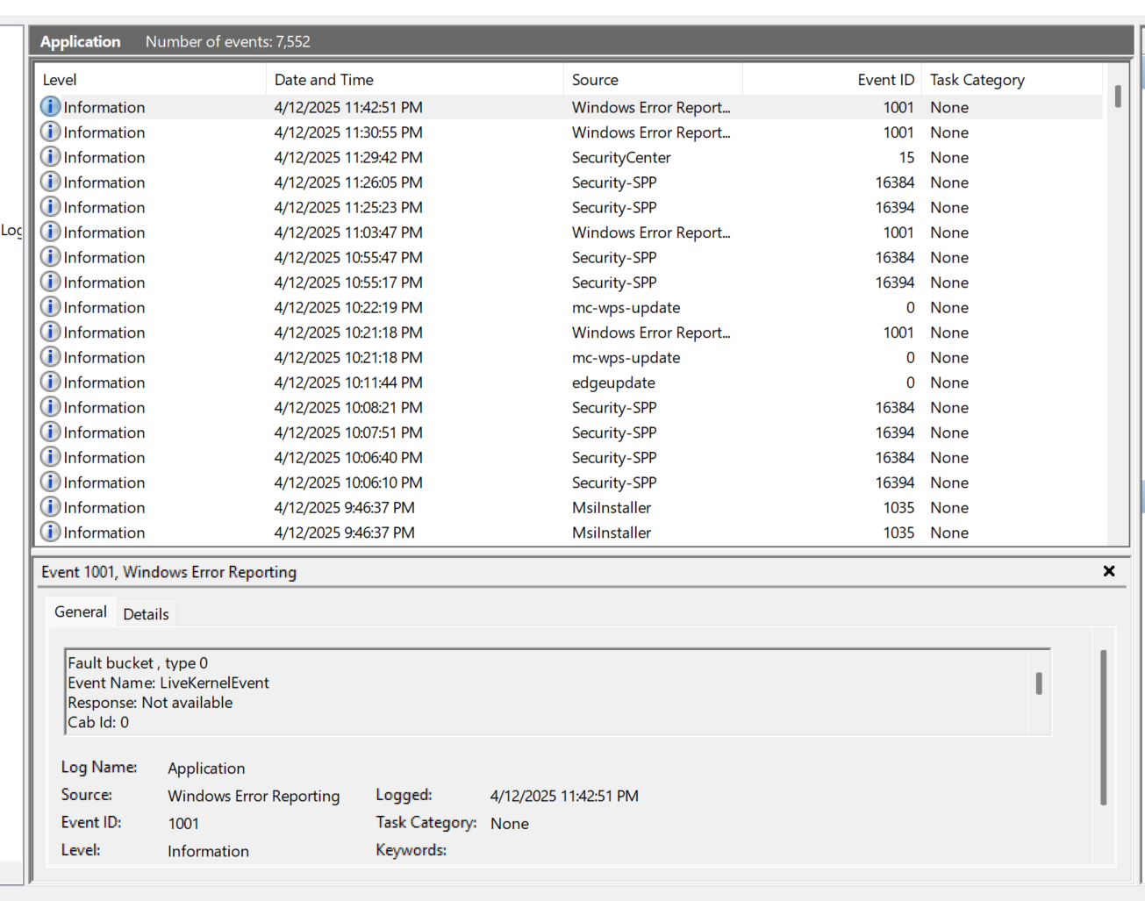
Figure 2: The screenshot above is the Application log within my Event Viewer.

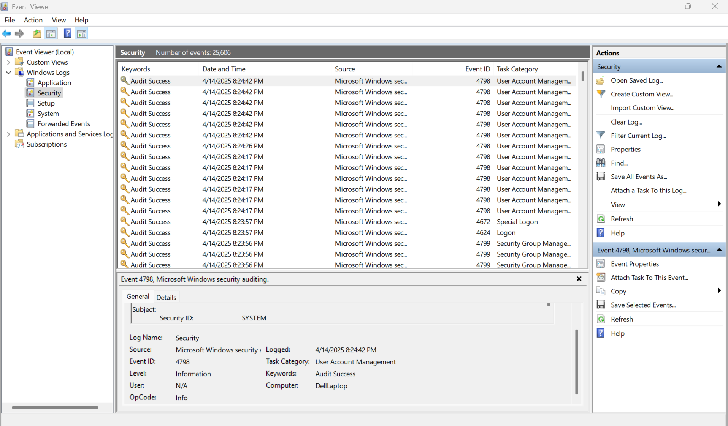
Figure 3: The screenshot above is the Security log within my Event Viewer.
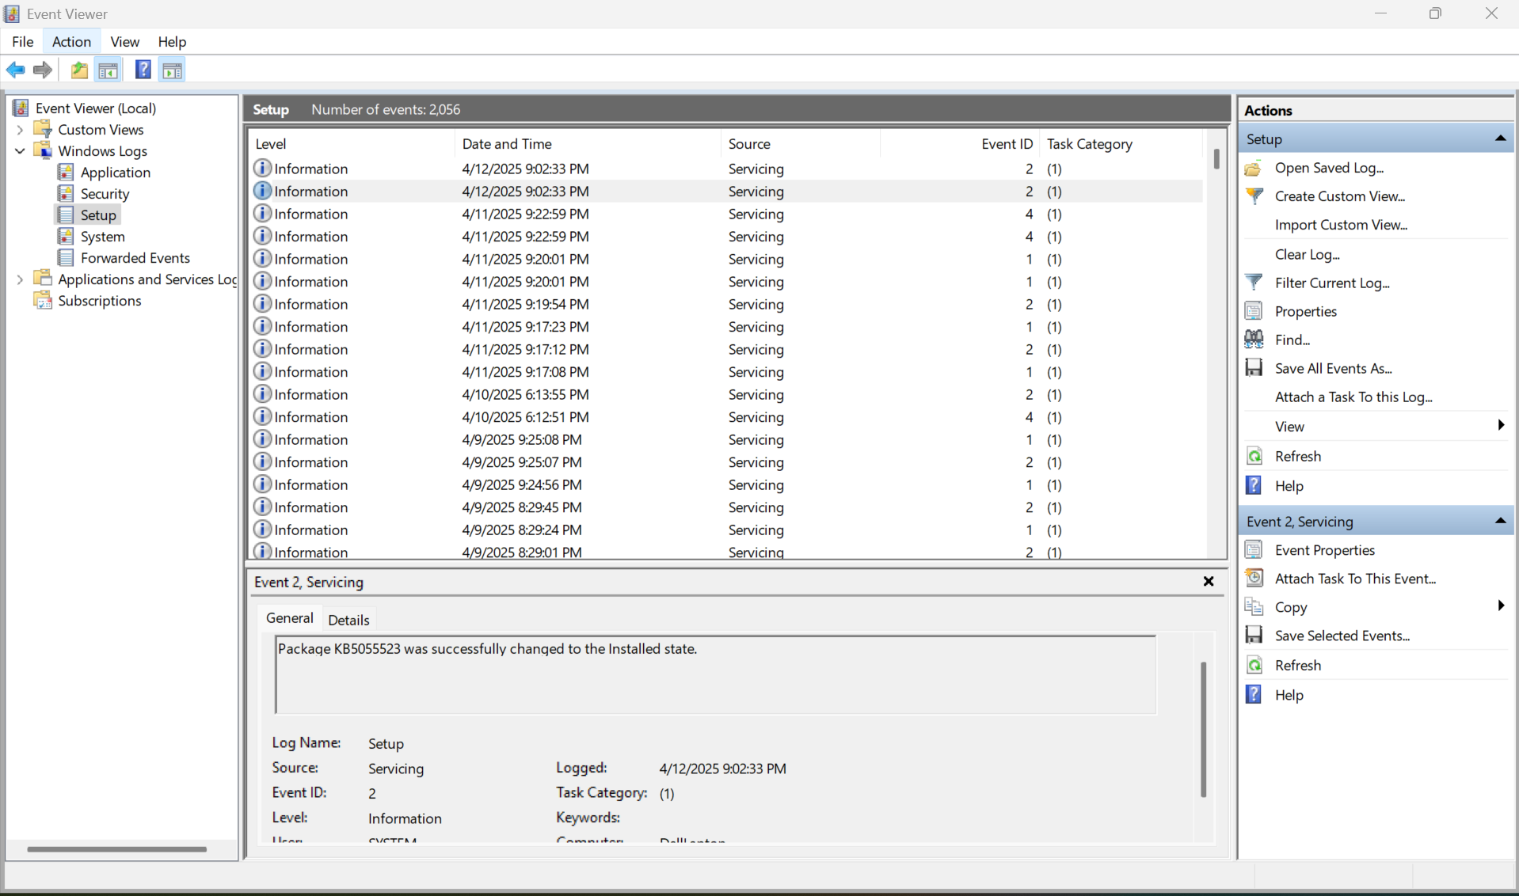
Figure 4: The screenshot above is the Setup log within my Event Viewer.

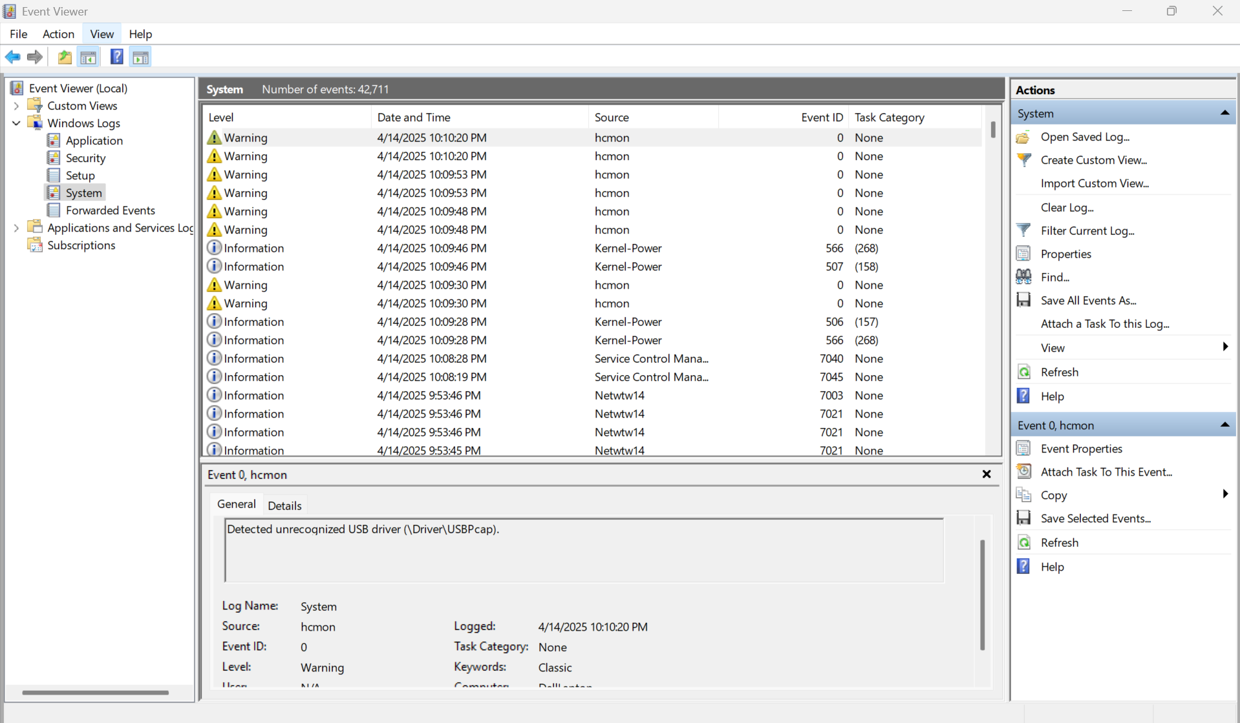
Figure 5: The screenshot above is the System log within my Event Viewer.

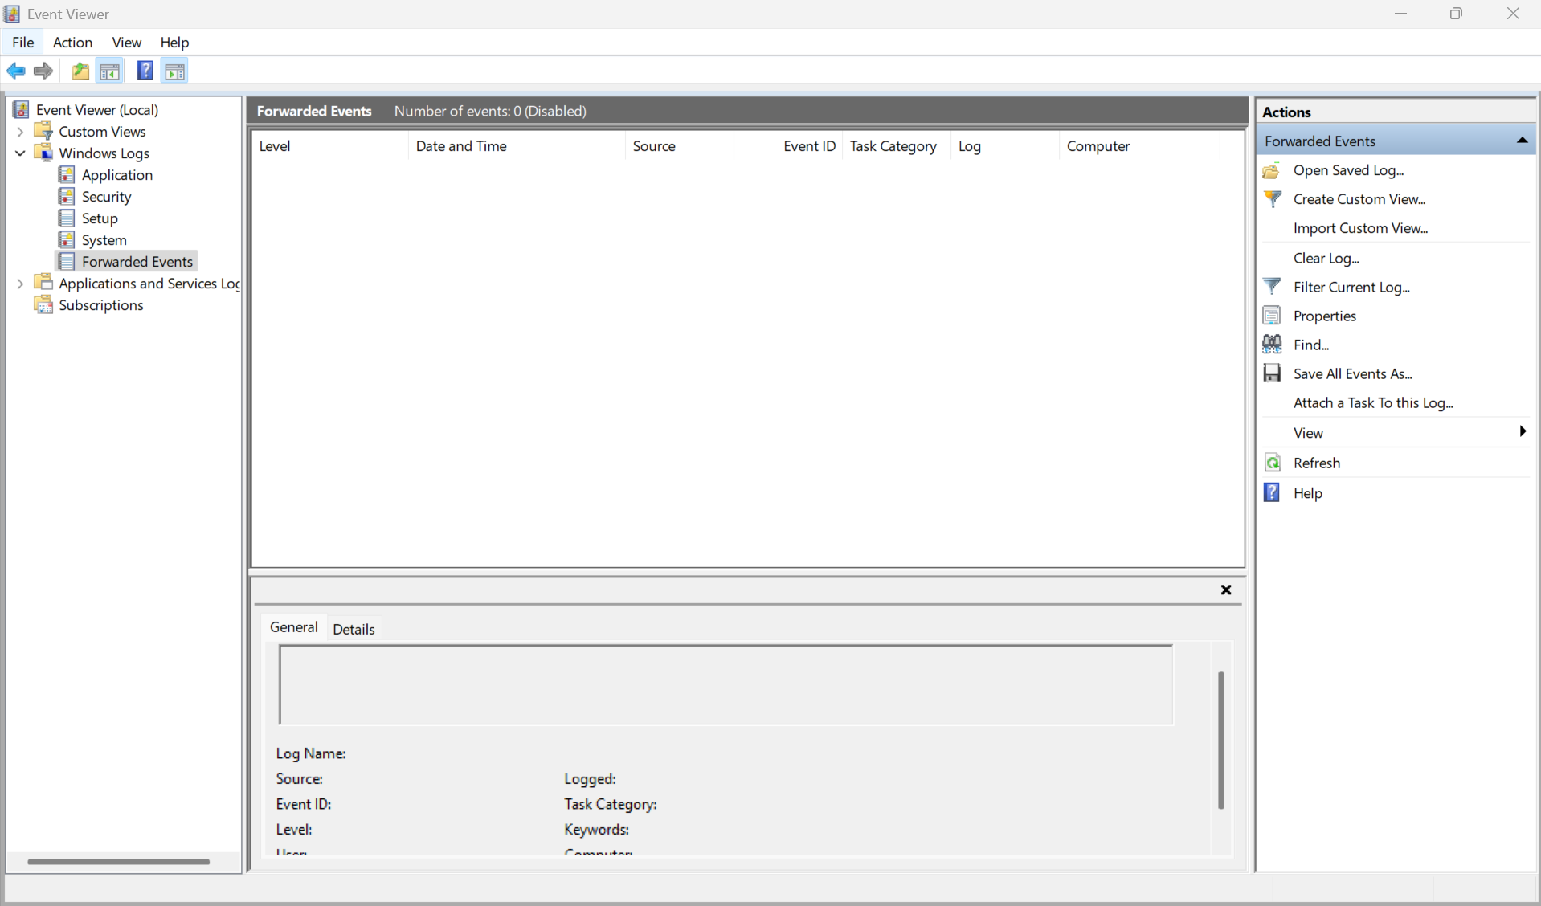
Figure 6: The screenshot above is the Forwarded Events log within my Event Viewer.

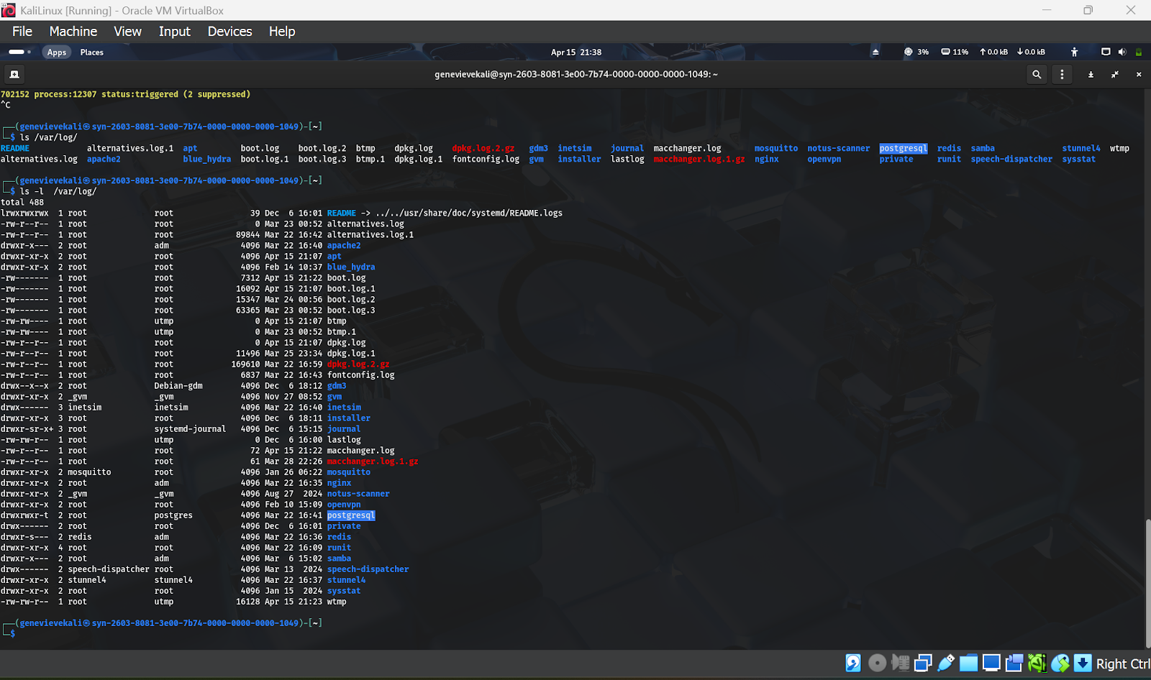Figure 7: The screenshot above is the /var/log on my KaliLinux CLI.

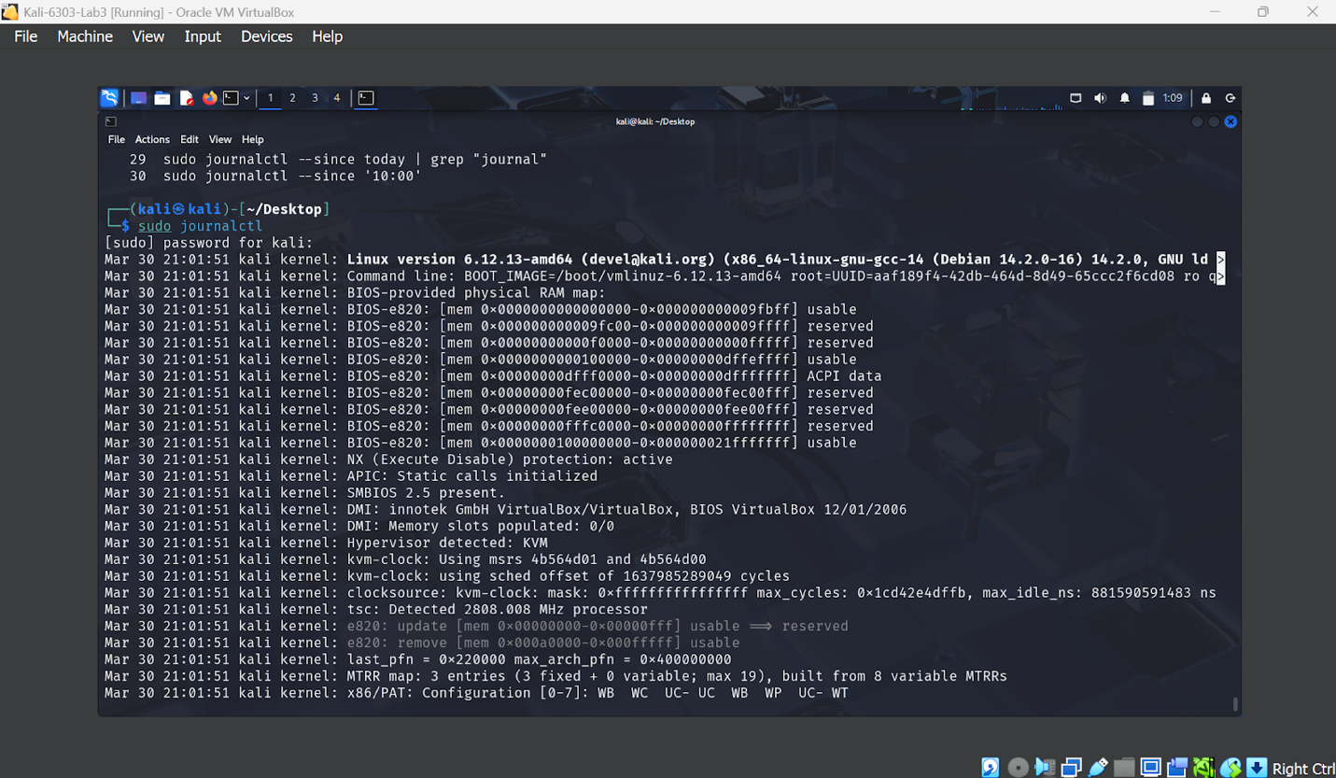
Figure 8: The screenshot above is the log files for Kali Linux.

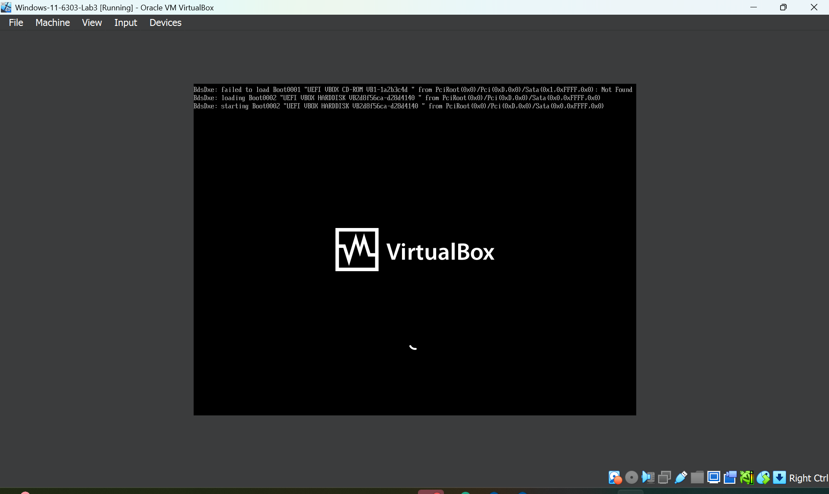
Figure 9: The Figure above shows the errors I received on my Windows VM when I opened it for the first time.

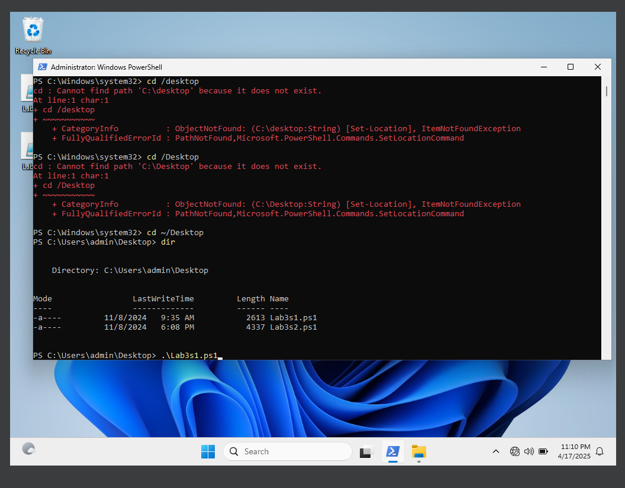
Figure 10: Above is my Windows VM PowerShell being run as administrator as well as the command ran: “.\Lab3s1.ps1”.

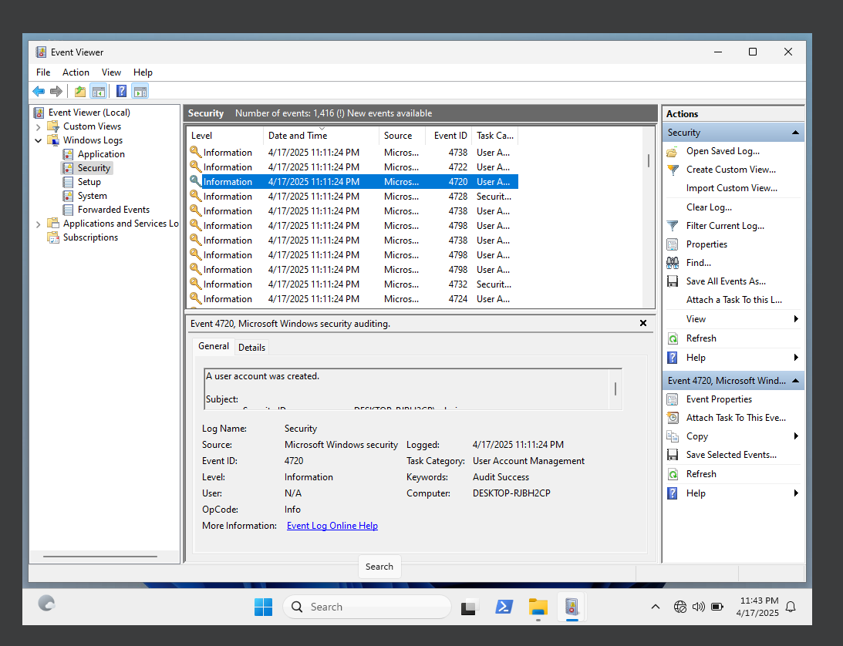
Figure 11: Event ID 4720 within the Security log. “A user account was created”.

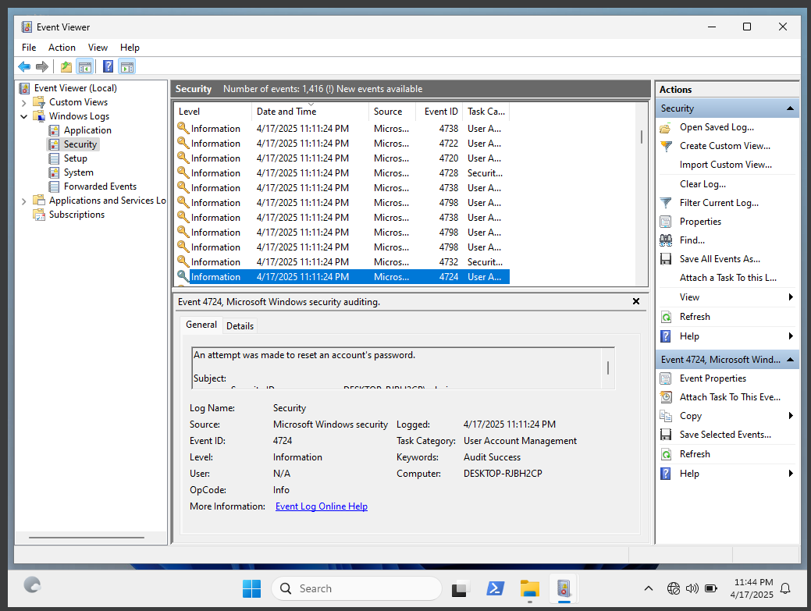
Figure 12: Event ID 4724 within the Security log. “An attempt was made to reset an account’s password”.

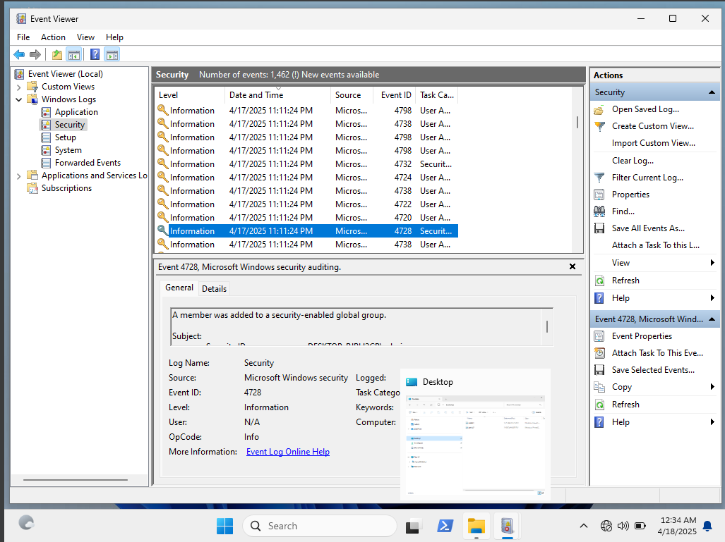
Figure 13: Event ID 4728: “A member was added to a security-enabled global group” - this applies to Tyler, Thomas, Dade, and Elliot.

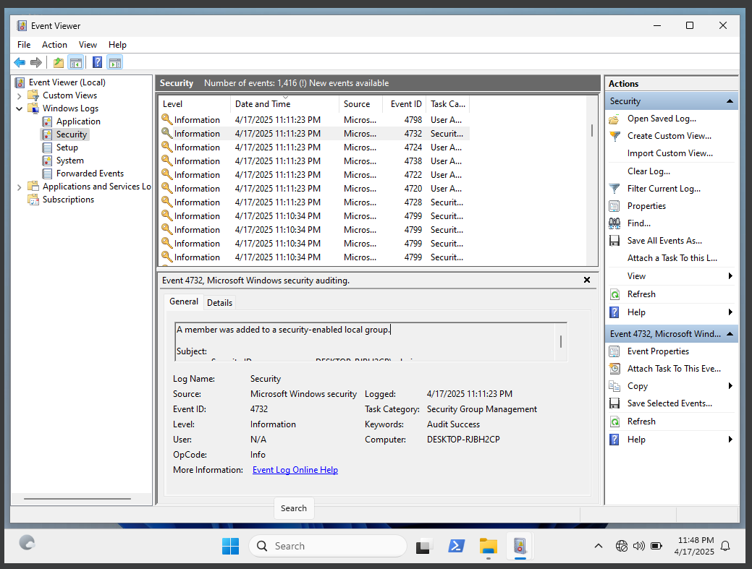
Figure 14: Event ID 4732 within the Security log. “A member was added to a security-enabled local group” this applies to Tyler, Thomas, Dade, and Elliot.

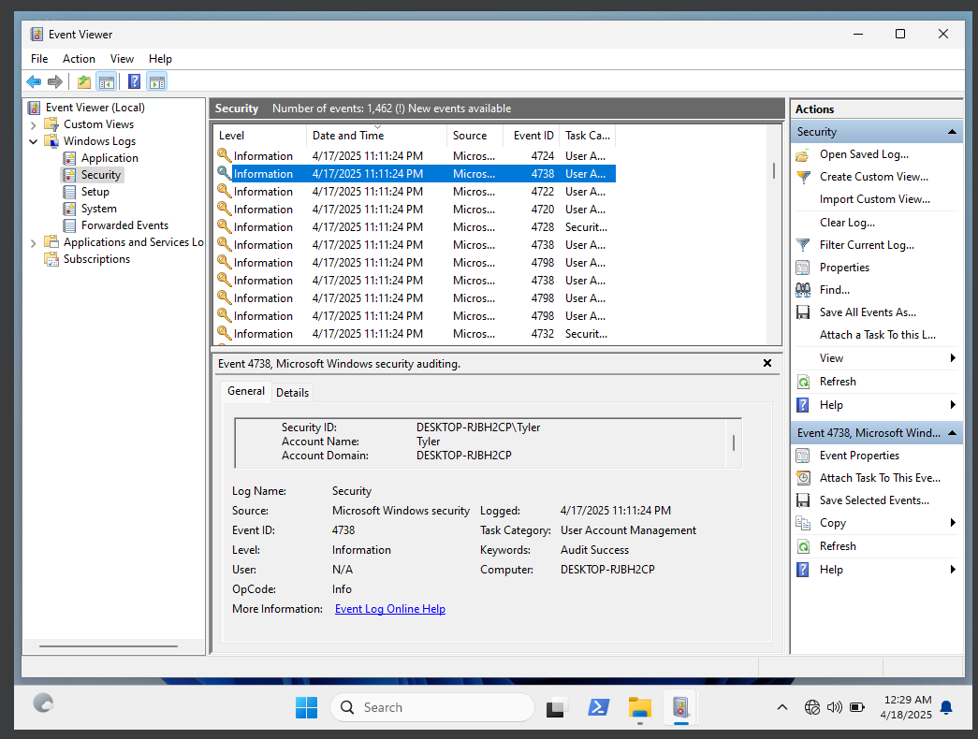
Figure 15: 4738. “A user account was changed” this applies to users Elliot, Thomas, Dade, and Tyler.
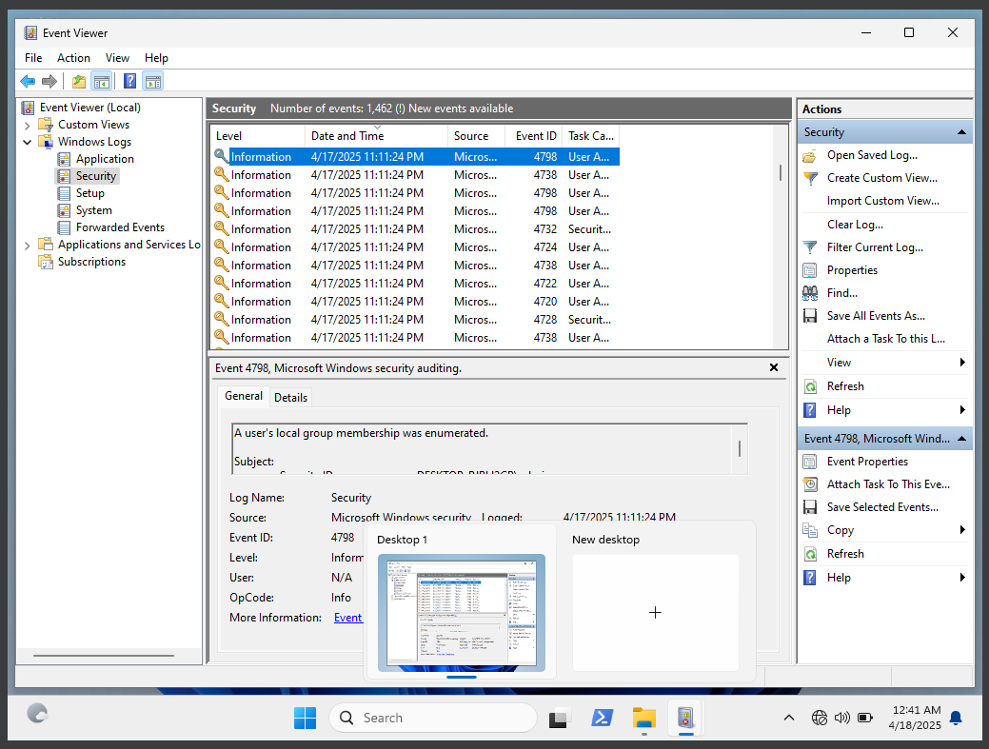
Figure 16: Event ID 4798: “A users local group membership was enumerated”. This applies to users Elliot, Thomas, Dade, and Tyler.

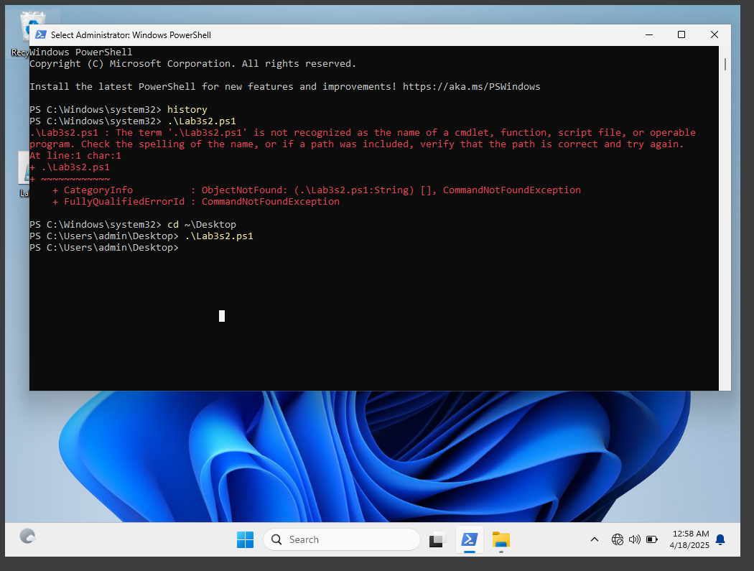
Figure 17: Successfully running the second script Lab3s2.ps1.

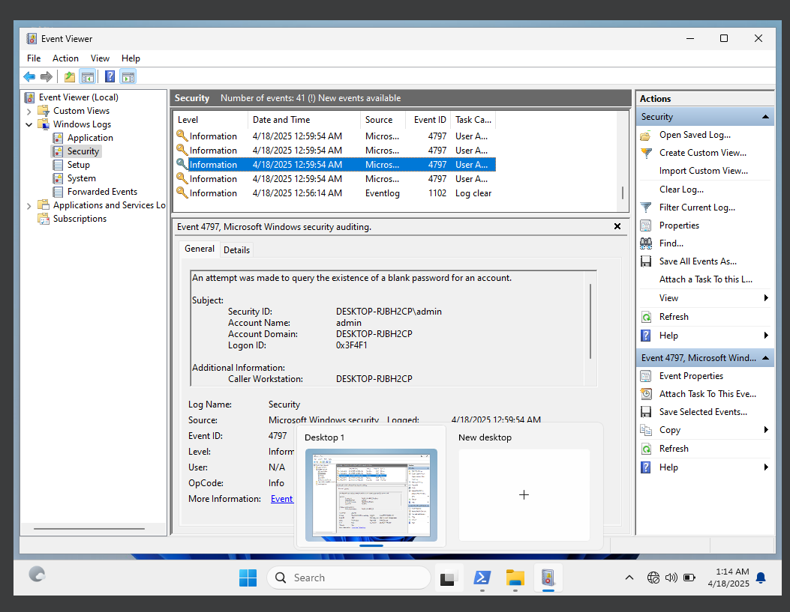
Figure 18: Event ID 4797: “An attempt was made to query the existence of a blank password for an account.” This occurred 4 times.

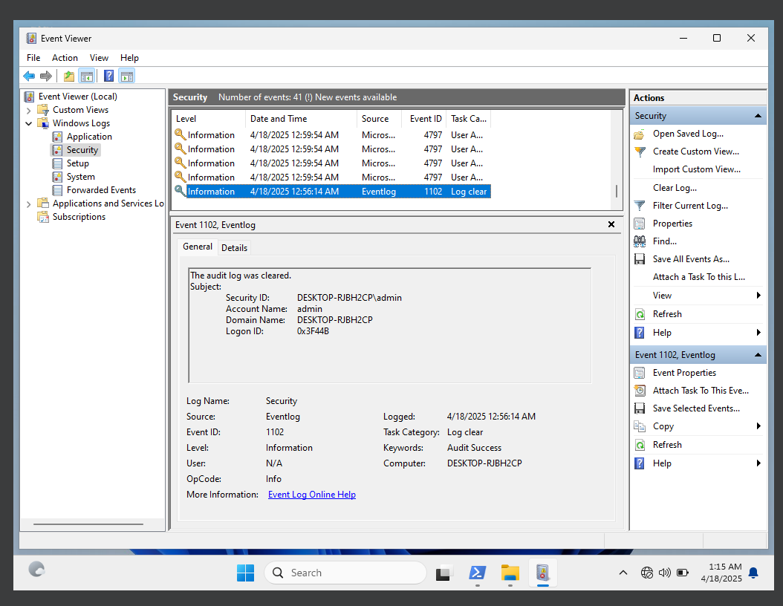
Figure 19: Event ID 1102: “Log Clear”. This means that the audit log was cleared. Located within the Security Log.
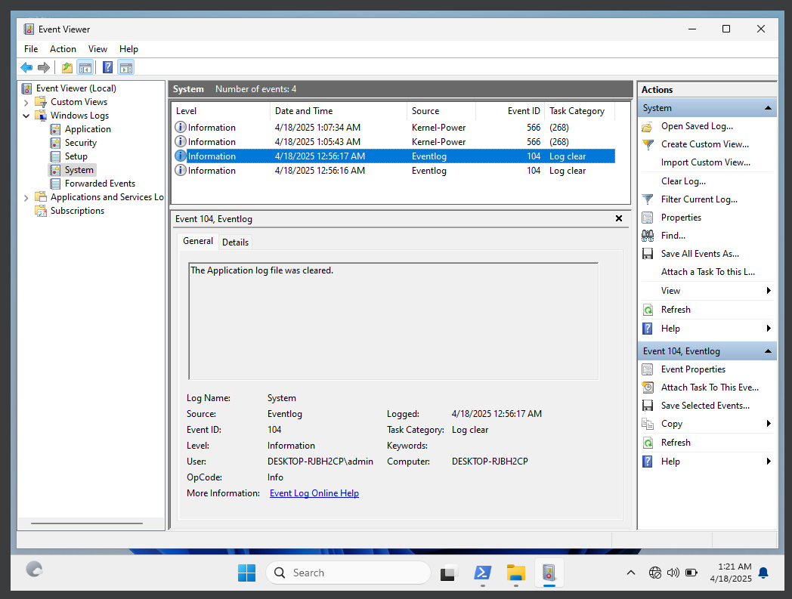
Figure 20: Event ID 104: “The Application log file was cleared” (with the System Log). This occurred twice.

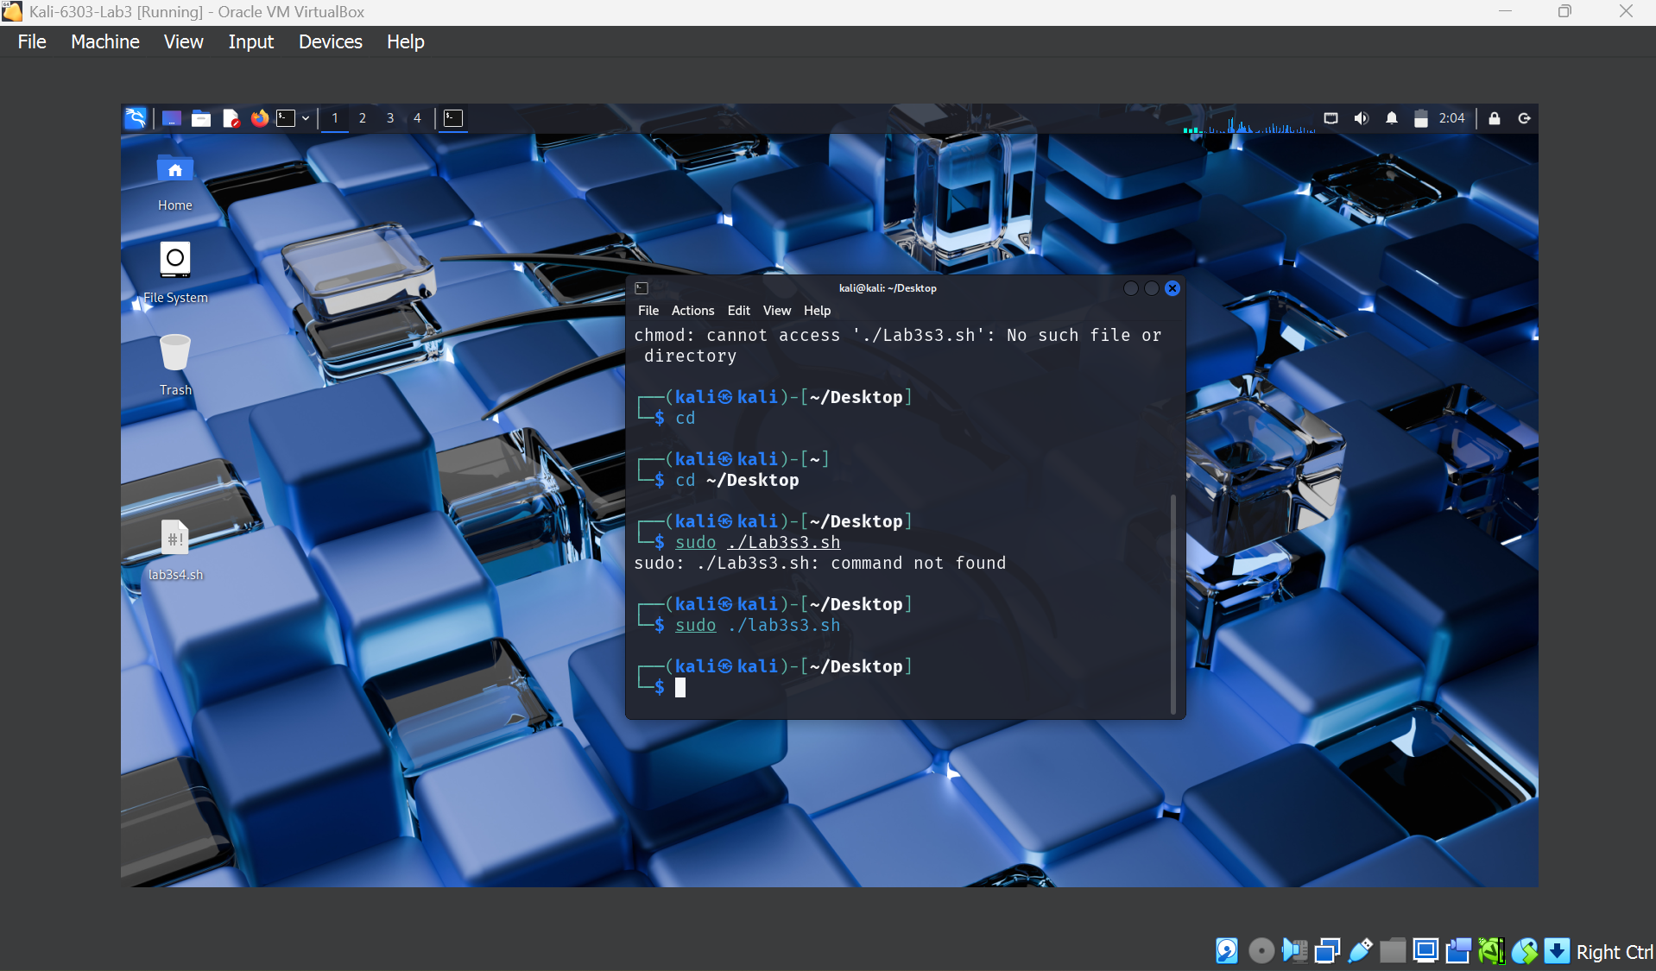
Figure 21: I ran the script and the icon in the corner disappeared. I entered “sudo ./lab3s3.sh”

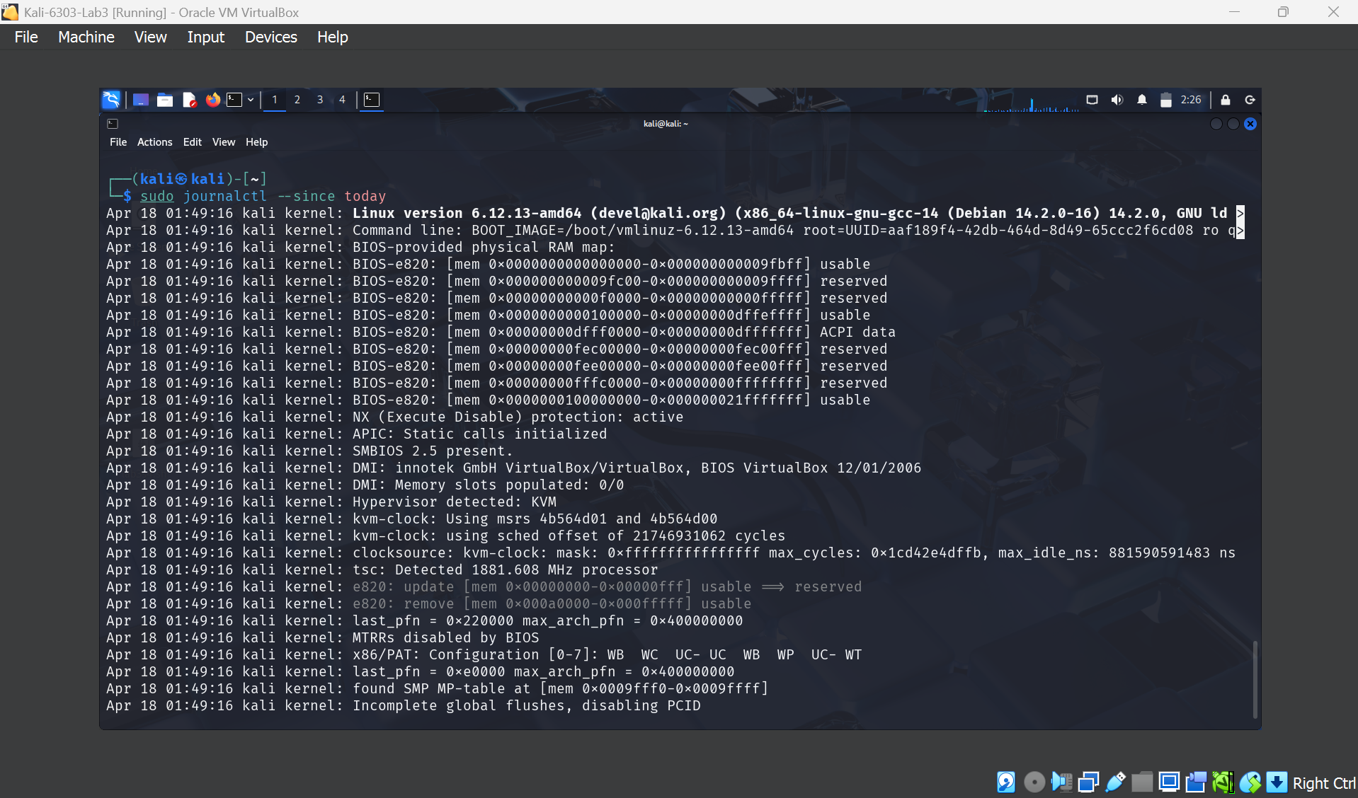
Figure 22: “sudo journalctl - - since today” Part 1 (regarding script lab3s3.sh).

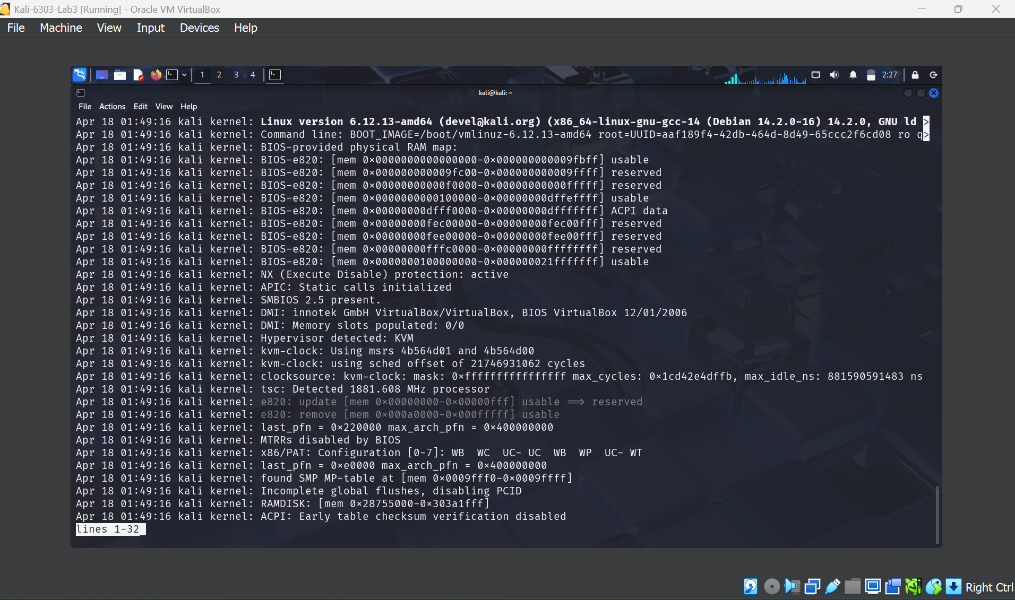
Figure 23: “sudo journalctl - - since today” results. Part 2 (regarding script lab3s3.sh).

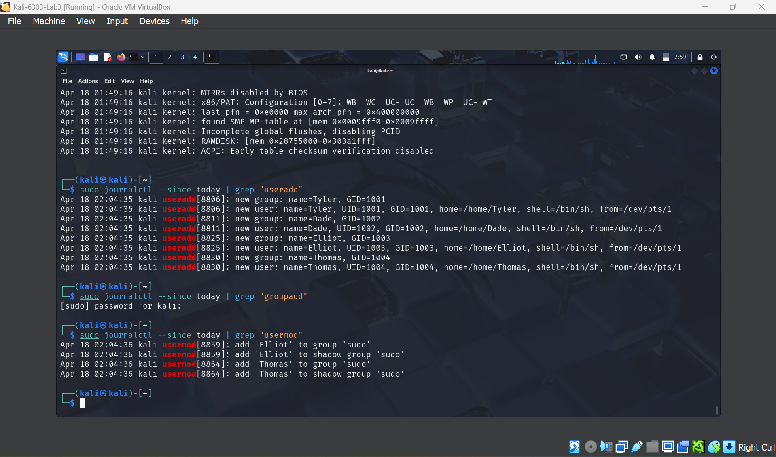
Figure 24: entered “sudo journalctl --since today | grep 'useradd'” and “sudo journalctl --since today | grep ‘usermod’”. These are the results.

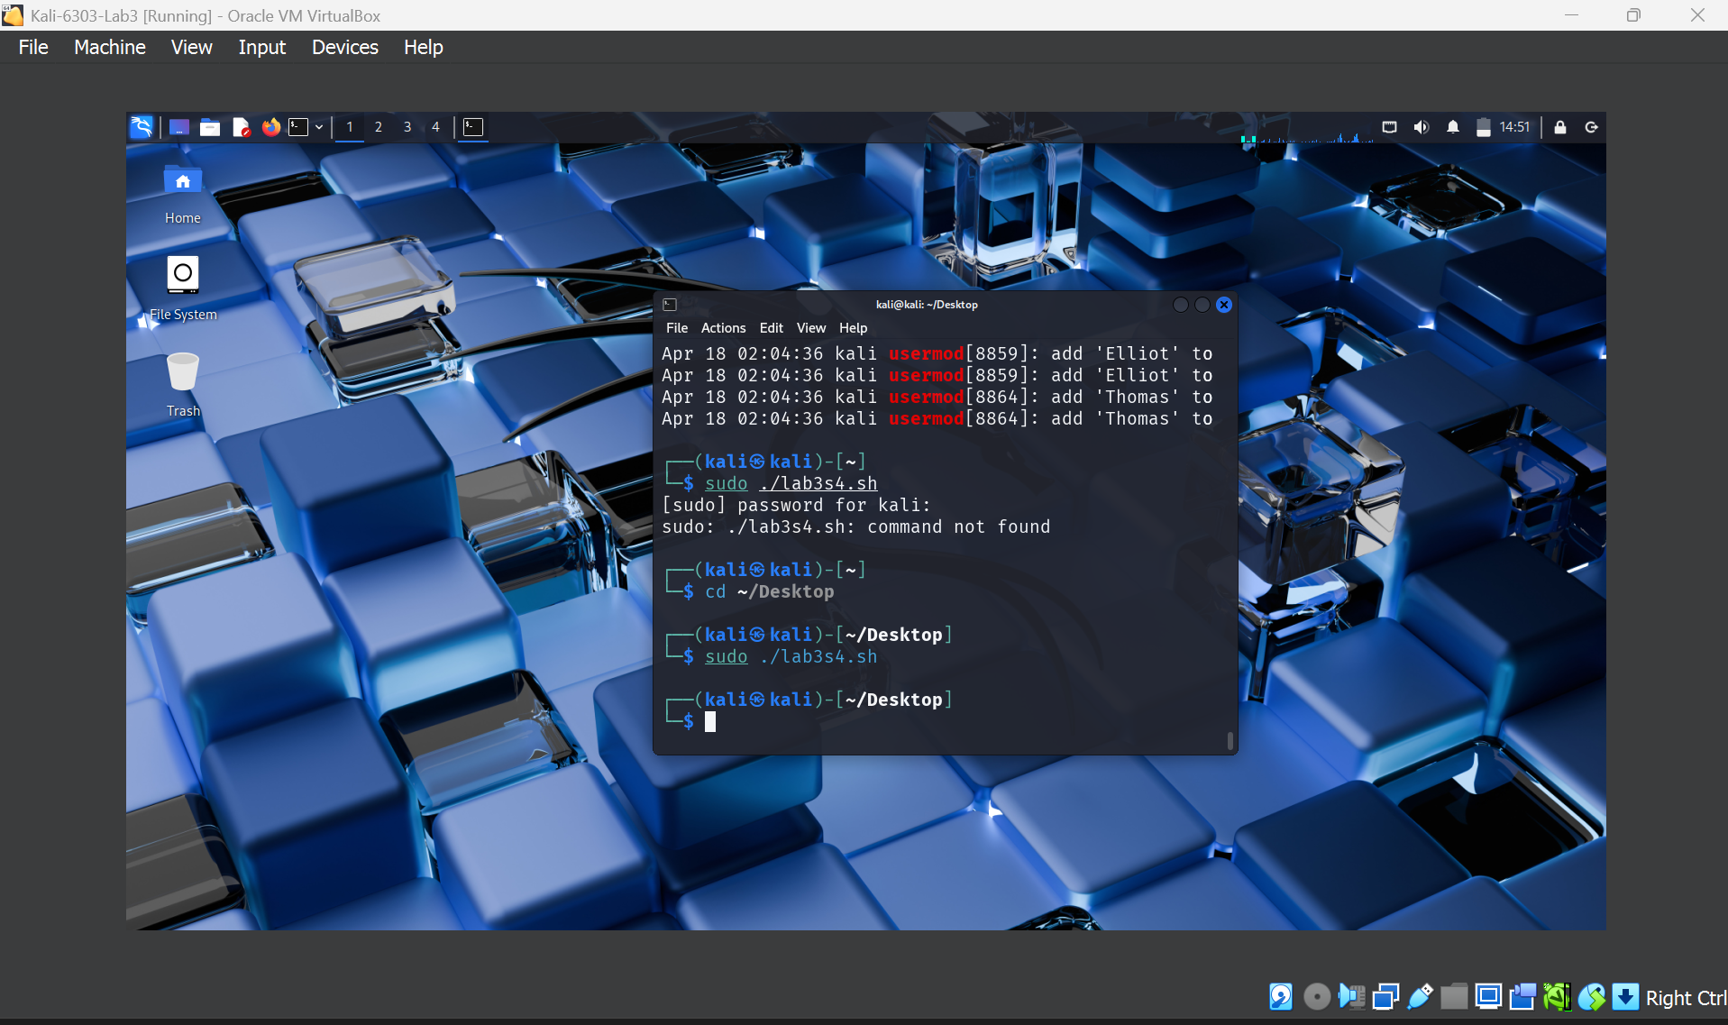
Figure 25: I ran the script and the icon in the corner disappeared. I entered “sudo ./lab3s4.sh”

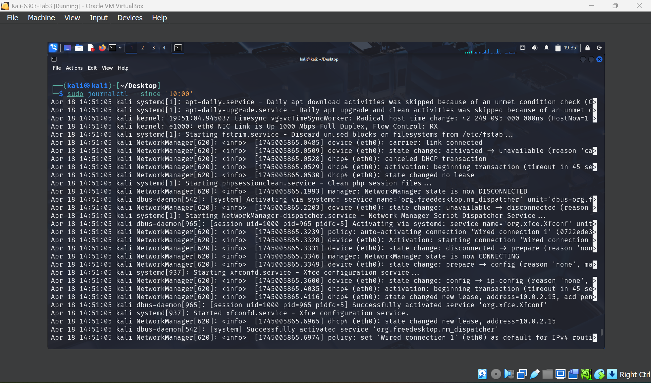
Figure 26: entered “sudo journalctl --since ‘10:00’’and these are the results.

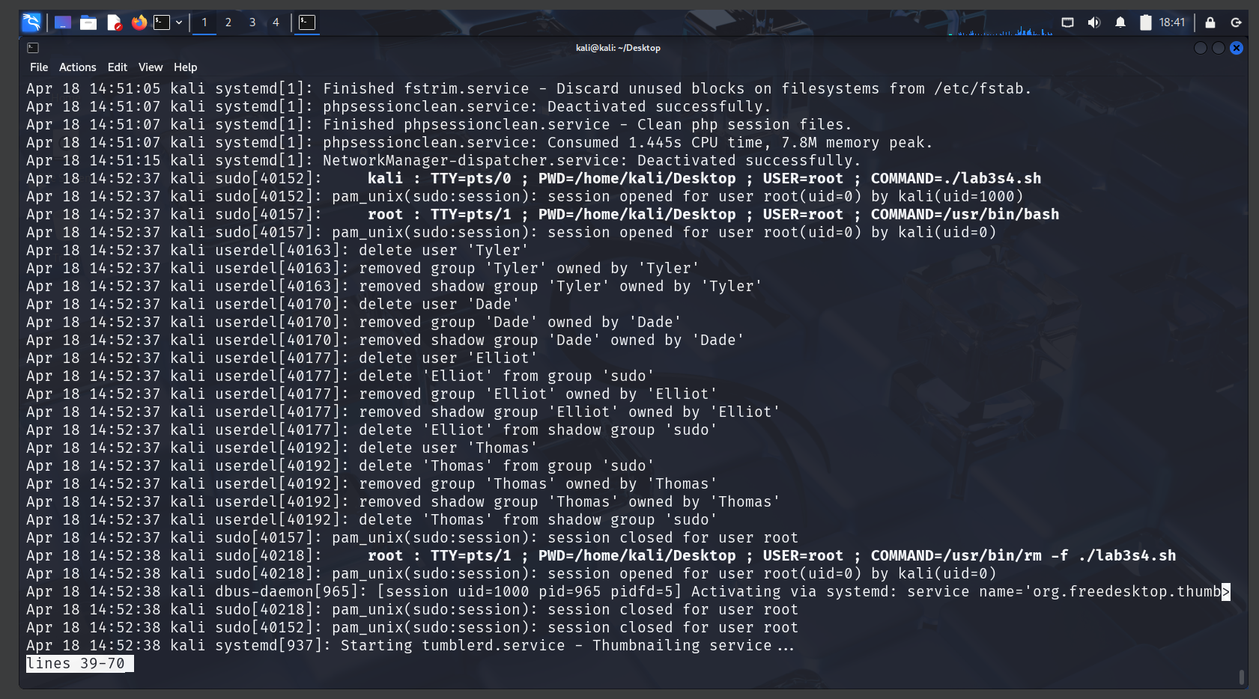
Figure 27: I reviewed the event logs in Kali Linux after running “sudo ./lab3s4.sh”.

