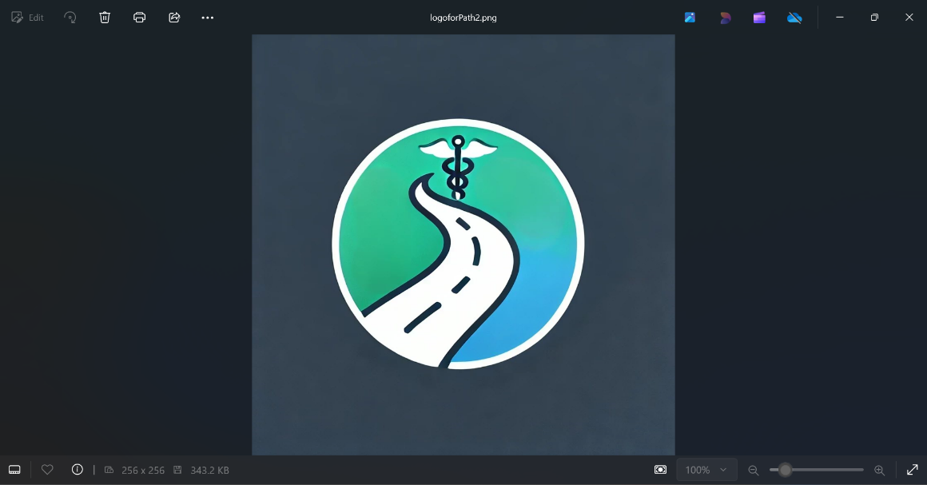**PATH (Patient Assistance for Treatment & Healing) : A Comprehensive GPT Agent for Cancer Patients or at High Risk for Cancer**

GuidedPATH (Guided Patient Assistance for Treatment & Healing)TM is an advanced GPT-powered patient assistance platform designed to provide comprehensive, personalized support for patients diagnosed with cancer and severe inflammatory/immunological (I/I) diseases, such as rheumatoid arthritis, Crohn's disease, lupus, and psoriasis. This platform focuses on four core functions: providing essential information on treatment guidelines, identifying clinical trial options, offering patient assistance through support groups, insurance navigation, top doctor referrals, and managing medication. By leveraging the latest AI technology, GuidedPATH delivers accurate and real-time support for patients managing these complex diseases. This proposal outlines the core features, challenges, competitor landscape, differentiation strategies, partnership strategy, and phased implementation plan.

**Core Functions of GuidedPATH**

1. **Guidelines Reading**
   * **Access to the Latest Guidelines**: GuidedPATH provides up-to-date treatment guidelines for cancer and I/I diseases, incorporating information from key institutions such as ASCO for cancer and EULAR for I/I diseases.
   * **Personalized Recommendations**: Using Retrieval-Augmented Generation (RAG), GuidedPATH delivers personalized treatment recommendations based on the patient’s medical history, diagnosis, and preferences. Real-world data integration ensures nuanced, patient-centered advice.
   * **Regular Updates**: Continuous updates reflect the latest medical advances, ensuring patients always have the most current information.
   * **Disease-Specific Multimodal Care**: Offers recommendations for multimodal care, including drug therapies, biologics, immunosuppressants, and lifestyle changes.

**Literature Integration: NEJM Paper on GPT for Cancer Treatment Guidelines**

GuidePATH will utilize and further improve the methodology presented in a recent NEJM publication, which used GPT to read and retrieve cancer treatment guidelines (ASCO and ESMO). By integrating Retrieval-Augmented Generation (RAG), GuidePATH will ensure the delivery of high-quality, up-to-date cancer treatment information to patients.

**Citation:**

NEJM AI 2024;1(6). Published May 17, 2024. DOI: 10.1056/AIcs2300235. VOL. 1 NO.

1. **Clinical Trial Finder**
   * **Comprehensive Clinical Trial Database**: Continuously updated with trials from research centers and pharmaceutical companies.
   * **Advanced Filtering**: Allows patients to search trials by disease type, stage, location, and therapy.
   * **Eligibility Check**: Interactive questionnaire helps patients determine their eligibility based on specific disease characteristics and medical history.
   * **Application Assistance and Notifications**: Guided steps for trial applications and real-time notifications when new trials match their disease profile.
2. **Patient Assistance**
   * **Support and Advocacy Groups**: Personalized recommendations for disease-specific support groups.
   * **Insurance Navigation**: Simplifies navigating insurance coverage for treatments and clinical trials.
   * **Specialist Referrals**: Refers patients to top hospitals, cancer centers, and specialists.
   * **Financial Assistance**: Provides information on financial aid programs for high-cost treatments.
3. **Medication Management**
   * **Medication Scheduling and Reminders**: Customizable medication schedules with reminders for complex regimens.
   * **Drug Interaction Alerts**: Identifies potential drug interactions to reduce adverse events.
   * **Side Effect Monitoring**: Allows patients to log side effects in real-time and communicate with healthcare teams.
   * **Pharmacy Integration**: Partners with pharmacies for prescription refills and mail-order services.

**Additional Future Features**

1. **Symptom Checker and Virtual Triage**
2. **Mental Health Support**
3. **Telemedicine Integration**
4. **Educational Webinars**
5. **Nutrition and Wellness Guidance**

**Competitor Landscape**

| **Competitor** | **Key Features** | **Strengths** | **Weaknesses** |
| --- | --- | --- | --- |
| **Belong.Life** | Cancer-focused patient navigation, clinical trial matching, support groups | Strong community focus and direct links to trials | Limited to cancer, lacks personalization with real-world data |
| **Ciitizen** | Medical record collection, trial matching, patient advocacy | Empowers patients with data control | Not as focused on personalized recommendations |
| **PatientsLikeMe** | Peer support, treatment reports, symptom management | Large patient community, chronic disease focus | Lacks AI-driven personalization, user-generated content limits |
| **SmartPatient MyTherapy** | Medication management, reminders, health tracking | Strong focus on medication management | Does not cover patient assistance and clinical trial matching |
| **IBM Watson Health** | AI-driven treatment recommendations, clinical trial matching | Advanced AI, strong in oncology | High cost, complex integration with existing health systems |

**Differentiation Strategy**

To stand out in a crowded market, GuidedPATH must leverage its unique strengths:

1. **AI-Powered Personalization**: GuidedPATH’s RAG engine provides personalized, real-time recommendations based on the latest clinical guidelines and real-world data. This level of personalization, lacking in competitors like Belong.Life and PatientsLikeMe, sets GuidedPATH apart.
2. **End-to-End Patient Assistance**: Unlike competitors that focus on narrow services, GuidedPATH integrates the entire patient journey, from clinical trial eligibility checks to insurance navigation, addressing multiple touchpoints in patient care.
3. **Pharmacy and Insurance Integration**: GuidedPATH’s integration with pharmacies for seamless prescription refills and alerts, combined with its partnership with insurance companies to streamline claims processing, provides a significant advantage. Insurance companies could benefit from reduced administrative costs and improved customer satisfaction.
4. **Clinical Trial Finder with Advanced Filtering**: GuidedPATH’s advanced filtering and eligibility check systems provide a more nuanced experience than other platforms, ensuring patients are matched with the most appropriate clinical trials.
5. **Comprehensive Support Ecosystem**: In addition to its core functions, GuidedPATH could expand to include future features such as virtual triage, mental health support, and nutrition guidance, creating a well-rounded platform for comprehensive disease management.

**Partnership Strategy**

1. **Pharmacies and Specialty Drug Providers**: GuidedPATH will integrate with pharmacies to offer prescription management, refills, and drug interaction alerts directly through the platform. This simplifies medication management for patients and provides pharmacies with an opportunity to strengthen customer loyalty.
2. **Insurance Companies**: Collaborating with insurance providers will streamline the claims process for patients. GuidedPATH will assist with understanding coverage, submitting claims, and navigating the appeals process. Insurance companies could benefit from improved customer satisfaction and reduced administrative costs.
3. **Healthcare Providers and Hospitals**: By partnering with major cancer centers, rheumatology clinics, and I/I disease treatment hubs, GuidedPATH will integrate into existing care systems, providing patients and providers with a valuable tool for navigating complex treatments and clinical trials.
4. **Pharmaceutical Companies and Research Institutions**: Working with pharmaceutical companies and research institutions will ensure that patients have access to the latest clinical trials and cutting-edge therapies.

**Potential Revenue Streams**

1. **Subscription Model**: GuidedPATH will offer tiered subscription plans for patients and healthcare providers, with premium options providing access to advanced features like detailed trial analytics and second opinions from specialists.
2. **Pharmaceutical Sponsorships**: Pharmaceutical companies will have the opportunity to sponsor clinical trials or educational content on the platform, offering patients more access to cutting-edge therapies.
3. **Pharmacy Partnerships**: pharmacies can engage more meaningfully with patients by providing personalized medication recommendations, alerts for drug interactions, and automatic refill notifications. This would enhance patient loyalty and satisfaction with pharmacy services.
4. **Insurance Partnerships**: GuidedPATH will partner with insurance companies to streamline the claims process for high-cost treatments. By offering the platform as a value-added service, insurers can enhance patient satisfaction and reduce claim processing times.

**Phase-by-Phase Development Plan for GuidedPATH**

**Phase 1: Research and Planning**

* Conduct market research, identify regulatory requirements, and build relationships with key stakeholders.
* Develop user personas and define the core platform features.

**Phase 2: Design and Development of Core Features**

* Build the RAG engine for treatment guidelines.
* Develop the clinical trial database and patient assistance modules.
* Partner with hospitals, research centers, and pharmaceutical companies.

**Phase 3: Testing and Integration with Wearables**

* Test the platform’s core features with beta users.
* Ensure full integration with wearable devices.

**Phase 4: Full Launch and Marketing**

* Launch the platform with targeted marketing for cancer and I/I disease patients.
* Establish partnerships and promote the platform through healthcare providers and advocacy groups.